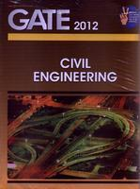
GATE 2012 Civil Engineering
ISBN: 8183550240
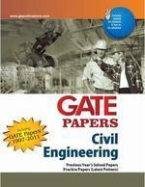
GATE PAPERS Civil Engineering
ISBN: 8183550355
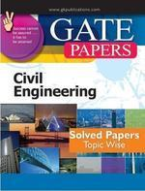
Gate Papers Civil Engg. Solved Papers (Topic Wise)
ISBN: 8183554466
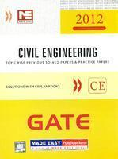
GATE 2012 Civil Engineering
ISBN: 9381069066

Popular Master Guide Gate Civil Engineering
ISBN: 8178121336

