

Sales manager interview questions

with answers

What do you think are the most important skills in succeeding in sales?

 | You could put a number on the skills to structure your answer around this. For example, “In my opinion, the three most important sales skills are…” Instead of referring to specific sales techniques, you should mention competencies and skills which a salesperson need to get success. Below are some skills including:  • Adjust your approach to different people and situations.  • Ask a right question and how to listen.  • How to communicate and handle dissatisfaction and rejection of customers.  • Make plan and comply with it.  • Make influence on and persuade customers.  • To be good at negotiating for common agreement.

What do you like and dislike about the sales process?

 | Use this question to know the candidate’s self-awareness and motivation. Know your strengths in the sales process as these will translate into what you like. The interviewer will give priority to you when your “likes” and strengths fix the sales position.  For example, if you are discussing your strengths with the interviewer, demonstrate and describe how you enjoy this aspect of sales and your pleasure at coming up with win-win solutions. You need to emphasize that this will be ensured to satisfy customers and increase sales for the company.  You note that you should take careful when responding to the “dislikes”. During negotiation on sales solutions, you should choose a characteristic of your current or precious company, for example you done poor delivery on the sales or lack of flexibility. It is positive manner to answer this question. You give your “dislikes” to get the solutions for the sort of problems. For example, there is obstruction in the delivery of company products and this makes customers unsatisfied. So you will discuss how set up a follow-up process to speed up the delivery of products.

Why did you leave your last job?

 | 1. Some sample answers to the interview question: “Why are you leaving your last job?”  • There is no opportunity to promote in my current job and I’m ready to face a new challenge;  • I have worked there for 04 years with much experience and skills. I want to be promoted but the Company do not offer me that opportunity;  • The company has cut down with its focus on the business line my job is responsible for;  • My family transferred to another region, or, my current workplace is too far away from my home;  • My old company often paid late and had inadequate compensation policy.  2. You should avoid answers that:  • Speak ill of your old boss, colleague, etc.;  • They punished me many times for…  • I did not complete my job.

Why should we hire you?

 | For one, the interview question “give us reasons to hire you”, “why should we employ you” or “what can you bring to our company” is something that differentiates the best candidates from the other good candidates.  This question deals with your ability to sell yourself. Think of yourself as the product. Why should the customer buy?  Tips to answer:  • One of the best ways to answer this question is to make a short list of all your advantages and create a paragraph that would point out the positive aspects that you would bring to the new job position.  • One of the points that you can raise is the similarity of the job profile you are aiming for at the company to the job profile you enjoyed in your previous job.  • You can also draw the interviewer’s attention to your key skills and strengths, namely – quick learning, excellent communication skills, etc.  • In addition, your professional ambitions should be made clear – the motivation and dedication that you have for the profession and the opening position.

What is your greatest weakness?

 | 1. Ways to answer:  a) First way: Turning your strong point into weak point.  For example: I am a perfectionist and therefore, I rarely believe in anyone who can work as well as me. As a result, I am afraid to delegate important tasks to others.  This approach has a weak side as that if you are not clever, you will cause the employer to believe that you are cheating him.  b) Second way: Solving your weakness absolutely.  A better approach is that you state one point which was once your weakness, but you have done well to resolve it.  For example: I tended to be a perfectionist, therefore I didn’t like to delegate to others. But I have found out that in order to develop the organization, everyone in the organization must be experienced with many tasks and this is very good for an efficient team work.  2. Steps to answer:  • You need to show it through your attitude and voice: It is really your weakness. And, you may also state some situations how much that weakness has caused you difficulties.  • Give your solution to resolve that weakness, partly or wholly.  • Solutions to a weakness may be training, mentoring, etc

Why do you think you would do well at this job?

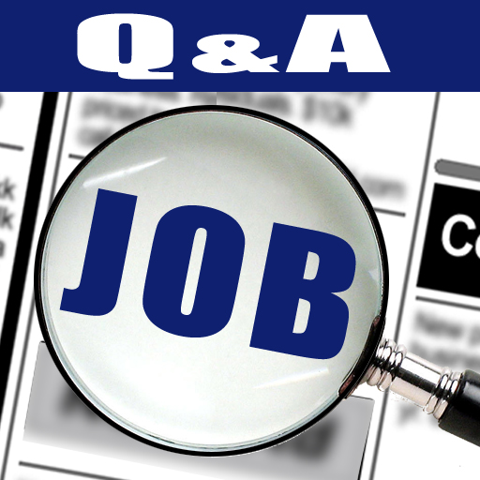 | Give several reasons and include skills, experience and interest.  1. I am a person that learn quickly and perform better under pressure, am a very good team player that motivate others in other to achieve the company’s common goals  2. Will do well in this job because I already have previous experience in the similar field. so I will use my previous experience in this job and I am interested in learning new things and enhance my skills.  3. I believe I will do well in this job because I have the relevant skills and experience. I also have the drive, interest and determination to make a real success of this role.

What are your career goals?

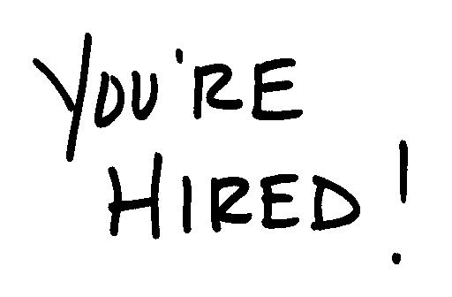 | 1. The reasons of this question:  This question will test your ability and ambition to develop yourself as well as the ability to plan for the future.  2. Levels of career goals:  • You are not sure about your goals, then answer: I’m rather busy with my duties and goals of the Company; as a result, I haven’t focused much on my long-term personal goals.  • You have goals not or very little relating to the current job: For example, you are applying for a sales manager, but your career goal is to become the head of marketing department in the next 5 years.  • Current job oriented career goals: For example, you are working as a sales manager, you goal is to become the area sales manager in the next 2 years and in the next 5 years, you will be the regional sales manager.  3. “Career goals” tips:  You can state some of your goals as following:  • Study for an MBA certificate or other degrees…  • Become specialist in the sector…  • Get to the title of XYZ something.  Note that long-term goals must be set for the next 3-5 years.

What have you learned from mistakes on the job?

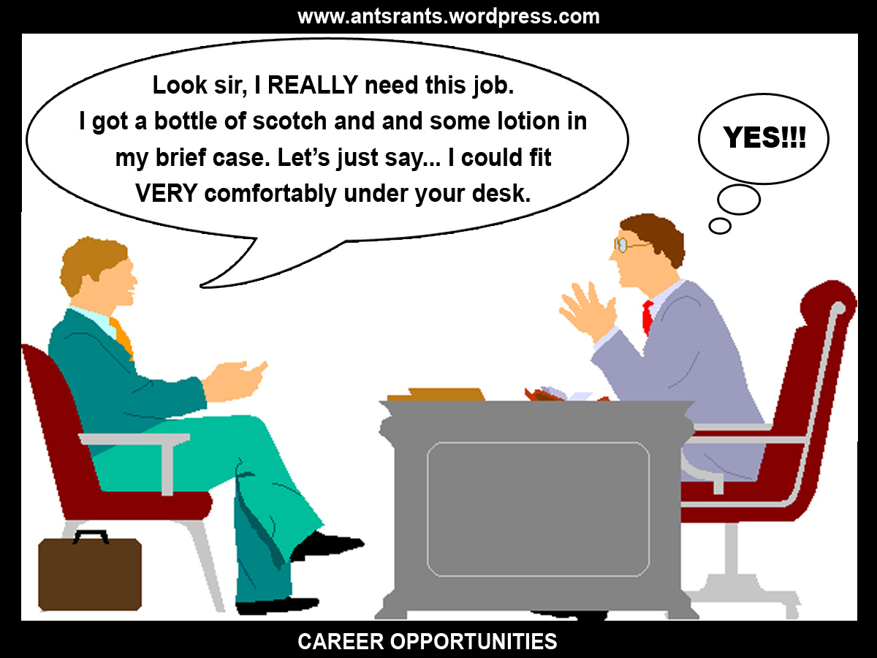 | Answer tips  Here you have to come up with something or you strain credibility. Make it small, well intentioned mistake with a positive lesson learned. An example would be working too far ahead of colleagues on a project and thus throwing coordination off.  Everyone makes mistakes, of course, but some companies are more willing to learn from them than punish those involved.  You’ve learned that when you do make mistakes, someone is usually disappointed in the choice you made, but you have to figure it out for yourself, they might help you decide what ‘s right and what ‘ss wrong, but you’ll be the decider on which you choose. You’ve learned that people do care about you, and to not do it again if you don’t want to.  Answer samples  Every one makes mistakes but only few people can realize there mistakes and they don’t want to repeat those mistakes again….. I am the one in those few people, I don’t want to repeat the mistakes which had done by me in my job/work.

What have you done to improve your knowledge in the last year?

 | Answer tips  • Try to include improvement activities that relate to the job. A wide variety of activities can be mentioned as positive self-improvement. Have some good ones handy to mention.  • Employers look for applicants who are goal-oriented. Show a desire for continuous learning by listing hobbies non-work related. Regardless of what hobbies you choose to showcase, remember that the goal is to prove self-sufficiency, time management, and motivation.  Answer samples  • Every should learn from his mistake. I always try to consult my mistakes with my kith and kin especially with elderly and experienced person.  • I enrolled myself into a course useful for the next version of our current project. I attended seminars on personal development and managerial skills improvement.

What experience do you have in this field?

 | Answer tips  • Speak about specifics that relate to the position you are applying for. If you do not have specific experience, get as close as you can.  • If you are being asked this question from your employer then you can explain your experience. Tell the employer what responsibilities you were performing during your job. You can tell what programs you developed and what modules you worked on. What were your achievements regarding different programs.  Answer sample  I have been working with computers since 2001 I also have a degree in network support/computer repair. I have built my last 3 computers, have work with Dell as an employee. So I have around 15 years experience working with computers.

Useful interview materials:

Free ebook: 75 common interview questions and answers
http://interviewquestionsaz.blogspot.com/p/free-ebook-75-interview-questions-and.html

Top 10 interview secrets to win every job interview
http://interviewquestionsaz.blogspot.com/2013/07/top-10-secrets-to-win-every-job.html

13 types of interview questions and how to face them
http://interviewquestionsaz.blogspot.com/p/13-types-of-interview-questions.html

Top 12 common mistakes in job interviews
http://interviewquestionsaz.blogspot.com/2013/07/top-12-common-mistakes-in-job-interviews.html

Job interview checklist 40 points
http://interviewquestionsaz.blogspot.com/2013/07/job-interview-checklist-40-points.html

Top 3 interview thank you letter samples
http://interviewquestionsaz.blogspot.com/2013/07/top-3-interview-thank-you-letter-samples.html

Other job interview tips

- Practice types of job interview such as screening interview, phone interview, second interview, situational interview, behavioral interview (competency based), technical interview, group interview…

- Send interview thank you letter to employers after finishing the job interview: first interview, follow-up interview, final interview.

- If you want more interview questions for entry-level, internship, freshers, experienced candidates, you can ref free ebook: 75 interview questions and answers.

- Prepare list of questions in order to ask the employer during job interview: http://interviewquestionsaz.blogspot.com/2013/07/top-10-questions-to-ask-employer-duting.html

