IIT JEE 2010 Solutions Paper 1

IIT JEE Chemistry
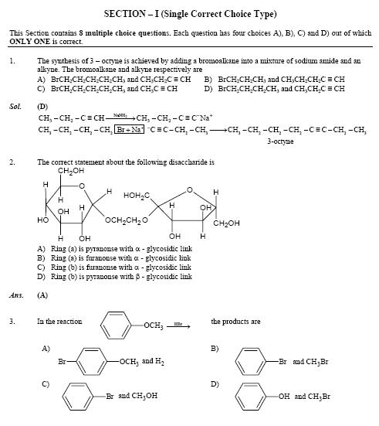 | 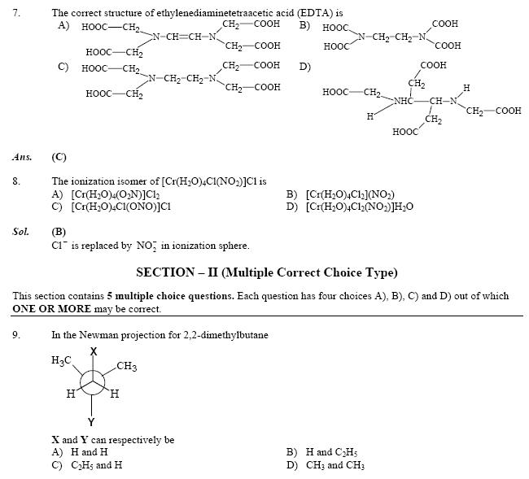 | 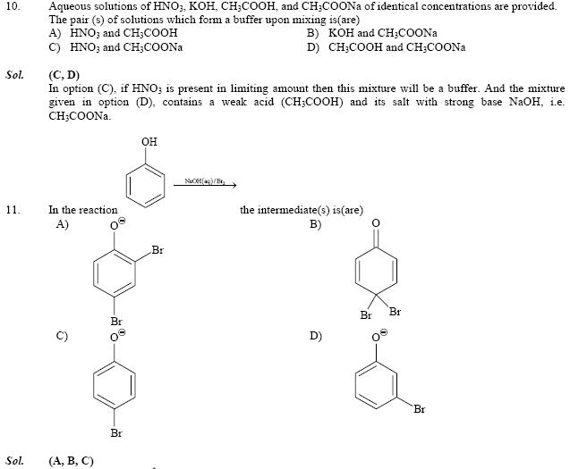 | 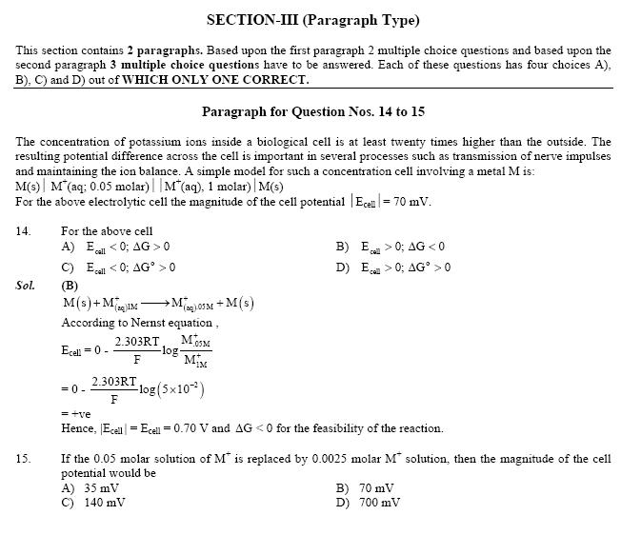
 |  | IIT Maths Solutions
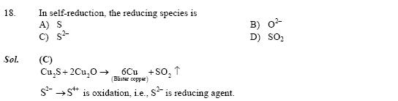 | 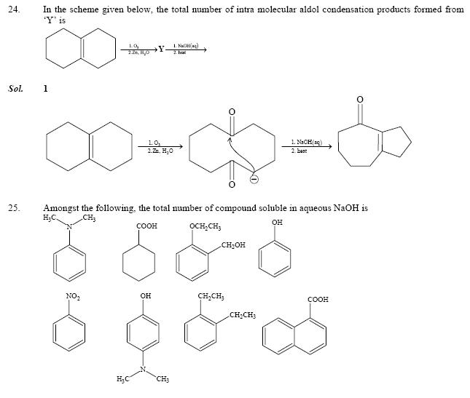 | 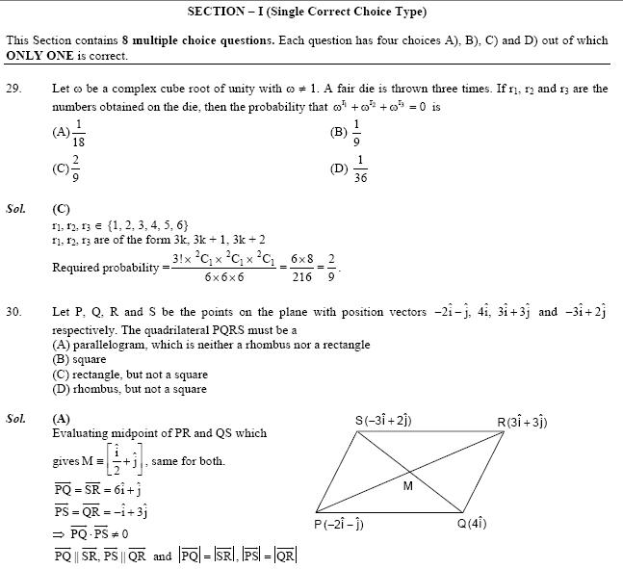 | 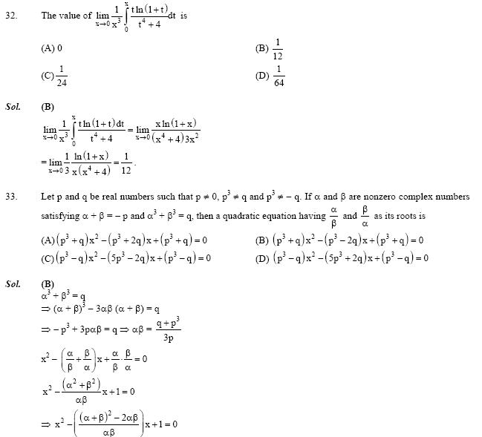
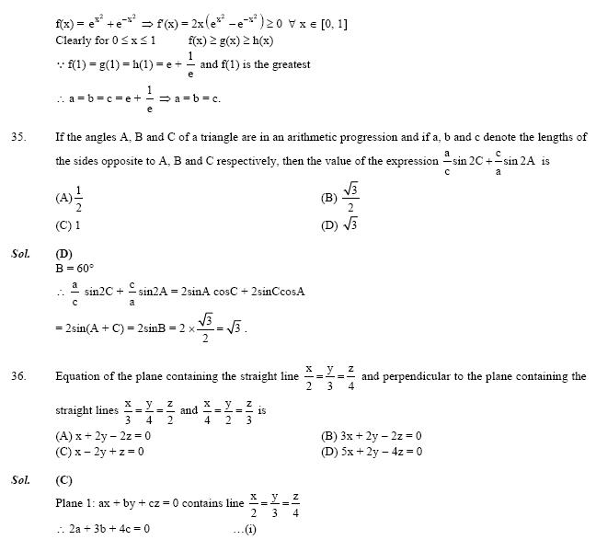 | 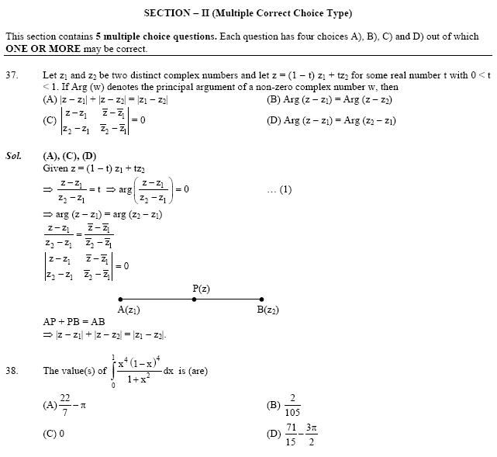 | 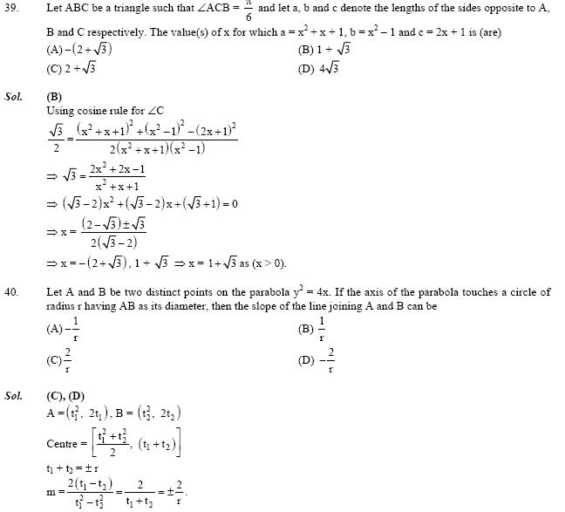 | 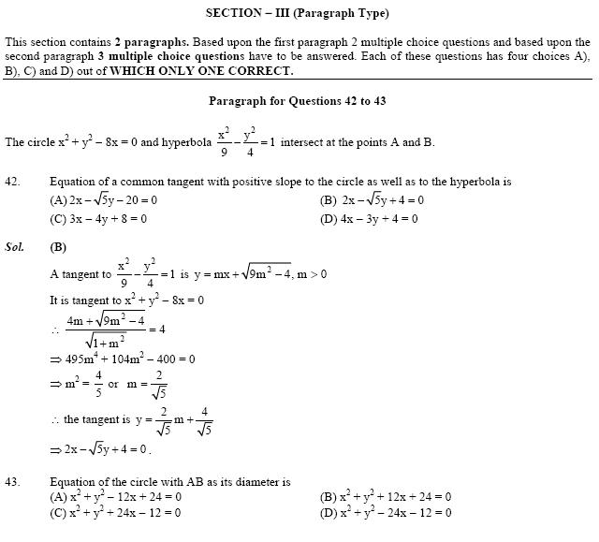
 |  |  | IIT Physics Solutions
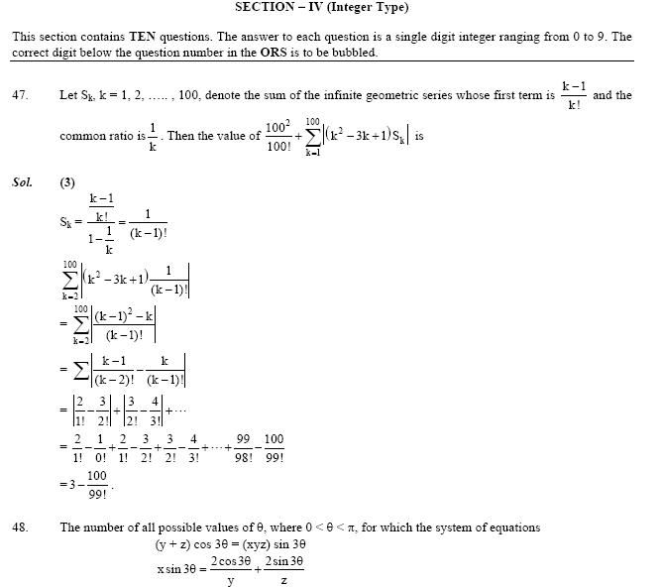 | 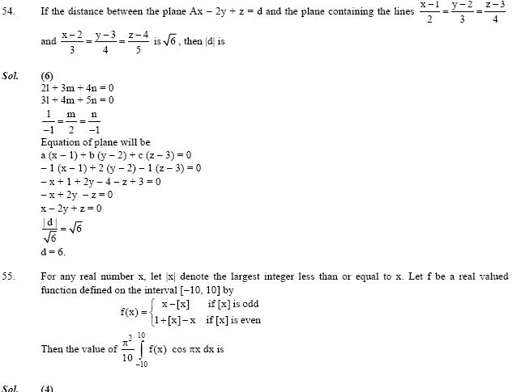 |  | 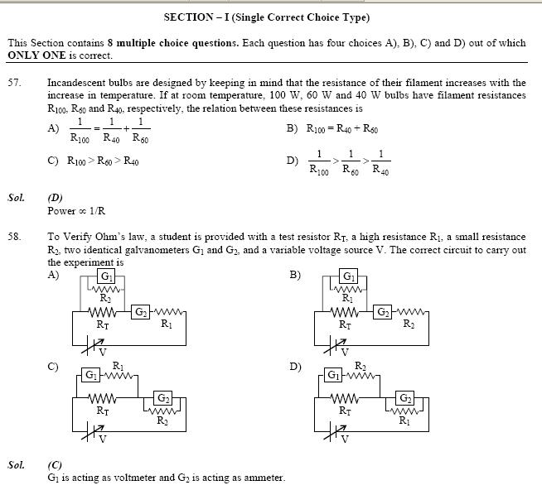
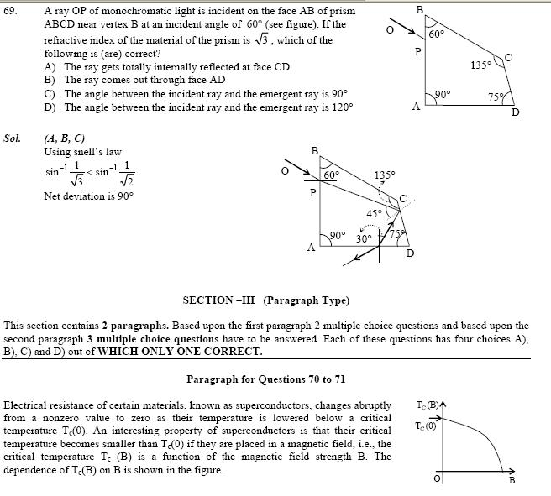
_______________________________________________________________________
IIT JEE 2010 Solutions Paper 2

IIT JEE Chemistry
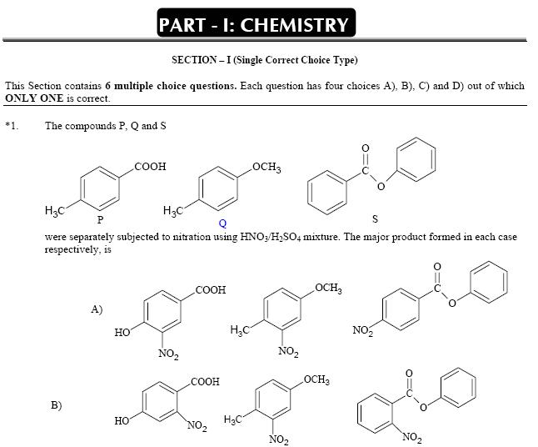 | 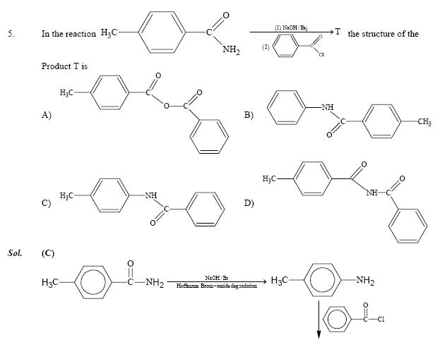 | 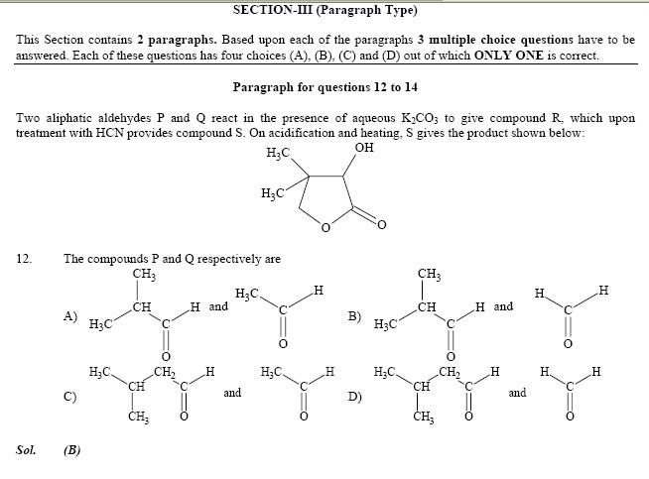 | 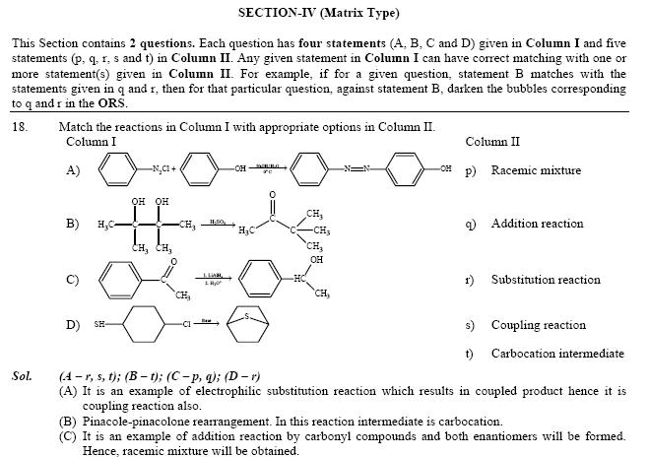
IIT Maths Solutions
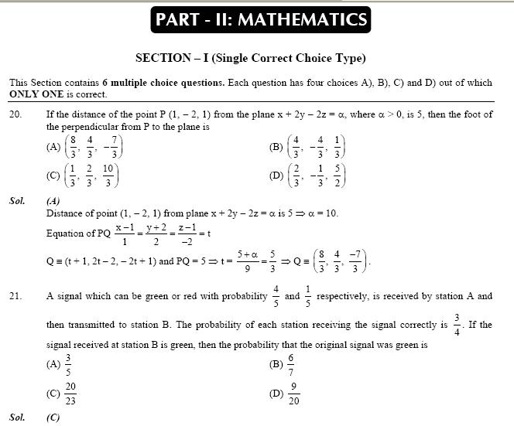 | 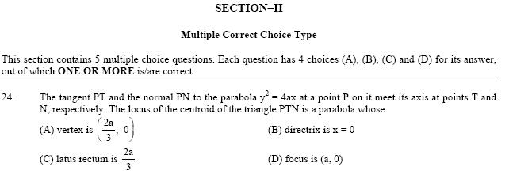 | 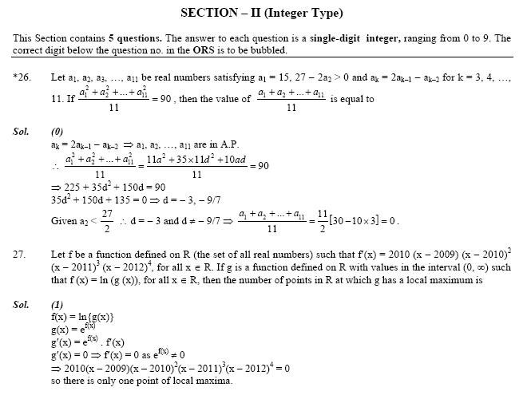 | 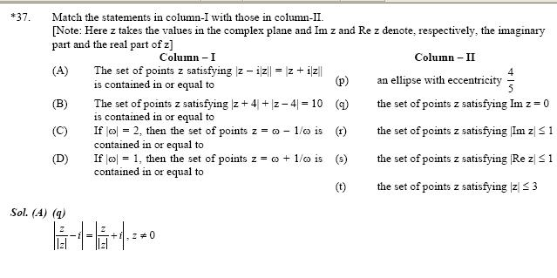
IIT Physics Solutions
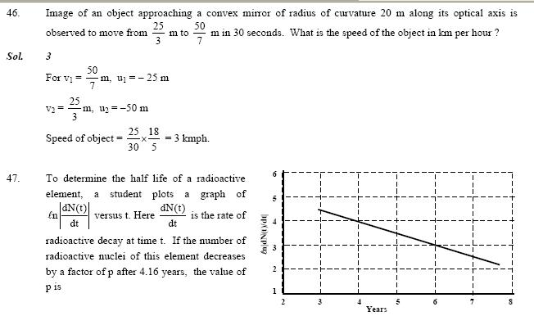 | 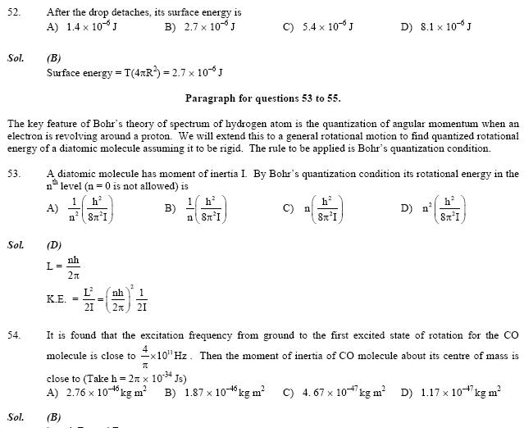 | 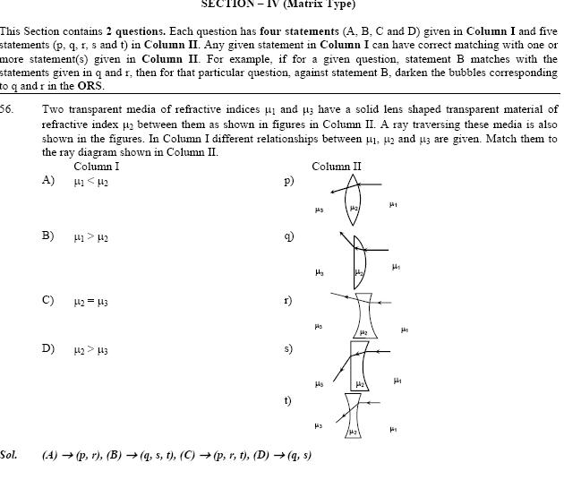 | 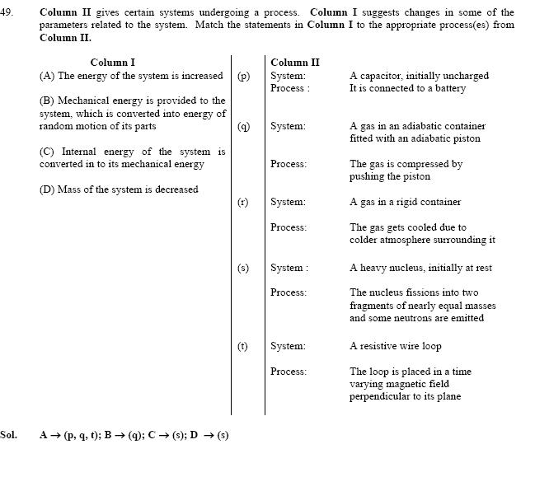
IIT JEE 2010 Solutions and Answer Keys
fiitjee iit jee 2010 solutions
Bansal Classes iit jee 2010 solutions
Resonance iit jee 2010 solutions
Brilliant Tutorial iit jee 2010 solutions
Narayana iit jee 2010 solutions
IIT JEE 2010 Entrance Exam | IIT JEE 2010 Cut offs | IIT JEE 2010 Paper Solutions | IIT JEE 2010 Answers Key |IIT JEE 2010 Paper Analysis | IIT JEE 2010 Results | IIT JEE 2010 Topper and Merit List

