Govt. of Maharashtra
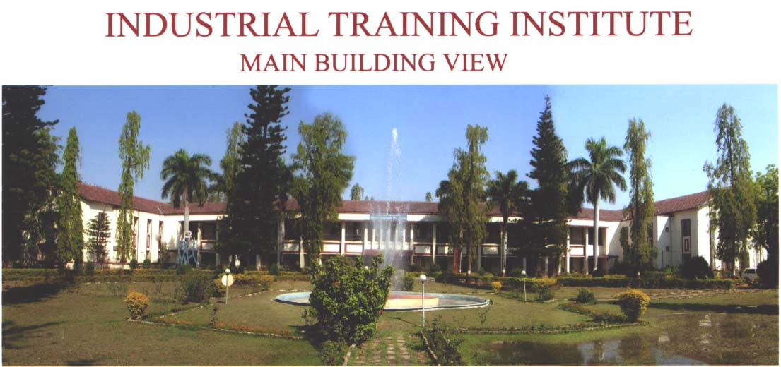

Sanctioned Trades
1.Three Year Duration Trades 3
No. of Trainees 80
No. of Units 5
2. Two Year Duration Trades 19
No. of Trainees 686
No. of Units 46
3. One Year Duration Trades
Engineering 8
No. of Trainees 240
No. of Units 16
4 One Year Duration
Non-Engineering 07
No. of Trainees 144
No. of Units 09
5 Centre of Excellence 96
Total Trades 36
Total No. of Units 83
Total No. of Trainees 1244

Scheme started in Year : 1997
Joint Project Of
Govt. Of India – Govt. Of Germany – gtz
World Bank Project
Courses No.of Participants trained in
2004-05
1. Industrial Automation 381
2. Auto Cad 108
3. Analog & Digital Electronics 327 ( Teacher’s Training Programme – 279)
4. P. C. Maintenance 396 ( Teacher’s Training Programme – 279)
Total No.of Trainees Trained In 2004-05 : 1212
Total Tution Fees Collected In 2003-04 : Rs.9,19,650/-
M.E. 040
B.E. 313
Diploma 257
I.T.I. 045
Others 560
Total Tuition Fees Collected
In the period 1999-2004: Rs.25,14,700/-
Total No. of Industries: 150

Note: Best Hi-tech Training Centre in India among 10 Hi-tech Centers across the Country.

The trainees from COPA,DTP,SP,STGM,
STGE are being trained with the help of
JHIT Institute
Duration– One and Half Month
Fees – 1000/- (For I.T.I. Trainees)
- 2000/- (For Others)
Five batches completed. 100 trainees trained so for ,all got placement.

