Cells

Overview of the Cellular Basis of Life
- A cell is composed primarily of four elements: carbon, hydrogen, oxygen, and nitrogen plus many trace elements. Living matter is over 60 percent water. The major building material of the cell is protein.
- Cells vary in size from microscopic to over a meter in length. Shape often reflects function. For example, muscle cells have a long axis to allow shortening.

Anatomy of a Generalized Cell
- Cells have three major regions nucleus, cytoplasm, and plasma membrane.
    - The nucleus, or control center, directs cell activity and is necessary for reproduction. The nucleus contains genetic material (DNA), which carries instructions for synthesis of proteins.
    - The plasma membrane limits and encloses the cytoplasm and acts as a selective barrier to the movement of substances into and out of the cell. It is composed of a bi-lipid layer containing proteins. The water-impermeable lipid portion forms the basic membrane structure. The proteins (many of which are glycoproteins) act as enzymes or carriers in membrane transport, form membrane channels or pores, provide receptor sites for hormones and other chemicals, or play a role in cellular recognition and interactions during development and immune reactions (Figure 3.1).
Specializations of the plasma membrane include microvilli (which increase the absorptive area) and cell junctions (desmosomes, tight junctions, and gap junctions).
    - The cytoplasm is where most cellular activities occur. Its fluid substance, the cytosol, contains inclusions, stored or inactive materials in the cytoplasm (fat globules, water vacuoles, crystals, and the like) and specialized bodies called organelles, each with a specific function. For example, mitochondria are sites of ATP synthesis, ribosomes are sites of protein synthesis, and the Golgi apparatus packages substances for export from the cell. Lysosomes carry out intracellular digestion, and peroxisomes disarm dangerous chemicals in the cells. Cytoskeletal elements function in cellular support and motion. The centrioles play a role in cell division and form the bases of cilia and flagella (Figure 3.2).
Return to top

Cell Physiology
- All cells exhibit irritability, digest foods, excrete wastes, and are able to reproduce, grow, move, and metabolize.
- Transport of substances through the cell membrane:
  - Passive transport processes include diffusion and filtration.
    - Diffusion is the movement of a substance from an area of its higher concentration to an area of its lower concentration. It occurs because of kinetic energy of the molecules themselves. The diffusion of dissolved solutes through the plasma membrane is simple diffusion (Figure 3.3). The diffusion of water through the plasma membrane is osmosis. Diffusion that requires a protein carrier is facilitated diffusion.
    - Filtration is the movement of substances through a membrane from an area of high hydrostatic pressure to an area of lower fluid pressure. In the body, the driving force of filtration is blood pressure.
  - Active transport processes use energy (ATP) provided by the cell.
    - In solute pumping, substances are moved across the membrane against an electrical or a concentration gradient by proteins called solute pumps. This accounts for the transport of amino acids, some sugars, and most ions.
    - The two types of ATP-activated bulk transport are exocytosis and endocytosis. Exocytosis moves secretions and other substances out of cells; a membrane-bound vesicle fuses with the plasma membrane, ruptures, and ejects its contents to the cell exterior. Endocytosis, in which particles are taken up by enclosure in a plasma membrane sac, includes phagocytosis (uptake of solid particles) and pinocytosis (uptake of fluids) (Figure 3.4).
- Osmotic pressure, which reflects the solute concentration of a solution, determines whether cells gain or lose water.
  - Hypertonic solutions contain more solutes (and less water) than do cells. In these solutions, cells lose water by osmosis and crenate.
  - Hypotonic solutions contain fewer solutes (and more water) than do the cells. In these solutions, cells swell and may rupture (lysis) as water rushes in by osmosis.
  - Isotonic solutions, which have the same solute-to-solvent ratio as cells, cause no changes in cell size or shape (Figure 3.5).
- Cell division has two phases, mitosis (nuclear division) and cytokinesis (division of the cytoplasm).
  - Mitosis begins after DNA has been replicated; it consists of four stages: prophase, metaphase, anaphase, and telophase. The result is two daughter nuclei, each identical to the mother nucleus.
  - Cytokinesis usually begins during anaphase and progressively pinches the cytoplasm in half.
  - Mitotic cell division provides an increased number of cells for growth and repair.
- Protein synthesis involves both DNA (the genes) and RNA.
  - A gene is a segment of DNA that carries the instructions for building one protein. The information is in the sequence of bases in the nucleotide strands. Each three-base sequence (triplet) specifies one amino acid in the protein.
  - Messenger RNA carries the instructions for protein synthesis from the DNA gene to the ribosomes. Transfer RNA transports amino acids to the ribosomes. Ribosomal RNA forms part of the ribosomal structure and helps coordinate the protein building process.
Return to top

Body Tissue
- Epithelium is the covering, lining, and glandular tissue. Its functions include protection, absorption, and secretion. Epithelia are named according to arrangement (simple, stratified)(Figure 3.6) and cell shape (squamous, cuboidal, columnar) (Figure 3.7).
- Connective tissue is the supportive, protective, and binding tissue. It is characterized by the presence of a nonliving, extracellular matrix produced and secreted by the cells; it varies in amount and consistency. Fat, ligaments and tendons, bones, and cartilage are all connective tissues or connective tissue structures.
- Nervous tissue is composed of cells called neurons, which are highly specialized to receive and transmit nerve impulses and supporting cells. Neurons are important in control of body processes. Nervous tissue is located in nervous system structures - brain, spinal cord, and nerves (Figure 3.8).
- Muscle tissue is specialized to contract, or shorten, which causes movement. There are three types: skeletal (attached to the skeleton), cardiac (forms the heart), and smooth (in the walls of hollow organs).
- Tissue repair (wound healing) may involve regeneration, fibrosis, or both. In regeneration, the injured tissue is replaced by the same type of cells. In fibrosis, the wound is repaired with scar tissue. Epithelia and connective tissues regenerate well. Mature cardiac muscle and nervous tissue are repaired by fibrosis.

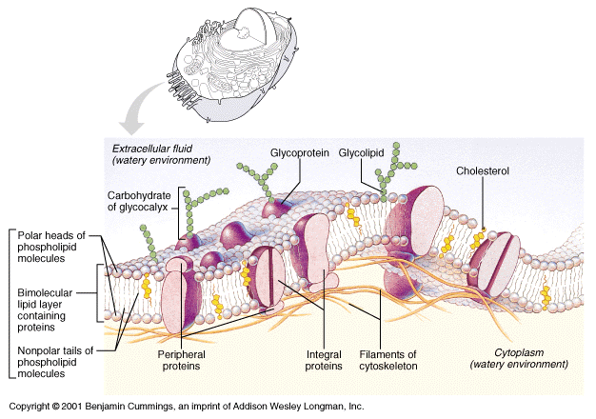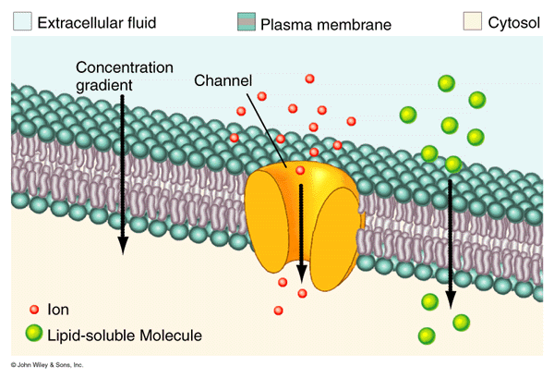
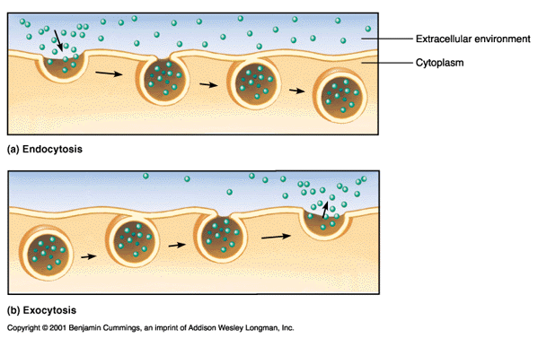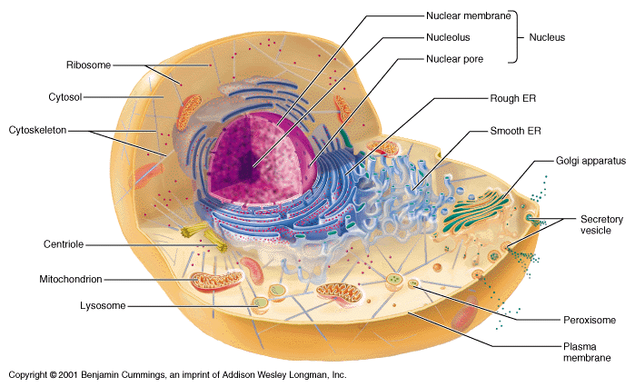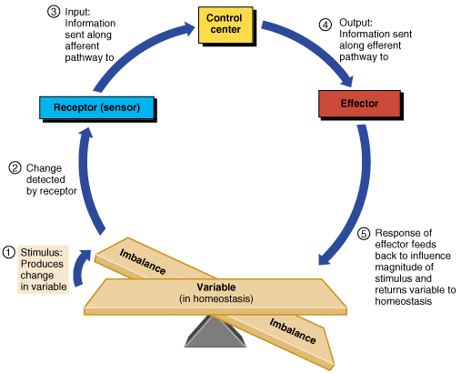Top of Form
Bottom of Form

