PHYSICS
Duration: Three Hours Maximum Marks: 100
Read the following instruction carefully
- This question paper contains 24 pages including blank pages for rough work. Please check all pages and report discrepancy, if any.
- Write your registration number, your, name and name of the examination centre at the specified locations on the right half of the Optical Response Sheet (ORS).
- Using HB pencil, darken the appropriate bubble under each digit of your registration number and the letters corresponding to your paper code.
- All questions in this paper are of objective type.
- Questions must be answered on the ORS by darkening the appropriate bubble marked A, B, C, D) using HB pencil against the question number on the left hand side of the ORS. For each question darken the double of the correct answer. In case you wish to change an answer, erase the old answer completely. More than one answer bubbled against a question will be treated as an incorrect response.
- There are a total of 65 questions carrying 100 marks.
- Questions Q.1 – Q.25 will carry 1-mark each, and questions Q.26 – Q.55 will carry 2-marks each.
- Questions Q.48- Q.51 (2 pairs) are common data questions and question pairs (Q.52, Q.53) and (Q.54, Q.55) are linked answer questions. The answer to the second question of the linked answer questions depends on the answer to the first question of the pair. If the first question in the linked pair is wrongly answered or is un-attempted, then the answer to the second question in the pair will not be evaluated.
- Questions Q.56 - Q.65 belong to General Aptitude (GA). Questions Q.56 - Q.60 will carry 1-mark each, and questions Q.61 – Q.65 will carry 2-marks each. The GA questions will begin on a fresh page starting from page 15.
- Un-attempted questions will carry zero marks.
- Wrong answers will carry NEGATIVE marks. For Q.1–Q.25 and Q.56 – Q.60, 1/3 mark will be deducted for each wrong answer. For Q.26 – Q.51 and Q.61 - Q.65, 2/3 mark will be deducted for each wrong answer. The question pairs (Q.52, Q.53), and (Q.54, Q.55) are questions with linked answers. There will be negative marks only for wrong answer to the first question of the linked answer question pair i.e., for Q.52 and Q.54, 2/3 mark will be deducted for each wrong answer. There is no negative marking for Q.53 and Q.55.
- Calculator (without data connectivity) is allowed in the examination hall.
- Charts, graph sheets or tables are NOT allowed in the examination hall.
- Rough work can be done on the question paper itself. Additionally, blank pages are provided at the end of the question paper for rough work.
Some useful physical constants

Speed of light
Speed of light
Boltzmann constant
Charge of electron

Q.1-25 Carry one mark each
- Consider an anti-symmetric tensor with the indices i and j. running from 1 to 5. The number of independent components of tile tensor is
      - 3
      - 10
      - 9
      - 6
- The value of the integral where the contour C is the unit circle: is
      - 0
- The eigenvalues of the matrix are
      - 5, 2, -2
      - -5, -1, -1
      - 5, 1, -1
      - -5, 1, 1
- If then the Laplace transform of is
- The valence electrons do not directly determine the following property of a metal.
      - Electrical conductivity
      - Thermal conductivity
      - Shear modulus
      - Metallic lustre
- Consider X-ray diffraction from a crystal with a face-centered-cubic (fcc) lattice. The lattice plane for which there is NO diffraction peak is
      - (2, 1, 2)
      - (1, 1, 1)
      - (2, 0, 0)
      - (3, 1, 1)
- The Hall coefficient, R_{H}, of sodium depends on
      - The effective charge carrier mass and density
      - The charge carrier density and relaxation time
      - The charge earner density only
      - The charge earner density only
- The Bloch theorem states that within crystal, the wave function, , of an electron has the form
      - where is an arbitrary function and is an arbitrary vector
      - where is an arbitrary function and is a reciprocal lattice vector
      - where is a lattice vector and is a reciprocal lattice vector
      - where is a lattice vector and is an arbitrary vector
- In an experiment involving a ferromagnetic medium, the following observations were made. Which one of the plots does NOT correctly represent the property of the medium? (T_{C} is the Curie temperature)
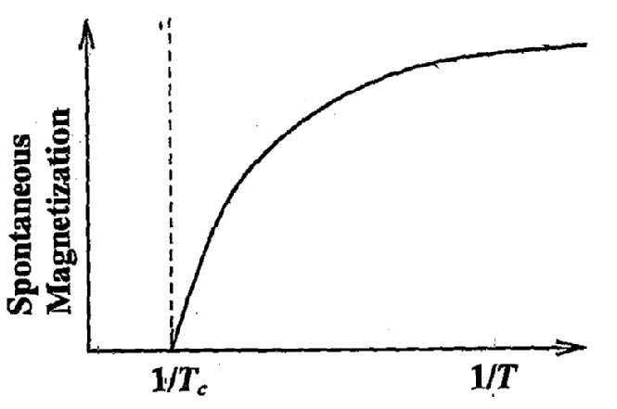
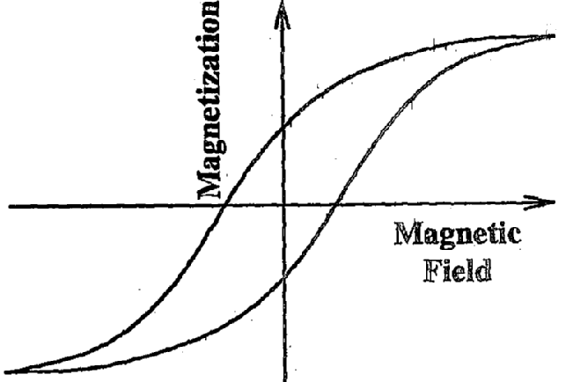
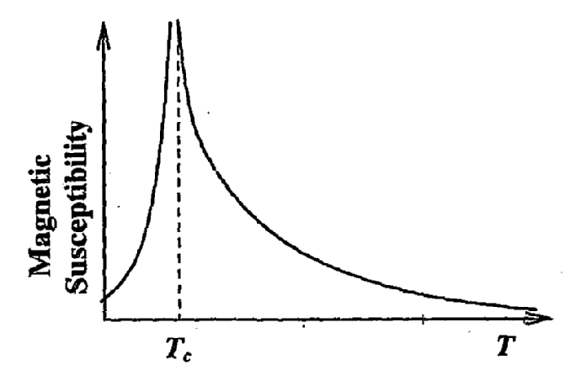
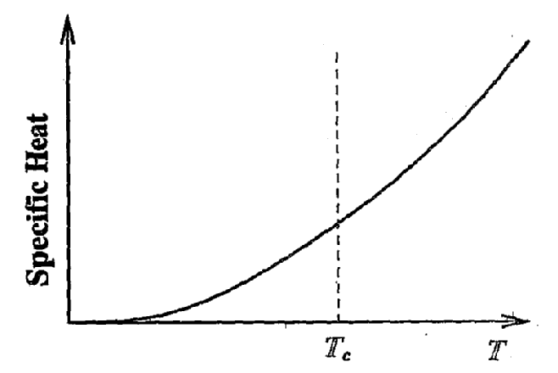
- The thermal conductivity of a given material reduces when it undergoes a transition from its normal state to the superconducting state. The reason is:
      - The Cooper pairs cannot transfer energy to the lattice
      - Upon the formation of Cooper pairs, the lattice becomes less efficient in heat transfer
      - The electrons in the normal state lose their ability to transfer heat because of their coupling to the Cooper pairs
      - The heat capacity increases on transition to the superconducting state leading to a reduction in thermal conductivity
- The basic process underlying the neutron β-decay is
- In the nuclear shell model the spin parity of ¹⁵N is given by
- Match the reactions on the left with the associated interactions on the right.
(i) Strong
(ii) Electromagnetic
(iii) Weak
      - (1, iii), (2, ii), (3, i)
      - (1, i), ‘(2, ii), (3, iii)
      - (1, ii), (2, i), (3, iii)
      - (1, iii)r (2, i), (3, i)
- To detect trace amounts of a gaseous specie in mixture of gases, the preferred probing tool is
      - Ionization spetroscopy with X-rays
      - NMR spectroscopy
      - ESR spectroscopy
      - Laser spectroscopy
- A collection of N atoms is exposed to a strong resonant electromagnetic radiation with N_{g} atoms in the ground state and N_{e} atoms in the excited state, such that N_{g} + N_{e} = N. This collection of two-level atoms will have the following population distribution:
- Two states of an atom have definite parities. An electric dipole transition between these states is
      - Allowed if both the states have even parity
      - Allowed if both the states have odd parity
      - Allowed if the two states have opposite parities
      - Not allowed unless a static electric field is applied
- The spectrum of radiation emitted by a black body at a temperature 1000 K peaks in the
      - Visible range of frequencies
      - Infrared range of frequencies
      - Ultraviolet range of frequencies
      - Microwave range of frequencies
- An insulating sphere of radius a carries a charge density The leading order term of the electric field at a distance d, for away from the charge distribution, is proportional to
- The voltage resolution of a 12-bit digital to analog converter (DAC), whose output varies from -10V to +10 V is, approximately
      - 1 mV
      - 5 mV
      - 20 mV
      - 100 mV
- In one of the following circuits, negative feedback does not operate for a negative input. Which one is it? The opamps are running from ±15 V supplies.
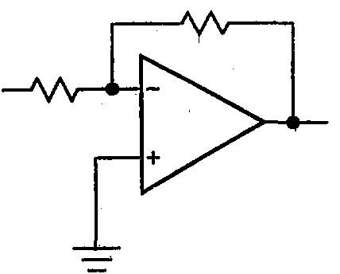
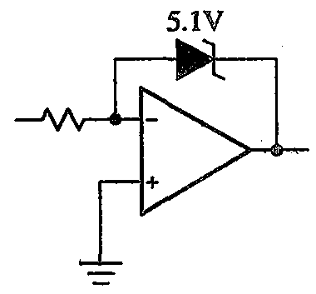
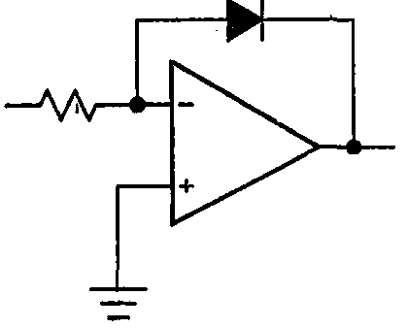
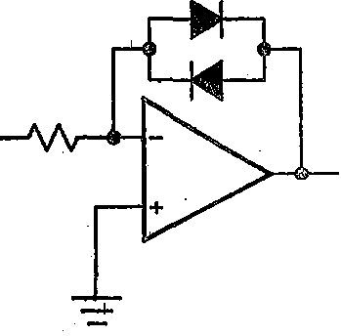
- A system of N non-interacting c1asscal point particles is constrained to move on the two-dimensional surface of a sphere. The internal energy of the system is
- Which of the following atoms cannot exhibit Bose-Einstein, condensation, even in principle?
- For the set of all Lorentz transformations with velocities along the x-axis, consider the two statements given below:
P: If L is a Lorentz transformation then, L⁻¹ is also a Lorentz transformation.
Q: If L₁ and L₂ are Lorentz transformations then, L₁L₂ is necessarily a Lorentz transformation.
Choose the correct option
      - P is true and Q is false
      - Both P and Q are true
      - both P and Q are false
      - P is false and Q is true.
- Which of the following is an allowed wave function for a particle in a bound state? N is a constant and .
- A particle is confined within a spherical region radius one femtometer (10⁻¹⁵ m). Its momentum can be expected to be about

Q.26-55 Carry two marks each

- For the complex function, which of the following statements is correct?
      - is a branch point
      - is a pole of order one
      - is a removable singularity
      - is an essential singularity
- The solution of the differential equation for subject to the initial conditions and is
- Given the recurrence relation for the Legendre polynomials
which of the following integrals has a non-zero value?
- For a two-dimensional free electron gas, the electronic density n, and the Fermi energy E_{F}, are related by,
- Far away from any of the resonance frequencies of a medium, the real part of the dielectric permittivity is
      - Always independent of frequency
      - Monotonically decreasing with frequency
      - Monotonically increasing with frequency
      - A non-monotonic function of frequency
- The ground state wave function of deuteron is in a superposition of s and d state. Which of the following is NOT true as a consequence?
      - It has a non-zero quadruple moment
      - The neutron-proton potential is non-central
      - The orbital wave-function is not spherically symmetric
      - The Hamiltonian does not conserve the total angular momentum
- The first three energy levels of ²²⁸Th₉₀ are shown below
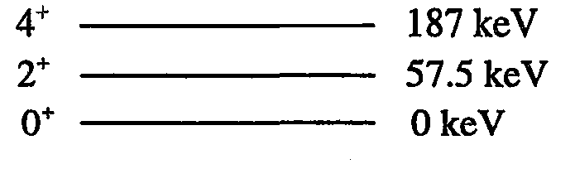
The expected spin-parity and energy of the next level are given by
      - (6⁺ ; 400 keV)
      - (6⁺ ; 300 keV)
      - (2⁺ ; 400 keV)
      - (4⁺ ; 300 keV)
- The quark content of and p is indicated:
In the process, considering strong interaction only, which of the following statements is true?
      - The process is allowed because
      - The process is allowed because
      - The process is not allowed because and
      - The process is not allowed because the baryon number is violated
- The three principal moments of inertia of a methanol (CH₃OH) molecule have the property and . The rotational energy eigenvalues are
- A particle of mass m is confined in the potential
Let the wave-function of the particle be given by
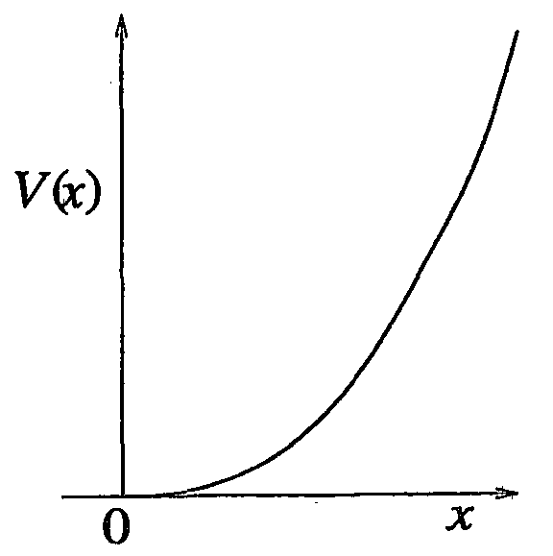
where and are the eigen functions of the ground state and the first excited state respectively. The expectation value of the energy is
- Match the typical spectra of stable mo1ecule with the corresponding wave-number range
    - Electronic spectra
    - Rotational spectra
    - Molecular dissociation
i. 10⁶ cm⁻¹ and above
ii. 10⁻⁵-10⁶ cm⁻¹
iii. 10⁰-10² cm⁻¹
      - 1-ii, 2-i, 3-iii
      - 1-ii, 2-iii, 3-i
      - 1-iii, 2-ii, 3-i
      - 1-i, 2-ii, 3-iii
- Consider the operations (parity) and (time-reversal). For the electric and magnetic field and , which of the following set of transformations is correct?
- Two magnetic dipoles of magnitude m each are placed in a plane as shown.
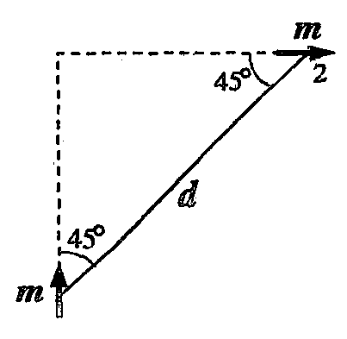
The energy of interaction is given by
      - Zero
- Consider a conducting loop of radius a and total loop resistance R placed ma region with a magnetic field B thereby enclosing a flux The loop is connected to an electronic circuit as shown, the capacitor being initially uncharged.
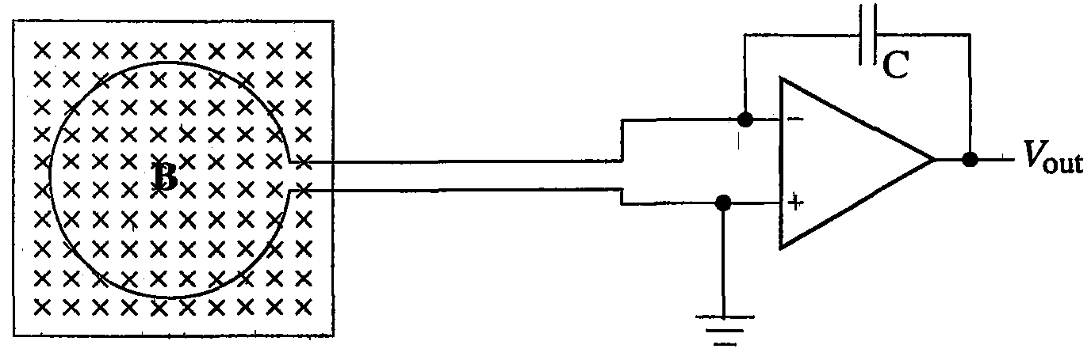
If the loop is pulled out of the region of the magnetic field at a constant speed u, the final output voltage V_{out} is independent of
      - u
      - R
      - C
- The figure shows a constant current source charging a capacitor that is initial1 uncharged.
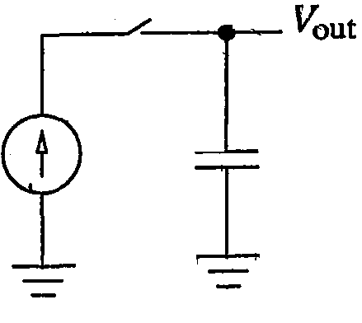
If the switch is closed at t = 0, which of the following plots depicts correctly the output voltage of the circ4iit as a function of time?

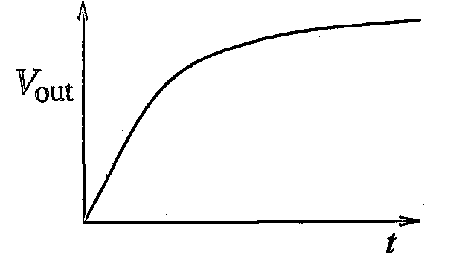

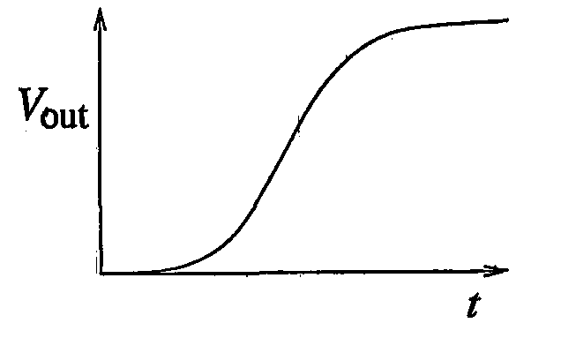

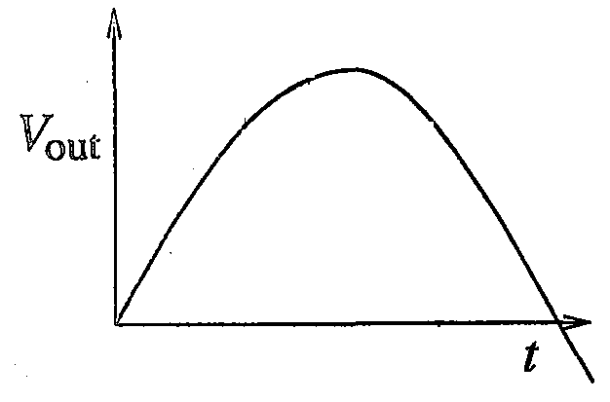

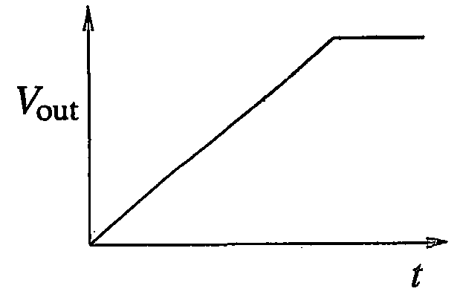
- For any set of inputs, A and B, the following circuits give the same output, Q, except one. Which one is it?

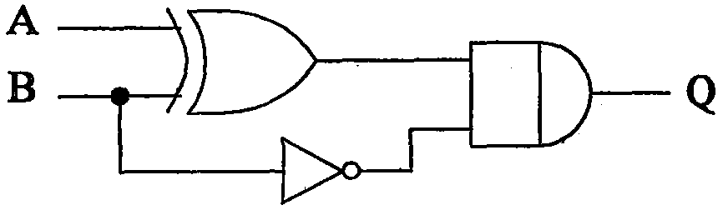

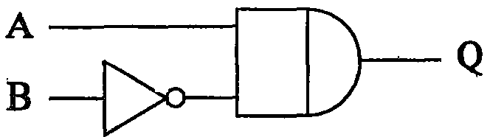

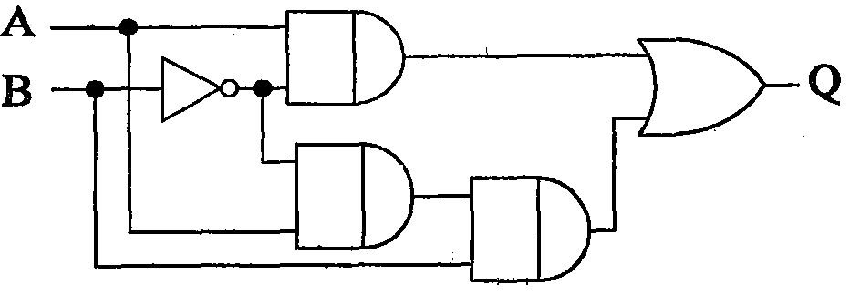

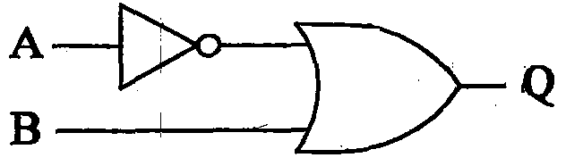
- CO₂ molecule has the first few energy levels uniformly separated by approximately 2.5 meV. At temperature of 300 K, the ratio of the number of molecules in the 4th excited state to the number in the 2nd excited state is about
      - 0.5
      - 0.6
      - 0.8
      - 0.9
- Which among the following sets of Maxwell relations is correct? (U-internal energy, H-enthalpy, A-Helmholtz free energy and G-Gibbs free energy)
      - and
      - and
      - and
      - and
- For a skin-s particle, in the eigen basis of the expectation value is
- A particle is placed in a region with the potential where
Then,
      - and are points of stable equilibrium
      - is a point of stable equilibrium and is a point of unstable equilibrium
      - and are points of unstable equilibrium
      - There are no points of stable or unstable equilibrium
- A meson at rest decays into two photons, which move along the x-axis. They are both detected simultaneously after a time, t = 10 s. In an inertial frame moving with a velocity V = 0.6 c in the direction of one of the photons, the time interval between the two detections is
      - 15 s
      - 0 s
      - 10 s
      - 20 s
- A particle of mass m is confined in an infinite potential well:
It is subjected to a perturbing potential within the well. Let and be the corrections to the ground state energy in the first and second order in , respectively. Which of the following are true?
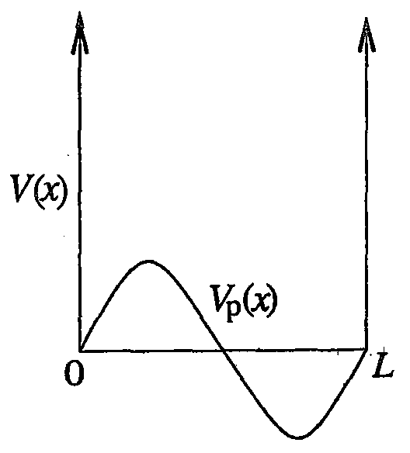
      - depends on the sign of

Common Data Questions
Common Data for Questions 48 and 49:
In the presence of a weak magnetic field, atomic hydrogen undergoes the transition:
by emission of radiation.

- The number of distinct spectral lines that are observed in the resultant Zeeman spectrum is
      - 2
      - 3
      - 4
      - 6
- The spectral line corresponding to the transition
is observe along the direction of the applied magnetic field. The emitted electromagnetic field is
      - Circularly polarized
      - Linearly polarized
      - Un-polarized
      - Not emitted along the magnetic field direction

Common Data for Questions 50 and 51:
The partition function for a gas of photons is given by

- The specific heat of the photon gas varies with temperature as

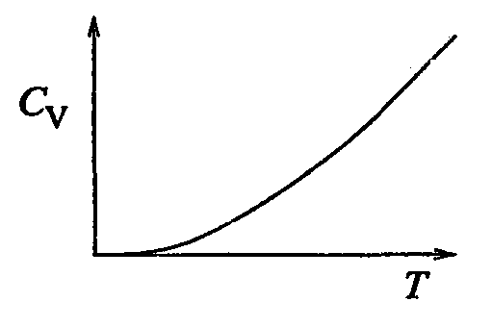

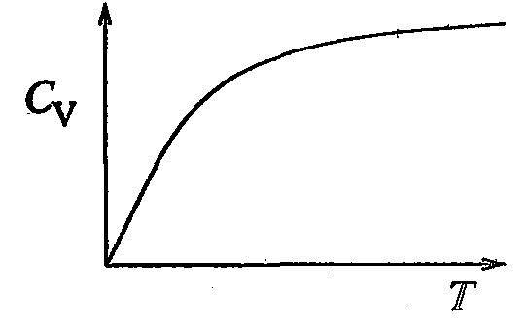

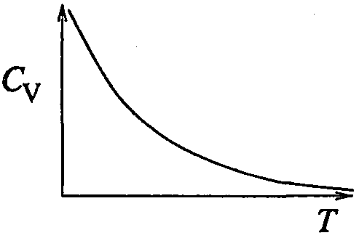

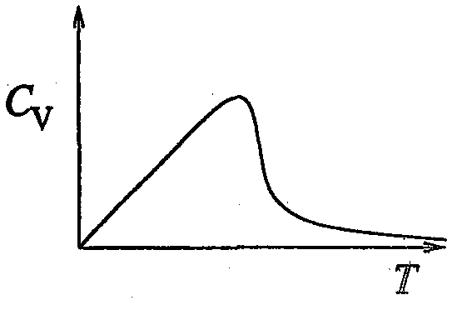
- The pressure of the photon gas is

Linked Answer Questions
Statement for Linked Answer Questions 52 and 53:
Consider the propagation of electromagnetic waves in a linear, homogeneous and isotropic material medium with electric permittivity ε, and magnetic permeability μ.

- For a plane wave of angular frequency ω and propagation vector propagating in the medium Maxwell’s equations reduce to
- If ε and μ assume negative values in a certain frequency range, then the directions of the propagation vector and the Poynting vector in that frequency range are related as
      - and are parallel
      - and are anti-parallel
      - andare perpendicular to each other
      - and make an angle that depends on the magnitude of |ε| and |μ|

Statement for Linked Answer Questions 54 and 55:
The Lagrangian for a simple pendulum is given by:

- Hamilton’s equations are then given by
- The Poisson bracket between and is

General Aptitude (GA) Questions
Q.56-Q.60 carry one mark each:

- Choose the most’ appropriate word from the options given below to complete the following sentence:
His rather casual remarks on politics _____________ his lack of seriousness about the subject.
      - masked
      - belied
      - betrayed
      - suppressed
- Which of the following options is the closest in meaning to the word below:
Circuitous
      - cyclic
      - indirect
      - confusing
      - crooked
- Choose the most appropriate word from the options given below to complete the following sentence:
If we manage to _________our natural resources, we would leave a better planet or our children.
      - uphold
      - restrain
      - cherish
      - conserve
- 25 persons are in a room. 15 of them play hockey, 17 of them play football and 10 of them play both hockey and football. Then the number of persons playing either hockey nor football is :
      - 2
      - 17
      - 13
      - 3
- The question below consists of a pair of related words followed by four pairs of words. Select the pair that best expresses the relation in the original pair.
Unemployed : Worker
      - fallow : land
      - unaware : sleeper
      - wit : jester
      - renovated : house

Q.61-Q.65 carry two marks each:

- If 137 + 276 = 435 how much is 731 + 672?
      - 534
      - 1403
      - 1623
      - 1513
- Hari (H), Gita (G), Irfan (I) and Saira (S) are siblings (i.e. brothers and sisters). All were born on 1st January. The age difference between any two successive siblings (that is born one after another is less than 3 years. Given the following facts:
i. Hari’s age + Gita’s age > Irfan’s age + Saira’s age
ii. The age difference between Gita and Saira is 1 year. However, Gita is not the oldest and Saira is not the youngest
iii. There are no twins.
In what order were they born (oldest first)?
      - HSIG
      - SGHI
      - IGSH
      - IHSG
- Modern warfare has changed from large scale clashes of armies to suppression of civilian populations. Chemical agents that do their work silently appear to be suited to such warfare; and regretfully, there exist people in military establishments who think that chemical agents are useful tools for their cause.
Which of the following statements best sums up the meaning of the above passage:
      - Modern warfare has resulted in civil strife
      - Chemical agents are useful in modern warfare
      - Use of chemical agents in warfare would be undesirable
      - People in military establishments like to use chemical agents in war.
- 5 skilled workers can build a wall in 20 days; 8 semi-skilled workers can build a wall in 25 days; 10 unskilled workers can build a wall in 30 days. If a team has 2 skilled, 6 semi-skilled and 5 unskilled workers, how long will it take to build the wall?
      - 20 days
      - 18 days
      - 16 days
      - 15 days
- Given digits 2, 2, 3, 3, 3, 4, 4, 4, 4 how many distinct 4 digit numbers greater than 3000 can be formed?
      - 50
      - 51
      - 52
      - 54

