Booklet color : Blue

1)

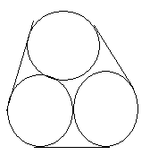

Diameter of circle is d, Find length of string.(outer string that covers the circle)

Ans: d (pi + 3)

2) Diamond\’s value is proportional to its weight² .When the diamond broke wts of pieces in ratio 1:2:3;4:5.

Total loss in value is 85,000.What is the value of the diamond twice the wt of the original diamond.

Ans : 45,000

3)Person X join a job at 20 yrs.First 3 years sal =10,000 p.a. Afterwards every year inc of 2,000 per year for 10 year. Then sal become const till retirement. at retirement avg sal is 25,000. ( thro’out career) what age he retires.?

4) In an island there r tribals who speak lang of atmost 4 words.Lang consists of 4 alphabets.How many words can be formed in that language? Ans 340?....( 4! = 1*2*3*4 = 24*)

5) It was found that the cause for the malaria was the swamp marsh and so r swamps were drained .Mosquito the real cause for malaria due to lack of breeding grounds (Swamps) also was wiped out. What does this illustrate?

(Ans: (Possible) when many conditions form a result, eradication of one cause also eradicates the result)

6) An officer kept files on his table at various times in the order 1,2,3,4,5,6.Typist can take file from top whenever she has time and type it. What order she cann’t type.?

(Ans : 4,5,6,2,3,1)

7) A and B r fighting .B fires 3 times as many missiles as A. Total hits: total misses = 1/7 .B’s misses 357.B’s hits – A’s hits = 66.A’s hits?

8)40 shots taken.50p for a hit.10p for a miss.(he have to give).Finally he has Rs.5.How many hits.? Ans 15

9)Find avg of a,b,c,d,e .Given data : avg of any 4 num =avg of any 3 num 2)(a+b)² = 36

Which of the above are sufficient?

10) What is the difference in times btwn clk 1 & clk2.

- both show same time 6 hrs back 2 ) 1 clk gains 1 min an hr,clk2 gains 2 min an hour.
Like abv….

11)A takes 9 strides to B’s 7 strides. A stride = 1meter.B stride =1.2m B gets the start of 24m.What dist should A travel to overtake B?

12) Tortoise gets 100 m head start. Hare is 10 times faster as tort. What is the dist traveled by hare to catch up tort? Ans:111

13)4 weights r weighed in pairs. Weights of pairs are determined as 103,105,106,106,107,109 What is the min wt?
Ans 51

14) Constant cost = 300
and 1.75 / copy. How many copies should he sell at 7.75 /copy to make a profit.

15)
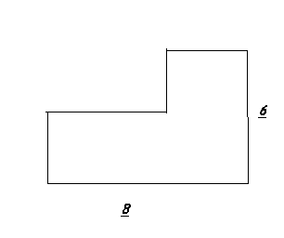
Find the perimeter ? ANs 28

16) 20 members avg =10.5. 3 memb of 11.5,12.5,13.5 left and 3 memb of 10.5,12.5,14.5 joined along with a teacher of 21 yr.Now avg = ….Ans 11.

17)

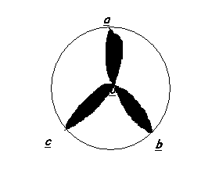
Find the area of shaded. Radius of circle = 1cm…..Arcs r drawn with center at circumference.

18)

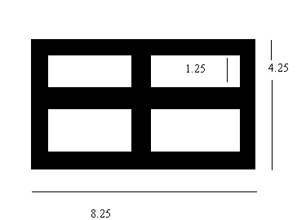

Find the area of the shaded portion?

- Solid cube of 6 * 6 * 6. This cube is cut into to 216 small cubes.(1 * 1 * 1).the big cube is painted in all its faces. Then how many of cubes are painted at least 2 sides. (Ans 56) here add edges(12*4=48) + corners(8) = 56

- A Bacteria is doubling at every 4 min. After 40 min 1024 bact. Then 256 when>…..? Ans : 32 min

- A bag contains 3 balls of 11 different colors each. Find the min no of chances to find at least 3 balls of same color?

Ans : 23

- If x² < 4 then 100/x is….? Ans : 100/x > 50 & 100/x < -50.

- If [x] is the int less than x and |x| is the abs val of x.Then max of [x]/|x| is Ans d)none

- A work in 12 days b in 15 days. Find the no of days if they work on alternate days. Ans 13 ¼

- A,B,C r positive int.Out of them 2 r odd. Then 5²ª + ( b-5)³ (c-3)² = ? Ans : always odd.

- A squarer side is 5cm.If a square of side 10cm is hinged @ the center of the prev square. when they r rotated common area to both squares (Ans : Does not change)

- 3p² + pq + 5q² is even. If

  - If p is odd, q is odd
  - If p is even, q is odd
  - If p is odd ,p is even
  - Atleast one of p and q is odd.

Choices are given. Ans : 4) None of these

- A lady has to feed a dog for the one week from Monday to Sunday .She has food types M,N,O,P,Q,R,S .

MNOP → protein enriched RS -→ vitamin enriched. Vitamin enriched cannot be fed on consecutive days.

Conditions given : M should be fed before S.
M should be fed before Q.
R Should be fed before S.
Before N and Q there should be four types.
Based on this 3 ?s are asked.All r easy to answer…
- A man bought at the cost of 5 plums a rupee and 2 oranges a rupee.He sells 10 plums and 6 oranges at the selling price of 4 plums a rupee and 3 oranges a rupee.What is his gain or loss? Ans loss of 50p.
- Out of 32 books the cost of 10 books is Rs. 50 each and he got a profit of 4%. He sells 15 books at a profit of 3.8461% on the selling price of Rs 70. The remaining cost is 576. The remaining books are sold at Rs 74. What is his total profit.
- Two solutions have milk & water in the ratio 7:5 and 6:11.Find the proportion in which these two solutions should
Be mixed so that the resulting solution has 1 part milk and 2 parts water?
a)35:3 b)21:36 c)not possible Ans :c

