Sample Paper – 2011
Class –XII
Subject –Physics

General instructions:
- All questions are compulsory.
- Question numbers 1 to 8 are very short answer type questions, carrying one mark each.
- Question numbers 9 to 18 are short answer type questions, carrying two marks each.
- Question numbers 19 to 27 are also short answer type questions, carrying three marks each.
- Question numbers 28 to 30 are long answer type question, carrying five marks.
- Use of calculator is not permitted. However, you may use log tables, if necessary.
Q1. | Define the term radius of gyration. | (1mark)
Q2. | What is the geometrical shape of the wavefront when a plane wave passes through a convex lens? | (1mark)
Q3. | Calculate the r.m.s value of alternating current shown in the figure.  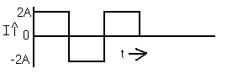 | (1mark)
Q4. | An electron and a proton have the same kinetic energy. Which of the two has a greater De Broglie wavelength? Explain. | (1mark)
Q5. | An electron is moving in the anticlockwise sense in a horizontal circular orbit. What is the direction of the magnetic field at the centre of orbit? | (1mark)
Q6. | Define coefficient of mutual inductance for a pair of coils. | (1mark)
Q7. | If the radius of the Gaussian surface enclosing a charge is halved, how does the electric flux through the Gaussian surface change? | (1mark)
Q8. | A convex lens is held under water. How will its power change? Explain. | (1mark)
Q9. | Explain with the help of a circuit diagram, how the thickness of depletion layer in p-n junction diode changes when it is forward biased. | (2 marks)
Q10. | A coil of area 2m² is placed in a magnetic field B(t) = 4t + 3 Tesla. The resistance of the coil is 100 milliohm. Find the induced current in the coil. | (2 marks)
Q11. | Three light rays red (R), green (G) and blue (B) are incident on a right angled prism ‘abc’ at faces ‘ab’. The refractive indices of the material of the prism for red, green and blue wave lengths are1.39, 1.44 and 1.47 respectively. Out of the three, which colour ray will emerge out of the face ‘ac’? Justify your answer. Trace the path of the green (G) ray after passing through the face ‘ab’.  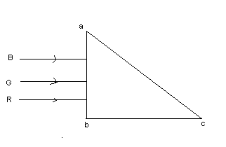 | (2 marks)
Q12. | Give two differences between interference and diffraction pattern of light? | (2 marks)
Q13. | The voltage –current graph for two resisters of same material and same radii with lengths L₁ and L₂ are shown. If L₁ > L₂, state with reason , which reason which of the graphs represents voltage –current change for L₁  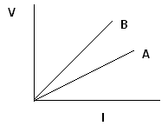 | (2 marks)
Q14. | Calculate the electric potential at the center of a square of side 1.414m, which carries at its 4 corner charges of 2nC, 1nC, -2nC, -3nC respectively. | (2 marks)
Q15. | You are given 8 Ω resistor. What length of constantan wire of resistance 120 Ω m⁻ ¹ should be joined in parallel with it to get a value of 6Ω? | (2 marks)
Q16. | What is meant by coherent sources of light?  Can two identical independent sodium lamps act as coherent sources? Give reason for your answer. | (2 marks)
Q17. | A galvanometer coil has a resistance of 15 ohm and shows a full scale deflection for a current of 4mA. Calculate the value of resistance required to convert in to an ammeter of range 0 to 6A. | (2 marks)
Q18. | IN INDIA, domestic power supply is at 220 volt, 50 Hz, while in U.S.A. it is 110 volt, 50 Hz. Give one advantage and disadvantage of 220 volt supply over 110 V supply ? | (2 marks)
Q19. | Draw a circuit diagram of a common-emitter amplifier using a n-p-n transistor. Prove that in this amplifier, the output voltage is 180⁰ out of phase with the input voltage | (3 marks)
Q20. | A 4 μF capacitor is charged by a 200 V supply. It is then disconnected from the supply and is reconnected to another uncharged 2 μF capacitor. What is the potential difference across the combination?  How much electrostatic energy is lost in the form of heat and electromagnetic radiation? | (3 marks)
Q21. | Plot a graph showing the  - Variation of photo-current with the intensity of incident radiation.  - Variation of photo-current with collector plate potential for 2 different intensities.  - Variation of photo-current with collector plate potential for 2 different frequency. | (3 marks)
Q22. | Two long parallel straight wires X and Y separated by a distance of 5 cm in air carry currents of 10 A and 5A respectively in opposite direction. Calculate the magnitude and the direction of force on a 20 cm length of the wireY. | (3 marks)
Q23. | The oscillating magnetic field in the electromagnetic wave is given by  B_{y} = (8×10⁻⁶) sin [2×10¹¹t +300πx] T  (1) Calculate the wavelength of the electromagnetic wave.  (2) Write down the expression for the oscillating electric field. | (3 marks)
Q24. | Why is a potentiometer preferred over a voltmeter for determining the emf of a cell? Two cells of emf E₁ and E₂ are connected together in two ways shown below  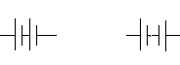  The balance points in a given potentiometer experiment for these two combinations of cells are found to be at 351 cm and 70.2 cm respectively. Calculate the ratio of the emfs of the two cells. | (3 marks)
Q25. | What is the effect on the interference pattern observed in a Young’s double slit experiment in the following cases:  i) Screen is moved away from the plane of the slits.  ii) Separation between the slits is increased, and  iii) Widths of the slits are doubled, Give reasons for your answer. | (3 marks)
Q26. | Suppose that the electric field amplitude of an electromagnetic wave is E₀=120N/C and that it frequencies is 50 MHz (a) Determine B₀,ω and k (b)Find the expression for ‘E’. | (3 marks)
Q27. | A sinusoidal voltage of peak value 283V and frequency 50Hz is applied to a series LCR circuit in which R = 3Ω, L = 25.48mH and C = 796 µF. Find (a)the impedance of the circuit (b)the phase difference between the voltage across the source and the current (c)the power dissipated and the circuit. | (3 marks)
Q28. | Give principle, construction and working of A.C. generator.  OR  Give principle, construction and working of Transformer. | (5 marks)
Q29. | Draw a labelled ray diagram of an astronomical telescope, forming an image at infinity. An astronomical telescope uses two lenses of powers 10 D and 1D respectively.  - State with reason, which lens is preferred as objective and eye-piece.  - Calculate the magnifying power of the telescope, if the final image is formed at the near point.  - How does the light gathering power of a telescope change, if the aperture of the objective lens is doubled?  OR  Draw a labelled ray diagram showing the image formed by a compound microscope. Write the expressions for its magnifying power.  Define the term resolving power of a microscope. How does the resolving power of a compound microscope change on  - decreasing the diameter of its objective lens?  - Increasing the focal length of its objective lens?  Justify your answer in each case. | (5 marks)
Q30. | Derive an expression for the magnetic field at a point  on the axis of a current carrying circular loop.  Two coaxial circular loops L₁ and L₂ of radii 3 cm and 4 cm are placed as shown. What should be the magnitude and direction of the current in the loop L₂ so that the net magnetic field at the point O is zero?  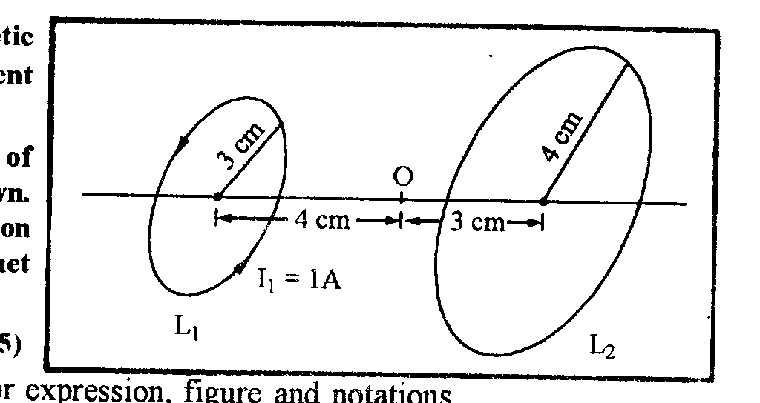  OR  Draw a schematic diagram of cyclotron. Explain its underlying principle and working, stating clearly the function of the electric and magnetic fields applied on a charged particle. | (5 marks)

Paper Sumitted By:
Name: Manish Harish
Email: mnshhrsh@yahoo.co.in
Phone No. 9818223469

