Sample Paper – 2009
Class – X
Subject – Chemistry

Section A
(Answer all)

Q.1 Name the salt from the following: (5)
KNO_{3;} NH₄NO_{3;} Pb (NO₃)_{2;} Zu (NO₃)_{2;} Cu (NO₃)₂.
- Which leaves no residue on heating?
- Which leaves a gelatinous precipitate?
- Which decrepitates on heating?
- Which salt leaves potassium cation and nitrate anion on heating?
- Which leaves a black residue on heating?

Q. 2 (5)
(a) How do you test for metallic nitrate with acidified copper?
(b) Distinguish between dilute and concentrated H₂SO₄?
(c) How do you test for hydrocarbon using ammonical cuprous chloride?
(d) Name the organic compound which forms carbon tetra chloride on reaction with Chlorine?

Q. 3 Fill in the blanks: (5)
(a) An example of a salt which is not a hydrated salt is ____________ [Blue vitriol, Washing soda].
(b) An example of a deliquescent salt is _______________ [Epsom salt, hydrated copper sulphate, Globers salt, copper nitrate].
(c) A salt which on hydrolysis produces a neutral solution is ______________ [Sodium chloride, Ammonium chloride. Sodium carbonate].
(d) The more volatile acid obtained when the less volatile acid reacts with Sodium bicarbonate is _____________ [Sulphuric acid, Carbonic acid, Nitric acid].

Q. 4 Name them: (5)
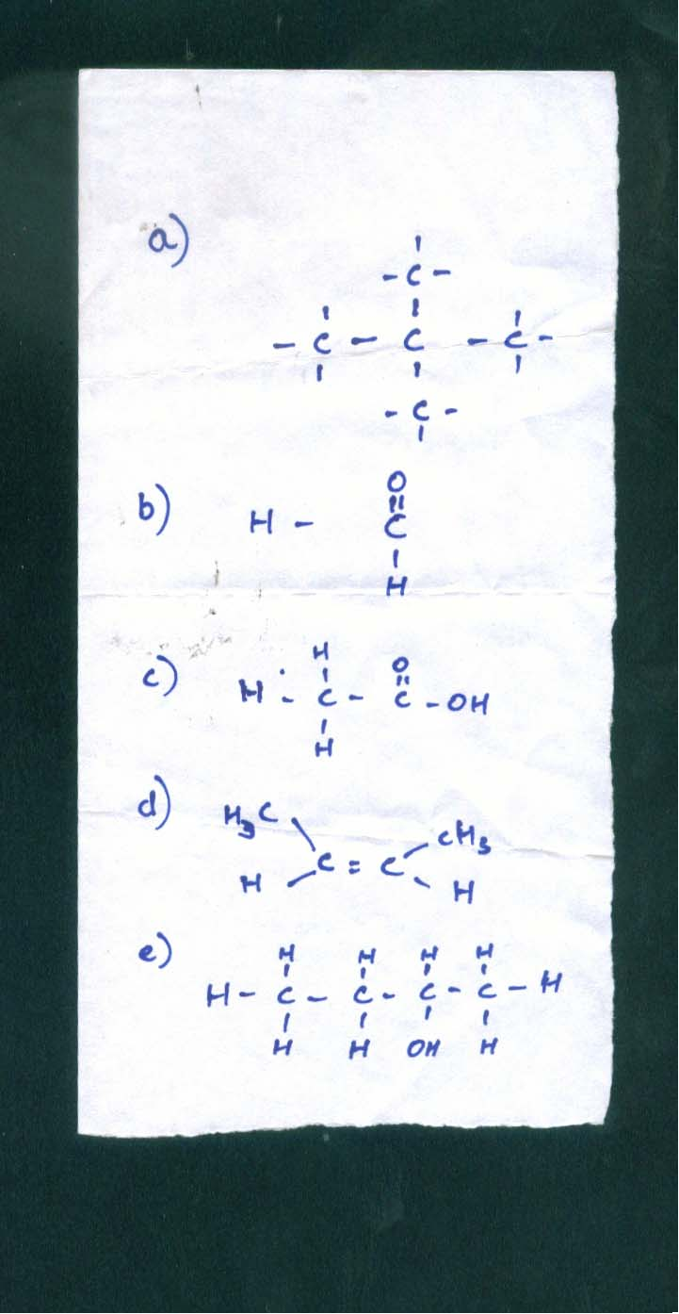
Q. 5 (5)
(a) Calculate the percentage of Aluminum in cryolite.Na=23; Al=27; F=19?
(b) Determine the empirical formula of the compound whose composition by Mass is 42% Nitrogen, 48% Oxygen and 9% Hydrogen? Given H=1; N=14; O=16.

Q. 6 A compound has a formula H₂Y.Y denotes a non-metal. State the following: (5)
(a) Electronic configuration of Y?
(b) Valency of Y?
(c) Bonding in H₂Y?
39
(d) The bonding present in the compound formed between Potassium K and Y?
19
40
- The formula of the compound formed between Ca and Y?
20

Q. 7 (5)
(a) Arrange metals in the order of their reactivity?
(b) Give the name of a carbonate ore of iron?
(c) An oxide ore of iron?
(d) Write the formula of Hematite?
(e) Name a metal which does not react with air at room temperature?

Q. 8 Choose the correct answer: (5)
(a) Elements of group 3 to 12 are known as:
i) Normal elements ii) Transition elements iii) Halogens iv) Actinides
(b) Aluminum and phosphorous belong respectively to groups:
i) 10 and 12 ii) 13 and 15 iii) 10 and 15 iv) 12 and 13
(c) Ionization potential:
i) Goes up and down ii) Decreases iii) Increases
(d) Electron affinity of the elements in groups 1 to 7:
i) Goes up and then down ii) Increases iii) Decreases and then increases iv) Decreases
(e) Atomic size:
i) Decreases ii) increases iii) remains the same iv) Sometimes increases and sometimes decreases.

Section B
(Answer any FOUR)

Q. 9 Answer the following based on the flow chart below: (10)

Sulphur
Sulphuric
Acid

Sulphur Di Oxide
Sodium Sulphite

Sulphur
Tri Oxide
A
B
C
D
E
F

(a) Name the catalyst which helps in the conversion of Sulphur di oxide to sulphur tri oxide in step C?
(b) In the contact process for the manufacture of Sulphuric acid, Sulphur trioxide is not converted to Sulphuric acid by reacting with water, instead a two step procedure is used. Write the equations for the two steps involved in D?
(c) What type of substances will liberate sulphur di oxide from sodium sulphate in Step E?
(d) Write the equation for the reaction by which Sulphur di oxide is converted to Sodium Sulphite in Step F?

Q. 10 Complete the equations: (10)
- 8 NH₃ + 3Cl₂ →
- Pb (NO₃)₂ + 2HCl →
- S + HNO₃ →
- 4 NH₃ + 3O₂ →
- NaHCO₃ + H₂SO₄ →

Q. 11 Give balanced equations for the following: (10)
(a) An alkyne to an alkene.
(b) An alkane to alcohol.
(c) A Carboxylic acid to an Ammonium salt.
(d) Methane from methane.
(e) Ethylene glycol from ethane.

Q. 12
(a) Define calcinations and to what ore does it takes place?
(b) Explain froth flotation process?
(c) What is the meaning of gangue and write the formula of slag?
(d) Why is NaOH added in the manufacture of aluminum?
(e) Why should graphite anode be replaced from time to time?

Q. 13 (10)
(a) Define Electrolysis?
(b) Give one example which contains ions only, molecules only, both ions and molecules?
(c) Name the particles present in a compound which is non electrolyte?
(d) If an electrolyte is described as a strong electrolyte. What does it mean?
(e) Phosphorous is oxidized to phosphoric acid by Conc. HNO₃ as represented by the equation:
P + 5HNO₃ → H₃PO₄ + 5NO₂ + H₂O.
i) Calculate the mass of phosphoric acid which can be obtained by 12.4 Gms of phosphorous?
ii) Calculate the mass of nitric acid consumed in the above reaction?
iii) Calculate the volume of nitrogen di oxide at STP? (P=31;H=1;N=14;O=16)

Q. 14 (10)
(a) From the list of chemicals given below select one chemical at a time for the description given from i to v
A) SO₂ B) Cu0 C) H₂SO₄ D) ZnO E) NaOH

- Acidic oxide?
- An alkali?
- An amphoteric oxide?
- An oxy acid?
- A basic oxide?
(b) State Gay Lusacs Law?
(c) Define or explain with examples:
i) Normal salt?
ii) Double salt?
iii) Acidic Salt?
iv) Basic salt?
(d) Salts can be prepared by number of methods listed below. Write one fully balanced equation to justify the methods below:

- By the action of an acid with an alkali solution?
- By the action of an acid with hydrogen carbonate of a metal?
- By the displacement reaction?
- By the direct combination of the elements?

