MP PET 2009
MATHS
Q. 1. The mean of the numbers a, b, 8, 5, 10 is 6 and the variance is 6.80 . Then which one of the following gives possible values a and b?
- a = 1, b = 6
- a = 3, b = 4
- a = 0, b = 7
- a = 5, b = 2
Sol.
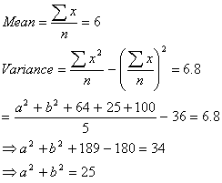
Possible values of a and b is given by (2)
Q. 2. The vector lies in the plane of the vectors and bisects the angle between. Then which one of the following gives possible values of
Sol.
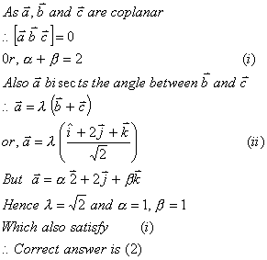
Q. 3.
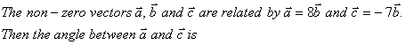

- 0
Sol. The sign of are opposite. Hence they are parallel but directions are opposite.
Therefore angle between
Q. 4. The line passing through the points (5, 1, a) and (3, b, 1) crosses the yz-plane at the point 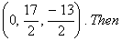
- a = 6, b = 4
- a = 8, b = 2
- a = 2, b = 8
- a = 4, b = 6
Sol. Equation of line through (5, 1, a) and (3, b, 1) is
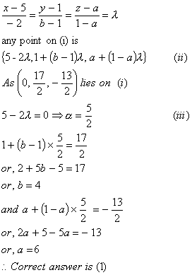
Q. 5. If the straight lines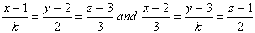 intersect at a point, then the integer k is equal to
- 2
- 2
- 5
- 5
Sol.As the given lines intersect
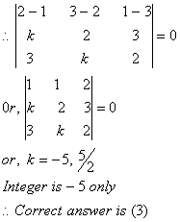
Q. 6. The differential of the family of circles with fixed radius 5 units and centre on the line y = 2 is
Sol.The required equation of circle is
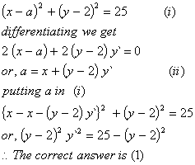
Q. 7. Let a, b, c be any real numbers. Suppose that there are real numbers x, y, z not all zero such that
- 0
- 1
- 2
- - 1
Sol.
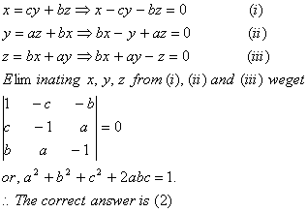
Q. 8. Let A be a square matrix all of whose entries are integers. Then which one of the following is true?
Sol. The obvious answer is (1).
Q. 9. The quadratic equations and have one root in common. The other roots of the first and second equations are integers in the ratio 4 : 3. Then the common root is
- 3
- 2
- 1
- 4
Sol.
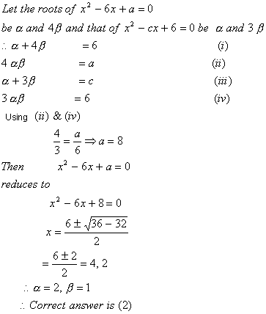
Q. 10. How many different words can be formed by jumbling the letters in the word MISSISSIPPI in which no two S are adjacent?
Sol. M = 1, I = 4, P = 2
These letters can be arranged by
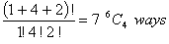
The remaining 8 gaps can be filled by 4 S by
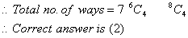
Q. 11.
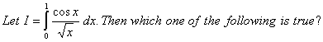
- 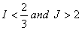
- 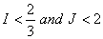
- 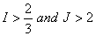
Sol.
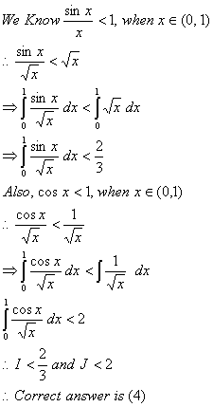
Q. 12.The area of the plane region bounded by the curve
Sol.
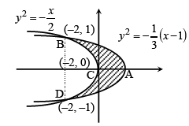
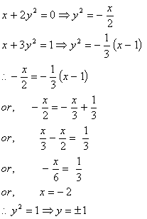
Area of the region BCA
