School Management System
By
Sönmez Serkan Söğüt
Maxim Shylov

Fatih University
Department of Computer Engineering
January 2003

Supervisor: Atakan KURT

FATİH UNIVERSITY
FACULTY OF ENGINEERING
COMPUTER ENGINEERING DEPARTMENT

CENG499 - SENIOR DESIGN PROJECT

Project Title : School Management System
Student Name: Sönmez Serkan Söğüt, Maxim Shylov
Student ID : 07019820, 07019936
Date :
Grade :

Advisor Jury Member Jury Member

ABSTRACT
The system capable of managing school resources, working on different platforms and supporting multi language was designed in this project. The implemented system takes advantages from XML technology. Hence, making easier to change view of entire system by performing XSL transformation of XML interfaces into HTML pages. The support of multi language is achieved by storing words, which are used in the system, in the database. The implementation of the system was done using PHP and Web Services technologies, allowing system to be run locally or in distributed mode. When the system works in distributed mode the system’s one part namely server handles requests obtained from client via Simple Object Access Protocol (SOAP) 1.1 and sends respond messages if needed via SOAP 1.1.
ÖZ
Bu projede okul kaynaklarının farklı platformlarda ve birçok dilde yönetilmesini sağlayacak bir system tasarlanmıştır. Bu sistemde XML teknolojisinin avantajları kullanılmıştır. Sistemde arayüzün kolayca değiştirilmesi ve XML arayüzünün HTML sayfalarına dönüştürülmesi için XSL dönüşümü kullanılmıştır. Sistemin bir çok dili desteklemesi sistemde kullanılan bütün kelimelerin veritabanında saklanması ile gerçekleştirilmiştir. Sistemin lokal ve dağıtılmış olarak çalıştırabilmek için PHP ve Web Servis teknolojisi kullanılmıştır. Sistem dağıtılmış olarak çalıştırıldığı zaman, istemcilerden gelen istekler sunucu tarafından SOAP 1.1 (Simple Object Access Protocol) ile alınır ve cevaplanır.
Table of contents

CHAPTER 1 1
1.1 Intoductıon 1
1.2 Outline of the Thesis 2
CHAPTER 2 3
2.1 XML 3
2.1.1 DTD 4
2.1.2 XML Properties 4
2.1.2.1 Simplicity 4
2.1.2.2 Extensibility 4
2.1.2.3 Interoperability 5
2.1.2.4 Openness 5
2.1.3 XSL 5
2.2 WEB SERVICES 6
2.2.1 JAX-RPC 6
2.2.1.1 JAX-RPC Concepts 6
2.2.1.1.1 Service Endpoints 6
2.2.1.1.2 Artifacts 7
2.2.1.1.3 Java-WSDL/XML Mappings 7
2.2.1.1.4 Bindings 8
2.2.1.1.5 Stubs 8
2.2.2 Servlet 8
2.3 PHP 9
CHAPTER 3 10
3.1 use case Model 10
3.1.1 Actors 10
3.1.2 Use Cases 10
3.2 class dıagrams 13
3.2.1 Server 13
3.2.2 Client 14
3.3 er dıagram 14
3.4 modules 17
CHAPTER 4 21
4.1 Faculty 22
4.2 Department 23
4.3 Room 26
4.4 Hour 28
4.5 Semester 29
4.6 Calendar 30
4.7 Person 32
4.8 History 35
4.9 Course Template 38
4.10 Course Curriculum 41
4.11 Course 42
4.12 Schedule 43
4.13 Attendance 45
4.14 Add-Drop 47
4.15 Exam 47
4.16 Grade 49
CHAPTER 5 52
5.1 CONCLUSION 52
Appendices 54
A Database 54
A.1 Attendance Table 54
A.2 Authority Table 54
A.3 Calendar Table 54
A.4 Course Curriculum Table 55
A.5 Course Equal Prerequisite Table 55
A.6 Course Template Table 55
A.7 Department Table 56
A.8 Exam Table 56
A.9 Faculty Table 56
A.10 Grade Table 57
A.11 History Discipline Table 57
A.12 History Education Table 57
A.13 History Health Table 58
A.14 History Legal Table 58
A.15 History Work Table 58
A.16 Hour Table 59
A.17 Lang Table 59
A.18 Person Table 59
A.19 Room Table 60
A.20 Schedule Table 61
A.21 School Table 61
A.22 Semester Table 61
A.23 Took Course Table 62
A.24 Word Table 62
A.25 Course Table 62
B Constant values 64
C Document type DEFINıTION (DTD) 67
D XML format for Interfaces 73
D.1 Faculty 73
D.1.1 List Faculty 73
D.1.2 Faculty Detail 73
D.1.3 New / Update Faculty 74
D.2 Department 74
D.2.1 List Department 74
D.2.2 Detail Department 75
D.2.3 New / Update Department 76
D.3 Room 76
D.3.1 List Room 76
D.3.2 Detail Room 77
D.3.3 New / Update Room 78
D.4 Hour 79
D.4.1 Hour List 79
D.4.2 New / Update Hour 79
D.5 Calendar 80
D.5.1 Calendar List 80
D.5.2 New Calendar 81
D.6 Semester 82
D.6.1 Semester List 82
D.6.2 New Semester 82
D.7 Person 83
D.7.1 Person List 83
D.7.2 Person Detail 84
D.7.3 New / Update Person 85
D.8 History 87
D.8.1 List Work History 87
D.8.2 New Work History 87
D.8.3 List Education History 88
D.8.4 Education History Detail 88
D.8.5 New / Update Education History 89
D.8.6 New Discipline 91
D.8.7 List Healty History 91
D.8.8 New Healty History 92
D.8.9 List Legal History 92
D.8.10 New Legal History 92
D.9 Course Template 93
D.9.1 Course Template List 93
D.9.2 Course Template Detail 94
D.9.3 New / Update Course Template 94
D.9.4 New Equval-Prerequisite Course 95
D.10 Course Curriculum 96
D.10.1 Course Curriculum List 96
D.10.2 New Course Curriculum 97
D.11 Course 97
D.11.1 Course List 97
D.11.2 Course Detail 98
D.11.3 New / Update Course 100
D.12 Schedule 100
D.12.1 Show Schedule 100
D.12.2 New / Update Schedule 102
D.13 Attendance 102
D.13.1 Course Attendance List 102
D.13.2 Student Attendance List 103
D.13.3 New Attendance 104
D.14 Add-Drop 105
D.14.1 Add-Drop Screen 105
D.14.2 Course List 105
D.15 Exam 106
D.15.1 Exam List 106
D.15.2 Exam Detail 107
D.15.3 New / Update Exam 108
D.16 Grade 109
D.16.1 Exam Grades 109
D.16.2 Student Grades 110
D.16.3 New / Update Grade 111

Table of fıgures
Figure 1.1: WSDL is used to describe endpoint of server. 7
Figure 3.1: Use Case diagram for School Management System 12
Figure 3.2: Server side Class Diagram. 13
Figure 3.3: Client side Class Diagram. 14
Figure 3.4: ER diagram for School Management System. 15
Figure 3.5: Authorities of user group on modules 19
Figure 3.6: Summarizes the dependency relations between modules. 20
Figure 4.1: Login interface 21
Figure 4.2: The Home page interface 21
Figure 4.3: The faculties of the school are listed when Faculty module is accessed 22
Figure 4.4: Faculty details interface 23
Figure 4.5: New/Update Faculty interface. 23
Figure 4.6: The interface displayed when department module is entered. 24
Figure 4.7: Department details interface. 25
Figure 4.8: New/Update department interface. 25
Figure 4.9: The interface displayed when administrator switches to the Room module. 26
Figure 4.10: Room details interface 27
Figure 4.11: New/Update Room interface 27
Figure 4.12: Hours interface which is displayed when administrator accesses hour module. 28
Figure 4.13: New/Update hour interface. 29
Figure 4.14: The interface displayed when permitted user switches to Semester module. 30
Figure 4.15: New/Update semester interface. 30
Figure 4.16: The interface displayed when user switches to calendar module. 31
Figure 4.17: New event interface. 31
Figure 4.18: The interface which is displayed when users, permitted to perform addition, modification and deletion of records enter person module. 32
Figure 4.19: Person details interface. 34
Figure 4.20: New/Update person interface. 35
Figure 4.21: New education interface. 36
Figure 4.22: New discipline interface 37
Figure 4.23: New work history interface. 37
Figure 4.24: New health history interface. 37
Figure 4.25: New legal punishment history interface. 38
Figure 4.26: The interface displayed when user switches to course template module. 39
Figure 4.27: Course template interface. 40
Figure 4.28: New/Update course template interface. 40
Figure 4.29: The interface displayed when user switches to course curriculum module. 41
Figure 4.30: Add course to curriculum interface. 42
Figure 4.31: The interface displayed when permitted users switch from home page to course module. 42
Figure 4.32: Create semester course interface. 43
Figure 4.33: The interface that is displayed when user switches from home page to schedule module. 44
Figure 4.34: View of the interface that is used to add new course to schedule. 45
Figure 4.35: The interface displayed when user enters the attendance module. 45
Figure 4.36: New attendance interface. 46
Figure 4.37: Student attendance interface view. 46
Figure 4.38: Interface vieved by student affair. 47
Figure 4.39: The interface viewed by chairman and teacher. 47
Figure 4.40: The interface that is displayed when user switches to exam module. 48
Figure 4.41: Exam detail interface. 48
Figure 4.42: New/Update grade interface. 49
Figure 4.43: The interface displayed when student user switches to grade module. 50
Figure 4.44: The interface displayed when teacher user switches to grade module. 50
Figure 4.45: Update grade interface. 51

Intoductıon
Nowadays education plays a great role in development of any country. Many of education organizations try to increase education quality. One of the aspects of this improvement is managing of school resources.
With growth of internet many of education organizations perform management of education resources online. However, the sites developed by those organizations support a few languages and have to be redesigned in case new languages are required to be added or interface of the entire site is required to be changed. The redesigning process takes a long time since thousand lines of code should be rewritten or modified.
Taking all these disadvantages into account the system that manages school resources and supports multi languages and whose interface can be changed without rewriting all the code can be designed. To meet all requirements the system also can run on different platforms. All of those aspects of the system can be achieved by using XML. However XML is a simple text format that should be transformed to html format. To perform this transform XSL should be used. In addition the system can be designed in such a way that it runs for a single school or for different schools. The single school implementation can be achieved using the PHP technology. However, the implementation for different schools can be performed in many ways. One of those is Java Web Service technology, which is used for business applications. In Java Web Services the methods that can be called by the client are identified by WSDL document. For purpose of connecting to server the messages are sent using Simple Object Access Protocol.
Based on this assumptions and facts the system capable of working on different platforms and supporting multi language was designed. The implemented system takes advantages from XML technology. Hence, making easier to change view of entire system by performing XSL transformation of XML interfaces into HTML pages. The multi language support is achieved by storing words, which are used in the system, in the database. The implementation of the system was done using PHP and Web Services technologies, allowing system to be run locally or in distributed mode. When the system works in distributed mode the system’s one part namely server handles requests obtained from client via Simple Object Access Protocol (SOAP) 1.1 and sends respond messages if needed via SOAP 1.1.

Outline of the Thesis
The overview of related and used technologies in the implementation is given in Chapter 2. The architecture and way of communication between client and service is explained in Chapter 3. The detailed information about implementation of the system is presented in Chapter 4. Chapter 5 provides the summary of the implemented system. The Appendices provides some additional information concerning the system.

XML
Extensible Markup Language (XML) is a simple, very flexible text format that can be used to create web pages – and much more. XML helps developers to define standards for the text that should appear in the document. In addition, it defines the order in which information should appear. All this advantages provide ability to reuse defined content of the document in any application. On the other hand, XML provides syntax for sharing information between different organizations.
Similar to HTML, XML uses elements and attributes which defined in the document using tags. Those tags start with < and close with >. The end tag includes / character before the name of the element. The empty tag can be created in to ways:
<ELEMENT ATRRIBUTE></ELEMENT>
<ELEMENT ATTRIBUTE/>

For example, the following bit of a document includes four elements.
<?xml version="1.0" encoding="UTF-8"?>
<SCHOOL>
<NAME>FATIH UNIVERSITY</NAME>
<FACULTIES>
<FACULTY NO=”07”>
<NAME>Engineering Department</NAME>
</FACULTY>
</FACULTIES>
</SCHOOL>

The first start tag opens the SCHOOL element, which has the NAME element with its content and FACULTIES element with FACULTY element whose attribute NO set to "07". End tags close the FACULTY, the FACULTIES, and SCHOOL elements, producing a nested structure. These nested structures are good at representing typical document and data structures and a very easy for computer programs to store and manipulate. XML enforces its rule. Unlike HTML browsers, XML parsers are supposed to produce error messages for illegal or malformed markup. Forcing the author to clean up their markup allows the parsers on the receiving end to do much less work. It also provides authors with confidence that their work will be interpreted consistently, without having to wonder how multiple browsers would interpret the same document.

DTD
XML provides syntax for specifying document structure. The Document Type Definition (DTD) provides XML parsers a set of rules with which they can validate the document. However, validation doesn't imply that the contents of the document are correct, or that certain data fields are numbers or text; rather, it means that all the elements of the document fit into the structure specified by the DTD. For example, the fragment below specifies the structure used in the example above.
<! ELEMENT SCHOOL (NAME, FACULTIES)>
<! ELEMENT NAME (#PCDATA)>
<! ELEMENT FACULTIES (FACULTY, NAME)
<! ATTLIST FACULTY NO CDATA #IMPLIED>

The SCHOOL element must contain a NAME and a FACULTIES element, and the FACULTIES element must contain a FACULTY and a NAME element. The FACULTY element may have an attribute NO. The NAME element may contain text, entities, processing instructions, and any other valid XML text except other elements.
XML permits the use of documents, called 'well-formed documents' that use only its rules for document syntax, without specifying a DTD. Documents that contain (and/or refer to) a properly written DTD, and meet the requirements it sets, are referred to as 'valid'. Validation can be an important step in the authoring process, and may also be performed at any step in processing. Developers can choose how often, and when, to screen a document to check its structure. Applications which need to process lots of information quickly, or which can't afford the additional processing requirements imposed by validation, can stick to well-formed documents. Well-formed documents also provide an easy bottom rung on the XML learning ladder - by sticking to the basic syntax; developers can create parseable documents with any structure they choose, moving up to more formal DTDs when the need arises.

XML Properties

Simplicity
The XML provides a friendly environment for both programmers and document authors, since the syntax of the XML document defined by DTD makes its readable.

Extensibility
The XML is extensible since it allows developers to create their own DTDs, which create ‘extensible’ set of tags that can be used for different applications. In addition, XML is extended with several standards that add styles, linking, and referencing ability to the core XML set of capabilities. XML can use many of the standards applied to HTML, like Cascading Style Sheets (CSS) and Hypertext Transfer Protocol (HTTP).

Interoperability
XML can be used on variety of platform since structure of XML document behaves consistently. In addition, XML supports different types of encoding, allowing XML to be used all over the world in different computing environments.

Openness
The standard for XML is completely open and can be freely available on the web. In addition, the XML document developed for a certain application can be reused in other application.

XSL
XSL is a language for formatting an XML document (for example, showing how the data described in the XML document should be presented in a Web page).
XSL Transformations (XSLT) is a standard way to describe how to transform the structure of an XML (Extensible Markup Language) document into an XML document with a different structure. For example, the following bit of XSL document transforms the code given above to HTML format.
<?xml version="1.0" encoding="UTF-8"?>
<xsl:stylesheet version="1.0" xmlns:xsl="http://www.w3.org/1999/XSL/Transform" xmlns:fo="http://www.w3.org/1999/XSL/Format">
<xsl:template match="SCHOOL">
<xsl:value-of select="."/>
<table>
<tr>
<td>NO</td>
<td>NAME</td>
</tr>
<xsl:for-each select="FACULTIES">
<tr>
<td><xsl:value-of select="FACULTY/@NO"/></td>
<td><xsl:value-of select="FACULTY/NAME"/></td>
</tr>
</xsl:for-each>
</table>
</xsl:template>
</xsl:stylesheet>

WEB SERVICES
Web Services is a new technology which allows organizations to share business processes as services. In addition, it allows those services to be accessed from different platforms. Since Web services ensure complete interoperability between systems, new business partnerships can be constructed dynamically and automatically. In Web Services the business services can be decentralized and distributed over the internet and accessed by a wide range of communication devices. Web Services can be implemented in different programming languages. However, we will discuss java implementation of Web Services.

JAX-RPC
JAX-RPC is a Java API for accessing Web services through XML (SOAP-based) RPC calls. It allows a Java-based client to call Web service methods in a distributed environment, for example, where the client and the Web service are on different systems.
Although JAX-RPC is a Java API, it doesn't limit the client and the Web service to both be deployed on a Java platform. A Java-based client can use JAX-RPC to make SOAP-based RPC calls to Web service methods on a non-Java platform. A client on a non-Java platform can access methods in a JAX-RPC enabled Web service on a Java platform.
Complexity of SOAP is hidden within JAX-RPC. A SOAP message is not needed to be coded explicitly when JAX-RPC is used to make an RPC call. The call simply is coded using java API. JAX-RPC converts the RPC call to a SOAP message and then transports the SOAP message to the server/client. The server/client converts the SOAP message and then processes it.

JAX-RPC Concepts

Service Endpoints
JAX-RPC uses WSDL to describe endpoints on server providing Web services.. Each of these endpoints identifies the distinct actions provided by the Web service, and the data passed to each action. In JAX-RPC, requests are directed to endpoints. The endpoints are implemented as Servlets. After an endpoint receives a request, it delegates the request to the Web service's business logic, which can be also implemented as Servlet.
WSDL defines an XML schema describing Web service. Because JAX-RPC doesn't limit the client and the Web service to both be on a Java platform, it needs a way for a Web service to be defined such that the definition is recognized on multiple platforms. WSDL provides for this platform-independent definition. Figure 1.1 shows the rely of client on WSDL to identify server endpoints and services provided by server.
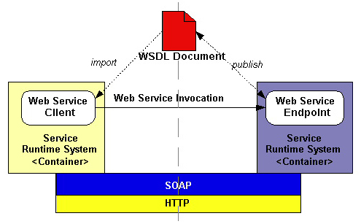
Figure 1.1: WSDL is used to describe endpoint of server.

Artifacts
All classes, interfaces, and other files located on client and server side and used by JAX-RPC to handle communication between client and service endpoint are called artifacts.
Stubs, ties, serializers, and deserializers are the required artifacts for client-server communication. Stubs are classes that represent a service endpoint on the client. This allows a JAX-RPC client to invoke a remote method on a service endpoint as though the method were local. A tie is the server-side analog to a stub. It represents the service endpoint on the server. Serializers and deserializers are classes that are used to serialize a Java type to XML, or XML to Java, respectively.

Java-WSDL/XML Mappings
The JAX-RPC specification defines the mapping between the definition of a JAX-RPC service endpoint and a WSDL service description. For example, it specifies that a service endpoint interface is mapped to a WSDL portType structure, and the methods defined in the service endpoint interface are mapped to operation elements in the portType structure. A JAX-RPC implementation must be able to produce a Web service description according to the mappings defined in the JAX-RPC specification.

Bindings
In generating a WSDL document, a mapping tool configures one or more protocol bindings for each service endpoint. The binding ties an abstract service endpoint definition to a specific protocol and transport. It's important to note that the JAX-RPC specification does not mandate any specific XML-based protocol for exchanging and transporting information. However, the specification does state that "An interoperable JAX-RPC system is required to support the SOAP 1.1 with attachment protocol." What this means is that for interoperability, a JAX-RPC implementation must support SOAP 1.1 with attachments, but additional protocols can be supported. Similarly, the JAX-RPC specification requires an implementation to support HTTP 1.1 network transport protocol. However an implementation can support additional transport protocols.

Stubs
Stubs are used when a JAX-RPC client knows what method to call and how to call it. Invoking a remote method through a stub is like invoking a remote method using the Java Remote Method Invocation (RMI) system. As is the case for RMI, in JAX-RPC, a stub is designed to simplify remote method calls by making them appear like local method calls. A local stub object is used to represent a remote object. To make a remote method call, all a JAX-RPC client needs to do is make the method call on the local stub. The stub (using the underlying runtime environment) then formats the method call and directs it to the server - this process is called marshalling. On the server, a class called a tie (also called a skeleton) unmarshals this information and makes the call on the remote object. The process is then reversed for returning information to the client.

Servlet
Servlets are modules of Java code that run in a server to answer client requests. Servlets are not tied to a specific client-server protocol but they are most commonly used with HTTP and the word "Servlet" is often used in the meaning of "HTTP Servlet".
Servlets make use of the Java standard extension classes in the packages javax.servlet and javax.servlet.http. Since Servlets are written in the highly portable Java language and follow a standard framework, they provide a means to create sophisticated server extensions in a server and operating system independent way.

PHP
PHP is a widely-used general-purpose scripting language that is especially suited for Web development and can be embedded into HTML. More information about PHP can be obtained from PHP official site.

This section describes the main aspects of the system design and architecture. The first section describes business design represented in terms of use case diagrams. The second section provides class diagrams that were designed for Java Web Services. The third section provides ER diagram for database of the system. And finally the fourth section provides brief information about modules of the system.

use case Model

Actors
There are six types of actors in the system namely administrator, teacher, assistant, chairman, secretary/student affair, chairman, and student. The actors have access via the online interface of the system which requires authorization.

Use Cases
The Use Case diagram for the system is shown in Figure 3.1. As can be seen from the diagram each actor has access to different Use Case, but some of them overlap.
The administrator is able to manage such resources as faculty, department, room, hour, authorities, calendar, semester, and person. It means that Administrator can add modify and delete information related to those resources.
The assistant is able to view information about course, attendance, exam, grade, and schedule of course he is assists. On the other hand, in case he is given permission, he is able to create new exam and update attendance.
The teacher able to view information about course, attendance, exam, grade, and schedule of course he is giving. Also he is able to update attendance, grade, and syllabus of the course he is giving and, create new exams.
The student is able to view information about course, attendance, exam, grade, and schedule of course he is taking. Also he is able to view curriculum of own department and take courses if permission is given.
Chairman is able to view information about course, attendance, exam results, grades, student details, teacher evaluation results, and curriculum of his department. Also he is able to update course, schedule and curriculum of his department. In addition he can open new course and approve students add/drop and add courses to list of courses student selected.
Secretary/ Student affair is able to manage such resources as calendar, semester and person information in case permission is given by the administrator. On the other hand, he is responsible for opening and closing add/drop. Updating of evaluation results and course information can also be performed by this actor.

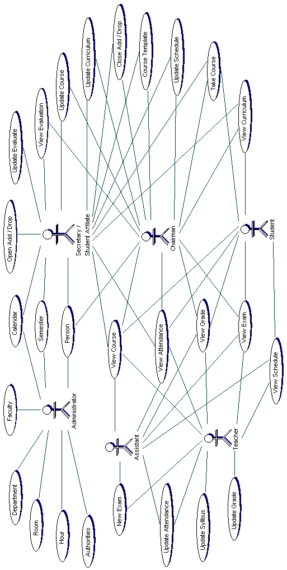 | Figure 3.1: Use Case diagram for School Management System

class dıagrams
The class diagrams are designed just for .Java Web Service side of the project. The project can be divided into two subsystems; one is server side and the other is client.

Server
The server side class diagram is shown in Figure 3.2. SMSImpl class is the boundary class of server subsystem. In other words when request is obtained from the client the SMSImpl class’ method is invoked. SMSImpl class contains all classes responsible for generating response messages. DBConnector class is the boundary class between server subsystem and MySQL database. The database tables’ schema is provided in appendix A. GeneralOperations class consists of methods that are used by several classes. An example of such method is the generation of the Header of the response message. The response messages are the strings satisfying the XML format provided in appendix D.
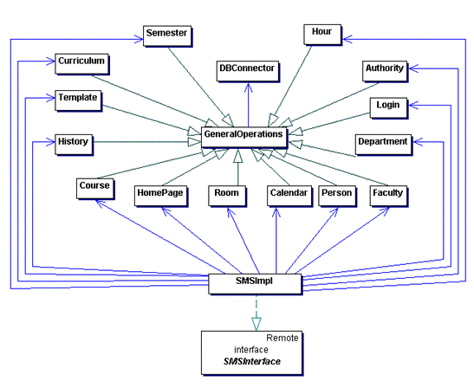
Figure 3.2: Server side Class Diagram.

Client
The client side class diagram is provided in Figure 3.2. The client side consists of servlets that perform a request to the server side according to the parameters send from the browser either by post or get method. The response from the server is then displayed to the terminal of the user. The client side should be configured before usage. It contains xsl_dtd.properties file which identifies the location of DTD and XSL files. HeaderClient class reads configuration file and generate a header for each response obtained by servlets. In case configuration file is absent the default xml header is generated. The default xml header generated by class as follows:
<? xml version="1.0" encoding="UTF-8"?>
<! DOCTYPE SYSTEM SYSTEM "rules.dtd">
<? xml-stylesheet type="text/xsl" href="xsl\default.xsl"?>
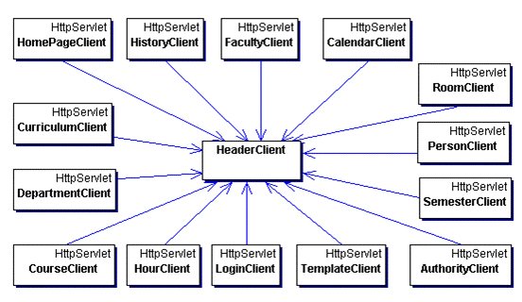
Figure 3.3: Client side Class Diagram.

er dıagram
ER diagram represent the structure and relationship between tables of database used in project. The ER Diagram is represented in Figure 3.4.
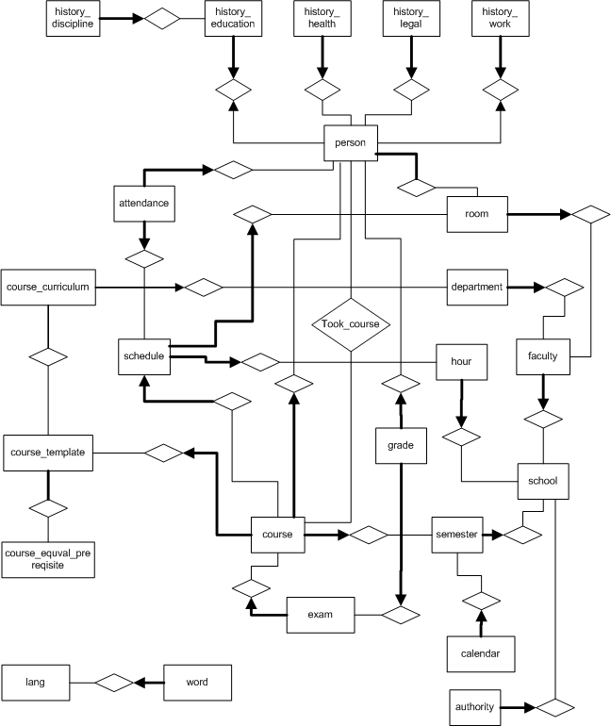
Figure 3.4: ER diagram for School Management System.

The database schemas are provided below:
attendance (scheduleid, personid, date, present)

authority (schoolid, userid, adddrop, attendance, calendar, schedule, semester, template, curriculum, course, person, student)

calendar (calendarid, semesterid, event, type, begindate, enddate)

course (courseid, templateid, departmentid, semesterid, personid, assistantid, section, required, capacity, outdepartment, outfaculty, web, email, mainbook, referencebook1, referencebook2, referencebook3, project, assignment, lab, grading, honercode, latework,content)

course_curriculum (curriculumid, departmentid, templateid, semester, type, credit)

course_equal_prerequisite (templateid1, templateid2, type)

course_template (templatecourseid, courseno, departmentid, coursetype, name, credit, theory, practice, laboratory, objective, description, offeredsemester, technical)

department (departmentid, departmentno, facultyid, name, comment, phone, fax, email, web)

exam (examid, courseid, type, date, duedate, comment, header, footer, percentage)

faculty (facultyid, schoolid, facultyno, name, comment, phone, fax, email, web)

grade (examid, personid, grade)

history_discipline (disciplineid, educationid, event, punishment, eventdate)

history_education (educationid, personid, studentno, level, here, school, faculty,
department, gradetype, studyyear, entrytype, status, registrationdate, startdate, enddate, diplomano, diplomatype, diplomadate, diplomagrade, gpa)

history_health (healthid, personid, problem, startdate, enddate)

history_legal (legalid, personid, punishment, event, society, startdate)

history_work (workid, personid, status, here, society, unit, department, startdate, enddate)

hour (hourid, schoolid, day, hour, beginhour, endhour, closed)

lang (langid, name, encoding)

person (personid, schoolid, personno, roomid, usergroup, persontype, workstatus,
title, firstname, lastname, sex, password, image, marital, driverlicence, bloodgroup,
healthstatus, religion, motherjob, fatherjob, country, city, town, address, birthday, birthlocation, fathername, mothername, idcity, idtown, idvolume, idpage, idfileno, iddate, idserial, email, mobile, phone1, phone2, language, style, adddrop)

oom (roomid, roomno, facultyid, building, type, capacity, volume, area, phone, comment)

schedule (scheduleid, courseid, roomid, hourid, sharable)

school (schoolid, name, command, phone, fax, email, web, maxcredit, boundarycredit, boundarygpa, gpagrade, gradetype)

semester (semesterid, schoolid, name, begindate, enddate)

took_course (courseid, personid, grade, lettergrade, status, closed)

word (wordid, langid, word)

modules
The School Management System consists of sixteen modules. These are Add/drop, Attendance, Calendar, Schedule, Exam, Grade, Semester, Course Template, Course Curriculum, Course, Student, Person, Faculty, Department, Room, and Hour. Each module can be accessed by a restricted group of users. This section provides a general overview of each model and more details are presented in Implementation section.
The Faculty module provides storage of faculties’ information of the school. It includes such operations as creation of new faculty record, modification of the existing faculty record, viewing information about existing faculty, and deletion of existing faculty records. The management of faculty records is permitted just for administrators of the school.
The Department module provides storage of departments’ information of the faculty that was created. This module provides such operations as addition of new department record, modification of existing department record, viewing information about department, and deletion of existing department records. This module can be accessed only by the administrators of the school.
The Room module provides storage of the rooms’ information of the school. Such operations as creation of new room record, modification of existing room record, viewing information about existing room, and deletion of existing room records are provided. This module can be accessed only by administrator.
The Hour module provides storage of the hours’ information of the lectures in the school. This module provides such operations as addition of new hour record, modification of existing hour record, viewing the list of existing lecture hours, and deletion of existing hour record. The Hour module can be accessed only by administrators of the school.
The Person/Student module provides storage of the persons’ information working or studying in the school. Such information as person’s work history, discipline punishments’ history, legal punishments’ history, education history, and current work or education information is stored. The module allows performing such operations as addition of new records, modification of existing records, viewing details of existing records, and deletion of existing records of those listed above. This module can be accessed by all users. However, addition of new personnel records, modification and deletion of existing personnel records is permitted to administrator and secretaries of the school. Chairman and secretaries can make manage only records for students of own department. Student affair can manage all students’ records.
The Semester module is used to store records related with semester. The records contain name start date and end date of semester. This module can be accessed by secretaries of school, student affair and administrators of the school.
The Calendar module is used two manage records related with calendar of activities that take place during a certain semester. This module can be accessed by all users of the system. However, modification of information can be done just by secretaries of the school, student affair and administrators.
The Course Template module is used to manage information related with courses that can be opened in the school. This module can be accessed by chairmen, secretaries and student affair.
The Course Curriculum module is responsible for representing and storing information related with curriculum for course. This module is accessible by all users accept administrator. However, modifications of information represented by this module can be done only by chairmen, secretaries, and student affair. In addition, chairmen and secretaries can modify only curriculums of own department courses.
The Course module represents and stores information related with opened courses for a semester. This module can be accessed by all users accept administrators. The permissions for modification of records are the same as in Course Curriculum module.
The Schedule module is responsible for representing and storing of data related with schedules for courses. This module can be accessed by all users accept administrators. The permissions for this module are the same as for Course module.
The Attendance module is responsible for storing and representing of information related with students attendance for each course. This module can be accessed by all users accept administrators. Student can view own attendance, whether other users can view and modify the information stored by module.
The Add-Drop module is used to open add-drop period and approve students taken courses. This module can be accessed by all users accept administrators and secretaries. However, only teachers, chairmen, and student affair can approve courses taken by students.
The Exam module is responsible for storing and representing of information related with exams. This module can be accessed by teachers and students. Students only allowed viewing information of courses taken by them. The teachers are responsible for modifying of information managed by this module.
The Grade module is responsible for representing and storing of records related with students grades taken from exams. The module can be accessed by teachers and students. The permissions for this module are the same as for Exam module.
Figure 3.5 summarizes the authority for changing records within system.
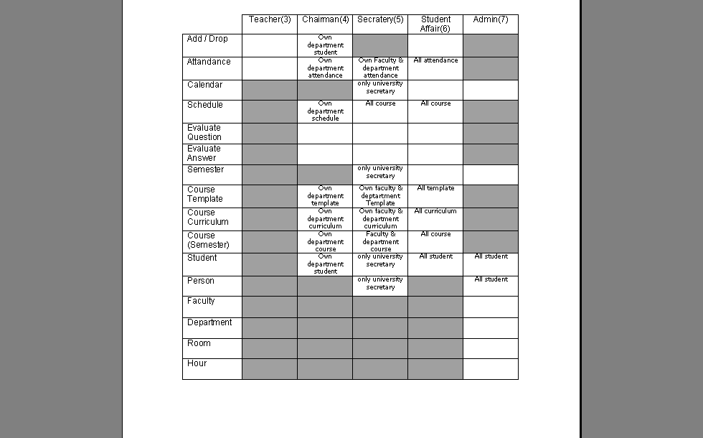
Figure 3.5: Authorities of user group on modules
Figure 3.6 summarizes the dependency relations between modules.
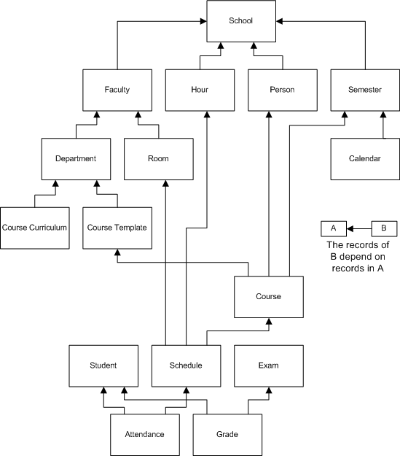
Figure 3.6: Summarizes the dependency relations between modules.

The aim of this chapter is to make clear user-system interaction and system implementation aspects. Therefore, more details about system’s modules are provided.
The user can enter the system entering his personal number and password (in Java Web Service implementation specification of school also required) as shown in Figure 4.1.
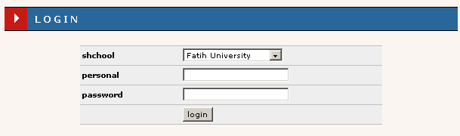
Figure 4.1: Login interface
In case some information is wrong error message is displayed and access is rejected. After the successful entrance the home page, that provides the switch between modules by means of set of appropriate links, is displayed as shown in Figure 4.2.
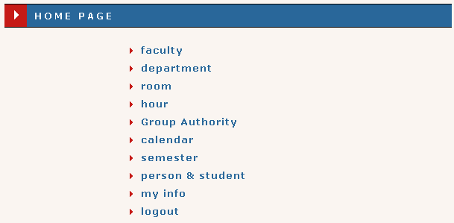
Figure 4.2: The Home page interface
The system automatically detects the home page for each user. This decision is performed on base of entered personal number. Therefore, before any user can perform an entrance his record should be stored in the database of the system.
Each interface explained in this chapter has two combo boxes, one for different languages found in the system, and the other for the view of the interface. Different interfaces and languages changes are stored in the database to be remembered next time user enters the system. The change in view of interfaces is achieved by using the power of the XSL.

Faculty
The Faculty model can be accessed only by administrator. When administrator switches to faculty model the list of faculties specifying number of faculty and its name is displayed as shown in Figure 4.3 Each row in the list contains detail link, by pressing which user can reach the details of the faculty. With purpose of returning back to home page and entering of new record links are provided.
The interface for faculty’s details is shown in Figure 4.4. As can be seen from the figure there are four links allowing administrator to update or delete current record, or return back to the list of faculties, or return back to the home page. In case, the link for deletion of the record is pressed, the record is deleted if no other record is using information provided by record.
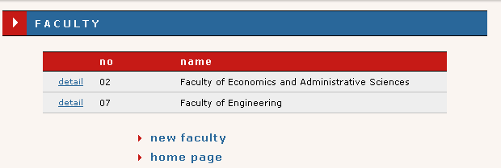
Figure 4.3: The faculties of the school are listed when Faculty module is accessed

Pressing the new faculty link the user switches to new faculty interface which provides fields for information input (Figure 4.5). Some of those fields, which are required, are specified by star ‘*’ at the beginning of field’s name. If those fields are left blank or the entered faculty number exists the appropriate error message is displayed. The interface provides two links. One of them is used to return back to the faculty list (faculty), and other used to return back to home page (home page).
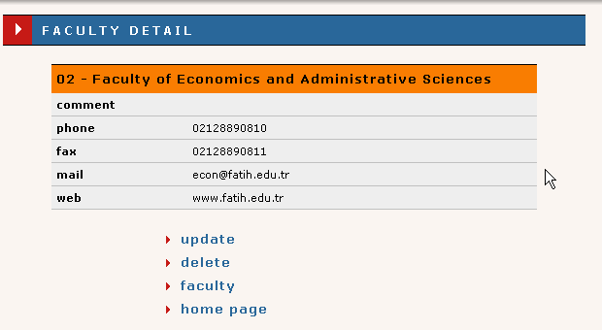
Figure 4.4: Faculty details interface

The update interface is similar to new faculty interface. The main difference is the fact that fields whose corresponding information is stored in database are filled.
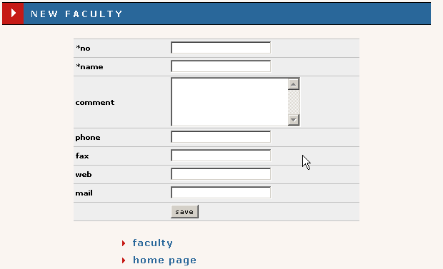
Figure 4.5: New/Update Faculty interface.

CAUTION: Be careful while changing name and number of faculty. These changes may dramatically affect existing records.

Department
The department module can be accesses by selecting department link from the list of links of home page. However, it can be accessed only by administrator. When administrator switches to the model the list of all departments is displayed. However, if he wishes, he can view departments of one faculty by selecting the faculty from provided above departments’ list combo box. This is depicted on Figure 4.6. Each row of the departments list consists of link to the department’s detail, department number, and department name. In addition link to create new department record and link to return back to home page are provided.
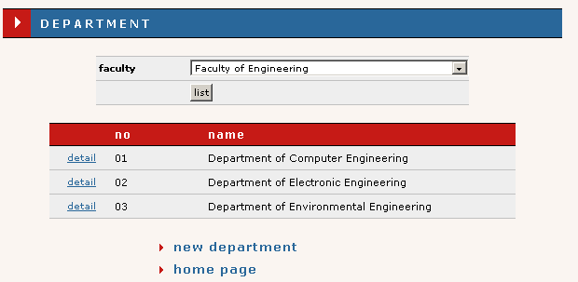
Figure 4.6: The interface displayed when department module is entered.

The user is forwarded to department detail interface, when department detail link is clicked. The interface of department details is shown in Figure 4.7 As can be seen from the figure such information as faculty number and faculty name to which department belongs is provided. In addition, department’s number and name, and other information is provided in interface. Four links, with which help the administrator can update or delete current record, return back to list of departments or return back to the home page, are also provided.
New department interface is displayed when administrator clicks new department link. This interface provides a form containing a number of field, from which field containing a star ‘*’ at the beginning of name must be filled up. Figure 4.8 displays the default view of new department interface. In addition to form, two links used to return back to list of departments and return back to home page are provided. When save button is pressed the required fields are checked for emptiness. If required fields are empty or entered department number already exists an appropriate error message is displayed.
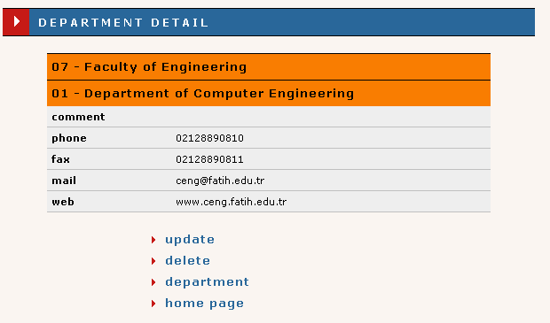
Figure 4.7: Department details interface.

The update department interface, which can be accessed by clicking update link in department details interface, is similar to new department interface (Figure 4.8). However, the fields in this interface are field by information obtained from database. When update button is pressed the required fields are checked for emptiness. If error occurs the appropriate message is displayed, otherwise the record is updated.
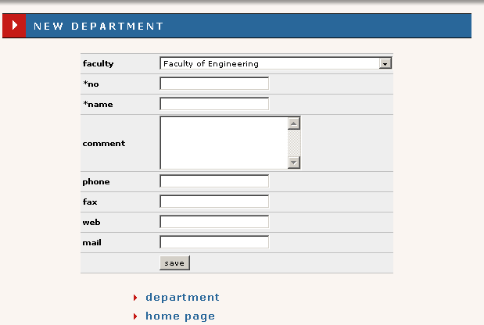
Figure 4.8: New/Update department interface.
CAUTION: Be careful while changing name and number of department. These changes may dramatically affect existing records.

Room
The Room module is accessible only by administrator. When the administrator switches to this module via home page the list of all rooms in the school is displayed. The Figure 4.9 shows the default interface displayed when Room module is accessed. As can be see from the figure the list of rooms can be filtered using the two com box and one text field. The filtering criteria are faculty, type and building. The filter is activated by pressing list button. Each row of list of rooms contains room detail link, room number, room type, building name where room is located, and room capacity information. Extra information such as total number of records, current page number and total number of pages is also provided. Each page can contain thirty rows of records. In addition, two links, one of which is used to switch to new room interface through which new room record is added, and another is used to forward user back to the home page, are provided.
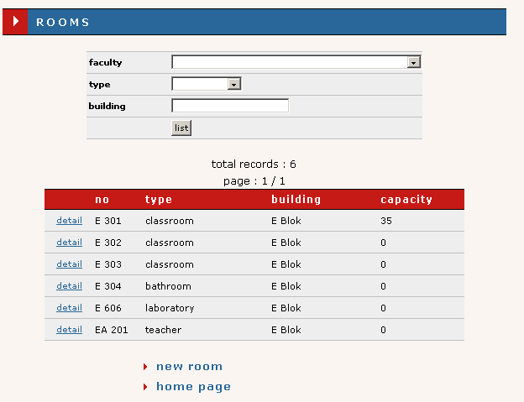
Figure 4.9: The interface displayed when administrator switches to the Room module.

The administrator can view room’s detail by clicking room details room. The interface displayed when link is clicked is shown in Figure 4.10 Such information as number and name of faculty to which room belongs to and other information are provided. Room details interface contains four links, which are used to update or delete current record, return back to list of rooms or return back to home page.
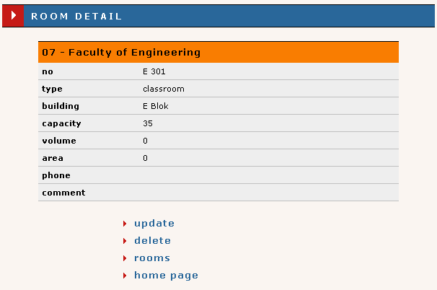
Figure 4.10: Room details interface
The administrator can add a new room record by clicking new room link. The interface that appears after clicking the link is shown in Figure 4.11. As can be seen from the figure the interface consists of the form whose required fields have a star ‘*’ at the beginning of the label. To submit and save the record administrator should press save button. The submitted information can be saved to the base if and only if required fields are not empty and entered room number not found in the existing records.
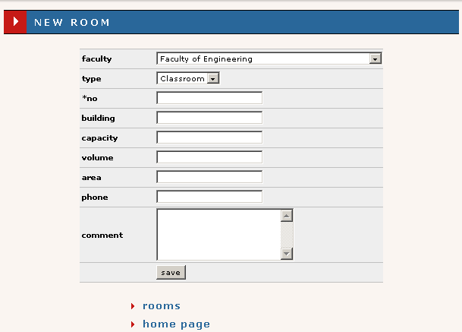
Figure 4.11: New/Update Room interface
In addition, this interface provides two links through which administrator can return back to list of rooms or home page.
The administrator can update existing room record by clicking update room link in room details interface. The administrator is forwarded to room update interface when he clicks update link. This interface is similar to new room interface shown in Figure 4.11. However, the fields are filled with appropriate information obtained from the database.
CAUTION: Be careful while changing name and number of room. These changes may dramatically affect existing records.

Hour
The Hour module can be accessed only administrator via his home page. The list of hours when lecture can take place for each week is displayed when the module is accessed as shown in Figure 4.12. Each row of list of hours contains link to delete existing hour, link to update existing record, lectures number, and range in which lecture takes place. Two links are provided in this interface. One is used to ad a new record and the other is used to return back to the home page.
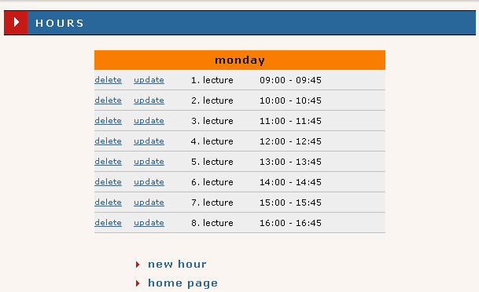
Figure 4.12: Hours interface which is displayed when administrator accesses hour module.
The administrator can add new hour record by clicking new hour link. The new hour interface is displayed when new hour link is clicked as shown in Figure 4.13. This interface consists of form which contains required fields marked by star ‘*’ and two links. Those links are used to return back to list of hours and home page. The information entered into the fields can be saved if and only if save button is pressed, all required fields are filled correctly, and no hour overlapping occurred.
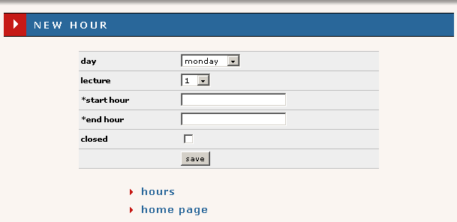
Figure 4.13: New/Update hour interface.
The lecture hour information can be updated by clicking update hour link. The update hour interface appears when update hour link is clicked. The interface is similar to new hour interface. However, fields are filled with appropriated information obtained from the database of the system.

Semester
The Semester module can be accessed only by administrators, school secretaries, and student affair. The interface that is displayed when permitted user switches this module is shown in Figure 4.14. As can be seen from figure the list of semester records is displayed in this interface. Each row of the list contains link to update semester record, link to delete semester record, name of semester, start date of the semester, and end date of the semester. In addition, two links one for addition of new record for semester and the other for returning back to home page are provided.
The permitted users can add new record by clicking new semester link. The interface displayed after clicking the link is shown in Figure 4.15. The new semester interface contains the form whose all fields are required as the have stars ‘*’ at the beginning of their labels. The information filled into fields can be saved to database if and only if save button is pressed and all the required information entered correctly. In case some error occurs appropriate error message is displayed. Two links allowing user to return back to the list of semesters or return back to home page are provided.
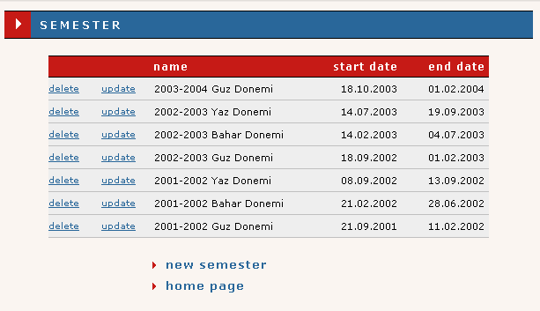
Figure 4.14: The interface displayed when permitted user switches to Semester module.
The existing record for semester can be updated by clicking the update link in the list of semesters. The update interface is similar to new semester interface. However, the fields are filled by the appropriate information brought from the database.
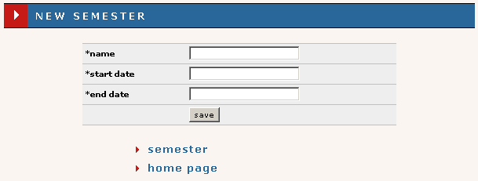
Figure 4.15: New/Update semester interface.

Calendar
The calendar module can be accessed by all users of the system. The interface displayed when user switches to this module is shown in Figure 4.16. As can be seen from the figure the information for each semesters activity calendar can be viewed by selecting semester from provided combo box and pressing list button. The semester name, its start date and finish date are provided in the interface. If any event exists for the selected semester, list of events is also displayed in the interface. Each row of the list consists of link, event type, event, start date of event, and end date of event. Delete event link used to delete event is displayed only for administrator, school secretary, and student affair users. The event that have no end date are said to hold just for date specified in the start date column. As can be seen from the figure two links are provided. However, add event link, which is used to add new event, can be viewed and entered only by administrator, school secretary, and school affair users. The home page link can be used to return back to home page.
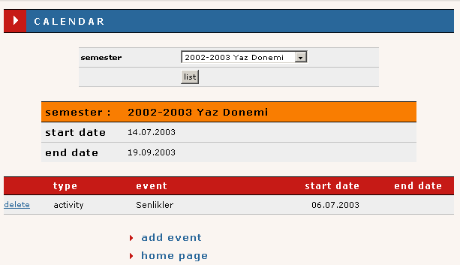
Figure 4.16: The interface displayed when user switches to calendar module.
The permitted individuals can add new event by clicking add event link. The interface displayed as response to that action is shown in Figure 4.17. As can be seen from the figure the form for entering information is provided. The required fields have the star ‘*’ at the beginning of field’s label. The information can be saved if and only if the required information is entered correctly. New event interface also provides to links which helps user to return back to list of events or home page.
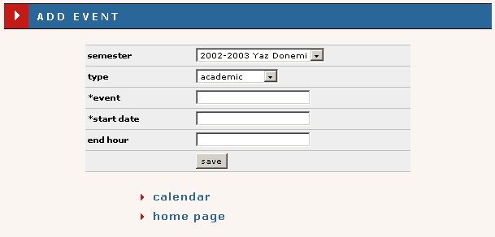
Figure 4.17: New event interface.
You may notice that update of events is not possible. The reason of this is the fact that records related to calendar events have no relation to other records stored in the database and can be freely deleted.

Person
The person module can be accessed by all user supported by the system. However, each user have own restriction on this module. All users can view own information. School secretaries and administrators can add, modify, and delete personnel and student information. Chairman can add, modify and delete information only for students of own department. Student affair can add, modify and delete only students’ information. The interface shown in Figure 4.18 is displayed when users, permitted to perform addition, modification and deletion of records, are switch to person module. The interface displayed on figure displayed for administrators and school secretaries.
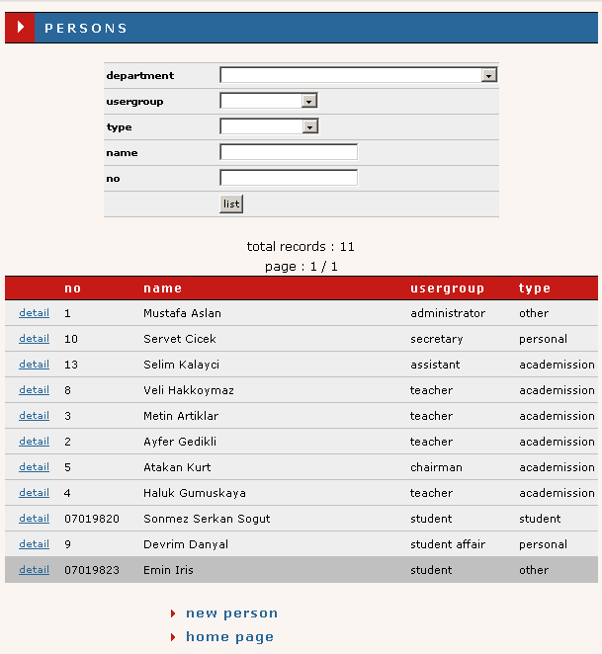
Figure 4.18: The interface which is displayed when users, permitted to perform addition, modification and deletion of records enter person module.
As can be seen from figure the list of persons’ information is provided in this interface. In addition, the set of filters is provided. The department filter is set to chairman’s department and user group filter is set to student when chairman enters person module. The department and user group combo boxes are not displayed in this case. The user group filter is set to student and not displayed when student affair enters the person module. The list of persons contains link to person’s details, person number, person name and surname, user group, and person type. Extra information such as total number of records and page, and current page is also provided. Each page can contain thirty records. Two links, with whose help user can add new person’s information or return to home page also present.
The users who have no permission to perform addition, modification and deletion of person’s records are directly forwarded to person details interface. However, those who have those rights can reach person details interface by clicking details link that shown in Figure 4.18. The details interface is shown in figure 4.19. It provides such information as person’s personal, family, contact, and identification information. Also it provides lists of education, work, health, and legal punishment histories. Each row of education list contains link to education details, school name, faculty name, department name, and current status information. The users permitted to perform addition, modification, and deletion operations are provided links that help users to add new work, health, legal, and new education history. However, other users can just view details of those histories by clicking detail links.
The permitted users can add new person information by clicking new person link as shown in Figure 4.18. The interface where user is forwarded after clicking the link is shown in Figure 4.20. This interface contains a form whose some fields are required and identified by the start ‘*’ at the beginning of the label. By pressing save button user can save the information which he filled to the fields. However, this information can be saved if and only if all required fields are filled and no error occurred. In case error occurs the appropriate error message is displayed.
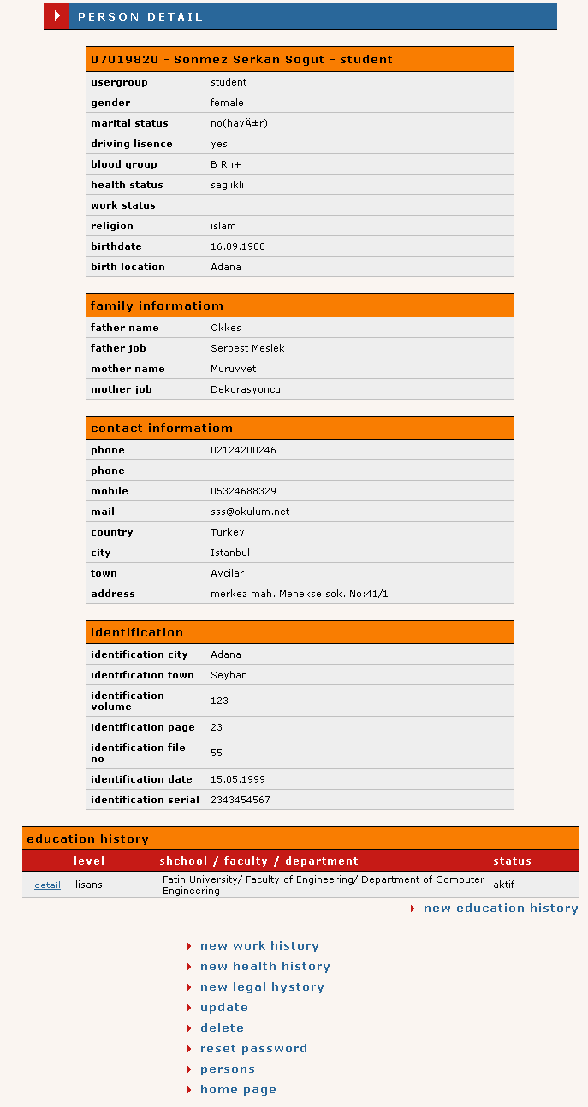
Figure 4.19: Person details interface.

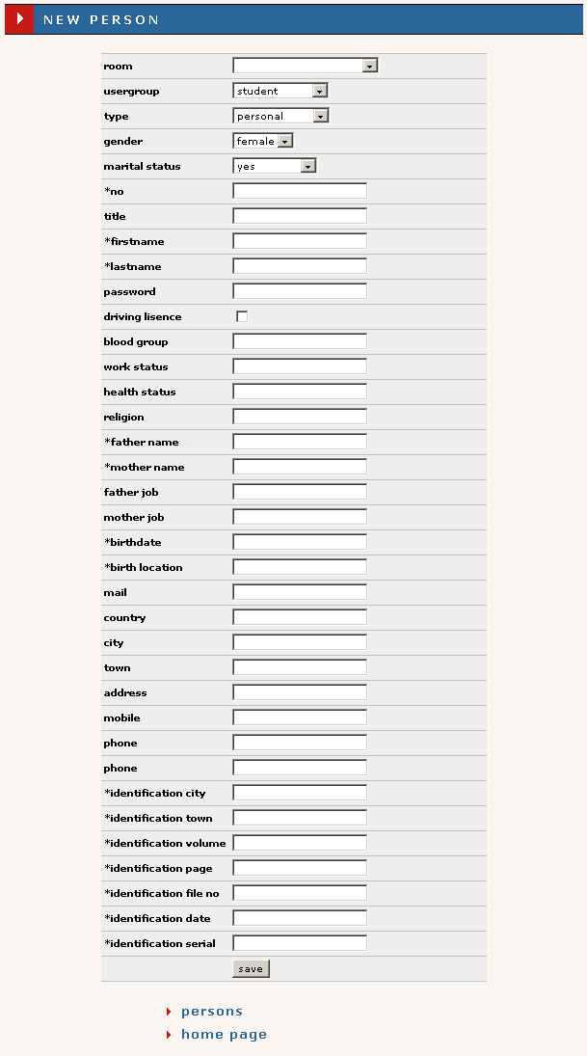
Figure 4.20: New/Update person interface.

History
The history module can be accessed only by users who are permitted to add, delete, and modify records related to person information. This module can be accessed only through person module. The module itself consists of set of forms that provide opportunity of users to add new education, work, legal punishment, discipline punishment, and health history information. Some fields in these interfaces are required and are identified by star ’*’ at the beginning of fields label. The information of those fields can be saved only when save button is pressed, all required fields are filled and no error occurred. In case error occurs the appropriate message is displayed. These interfaces are shown in Figure 4.21, Figure 4.22, Figure 4.23, Figure 4.24, and Figure 4.25, In addition, each interface provides link to return back to the interface from where user came, and a link to the home page.
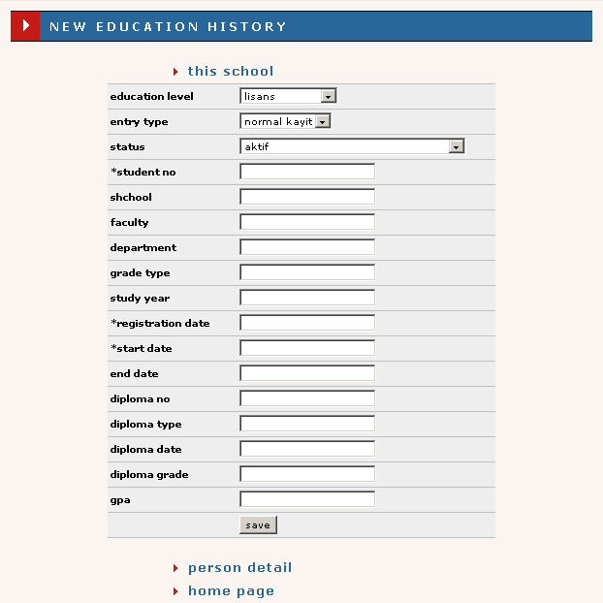
Figure 4.21: New education interface.
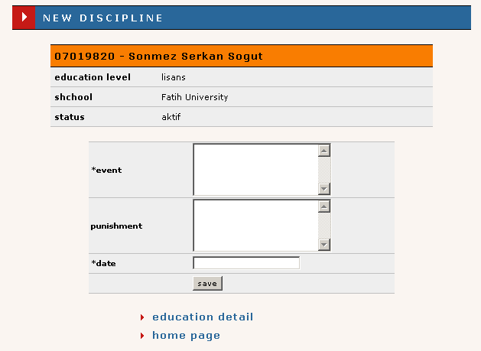
Figure 4.22: New discipline interface
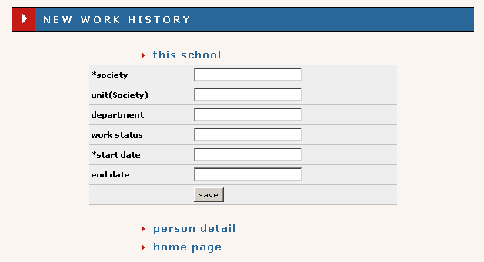
Figure 4.23: New work history interface.
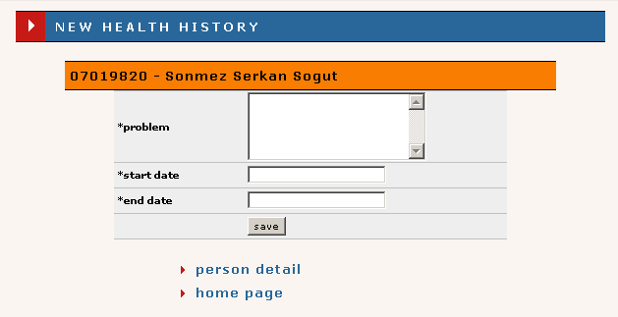
Figure 4.24: New health history interface.

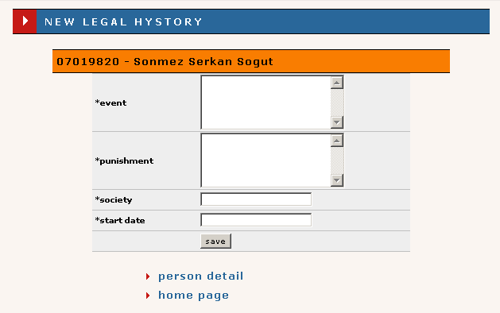
Figure 4.25: New legal punishment history interface.

Course Template
The course template module can be accessed by chairman, secretary, and student affair users. However, the chairman can add, modify, and delete courses related with his department. Secretary can add, modify, and delete courses related with his faculty or department. And finally, student affair can add, modify, and delete courses related with whole school. The interface displayed when user switches from home page to course template module is shown in Figure 4.26. As can be seen from the figure the list of courses that exist is shown. Each row of the list contains link to details of the course, course’s name, course type, and course’s credits. The combo box and range of selection within it is provided according to the permissions of the user. The number of courses shown per page is 30. Links allowing user to switch to new course template and to return back to home page are also provided.
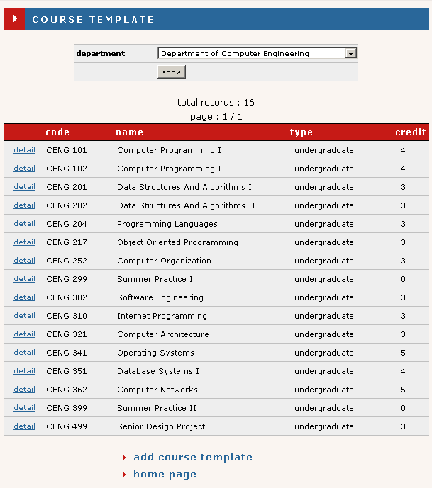
Figure 4.26: The interface displayed when user switches to course template module.
By clicking details link user is able to vie details of the course. The details interface is displayed in Figure 4.27. In addition to courses, links allowing user to update and delete current record, add equal - prerequired course for current course, create copy of current course in courses record, return back to list of template courses and home page are provided. The clicking of create semester course link switches user to new course interface located in course module which will be explained later.
The user can create a new template by clicking new course template link provided with list of template courses. The interface containing a form requesting for new course template information is displayed as shown in Figure 4.28 when user clicks new course template link. Some fields of the form, which identified by star ‘*’ at the beginning of field’s label, are required. The information entered into fields can be saved only when user clicks save button and all required fields are filled and no error occurred. In case error occurred or some of the required fields are not filled an appropriate error message is displayed. In addition, an interface contains to links, whit whose help user can return back to the list of template courses or to home page.
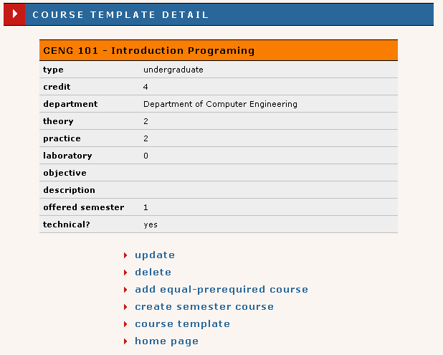
Figure 4.27: Course template interface.
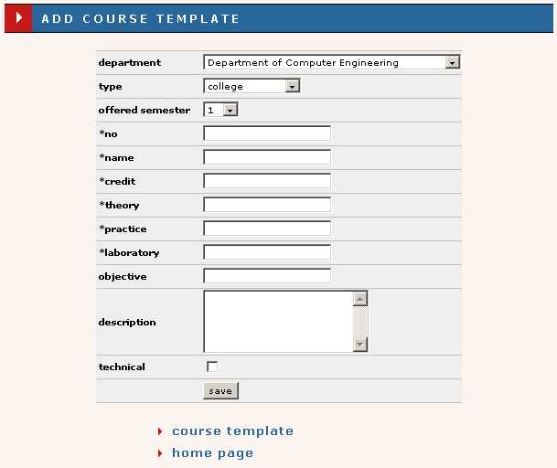
Figure 4.28: New/Update course template interface.
The update operation can be performed by clicking update link in the template course details interface. The interface displayed to response to this operation is similar to new course template interface. However, fields in this case are filled with appropriate information obtained from the database. Update template course interface contains the same links as new template course interface. One of which used to return to the list of template courses, and the other to the home page.

Course Curriculum
The course curriculum module can be accessed all users. However, the chairman can make changes to course curriculum related with his department. Secretary can make changes to course curriculum related with his faculty or department. And finally, student affair can make changes to course curriculum related with whole school. Other users just can view the record found for curriculum. The interface displayed when user switches to course curriculum module is shown in Figure 4.29. As can be seen from the figure the interface provides the list of courses for each semester. The delete link, which is used to delete course from the curriculum, can be seen only by permitted individuals. In addition, two links are provided. One is used to add new course to the curriculum (seen only by permitted users), and the other is used to return back to home page.
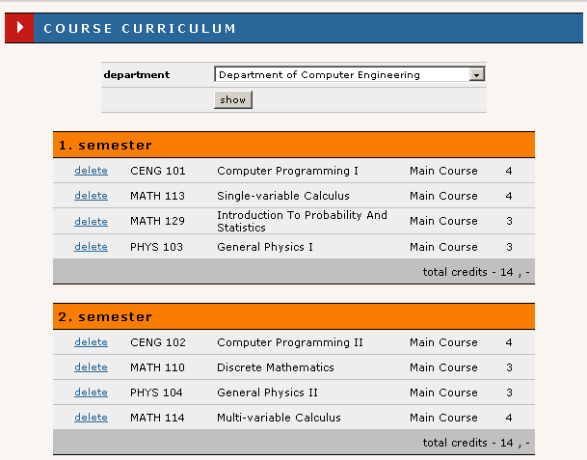
Figure 4.29: The interface displayed when user switches to course curriculum module.
The permitted users can add new course to curriculum by clicking add course. The interface displayed when this operation is performed is displayed in Figure 4.30. As can be seen from figure interface contains a form that can be submitted by clicking save button. In no error occurs during submission the information is stored in the system’s database. The interface also allows users to return back to course curriculum and home page by providing two links.
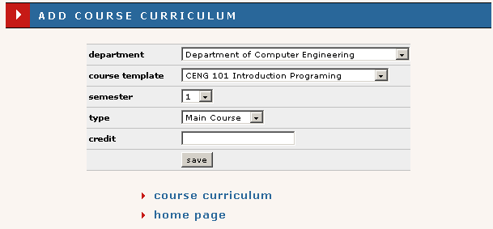
Figure 4.30: Add course to curriculum interface.

Course
The course module can be accessed by all users of the system except administrator. However, only chairman, secretary and student affair can make changes. The chairman can add, modify, and delete only own department courses. Secretary can add, modify, and delete only of own faculty or department, depending of secretary type.
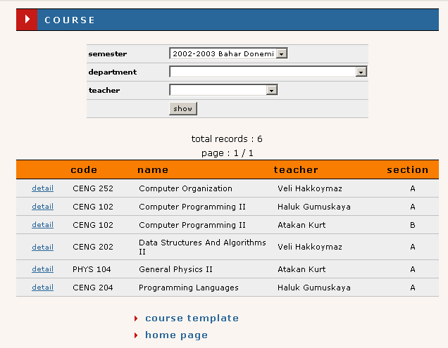
Figure 4.31: The interface displayed when permitted users switch from home page to course module.
The interface displayed when permitted users switch from home page to course module is shown in Figure 4.31. As can be seen from the figure the interface provides the list of all available courses. Each row of the list contains a link switching user to course detail interface that provides information about the course. The list also can be filtered using the filters provided above the list of courses. The filters can be activated by pressing show button bellow filters. However, filters are available according to permissions of users. For example, department filter is not available for chairman since he can manage only courses of own department. The number of courses displayed per page is limited to thirty. In addition, two links, one of which is used to create template course and forwards user to course template module’s new template interface, and the other is used to return back to the home page.
The create semester course interface is invoked via course template when new copy of template course is wished to be created. This interface is shown in Figure 4.32. The interface contains a form whose some fields are required and marked by star ‘*’. The interface provides two links, one of which is used to switch user to course template interface, and the other is used to return back to home page.
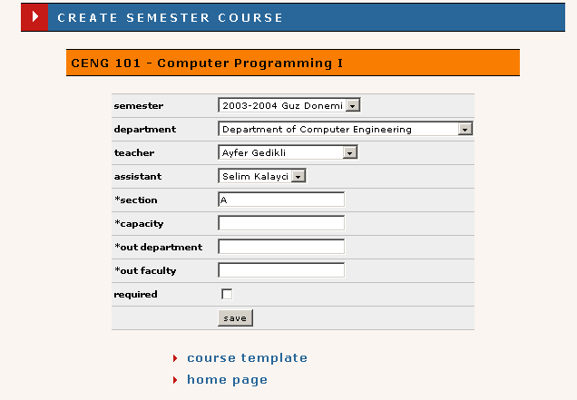
Figure 4.32: Create semester course interface.

Schedule
The schedule module can be accessed by all users except administrator. However, the part that is viewed by user changes depending on user’s type. Student, teacher and assistant can view only own schedules. The chairman can view schedule for own department and can make changes to it. The same can be said for secretary who can view the schedule for own department or faculty, depending on secretaries responsibilities. The student affair can view the schedule for whole school. The interface that is displayed when user switches from home page to schedule module is shown in Figure 4.33.
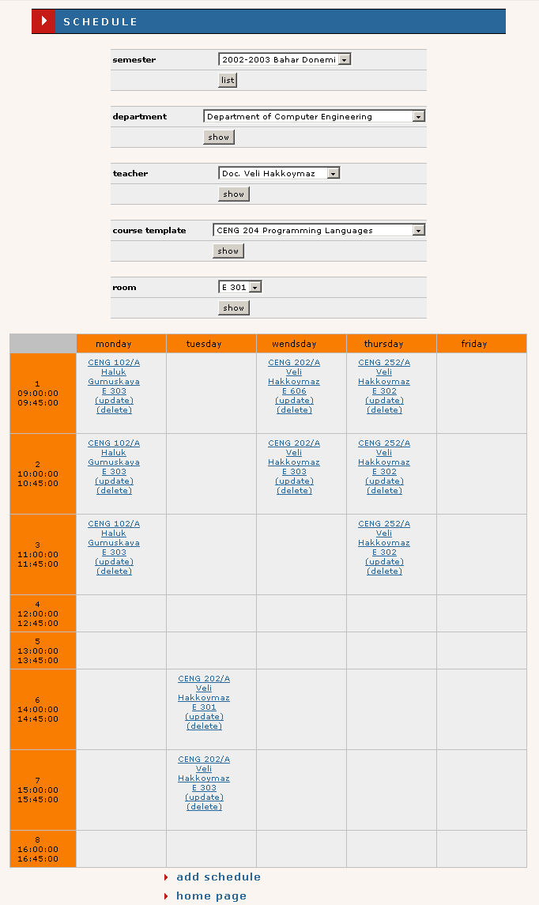
Figure 4.33: The interface that is displayed when user switches from home page to schedule module.
As can be seen from figure the schedule is shown for each week. Some filters allowing users with higher responsibilities to select schedule they wish to view are provided. The interface is also provides two links, on of which is used to add new lecture to schedule, and the other is used to return back to home page.
The interface displayed when permitted user clicks add schedule link is shown in Figure 4.34. The interface contains the form that can be submitted by pressing save button. However, the information is saved only when no overlapping and repetition of course occurs. In case, error occurred an appropriate error is displayed. User can also return back to schedule or home page using provided links at the bottom of the interface.
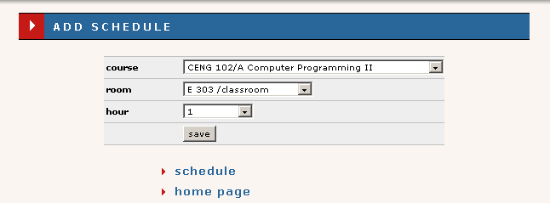
Figure 4.34: View of the interface that is used to add new course to schedule.

Attendance
The course attendance can be accessed by all users of the system accept administrator. However, only teacher, secretary, chairman, and student affair can perform changes. The teacher can add and delete attendance for own course. Secretary can add and delete attendance for own department or faculty, depending on the responsibilities.
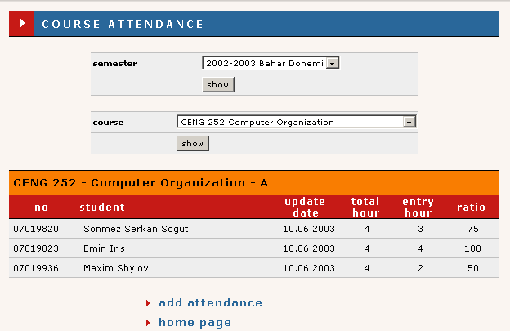
Figure 4.35: The interface displayed when user enters the attendance module.
The student affair can add and delete attendance for whole school. The interface displayed when user having permission to make changes enters the attendance module from home page is shown in Figure 4.35. The view displayed for student contains list of lectures, last update time, total lecture hours, number of entered hours, and ration of entered to total hours as shown in Figure 4.37. As can be seen from the figure the authorized individuals can filter attendance list with help of provided filters. In addition two links, one of which is used to add new attendance and the other for returning back to home page are provided.
The interface shown in Figure 4.36 is displayed when user clicks add attendance link. The interface contains the form which has some required fields identified by star ‘*’ at the beginning of field’s label. The check box is used to identify whether student visited the lecture or not. The information filled into forma can be submitted by clicking save button. If no error related with required fields occurs, the information is stored in the systems database. Otherwise the appropriate error message is displayed. The interface also provide two links with whose help user can return back to list of attendances or to home page.
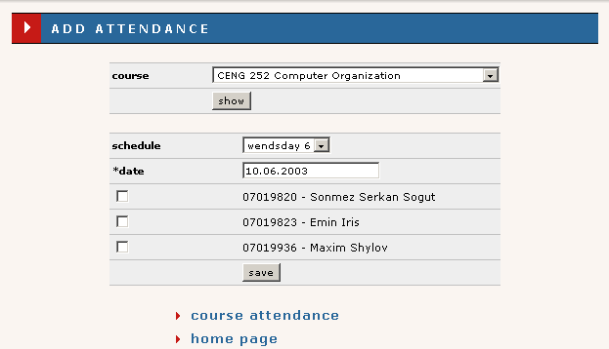
Figure 4.36: New attendance interface.
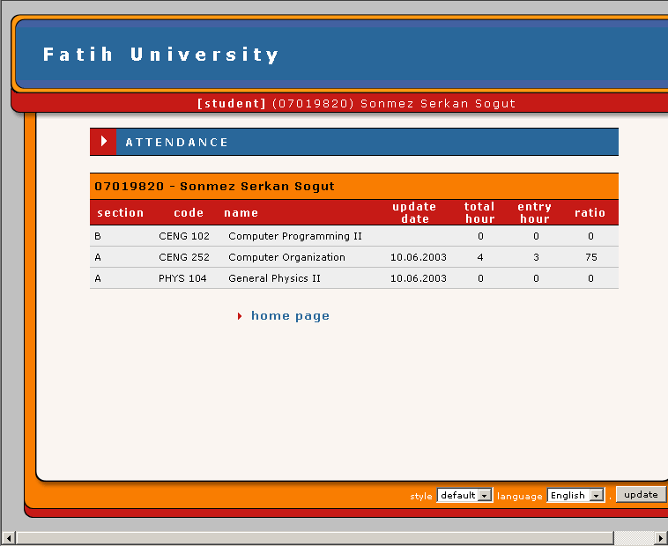
Figure 4.37: Student attendance interface view.

Add-Drop
The add-drop module can be accessed by student, chairman, teacher, and student affair. The interface viewed by student affair is shown in Figure 4.38. As can be seen from the figure student affair can open and close add-drop. In addition he can approve students selected courses.
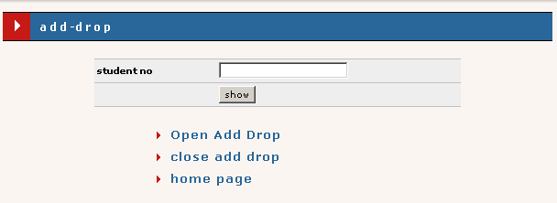
Figure 4.38: Interface vieved by student affair.
The interface of add-drop for chairman and for teacher is shown in Figure 4.39. As can be seen from the figure those users can approve students selected courses, and view must and taken courses. For this purpose links are provided. The interface for student is similar to chairman’s interface the main difference is the absence of link that is used to approve taken courses.
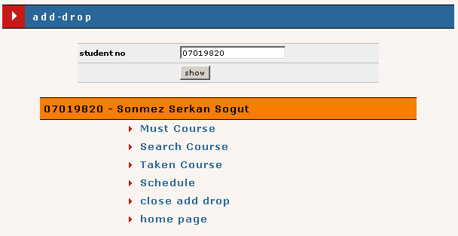
Figure 4.39: The interface viewed by chairman and teacher.

Exam
The exam module can be accessed by teacher and student users. The interface that is displayed when user switches to exam module is shown in Figure 4.40. The main difference between teacher and student is the ability of teacher to add grades and exams for lectures given by him.
The interface displayed when detail link is clicked is shown in Figure 4.41. This interface provides links to return back to home page and exam page, and links for update and deletion of current record, which are visible only by teacher.
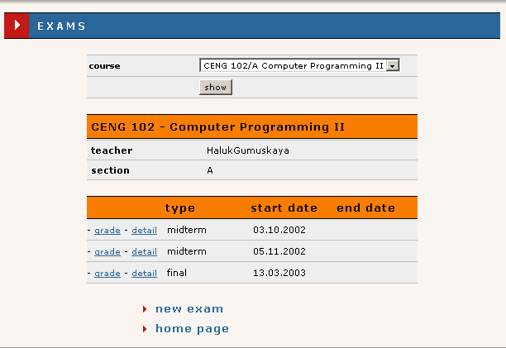
Figure 4.40: The interface that is displayed when user switches to exam module.
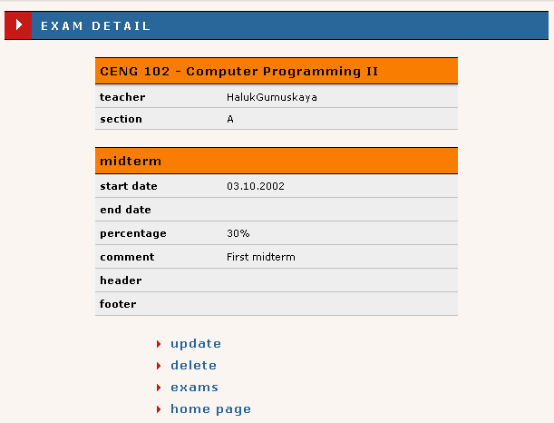
Figure 4.41: Exam detail interface.
The teacher also can add new grade by clicking new exam link. The interface displayed when update link is clicked is shown in Figure 4.42. As can be seen from figure the interface provides form which has some required fields that identified by star ’*’ at the beginning of required field’s label. The information filled into fields can be submitted by pressing save button at the end of form. If no error occurs during submission of the form the information is stored into database of the system, otherwise the appropriate error message is displayed. Two additional link allowing user return back to list of exams and home page are provided.
The update interface that can be reached by clicking update link in exam detail interface is similar to new exam interface. However, fields are filled with appropriate information brought from the database of the system.
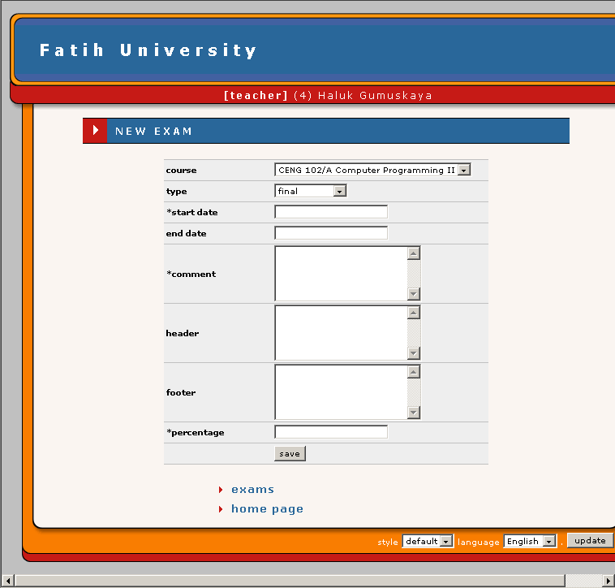
Figure 4.42: New/Update grade interface.

Grade
The grade module can be accessed by both student and teacher users of the system. The interfaces for student and teacher users are shown in Figure 4.43 and Figure 4.43 respectively. As can be seen from figure the student can freely learn grades for lectures he takes in current semester. The teacher can view student’s grades and update them using the links provided in interface. To switch to grades interface teacher have to click grade link in the exam interface. Also he can return back to exam and back to home page from grade interface.
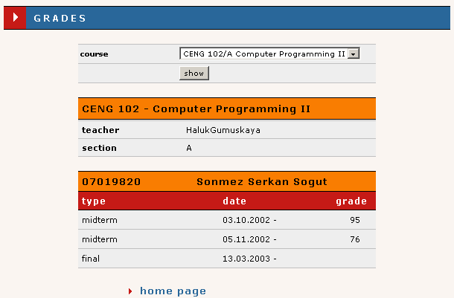
Figure 4.43: The interface displayed when student user switches to grade module.
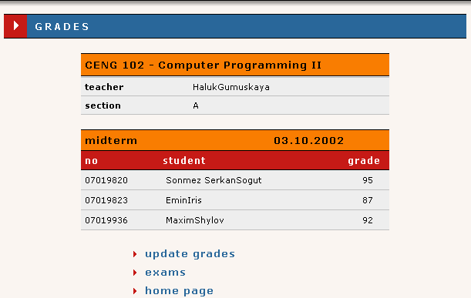
Figure 4.44: The interface displayed when teacher user switches to grade module.
The teacher can update grades for each exam he entered in exam module. The interface displayed when teacher clicks update link in grade interface is shown in Figure 4.45. The interface contains a form consisting of fields each one for one student. After filling the fields teacher can save entered information by pressing save button at the end of the form.
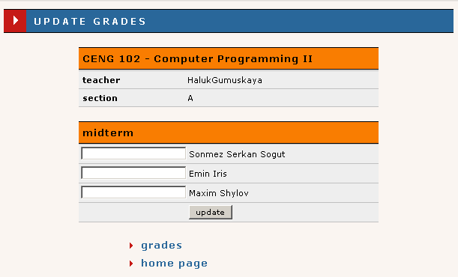
Figure 4.45: Update grade interface.

CONCLUSION
The School Management System which capable of storing school resources such as students and staff of the school and their relationship was implemented. It is easily to track the relations of students and courses they have taken, courses and teacher they are given by using the friendly interface of the system. The system supports different platforms and different languages. In addition, the interfaces of the system can be easily configured by introducing new XSL transformation files for interfaces of the system, which are implemented in terms of XML standards. The system can work in local or distributed manner. It means that the system can be used on local machines for management of one school or can be located on one server and clients from different schools can connect to the server and obtain requested information.
The system can be easily extended by introducing new modules. An example of such, future work is evaluation questions module that can be used to evaluate teachers, and output the statistics of the evaluation.
REFERENCES
[1] Extensible Markup Language (XML) 1.0 by http://www.w3.org/TR/REC-xml
[2] W3 Schools XML Tutorial by http://www.w3schools.com/xml/default.asp
[3] W3 Schools XSL Tutorial by http://www.w3schools.com/xsl/default.asp
[4] W3 Schools DTD Tutorial by http://www.w3schools.com/dtd/default.asp
[5] W3 Schools XPath Tutorial by http://www.w3schools.com/xpath/default.asp
[6] XML Syntax Quick Reference by http://www.mulberrytech.com
[7] XML Pocket Reference, 2nd Edition by Robert Eckstein & Michel Casabianca
[8] PHP online manual by http://www.php.net/manual/en/
[9] MySQL manual by http://www.mysql.com/downloads/
[10] Technical Articles & Tips JAX-RPC on the Sun ONE Web Services Platform Developer Edition, by http://developers.sun.com/sw/building/tech_articles/jaxrpcs1.html
[11] Java Technology and Web Services by http://java.sun.com/webservices/index.html
[12] Java API for XML-Based RPC by http://java.sun.com/xml/jaxrpc/index.html
[13] Web Services Description Language (WSDL) 1.1 by http://www.w3.org/TR/wsdl

Appendices
- Database
There are twenty nine tables in database. These are explaining below;
  - Attendance Table
This table stores attendance records.
Field | Type | Attributes | Null | Default | Extra
scheduleid | mediumint(8) | UNSIGNED | No | 0
personid | mediumint(8) | UNSIGNED | No | 0
date | date |  | No | 0000-00-00
present | enum('y', 'n') |  | No | y

  - Authority Table
This table stores authorities for each user group.
Field | Type | Attributes | Null | Default | Extra
schoolid | smallint(5) | UNSIGNED | No | 0
userid | tinyint(3) | UNSIGNED | No | 0
adddrop | enum('y', 'n') |  | No | n
attendance | enum('y', 'n') |  | No | n
calendar | enum('y', 'n') |  | No | n
schedule | enum('y', 'n') |  | No | n
evaluate_question | enum('y', 'n') |  | No | n
evaluate_answer | enum('y', 'n') |  | No | n
semester | enum('y', 'n') |  | No | n
template | enum('y', 'n') |  | No | n
curriculum | enum('y', 'n') |  | No | n
course | enum('y', 'n') |  | No | n
person | enum('y', 'n') |  | No | n
student | enum('y', 'n') |  | No | n

  - Calendar Table
This tables stores calendar events.
Field | Type | Attributes | Null | Default | Extra
calendarid | mediumint(8) | UNSIGNED | No |  | auto_increment
semesterid | tinyint(3) | UNSIGNED | No | 0
event | varchar(255) |  | No
type | tinyint(3) | UNSIGNED | No | 1
begindate | date |  | No | 0000-00-00
enddate | date |  | Yes | NULL

  - Course Curriculum Table
This table stores course curriculum for each department.
Field | Type | Attributes | Null | Default | Extra
curriculumid | smallint(6) |  | No |  | auto_increment
departmentid | smallint(6) |  | No | 0
templateid | smallint(6) |  | Yes | NULL
semester | tinyint(3) | UNSIGNED | No | 0
type | tinyint(3) | UNSIGNED | No | 0
credit | tinyint(4) |  | No | 0

  - Course Equal Prerequisite Table
This table stores equal and prerequisite course for each course
Field | Type | Attributes | Null | Default | Extra
templateid1 | mediumint(8) | UNSIGNED | No | 0
templateid2 | mediumint(8) | UNSIGNED | No | 0
type | enum('e', 'p') |  | No | e

  - Course Template Table
This table stores course template for each department.
Field | Type | Attributes | Null | Default | Extra
templatecourseid | smallint(5) | UNSIGNED | No |  | auto_increment
courseno | varchar(10) |  | No
departmentid | smallint(5) | UNSIGNED | No | 0
coursetype | tinyint(4) |  | No | 1
name | varchar(50) |  | No
credit | tinyint(3) | UNSIGNED | No | 3
theory | tinyint(3) | UNSIGNED | No | 3
practice | tinyint(3) | UNSIGNED | No | 0
laboratory | tinyint(3) | UNSIGNED | No | 0
objective | varchar(255) |  | Yes | NULL
description | mediumtext |  | Yes | NULL
offeredsemester | tinyint(4) |  | Yes | NULL
technical | enum('y', 'n') |  | No | n

  - Department Table
This table stores department for each faculty.
Field | Type | Attributes | Null | Default | Extra
departmentid | smallint(5) | UNSIGNED | No |  | auto_increment
departmentno | varchar(10) |  | Yes | NULL
facultyid | smallint(5) | UNSIGNED | No | 0
name | varchar(50) |  | No
comment | varchar(255) |  | Yes | NULL
phone | varchar(11) |  | Yes | NULL
fax | varchar(11) |  | Yes | NULL
email | varchar(60) |  | Yes | NULL
web | varchar(60) |  | Yes | NULL

  - Exam Table
This table stores exams of course.
Field | Type | Attributes | Null | Default | Extra
examid | int(10) | UNSIGNED | No |  | auto_increment
courseid | mediumint(8) | UNSIGNED | No | 0
type | tinyint(4) |  | No | 1
date | date |  | No | 0000-00-00
duedate | date |  | Yes | NULL
comment | mediumtext |  | No
header | mediumtext |  | Yes | NULL
footer | mediumtext |  | Yes | NULL
percentage | tinyint(4) |  | No | 0

  - Faculty Table
This table stores faculty for each school.
Field | Type | Attributes | Null | Default | Extra
facultyid | smallint(5) | UNSIGNED | No |  | auto_increment
schoolid | tinyint(3) | UNSIGNED | No | 0
facultyno | varchar(10) |  | No
name | varchar(50) |  | No
comment | varchar(255) |  | Yes | NULL
phone | varchar(11) |  | Yes | NULL
fax | varchar(11) |  | Yes | NULL
email | varchar(60) |  | Yes | NULL
web | varchar(60) |  | Yes | NULL

  - Grade Table
This table stores grades for each student whose taken by him.
Field | Type | Attributes | Null | Default | Extra
examid | int(10) | UNSIGNED | No | 0
personid | mediumint(8) | UNSIGNED | No | 0
grade | float |  | Yes | NULL

  - History Discipline Table
This table stores discipline record for each person and student
Field | Type | Attributes | Null | Default | Extra
disciplineid | smallint(5) | UNSIGNED | No |  | auto_increment
educationid | mediumint(8) | UNSIGNED | No | 0
event | varchar(255) |  | No
punishment | varchar(255) |  | Yes | NULL
eventdate | date |  | No | 0000-00-00

  - History Education Table
This table stores education history for each person and student.
Field | Type | Attributes | Null | Default | Extra
educationid | mediumint(8) | UNSIGNED | No |  | auto_increment
personid | mediumint(8) | UNSIGNED | No | 0
studentno | varchar(10) |  | No
level | tinyint(3) | UNSIGNED | No | 0
here | enum('y', 'n') |  | No | n
school | varchar(50) |  | Yes | NULL
faculty | varchar(50) |  | Yes | NULL
department | varchar(50) |  | Yes | NULL
gradetype | varchar(10) |  | Yes | NULL
studyyear | tinyint(3) | UNSIGNED | Yes | NULL
entrytype | tinyint(3) | UNSIGNED | Yes | NULL
status | tinyint(3) | UNSIGNED | No | 0
registrationdate | date |  | No | 0000-00-00
startdate | date |  | Yes | NULL
enddate | date |  | Yes | NULL
diplomano | varchar(8) |  | Yes | NULL
diplomatype | varchar(50) |  | Yes | NULL
diplomadate | date |  | Yes | NULL
diplomagrade | float | UNSIGNED | Yes | NULL
gpa | float | UNSIGNED | Yes | NULL

  - History Health Table
This table store health history for each person and student.
Field | Type | Attributes | Null | Default | Extra
healthid | mediumint(8) | UNSIGNED | No |  | auto_increment
personid | mediumint(8) | UNSIGNED | No | 0
problem | mediumtext |  | No
startdate | date |  | No | 0000-00-00
enddate | date |  | No | 0000-00-00

  - History Legal Table
This table stores legal history for each person and student.
Field | Type | Attributes | Null | Default | Extra
legalid | smallint(5) | UNSIGNED | No |  | auto_increment
personid | mediumint(8) | UNSIGNED | No | 0
punishment | varchar(255) |  | No
event | varchar(255) |  | No
society | varchar(255) |  | No
startdate | date |  | No | 0000-00-00

  - History Work Table
This table stores word history for each person and student.
Field | Type | Attributes | Null | Default | Extra
workid | smallint(5) | UNSIGNED | No |  | auto_increment
personid | mediumint(8) | UNSIGNED | No | 0
status | varchar(50) |  | Yes | NULL
here | enum('y', 'n') |  | No | n
society | varchar(100) |  | No
unit | varchar(100) |  | Yes | NULL
department | varchar(100) |  | Yes | NULL
startdate | date |  | No | 0000-00-00
enddate | date |  | Yes | NULL

  - Hour Table
This table stores course hour for each school.
Field | Type | Attributes | Null | Default | Extra
hourid | tinyint(3) | UNSIGNED | No |  | auto_increment
schoolid | tinyint(3) | UNSIGNED | No | 0
day | tinyint(3) | UNSIGNED | No | 0
hour | tinyint(3) | UNSIGNED | No | 0
Beginhour | time |  | No | 00:00:00
endhour | time |  | No | 00:00:00
closed | enum('y', 'n') |  | Yes | n

  - Lang Table
This table stores language names and encoding codes.
Field | Type | Attributes | Null | Default | Extra
langid | tinyint(3) | UNSIGNED | No |  | auto_increment
name | varchar(10) |  | No
encoding | varchar(15) |  | No

  - Person Table
This table stores persons and students.
Field | Type | Attributes | Null | Default | Extra
personid | mediumint(8) | UNSIGNED | No |  | auto_increment
schoolid | tinyint(3) | UNSIGNED | No | 0
personno | varchar(10) |  | No
roomid | smallint(5) | UNSIGNED | Yes | NULL
usergroup | tinyint(3) | UNSIGNED | No | 1
persontype | tinyint(4) |  | No | 1
workstatus | varchar(30) |  | Yes | NULL
title | varchar(10) |  | Yes | NULL
firstname | varchar(30) |  | No
lastname | varchar(20) |  | No
sex | enum('m', 'f') |  | No | m
password | varchar(32) |  | No
image | enum('y', 'n') |  | Yes | n
marital | enum('y', 'n') |  | Yes | n
driverlicence | enum('y', 'n') |  | Yes | n
bloodgroup | varchar(10) |  | Yes | NULL
healthstatus | varchar(30) |  | Yes | NULL
religion | varchar(15) |  | Yes | NULL
motherjob | varchar(100) |  | Yes | NULL
fatherjob | varchar(100) |  | Yes | NULL
country | varchar(50) |  | Yes | NULL
city | varchar(30) |  | Yes | NULL
Town | varchar(50) |  | Yes | NULL
address | varchar(100) |  | Yes | NULL
birthday | date |  | No | 0000-00-00
birthlocation | varchar(50) |  | No
fathername | varchar(50) |  | No
mothername | varchar(50) |  | No
idcity | varchar(30) |  | No
idtown | varchar(20) |  | No
idvolume | varchar(10) |  | No
idpage | smallint(5) | UNSIGNED | No | 0
idfileno | smallint(5) | UNSIGNED | No | 0
iddate | date |  | No | 0000-00-00
idserial | varchar(10) |  | No
email | varchar(100) |  | Yes | NULL
mobile | varchar(11) |  | Yes | NULL
phone1 | varchar(11) |  | Yes | NULL
phone2 | varchar(11) |  | Yes | NULL
language | tinyint(3) | UNSIGNED | No | 1
Style | varchar(10) |  | No | default
adddrop | enum('y', 'n') |  | No | n

  - Room Table
This table stores rooms for each faculty.
Field | Type | Attributes | Null | Default | Extra
roomid | smallint(5) | UNSIGNED | No |  | auto_increment
roomno | varchar(10) |  | No
facultyid | smallint(5) | UNSIGNED | Yes | NULL
building | varchar(50) |  | Yes | NULL
type | tinyint(4) |  | No | 1
capacity | smallint(5) | UNSIGNED | Yes | NULL
volume | smallint(5) | UNSIGNED | Yes | NULL
area | smallint(5) | UNSIGNED | Yes | NULL
phone | varchar(15) |  | Yes | NULL
comment | varchar(255) |  | Yes | NULL

  - Schedule Table
This table stores schedules for each course.
Field | Type | Attributes | Null | Default | Extra
scheduleid | mediumint(8) | UNSIGNED | No |  | auto_increment
courseid | mediumint(8) | UNSIGNED | No | 0
roomid | smallint(5) | UNSIGNED | No | 0
hourid | tinyint(3) | UNSIGNED | No | 0
sharable | enum('y', 'n') |  | Yes | n

  - School Table
This table stores schools.
Field | Type | Attributes | Null | Default | Extra
schoolid | smallint(6) |  | No |  | auto_increment
name | varchar(50) |  | No
command | varchar(255) |  | Yes | NULL
phone | varchar(11) |  | Yes | NULL
Fax | varchar(11) |  | Yes | NULL
email | varchar(60) |  | Yes | NULL
web | varchar(60) |  | Yes | NULL
maxcredit | tinyint(4) |  | No | 29
boundarycredit | tinyint(4) |  | No | 21
boundarygpa | float |  | No | 1.5
gpagrade | float | UNSIGNED | No | 4
gradetype | smallint(5) | UNSIGNED | No | 100

  - Semester Table
This table stores semester dates and name for each school.
Field | Type | Attributes | Null | Default | Extra
semesterid | smallint(5) | UNSIGNED | No |  | auto_increment
schoolid | tinyint(3) | UNSIGNED | No | 0
name | varchar(50) |  | No
begindate | date |  | No | 0000-00-00
enddate | date |  | No | 0000-00-00

  - Took Course Table
This table stores course which taken by student.
Field | Type | Attributes | Null | Default | Extra
courseid | mediumint(8) | UNSIGNED | No | 0
personid | mediumint(8) | UNSIGNED | No | 0
grade | char(2) |  | No
lettergrade | char(2) |  | No
status | varchar(5) |  | No
closed | enum('y', 'n') |  | No | n

  - Word Table
This table stores words for each language.
Field | Type | Attributes | Null | Default | Extra
wordid | smallint(5) | UNSIGNED | No |  | auto_increment
langid | tinyint(3) | UNSIGNED | No | 0
word | varchar(100) |  | No

  - Course Table
This table stores information about courses which open for each semester and teacher.
Field | Type | Attributes | Null | Default | Extra
courseid | mediumint(8) | UNSIGNED | No |  | auto_increment
templateid | smallint(5) | UNSIGNED | No | 0
departmentid | smallint(5) | UNSIGNED | Yes | NULL
semesterid | smallint(5) | UNSIGNED | No | 0
personid | mediumint(8) | UNSIGNED | No | 0
assistantid | mediumint(9) |  | Yes | NULL
section | char(1) |  | No | A
required | enum('y', 'n') |  | No | n
capacity | smallint(6) |  | No | 0
outdepartment | smallint(5) | UNSIGNED | No | 0
outfaculty | smallint(5) | UNSIGNED | No | 0
web | varchar(100) |  | Yes | NULL
email | varchar(100) |  | Yes | NULL
mainbook | varchar(255) |  | Yes | NULL
referencebook1 | varchar(255) |  | Yes | NULL
referencebook2 | varchar(255) |  | Yes | NULL
referencebook3 | varchar(255) |  | Yes | NULL
project | varchar(255) |  | Yes | NULL
assignment | varchar(255) |  | Yes | NULL
lab | varchar(255) |  | Yes | NULL
grading | varchar(255) |  | Yes | NULL
honercode | varchar(255) |  | Yes | NULL
latework | varchar(255) |  | Yes | NULL
content | mediumtext |  | Yes | NULL

- Constant values
The values used by programs. The database stores the numbers before each phrase.
Person types in person table;
- Other
- Academician
- Person
- Student
- Director

User groups in person table;
- Student
- Assistant
- Teacher
- Chairman
- Student Affair
- Administrator
- Other

Name of day in hour table;
- Monday
- Tuesday
- Wednesday
- Thursday
- Friday
- Saturday
- Sunday

Course types in course template table;
- Collage
- Undergraduate
- Master
- PhD
- Public

Event types in calendar type;
- Academic
- Activity
- Announcement
- Holiday

Exam types in exam types;
- Final
- Midterm
- Assignment
- Experiment
- Project
- Quiz
- Dialog

Levels in history education tables;
- Primary school
- Middle school
- High school
- Önlisans
- Lisans
- Yüksek lisans
- Doktora
- Uzmanlık
- Other

Entry types in history education table;
- Normal kayıtla
- Sınavla
- Yatay Geçiş
- Dikey Geçiş

Status in history education table;
- Aday öğrenci
- Active
- Kaydı dondurulmuş
- Uzaklaştırılmış
- Kendi isteği ile kaydı silinmiş
- İlişkisi kesilmiş (Devamsızlık)
- İlişkisi kesilmiş (Başarısız)
- İlişkisi kesilmiş (Sağlık Sorunu)
- İlişkisi kesilmiş (Vefat)
- İlişkisi kesilmiş (Yatay geçiş)
- İlişkisi kesilmiş (Dikey geçiş)
- Mezun

Types in room tables;
- Classroom
- Laboratory
- Cffice
- Teacher
- Assistant
- Bothroom
- Other
- Document type DEFINıTION (DTD)
<!-- Author: Sonmez Serkan Sogut -->
<!-- Create: 19.04.2003 03:19 -->
<!-- Update: 22.06.2003 13:42 -->
<!ELEMENT SYSTEM (SCHOOL, LANG_STYLE?, USER?, TITLE, INFO*, WARNING*, FORM*, ((SEMESTER_COURSE, (EXAMS | EXAM | GRADES | EVALUATE_QUESTIONS | SCHEDULES)?) | SEMESTER_COURSES | CURRICULUMS | TRANSCRIPTS | (SEMESTER?, (TEMPLATE_COURSE? | CALENDARS?)) | TEMPLATE_COURSES | SEMESTERS | HOURS | (PERSON, EDUCATION_HISTORY?)? | PERSONS? | FACULTY? | FACULTIES? | EVALUATE_QUESTIONS | SCHEDULES | ATTENDANCES | ROOMS | (FACULTY, (DEPARTMENT | DEPARTMENTS | ROOM))?), FORM*, INFO*, LINK*)>
<!ELEMENT TITLE (#PCDATA)>
<!ELEMENT NO (#PCDATA)>
<!ELEMENT NAME (#PCDATA)>
<!ELEMENT GROUP (#PCDATA)>
<!ELEMENT IMAGE (#PCDATA)>
<!ELEMENT LINK (#PCDATA)>
<!ELEMENT COMMENT (#PCDATA)>
<!ELEMENT PHONE (#PCDATA)>
<!ELEMENT FAX (#PCDATA)>
<!ELEMENT MAIL (#PCDATA)>
<!ELEMENT WEB (#PCDATA)>
<!ELEMENT TYPE (#PCDATA)>
<!ELEMENT SCHOOL (IMAGE, NAME)>
<!ELEMENT USER (NO, NAME, GROUP)>
<!ELEMENT VOLUME (#PCDATA)>
<!ELEMENT SECTION (#PCDATA)>
<!ELEMENT START_DATE (#PCDATA)>
<!ELEMENT END_DATE (#PCDATA)>
<!ELEMENT GRADE (#PCDATA)>
<!ELEMENT GPA (#PCDATA)>
<!ELEMENT INFO ANY>
<!ELEMENT WARNING (#PCDATA)>
<!ELEMENT LESSON (#PCDATA)>
<!ELEMENT CREDIT (#PCDATA)>
<!-- FACULTY -->
<!ELEMENT FACULTY (LINK?, NO, NAME, (COMMENT, PHONE, FAX, MAIL, WEB)?)>
<!ELEMENT FACULTIES (FACULTY+)>
<!-- DEPARTMENT -->
<!ELEMENT DEPARTMENT (LINK?, NO, NAME, (COMMENT, PHONE, FAX, MAIL, WEB)?)>
<!ELEMENT DEPARTMENTS (DEPARTMENT+)>
<!-- ROOM -->
<!ELEMENT ROOM (LINK?, NO, (TYPE, BUILDING, CAPACITY)?, (VOLUME, AREA, COMMENT, PHONE)?)>
<!ELEMENT BUILDING (#PCDATA)>
<!ELEMENT CAPACITY (#PCDATA)>
<!ELEMENT AREA (#PCDATA)>
<!ELEMENT ROOMS (ROOM+)>
<!-- HOURS -->
<!ELEMENT HOURS (DAY+ | HOUR+)>
<!ELEMENT DAY ((HOUR+ | SCHEDULE+)?)>
<!ELEMENT HOUR (LINK*, LESSON, (START_HOUR, END_HOUR, CLOSED?), DAY*)>
<!ELEMENT START_HOUR (#PCDATA)>
<!ELEMENT END_HOUR (#PCDATA)>
<!ELEMENT CLOSED (#PCDATA)>
<!-- SCHEDULES-->
<!ELEMENT SCHEDULES (HOURS+)>
<!ELEMENT SCHEDULE (SEMESTER_COURSE?, ROOM?, SHARABLE?, OFFICE_HOUR?, LINK*)>
<!ELEMENT SHARABLE (#PCDATA)>
<!ELEMENT OFFICE_HOUR (#PCDATA)>
<!-- SEMESTERS -->
<!ELEMENT SEMESTERS (SEMESTER+)>
<!ELEMENT SEMESTER (LINK*, NAME, START_DATE, END_DATE)>
<!-- CALENDARS -->
<!ELEMENT CALENDARS (CALENDAR+)>
<!ELEMENT CALENDAR (LINK?, TYPE, EVENT, START_DATE, END_DATE)>
<!-- PERSON -->
<!ELEMENT PERSON (LINK?, NO, GROUP?, TYPE?, TITLE?, FIRST_NAME, LAST_NAME, ROOM?, (SEX, IMAGE, MARITAL, WORK_STATUS, LANGUAGE, DRIVER_LISANCE, BLOOD_GROUP, HEALTH_STATUS, RELIGION, BIRTHDAY, BIRTH_LOCATION, FAMILY, CONTACT, PERSON_ID, (EDUCATION_HISTORIES | WORK_HISTORIES | HEALTH_HISTORIES | LEGAL_HISTORIES)*)?)>
<!ELEMENT PERSONS (PERSON+)>
<!ELEMENT FIRST_NAME (#PCDATA)>
<!ELEMENT LAST_NAME (#PCDATA)>
<!ELEMENT SEX (#PCDATA)>
<!ELEMENT MARITAL (#PCDATA)>
<!ELEMENT WORK_STATUS (#PCDATA)>
<!ELEMENT LANGUAGE (#PCDATA)>
<!ELEMENT DRIVER_LISANCE (#PCDATA)>
<!ELEMENT BLOOD_GROUP (#PCDATA)>
<!ELEMENT HEALTH_STATUS (#PCDATA)>
<!ELEMENT RELIGION (#PCDATA)>
<!ELEMENT BIRTHDAY (#PCDATA)>
<!ELEMENT BIRTH_LOCATION (#PCDATA)>
<!ELEMENT FAMILY (FATHER_NAME, FATHER_JOB, MOTHER_NAME, MOTHER_JOB)>
<!ELEMENT FATHER_NAME (#PCDATA)>
<!ELEMENT FATHER_JOB (#PCDATA)>
<!ELEMENT MOTHER_NAME (#PCDATA)>
<!ELEMENT MOTHER_JOB (#PCDATA)>
<!ELEMENT CONTACT (PHONE+, MOBILE?, MAIL, COUNTRY, CITY, TOWN, ADDRESS)>
<!ELEMENT MOBILE (#PCDATA)>
<!ELEMENT COUNTRY (#PCDATA)>
<!ELEMENT CITY (#PCDATA)>
<!ELEMENT TOWN (#PCDATA)>
<!ELEMENT ADDRESS (#PCDATA)>
<!ELEMENT PERSON_ID (CITY, TOWN, VOLUME, PAGE, FILE_NO, DATE, SERIAL)>
<!ELEMENT PAGE (#PCDATA)>
<!ELEMENT FILE_NO (#PCDATA)>
<!ELEMENT DATE (#PCDATA)>
<!ELEMENT SERIAL (#PCDATA)>
<!ELEMENT LEVEL (#PCDATA)>
<!ELEMENT HERE (#PCDATA)>
<!ELEMENT SOCIETY (#PCDATA)>
<!ELEMENT STATUS (#PCDATA)>
<!ELEMENT EDUCATION_HISTORIES (EDUCATION_HISTORY+, LINK)>
<!ELEMENT EDUCATION_HISTORY (LINK?, LEVEL, HERE?, SOCIETY, UNIT?, SECTION?, STATUS, (STUDENT_NO, STUDY_YEAR, ENTRY_TYPE, REGISTRATION, START_DATE, END_DATE, DIPLOMA, DISCIPLINE_HISTORIES*)?)>
<!ELEMENT STUDENT_NO (#PCDATA)>
<!ELEMENT STUDY_YEAR (#PCDATA)>
<!ELEMENT REGISTRATION (#PCDATA)>
<!ELEMENT ENTRY_TYPE (#PCDATA)>
<!ELEMENT DIPLOMA (NO, TYPE, DATE, GRADE_TYPE, GRADE, GPA)>
<!ELEMENT GRADE_TYPE (#PCDATA)>
<!ELEMENT DISCIPLINE_HISTORIES (DISCIPLINE_HISTORY+, LINK)>
<!ELEMENT DISCIPLINE_HISTORY (LINK, EVENT, PUNISHMENT, DATE)>
<!ELEMENT WORK_HISTORIES (WORK_HISTORY+, LINK)>
<!ELEMENT WORK_HISTORY (LINK?, STATUS, HERE?, SOCIETY, UNIT, SECTION, START_DATE, END_DATE)>
<!ELEMENT UNIT (#PCDATA)>
<!ELEMENT HEALTH_HISTORIES (HEALTH_HISTORY+, LINK)>
<!ELEMENT HEALTH_HISTORY (LINK?, PROBLEM, START_DATE, END_DATE)>
<!ELEMENT PROBLEM (#PCDATA)>
<!ELEMENT LEGAL_HISTORIES (LEGAL_HISTORY+, LINK)>
<!ELEMENT LEGAL_HISTORY (LINK?, PUNISHMENT, EVENT, SOCIETY, START_DATE)>
<!ELEMENT PUNISHMENT (#PCDATA)>
<!ELEMENT EVENT (#PCDATA)>
<!-- TEMPLATE COURSES -->
<!ELEMENT TEMPLATE_COURSES (TEMPLATE_COURSE+)>
<!ELEMENT TEMPLATE_COURSE (LINK?, NO, NAME, (TYPE, CREDIT, (DEPARTMENT, THEORY, PRACTICE, LABORATORY, OBJECTIVE, DESCRIPTION, OFFERED_SEMESTER, TECHNICAL, EQUAL_PREREQUISITES*)?)?)>
<!ELEMENT THEORY (#PCDATA)>
<!ELEMENT PRACTICE (#PCDATA)>
<!ELEMENT LABORATORY (#PCDATA)>
<!ELEMENT OBJECTIVE (#PCDATA)>
<!ELEMENT DESCRIPTION (#PCDATA)>
<!ELEMENT TECHNICAL (#PCDATA)>
<!ELEMENT OFFERED_SEMESTER (#PCDATA)>
<!ELEMENT EQUAL_PREREQUISITES (EQUAL_PREREQUISITE+, LINK?)>
<!ELEMENT EQUAL_PREREQUISITE (LINK?, NO, NAME)>
<!-- CURRICULUMS -->
<!ELEMENT CURRICULUMS (CURRICULUM+)>
<!ELEMENT CURRICULUM (NO, CURRICULUM_COURSE+, CREDIT, GPA?)>
<!ELEMENT CURRICULUM_COURSE (LINK?, NO?, NAME, TYPE, CREDIT, GRADE?)>
<!-- SEMESTER COURSES -->
<!ELEMENT SEMESTER_COURSES (SEMESTER_COURSE+)>
<!ELEMENT SEMESTER_COURSE (LINK*, TEMPLATE_COURSE, PERSON, SECTION, (REQUIRED, CAPACITY, OUT_DEPARTMENT?, OUT_FACULTY?, SYLLABUS)?)>
<!ELEMENT REQUIRED (#PCDATA)>
<!ELEMENT OUT_DEPARTMENT (#PCDATA)>
<!ELEMENT OUT_FACULTY (#PCDATA)>
<!ELEMENT SYLLABUS (WEB, MAIL, BOOK*, PROJECT, ASSIGNMENT, LABORATORY, GRADE, HONERCODE, LATEWORK, CONTENT)>
<!ELEMENT BOOK (#PCDATA)>
<!ELEMENT HONERCODE (#PCDATA)>
<!ELEMENT LATEWORK (#PCDATA)>
<!ELEMENT PROJECT (#PCDATA)>
<!ELEMENT ASSIGNMENT (#PCDATA)>
<!ELEMENT CONTENT (#PCDATA)>
<!-- EXAMS -->
<!ELEMENT EXAMS (EXAM+)>
<!ELEMENT EXAM (LINK*, TYPE, START_DATE, END_DATE?, (COMMENT, HEADER, FOOTER, PERCENTAGE)?)>
<!ELEMENT HEADER (#PCDATA)>
<!ELEMENT FOOTER (#PCDATA)>
<!ELEMENT PERCENTAGE (#PCDATA)>
<!-- GRADES -->
<!ELEMENT GRADES ((EXAM | PERSON), MARK+)>
<!ELEMENT MARK ((PERSON | EXAM), GRADE)>
<!-- EVALUATE-->
<!ELEMENT EVALUATE (SEMESTER_COURSE, EVALUATE_QUESTIONS+)>
<!ELEMENT EVALUATE_QUESTIONS (EVALUATE_QUESTION+)>
<!ELEMENT EVALUATE_QUESTION (LINK*, TYPE, QUESTION, COMMENT?, RATIO?)>
<!ELEMENT RATIO (#PCDATA)>
<!ELEMENT QUESTION (#PCDATA)>
<!-- ATTENDANCES -->
<!ELEMENT ATTENDANCES ((PERSON | SEMESTER_COURSE), ATTENDANCE+)>
<!ELEMENT ATTENDANCE ((SEMESTER_COURSE | PERSON), DATE, TOTAL_HOUR, ENTRY_HOUR, RATIO)>
<!ELEMENT TOTAL_HOUR (#PCDATA)>
<!ELEMENT ENTRY_HOUR (#PCDATA)>
<!-- LANG STYLE -->
<!ELEMENT LANG_STYLE (FORM)>
<!-- FORM -->
<!ELEMENT FORM (INPUT* | SELECT* | TEXTAREA*)+>
<!ATTLIST FORM action CDATA #REQUIRED>
<!ELEMENT INPUT (#PCDATA)>
<!ATTLIST INPUT
type (submit | text | hidden | textarea | password | file | checkbox | radio) #REQUIRED
name CDATA #REQUIRED
value CDATA #IMPLIED
size CDATA #IMPLIED
selected (1) #IMPLIED
align (right | left) #IMPLIED
>
<!ELEMENT SELECT (OPTION*, OPTION_GROUP*, OPTION*)>
<!ATTLIST SELECT
name CDATA #REQUIRED
value CDATA #REQUIRED
required (1) #IMPLIED
selected (1) #IMPLIED
align (right | left) #IMPLIED
>
<!ELEMENT OPTION_GROUP (OPTION+)>
<!ATTLIST OPTION_GROUP name CDATA #REQUIRED>
<!ELEMENT OPTION (#PCDATA)>
<!ATTLIST OPTION
value CDATA #REQUIRED
selected (1) #IMPLIED
>
<!ATTLIST NO display CDATA #IMPLIED>
<!ATTLIST NAME display CDATA #IMPLIED>
<!ATTLIST GROUP display CDATA #IMPLIED>
<!ATTLIST LINK
ref CDATA #REQUIRED
warning CDATA #IMPLIED
>
<!ATTLIST COMMENT display CDATA #IMPLIED>
<!ATTLIST PHONE display CDATA #IMPLIED>
<!ATTLIST FAX display CDATA #IMPLIED>
<!ATTLIST MAIL display CDATA #IMPLIED>
<!ATTLIST WEB display CDATA #IMPLIED>
<!ATTLIST TYPE display CDATA #IMPLIED>
<!ATTLIST BUILDING display CDATA #IMPLIED>
<!ATTLIST CAPACITY display CDATA #IMPLIED>
<!ATTLIST VOLUME display CDATA #IMPLIED>
<!ATTLIST AREA display CDATA #IMPLIED>
<!ATTLIST FIRST_NAME display CDATA #IMPLIED>
<!ATTLIST LAST_NAME display CDATA #IMPLIED>
<!ATTLIST TITLE display CDATA #IMPLIED>
<!ATTLIST MARITAL display CDATA #IMPLIED>
<!ATTLIST WORK_STATUS display CDATA #IMPLIED>
<!ATTLIST LANGUAGE display CDATA #IMPLIED>
<!ATTLIST DRIVER_LISANCE display CDATA #IMPLIED>
<!ATTLIST BLOOD_GROUP display CDATA #IMPLIED>
<!ATTLIST HEALTH_STATUS display CDATA #IMPLIED>
<!ATTLIST RELIGION display CDATA #IMPLIED>
<!ATTLIST BIRTHDAY display CDATA #IMPLIED>
<!ATTLIST BIRTH_LOCATION display CDATA #IMPLIED>
<!ATTLIST FATHER_NAME display CDATA #IMPLIED>
<!ATTLIST FATHER_JOB display CDATA #IMPLIED>
<!ATTLIST MOTHER_NAME display CDATA #IMPLIED>
<!ATTLIST MOTHER_JOB display CDATA #IMPLIED>
<!ATTLIST MOBILE display CDATA #IMPLIED>
<!ATTLIST COUNTRY display CDATA #IMPLIED>
<!ATTLIST CITY display CDATA #IMPLIED>
<!ATTLIST TOWN display CDATA #IMPLIED>
<!ATTLIST ADDRESS display CDATA #IMPLIED>
<!ATTLIST PAGE display CDATA #IMPLIED>
<!ATTLIST FILE_NO display CDATA #IMPLIED>
<!ATTLIST DATE display CDATA #IMPLIED>
<!ATTLIST SERIAL display CDATA #IMPLIED>
<!ATTLIST CONTACT display CDATA #IMPLIED>
<!ATTLIST PERSON_ID display CDATA #IMPLIED>
<!ATTLIST FAMILY display CDATA #IMPLIED>
<!ATTLIST SEX display CDATA #IMPLIED>
<!ATTLIST EDUCATION_HISTORIES display CDATA #IMPLIED>
<!ATTLIST WORK_HISTORIES display CDATA #IMPLIED>
<!ATTLIST HEALTH_HISTORIES display CDATA #IMPLIED>
<!ATTLIST LEGAL_HISTORIES display CDATA #IMPLIED>
<!ATTLIST LEVEL display CDATA #IMPLIED>
<!ATTLIST HERE display CDATA #IMPLIED>
<!ATTLIST SOCIETY display CDATA #IMPLIED>
<!ATTLIST STATUS display CDATA #IMPLIED>
<!ATTLIST UNIT display CDATA #IMPLIED>
<!ATTLIST START_DATE display CDATA #IMPLIED>
<!ATTLIST END_DATE display CDATA #IMPLIED>
<!ATTLIST SECTION display CDATA #IMPLIED>
<!ATTLIST PROBLEM display CDATA #IMPLIED>
<!ATTLIST PUNISHMENT display CDATA #IMPLIED>
<!ATTLIST EVENT display CDATA #IMPLIED>
<!ATTLIST GRADE_TYPE display CDATA #IMPLIED>
<!ATTLIST GRADE display CDATA #IMPLIED>
<!ATTLIST GPA display CDATA #IMPLIED>
<!ATTLIST REGISTRATION display CDATA #IMPLIED>
<!ATTLIST ENTRY_TYPE display CDATA #IMPLIED>
<!ATTLIST STUDY_YEAR display CDATA #IMPLIED>
<!ATTLIST STUDENT_NO display CDATA #IMPLIED>
<!ATTLIST DISCIPLINE_HISTORIES display CDATA #IMPLIED>
<!ATTLIST DIPLOMA display CDATA #IMPLIED>
<!ATTLIST DAY display CDATA #IMPLIED>
<!ATTLIST LESSON display CDATA #IMPLIED>
<!ATTLIST START_HOUR display CDATA #IMPLIED>
<!ATTLIST END_HOUR display CDATA #IMPLIED>
<!ATTLIST CREDIT display CDATA #IMPLIED>
<!ATTLIST THEORY display CDATA #IMPLIED>
<!ATTLIST PRACTICE display CDATA #IMPLIED>
<!ATTLIST LABORATORY display CDATA #IMPLIED>
<!ATTLIST OBJECTIVE display CDATA #IMPLIED>
<!ATTLIST DESCRIPTION display CDATA #IMPLIED>
<!ATTLIST TECHNICAL display CDATA #IMPLIED>
<!ATTLIST EQUAL_PREREQUISITES display CDATA #IMPLIED>
<!ATTLIST OFFERED_SEMESTER display CDATA #IMPLIED>
<!ATTLIST CURRICULUM_SEMESTER display CDATA #REQUIRED>
<!ATTLIST PERCENTAGE display CDATA #REQUIRED>
<!ATTLIST HEADER display CDATA #REQUIRED>
<!ATTLIST FOOTER display CDATA #REQUIRED>
<!ATTLIST OUT_DEPARTMENT display CDATA #REQUIRED>
<!ATTLIST OUT_FACULTY display CDATA #REQUIRED>
<!ATTLIST SYLLABUS display CDATA #REQUIRED>
<!ATTLIST BOOK display CDATA #REQUIRED>
<!ATTLIST PROJECT display CDATA #REQUIRED>
<!ATTLIST ASSIGNMENT display CDATA #REQUIRED>
<!ATTLIST HONERCODE display CDATA #REQUIRED>
<!ATTLIST LATEWORK display CDATA #REQUIRED>
<!ATTLIST CONTENT display CDATA #REQUIRED>
<!ATTLIST REQUIRED display CDATA #REQUIRED>
<!ATTLIST QUESTION display CDATA #IMPLIED>
<!ATTLIST RATIO display CDATA #IMPLIED>
<!ATTLIST SHARABLE display CDATA #IMPLIED>
<!ATTLIST OFFICE_HOUR display CDATA #IMPLIED>
<!ATTLIST TOTAL_HOUR display CDATA #IMPLIED>
<!ATTLIST ENTRY_HOUR display CDATA #IMPLIED>
<!ATTLIST PERSON status (active | passive) #IMPLIED>

- XML format for Interfaces
  - Faculty
    - List Faculty
<?xml version="1.0" encoding="UTF-8"?>
<?xml-stylesheet type="text/xsl" href="D:\WWW\university\xsl\main.xsl"?>
<!DOCTYPE SYSTEM SYSTEM "D:\WWW\university\rules.dtd">
<SYSTEM>
<SCHOOL>
<IMAGE>../image/school.gif</IMAGE>
<NAME>FATIH UNIVERSITY</NAME>
</SCHOOL>
<USER>
<NO>07019820</NO>
<NAME>Sönmez Serkan Söğüt</NAME>
<GROUP>Student</GROUP>
</USER>
<TITLE>FACULTIES</TITLE>
<FACULTIES>
<FACULTY>
<LINK ref="faculty.php?Action=detail&amp;FacultyId=">Detail</LINK>
<NO display="No">07</NO>
<NAME display="Name">Mühendislik Fakültesi</NAME>
</FACULTY>
</FACULTIES>
<LINK ref="faculty.php?Action=new">New Faculty</LINK>
<LINK ref="home.php">Home SYSTEM</LINK>
</SYSTEM>

    - Faculty Detail
<?xml version="1.0" encoding="UTF-8"?>
<!DOCTYPE SYSTEM SYSTEM "D:\WWW\university\rules.dtd">
<?xml-stylesheet type="text/xsl" href="D:\WWW\university\xsl\main.xsl"?>
<SYSTEM>
<SCHOOL>
<IMAGE>../image/school.gif</IMAGE>
<NAME>FATIH UNIVERSITY</NAME>
</SCHOOL>
<USER>
<NO>07019820</NO>
<NAME>Sönmez Serkan Söğüt</NAME>
<GROUP>Student</GROUP>
</USER>
<TITLE>FACULTY DETAIL</TITLE>
<FACULTY>
<NO>07</NO>
<NAME>Mühendislik Fakültesi</NAME>
<COMMENT display="Comment"></COMMENT>
<PHONE display="Phone"></PHONE>
<FAX display="Fax"></FAX>
<MAIL display="Mail"></MAIL>
<WEB display="Web"></WEB>
</FACULTY>
<LINK ref="faculty.php?Action=form&amp;FacultyId=">Update</LINK>
<LINK ref="faculty.php?Action=delete&amp;FacultyId=">Delete</LINK>
<LINK ref="faculty.php">Faculties</LINK>
<LINK ref="home.php">Home SYSTEM</LINK>
</SYSTEM>

    - New / Update Faculty
<?xml version="1.0" encoding="UTF-8"?>
<!DOCTYPE SYSTEM SYSTEM "D:\WWW\university\rules.dtd">
<?xml-stylesheet type="text/xsl" href="D:\WWW\university\xsl\main.xsl"?>
<SYSTEM>
<SCHOOL>
<IMAGE>../image/school.gif</IMAGE>
<NAME>FATIH UNIVERSITY</NAME>
</SCHOOL>
<USER>
<NO>07019820</NO>
<NAME>Sönmez Serkan Söğüt</NAME>
<GROUP>Student</GROUP>
</USER>
<TITLE>NEW FACULTY</TITLE>
<FORM action="faculty.php?Action=save">
<INPUT type="hidden" name="FacultyId" value=""/>
<INPUT type="text" name="No" value="" size="10">*Faculty No</INPUT>
<INPUT type="text" name="Name" value="" size="50">*Faculty Name</INPUT>
<INPUT type="textarea" name="Comment" value="Comment"></INPUT>
<INPUT type="text" name="Phone" value="" size="11">Phone</INPUT>
<INPUT type="text" name="Fax" value="" size="11">Fax</INPUT>
<INPUT type="text" name="Web" value="" size="60">Web</INPUT>
<INPUT type="text" name="Mail" value="" size="60">Mail</INPUT>
<INPUT type="submit" name="" value="Save/Update"/>
</FORM>
<LINK ref="faculty.php">Faculties</LINK>
<LINK ref="home.php">Home Page</LINK>
</SYSTEM>

  - Department
    - List Department
<?xml version="1.0" encoding="UTF-8"?>
<?xml-stylesheet type="text/xsl" href="D:\WWW\university\xsl\main.xsl"?>
<!DOCTYPE SYSTEM SYSTEM "D:\WWW\university\rules.dtd">
<SYSTEM>
<SCHOOL>
<IMAGE>../image/school.gif</IMAGE>
<NAME>FATIH UNIVERSITY</NAME>
</SCHOOL>
<USER>
<NO>07019820</NO>
<NAME>Sönmez Serkan Söğüt</NAME>
<GROUP>Student</GROUP>
</USER>
<TITLE>DEPARTMENTS</TITLE>
<FORM action="">
<SELECT name="FacultyId" value="">
<OPTION value=""/>
</SELECT>
<INPUT type="submit" name="" value="List"/>
</FORM>
<FACULTY>
<NO display="No">07</NO>
<NAME display="Name">Mühendislik Fakültesi</NAME>
</FACULTY>
<DEPARTMENTS>
<DEPARTMENT>
<LINK ref="department.php?action=detail&amp;DepartmentId=3">Detail</LINK>
<NO display="No">03</NO>
<NAME display="Name">Elektronik Mühendisliği</NAME>
</DEPARTMENT>
</DEPARTMENTS>
<LINK ref="department.php?Action=new">New Department</LINK>
<LINK ref="home.php">Home Page</LINK>
</SYSTEM>

    - Detail Department
<?xml version="1.0" encoding="UTF-8"?>
<!DOCTYPE SYSTEM SYSTEM "D:\WWW\university\rules.dtd">
<?xml-stylesheet type="text/xsl" href="D:\WWW\university\xsl\main.xsl"?>
<SYSTEM>
<SCHOOL>
<IMAGE>../image/school.gif</IMAGE>
<NAME>FATIH UNIVERSITY</NAME>
</SCHOOL>
<USER>
<NO>07019820</NO>
<NAME>Sönmez Serkan Söğüt</NAME>
<GROUP>Student</GROUP>
</USER>
<TITLE>DEPARTMENT DETAIL</TITLE>
<FACULTY>
<NO display="No">01</NO>
<NAME display="Name">Mühendislik Fakültesi</NAME>
</FACULTY>
<DEPARTMENT>
<NO>07</NO>
<NAME>Bilgisayar Mühendisliği</NAME>
<COMMENT display="Comment">
</COMMENT>
<PHONE display="Phone">212 8890810 - xxx</PHONE>
<FAX display="Fax">212 8890912</FAX>
<MAIL display="Mail">ceng@fatih.edu.tr</MAIL>
<WEB display="Web">www.ceng.fatih.edu.tr</WEB>
</DEPARTMENT>
<LINK ref="department.php?Action=update">Update Department</LINK>
<LINK ref="department.php?Action=delete&amp;DepartmentId=">Delete Department</LINK>
<LINK ref="department.php">Departments</LINK>
<LINK ref="home.php">Home Page</LINK>
</SYSTEM>

    - New / Update Department
<?xml version="1.0" encoding="UTF-8"?>
<!DOCTYPE SYSTEM SYSTEM "D:\WWW\university\rules.dtd">
<?xml-stylesheet type="text/xsl" href="D:\WWW\university\xsl\main.xsl"?>
<SYSTEM>
<SCHOOL>
<IMAGE>../image/school.gif</IMAGE>
<NAME>FATIH UNIVERSITY</NAME>
</SCHOOL>
<USER>
<NO>07019820</NO>
<NAME>Sönmez Serkan Söğüt</NAME>
<GROUP>Student</GROUP>
</USER>
<TITLE>NEW DEPARTMENT</TITLE>
<FORM action="department.php?Action=save">
<INPUT type="hidden" name="DepartmentId" value=""/>
<SELECT name="FacultyId" value="Faculty">
<OPTION value=""/>
</SELECT>
<INPUT type="text" name="No" value="" size="10">No</INPUT>
<INPUT type="text" name="Name" value="" size="50">Name</INPUT>
<INPUT type="textarea" name="Comment" value="Comment"/>
<INPUT type="text" name="Phone" value="" size="11">Phone</INPUT>
<INPUT type="text" name="Fax" value="" size="11">Fax</INPUT>
<INPUT type="text" name="Web" value="" size="60">Web</INPUT>
<INPUT type="text" name="Mail" value="" size="60">Mail</INPUT>
<INPUT type="submit" name="" value="Save/Update"/>
</FORM>
<LINK ref="department.php">Departments</LINK>
<LINK ref="home.php">Home Page</LINK>
</SYSTEM>
  - Room
    - List Room
<?xml version="1.0" encoding="UTF-8"?>
<!DOCTYPE SYSTEM SYSTEM "D:\WWW\university\rules.dtd">
<?xml-stylesheet type="text/xsl" href="D:\WWW\university\xsl\main.xsl"?>
<SYSTEM>
<SCHOOL>
<IMAGE>../image/school.gif</IMAGE>
<NAME>FATIH UNIVERSITY</NAME>
</SCHOOL>
<USER>
<NO>07019820</NO>
<NAME>Sönmez Serkan Söğüt</NAME>
<GROUP>Student</GROUP>
</USER>
<TITLE>ROOMS</TITLE>
<FORM action="room.php">
<SELECT name="FacultyId" value="Choice Faculty">
<OPTION value=""/>
<OPTION value="1">Mühendislik Fakiltesi</OPTION>
<OPTION value="2">Fen-Edebiyat Fakiltesi</OPTION>
<OPTION value="3" selected="1">İktisat Fakiltesi</OPTION>
</SELECT>
<SELECT name="Type" value="Room Type">
<OPTION value=""/>
<OPTION value="1">Classroom</OPTION>
<OPTION value="2">Laboratory</OPTION>
<OPTION value="3">Office</OPTION>
<OPTION value="4">Teacher</OPTION>
<OPTION value="5">Assistant</OPTION>
<OPTION value="6">Bothroom</OPTION>
<OPTION value="7">Other</OPTION>
</SELECT>
<INPUT type="text" name="Building" value="" size="50">Building</INPUT>
<INPUT type="submit" name="" value="List Rooms"/>
</FORM>
<ROOMS>
<ROOM>
<LINK ref="room.php?Action=detail&amp;RoomId=">Detail</LINK>
<NO display="No">E121</NO>
<TYPE display="Type">Classroom</TYPE>
<BUILDING display="BUILDING">E Blok</BUILDING>
<CAPACITY display="Capacity">43</CAPACITY>
</ROOM>
<ROOM>
<LINK ref="">Detail</LINK>
<NO>E122</NO>
<TYPE>Classroom</TYPE>
<BUILDING>E Blok</BUILDING>
<CAPACITY>45</CAPACITY>
</ROOM>
<ROOM>
<LINK ref="">Detail</LINK>
<NO>E123</NO>
<TYPE>Classroom</TYPE>
<BUILDING>E Blok</BUILDING>
<CAPACITY>123</CAPACITY>
</ROOM>
</ROOMS>
<LINK ref="room.php?Action=form">New Room</LINK>
<LINK ref="home.php">Home Page</LINK>
</SYSTEM>

    - Detail Room
<?xml version="1.0" encoding="UTF-8"?>
<!DOCTYPE SYSTEM SYSTEM "D:\WWW\university\rules.dtd">
<?xml-stylesheet type="text/xsl" href="D:\WWW\university\xsl\main.xsl"?>
<SYSTEM>
<SCHOOL>
<IMAGE>../image/school.gif</IMAGE>
<NAME>FATIH UNIVERSITY</NAME>
</SCHOOL>
<USER>
<NO>07019820</NO>
<NAME>Sönmez Serkan Söğüt</NAME>
<GROUP>Student</GROUP>
</USER>
<TITLE>DEPARTMENT DETAIL</TITLE>
<FACULTY>
<NO display="No">01</NO>
<NAME display="Name">Mühendislik Fakültesi</NAME>
</FACULTY>
<ROOM>
<NO display="No">E 125</NO>
<TYPE display="Type">Classroom</TYPE>
<BUILDING display="Building">E Blok</BUILDING>
<CAPACITY display="Capacity">234</CAPACITY>
<VOLUME display="Volume">320</VOLUME>
<AREA display="Area">345</AREA>
<COMMENT display="Comment"></COMMENT>
<PHONE display="Phone">212 8890810</PHONE>
</ROOM>
<LINK ref="room.php?Action=form">Update</LINK>
<LINK ref="room.php?Action=delete&amp;RoomId=">Delete</LINK>
<LINK ref="room.php">Rooms</LINK>
<LINK ref="home.php">Home Page</LINK>
</SYSTEM>

    - New / Update Room
<?xml version="1.0" encoding="UTF-8"?>
<!DOCTYPE SYSTEM SYSTEM "D:\WWW\university\rules.dtd">
<?xml-stylesheet type="text/xsl" href="D:\WWW\university\xsl\main.xsl"?>
<SYSTEM>
<SCHOOL>
<IMAGE>../image/school.gif</IMAGE>
<NAME>FATIH UNIVERSITY</NAME>
</SCHOOL>
<USER>
<NO>07019820</NO>
<NAME>Sönmez Serkan Söğüt</NAME>
<GROUP>Student</GROUP>
</USER>
<TITLE>NEW ROOM</TITLE>
<FORM action="room.php?Action=save">
<INPUT type="hidden" name="RoomId" value="1"/>
<SELECT name="FacultyId" value="Faculties">
<OPTION value="">Mühendislik Fakiltesi</OPTION>
<OPTION value="">Fen-Edebiyat Fakültesi</OPTION>
<OPTION value="">İktisat Fakültesi</OPTION>
</SELECT>
<INPUT type="text" name="No" value="" size="10">Room No</INPUT>
<INPUT type="text" name="Building" value="" size="50">Building</INPUT>
<SELECT name="Type" value="Room Type">
<OPTION value="1">Classroom</OPTION>
<OPTION value="2">Laboratory</OPTION>
<OPTION value="3">Office</OPTION>
<OPTION value="4">Teacher</OPTION>
<OPTION value="5">Assistant</OPTION>
<OPTION value="6">Bothroom</OPTION>
<OPTION value="7">Other</OPTION>
</SELECT>
<INPUT type="text" name="Capacity" value="" size="4">Capacity</INPUT>
<INPUT type="text" name="Volume" value="" size="4">Volume</INPUT>
<INPUT type="text" name="Area" value="" size="4">Area</INPUT>
<INPUT type="text" name="Phone" value="" size="11">Phone</INPUT>
<INPUT type="textarea" name="Comment" value="Comment"/>
<INPUT type="submit" name="" value="Save/Update"/>
</FORM>
<LINK ref="room.php">Rooms</LINK>
<LINK ref="home.php">Home Page</LINK>
</SYSTEM>
  - Hour
    - Hour List
<?xml version="1.0" encoding="UTF-8"?>
<!DOCTYPE SYSTEM SYSTEM "D:\WWW\university\rules.dtd">
<?xml-stylesheet type="text/xsl" href="D:\WWW\university\xsl\default.xsl"?>
<SYSTEM>
<SCHOOL>
<IMAGE>../image/school.gif</IMAGE>
<NAME>FATIH UNIVERSITY</NAME>
</SCHOOL>
<USER>
<NO>07019820</NO>
<NAME>Sönmez Serkan Söğüt</NAME>
<GROUP>Student</GROUP>
</USER>
<TITLE>HOURS</TITLE>
<HOURS>
<DAY display="Monday">
<HOUR>
<LINK ref="hour.php?Action=delete&amp;HourId=" warning="deneme">Delete</LINK>
<LINK ref="hour.php?Action=form&amp;HourId=">Update</LINK>
<LESSON display="Lesson">1</LESSON>
<START_HOUR display="Start Hour">09:00</START_HOUR>
<END_HOUR display="End Hour">09:50</END_HOUR>
<CLOSED/>
</HOUR>
</DAY>
</HOURS>
<LINK ref="hour.php?Action=form">New Hour</LINK>
<LINK ref="home.php">Home Page</LINK>
</SYSTEM>
    - New / Update Hour
<?xml version="1.0" encoding="UTF-8"?>
<!DOCTYPE SYSTEM SYSTEM "D:\WWW\university\rules.dtd">
<?xml-stylesheet type="text/xsl" href="D:\WWW\university\xsl\main.xsl"?>
<SYSTEM>
<SCHOOL>
<IMAGE>../image/school.gif</IMAGE>
<NAME>FATIH UNIVERSITY</NAME>
</SCHOOL>
<USER>
<NO>07019820</NO>
<NAME>Sönmez Serkan Söğüt</NAME>
<GROUP>Student</GROUP>
</USER>
<TITLE>NEW HOUR</TITLE>
<FORM action="hour.php?Action=save">
<INPUT type="hidden" name="HourId" value=""/>
<SELECT name="Day" value="Days">
<OPTION value="1">Monday</OPTION>
<OPTION value="2">Tuesday</OPTION>
<OPTION value="3">Wednesday</OPTION>
<OPTION value="4">Thursday</OPTION>
<OPTION value="5">Friday</OPTION>
<OPTION value="6">Saturday</OPTION>
<OPTION value="7">Sunday</OPTION>
</SELECT>
<SELECT name="Lesson" value="Lecture">
<OPTION value="1">1</OPTION>
<OPTION value="2">2</OPTION>
<OPTION value="3">3</OPTION>
</SELECT>
<INPUT type="text" name="Begin">Begin Hour</INPUT>
<INPUT type="text" name="End">End Hour</INPUT>
<INPUT type="checkbox" name="Closed">Closed Hour</INPUT>
<INPUT type="submit" name="" value="Save/Update Hour"/>
</FORM>
<LINK ref="hour.php">Hours</LINK>
<LINK ref="home.php">Home Page</LINK>
</SYSTEM>
  - Calendar
    - Calendar List
<?xml version="1.0" encoding="UTF-8"?>
<!DOCTYPE SYSTEM SYSTEM "D:\WWW\university\rules.dtd">
<?xml-stylesheet type="text/xsl" href="D:\WWW\university\xsl\main.xsl"?>
<SYSTEM>
<SCHOOL>
<IMAGE>../image/school.gif</IMAGE>
<NAME>FATIH UNIVERSITY</NAME>
</SCHOOL>
<USER>
<NO>07019820</NO>
<NAME>Sönmez Serkan Söğüt</NAME>
<GROUP>Student</GROUP>
</USER>
<TITLE>CALENDAR</TITLE>
<FORM action="calendar.php">
<SELECT name="SemesterId" value="Semeters">
<OPTION value="">1997 Spring</OPTION>
<OPTION value="">1996 Spring</OPTION>
</SELECT>
<INPUT type="submit" name="" value="Show"/>
</FORM>
<SEMESTER>
<NAME display="Semester"/>
<START_DATE display="Start Date"/>
<END_DATE display="End Date"/>
</SEMESTER>
<CALENDARS>
<CALENDAR>
<LINK ref="calendar.php?Action=delete&amp;CalendarId">Delete</LINK>
<TYPE display="Type">Academic</TYPE>
<EVENT display="Event">Deneme deneme</EVENT>
<START_DATE display="Start date">12.02.2002</START_DATE>
<END_DATE display="End Date">12.02.2002</END_DATE>
</CALENDAR>
</CALENDARS>
<LINK ref="calendar.php?Action=form">Add Event</LINK>
<LINK ref="home.php">Home Page</LINK>
</SYSTEM>
    - New Calendar
<?xml version="1.0" encoding="UTF-8"?>
<!DOCTYPE SYSTEM SYSTEM "D:\WWW\university\rules.dtd">
<?xml-stylesheet type="text/xsl" href="D:\WWW\university\xsl\main.xsl"?>
<SYSTEM>
<SCHOOL>
<IMAGE>../image/school.gif</IMAGE>
<NAME>FATIH UNIVERSITY</NAME>
</SCHOOL>
<USER>
<NO>07019820</NO>
<NAME>Sönmez Serkan Söğüt</NAME>
<GROUP>Student</GROUP>
</USER>
<TITLE>ADD CALENDAR EVENT</TITLE>
<SEMESTER>
<NAME display="Semester">2003 Spring</NAME>
<START_DATE display="Start Date">111</START_DATE>
<END_DATE display="End Date">3434</END_DATE>
</SEMESTER>
<FORM action="calendar.php?Action=save">
<INPUT type="text" name="Event" size="255">Event</INPUT>
<SELECT name="Type" value="Event Type">
<OPTION value="1">Academic</OPTION>
<OPTION value="2">Activity</OPTION>
<OPTION value="3">Announcement</OPTION>
<OPTION value="4">Holiday</OPTION>
</SELECT>
<INPUT type="text" name="BeginDate">Begin Date</INPUT>
<INPUT type="text" name="EndDate">End Date</INPUT>
<INPUT type="submit" name="" value="Save"/>
</FORM>
<LINK ref="calendar.php">Calendar</LINK>
<LINK ref="home.php">Home Page</LINK>
</SYSTEM>
  - Semester
    - Semester List
<?xml version="1.0" encoding="UTF-8"?>
<!DOCTYPE SYSTEM SYSTEM "D:\WWW\university\rules.dtd">
<?xml-stylesheet type="text/xsl" href="D:\WWW\university\xsl\main.xsl"?>
<SYSTEM>
<SCHOOL>
<IMAGE>../image/school.gif</IMAGE>
<NAME>FATIH UNIVERSITY</NAME>
</SCHOOL>
<USER>
<NO>07019820</NO>
<NAME>Sönmez Serkan Söğüt</NAME>
<GROUP>Student</GROUP>
</USER>
<TITLE>SEMESTERS</TITLE>
<SEMESTERS>
<SEMESTER>
<LINK ref="semester.php?Action=delete&amp;SemesterId=">Delete</LINK>
<LINK ref="semester.php?Action=form&amp;SemesterId=">Update</LINK>
<NAME display="Name">2001 Spring</NAME>
<START_DATE display="Start Date">03.11.2001</START_DATE>
<END_DATE display="End Date">16.02.2002</END_DATE>
</SEMESTER>
</SEMESTERS>
<LINK ref="semester.php?Action=form&amp;SemesterId=">New Semester</LINK>
<LINK ref="home.php">Home Page</LINK>
</SYSTEM>
    - New Semester
<?xml version="1.0" encoding="UTF-8"?>
<!DOCTYPE SYSTEM SYSTEM "D:\WWW\university\rules.dtd">
<?xml-stylesheet type="text/xsl" href="D:\WWW\university\xsl\main.xsl"?>
<SYSTEM>
<SCHOOL>
<IMAGE>../image/school.gif</IMAGE>
<NAME>FATIH UNIVERSITY</NAME>
</SCHOOL>
<USER>
<NO>07019820</NO>
<NAME>Sönmez Serkan Söğüt</NAME>
<GROUP>Student</GROUP>
</USER>
<TITLE>NEW SEMESTER</TITLE>
<FORM action="semster.php?Action=form">
<INPUT type="hidden" name="SemesterId" value=""/>
<INPUT type="text" name="Name">Name</INPUT>
<INPUT type="text" name="Begin">Begin Date</INPUT>
<INPUT type="text" name="End">End Date</INPUT>
<INPUT type="submit" name="" value="Save/Update Semester"/>
</FORM>
<LINK ref="semester.php">Semesters</LINK>
<LINK ref="home.php">Home Page</LINK>
</SYSTEM>
  - Person
    - Person List
<?xml version="1.0" encoding="UTF-8"?>
<!DOCTYPE SYSTEM SYSTEM "D:\WWW\university\rules.dtd">
<?xml-stylesheet type="text/xsl" href="D:\WWW\university\xsl\main.xsl"?>
<SYSTEM>
<SCHOOL>
<IMAGE>../image/school.gif</IMAGE>
<NAME>FATIH UNIVERSITY</NAME>
</SCHOOL>
<USER>
<NO>07019820</NO>
<NAME>Sönmez Serkan Söğüt</NAME>
<GROUP>Student</GROUP>
</USER>
<TITLE>NEW PERSON</TITLE>
<INFO>Toplam 250 kayıt</INFO>
<INFO>Sayfa 3 / 10</INFO>
<FORM action="person.php">
<INPUT type="text" name="Number">Number</INPUT>
<INPUT type="text" name="Name">Name</INPUT>
<SELECT name="Group" value="User Group">
<OPTION value="0"/>
<OPTION value="2">Assistant</OPTION>
<OPTION value="3">Teacher</OPTION>
<OPTION value="4">Chairman</OPTION>
<OPTION value="5">Student Affair</OPTION>
<OPTION value="6">Administrator</OPTION>
<OPTION value="">No Entry</OPTION>
</SELECT>
<SELECT name="Type" value="Person Type">
<OPTION value="0"/>
<OPTION value="">Academician</OPTION>
<OPTION value="">Personal</OPTION>
<OPTION value="">Director</OPTION>
<OPTION value="">Other</OPTION>
</SELECT>
<SELECT name="FacultyId" value="Faculties">
<OPTION value="0"/>
<OPTION value="">Mühendislik Fakiltesi</OPTION>
<OPTION value="">Fen-Edebiyat Fakültesi</OPTION>
<OPTION value="">İktisat Fakültesi</OPTION>
</SELECT>
<!-- eger FacultyId varsa department kısmını goster -->
<SELECT name="DepartmentId" value="Departments">
<OPTION value="0"/>
<OPTION value="">Bilgisayar Mühendisliği</OPTION>
<OPTION value="">Elektronik Mühendisliği</OPTION>
<OPTION value="">Endüstri Mühendisliği</OPTION>
</SELECT>
<INPUT type="submit" name="" value="List"/>
</FORM>
<PERSONS>
<PERSON status="active">
<LINK ref="person.php?Action=detail&amp;PersonId=">Detail</LINK>
<NO display="Number">07019820</NO>
<GROUP display="User Group">Student</GROUP>
<TYPE display="Type">Academician</TYPE>
<FIRST_NAME display="First Name">Sönmez Serkan</FIRST_NAME>
<LAST_NAME display="Last Name">Söğüt</LAST_NAME>
</PERSON>
</PERSONS>
<LINK ref="person.php?No=&amp;Name=&amp;FacultyId=&amp;DepartmentId=&amp;Page=">Go Page 4</LINK>
<LINK ref="person.php?No=&amp;Name=&amp;FacultyId=&amp;DepartmentId=&amp;Page=">Go Page 2</LINK>
<LINK ref="person.php?Action=form">New Persons</LINK>
<LINK ref="home.php">Home Page</LINK>
</SYSTEM>
    - Person Detail
<?xml version="1.0" encoding="UTF-8"?>
<!DOCTYPE SYSTEM SYSTEM "D:\WWW\university\rules.dtd">
<?xml-stylesheet type="text/xsl" href="D:\WWW\university\xsl\default.xsl"?>
<SYSTEM>
<SCHOOL>
<IMAGE>../image/school.gif</IMAGE>
<NAME>FATIH UNIVERSITY</NAME>
</SCHOOL>
<USER>
<NO>07019820</NO>
<NAME>Sönmez Serkan Söğüt</NAME>
<GROUP>Student</GROUP>
</USER>
<TITLE>PERSON DETAIL</TITLE>
<PERSON status="active">
<NO display="No">01982930</NO>
<GROUP display="User Group">Student</GROUP>
<TYPE display="Type">Student</TYPE>
<TITLE>Mr.</TITLE>
<FIRST_NAME>Sönmez Serkan</FIRST_NAME>
<LAST_NAME>Söğüt</LAST_NAME>
<ROOM>
<NO display="Room">E345</NO>
</ROOM>
<SEX display="Gender">Erkek</SEX>
<IMAGE>xxx.gif</IMAGE>
<MARITAL display="Marital">Bekar</MARITAL>
<WORK_STATUS display="Work Status">Deneme</WORK_STATUS>
<LANGUAGE display="Language">Türkçe</LANGUAGE>
<DRIVER_LISANCE display="Driver Lisance">Yok</DRIVER_LISANCE>
<BLOOD_GROUP display="Blood Group">B Rh +</BLOOD_GROUP>
<HEALTH_STATUS display="Healty Status">Sağlıklı</HEALTH_STATUS>
<RELIGION display="Religion">İslam</RELIGION>
<BIRTHDAY display="Birthday">16.09.1980</BIRTHDAY>
<BIRTH_LOCATION display="Birth Location">Adana</BIRTH_LOCATION>
<FAMILY display="Family Information">
<FATHER_NAME display="Father Name">Ökkeş Söğüt</FATHER_NAME>
<FATHER_JOB display="Father Job">Serbest Meslek</FATHER_JOB>
<MOTHER_NAME display="Mother Name">Mürüvvet Söğüt</MOTHER_NAME>
<MOTHER_JOB display="Mother Job">Dekaratör</MOTHER_JOB>
</FAMILY>
<CONTACT display="Contact Information">
<PHONE display="Phone">212 4200246</PHONE>
<PHONE display="Phone">505 3221351</PHONE>
<MOBILE display="Mobile Phone">535 4688329</MOBILE>
<MAIL display="Mail">sss@okulum.net</MAIL>
<COUNTRY display="Country">Turkey</COUNTRY>
<CITY display="Cıty">Istanbul</CITY>
<TOWN display="Town">Avcilar</TOWN>
<ADDRESS display="Address">Merkez Mah. Menekse sok. demirci apt. no:41/1</ADDRESS>
</CONTACT>
<PERSON_ID display="Identification">
<CITY display="City">Adana</CITY>
<TOWN display="Town">Seyhan</TOWN>
<VOLUME display="Volume">234</VOLUME>
<PAGE display="Page">E-34</PAGE>
<FILE_NO display="File No">345</FILE_NO>
<DATE display="Date">23.10.1995</DATE>
<SERIAL display="Serial">F345435456</SERIAL>
</PERSON_ID>
</PERSON>
<LINK ref="person.php?Action=form&amp;PersonId">Update</LINK>
<LINK ref="person.php?Action=delete&amp;PersonId">Delete</LINK>
<LINK ref="person.php">Persons</LINK>
<LINK ref="home.php">Home Page</LINK>
</SYSTEM>
    - New / Update Person
<?xml version="1.0" encoding="UTF-8"?>
<!DOCTYPE SYSTEM SYSTEM "D:\WWW\university\rules.dtd">
<?xml-stylesheet type="text/xsl" href="D:\WWW\university\xsl\main.xsl"?>
<SYSTEM>
<SCHOOL>
<IMAGE>../image/school.gif</IMAGE>
<NAME>FATIH UNIVERSITY</NAME>
</SCHOOL>
<USER>
<NO>07019820</NO>
<NAME>Sönmez Serkan Söğüt</NAME>
<GROUP>Student</GROUP>
</USER>
<TITLE>NEW PERSON</TITLE>
<FORM action="person.php?Action=save">
<!-- eger personId değeri varsa bu bir update işlemidir -->
<INPUT type="hidden" name="PersonId" value=""/>
<INPUT type="text" name="No" value="" size="10">Person No</INPUT>
<SELECT name="RoomId" value="Room No">
<OPTION value="0"/>
<OPTION value="">E 124</OPTION>
<OPTION value="">E 145</OPTION>
<OPTION value="">E 654</OPTION>
</SELECT>
<SELECT name="Group" value="User Group">
<OPTION value="1">Student</OPTION>
<OPTION value="2">Assistant</OPTION>
<OPTION value="3">Teacher</OPTION>
<OPTION value="4">Chairman</OPTION>
<OPTION value="5">Secretary</OPTION>
<OPTION value="6">Student Affair</OPTION>
<OPTION value="7">Administrator</OPTION>
<OPTION value="8">Other</OPTION>
</SELECT>
<SELECT name="Type" value="Person Type">
<OPTION value="1">Other</OPTION>
<OPTION value="2">Academician</OPTION>
<OPTION value="3">Personal</OPTION>
<OPTION value="4">Student</OPTION>
<OPTION value="5">Director</OPTION>
</SELECT>
<INPUT type="text" name="WorkStatus" value="" size="30">Work Status</INPUT>
<INPUT type="text" name="Title" value="" size="10">Title</INPUT>
<INPUT type="text" name="FirstName" value="" size="30">First Name</INPUT>
<INPUT type="text" name="LastName" value="" size="20">Last Name</INPUT>
<SELECT name="Sex" value="Sex">
<OPTION value="f">Female</OPTION>
<OPTION value="m">Male</OPTION>
</SELECT>
<INPUT type="password" name="Password" value="" size="10">Password</INPUT>
<INPUT type="file" name="Image" value="">Person Image</INPUT>
<SELECT name="Marital" value="Marital Status">
<OPTION value="1">Evli</OPTION>
<OPTION value="0">Bekar</OPTION>
</SELECT>
<INPUT type="checkbox" name="Driver" value="1" selected="1">Driver Lisance</INPUT>
<INPUT type="text" name="Driver" value="1" selected="1">Blood Group</INPUT>
<INPUT type="text" name="HealtyStatus" value="" size="30">Healty Status</INPUT>
<INPUT type="text" name="FatherJob" value="" size="100">Father Job</INPUT>
<INPUT type="text" name="MotherJob" value="" size="100">Mother Job</INPUT>
<INPUT type="text" name="Country" value="" size="50">Country</INPUT>
<INPUT type="text" name="City" value="" size="30">City</INPUT>
<INPUT type="text" name="Town" value="" size="50">Town</INPUT>
<INPUT type="text" name="Address" value="" size="100">Address</INPUT>
<INPUT type="text" name="Birthday" value="">Birthday</INPUT>
<INPUT type="text" name="BirthdayLocation" value="" size="50">Birthday Location</INPUT>
<INPUT type="text" name="FatherName" value="" size="50">Father Name</INPUT>
<INPUT type="text" name="MotherName" value="" size="50">Mother Name</INPUT>
<INPUT type="text" name="IDCity" value="" size="30">City</INPUT>
<INPUT type="text" name="IDTown" value="" size="20">Town</INPUT>
<INPUT type="text" name="IDVolume" value="" size="10">Volume</INPUT>
<INPUT type="text" name="IDPage" value="" size="3">Page</INPUT>
<INPUT type="text" name="IDFileNo" value="" size="3">FileNo</INPUT>
<INPUT type="text" name="IDDate" value="">Date</INPUT>
<INPUT type="text" name="IDSerial" value="" size="10">Serial</INPUT>
<INPUT type="text" name="Mail" value="" size="100">Mail</INPUT>
<INPUT type="text" name="Mobile" value="" size="11">Mobile</INPUT>
<INPUT type="text" name="Phone1" value="" size="11">Phone1</INPUT>
<INPUT type="text" name="Phone2" value="" size="11">Phone2</INPUT>
<INPUT type="submit" name="" value="Save/Update"/>
</FORM>
<LINK ref="person.php">Persons</LINK>
<LINK ref="home.php">Home Page</LINK>
</SYSTEM>
  - History
    - List Work History
<WORK_HISTORIES display="Work Histories">
<WORK_HISTORY>
<LINK ref="history.php?Action=deletework&amp;WorkId">Delete</LINK>
<STATUS display="Status">status</STATUS>
<SOCIETY display="Society">Deneme</SOCIETY>
<UNIT display="Unit">Deneme unit</UNIT>
<SECTION display="SECTION">Deneme section</SECTION>
<START_DATE display="Start Date">22.12.2001</START_DATE>
<END_DATE display="End Date">22.12.2002</END_DATE>
</WORK_HISTORY>
<LINK ref="history.php?Action=formwork">New Work History</LINK>
</WORK_HISTORIES>
    - New Work History
<?xml version="1.0" encoding="UTF-8"?>
<!DOCTYPE SYSTEM SYSTEM "D:\WWW\university\rules.dtd">
<?xml-stylesheet type="text/xsl" href="D:\WWW\university\xsl\main.xsl"?>
<SYSTEM>
<SCHOOL>
<IMAGE>../image/school.gif</IMAGE>
<NAME>FATIH UNIVERSITY</NAME>
</SCHOOL>
<USER>
<NO>07019820</NO>
<NAME>Sönmez Serkan Söğüt</NAME>
<GROUP>Student</GROUP>
</USER>
<TITLE>NEW WORK HISTORY</TITLE>
<PERSON status="active">
<NO>07019820</NO>
<FIRST_NAME>Sönmez Serkan</FIRST_NAME>
<LAST_NAME>Söğüt</LAST_NAME>
</PERSON>
<FORM action="history.php?Action=savework">
<INPUT type="hidden" name="PersonId" value=""/>
<INPUT type="text" name="Status" size="50">Work Status</INPUT>
<INPUT type="checkbox" name="Here">This School</INPUT>
<INPUT type="text" name="Society" size="100">Society Name</INPUT>
<INPUT type="text" name="Unit" size="100">Unit Name</INPUT>
<INPUT type="text" name="Department" size="100">Department Name</INPUT>
<INPUT type="text" name="StartDate">Start Date</INPUT>
<INPUT type="text" name="EndDate">End Date</INPUT>
<INPUT type="submit" name="" value="Save"/>
</FORM>
<LINK ref="person.php?Action=detail&amp;PersonId">Person Detail</LINK>
<LINK ref="home.php">Home Page</LINK>
</SYSTEM>
    - List Education History
<EDUCATION_HISTORIES display="Education Histories">
<EDUCATION_HISTORY>
<LINK ref="history.php?Action=EducationDetail&amp;EducationId=3">detail</LINK>
<LEVEL display="level">lisans</LEVEL>
<SOCIETY display="shchool">Fatih University</SOCIETY>
<UNIT display="shchool"/>
<SECTION display="shchool"/>
<STATUS display="status">aktif</STATUS>
</EDUCATION_HISTORY>
<LINK ref="history.php?Action=formeducation">New Education History</LINK>
</EDUCATION_HISTORIES>
    - Education History Detail
<?xml version="1.0" encoding="UTF-8"?>
<?xml-stylesheet type="text/xsl" href="D:\WWW\university\xsl\main.xsl"?>
<!DOCTYPE SYSTEM SYSTEM "D:\WWW\university\rules.dtd">
<SYSTEM>
<SCHOOL>
<IMAGE>../image/school.gif</IMAGE>
<NAME>FATIH UNIVERSITY</NAME>
</SCHOOL>
<USER>
<NO>07019820</NO>
<NAME>Sönmez Serkan Söğüt</NAME>
<GROUP>Student</GROUP>
</USER>
<TITLE>EDUCATION HISTORY</TITLE>
<PERSON status="active">
<NO>07019820</NO>
<FIRST_NAME>Sönmez Serkan</FIRST_NAME>
<LAST_NAME>Söğüt</LAST_NAME>
</PERSON>
<EDUCATION_HISTORY>
<LEVEL display="Level">Lise</LEVEL>
<HERE display="Here?">No</HERE>
<SOCIETY display="School">Güney Lisesi</SOCIETY>
<UNIT display="Faculty">fff</UNIT>
<SECTION display="Department">ddd</SECTION>
<STATUS display="Status">Mezun</STATUS>
<STUDENT_NO display="Student No">07019820</STUDENT_NO>
<STUDY_YEAR display="Study Year">3</STUDY_YEAR>
<ENTRY_TYPE display="Entry Type">Normal Kayıtla</ENTRY_TYPE>
<REGISTRATION display="Registration"/>
<START_DATE display="Start Date">16.09.1994</START_DATE>
<END_DATE display="End Date">23.10.1996</END_DATE>
<DIPLOMA display="Diploma Information">
<NO display="No">1243</NO>
<TYPE display="Type">Lise</TYPE>
<DATE display="Date">13.43.3000</DATE>
<GRADE_TYPE display="Grade Type">5.0 üzerinden</GRADE_TYPE>
<GRADE display="Grade">70</GRADE>
<GPA display="GPA">3,5</GPA>
</DIPLOMA>
<DISCIPLINE_HISTORIES display="Discipline History">
<DISCIPLINE_HISTORY>
<LINK ref="history.php?Action=deletediscipline&amp;DisciplineId=">Delete</LINK>
<EVENT display="Event">Hocaları rahatsız etme</EVENT>
<PUNISHMENT display="Punishment">Uzaklastırma</PUNISHMENT>
<DATE display="date">14.06.2000</DATE>
</DISCIPLINE_HISTORY>
<LINK ref="history.php?Action=formdiscipline">New Discipline History</LINK>
</DISCIPLINE_HISTORIES>
</EDUCATION_HISTORY>
<LINK ref="history.php?Action=formeducation&amp;EducationId=">Update</LINK>
<LINK ref="history.php?Action=deleteeducation&amp;EducationId=">Delete</LINK>
<LINK ref="person.php?Action=detail&amp;PersonId=">Personal Detail</LINK>
<LINK ref="person.php">Persons</LINK>
<LINK ref="home.php">Home Page</LINK>
</SYSTEM>
    - New / Update Education History
<?xml version="1.0" encoding="UTF-8"?>
<!DOCTYPE SYSTEM SYSTEM "D:\WWW\university\rules.dtd">
<?xml-stylesheet type="text/xsl" href="D:\WWW\university\xsl\main.xsl"?>
<SYSTEM>
<SCHOOL>
<IMAGE>../image/school.gif</IMAGE>
<NAME>FATIH UNIVERSITY</NAME>
</SCHOOL>
<USER>
<NO>07019820</NO>
<NAME>Sönmez Serkan Söğüt</NAME>
<GROUP>Student</GROUP>
</USER>
<TITLE>NEW EDUCATION HISTORY</TITLE>
<PERSON status="active">
<NO>07019820</NO>
<FIRST_NAME>Sönmez Serkan</FIRST_NAME>
<LAST_NAME>Söğüt</LAST_NAME>
</PERSON>
<FORM action="history.php?Action=formeducation">
<INPUT type="hidden" name="EducationId"/>
<INPUT type="hidden" name="PersonId"/>
<INPUT type="text" name="StudentNo" value="" size="10">Student No</INPUT>
<SELECT name="Level" value="Education Level">
<OPTION value="1">İlkokul</OPTION>
<OPTION value="2">Ortaokul</OPTION>
<OPTION value="3">Lise</OPTION>
<OPTION value="4">Önlisans</OPTION>
<OPTION value="5">Lisans</OPTION>
<OPTION value="6">Yüksek Lisans</OPTION>
<OPTION value="7">Doktora</OPTION>
<OPTION value="8">Uzmanlık</OPTION>
<OPTION value="9">Other</OPTION>
</SELECT>
<INPUT type="checkbox" name="Here" value="1" selected="1">This Shool</INPUT>
<INPUT type="text" name="School" value="" size="50">School Name</INPUT>
<INPUT type="text" name="Faculty" value="" size="50">Faculty</INPUT>
<INPUT type="text" name="Department" value="" size="50">Department</INPUT>
<INPUT type="text" name="GradeType" value="">Grade Type</INPUT>
<INPUT type="text" name="StudyYear" value="">Study Year</INPUT>
<SELECT name="EntryType" value="Entry Type">
<OPTION value="0"/>
<OPTION value="1">Normal Kayıt</OPTION>
<OPTION value="2">Sınavla</OPTION>
<OPTION value="3">Yatay Geçişle</OPTION>
<OPTION value="4">Dikey Geçişle</OPTION>
</SELECT>
<SELECT name="Status" value="Status">
<OPTION value="0"/>
<OPTION value="1">Aday</OPTION>
<OPTION value="2">Aktif</OPTION>
<OPTION value="3">Kaydı Dondurulmus</OPTION>
<OPTION value="4">Uzaklaştırılmış</OPTION>
<OPTION value="5">Kendi İsteği İle Kaydı Silinmiş</OPTION>
<OPTION value="6">İlişkisi Kesilmiş (Devamsızlık)</OPTION>
<OPTION value="7">İlişkisi Kesişmiş (Başarısız)</OPTION>
<OPTION value="8">İlişkisi Kesilmiş (Sağlık Sorunu)</OPTION>
<OPTION value="9">İlişkisi Kesilmiş (Vefat)</OPTION>
<OPTION value="10">Transfer (Yatay Geçiş)</OPTION>
<OPTION value="11">Transfer (Dikey Geçiş)</OPTION>
<OPTION value="12">Mezun</OPTION>
</SELECT>
<INPUT type="text" name="RegistrationDate" value="">Registration Date</INPUT>
<INPUT type="text" name="StartDate" value="">Start Date</INPUT>
<INPUT type="text" name="EndDate" value="">End Date</INPUT>
<INPUT type="text" name="DiplmaNo" value="">Diplma No</INPUT>
<INPUT type="text" name="DiplmaType" value="">Diplma Type</INPUT>
<INPUT type="text" name="DiplomaDate" value="">Diploma Date</INPUT>
<INPUT type="text" name="DiplomaGrade" value="">Diploma Grade</INPUT>
<INPUT type="text" name="Gpa" value="">Gpa</INPUT>
<INPUT type="submit" name="" value="Save/Update"/>
</FORM>
<LINK ref="history.php?Action=educationdetail&amp;EducationId=">Education Detail</LINK>
<LINK ref="person.php?Action=detail&amp;PersonId=">Person Detail</LINK>
<LINK ref="home.php">Home Page</LINK>
</SYSTEM>
    - New Discipline
<?xml version="1.0" encoding="UTF-8"?>
<!DOCTYPE SYSTEM SYSTEM "D:\WWW\university\rules.dtd">
<?xml-stylesheet type="text/xsl" href="D:\WWW\university\xsl\main.xsl"?>
<SYSTEM>
<SCHOOL>
<IMAGE>../image/school.gif</IMAGE>
<NAME>FATIH UNIVERSITY</NAME>
</SCHOOL>
<USER>
<NO>07019820</NO>
<NAME>Sönmez Serkan Söğüt</NAME>
<GROUP>Student</GROUP>
</USER>
<TITLE>NEW DISCIPLINE</TITLE>
<PERSON status="active">
<NO>07019820</NO>
<FIRST_NAME>Sönmez Serkan</FIRST_NAME>
<LAST_NAME>Söğüt</LAST_NAME>
</PERSON>
<EDUCATION_HISTORY>
<LEVEL display="Level">Lise</LEVEL>
<SOCIETY display="School">Güney Lisesi</SOCIETY>
<STATUS display="Status">Mezun</STATUS>
</EDUCATION_HISTORY>
<FORM action="history.php?Action=savediscipline">
<INPUT type="hidden" name="EducationId" value=""/>
<INPUT type="textarea" name="Event" value="Event"/>
<INPUT type="textarea" name="Punishment" value="Punishment"/>
<INPUT type="text" name="EventDate" value="">Event Date</INPUT>
<INPUT type="submit" name="" value="Save/Update"/>
</FORM>
<LINK ref="history.php?Action=educationdetail&amp;EducationId=">Education Detail</LINK>
<LINK ref="person.php?Action=detail&amp;PersonId=">Person Detail</LINK>
<LINK ref="home.php">Home Page</LINK>
</SYSTEM>
    - List Healty History
<HEALTH_HISTORIES display="Healty Histories">
<HEALTH_HISTORY>
<LINK ref="history.php?Action=deletehealth&amp;HealthId">Delete</LINK>
<PROBLEM display="Healty Problem">Bacagı kırıldı</PROBLEM>
<START_DATE display="Start Date">12.03.2001</START_DATE>
<END_DATE display="End Date">17.03.2002</END_DATE>
</HEALTH_HISTORY>
<LINK ref="history.php?Action=formhealth">New Healty History</LINK>
</HEALTH_HISTORIES>
    - New Healty History
<?xml version="1.0" encoding="UTF-8"?>
<!DOCTYPE SYSTEM SYSTEM "D:\WWW\university\rules.dtd">
<?xml-stylesheet type="text/xsl" href="D:\WWW\university\xsl\main.xsl"?>
<SYSTEM>
<SCHOOL>
<IMAGE>../image/school.gif</IMAGE>
<NAME>FATIH UNIVERSITY</NAME>
</SCHOOL>
<USER>
<NO>07019820</NO>
<NAME>Sönmez Serkan Söğüt</NAME>
<GROUP>Student</GROUP>
</USER>
<TITLE>NEW HEALTH HISTORY</TITLE>
<PERSON status="active">
<NO>07019820</NO>
<FIRST_NAME>Sönmez Serkan</FIRST_NAME>
<LAST_NAME>Söğüt</LAST_NAME>
</PERSON>
<FORM action="history.php?Action=savehealth">
<INPUT type="hidden" name="PersonId" value=""/>
<INPUT type="textarea" name="Problem" value="Healty Problem"/>
<INPUT type="text" name="StartDate">Start Date</INPUT>
<INPUT type="text" name="EndDate">End Date</INPUT>
<INPUT type="submit" name="" value="Save"/>
</FORM>
<LINK ref="person.php?Action=detail&amp;PersonId=">Person Detail</LINK>
<LINK ref="home.php">Home Page</LINK>
</SYSTEM>
    - List Legal History
<LEGAL_HISTORIES display="Legal Histories">
<LEGAL_HISTORY>
<LINK ref="history.php?Action=deletelegal&amp;legalId=">Delete</LINK>
<PUNISHMENT display="Conviction">1 ay hapis</PUNISHMENT>
<EVENT display="Event">Hırsızlık</EVENT>
<SOCIETY display="Society">Deneme</SOCIETY>
<START_DATE display="Start Date">12.03.2001</START_DATE>
</LEGAL_HISTORY>
<LINK ref="history.php?Action=formlegal">New Legal History</LINK>
</LEGAL_HISTORIES>
    - New Legal History
<?xml version="1.0" encoding="UTF-8"?>
<!DOCTYPE SYSTEM SYSTEM "D:\WWW\university\rules.dtd">
<?xml-stylesheet type="text/xsl" href="D:\WWW\university\xsl\main.xsl"?>
<SYSTEM>
<SCHOOL>
<IMAGE>../image/school.gif</IMAGE>
<NAME>FATIH UNIVERSITY</NAME>
</SCHOOL>
<USER>
<NO>07019820</NO>
<NAME>Sönmez Serkan Söğüt</NAME>
<GROUP>Student</GROUP>
</USER>
<TITLE>NEW LEGAL HISTORY</TITLE>
<PERSON status="active">
<NO>07019820</NO>
<FIRST_NAME>Sönmez Serkan</FIRST_NAME>
<LAST_NAME>Söğüt</LAST_NAME>
</PERSON>
<FORM action="history.php?Action=save">
<INPUT type="hidden" name="PersonId" value=""/>
<INPUT type="text" name="Punishment" value="">Punishment</INPUT>
<INPUT type="textarea" name="Event" value="Event"/>
<INPUT type="text" name="Society" size="255" value="">Society</INPUT>
<INPUT type="text" name="StartDate" value="">Start Date</INPUT>
<INPUT type="text" name="EndDate" value="">End Date</INPUT>
<INPUT type="submit" name="" value="Save"/>
</FORM>
<LINK ref="person.php?Action=detail&amp;PersonId=">Person Detail</LINK>
<LINK ref="home.php">Home Page</LINK>
</SYSTEM>
  - Course Template
    - Course Template List
<?xml version="1.0" encoding="UTF-8"?>
<!DOCTYPE SYSTEM SYSTEM "D:\WWW\university\rules.dtd">
<?xml-stylesheet type="text/xsl" href="D:\WWW\university\xsl\main.xsl"?>
<SYSTEM>
<SCHOOL>
<IMAGE>../image/school.gif</IMAGE>
<NAME>FATIH UNIVERSITY</NAME>
</SCHOOL>
<USER>
<NO>07019820</NO>
<NAME>Sönmez Serkan Söğüt</NAME>
<GROUP>Student</GROUP>
</USER>
<TITLE>COURSES TEMPLATE</TITLE>
<FORM action="course_template.php">
<SELECT name="DepartmentId" value=" Department List">
<OPTION value="">Computer Engineering</OPTION>
</SELECT>
<INPUT type="submit" name="" value="List"/>
</FORM>
<TEMPLATE_COURSES>
<TEMPLATE_COURSE>
<LINK ref="course_template.php?Action=detail&amp;TemplateId=">Detail</LINK>
<NO display="Code">CENG 435</NO>
<NAME display="Name">Robotic</NAME>
<TYPE display="Type">Undergraduate</TYPE>
<CREDIT display="Credit">3</CREDIT>
</TEMPLATE_COURSE>
</TEMPLATE_COURSES>
<LINK ref="course_template.php?Action=form">New Template</LINK>
<LINK ref="home.php">Home Page</LINK>
</SYSTEM>
    - Course Template Detail
<?xml version="1.0" encoding="UTF-8"?>
<!DOCTYPE SYSTEM SYSTEM "D:\WWW\university\rules.dtd">
<?xml-stylesheet type="text/xsl" href="D:\WWW\university\xsl\main.xsl"?>
<SYSTEM>
<SCHOOL>
<IMAGE>../image/school.gif</IMAGE>
<NAME>FATIH UNIVERSITY</NAME>
</SCHOOL>
<USER>
<NO>07019820</NO>
<NAME>Sönmez Serkan Söğüt</NAME>
<GROUP>Student</GROUP>
</USER>
<TITLE>TEMPLATE COURSE DETAIL</TITLE>
<TEMPLATE_COURSE>
<NO display="Code">CENG 322</NO>
<NAME display="Name">Internet Programing</NAME>
<TYPE display="Type">Undergraduate</TYPE>
<CREDIT display="Credit">3</CREDIT>
<DEPARTMENT>
<NO>07</NO>
<NAME display="Department">Computer Engineering</NAME>
</DEPARTMENT>
<THEORY display="Theory">3</THEORY>
<PRACTICE display="Practice">0</PRACTICE>
<LABORATORY display="Laboratory">0</LABORATORY>
<OBJECTIVE display="Objective">xx</OBJECTIVE>
<DESCRIPTION display="Description"> </DESCRIPTION>
<OFFERED_SEMESTER display="Offered Semester">5</OFFERED_SEMESTER>
<TECHNICAL display="Technical?">Yes</TECHNICAL>
</TEMPLATE_COURSE>
<LINK ref="course_template.php?Action=form&amp;TemplateId=">Update </LINK>
<LINK ref="course_template.php?Action=delete&amp;TemplateId=" warning="Are You Sure?">Delete </LINK>
<LINK ref="course.php?Action=form&amp;TemplateId=">Create Semester Course</LINK>
<LINK ref="course_template.php">Course Template</LINK>
<LINK ref="home.php">Home Page</LINK>
</SYSTEM>
    - New / Update Course Template
<?xml version="1.0" encoding="UTF-8"?>
<!DOCTYPE SYSTEM SYSTEM "D:\WWW\university\rules.dtd">
<?xml-stylesheet type="text/xsl" href="D:\WWW\university\xsl\main.xsl"?>
<SYSTEM>
<SCHOOL>
<IMAGE>../image/school.gif</IMAGE>
<NAME>FATIH UNIVERSITY</NAME>
</SCHOOL>
<USER>
<NO>07019820</NO>
<NAME>Sönmez Serkan Söğüt</NAME>
<GROUP>Student</GROUP>
</USER>
<TITLE>NEW TEMPLATE COURSE</TITLE>
<FORM action="course_template.php?Action=form">
<INPUT type="hidden" name="TemplateId" value=""/>
<INPUT type="text" name="Code" value="" size="10">Course Code</INPUT>
<SELECT name="DepartmentId" value="Course Department">
<OPTION value="">Computer Engineering</OPTION>
</SELECT>
<SELECT name="Type" value="Course Type">
<OPTION value="1">Collage</OPTION>
<OPTION value="2">Undergraduate</OPTION>
<OPTION value="3">Master</OPTION>
<OPTION value="4">PhD</OPTION>
<OPTION value="5">Public</OPTION>
</SELECT>
<INPUT type="text" name="Name" value="" size="50">Course Name</INPUT>
<INPUT type="text" name="Credit" value="" size="2">Course Credit</INPUT>
<INPUT type="text" name="Theory" value="" size="2">Theory Credit</INPUT>
<INPUT type="text" name="Practice" value="" size="2">Practice Credit</INPUT>
<INPUT type="text" name="Laboratory" value="" size="2">Laboratory Credit</INPUT>
<INPUT type="text" name="Objection" value="" size="255">Objection</INPUT>
<INPUT type="textarea" name="Description" value="Description"/>
<SELECT name="Semester" value="Offered Semester">
<OPTION value=""/>
</SELECT>
<INPUT type="checkbox" name="Technical" value="">Technical</INPUT>
<INPUT type="submit" name="" value="Save"/>
</FORM>
<LINK ref="course_template.php?Action=detail&amp;TemplateId=">Template Detail</LINK>
<LINK ref="course_template.php">Template Courses</LINK>
<LINK ref="home.php">Home Page</LINK>
</SYSTEM>
    - New Equval-Prerequisite Course
<?xml version="1.0" encoding="UTF-8"?>
<!DOCTYPE SYSTEM SYSTEM "D:\WWW\university\rules.dtd">
<?xml-stylesheet type="text/xsl" href="D:\WWW\university\xsl\main.xsl"?>
<SYSTEM>
<SCHOOL>
<IMAGE>../image/school.gif</IMAGE>
<NAME>FATIH UNIVERSITY</NAME>
</SCHOOL>
<USER>
<NO>07019820</NO>
<NAME>Sönmez Serkan Söğüt</NAME>
<GROUP>Student</GROUP>
</USER>
<TITLE>ADD EQUVAL / PREREQUISITE COURSE</TITLE>
<TEMPLATE_COURSE>
<NO display="Code">CENG 322</NO>
<NAME display="Name">Internet Programing</NAME>
</TEMPLATE_COURSE>
<FORM action="course_template.php?Action=saveeuvalprerequisite">
<INPUT type="hidden" name="CourseId1" value=""/>
<SELECT name="CourseId2" value="Course Name">
<OPTION value="">EE 345</OPTION>
</SELECT>
<INPUT type="radio" name="Condition" value="p" selected="1">Prerequisite</INPUT>
<INPUT type="radio" name="Condition" value="e">Equval</INPUT>
<INPUT type="submit" name="" value="Add"/>
</FORM>
<LINK ref="course_template.php?Action=detail&amp;TemplateId=">Template Detail</LINK>
<LINK ref="course_template.php">Template Courses</LINK>
<LINK ref="home.php">Home Page</LINK>
</SYSTEM>
  - Course Curriculum
    - Course Curriculum List
<?xml version="1.0" encoding="UTF-8"?>
<!DOCTYPE SYSTEM SYSTEM "D:\WWW\university\rules.dtd">
<?xml-stylesheet type="text/xsl" href="D:\WWW\university\xsl\main.xsl"?>
<SYSTEM>
<SCHOOL>
<IMAGE>../image/school.gif</IMAGE>
<NAME>FATIH UNIVERSITY</NAME>
</SCHOOL>
<USER>
<NO>07019820</NO>
<NAME>Sönmez Serkan Söğüt</NAME>
<GROUP>Student</GROUP>
</USER>
<TITLE>COURSE CURRICULUM</TITLE>
<FORM action="curriculum.php">
<SELECT name="DepartmentId" value="Select Department">
<OPTION value="">Computer Engineering</OPTION>
</SELECT>
<INPUT type="submit" name="" value="Show"/>
</FORM>
<CURRICULUMS>
<CURRICULUM>
<NO display="Semester">1</NO>
<CURRICULUM_COURSE>
<LINK ref="curriculum.php?Action=delete&amp;CurriculumId=">Delete</LINK>
<NO display="Code"/>
<NAME display="Name"/>
<TYPE display="Type">Main Course</TYPE>
<CREDIT display="Credit">3</CREDIT>
</CURRICULUM_COURSE>
<CREDIT display="Total Credit">23</CREDIT>
</CURRICULUM>
<INFO>Toplam Kredi: 121</INFO>
<LINK ref="curriculum.php?Action=form">Add Course Curriculum</LINK>
<LINK ref="home.php">Home Page</LINK>
</SYSTEM>
    - New Course Curriculum
<?xml version="1.0" encoding="UTF-8"?>
<!DOCTYPE SYSTEM SYSTEM "D:\WWW\university\rules.dtd">
<?xml-stylesheet type="text/xsl" href="D:\WWW\university\xsl\main.xsl"?>
<SYSTEM>
<SCHOOL>
<IMAGE>../image/school.gif</IMAGE>
<NAME>FATIH UNIVERSITY</NAME>
</SCHOOL>
<USER>
<NO>07019820</NO>
<NAME>Sönmez Serkan Söğüt</NAME>
<GROUP>Student</GROUP>
</USER>
<TITLE>ADD COURSE CURRICULUM</TITLE>
<FORM action="curriculum.php?Action=save">
<SELECT name="DepartmentId" value="Department">
<OPTION value="" selected="1">Computer Engineering</OPTION>
</SELECT>
<SELECT name="SemesterId" value="Semester">
<OPTION value="1">1</OPTION>
<OPTION value="2">2</OPTION>
</SELECT>
<SELECT name="CourseId" value="Course Template">
<OPTION value=""/>
<OPTION_GROUP name="Deneme">
<OPTION value="Course">Course Code - Course Name</OPTION>
</OPTION_GROUP>
</SELECT>
<INPUT type="text" name="Type">Type</INPUT>
<INPUT type="text" name="Credit">Credit</INPUT>
<INPUT type="submit" name="" value="Add"/>
</FORM>
<LINK ref="curriculum.php">Curriculum</LINK>
<LINK ref="home.php">Home Page</LINK>
</SYSTEM>
  - Course
    - Course List
<?xml version="1.0" encoding="UTF-8"?>
<!DOCTYPE SYSTEM SYSTEM "D:\WWW\university\rules.dtd">
<?xml-stylesheet type="text/xsl" href="D:\WWW\university\xsl\main.xsl"?>
<SYSTEM>
<SCHOOL>
<IMAGE>../image/school.gif</IMAGE>
<NAME>FATIH UNIVERSITY</NAME>
</SCHOOL>
<USER>
<NO>07019820</NO>
<NAME>Sönmez Serkan Söğüt</NAME>
<GROUP>Student</GROUP>
</USER>
<TITLE>SEMESTER COURSES</TITLE>
<FORM action="course.php">
<SELECT name="DepartmentId" value="Departments">
<OPTION value="" selected="1">Computer Engineering</OPTION>
</SELECT>
<SELECT name="PersonId" value="PersonId">
<OPTION value="" selected="1">Atakan</OPTION>
</SELECT>
<SELECT name="SemesterId" value="Semesters">
<OPTION value="">2003 Spring</OPTION>
<OPTION value="">2002 Spring</OPTION>
</SELECT>
<INPUT type="submit" name="" value="List Courses"/>
</FORM>
<SEMESTER_COURSES>
<SEMESTER_COURSE>
<LINK ref="course.php?Action=detail&amp;CourseId=">detail</LINK>
<TEMPLATE_COURSE>
<NO display="Code">CENG 121</NO>
<NAME display="Name">Internet Programing</NAME>
</TEMPLATE_COURSE>
<PERSON>
<NO/>
<TITLE>Dr.</TITLE>
<FIRST_NAME display="Teacher">Atakan</FIRST_NAME>
<LAST_NAME>Kurt</LAST_NAME>
</PERSON>
<SECTION display="Section">A</SECTION>
</SEMESTER_COURSE>
</SEMESTER_COURSES>
<LINK ref="home.php">Home Page</LINK>
</SYSTEM>
    - Course Detail
<?xml version="1.0" encoding="UTF-8"?>
<!DOCTYPE SYSTEM SYSTEM "D:\WWW\university\rules.dtd">
<?xml-stylesheet type="text/xsl" href="D:\WWW\university\xsl\main.xsl"?>
<SYSTEM>
<SCHOOL>
<IMAGE>../image/school.gif</IMAGE>
<NAME>FATIH UNIVERSITY</NAME>
</SCHOOL>
<USER>
<NO>07019820</NO>
<NAME>Sönmez Serkan Söğüt</NAME>
<GROUP>Student</GROUP>
</USER>
<TITLE>COURSES DETAIL</TITLE>
<SEMESTER_COURSE>
<TEMPLATE_COURSE>
<NO display="Code">CENG 322</NO>
<NAME display="Name">Internet Programing</NAME>
<TYPE display="Type">Undergraduate</TYPE>
<CREDIT display="Credit">3</CREDIT>
<DEPARTMENT>
<NO/>
<NAME display="Department">Computer Engineering</NAME>
</DEPARTMENT>
<THEORY display="Theory">3</THEORY>
<PRACTICE display="Practice">0</PRACTICE>
<LABORATORY display="Laboratory">0</LABORATORY>
<OBJECTIVE display="Objective">xx</OBJECTIVE>
<DESCRIPTION display="Description">s dsad safasd fasf sf vds fgsdgf g df vcv z vdxc</DESCRIPTION>
<OFFERED_SEMESTER display="Offered Semester">5</OFFERED_SEMESTER>
<TECHNICAL display="Technical?">Yes</TECHNICAL>
<EQUAL_PREREQUISITES display="Equval Courses">
</TEMPLATE_COURSE>
<PERSON>
<NO/>
<TITLE>Dr.</TITLE>
<FIRST_NAME display="Teacher">Atakan</FIRST_NAME>
<LAST_NAME>Kurt</LAST_NAME>
</PERSON>
<SECTION display="Section">A</SECTION>
<REQUIRED display="Required"/>
<CAPACITY display="Capacity"/>
<OUT_DEPARTMENT display="Out Department"/>
<OUT_FACULTY display="Out Faculty"/>
<SYLLABUS display="Syllabus">
<WEB display="Web"/>
<MAIL display="Mail"/>
<BOOK display="Main Book"/>
<BOOK display="Reference Book1"/>
<BOOK display="Reference Book1"/>
<PROJECT display="Project"/>
<ASSIGNMENT display="Assingment"/>
<LABORATORY display="Laboratory"/>
<GRADE display="Grade"/>
<HONERCODE display="Honer Code"/>
<LATEWORK display="Latework"/>
<CONTENT display="Content"/>
</SYLLABUS>
</SEMESTER_COURSE>
<LINK ref="">Took Student</LINK>
<LINK ref="">Add / Drop</LINK>
<LINK ref="">Update Syllbus</LINK>
<LINK ref="">Update Course</LINK>
<LINK ref="">Delete Course</LINK>
<LINK ref="course.php">Course List</LINK>
<LINK ref="home.php">Home Page</LINK>
</SYSTEM>
    - New / Update Course
<?xml version="1.0" encoding="UTF-8"?>
<!DOCTYPE SYSTEM SYSTEM "D:\WWW\university\rules.dtd">
<?xml-stylesheet type="text/xsl" href="D:\WWW\university\xsl\main.xsl"?>
<SYSTEM>
<SCHOOL>
<IMAGE>../image/school.gif</IMAGE>
<NAME>FATIH UNIVERSITY</NAME>
</SCHOOL>
<USER>
<NO>07019820</NO>
<NAME>Sönmez Serkan Söğüt</NAME>
<GROUP>Student</GROUP>
</USER>
<TITLE>SEMESTER COURSES</TITLE>
<TEMPLATE_COURSE>
<NO display="Code">ENG 123</NO>
<NAME display="Name">Internet Programing</NAME>
</TEMPLATE_COURSE>
<FORM action="course.php?Action=form">
<INPUT type="hidden" name="CourseId" value=""/>
<INPUT type="hidden" name="TemplateId" value=""/>
<SELECT name="Semester" value="Semester">
<OPTION value=""/>
</SELECT>
<SELECT name="DepartmentId" value="Department">
<OPTION value=""/>
</SELECT>
<INPUT type="text" name="Section" value="">Course Section</INPUT>
<SELECT name="Teacher" value="Teacher">
<OPTION value=""/>
</SELECT>
<INPUT type="checkbox" name="Required" value="y">Required</INPUT>
<INPUT type="text" name="Capacity" value="" size="3">Capacity</INPUT>
<INPUT type="text" name="OutDepartment" value="" size="3">Out Department</INPUT>
<INPUT type="text" name="OutFaculty" value="" size="3">Out Faculty</INPUT>
<INPUT type="submit" name="" value="Save/Update"/>
</FORM>
<LINK ref="course_template.php?Action=detail&amp;TemplateId">Template Detail</LINK>
<LINK ref="course.php">Semester Courses</LINK>
<LINK ref="home.php">Home Page</LINK>
</SYSTEM>
  - Schedule
    - Show Schedule
<?xml version="1.0" encoding="UTF-8"?>
<!DOCTYPE SYSTEM SYSTEM "D:\WWW\university\rules.dtd">
<?xml-stylesheet type="text/xsl" href="D:\WWW\university\xsl\main.xsl"?>
<SYSTEM>
<SCHOOL>
<IMAGE>../image/school.gif</IMAGE>
<NAME>FATIH UNIVERSITY</NAME>
</SCHOOL>
<USER>
<NO>07019820</NO>
<NAME>Sönmez Serkan Söğüt</NAME>
<GROUP>Student</GROUP>
</USER>
<TITLE>SCHEDULE</TITLE>
<FORM action="schedule.php?Action=department">
<SELECT name="SemesterId" value="Semester">
<OPTION value=""/>
</SELECT>
<INPUT type="submit" name="" value="Show"/>
</FORM>
<FORM action="schedule.php?Action=department">
<SELECT name="DepartmentId" value="Department">
<OPTION value=""/>
</SELECT>
<INPUT type="submit" name="" value="Show"/>
</FORM>
<FORM action="schedule.php?Action=person&amp;DepartmentId=">
<SELECT name="PersonId" value="Teacher">
<OPTION value=""/>
</SELECT>
<INPUT type="submit" name="" value="Show"/>
</FORM>
<FORM action="schedule.php?Action=course&amp;CourseId=">
<SELECT name="CourseId" value="Course">
<OPTION value=""/>
</SELECT>
<INPUT type="submit" name="" value="Show"/>
</FORM>
<SCHEDULES>
<HOURS>
<HOUR>
<LESSON>1</LESSON>
<START_HOUR>9:00</START_HOUR>
<END_HOUR>9:45</END_HOUR>
<DAY display="Monday">
<SCHEDULE>
<LINK ref="schedule.php?Action=delete&amp;ScheduleId=">Serkan</LINK>
<LINK ref="schedule.php?Action=delete&amp;ScheduleId=">Delete</LINK>
<LINK ref="schedule.php?Action=form&amp;ScheduleId=">Update</LINK>
</SCHEDULE>
</DAY>
</HOUR>
</HOURS>
</SCHEDULES>
<!-- kullanıcının yetkisi varsa -->
<LINK ref="schedule.php?Action=form">Add Schedule</LINK>
<LINK ref="home.php">Home Page</LINK>
</SYSTEM>
    - New / Update Schedule
<?xml version="1.0" encoding="UTF-8"?>
<!DOCTYPE SYSTEM SYSTEM "D:\WWW\university\rules.dtd">
<?xml-stylesheet type="text/xsl" href="D:\WWW\university\xsl\main.xsl"?>
<SYSTEM>
<SCHOOL>
<IMAGE>../image/school.gif</IMAGE>
<NAME>FATIH UNIVERSITY</NAME>
</SCHOOL>
<USER>
<NO>07019820</NO>
<NAME>Sönmez Serkan Söğüt</NAME>
<GROUP>Student</GROUP>
</USER>
<TITLE>ADD SCHEDULE</TITLE>
<!-- eger department seçilmiş ise -->
<FORM action="">
<INPUT type="hidden" name="Id"/>
<SELECT name="CourseId" value="Course">
<OPTION value=""/>
</SELECT>
<SELECT name="Room" value="Room">
<OPTION value=""/>
</SELECT>
<SELECT name="Hour" value="Hour">
<OPTION value=""/>
</SELECT>
<INPUT type="checkbox" name="Sharable" value="y">Sharable</INPUT>
<INPUT type="checkbox" name="OfficeHour" value="y">Office Hour</INPUT>
<INPUT type="submit" name="" value="Save"/>
</FORM>
<LINK ref="schedule.php">Schedules</LINK>
<LINK ref="home.php">Home Page</LINK>
</SYSTEM>
  - Attendance
    - Course Attendance List
<?xml version="1.0" encoding="UTF-8"?>
<!DOCTYPE SYSTEM SYSTEM "D:\WWW\university\rules.dtd">
<?xml-stylesheet type="text/xsl" href="D:\WWW\university\xsl\main.xsl"?>
<SYSTEM>
<SCHOOL>
<IMAGE>../image/school.gif</IMAGE>
<NAME>FATIH UNIVERSITY</NAME>
</SCHOOL>
<USER>
<NO>07019820</NO>
<NAME>Sönmez Serkan Söğüt</NAME>
<GROUP>Student</GROUP>
</USER>
<TITLE>COURSE ATTENDANCE</TITLE>
<FORM action="schedule.php?Action=department">
<SELECT name="SemesterId" value="Semester">
<OPTION value=""/>
</SELECT>
<INPUT type="submit" name="" value="Show"/>
</FORM>
<FORM action="schedule.php?Action=course&amp;CourseId=">
<SELECT name="CourseId" value="Course">
<OPTION value=""/>
</SELECT>
<INPUT type="submit" name="" value="Show"/>
</FORM>
<ATTENDANCES>
<SEMESTER_COURSE>
<TEMPLATE_COURSE>
<NO>CENG 122</NO>
<NAME>Internet Programing</NAME>
</TEMPLATE_COURSE>
<PERSON>
<NO/>
<FIRST_NAME/>
<LAST_NAME/>
</PERSON>
<SECTION>A</SECTION>
</SEMESTER_COURSE>
<ATTENDANCE>
<PERSON>
<NO display="No">07019820</NO>
<FIRST_NAME display="Student">Sönmez Serkan</FIRST_NAME>
<LAST_NAME> Söğüt</LAST_NAME>
</PERSON>
<DATE display="Update">12.10.2002</DATE>
<TOTAL_HOUR display="Total">100</TOTAL_HOUR>
<ENTRY_HOUR display="Entry">85</ENTRY_HOUR>
<RATIO display="Ratio"/>
</ATTENDANCE>
</ATTENDANCES>
<LINK ref="attendace.php?Action=form">Add Attendance</LINK>
<LINK ref="home.php">Home Page</LINK>
</SYSTEM>
    - Student Attendance List
<?xml version="1.0" encoding="UTF-8"?>
<!DOCTYPE SYSTEM SYSTEM "D:\WWW\university\rules.dtd">
<?xml-stylesheet type="text/xsl" href="D:\WWW\university\xsl\main.xsl"?>
<SYSTEM>
<SCHOOL>
<IMAGE>../image/school.gif</IMAGE>
<NAME>FATIH UNIVERSITY</NAME>
</SCHOOL>
<USER>
<NO>07019820</NO>
<NAME>Sönmez Serkan Söğüt</NAME>
<GROUP>Student</GROUP>
</USER>
<TITLE>STUDENT ATTENDANCE</TITLE>
<ATTENDANCES>
<PERSON>
<NO>07019820</NO>
<FIRST_NAME>Sönmez Serkan</FIRST_NAME>
<LAST_NAME> Söğüt</LAST_NAME>
</PERSON>
<ATTENDANCE>
<SEMESTER_COURSE>
<TEMPLATE_COURSE>
<NO display="Code">CENG 122</NO>
<NAME display="Course">INTERNET PROGRAMING</NAME>
</TEMPLATE_COURSE>
<PERSON>
<NO/>
<FIRST_NAME/>
<LAST_NAME/>
</PERSON>
<SECTION display="Section">A</SECTION>
</SEMESTER_COURSE>
<DATE display="Update">12.10.2002</DATE>
<TOTAL_HOUR display="Total">100</TOTAL_HOUR>
<ENTRY_HOUR display="Entry">85</ENTRY_HOUR>
<RATIO display="Ratio"/>
</ATTENDANCE>
</ATTENDANCES>
<LINK ref="home.php">Home Page</LINK>
</SYSTEM>
    - New Attendance
<?xml version="1.0" encoding="UTF-8"?>
<!-- edited with XMLSPY v5 rel. 3 U (http://www.xmlspy.com) by Sonmez Serkan Sogut (S.S.S) -->
<!DOCTYPE SYSTEM SYSTEM "D:\WWW\university\rules.dtd">
<?xml-stylesheet type="text/xsl" href="D:\WWW\university\xsl\main.xsl"?>
<SYSTEM>
<SCHOOL>
<IMAGE>../image/school.gif</IMAGE>
<NAME>FATIH UNIVERSITY</NAME>
</SCHOOL>
<USER>
<NO>07019820</NO>
<NAME>Sönmez Serkan Söğüt</NAME>
<GROUP>Student</GROUP>
</USER>
<TITLE>ADD COURSE ATTENDANCE</TITLE>
<FORM action="schedule.php?Action=course&amp;CourseId=">
<SELECT name="CourseId" value="Course">
<OPTION value=""/>
</SELECT>
<INPUT type="submit" name="" value="Show"/>
</FORM>
<!-- eger CourseId varsa -->
<FORM action="">
<INPUT type="text" name="Date">Date</INPUT>
<SELECT name="ScheduleId" value="Schedule">
<OPTION value=""/>
</SELECT>
<INPUT type="checkbox" name="StudentId" size="1" align="right">07019820 Sönmez Serkan Söğüt</INPUT>
<INPUT type="checkbox" name="StudentId" align="right">07019936 Maxim Shylov</INPUT>
<INPUT type="submit" name="" value="Save / Update"/>
</FORM>
<LINK ref="attendance.php?Action=course&amp;CourseId=">Course Attendance</LINK>
<LINK ref="">Home Page</LINK>
</SYSTEM>
  - Add-Drop
    - Add-Drop Screen
<?xml version="1.0" encoding="UTF-8"?>
<!DOCTYPE SYSTEM SYSTEM "D:\WWW\university\rules.dtd">
<?xml-stylesheet type="text/xsl" href="D:\WWW\university\xsl\main.xsl"?>
<SYSTEM>
<SCHOOL>
<IMAGE>../image/school.gif</IMAGE>
<NAME>FATIH UNIVERSITY</NAME>
</SCHOOL>
<USER>
<NO>07019820</NO>
<NAME>Sönmez Serkan Söğüt</NAME>
<GROUP>Student</GROUP>
</USER>
<TITLE>ADD / DROP</TITLE>
<!-- eger kullanıcı öğrenci değils ise -->
<FORM action="add_drop.php">
<INPUT type="text" name="StudentId" value="">Student No</INPUT>
<INPUT type="submit" name="" value="Show"/>
</FORM>
<PERSON>
<NO>07019820</NO>
<FIRST_NAME>Sönmez Serkan</FIRST_NAME>
<LAST_NAME>Söğüt</LAST_NAME>
</PERSON>
<LINK ref="add_drop.php?Action=must">Must Course</LINK>
<LINK ref="add_drop.php?Action=department">Department Course</LINK>
<LINK ref="add_drop.php?Action=search">Search Course</LINK>
<LINK ref="add_drop.php?Action=taken">Taken Course</LINK>
<LINK ref="">Schedule</LINK>
<LINK ref="home.php">Home Page</LINK>
</SYSTEM>
    - Course List
<?xml version="1.0" encoding="UTF-8"?>
<!DOCTYPE SYSTEM SYSTEM "D:\WWW\university\rules.dtd">
<?xml-stylesheet type="text/xsl" href="D:\WWW\university\xsl\main.xsl"?>
<SYSTEM>
<SCHOOL>
<IMAGE>../image/school.gif</IMAGE>
<NAME>FATIH UNIVERSITY</NAME>
</SCHOOL>
<USER>
<NO>07019820</NO>
<NAME>Sönmez Serkan Söğüt</NAME>
<GROUP>Student</GROUP>
</USER>
<TITLE>COURSE LIST</TITLE>
<FORM action="">
<SELECT name="Department" value="Departments">
<OPTION value="" selected="1">Computer Engineering</OPTION>
</SELECT>
<INPUT type="text" name="Code" value="">Course Code</INPUT>
<INPUT type="text" name="Name" value="">Course Name</INPUT>
<INPUT type="submit" name="" value="List Courses"/>
</FORM>
<SEMESTER_COURSES>
<SEMESTER_COURSE>
<LINK ref="">add</LINK>
<LINK ref="">detail</LINK>
<TEMPLATE_COURSE>
<NO display="Code">CENG 121</NO>
<NAME display="Name">Internet Programing</NAME>
</TEMPLATE_COURSE>
<PERSON>
<NO/>
<FIRST_NAME display="Teacher">Atakan</FIRST_NAME>
<LAST_NAME>Kurt</LAST_NAME>
</PERSON>
<SECTION display="Section">A</SECTION>
</SEMESTER_COURSE>
</SEMESTER_COURSES>
<LINK ref="add_drop.php">Add / Drop</LINK>
<LINK ref="home.php">Home Page</LINK>
</SYSTEM>
  - Exam
    - Exam List
<?xml version="1.0" encoding="UTF-8"?>
<!DOCTYPE SYSTEM SYSTEM "D:\WWW\university\rules.dtd">
<?xml-stylesheet type="text/xsl" href="D:\WWW\university\xsl\main.xsl"?>
<SYSTEM>
<SCHOOL>
<IMAGE>../image/school.gif</IMAGE>
<NAME>FATIH UNIVERSITY</NAME>
</SCHOOL>
<USER>
<NO>07019820</NO>
<NAME>Sönmez Serkan Söğüt</NAME>
<GROUP>Student</GROUP>
</USER>
<TITLE>EXAMS</TITLE>
<FORM action="exam.php">
<SELECT name="CourseId" value="Course List">
<OPTION value=""/>
</SELECT>
<INPUT type="submit" name="" value="List"/>
</FORM>
<SEMESTER_COURSE>
<TEMPLATE_COURSE>
<NO display="Code">CENG 121</NO>
<NAME display="Name">Internet Programing</NAME>
</TEMPLATE_COURSE>
<PERSON>
<NO/>
<FIRST_NAME display="Teacher">Atakan</FIRST_NAME>
<LAST_NAME>Kurt</LAST_NAME>
</PERSON>
<SECTION display="Section">A</SECTION>
</SEMESTER_COURSE>
<EXAMS>
<EXAM>
<LINK ref="grade.php?Action=exam&amp;ExamId=">Grade</LINK>
<LINK ref="exam.php?Action=detail&amp;ExamId=">Detail</LINK>
<TYPE display="Type">Midterm</TYPE>
<START_DATE display="Start Date">12.02.2003</START_DATE>
<END_DATE display="End Date"/>
</EXAM>
</EXAMS>
<LINK ref="exam.php?Action=form&amp;CourseId=">New Exam</LINK>
<LINK ref="home.php">Home Page</LINK>
</SYSTEM>
    - Exam Detail
<?xml version="1.0" encoding="UTF-8"?>
<!DOCTYPE SYSTEM SYSTEM "D:\WWW\university\rules.dtd">
<?xml-stylesheet type="text/xsl" href="D:\WWW\university\xsl\main.xsl"?>
<SYSTEM>
<SCHOOL>
<IMAGE>../image/school.gif</IMAGE>
<NAME>FATIH UNIVERSITY</NAME>
</SCHOOL>
<USER>
<NO>07019820</NO>
<NAME>Sönmez Serkan Söğüt</NAME>
<GROUP>Student</GROUP>
</USER>
<TITLE>EXAM DETAIL</TITLE>
<SEMESTER_COURSE>
<TEMPLATE_COURSE>
<NO display="Code">CENG 121</NO>
<NAME display="Name">Internet Programing</NAME>
</TEMPLATE_COURSE>
<PERSON>
<NO/>
<FIRST_NAME display="Teacher">Atakan</FIRST_NAME>
<LAST_NAME>Kurt</LAST_NAME>
</PERSON>
<SECTION display="Section">A</SECTION>
</SEMESTER_COURSE>
<EXAM>
<TYPE display="Type">Assingment</TYPE>
<START_DATE display="Start Date">12.12.2003</START_DATE>
<END_DATE display="End Date"/>
<COMMENT display="Commnet"> </COMMENT>
<HEADER display="Header"> </HEADER>
<FOOTER display="Footer"></FOOTER>
<PERCENTAGE display="Percentage">25%</PERCENTAGE>
</EXAM>
<LINK ref="exam.php?Action=form&amp;ExamId=">Update Exam</LINK>
<LINK ref="exam.php?CourseId=">Exams</LINK>
<LINK ref="home.php">Home Page</LINK>
</SYSTEM>
    - New / Update Exam
<?xml version="1.0" encoding="UTF-8"?>
<!DOCTYPE SYSTEM SYSTEM "D:\WWW\university\rules.dtd">
<?xml-stylesheet type="text/xsl" href="D:\WWW\university\xsl\main.xsl"?>
<SYSTEM>
<SCHOOL>
<IMAGE>../image/school.gif</IMAGE>
<NAME>FATIH UNIVERSITY</NAME>
</SCHOOL>
<USER>
<NO>07019820</NO>
<NAME>Sönmez Serkan Söğüt</NAME>
<GROUP>Student</GROUP>
</USER>
<TITLE>NEW EXAMS</TITLE>
<SEMESTER_COURSE>
<TEMPLATE_COURSE>
<NO display="Code">CENG 121</NO>
<NAME display="Name">Internet Programing</NAME>
</TEMPLATE_COURSE>
<PERSON>
<NO/>
<FIRST_NAME display="Teacher">Atakan</FIRST_NAME>
<LAST_NAME>Kurt</LAST_NAME>
</PERSON>
<SECTION display="Section">A</SECTION>
</SEMESTER_COURSE>
<FORM action="exam.php?Action=save">
<INPUT type="hidden" name="CourseId" value=""/>
<SELECT name="Type" value="Exam Type">
<OPTION value="1">Final</OPTION>
<OPTION value="2">Midterm</OPTION>
<OPTION value="3">Assingment</OPTION>
<OPTION value="4">Experiment</OPTION>
<OPTION value="5">Project</OPTION>
<OPTION value="6">Quiz</OPTION>
<OPTION value="7">Dialog</OPTION>
<OPTION value="8">Other</OPTION>
</SELECT>
<INPUT type="text" name="Date" value="">Date</INPUT>
<INPUT type="text" name="DueDate" value="">Due Date</INPUT>
<INPUT type="textarea" name="Comment" value="Comment"/>
<INPUT type="textarea" name="Header" value="Header"/>
<INPUT type="textarea" name="Footer" value="Footer"/>
<INPUT type="text" name="Percentage" value="">Percentage</INPUT>
<INPUT type="submit" name="" value="Save"/>
</FORM>
<LINK ref="exam.php?Action=detail&amp;CourseId=&amp;ExamId=">Exam Detail</LINK>
<LINK ref="exam.php?CourseId=">Exams</LINK>
<LINK ref="home.php">Home Page</LINK>
</SYSTEM>
  - Grade
    - Exam Grades
<?xml version="1.0" encoding="UTF-8"?>
<!DOCTYPE SYSTEM SYSTEM "D:\WWW\university\rules.dtd">
<?xml-stylesheet type="text/xsl" href="D:\WWW\university\xsl\main.xsl"?>
<SYSTEM>
<SCHOOL>
<IMAGE>../image/school.gif</IMAGE>
<NAME>FATIH UNIVERSITY</NAME>
</SCHOOL>
<USER>
<NO>07019820</NO>
<NAME>Sönmez Serkan Söğüt</NAME>
<GROUP>Student</GROUP>
</USER>
<TITLE>GRADES</TITLE>
<SEMESTER_COURSE>
<TEMPLATE_COURSE>
<NO display="Code">CENG 121</NO>
<NAME display="Name">Internet Programing</NAME>
</TEMPLATE_COURSE>
<PERSON>
<NO/>
<FIRST_NAME display="Teacher">Atakan</FIRST_NAME>
<LAST_NAME>Kurt</LAST_NAME>
</PERSON>
<SECTION display="Section">A</SECTION>
</SEMESTER_COURSE>
<GRADES>
<EXAM>
<TYPE display="Type">Midterm</TYPE>
<START_DATE display="Start Date">12.02.2003</START_DATE>
<END_DATE display="End Date"/>
</EXAM>
<MARK>
<PERSON>
<NO display="No">07019828</NO>
<FIRST_NAME display="Student">Sönmez Serkan</FIRST_NAME>
<LAST_NAME>Söğüt</LAST_NAME>
</PERSON>
<GRADE display="Grade">43</GRADE>
</MARK>
</GRADES>
<!-- eger ogretmen veya asistan ise asağıdaki link gösterilecek -->
<LINK ref="grade.php?Action=form&amp;ExamId=">Update Grade</LINK>
<LINK ref="exam.php?CourseId=">Exams</LINK>
<LINK ref="">Home Page</LINK>
</SYSTEM>
    - Student Grades
<?xml version="1.0" encoding="UTF-8"?>
<!DOCTYPE SYSTEM SYSTEM "D:\WWW\university\rules.dtd">
<?xml-stylesheet type="text/xsl" href="D:\WWW\university\xsl\main.xsl"?>
<SYSTEM>
<SCHOOL>
<IMAGE>../image/school.gif</IMAGE>
<NAME>FATIH UNIVERSITY</NAME>
</SCHOOL>
<USER>
<NO>07019820</NO>
<NAME>Sönmez Serkan Söğüt</NAME>
<GROUP>Student</GROUP>
</USER>
<TITLE>GRADES</TITLE>
<FORM action="exam.php">
<SELECT name="CourseId" value="Course List">
<!-- eger ogrenci ise aldığı dersler öğretmen ise verdigi dersler listelenecek -->
<OPTION value=""/>
</SELECT>
<INPUT type="submit" name="" value="List"/>
</FORM>
<SEMESTER_COURSE>
<TEMPLATE_COURSE>
<NO display="Code">CENG 121</NO>
<NAME display="Name">Internet Programing</NAME>
</TEMPLATE_COURSE>
<PERSON>
<NO/>
<FIRST_NAME display="Teacher">Atakan</FIRST_NAME>
<LAST_NAME>Kurt</LAST_NAME>
</PERSON>
<SECTION display="Section">A</SECTION>
</SEMESTER_COURSE>
<GRADES>
<PERSON>
<NO display="No">07019828</NO>
<FIRST_NAME display="Student">Sönmez Serkan</FIRST_NAME>
<LAST_NAME>Söğüt</LAST_NAME>
</PERSON>
<MARK>
<EXAM>
<TYPE display="Type">Midterm</TYPE>
<START_DATE display="Start Date">12.02.2003</START_DATE>
<END_DATE display="End Date">19.02.2003</END_DATE>
</EXAM>
<GRADE display="Grade">43</GRADE>
</MARK>
</GRADES>
<!-- eger ogretmen veya asistan ise asağıdaki link gösterilecek -->
<LINK ref="exam.php?CourseId=">Exams</LINK>
<LINK ref="">Home Page</LINK>
</SYSTEM>
    - New / Update Grade
<?xml version="1.0" encoding="UTF-8"?>
<!DOCTYPE SYSTEM SYSTEM "D:\WWW\university\rules.dtd">
<?xml-stylesheet type="text/xsl" href="D:\WWW\university\xsl\main.xsl"?>
<SYSTEM>
<SCHOOL>
<IMAGE>../image/school.gif</IMAGE>
<NAME>FATIH UNIVERSITY</NAME>
</SCHOOL>
<USER>
<NO>07019820</NO>
<NAME>Sönmez Serkan Söğüt</NAME>
<GROUP>Student</GROUP>
</USER>
<TITLE>UPDATE GRADES</TITLE>
<SEMESTER_COURSE>
<TEMPLATE_COURSE>
<NO display="Code">CENG 121</NO>
<NAME display="Name">Internet Programing</NAME>
</TEMPLATE_COURSE>
<PERSON>
<NO/>
<FIRST_NAME display="Teacher">Atakan</FIRST_NAME>
<LAST_NAME>Kurt</LAST_NAME>
</PERSON>
<SECTION display="Section">A</SECTION>
</SEMESTER_COURSE>
<EXAM>
<TYPE display="Type">Midterm</TYPE>
<START_DATE display="Start Date">12.02.2003</START_DATE>
<END_DATE display="End Date"/>
</EXAM>
<FORM action="grade.php?Action=save">
<INPUT type="hidden" name="CourseId" value=""/>
<INPUT type="hidden" name="ExamId" value=""/>
<INPUT type="text" name="STUDENTID" value="" size="3" align="right">Sönmez Serkan Söğüt</INPUT>
<INPUT type="text" name="STUDENTID" value="" size="3" align="right">Maxim Shylov</INPUT>
<INPUT type="submit" name="" value="Update"/>
</FORM>
<LINK ref="grade.php?Action=exam&amp;ExamId=&amp;CourseId=">Grades</LINK>
<LINK ref="exam.php?CourseId=">Exams</LINK>
<LINK ref="home.php">Home Page</LINK>
</SYSTEM>

