PHYSICS
SCIENCE Paper – 1
(One hour and a half) ___________________________________________________________________
Answers to this Paper must be written on the paper provided separately.
You will not be allowed to write during the first 15 minutes.
This time is to be spent in reading the Question Paper.
The time given at the head of this Paper is the time allowed for writing the answers.
____________________________________________________________________
Attempt all the questions from Section I and any four questions from Section II.
The intended marks for questions or parts of questions are given in brackets [ ].
____________________________________________________________________
SECTION I (40 Marks)
Attempt all questions from this Section.

Question 1
(a) Derive the relation between C G S and S I unit of force. [2]
(b) Classify the following into contact and non contact forces:
1. Tension 2. Friction 3. Gravitational force 4. Magnetic force. [2]
(c) Classify the following into levers as class I, class II or class III:
1. A door 2. Catapult 3. Wheelbarrow 4. Fishing rod. [2]
(d) Where is the centre of gravity of the following objects situated?
l. Ring 2. Rhombus 3. Scalene triangle 4. Cylinder. [2]
(e) Calculate the resultant torque from the following diagram: [2]

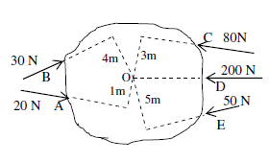

Question 2
(a) A uniform metre scale is in equilibrium position. Calculate the mass of the
ruler.
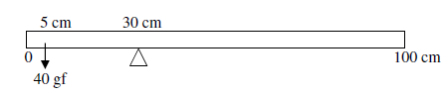

[2]
(b) When a ray of light passes from air to glass, for what angle of incidence, the
ray will not be deviated. [2]
(c) Name the lens that always forms a virtual and erect image. [2]
(d) A coin at the bottom of a trough containing water to a depth of 15 cm
appears to be 3.75 cm raised above from the bottom. Calculate the refractive
index of water. [2]
(e) Draw a ray diagram to illustrate how a ray of light incident obliquely on
one face of a rectangular glass slab of uniform thickness emerges. [2]

Question 3
(a) What are the factors on which the following characteristics of a musical note
depends? 1. intensity 2. timbre. [2]
(b) How does a trawler man catch fish in deep water? [2]
(c) What are the factors on which resistance of a conductor depends? [2]
(d) Name the material used for:
(i) Electric fuse.
(ii) Connecting wire.
(iii) Filament of an electric bulb.
(iv) Heating element of an electric toaster. [2]
(e) In cold countries the water in a lake freezes and forms a thick layer of ice on top during winter. Why? [2]

Question 4
(a) Calculate the wavelength of an electromagnetic wave of frequency 15 MHz. [2]
(b) State the function of a transformer. [2]
(c) State two uses of a cathode ray tube. [2]
(d) Show by equations, the effect on the proton number Z and mass number A
of the parent nucleus brought about by the two types of radioactive decay. [2]
(e) State one industrial use of and radiation.

SECTION II (40 Marks)
Attempt any four questions from this Section

Question 5
(a) An engine can pump 30,000 litres of water to a vertical height of 45 metres
in 10 minutes. Calculate the work done by the machine and the power.
(Density of water =kg /, 1000 litre = 1, g= 9.8). [3]
(b) On what basis would you classify an energy source as renewable? State two
advantages and two limitations of the energy received from the Sun. [3]
(c) A pulley system has a velocity ratio 5. Draw a neat labelled diagram of the
pulley system to lift a load by applying the effort in a convenient direction.
Mark the tension in your diagram.
(i) If the efficiency of the system is 80% find its mechanical advantage.
(ii) If a load of 10 kgf is pulled up by a distance of 2 m in 10 s, calculate
the power developed by the effort (given g = 10 ). [4]

Question 6
(a)
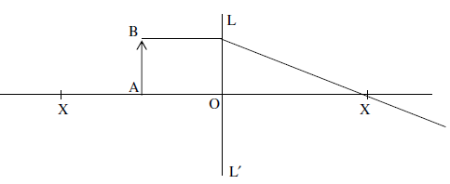

(i) Copy and complete the ray diagram to show the formation of the image
of the object AB
(ii) Name the lens LL'.
(iii) Name a device in which this principle is used. [3]
(b) Copy and complete the following diagrams to show the path of the ray of
monochromatic light in each case as it enters and emerges out of the prism.
Mark the angle wherever necessary (critical angle is 42°). [3]
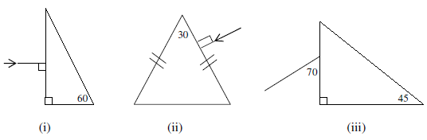

(c) (i) Name any four regions of electromagnetic spectrum in increasing order of
frequency.
(ii) Calculate the refractive index of a liquid with respect to air applying Snell's law (use geometric construction). [4]
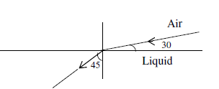

Question 7
(a) (i) Draw a displacement-distance graph for two waves A and B such that
the amplitude of wave A is three times that of wave B.
(ii) Give one example of forced vibration.
(iii) State two necessary conditions for hearing a distinct echo. [3]
(b) John fires a gun towards a hill and hears its echo after 5 seconds. He then
moves 320 m towards the hill and fires his gun again. This time he hears the
echo after 3 seconds. Calculate the velocity of sound. [3]
(c) The diagram shows an electrical circuit used for the verification of Ohm's law.
Label A, B C, D and E. Draw a sketch to show how the value of current
varies for different values of voltage across C. [4]

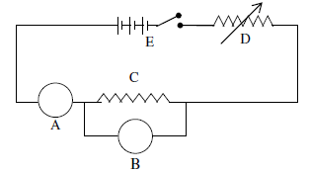

Question 8
(a)
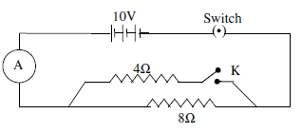

Calculate the reading of A when
(i) K is closed.
(ii) K is open. [3]
(b) In Mrs. Pinto’s flat there are 6 bulbs of 100 W each, a heater of 2 kW and 5
fans of 50W each. If these are used everyday as shown below, calculate the
cost of energy consumption for a month of 30 days at the rate of Rs.3.50
per kW h.
6 bulbs of 100 W each used 8 h per day
1 heater of 2 kW used half hour daily
5 fans of 50 W each are used 6 h everyday. [3]
(c) From the diagram given below:

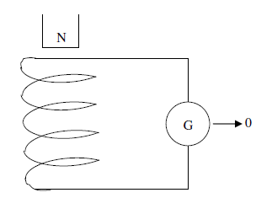

(i) What will you observe when-
(1) the magnet is dropped into the coil.
(2) the number of turns of the coil is increased?
(ii) What will be the direction of current flowing through the coil when the
magnet is dropped in? (Clockwise or anticlockwise).
(iii) State the law which explains this observation. [4]

Question 9
(a) Calculate the amount of heat given out while 400 g of water at 30 °C is
cooled and converted into ice at -2 °C.
Specific heat capacity of water = 4200 J/kg K
Specific heat capacity of ice = 2100 J/ kg K
Specific latent heat of fusion of ice = 336000 J/kg [3]
(b) A body of mass "" of a substance of specific heat capacity , at a
temperature is mixed with another body of mass "" of specific heat
capacity "" at a lower temperature . Deduce an expression for the
temperature of the mixture . [3]
(c) Draw a labelled diagram of an alternating current generator. Write the
function of its two main parts. [4]

Question 10
(a) (i) Define work function of a metal.
(ii) State two factors on which the rate of emission of thermions depend. [3]
(b) (i) Define Radioactivity.
(ii) A radioactive substance is oxidized. What change would you expect to
take place in the nature of its radioactivity? Give a suitable reason. [3]
(c) (i) State two precautions that must be taken while handling a radioactive
source.
(ii) Mention two possible sources of background radiation. [4]

