. How long will Lucy have to wait before for her $2,500 invested at 6% earns $600 in simple interest?
A. 2 years
B. 3 years
C. 4 years
D. 5 years
E. 6 years
2. Grace has 16 jellybeans in her pocket. She has 8 red ones, 4 green ones, and 4 blue ones. What is the minimum number of jellybeans she must take out of her pocket to ensure that she has one of each color?
A. 4
B. 8
C. 12
D. 13
E. 16
3. If r = 5 z then 15 z = 3 y, then r =
A. y
B. 2 y
C. 5 y
D. 10 y
E. 15 y
4. What is 35% of a number if 12 is 15% of a number?
A. 5
B. 12
C. 28
D. 33
E. 62
5. A computer is on sale for $1600, which is a 20% discount off the regular price. What is the regular price?
A. $1800
B. $1900
C. $2000
D. $2100
E. $2200
6. A car dealer sells a SUV for $39,000, which represents a 25% profit over the cost. What was the cost of the SUV to the dealer?
A. $29,250
B. $31,200
C. $32,500
D. $33,800
E. $33,999
7. After having to pay increased income taxes this year, Edmond has to sell his BMW. Edmond bought the car for $49,000, but he sold it for a 20% loss. What did Edmond sell the car for?
A. $24,200
B. $28,900
C. $35,600
D. $37,300
E. $39,200
8. If Sam can do a job in 4 days that Lisa can do in 6 days and Tom can do in 2 days, how long would the job take if Sam, Lisa, and Tom worked together to complete it?
A. 0.8 days
B. 1.09 days
C. 1.23 days
D. 1.65 days
E. 1.97 days
9. Find 0.12 Ã·12
A. 100
B. 10
C. 1
D. 0.01
E. 0.001
10. Divide x⁵ by x²
A. x²⁵
B. x¹⁰
C. x⁷
D. x³
E. x^{2.5}
11. Which of the following numbers could be described in the following way: an integer that is a natural, rational and whole number?
A. 0
B. 1
C. 2.33
D. -3
E. none of the above
12. Find the mode of the following list of numbers: 2, 4, 6, 4, 8, 2, 9, 4, 3, 8
A. 2
B. 3
C. 4
D. 5
E. 6
13. In the fraction 3/x, x may not be substituted by which of the following sets?
A. {1, 2, 4}
B. {-2,-3,-4}
C. {1, 3, 7}
D. {0, 10, 20}
E. {1.8, 4.3}
14. Sarah needs to make a cake and some cookies. The cake requires 3/8 cup of sugar and the cookies require 3/5 cup of sugar. Sarah has 15/16 cups of sugar. Does she have enough sugar, or how much more does she need?
A. She has enough sugar.
B. She needs 1/8 of a cup of sugar.
C. She needs 3/80 of a cup of sugar.
D. She needs 4/19 of a cup of sugar.
E. She needs 1/9 of a cup of sugar.
15. At a company fish fry, 1/2 in attendance are employees. Employees' spouses are 1/3 of the attendance. What is the percentage of the people in attendance who are not employees or employee spouses?
A. 10.5%
B. 16.7%
C. 25%
D. 32.3%
E. 38%
16. In a college, some courses contribute more towards an overall GPA than other courses. For example, a science class is worth 4 points; mathematics is worth 3 points; History is worth 2 points; and English is worth 3 points. The values of the grade letters are as follows, A= 4, B=3, C=2, D=1, F=0. What is the GPA of a student who made a â€œCâ€ in Trigonometry, a â€œBâ€ in American History, an â€œAâ€ in Botany, and a â€œBâ€ in Microbiology?
A. 2.59
B. 2.86
C. 3.08
D. 3.33
E. 3.67
17. There are 8 ounces in a Â½ pound. How many ounces are in 7 3/4 lbs?
A. 12 ounces
B. 86 ounces
C. 119 ounces
D. 124 ounces
E. 138 ounces
18. If the value of x and y in the fraction XZ/Y are both tripled, how does the value of the fraction change?
A. increases by half
B. decreases by half
C. triples
D. doubles
E. remains the same
19. What is the next number in the following pattern? 1, 1/2, 1/4, 1/8, ___
A. 1/10
B. 1/12
C. 1/14
D. 1/15
E. 1/16
20. Of the following units which would be more likely used to measure the amount of water in a bathtub?
A. kilograms
B. liters
C. milliliters
D. centigrams
E. volts
21. If a match box is 0.17 feet long, what is its length in inches the most closely comparable to the following?
A. 5 1/16 inch highlighter
B. 3 1/8 inch jewelry box
C. 2 3/4 inch lipstick
D. 2 3/16 inch staple remover
E. 4 1/2 inch calculator
22. Which of the following fractions is the equivalent of 0.5%?
A. 1/20
B. 1/200
C. 1/2000
D. 1/5
E. 1/500
23. In the graph below, no axes or origin is shown. If point B's coordinates are (10,3), which of the following coordinates would most likely be A's?
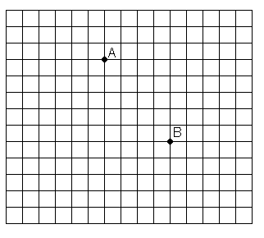
A. (17, -2)
B. (10, 6)
C. (6, 8)
D. (-10, 3)
E. (-2, -17)
24. Over the course of a week, Fred spent $28.49 on lunch. What was the average cost per day?
A. $4.07
B. $3.57
C. $6.51
D. $2.93
E. $5.41
25. Of the following units, which would be most likely to measure the amount of sugar needed in a recipe for 2 dozen cookies?
A. degrees Celsius
B. milliliters
C. quarts
D. kilograms
E. cups
26. Jim has 5 pieces of string. He needs to choose the piece that will be able to go around his 36-inch waist. His belt broke, and his pants are falling down. The piece needs to be at least 4 inches longer than his waist so he can tie a knot in it, but it cannot be more that 6 inches longer so that the ends will not show from under his shirt. Which of the following pieces of string will work the best?
A. 3 4/5 feet
B. 3 2/3 feet
C. 3 3/8 feet
D. 3 1/4 feet
E. 2 1/2 feet
27. After purchasing a flat screen television for $750, John realizes that he got a great deal on it and wishes to sell it for a 15% profit. What should his asking price be for the television?
A. $800.30
B. $833.60
C. $842.35
D. $862.50
E. $970.25
28. If 300 jellybeans cost you x dollars. How many jellybeans can you purchase for 50 cents at the same rate?
A. 150/x
B. 150x
C. 6x
D. x/6
E. 1500x
29. If 6 is 24% of a number, what is 40% of the same number?
A. 8
B. 10
C. 15
D. 20
E. 25
30. Lee worked 22 hours this week and made $132. If she works 15 hours next week at the same pay rate, how much will she make?
A. $57
B. $90
C. $104
D. $112
E. $122
31. The last week of a month a car dealership sold 12 cars. A new sales promotion came out the first week of the next month and the sold 19 cars that week. What was the percent increase in sales from the last week of the previous month compared to the first week of the next month?
A. 58%
B. 119%
C. 158%
D. 175%
E. 200%
32. If 8x + 5x + 2x + 4x = 114, the 5x + 3 =
A. 12
B. 25
C. 33
D. 47
E. 86
33. If two planes leave the same airport at 1:00 PM, how many miles apart will they be at 3:00 PM if one travels directly north at 150 mph and the other travels directly west at 200 mph?
A. 50 miles
B. 100 miles
C. 500 miles
D. 700 miles
E. 1,000 miles
34. What is the cost in dollars to steam clean a room W yards wide and L yards long it the steam cleaners charge 10 cents per square foot?
A. 0.9WL
B. 0.3WL
C. 0.1WL
D. 9WL
E. 3WL
35. Find 8.23 x 10⁹
A. 0.00000000823
B. 0.000000823
C. 8.23
D. 8230000000
E. 823000000000
36. During a 5-day festival, the number of visitors tripled each day. If the festival opened on a Thursday with 345 visitors, what was the attendance on that Sunday?
A. 345
B. 1,035
C. 1,725
D. 3,105
E. 9,315
37. Which of the following has the least value?
A. 0.27
B. 1/4
C. 3/8
D. 2/11
E. 11%
38. How many boys attended the 1995 convention?
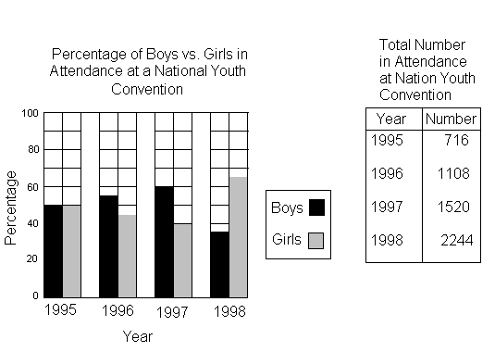
A. 358
B. 390
C. 407
D. 540
E. 716
39. Which year did the same number of boys and girls attend the conference?
A. 1995
B. 1996
C. 1997
D. 1998
E. None
40. Which two years did the least number of boys attend the convention?
A. 1995 and 1996
B. 1995 and 1998
C. 1996 and 1997
D. 1997 and 1994
E. 1997 and 1998

_{Answer Key}
1. C 2. D 3. A 4. C 5. C 6. B 7. E 8. B 9. D 10. D 11. B 12. C 13. D 14. C 15. B 16. C 17. D 18. E 19. E 20. B 21. D 22. B 23. C 24. A 25. E 26. C 27. D 28. A 29. B 30. B 31. A 32. C 33. C 34. A 35. D 36. E 37. E 38. A 39. A 40. A

