MP PET 2009
CHEMISTRY
Q. 1. Which one of the following is the correct statement?
- Chlorides of both beryllium and aluminium have bridged chloride structures in solid phase.
- B₂H₆.2NH₃ is known as 'inorganic benzene'.
- Boric acid is a protonic acid.
- Beryllium exhibits coordination number of six.
Sol: Becl₂ and Alcl₃ both have bridged structure in solid phase.
B₃N₃ H₆ is known as inorganic benzene.
Boric acid is Lewis acid.
Beryllium exhibits coordination number of 4
Q. 2.
- 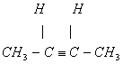
Sol:
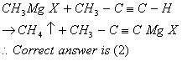
Q. 3. The correct decreasing order of priority for the functional groups of organic compounds in the IUPAC system of nomenclature is
Sol: The correct decreasing order of priority for the functional group of organic compounds in the IUPAC system of nomenclature is:
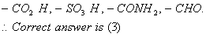
Q. 4. The pK_{a} of a weak acid, HA is 4.80. The pK_{b} of a weak base, BOH, is 4.78. The pH of an aqueous solution of the corresponding salt, BA, will be
- 7.01
- 9.22
- 9.58
- 4.79
Sol:
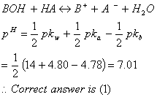
Q. 5.The hydrocarbon which can react with sodium in liquid ammonia is
Sol:
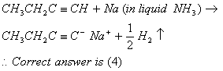
Q. 6.
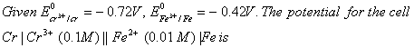
- -0.339 V
- -0.26 V
- 0.26 V
- 0.339 V
Sol:
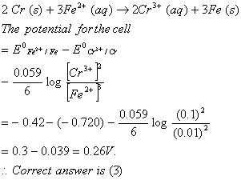
Q. 7. Amount of oxalic acid present in a solution can be determined by its titration with KMnO₄solution in the presence of H₂SO₄. The titration gives unsatisfactory result when carried out in the presence of HCl, because HCl
- reduces permanganate to Mn²⁺.
- oxidises oxalic acid to carbon dioxide and water.
- gets oxidised by oxalic acid to chlorine.
- furnishes H⁺ ions in addition to those from oxalic acid.
Sol: KMnO₄can oxidise HCl along with oxalic acid into Cl₂ and itself gets reduced to Mn²⁺.
Q. 8. Among the following substituted silanes the one which will give rise to cross linked silicone polymer on hydrolysis is
- R₂SiCl₂
- R₃SiCl
- R₄Si
- RSiCl₃
Sol:
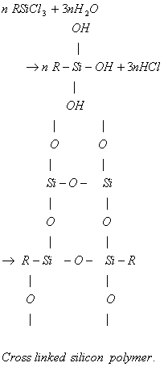
Correct answer is (4)
Q. 9. Oxidising power of chlorine in aqueous solution can be determined by the parameters indicated below:
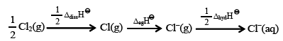
The energy involved in the conversion of
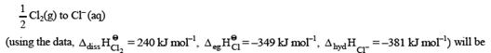
- –850 kJ mol^{–1}
- +120 kJ mol^{–1}
- +152 kJ mol^{–1}
- –610 kJ mol^{–1}
Sol:
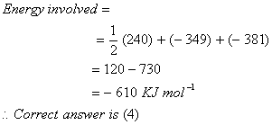
Q. 10. Which of the following factors is of no significance for roasting sulphide ores to the oxides and not subjecting the sulphide ores to carbon reduction directly?
- Metal sulphides are less stable than the corresponding oxides.
- CO₂is more volatile than CS₂.
- Metal sulphides are thermodynamically more stable than CS₂.
- CO₂is thermodynamically more stable than CS₂.
Sol:
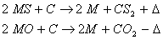
Hence, CO₂ is more stable than CS₂ while Ms are more stable than MO.
Q. 11. Four species are listed below:
Which one of the following is the correct sequence of their acid strength?
(1) (i) < (iii) < (ii) < (iv) (2) (iii) < (i) < (iv) < (ii) (3) (iv) < (ii) < (iii) < (i) (4) (ii) < (iii) < (i) < (iv)
Sol: The increasing order of acidic strength is
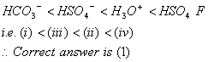
Q. 12. Which one of the following constitutes a group of the isoelectronic species?
Sol: Isoelectronic species have same number of electrons
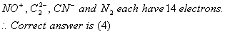

Q. 13. Phenol, when it first reacts with concentrated sulphuric acid and then with concentrated nitric acid, gives
- p-nitrophenol
- nitrobenzene
- 2,4,6-trinitrobenzene
- o-nitrophenol
Sol:
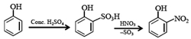
As, temperature is not mentioned, 0- mitrophenol is the only stable product.
Q. 14. The ionization enthalpy of hydrogen atom is 1.312 × 10⁶ J mol⁻¹. The energy required to excite the electron in the atom from n = 1 to n = 2 is
Sol:
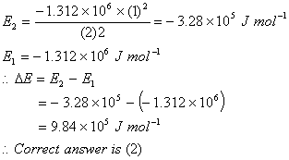
Q. 15. The organic chloro compound, which shows complete stereochemical inversion during a S_{N}2 reaction, is
- (CH₃)₂CHCl
- CH₃Cl
- (C₂H₅)₂CHCl
- (CH₃)₃CCl
Sol: Primary halides show inversion during S_{N}2 reaction more than secondary while secondary show more than tertiary.
Q. 16. Toluene is nitrated and the resulting product is reduced with tin and hydrochloric acid. The product so obtained is diazotized and then heated with cuprous bromide. The reaction mixture so formed contains
- mixture of o-; and p-bromoanilines
- mixture of o- and m-bromotoluenes
- mixture of o- and p-bromotoluenes
- mixture of o- and p-dibromobenzenes
Sol:
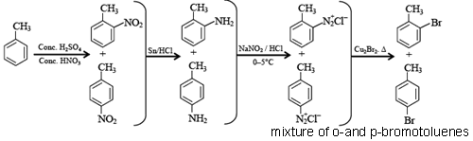
Q. 17. In the following sequence of reactions, the alkene affords the compound 'B'
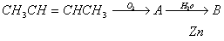
The compound B is
- CH₃CH₂COCH₃
- CH₃CHO
- CH₃CH₂CHO
- CH₃COCH₃
Sol:
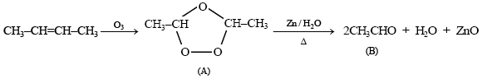
Correct answer is (2)

Q. 18. Which one of the following pairs of species have the same bond order?
Sol: The species which have the same number of total electrons will have the same bond order.
CN⁻ and NO⁺ each have 14 electrons and they will have same bond order.
Q. 19. At 80⁰C, the vapour pressure of pure liquid 'A' is 520 mm Hg and that of pure liquid 'B' is 1000 mm Hg. If a mixture solution of 'A' and 'B' boils at 80⁰C and 1 atm pressure, the amount of 'A' in the mixture is (1 atm = 760 mm Hg)
- 48 mol percent
- 50 mol percent
- 52 mol percent
- 34 mol percent
Sol:
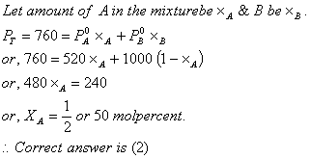
Q. 20. For a reaction 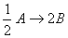 , rate of disappearance of 'A' is related to the rate of appearance of 'B' by the expression
- 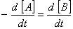
- 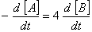
- 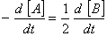
- 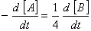
Sol:
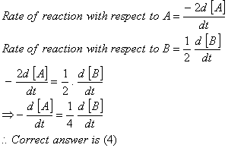
Q. 21. The equilibrium constants for the reactions respectively are in the ratio of 1 : 9. If the degree of dissociation of X and Z be equal then the ratio of total pressures at these equilibria is
- 1 : 3
- 1 : 9
- 1 : 36
- 1 : 1
Sol:
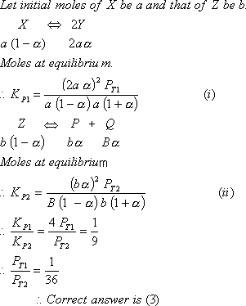
Q. 22. In context with the industrial preparation of hydrogen from water gas (CO + H₂), which of the following is the correct statement?
- H₂ is removed through occlusion with Pd.
- CO is oxidised to CO₂ with steam in the presence of a catalyst followed by absorption of CO₂in alkali.
- CO and H₂are fractionally separated using differences in their densities.
- CO is removed by absorption in aqueous Cu₂Cl₂solution.
Sol:
