B.E.E. (JUNE 2004)
N.B.
(1) Question No. 1 is compulsory.
(2) Attempt any four questions from remaining.
(3) Assume any suitable additional data if necessary and state them.
Section I

1. (a) Replace the network of sources shown below with (i) V_{aa’} and (ii) I_{bb}. (6)
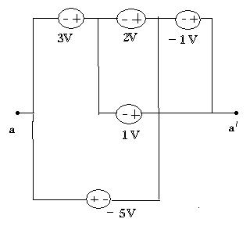
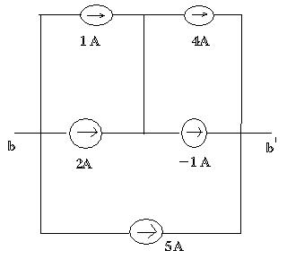
(b) For the network shown find v₁/v₀ and v₂/v₀. (6)
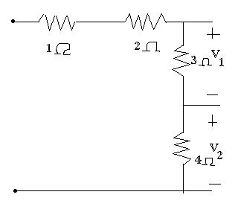

(c) Find I_{B}, I_{C} and I_{E}. in the circuit shown Assume β = 30. (8)
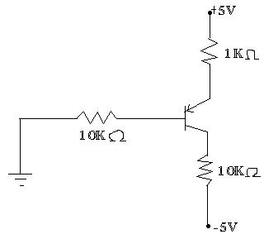
2. (a) Find the current supplied by each battery and the load voltage v_{L}. (10)
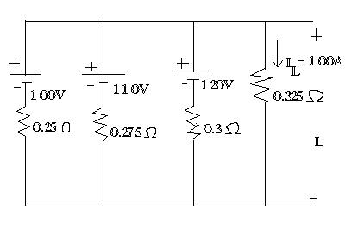
(b) An ac circuit consist of pure resistance and an inductive coil connected in series. The power dissipated in the resistance and in the coil are 1000 watts respectively. The voltage drops across the resistance and the coil are 200 V and 300 V respectively. Calculate the following.
1) Value of the resistance. (1)
2) Current through the circuit. (1)
3) Resistance of the coil. (2)
4) Impedance of the coil. (2)
5) Total Impedance of the circuit. (2)
6) Supply voltage. (2)

3. (a) Find the current in 1Ω resistance using Norton's theorem. (10)
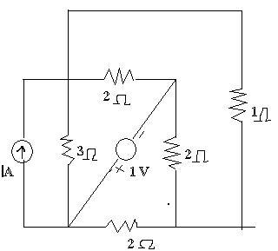
(b) Determine the current through 5Ω resistance using Nodal Analysis. (10)

4. (a) Derive from first principles and expression for the emf of a d.c. generator. (6)
(b) Explain double field revolving theory for single phase Induction motor. (6)
(c) Draw phaser diagram for single phase transformer for (i) Lagging and (ii) Leading power factor. (8)
5.(a) For the parallel branch shown, find the value of R₂ when the overall power factor is 0.92 lag. (10)
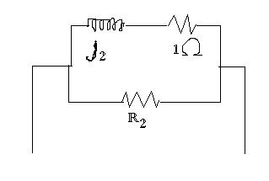
(b) A balance 3 phase load connected in delta, draws a power of 10 kW at 440 V at a power factor of 0.6 lead, find the values of circuit elements and the reactive volt-ampere drawn. (10)
6. Write detail notes on: (20)
i) LVDT
ii) Electromagnetic flow meter iii) PMMC instrument iv) Electro dynamometer
7. (a) Give construction and output characteristic of n-channel JFET. (6)
(b) Explain working of Bridge rectifier with LC filter, what is the use of bleeder resistor in it. (8)
(c) Explain how JFET works as an voltage amplifier (with circuit diagram and waveform) (6)

