Sample Paper 2011
Class- XII
Subject - Physics

Time: 3Hrs
No of pages: 05 M. Marks: 70
General instructions:
- All questions are compulsory.
- There is no overall choice. However, an internal choice has been provided in one question of two marks, one question of three marks and all three questions of five marks.
- Question numbers 1 to 8are very short answer type questions, carrying one mark each.
- Question numbers 9 to 18are short answer type questions, carrying two marks each.
- Question numbers 19 to 27are also short answer type questions, carrying three marks each.
- Question numbers 28 to 30 are long answer type questions, carrying five marks each.
- Use of calculator is not permitted. However, you may use log tables, if necessary.
- You may use the following values of physical constants wherever necessary:

c= 3X10⁸m/s h= 6.6X10⁻³⁴Js
e= 1.6X10⁻¹⁹C m_{e}= 9.31X10⁻³¹kg
μ₀ = 4πX10⁻⁷TmA⁻¹ m_{n}= 1.67X10⁻²⁷ kg
ε₀= 8.85X10⁻¹²C²N⁻¹m⁻² k= 1.38X10⁻²³JK⁻¹
Q1. | Name the type of lens used for correcting an astigmatic eye? | (1mark)
Q2. | The sequence of bands marked on a carbon resistor is Yellow, Red, Orange and silver. Find the resistance and the tolerance | (1mark)
Q3. | 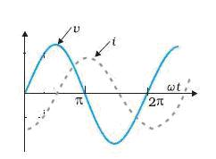  The fig. shows the variation of v and i vs ωt for a circuit element connected to A.C mains. Name the circuit element and the phase relation between current and voltage. | (1mark)
Q4. | What is the critical angle for a material of refractive index √2? | (1mark)
Q5. | 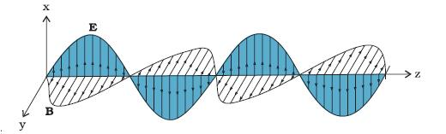  The above graph shows the variation of electric and magnetic fields of electromagnetic wave in space. Identify the direction of propagation of em wave. What is the phase relationship between electric and magnetic field for such wave? | (1mark)
Q6. | An electron and a proton moving with same speed enter the same magnetic field region at right angles to the direction of the field. For which of the two particles will the radius of the circular path be smaller? | (1mark)
Q7. | 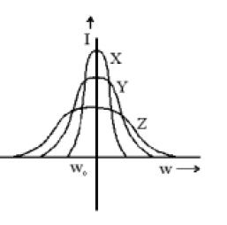  The above graph shows the variation of current amplitude vs angular frequency (ω) for a series LCR a.c. circuit obtained for different values of resistances X,Y,Z . Arrange the resistances in increasing order. | (1mark)
Q8. | If the number of turns of a solenoid is doubled, keeping the other factors constant, how does the self inductance of the solenoid change? | (1mark)
Q9. | 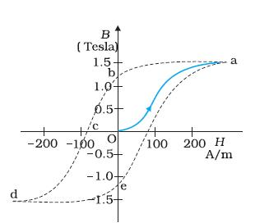  The graph shows the variation of B with H for a ferromagnetic material. What does each of the following represent in the fig? (i) Ob (ii) Oc.Should the area of the graph be less or more in case of a soft iron and why? | (2 marks)
Q10. | The electron drift speed in metals is small (~mms⁻¹) and the charge of the electron is also very small (~10⁻¹⁹C), but we can still obtain a large amount of current in a metal. Why? | (2 marks)
Q11. | The given figure shows the experimental set up of a metre bridge. The null point is found to be 60 cm away from the end A with X and Y in position as shown.  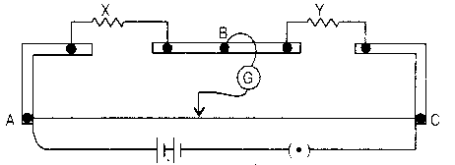  When a resistance of 15Ω is connected in series with ‘Y’, the null point is found to shift by 10 cm towards the end A of the wire. Find the position of null point if a resistance of 30Ω were connected in parallel with ‘Y’. | (2 marks)
Q12. | In the figure, the straight wire AB is fixed while the loop is free to move under the influence of the electric currents flowing in them. In which direction does the loop begin to move? Give reason for your answer. | (2 marks)
Q13. | Electromagnetic waves with wave length  (i) λ₁ is used to kill germs in water purifiers.  (ii) λ₂ are referred to as heat waves.  Identify the waves and arrange them in ascending order of their magnitudes. | (2 marks)
Q14. | Why does dispersion take place in a glass prism? Draw the graph showing the variation of angle of deviation with the angle of incidence of light, incident on one face of a prism. | (2 marks)
Q15. | The following graph shows the variation of terminal potential difference V, across a combination of three cells in series to a resistor, versus the current, I  (i) Calculate the e.m.f. of each cell.  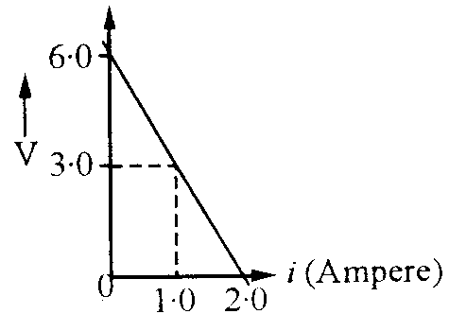  (ii) For what current I, will the power dissipation of the circuit be maximum? | (2 marks)
Q16. | Two point charges +Q & +4Q are separated by a distance of 6a. Find the point on the lining joining the two charges where the electric field is zero? | (2 marks)
Q17. | Write two merits of a reflecting type telescope over refracting type telescope. | (2 marks)
Q18. | A wire of 10 ohm resistance is stretched to thrice its original length, What will be its:-  (a) New resistivity  (b) New resistance? | (2 marks)
Q19. | 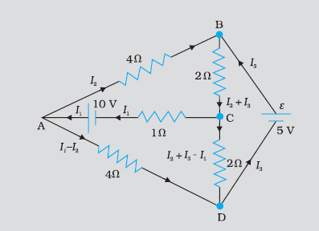  Determine the currents I₁ , I₂ , I₃ in the following network using Kirchhoff’s laws. | (3 marks)
Q20. | Two point charges 3μC and -3μC are located 20cm apart in vacuum.  (a) Calculate the electric field at the mid point of the line joining the two charges.  (b) What is the force experienced by a negative test charge of magnitude 1.5X10⁻⁹ C placed at this point? | (3 marks)
Q21. | Calculate the capacitance of the following multi slab capacitor.  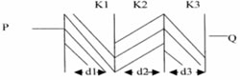 | (3 marks)
Q22. | What are eddy currents? How are these minimised? Mention two applications of eddy currents.  OR  Two different coils have self inductance L₁=8 mH and L₂ = 2 mH. At a certain instant, the current in the two coils is increasing at the same constant rate and the power supplied to the two coils is same. Find the ratio of (a) induced voltage (b) current and (c) energy stored in the two coils at that instant? | (3 marks)
Q23. | Derive an expression for Lens maker’s formula. | (3 marks)
Q24. | A double convex lens made of glass of refractive index 1.56 has both radii of curvature of magnitude 20 cm. If an object at a distance of 10 cm from this lens, find the position of the image formed. | (3 marks)
Q25. | Derive the expression for the torque on a rectangular coil of area A carrying current I placed in a magnetic field B. The angle b/w direction of B and the area vector of the coil is θ. | (3 marks)
Q26. | Suppose that the electric field amplitude of an electromagnetic wave is E₀=120N/C and that it frequencies is 50 MHz (a) Determine B₀,ω and k (b)Find the expression for ‘E’. | (3 marks)
Q27. | A sinusoidal voltage of peak value 283V and frequency 50Hz is applied to a series LCR circuit in which R = 3Ω, L = 25.48mH and C = 796 µF. Find (a)the impedance of the circuit (b)the phase difference between the voltage across the source and the current (c)the power dissipated and the circuit. | (3 marks)
Q28. | Give principle, construction and working of A.C. generator.  OR  Give principle, construction and working of Transformer. | (5 marks)
Q29. | Draw a labelled ray diagram of an astronomical telescope, forming an image at infinity. An astronomical telescope uses two lenses of powers 10 D and 1D respectively.  - State with reason, which lens is preferred as objective and eye-piece.  - Calculate the magnifying power of the telescope, if the final image is formed at the near point.  - How does the light gathering power of a telescope change, if the aperture of the objective lens is doubled?  OR  Draw a labelled ray diagram showing the image formed by a compound microscope. Write the expressions for its magnifying power.  Define the term resolving power of a microscope. How does the resolving power of a compound microscope change on  - decreasing the diameter of its objective lens?  - Increasing the focal length of its objective lens?  Justify your answer in each case. | (5 marks)
Q30. | Derive an expression for the magnetic field at a point  on the axis of a current carrying circular loop.  Two coaxial circular loops L₁ and L₂ of radii 3 cm and 4 cm are placed as shown. What should be the magnitude and direction of the current in the loop L₂ so that the net magnetic field at the point O is zero?  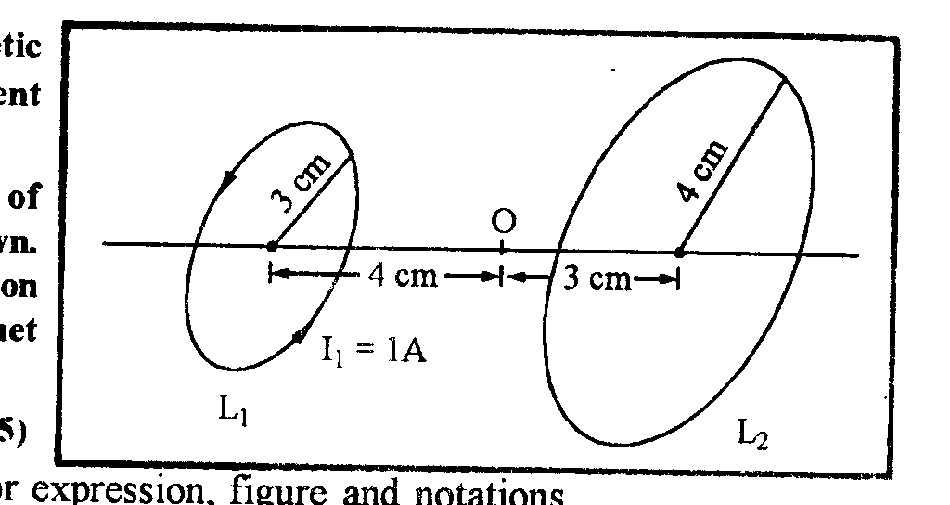  OR  Draw a schematic diagram of cyclotron. Explain its underlying principle and working, stating clearly the function of the electric and magnetic fields applied on a charged particle.  Prepared by:  Name Manish Harish  Email mnshhrsh@yahoo.co.in  Phone No. 9818223469 | (5 marks)

