FOR GENERAL KNOWLEDGE



FOR COMPUTER AWARENESS

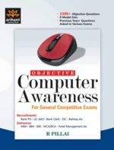
FOR QUANTITATIVE APPTITUDE

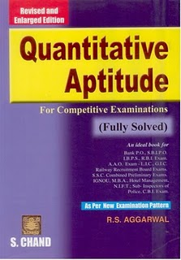

FOR REASONING
