1. A hollow cube of size 5 cm is taken, with a thickness of 1 cm. It is made of smaller cubes of size 1 cm. If 4 faces of the outer surface of the cube are painted, totally how many faces of the smaller cubes remain unpainted?
488 800 900 500
2.Alok and Bhanu play the following min-max game. Given the expression
N = 9 + X + Y – Z
where X, Y and Z are variables representing single digits (0 to 9), Alok would like to maximize N while Bhanu would like to minimize it. Towards this end, Alok chooses a single digit number and Bhanu substitutes this for a variable of her choice (X, Y or Z). Alok then chooses the next value and Bhanu, the variable to substitute the value. Finally Alok proposes the value for the remaining variable. Assuming both play to their optimal strategies, the value of N at the end of the game would be
27 18 20 0.0
3. A hare and a tortoise have a race along a circle of 100 yards diameter. The tortoise goes in one direction and the hare in the other. The hare starts after the tortoise has covered 1/5 of its distance and that too leisurely. The hare and tortoise meet when the hare has covered only 1/8 of the distance. By what factor should the hare increase its speed so as to tie the race?
37.80 8 40 5
4. There are two boxes, one containing 10 red balls and the other containing 10 green balls. You are allowed to move the balls between the boxes so that when you choose a box at random and a ball at random from the chosen box, the probability of getting a red ball is maximized. This maximum probability is
½ 14/19 37/38 3/4
6. A person drives with constant speed and after some time he sees a milestone with 2 digits. Then travels for 1 hours and sees the same 2 digits in reverse order. 1 hours later he sees that the milestone has the same 2 digits with a 0 between them. What is the speed of the car?
54.00 mph 45.00 mph 27.00 mph 36.00 mph
7. 15 suspects are rounded by the police and questioned about a bank robbery. Only one of them is guilty. The suspects are made to stand in a line and each person declares that the person next to him on his right is guilty. The rightmost person is not questioned. Which of the following possibilities are true?
A. All the suspects are lying. B. The leftmost suspect is guilty.
a.A only b.Both A and B c.B only d.Neither A nor B.
8. 30 teams enter a hockey tournament. A team is out of the tournament if it loses 2 games. What is the maximum number of games to be played to decide one winner?
60 59 61 30 34
9. A and B play a game of dice between them. The dice consist of colors on their faces (instead of numbers). When the dice are thrown, A wins if both show the same color; otherwise B wins. One die has 4 red face and 2 blue faces. How many red and blue faces should the other die have if the both players have the same chances of winning?
3 red and 3 blue faces 2 red and remaining blue
6 red and 0 blue 4 red and remaining blue
10. A and B play a game of dice between them. The dice consist of colors on their faces (instead of numbers). When the dice are thrown, A wins if both show the same color; otherwise B wins. One die has 3 red faces and 3 blue faces. How many red and blue faces should the other die have if the both players have the same chances of winning?
5 red and 1 blue faces 1 red and 5 blue faces
3 red and 3 blue faces Any of the solutions given
11. A circular dartboard of radius 1 foot is at a distance of 20 feet from you. You throw a dart at it and it hits the dartboard at some point Q in the circle. What is the probability that Q is closer to the center of the circle than the periphery?
0.75 1 0.5 0.25
12. On planet zorba, a solar blast has melted the ice caps on its equator. 8 years after the ice melts, tiny plantoids called echina start growing on the rocks. echina grows in the form of a circle and the relationship between the diameter of this circle and the age of echina is given by the formula
d = 4 * v (t – 8)for t = 8
where d represents the diameter in mm and t the number of years since the solar blast.
Jagan recorded the radius of some echina at a particular spot as 8mm. How many years back did the solar blast occur?
24 12 8 16
13. For the FIFA world cup, Paul the octopus has been predicting the winner of each match with amazing success. It is rumored that in a match between 2 teams A and B, Paul picks A with the same probability as A’s chances of winning.
Let’s assume such rumors to be true and that in a match between Ghana and Bolivia, Ghana the stronger team has a probability of 2/3 of winning the game. What is the probability that Paul will correctly pick the winner of the Ghana-Bolivia game?
4/9 2/3 1/9 5/9
14. Alice and Bob play the following coins-on-a-stack game. 20 coins are stacked one above the other. One of them is a special (gold) coin and the rest are ordinary coins. The goal is to bring the gold coin to the top by repeatedly moving the topmost coin to another position in the stack.
15.Alice starts and the players take turns. A turn consists of moving the coin on the top to a position i below the top coin (0 = i = 20). We will call this an i-move (thus a 0-move implies doing nothing). The proviso is that an i-move cannot be repeated; for example once a player makes a 2-move, on subsequent turns neither player can make a 2-move.
If the gold coin happens to be on top when it’s a player’s turn then the player wins the game.
Initially, the gold coinis the third coin from the top. Then
In order to win, Alice’s first move should be a 0-move.
In order to win, Alice’s first move should be a 1-move.
Alice has no winning strategy.
In order to win, Alice’s first move can be a 0-move or a 1-move
16. Given 3 lines in the plane such that the points of intersection form a triangle with sides of length 20, 20 and 30, the number of points equidistant from all the 3 lines is
4 3 0 1
17.A sheet of paper has statements numbered from 1 to 40. For each value of n from 1 to 40, statement n says "At least n of the statements on this sheet are true." Which statements are true and which are false?
- The even numbered statements are true and the odd numbered are false.
- The first 13 statements are true and the rest are false.
- The odd numbered statements are true and the even numbered are false.
- The first 26 statements are false and the rest are true.
18.A sheet of paper has statements numbered from 1 to 40. For all values of n from 1 to 40, statement n says: 'Exactly n of the statements on this sheet are false.' Which statements are true and which are false?
- The even numbered statements are true and the odd numbered statements are false.
- The odd numbered statements are true and the even numbered statements are false.
- All the statements are false.
- The 39th statement is true and the rest are false.
- 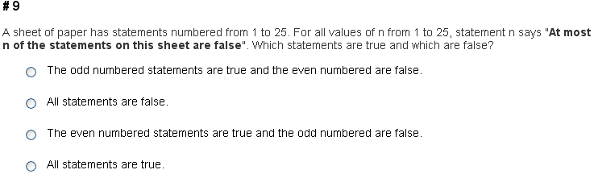 Ans: all statements are true

Ans:42 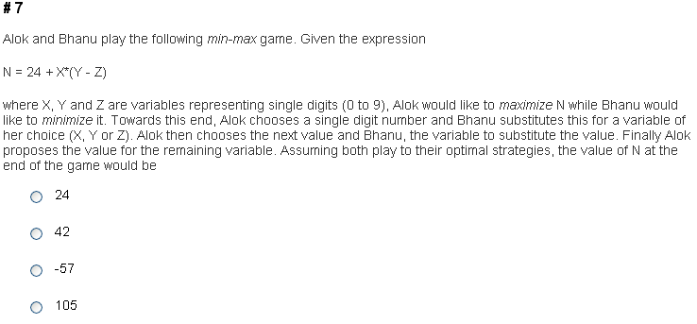
Ans:11 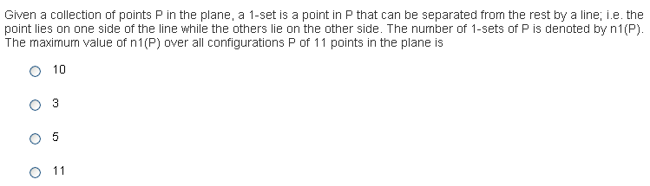
Ans: less cola in first than ink in second
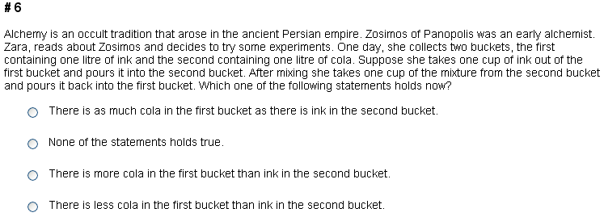

Ans: alice should pick 30 chips