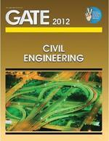
GATE 2012 Civil Engineering
ISBN: 818355024X
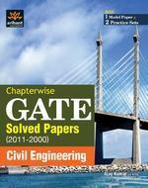
GATE Civil Engineering
ISBN: 8183487742
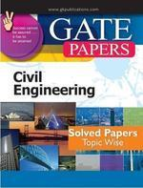
Gate Papers Civil Engg. Solved Papers (Topic Wise)
ISBN: 8183554466
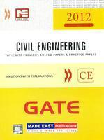
GATE 2012 Civil Engineering
ISBN: 9381069066

Popular Master Guide Gate Civil Engineering
ISBN: 8178121336

