BOOK 1: Fundamentals of Human Geography

Chapter – 1
Human Geography Nature and Scope

Q1: Differentiate between Regional and Systematic Approach.
Ans:
Regional Approach | Systematic Approach
1. First it considers area as a whole and then large regions are further sub-divided into smaller regions. | 1. The whole area is considered as a single geographical unit.
2. It highlights the geographical characteristics of the region. | 2. Elements/Components are selected in their totality and concentration is focused on the distribution and analysis of their elements.
3. Large regions are further sub-divided into smaller regions. | 3. All other components are studied one by one.
4. Macro-Meso and Micro are the examples of the regional approach. | 4. Climate, relief, Soil, Pattern of settlements are the examples of Systematic Approach.

Q 2: Mention three Characteristics of Neo-Determinism.
Ans:
- Introduced by Griffith Taylor.
- Reflects the middle path between the ideas of Environmental determinism
- and possibilism.
- Emphasizes in solving the problems without damaging the environment.
- It believes in the concept of Stop and Go Determinism.

Q 3: What is Naturalization of Humans?
Ans:
- Human activities are controlled and governed by Environment.
- Man is treated as a Passive agent.
- Human adjustment in the environment with the help of available
technology
- Example of Benda life in Abujhamaad area of central India.

CHAPTER 2
The World Population: Distribution, Density and Growth

Q1: Why is there great Variation among various regions in doubling their
population?
Ans:
- Developed countries have controlled their growth rate due to expansion
of educational facilities and advancement in medical facilities.
- Developed countries are taking more time to double their population.
- Developing countries are taking less time to double their population
- Due to lack of education and medical facilities.

Q2: Study the Diagram and answer the following questions?

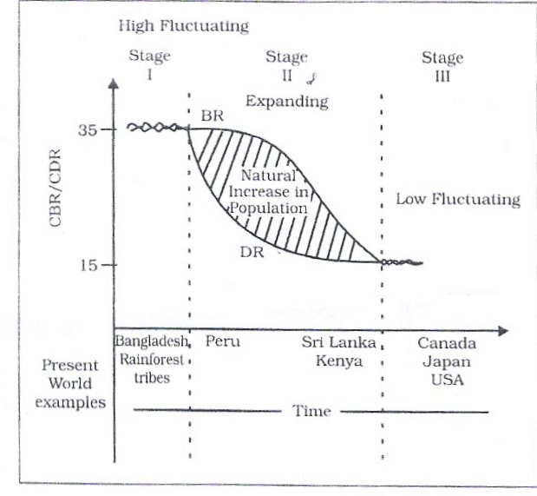

2.1) Name the Stage which shows high fluctuating rate of population
growth.
Ans: Stage I

2.2) Why is the population growth of Sri Lanka expanding?
Give one reason.
Ans: High Fertility rate and reduced mortality rate.

2.3) Give one reason responsible for low fluctuation in population growth
in Stage III.
Ans: Both fertility and mortality rate have declined considerably.

Q3: What are the positive impacts of population change?
Ans: Declining population has the following positive impacts:-
- Less pressure on land and on the other resources.
- Less pressure on infrastructure and civic amenities.
- Higher per Capita Income and better Standard of living.
An increasing population if in a desirable proportion, has the following
Positive impacts.
- Ample opportunities of work force and human resource.
- Favourable for expanding Economy.
- Resources can be utilized in a better way.
- Bio-diversity is kept intact.

CHAPTER-3
Population Composition

Q1: Study the Pyramid A & B and answer the questions.
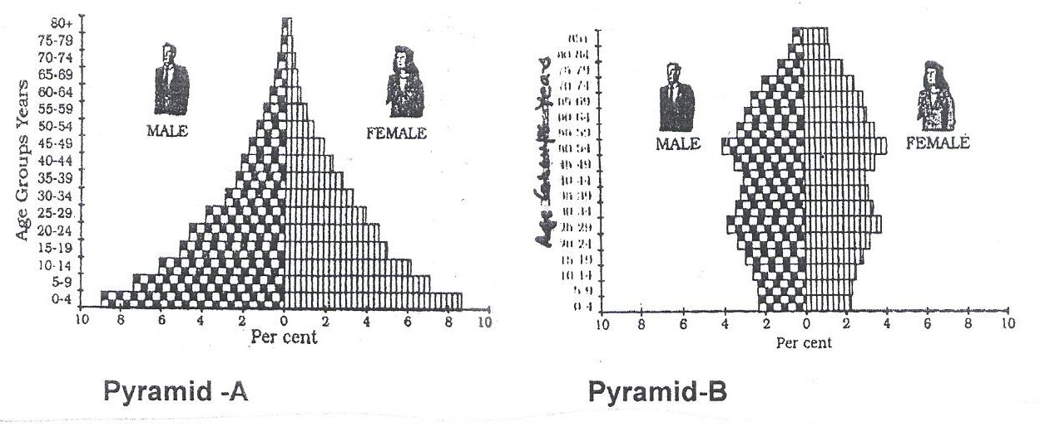
1.1 Identify the Pyramid which represents the maximum no.
of dependent population.
Ans: Pyramid A

  - What types of economies do you project for pyramid A & B.
Ans: A – Developing Economy
B – Developed Economy

  - Mention one reason for high longevity of life in Pyramid B.
Ans:
- Better health facilities.
- Awareness through Education.

Q2: Why are more number of workers engaged in non agricultural
activities in developed economies?
Ans:
- Better job opportunities.
- High wages and attractive perks.
- Better working conditions.
- Stagnation in agriculture and mechanized agriculture.
- White collar jobs.

CHAPTER – 4
Human Development

Q1: Briefly explain any three approaches of Human Development.
Ans:
- INCOME APPROACH: -
- Human development is seen as being linked to Income.
- Higher the level of Income, reveals higher human development.

- WELFARE APPROACH: -
- This approach argues for higher government expenditure on welfare
Schemes.

- BASIC NEEDS APPROACH: -
- Focused on Six basic needs such as health, education, food,
Water supply, sanitation and housing.

- CAPABILITY APPROACH: -
- Building Human capabilities in the areas of health, education
and access to resources.

Q2: Which factors affect the Human Development of a country?
Ans:
- The pattern of Govt. Expenditure on the Social Sector – Expenditure
on Education, Training & Health etc.
- The Political Environment of the country.
- The extent of freedom given to its people.

CHAPTER – 5
Primary Activities

Q1: The number of pastoral nomads has been decreasing and the
areas operated by them Shrinking. Why?
Ans:
- Due to imposition of political boundaries.
- New Settlement Plan by different countries.
- Urbanization and Industrialization.
- Due to development of Education and technology, nomads prefer
to lead a settled life.

Q2: What is Truck Farming? Mention any two features of truck farming.
Ans:
- This type of farming is practiced in the peripheral areas of
Metropolitan cities where, vegetables and milk are brought
daily to the cities by trucks by traveling overnight.
- Farmers are engaged in growing of vegetables, fruits and flowers etc.
- They use HYV seeds, Chemicals and fertilizers.
- This farming requires a well developed network of roads
connected with fields.

Q3: What is Plantation Agriculture? Why is it practiced mainly in
tropical and sub-tropical areas of the world?
Ans:
It is a special type of farming in which crops like tea, coffee,
bananas and rubber etc. are grown in big estates by using modern
techniques. Crops are grown for Commercial purposes.
This agriculture requires more investment.

Reasons for plantation agriculture in tropical areas:-
- Hot and Humid Climate.
- fertile soil
- Availability of cheap labour due to high density of population.

CHAPTER – 6
Secondary Activities

Q1: What are the Characteristics of modern large scale manufacturing?
Ans:
- Specialization of skills/methods of production.
- Mechanization
- Technological innovations
- Organizational Structure & Stratification.
- Uneven geographic Distribution.

Q2: ‘Africa has immense natural resources and yet it is industrially
the most backward continent’. Comment.
Ans:
- Unfavourable Climatic conditions.
- Low level of technological development.
- Lack of Rapid network of transport & communication.
- Lack of developed Energy Resources.
- Lack of market facilities.

Q3: Large scale Industries are often called the Capital Intensive Industries.
Why?
Ans:
- A large amount of raw material is used and is procured from far
off places.
- A lot of energy is required to drive heavy machines.
- Abundant and efficient labour is required.
- Quality Control by Special experts.
- Highly integrated transport system is needed.
- Large amount of capital is needed.

Q4: What are the basis of recognizing a traditionally industrial region?
Ans:
- High proportion of employment in manufacturing industries.
- High density, housing often of inferior type, and poor services.
- Unattractive environment.
- Problem of unemployment, emigration and abandoned land areas caused
by closure of factories because of a worldwide fall in demand.

Q5: Why is cotton textiles industry witnessing a declining trend in some
countries?
Ans:
- Stiff Competition with synthetic fibres.
- Lack of Ample raw material.
- Higher Labour cost.

CHAPTER – 7
Tertiary and Quaternary Activities

Q1: How tourism has become the single largest tertiary activity?
Ans: Tourism has become the single largest activity in the total
registered jobs and total revenue because:-

- It not only serves the purpose of recreation, it provides employment
to many local people. They provide services like transport,
accommodation, entertainment and other services.

- Tourism fosters the growth of infrastructure industries,
retail trading and craft industry.

- It also increases National Income.

Q2: Demand & transport affect tourism. How?
Ans:
Demand: -
- Demand for more holiday tour packages has increased rapidly due to higher
paying capacity.
- Improvement in Standard of living and increasing leisure time.

Transport:-
- Traveling is easier with better road system.
- Expansion of air travel has made it more comfortable.
- Advent of package holidays has reduced the cost.

Q3: Distinguish between Retail Trading Services & Wholesale
Trading Services.
Ans:
Retail Trading Services | Wholesale Trading Services
- This is the business  concerned with the sale of  goods directly to  consumers. | - Whole sale trading business  Consists of bulk business  through numerous  intermediary merchants and  supply houses.
- Retail Trading takes place  in fixed establishments  or stores solely devoted to  selling. | - Whole sale Trading is  done through large stores  or godowns.
- Retailers generally do not  extend the credit facility  to the consumers. | 3. Whole sellers often extend  credit to retailers
- Example: Street peddling,  door to door Vending  Machines & Internet etc. | 4. Example: Trading through  Various Agency dealers &  other suppliers etc.

Q4: What is ‘Digital Divide’?
Ans: A divide or Gap which has emerged between the developed and
developing nations due to difference in economic, political and social
disparities. In the field of Information and Communication Technology
(ICT) developed countries in general have surged forward while
Developing countries have lagged behind and this is known as
the ‘Digital divide’.

CHAPTER – 8
Transport and Communication

Q1: How does Modern Communication System strengthen
the concept of global village? Discuss.
Ans:
- Internet connecting about 1000 million people in more
than 100 countries.
- Satellite communication has increased accessibility of
people cutting across place and time.
- Fax, Telephone, mobile phone, television & Radio etc. are
widely used.
- Digitalization of the information has brought revolution.

Q2: List the factors which affect the Inland Water Transport?
Ans:
- Navigability of the water body/channel.
- Width and depth of the Canal/rivers etc.
- Continuity in the water flow.
- Transport technology.
- Demand

Q3: Study the diagram given below and answer the questions?

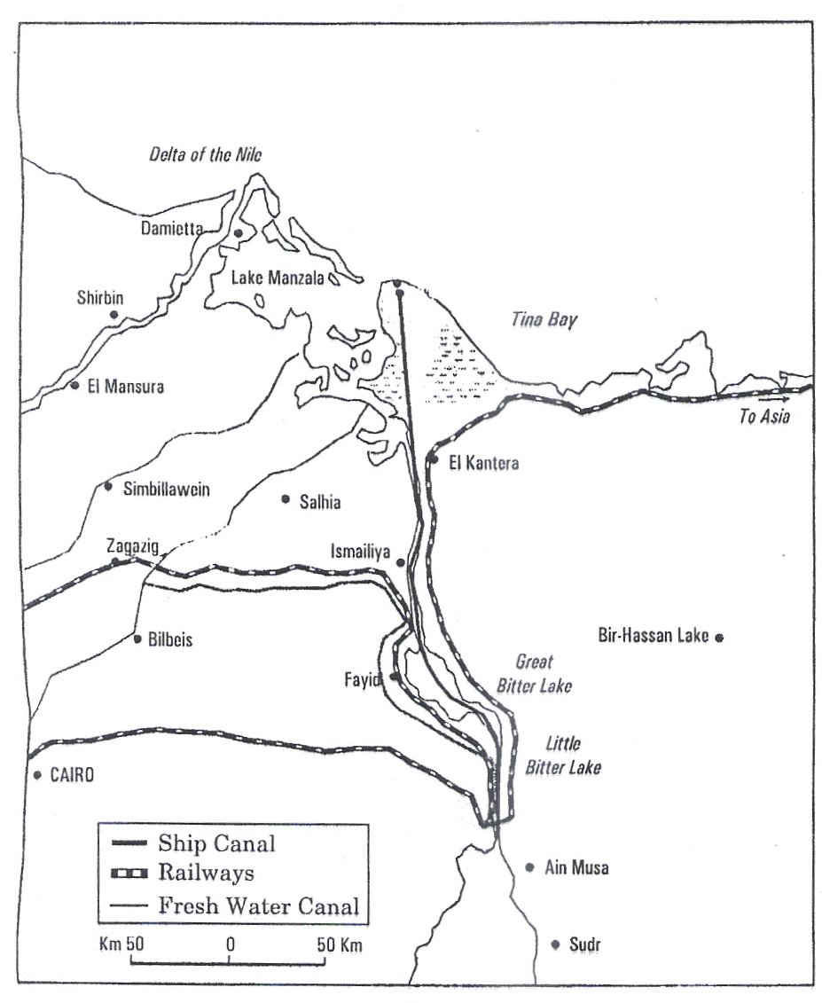

  - Name the shipping canal shown in the map.
  - What do the railway lines and fresh water canal indicate about
the relief of the region in the map?
  - How did relief helps in reducing the cost of construction of this
Shipping canal?

Ans: 1) Suez Canal
2) Generally a plain region
3) Construction cost is comparatively low due to plain terrain.

Q4: Suggest any five measures to overcome urban transport problem.
Ans:
- By imposing higher parking fee.
- Mass Rapid Transport (MRT).
- Improved Public Transport Services.
- Introducing Expressways.
- Increase in local train services.
- Promoting Metro Trains.
- Construction of Separate Traffic lanes, bridges & Flyovers etc.

CHAPTER – 9
International Trade

Q1: W.T.O. is often criticized for widening the Gap between
developed and developing countries. Examine critically.
Ans:
- Free Trade does not make ordinary people’s life more prosperous.
- Developed countries in the W.T.O. focus on their own
Commercial interests.
- Many developed countries have not fully opened their market for
the entry of the products of the developing countries.
- Issues pertaining to health, labour rights, child labour and environment
are normally ignored.

Q2: Mention three merits & three demerits of International Trade.
Ans:
Merits:-
- It leads to regional specialization.
- Helps in higher level of production.
- Worldwide availability of goods & services.
- Equalization of prices & wages.

Demerits:-
- It leads to dependence on other countries.
- Uneven levels of development.
- Commercial rivalry leading to wars.
- Global trade affects many aspect of life.

Q3: Study the table given below and answer the questions:

World Imports and Exports (in millions of U.S. $)
 | 1955 | 1965 | 1975 | 1985 | 1995 | 2005
Exports  Total Merchandise | 95000 | 190000 | 877000 | 1954000 | 5162000 | 10393000
Imports  Total Merchandise | 99000 | 199000 | 912000 | 2015000 | 5292000 | 10753000

3.1) Calculate the balance of trade in 2005.
3.2) Why do you think that the volume of trade has increased
over the decade?
3.3) What had been the growth in the Import during the year 2005
over the year 1955.
Ans: 3.1) 360000

3.2) a) Growth in manufacturing sector.
b) Growth in Service sector.
c) Specialization in agriculture and in other sectors.

3.3) Approximately 108 times.

CHAPTER – 10
Human Settlements

Q1: What according to WHO are the three factors of a healthy city?
Ans:
- A clean & safe environment.
- Meets the basic needs of all its inhabitants.
- Provides easily accessible Health Services.
Q2: What are the problems of rural settlement in developing countries?
Ans:
- Poorly equipped with infrastructure.
- Inadequate water supply
- General absence of toilets and Garbage disposal facilities.
- The house made up of mud, wood and thatch remains susceptible
to damage during natural calamities.
- Lack of proper ventilation.
- Unmetalled roads and lack of modern communication network.
- Lack of health, education and recreational infrastructure.

Q3: What is Sub-Urbanization? Mention two causes of Sub-urbanization.
Ans: It is a new trend of people moving away from congested urban areas
to cleaner areas outside the city in search of a better quality of living.
Causes of sub-urbanization:-
- Congestion in urban areas.
- Deterioration in civic amenities.
- Un healthy environmental conditions.
- High rate of land.

Q4: What is Conurbation? Who had coined the term ‘conurbation’ first.
Give two examples of Conurbation.
Ans: Conurbation refers to a large area of urban development that
resulted from the merging of originally separate towns or cities,
It was coined by Patrick Geddes in 1915.
Greater London, Manchester, Chicago and Tokyo are some examples of Conurbation.

Note : - Any other relevant point may also be added to the answers given in this question bank.

BOOK 2 : India; People and Economy
Chapter – 1
Population – Distribution, Density, Growth and Composition

Q1: “Socio-economic factors influence high density of population”. Give reasons with examples.
Ans:
- Evolution of settled agriculture and agricultural development.
- Pattern of human settlement.
- Development of transport network.
- Industrialization
- Urbanization
Examples: - River Plains and Coastal areas; Urban centres/Industrial areas.

Q2: What are the Challenges for the society with regards to adolescent population in India?
Ans:
- Lower age at marriage.
- Illiteracy- particularly among female population.
- School dropouts.
- Low intake of nutrients.
- High rate of maternal mortality of adolescent mothers.
- Drug abuse.
- Excessive exposure to the negative aspects of media in modern times.

Q3: What are the objectives of National Youth Policy of Govt. of India?
Ans:
- All round development of youth.
- Reinforcing the qualities of patriotism and responsible citizenship.
- To shoulder responsibility towards constructive development of the country.
- To ensure effective participation in decision making.
- Empowering women and girl child to bring parity.
- To look into youth health, sports and recreation.
- Creativity and awareness in the field of science and technology.

Q4: Which two categories of workers dominate in the occupational composition in India?
Ans:
- Cultivators.
- Agricultural Labourers.
- Household, industrial workers.

Q5: Why is there a decline in the number of workers in agricultural sector?
Ans:
- Availability of limited farming.
- Lack of employment in rural areas due to mechanization of agriculture.
- Seasonal nature of employment.
- Large scale urbanization and industrialization.
- Attraction & access towards tertiary and quarternary occupation.

Q6: “Female participation rate is low in India” Why?
Ans:
- Joint family system.
- Low rate of literacy among females.
- Frequent child birth.
- Greater family responsibility.
- Male dominated society.

Chapter – 2
Migration – types, causes & consequences

Q1: Give a brief account of three waves of Indian diaspora.
Ans:
- Migration in colonial period as labourers in plantation estates.
- Migration to neighboring countries mostly in South East Asia in search of economic opportunities.
- High skilled professionals migrated after 1960’s

Q2: Which urban agglomeration of India has the highest share of migrant population? Why.
Ans: Greater Mumbai
Reasons:-
- More employment opportunities.
- Urbanization and Industrialization.
- Relatively higher wages.
- Better education facilities.
- Other civic amenities.

Q3: What are the impacts of intermixing of people on society due to migration?
Ans: Positive impacts: -
- Evolution of composite culture.
- Breaking down the narrow regional considerations.
- Widening of mental horizons of the people.
Negative impacts: -
- Anominity which creates social vacuum and a sense of dejection.
- Prone to fall in the trap of anti-social activities like crime and drug abuse etc.
- Develops feeling of insecurity in the people of minority group.

Chapter – 3
Human development

Q1: Do you agree that “development must be woven around people, not the people around development”. Illustrate.
Ans: Yes.
- Orientation towards sustainable development.
- Empowerment of people.
- Encouraging democratization.
- Efforts to remove regional imbalances.
- Maximization of expenditure on welfare.
- Building human capabilities in the field of health, education and access to resources.

Q2: How the inter-related aspect of development has direct bearing on the deteriorating human conditions for the poor?
Ans: There are three inter-related processes of declining capabilities:-
- Social capabilities – due to displacement and weakening of social ties.
- Environmental capabilities – due to pollution
- Personal capabilities – due to increasing diseases and accidents.

Q3: The prime task before any development activity is to maintain parity between population and resources. Elaborate it in the light of Neo-Malthusian theory.
Ans:
- Proper balance between population and resources.
- To reduce the gap between population and resources.
- Limited resources but increase in demand due to population explosion.
- To maintain parity between population and resources.
- Over exploitation of the resources by rich and powerful people leads to conflicts and contradictions in the society.

Chapter – 4
Human Settlements

Q1: “Compact or clustered villages is a universal feature in the northern plains”. Give reasons.
Ans:
- Level and fertile land.
- Agriculture being the main occupation ha the capability to support more work force.
- Abundant supply of water for various activities.
- Social security.
- Better transportation facilities.
- Major portion of the population is landless; hence they are bound to live together.

Q2: Mention any three criteria for a settlement to be classified as a town according to 2001 census.
Ans:
- Population size should be 5000 or more.
- Density of population to be more than 400 persons/sq. km
- More than 75% of male workers should be engaged in non-agricultural activities.
- Administrative.

Q3: Why do the cities become multi-functional?
Ans:
- Each town has to perform a number of functions.
- Urban centers have to provide various services to cater to the needs of the people.
- Almost in all cities there is a CBZ (Central Business Zone) which performs multiple functions simultaneously.
- Effect of Globalization.

Q4: Study the diagram and answer the questions that follow:
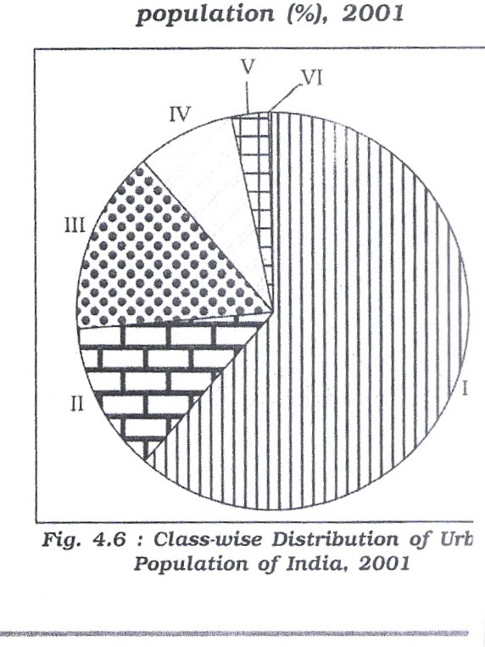

Class-wise distribution of urban population (%) of India, 2001

4.1: Into how many classes are urban centres classified by the Census of India?
4.2: Which class of urban centres has the largest urban population?
4.3: Which class of urban centres has the lowest urban population?

Ans:
4.1: Urban centres are classified into six classes.
4.2: Class I has the largest urban population.
4.3: Class VI has the lowest urban population.

Q5: Study the given table and answer the following questions:

Class | Population size | Number | Population (Million) | % of total Urban Population | % of Growth 1991-2002
All |  | 5161 | 285.35 | 100.00 | 31.13
I | 100000 and more | 423 | 172.04 | 61.48 | 23.12
II | 50,000 – 99,999 | 498 | 34.43 | 12.30 | 43.45
III | 20,000-49,999 | 1386 | 41.97 | 15.00 | 46.19
IV | 10,000-19,999 | 1560 | 22.60 | 8.08 | 32.94
V | 5,000-9,999 | 1057 | 7.98 | 2.85 | 41.49
VI | Less than 5,000 | 227 | 0.80 | 0.29 | 21.21

- Find out the total number of cities which have population less than twenty thousand.
- Find out the percentage of total urban population of the cities having population size less than twenty thousand.
- Which population size has the lowest number of cities? Give the number of cities of this population size.

Ans:
- The total number of cities is 2844 which have population less than 20,000.
- The percentage of total population size of less than 20,000 is 11.02%
- Less than 5000 population size has the lowest number of cities, the number of cities is 227 in this population size.

CHAPTER-5
Land, Resources & Agriculture

Q1: Study the diagram given below and answer the questions that follow:
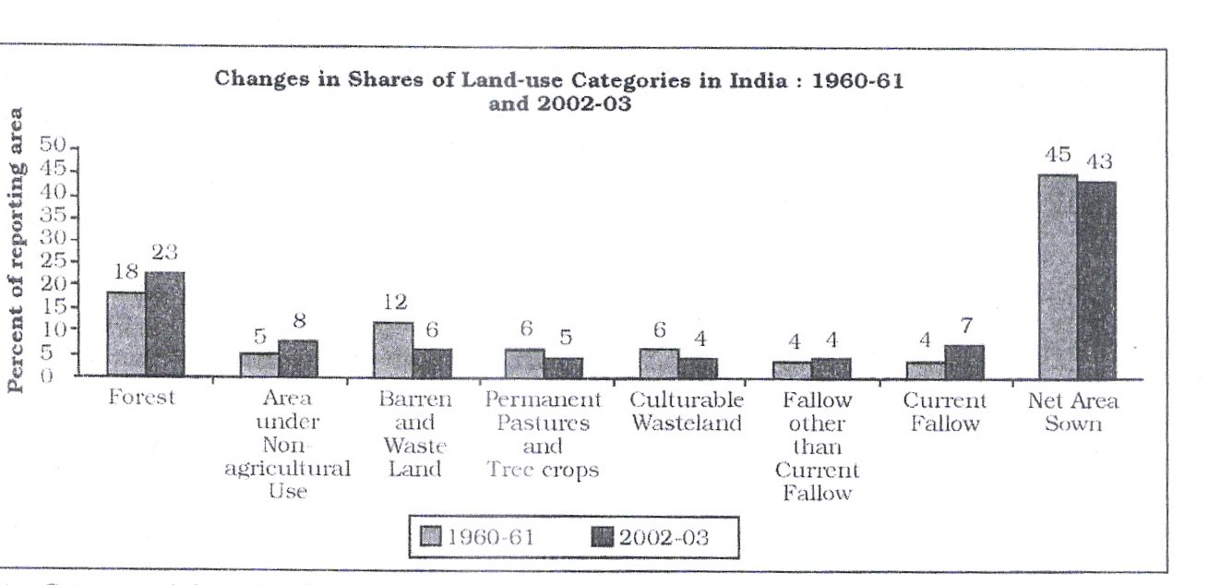

- Name any two types of land use which have registered increase between
1960-61 and 2002-03.
- Name any two types of land use which have registered decline between
1960-61 and 2002-03.
- Why has area under non-agricultural use increased and net sown area decreased between 1960-61 and 2002-03?

Ans:
- Forest, area under non-agricultural use and current fallow. (any two)
- Barren and waste land, permanent pastures and tree crops, culturable waste land and net area sown. (any two)

- Expansion of building activity on agricultural land.
- Due to increase in other activities like houses and transport purposes.

Q2: Compare the features of productive and protective irrigation.
Ans: Protective:
- To protect crops from adverse effects of soil moisture deficiency.
- To provide soil moisture to maximum possible area.
- To supplement rain fed irrigation.

Productive:
- To provide sufficient soil moisture in the cropping season to achieve high productivity.
- The water input in per unit area of cultivated land is higher than protective irrigation.
- To grow various water intensive crops such as rice, sugarcane etc.

Q3: Why does land resource more crucial to the livelihood of the people depending on agriculture?
Ans:
- Agriculture is a purely land based activity.
- Quality of land has a direct bearing on the productivity of agriculture.
- Land ownership in rural areas also has a social value and serves as a security for credit.

Q4: Why is traditional cropping pattern changing in India now a days?
Ans:
- Expansion in irrigation facilities has facilitated growth of non-traditional crops. For example growing rice in Punjab, wheat in W. Bengal etc.
- Modern technology or advent of package technology.
- Changing food habits of people.
- Initiation of policy of liberalization and free market economy.
- Easy credit facility to farmers.

Q5: Give three reasons why the green revolution was not equally successful in all parts of India?
Ans:
- Irrigation facilities were limited only to Punjab, Haryana and Western U.P.
- Farmers were not aware of modern technology and its accessibility.
- Good and high yielding varieties of seeds were not easily available because of faulty distribution and storage system.
- Poverty of farmers.
- Small size of land holdings.
- Lack of investment capacity.

Q6: “Indian farmers gamble with the monsoon”. Illustrate this
statement.
Ans:
- Uneven distribution of rainfall-spatial and temporal
- Uncertainty of monsoon.
- Lack of irrigation facilities
- Frequent flood and drought is a common phenomenon associated with the monsoon.

Q7: “The environment factors provide strong base for Indian agriculture”. Discuss.
Ans:
- Vast agriculture area.
- High percentage of agricultural landuse.
- Fertile soil.
- Longer growing season.
- Wide range of climatic conditions to grow various crops.

Q8: Why do the large number of farmers produce crops for self consumption in India?
Ans:
- Limited and small land holdings.
- Most of the farmers grow foodgrains to meet their family requirement.
- Lack of infrastructure and poor economic affordability.

Q9: Do you feel that the recent incidents of farmers’ suicides in different states of the country are the result of indebtedness?
Ans: Yes, the reasons are as follows:
- Meagre income or savings.
- Crop failure.
- Difficult procedure of financial institution which has pushed them to borrow from private money lenders at high rate of interest.
- Inadequate support price of procurement of crops.
- Low returns from agriculture.
- Lack of implementation of land reforms.

Chapter – 6
Water Resources

Q1: Why is ground water utilization very high in some states of India?
Ans: Punjab, Haryana, Rajasthan etc. have high ground water utilization.
- Ground water table is highly accessible.
- Provisions for other alternatives irrigation facilities are limited.
- Emphasis on growing high yielding crops.
- To increase the productivity.
- Changing pattern of crops.

Q2: What are the adverse impacts of over exploitation of ground water?
Ans:
- Decline in ground water table.
- Increased fluoride concentration in ground water has led to increase in concentration of arsenic matters for example. W. Bengal and Bihar.
- Deteriotation of water quality.

Q3: Why is irrigation more developed in northern plains than in peninsular India?
Ans:
- Northern plains have plain surface whereas in Peninsular India land is undulating.
- Availability of adequate ground & surface water resource than that in Peninsular India.
- Availability of perennial rivers.
- The slope of the land is so gentle that canal irrigation is convenient.
- Digging of canals and wells is easy due to nature of terrain and soft soil.

Q4: Study the given table and answer the questions that follow:

Percentage of net irrigated area to total area by wells and tubewells.

State | Percentage
Gujarat | 86.6
Rajasthan | 77.2
Madhya Pradesh | 66.5
Maharashtra | 65.0
Uttar Pradesh | 58.2
West Bengal | 57.6
Tamilnadu | 54.7

- Which state shows the highest percentage of net irrigated area of wells and tubewells?
- What are the implications of using ground water in drought prone areas of Rajasthan, Gujarat, Maharashtra and Tamilnadu?

Ans:
- Percentage of net irrigated area to total area by wells and tubewells is the highest in Gujarat (86.6%)

- The overuse of groundwater resources has led to decline in groundwater table in these states.
- Over withdrawal has increased fluoride concentration in groundwater.
- This practice in these states has led to increase in concentration of arsenic matter in parts of Maharashtra and Tamilnadu.

Q5: Study the above diagram and answer the following questions:

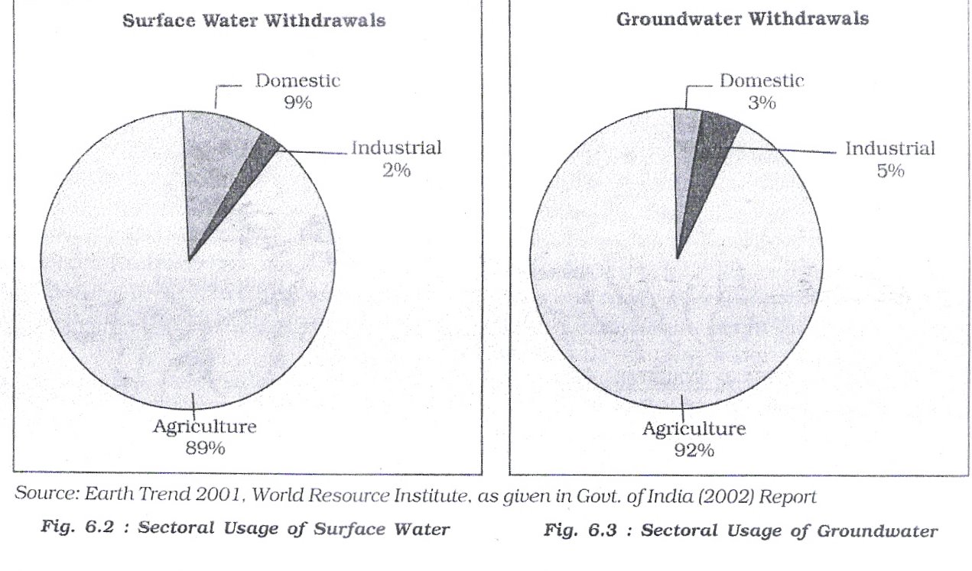
- Which sector accounts for most of the surface and groundwater utilization?
- How much percent of surface water is utilized in domestic sector?
- In industrial sector, both groundwater and surface water utilization is low. Why?

Ans:
- Agricultural sector (89% and 92% surface and groundwater respectively).
- 9%

- Because of low industrial development as compared to agricultural sector.
- Modern high tech. industries consume less amount of water.

Q6: Why do we need to encourage watershed development?
Ans:
- To prevent run-off.
- To increase storage and recharge of groundwater.
- Conservation, regeneration and judicious use of all resources like land, water, plants, animal etc.
- To encourage community and people participation. For example Neeru-Meeru, Haryali etc.

Chapter – 7
Mineral & Energy Resources

Q1: Most of the mineral bearing rock formations in India are distributed in peninsular plateau. Justify the statement by giving suitable examples.
Ans:
- Plateaus are the storehouse of minerals. Rocks of peninsular plateaus are of Precambrian and Cambrian era.
- Older rock system associated with the Dharwar, Arawali, Vindhyan and Gondwana System.
- These geological formations are rich in metallic and non-metallic minerals.
- Most of the parts of peninsular plateau are formed of igneous and metamorphic rocks.

Q2: Nuclear energy is the hope of future in India. Give three points.
Ans:
- India is deficient in mineral oil and its coal reserves would also exhaust soon.
- India has not been able to develop its potential of hydel power to such extent that it may depend on it fully because of some constraints.
- Technical know-how to harness nuclear energy is available.
- This power can play a complementary role in industrial and agricultural development in India.
- Availability of sufficient reserves of nuclear minerals like uranium and thorium.

Q3: Why is the petroleum referred to as “liquid gold”?
Ans:
- Crude petroleum consists of hydrocarbons of liquid and gaseous states varying in chemical composition, colour and specific gravity.
- Essential source of energy for all internal combustion engines in automobiles, railways and aircrafts.
- Because of its scarcity and diversified uses.
- Its by-products are major raw-material for petro-chemical and other industries.

Q4: India has got a strong base for the development of metallurgical industries. Discuss.
Ans:
- India is endowed with abundant reserves of ferrous minerals.
- Largest reserves of iron ore in Asia, occur in India.
- Superior quality of iron ore deposits (Haematite and Magnetite).
- Proximity to coal fields adds to its advantages.
- Manganese which is widely used for smelting of iron ore and manufacturing of Ferro alloys is found in almost all geological formations.

Q5: Study the following map of India and answer the questions:

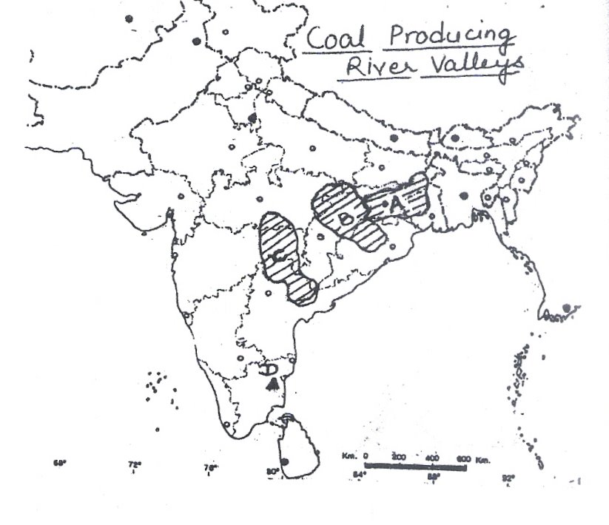
- Name the coal producing river valleys marked as A, B & C.
- Which is the most important coal field of the valley marked as A.?
- Name the lignite coal field of Tamil Nadu marked as D. Write two characteristics of this coal.

Ans:
1. A. Damodar Valley
B. Mahanadi and Son valley
C. Godavari Valley

2. Jharia coal field.

3. Neyveli coal field.

Characteristics
- Low graded coal contains high moisture.
- Low carbon content.
- Burns with high smoky flames and leaves much ash after being burnt.

Q6: Why is natural gas called precious gift of nature to man.
Ans: In our power deficient country natural gas is a precious gift to us because of the following reasons:

- It is used as a source of power as it is relatively cheaper & Eco-friendly.
- It is also used as raw material in the petro-chemical industry.
- It helps in establishing a power plant based on natural gas.
- Fertilizers are also produced by natural gas which is a boon to our agriculture.
- Its transportation is very easy and economical as it is transported through pipelines over long distances.

Q7: Why does Solar Energy in Rajasthan and Biogas in the plains and hills of North India have greater potential as non-conventional source of energy?
Ans: Solar Energy has greater potential to be developed in Rajasthan because of the following reasons. It has clear skies during most of the part of the year.

- Abundant Sun Shine almost through out the year.
- Lack of other alternative sources of energy.
- Supportive govt. policies.

Biogas has a greater potential in the northern plain due to following reasons:-
- Large number of Cattle and Livestock.
- High density of population and hence use huge human waste material.
- Availability of large agricultural residue.

Q8: Wind energy is absolutely pollution free, inexhaustible source of energy. It is not yet developed in India. Give reasons.
Ans: India already has started generating wind energy but is not well developed due to following reasons:-
- Lack of advance Technology.
- Lack of Infrastructure
- Lack of government & non-Govt. Support and non Govt. agencies.
- Initial high cost involved.

Chapter – 8
Manufacturing Industries

Q1: Study the given map and answer the following questions:
- Identify the steel plant of India marked as ‘A’.
- Name the country which collaborated to setup this Steel Plant.
- Mention any three factors which have helped in the growth of this iron & steel plant.
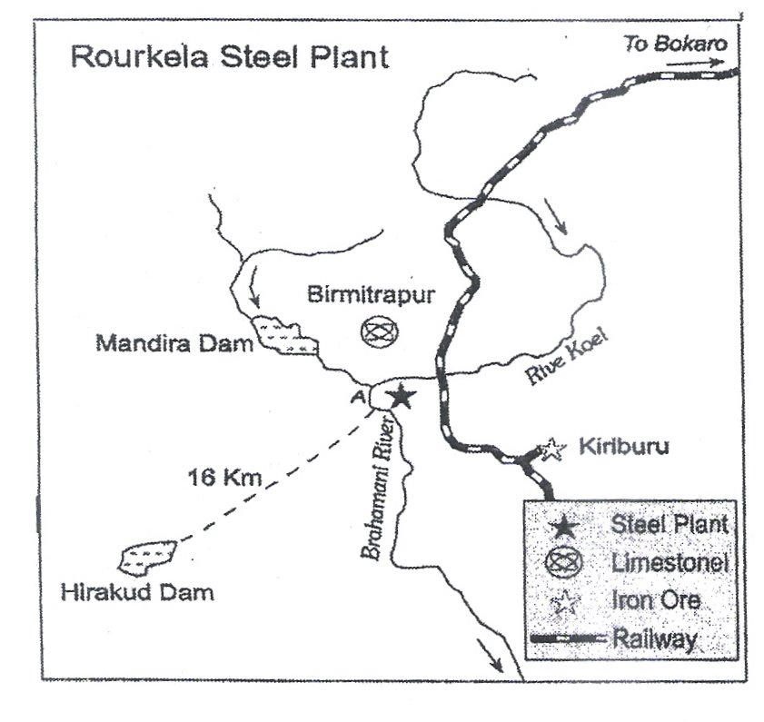

Ans:
- Rourkela steel plant.
- Germany.

- Hirakud project supplies power.
- Iron ore from Sundargarh & Kendujhar.
- Water is obtained from Koel & Sankh rivers.
- Coal from Jharia.
- Good rail & road connectivity.

Q2: Study the given map of India and answer the questions that follow:
  - Name the software parks shown as ‘A’ and ‘B’.
  - What type of industry has developed in the software technology park?
  - What is the percentage contribution by IT software and services industry in India’s GDP.
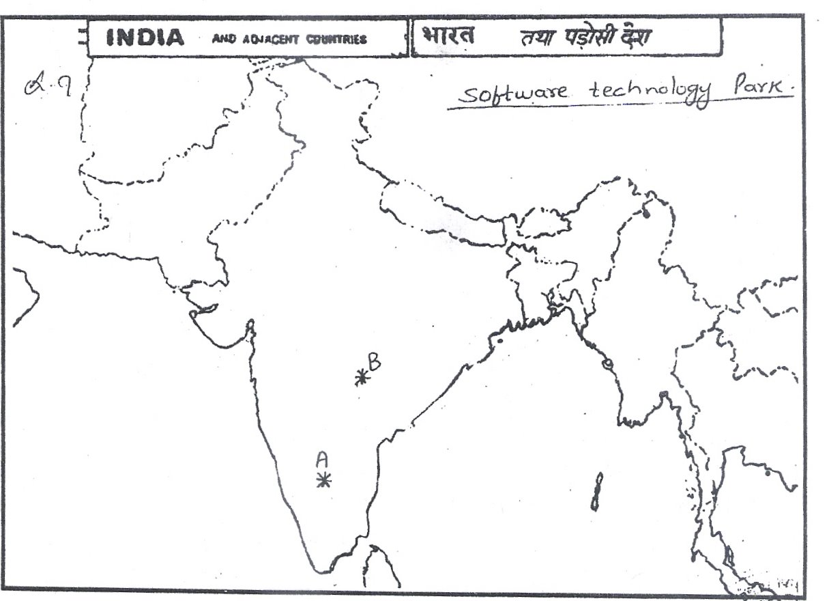

Ans:
- A – Bangalore B – Hyderabad
- IT software and service industry.
- 2%

Q3: Globalization has widened the gap between the developed and developing states of India. Justify the statement.
Ans:
- Major share of both domestic investment as well as foreign direct investment went to developed states. Example – out of the total proposed investment by the industrial entrepreneurs during 1991 – 2000, 23% was for Maharashtra, 17% for Gujarat, 7% for A.P., 6% for T.N. while U.P. had only 8%.
- Inspite of several concessions, seven north eastern states could get less than 1% of the proposed investment.
- Economically weaker states could not compete with the developed states in open market in attracting industrial investment proposals.

Q4: “The cotton textile mills are spread all over India”. Illustrate this statement with the reference to decentralization of cotton Industries.
Ans: Cloth is the basic requirement and hence its market is spread throughout the country.
- Both raw materials and finished products being light, can be easily transported over long distances.
- Easy availability – like labour, capital.
- Humid conditions can be created artificially inside mills anywhere.
- Land costs are rising, hence new mills are set up at new distant locations.

Q5: “The Iron & Steel industry is called a basic and heavy Industry”. Why? Explain.
Ans: Iron and steel industry is called a basic and heavy industry for the following reasons:

- The industry forms a base for all other industries.
- No industry can be imagined that does not make use of iron and steel in one form or the other.
- The industry lays the foundation of rapid development of all other sectors in the economy – agriculture, etc.
- It is a heavy industry because:-
- Its raw material is very bulky.
- Other minerals used like limestone; manganese, etc. are also very bulky.
- Coal used as source of power in blast furnaces is also very bulky.
- And finally its finished products are also very bulky.

Q6: 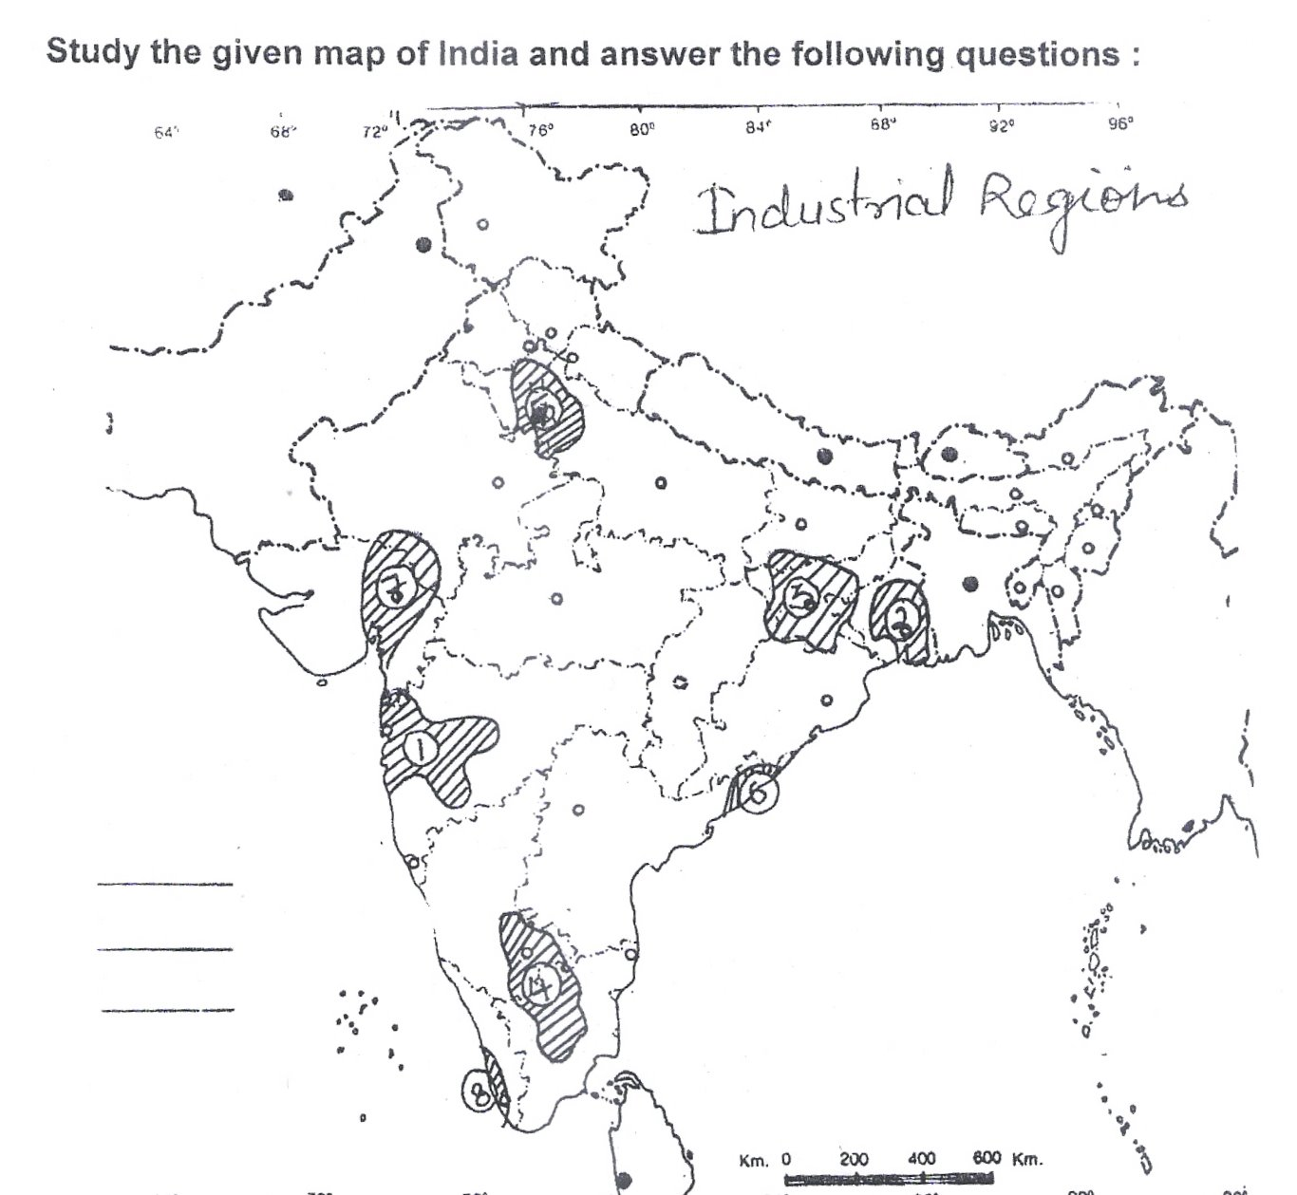

- Identify the industrial region which predominates in mining activity and metallurgical industry.
- Why is this industry well developed in this region?
- Name the second important industry of this region.

Ans:
- Chhota Nagpur Industrial Region.
- Variety of mineral ores with large deposits and cheap labour.
- Engineering Industry.

Q3: Discuss the various locational advantages of iron and steel industry in Jamshedpur.
Ans:
- Iron ore is obtained from Noamundi and Badam Pahar.
- Coal is obtained from Joda mines in Orissa.
- Water is obtained from Subernrekha and Kharkai rivers.
- Very close to Mumbai – Kolkata railway line and about 240 km away from kolkata which is the nearest port for the export of steel.
- Coaking coal obtained from Jharia and west Bokaro coal fields.

Chapter – 9
Planning and Sustainable Development in Indian Context

Q1: Why does the ‘planning commission’ introduce the approaches of ‘target area planning’ and ‘target group’ planning?
Ans:
- In order to arrest the accentuations of regional social disparity. Example command Area Development Programme.
- In order to arrest the accentuations of social disparity. Example the Small Farmers Development Agency.

Q2: How did the notion of sustainable development emerge? Also, state some of its salient features.
Ans:
- Rise in the awareness of environmental issues in western world.
- Concern of people about undesirable effects of industrial development on the environment.
- The publication like – “The population Bomb” and “The limits to Growth” further raised the issue.

Salient features: -
- It takes care of ecological, social and economic aspects of development.
- It meets the needs of the present without compromising to the needs & aspirations of the future generations.
- It takes into account the development of whole human being.

Q3: Discuss the negative affects of Indira Gandhi Canal Irrigation on Environment.
Ans: The negative affects of Indira Gandhi Canal Irrigation on environment are given below:
- Intensive irrigation and excessive use of water has led to the emergence of twin environment problems of water logging and soil salinity.
- The ground water level is rising alarmingly in most parts of stage I of the command area.
- Water logging and soil salinity have adversely affected soil fertility and agriculture productivity.

Q4: Study the map of Bharmaur Tribal Region given and answer the following questions:
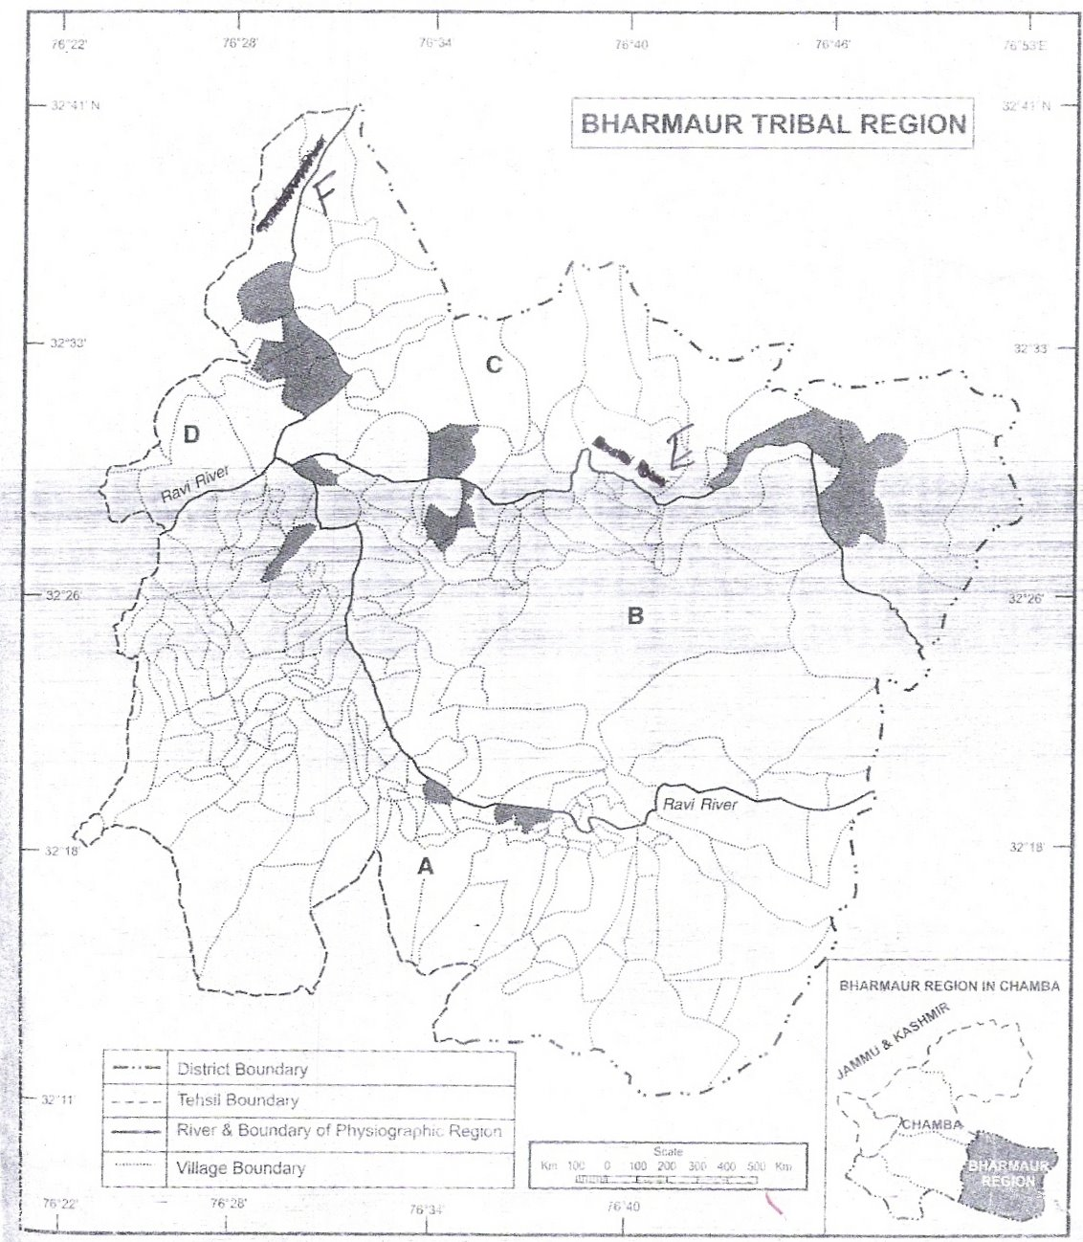

- What is the approximate Latitudinal and Longitudinal extent of the area shown in this map?
- Name the tributaries of the Ravi river marked by E and F respectively. What is the significance of these tributaries?
- Name the physiographic divisions marked by A and B respectively. Why these areas have developed more than the others?
- Name the physiographic divisions marked by C and D respectively. Why these divisions still lack in sufficient infrastructure?

Ans:
- The approximate Latitudinal and Longitudinal extent of the area is 32°11’ to 32°41’ and 76°22’ to 76°53’
- The name of the tributaries of Ravi river E is Budhil river and F is Tundahan river.
- The name of the physiographic division of A is Holi area and B is Khani area.

These two areas are comparatively more developed due to the development of means of transport and communications, being the lower reaches of hilly tracts of land.

4. The name of the physiographic division of C and D is Kugti area and Tundah area.
These divisions have lack of infrastructure due to the hilly steep terrain and being remote areas of villages as compared to Khani and Holi area.

Q5: Study the given map of Indira Gandhi Canal and answer the following questions:
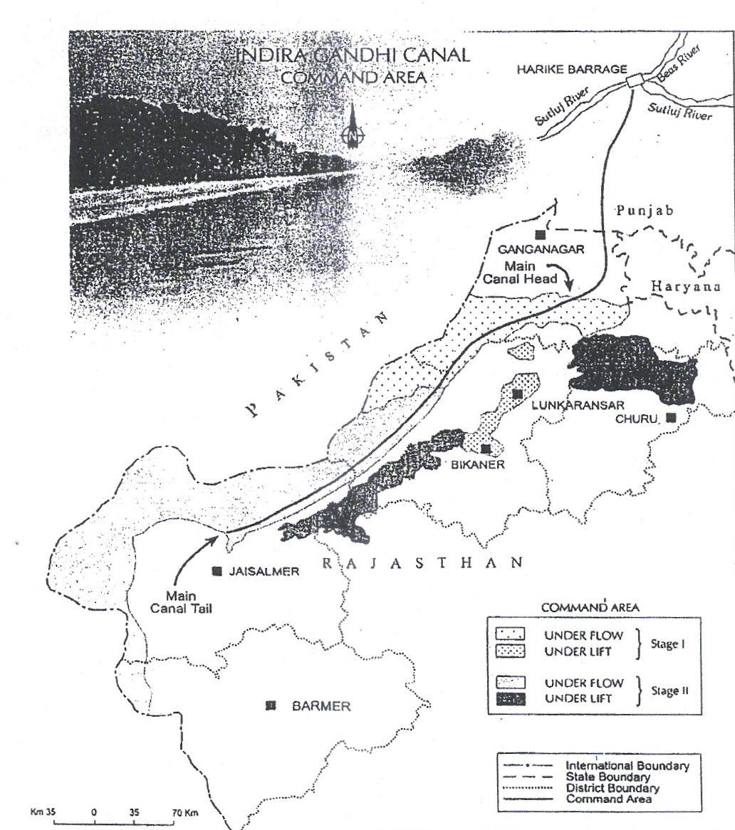

- Name the districts which are served by I.G.C. under flow in I & II stage.
- Why is the eastern part of the canal area under lift irrigation?
- When was irrigation started in Phase I and Phase II?

Ans:
  - Ganaganagar, Bikaner, Jaisalmer.
  - Due to higher elevated topography in eastern side.
  - Ist phase – 1960, IInd phase – 1980.

Chapter – 10
Transport & Communication

Q1: Why is the density of rural roads very low in hilly, plateau and forested areas?
Ans:
- Uneven topography in hilly and plateau areas.
- Low population density.
- Relatively lesser economic activity.
- Costs of construction are relatively higher.
- Settlements are located far away from one other.

Q2: When and why was the border Road Organization established?
Ans: Border road Organization (BRO) was established in May – 1960.
Because –
- There was a need to accelerate economic development of the border areas.
- To strengthen the defence preparedness and steady flow of arms and ammunitions along the border in strategically sensitive areas.
- To promote the harmonious relationship with the neighboring countries.

Q3: “Among all the personal communication system internet is the most effective and advance one”. Give reasons.
Ans:
- Enables the user to establish direct contact.
- Widely used in urban areas.
- Acts like a huge central warehouse of data & other information.
- Provides an efficient access to information at relatively low cost.
- Increasingly used for e-commerce and many transactions.
- Saves time:- It is the most time efficient device.

Q4: Inspite of numerous rivers, why are India’s inland waterways poorly developed?
Ans:
- Seasonal fluctuations in the volume of water level of most rivers.
- Higher silting in the river bed.
- Reduction in water level due to diversion of water for irrigation.
- Floods and swift currents.
- Tough competition from roads railways transport with regard to convenience.
- Lack of mechanized vessels.
- Undulating topography.

Q5: Why has The Container transport becomes more popular now a days?
Ans:
- It provides door to door service.
- It has reduced transport and delivery time.
- The service is economical both to the railways and its customers.
- Safety and security of product.

Q6: What is the “Open Sky policy”?
Ans: To help the Indian exporters and make their export more competitive, the government had introduced an “open sky policy” for Cargo in April 1992. Under this policy, the government of India has allowed foreign airlines or association of exporters to use the Indian sky for bringing any freighters to the country.

Chapter -11
International Trade

Q1: What are the main characteristics of India’s foreign trade?
Ans:
- Very less share (0.5%) of India in International trade.
- Per capita trade is less.
- Priority to sea routes / Maximum trade is carried out through sea-routes.
- Unfavourable balance of trade.
- Variation in direction of trade.
- Variety of trade items/composition.
- High increase in import and export.

Q2: Explain the changing pattern of the international trade of India.
Ans: Change in Export :
- The share of agriculture and allied products has declined.
- Share of petroleum and its products increased.
- Share of mineral ores remained constant.
- The decline in traditional items due to tough competition like jute products.
- Significant growth in the export of engineering & leather goods.

Change in Import :
- Share of foodgrains import is replaced by petroleum and fertilizers.
- Import of capital goods has increased.
- Import of edible oil and pulses in place of food items.
- Gold and Silver import has increased.
- Import of professional instruments has also increased.

Q3: Why does India import edible oil and pulses in spite of being an agriculturally rich country?
Ans:
- More demand due to rapid growth of population.
- Most of the cultivated land is under food crops.
- Per hectare productivity of pulses is low as compared to other crops.
- It is less profitable as compared to other crops.
- Risky Farming due to high vulnerability.
- Increase in the purchasing power of the individuals.

Q4: India’s international trade has undergone a sea-change in recent years. Give five arguments in support of this statement.
Ans: Change in India’s International trade: -
- There is a change in India’s international trade in terms of volume, composition and direction.
- Although India’s contribution to world trade is low, yet it plays a significant role in the world economy.
- In 1950-51, India’s external trade was worth Rs. 12140 million which rose to Rs. 8371330 million in 2004-05.
- The nature of India’s foreign has also changed and the volume of imports and exports increased.
- The value of imports continues to be higher than the value of exports.
- Trade deficit increased mainly due to the price rise in crude petroleum.

Q5: Mention the measures adopted by the Govt. of India to double its share in the international trade.
Ans:
- Liberalization of imports.
- Reduction in import duties.
- De-licensing and change from process to product patents.

Q6: Why does the west coast has more seaports than the east coast of India.
Ans:
- Availability of indented coastline.
- Depth of sea water is relatively more near coast.
- Early arrival of European traders and Arabs etc.
- Britishers encouraged to establish and promote the ports along the west coast to strengthen the connectivity from Europe.
- Opening of Suez Canal also promoted and encouraged the emergence of sea ports along the west coast.

Q7: Study the diagram given below and answer the questions that follow:-
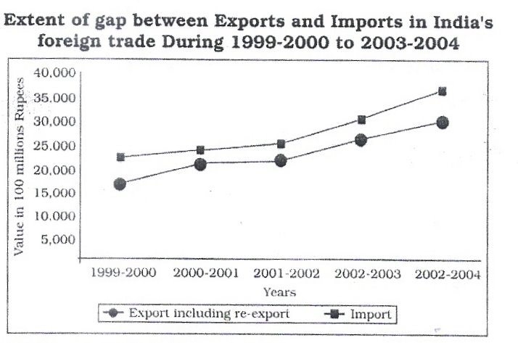
- In which year is the gap between exports and imports least? How much is the deficit in our foreign trade in this year?
- Which year shows the highest deficit in our foreign trade? Give its value.
- What is the main reason behind an increase in our trade deficit?
Ans:
- The least gap year between export and import is 2000-2001 and the deficit of this year is Rs.3000 million.
- The highest deficit year is 2003-04 & the deficit value in this year is Rs.8000 million.
- The main reason of increase in our trade deficit is higher price of petroleum products in international market.

Chapter – 12
Geographical perspective on selected issues and problems

Q1: Study the picture and answer the following questions.
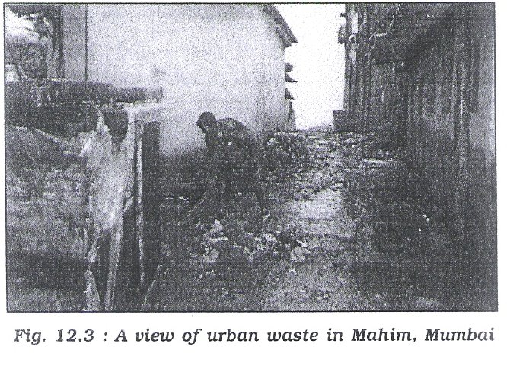
- Identify the problem shown in the diagram.
- Mention two implications of this problem?
- Is our urban waste worth anything? Mention atleast two uses.

Ans:
- Problem of urban waste disposal.
- a) Leads to dirty surroundings.
b) Leads to serious health problems.
3. Yes. Two uses: -
- Urban solid waste can be used to generate electricity.
- Garbage can be converted into compost.

Q2: Do you agree that industry is the most significant contributor of water pollution? Give five points.
Ans: Yes, the following residues of industries contribute to water pollution.
    - Industrial waste.
    - Polluted waste water.
    - Chemical residues.
    - Poisonous gases.
    - Numerous heavy metals.
    - Dust and smoke.

Q3: What are the impacts of rural – urban migration in India?
Ans: Positive Impacts: -
- Availability of cheap labour.
- Widening of outlook.
- Improvement in standard of living.
- Improved level of consumption.
- Development in their working skill.

Negative Impacts: -
- Rapid population growth in Mega cities.
- Excessive pressure on land, housing & other amenities.
- Deterioration in civic amenities.
- Increase in anti-social activities.
- Environmental degradation.

Q4: Why the oceanic noise has increased in the last forty years? Give reasons.
Ans: A study by Scripps institute of Oceanography has revealed that ocean Noise has increased tenfold since the 1960s. The reasons are as: -

- It is due to the vast increase in the volume of global shipping trade.
- The number of ships plying in the oceans has increased tremendously.
- The higher speed of vessels.
- The population has increased around the globe in recent decades.
- Increase in marine activity (exploration of petroleum and natural gas etc.; collection of marine food).
- Increase in naval activities.

Note : - Any other relevant point may also be added to the answers given in this question bank.

