QUESTIONS BASED ON HIGH ORDER THINKING SKILL
UNIT-1
SOLID STATE
1 MARK QUESTIONS
Q. 1. Name a liquefied metal which expands on solidification.
Ans. Gallium (Ga) is a silvery white metal, liquid at room temp. It expands by 3.1% on solidifica-tion.
Q. 2. How many number of molecules per unit cell which crystallizes in the form of end face centred (monoclinic) lattice with a molecule at each lattice.
Ans. 2.
Q. 3. What is the coordination number of carbon, in diamond ?
Ans. 4 and its unit cell has 8 atoms.
[The space lattice of diamond is FCC]
Q. 4. Name the solid which has weakest intermolecular force ?
Ans. Ice
Q. 5. Arrange the following types of interactions in correct order of their increasing strength :
Covalent, hydrogen bonding, Vander Waals, dipole dipole
Ans. Vander Waals < dipole dipole < hydrogen bonding < covalent.
Q. 6. Give reason for the appearance of colour in alkali metal halides.
Ans. Due to F-centres.
Q. 7. Which type of defect occur in Ag Br ?
Ans. Schottky defect and Frekel defect.
Q. 8. Give one example of doping which produces p-type of semi-conductors.
Ans. Ge doped with Al.
Q. 9. Out of (a) Graphite and (b) Carborundum which one is harder ?
Ans. Carborundum.
Q. 10. How can a material be made amorphous ?
Ans. By melting the material and by cooling it rapidly.
2 MARKS QUESTIONS
Q. 1. Give Reason :
The energy required to vaporize one mol of copper is smaller than that of energy required to vaporize 1 mol of diamond.
Ans. Copper is a metallic solid having metallic bonds while diamond is a covalent solid having covalent bonds. Metallic bonds are weaker than covalent bonds and thus less amount of energy is required to break metallic bonds than covalent bonds.
Q. 2. The unit cube length for LiCl (NaCl) is 5.14 °A. Assuming anion-anion contact. Calculate the ionic radius for Chloride ion.
Ans.

Interionic distance of LiCl = 5.14 / 2 = 2.57 A
AC =
=
= 3.63
therefore, radius of Cl– = ½ × 3.63 = 1.81 A
Q. 3. Give reasons :
(a) Diamond and rhombic Sulphur are covalent solids, but the latter has lower melting points.
(b) Among NaCl and CsCl, CsCl is quite stable.
Ans. (a) Due to weak Vander Waal’s Force in Sulphur molecule.
(b) CsCl coordination number is 8. It is surrounded by 8 anion tightly.
Q. 4. How many unit cells are present in a cube shaped ideal crystal of NaCl of mass 1 gm ?
Ans. Mass of 1 unit cell = volume × density
= a³ × d
=
=
No. of unit cells in 1 gm = 1/M
= 6.023 × 1023 / 58.5 × 4
= 2.57 × 1021
Q. 5. In the mineral spinal; having the formula MgAl2O4. The oxide ions are arranged in CCP, Mg2+ ions occupy the tetrahedral voids. While Al3+ ions occupy the octahedral voids.
(i) What percentage of tetrahedral voids is occupied by Mg2+ ions ?
(ii) What percentage of octahedral voids is occupied by Al3+ ions ?
Ans. According to the formula, MgAl2O4. If there are 4 oxide ions, there will be 1 Mg2+ ions and 2 Al3+. But if the 4 O2– ions are ccp in arrangement, there will be 4 octahedral and 8 tetrahedral voids.
(i) Percentage of tetrahedral voids occupied by Mg2+ = (1 / 8) × 100
= 12.5%
(ii) Percentage of octahedral voids occupied by Al3+ = (2 / 4) × 100
= 50%
Q. 6. Give reasons :
(a) Window glass of old building look milky.
b) Window glass of old building is thick at bottom.
(c) CaCl2 will introduce Schottky defect if added to AgCl crystal.
Ans. (a) Due to annealing over a number of years glass acquires some crystalline character.
(b) Glass is not a true solid. But a super-cooled liquid of high viscosity. It has the property to flow.
(c) 2 Ag+ will be replaced by 1 Ca2+ ions to maintain electrical neutrality. Thus a hole is created and lattice site for every Ca2+ ion introduced.
Q. 7. Analysis shows that nickel oxide has the formula NiO.98O1.00. What fractions of nickel exist as Ni2+ and Ni3+ ions ?
Ans. NiO.98O1.00
Let Ni2+ be x and Ni3+ be 0.98 – x
Total charge on compd. is equal to zero.
[2 (Ni2+) + 3 (Ni3+) – 2 (O2–)] = 0
2 x + 3 (0.98 – x) – 2 = 0
x = 0.94
Therefore Ni2+ % = × 100 = 96%
Ni3+ = 4%
Q. 8. What type of defect can arise when a solid is heated ? Which physical property is affected by this and in what way ?
Ans. When a solid is heated vacancy defect arises. This is because on heating some atoms or ions leacve the lattice site completely some lattice sites are vacant. As a result of this defect the density of the substance decreases, because some atoms leave the structure completely.
Q. 9. (a) What happens when a Ferromagnetic or Ferrimagnetic solid is heated ?
(b) The ions of MgO and NaF all have the same number of electrons and intermolecular distance are about the same (235 & 215 pm). Why are the melting points are so different (2642 °C & 992 °C ?
Ans. (a) It changes into paramagnetic at hight temperature due to randomization of spins.
(b) The ions in MgO carry two unit charges. In NaCl only one unit charge. Hence electrostatic forces of attraction in MgO are stronger.
Q. 10. (a) If the radius of the Br ion is 0.182 nm, how large a cation can fit in each of the tetrahedral hole.
(b) AgI crystallizes in a cubic closed packed ZnS structure. What fraction of tetrahedral site is occupied by Ag ion ?
(c) At what temp. range, most of the metals becomes super conductors ?
Ans. (a) For a tetrahedron the limiting ratio is 0.225 – 0.414
For largest cation highest value 0.414 would be considered.
r+ / r– = 0.414
r+ = 0.414 × 0.182 = 0.075 nm.
(b) In FCC there are 8 tetrahedral voids. Out of this ½ is occupied by Ag cation.
(c) 2 k – 5 k.


UNIT—2
SOLUTION

1 MARK QUESTIONS
Q. 1. The vapour pressure of deliquescent substance is less or more than that of water vapours in air ?
Ans. Less than that of water vapours in air.
Q. 2. If α is the degree of dissociation of Na2SO4 then write the Vant Hoff factor used for calculating the molecular mass.
Ans. α = i – 1 / m – 1
α (m – 1) = i – 1
1 + α (m – 1) = i
i = 1 + α (3 – 1)
= 1 + 2 α.
Q. 3. If 6.023 × 1020 molecules of urea are present in 100 ml of its soln. then what is the conc. of urea soln. ?
Ans. N0 = 6.023 × 1023 = 1 mol
6.023 × 1020 molecules = 0.001 mol in 10 ml
M = =
= 0.01 M.
Q. 4. Why camphor is used in molecular mass determination ?
Ans. Because it has very high cryoscopic constant.
It has large depression in m. p. when an organic solute is dissolved in it.
Q. 5. 0.004 M soln of Na2SO4 is isotonic with 0.01 M soln of glucose at the temp. What is the apparent degree of dissociation of Na2SO4 ?
Ans. 75%
Q. 6. What happen when mango is placed in dilute aqueous soln of HCl ?
Ans. When mango is placed in dilute aqueous soln. of HCl it swells.
Q. 7. Out of (a) 200 ml of 2 M NaCl Soln and (b) 200 ml of 1 M glucose Soln. which one has higher osmotic pressure ?
Ans. (a) 200 ml of 2 M NaCl Soln.
NaCl is an electrolyte which dissolve to give ions. Glucose and urea are non electrolytes. Thus glucose has minimum conc. and hence minimum osmotic pressure.
Q. 8. Out of (a) 0.01 M KNO3 (b) 0.01 M Na2SO4 which aqueous soln. will exhibit high B. P. ?
Ans. (a) 0.01 M Na2SO4
Q. 9. Out of (a) 1 M CaCl2 (b) 1 M AlCl3 which aqueous soln. will show max. vapour pressure at 300 K ?
Ans. (a) 1 M CaCl3, if we assume 100% dissociation, i for CaCl2 = 3 and AlCl3 = 4 and relative lowering of V. P. is directly proportional to i.
Q. 10. Out of (a) HNO3 + H2O and (b) C6H6 + C6H5CH3 which will form max. boiling azeotrope ?
Ans. (a) HNO3 + H2O.

2 MARKS QUESTIONS
Q. 1. Two solns of a substance (non-electrolyte) are mixed in the following manner – 480 ml of 1.5 M (First Soln) + 520 ml of 1.2 M (Second Soln). What is the molarity of the final mixture ?
Ans. Total molarity =
= = 1.344 M
Q. 2. To get the hard boiled eggs, why common salt is added to water before boiling the eggs ?
Ans. Due to addition of common salt the B. P. of the salt containing water elevated, hence the egg at high temp. becomes hard.
Q. 3. Equimolal Soln of NaCl and BaCl2 are prepared in H2O. B. F. pt. of NaCl is found to be – 2 °C. What freezing point do you expect from BaCl2 soln ?
Ans. i for NaCl = 2 i for BaCl2 = 3
Therefore ΔTF (BaCl2) =
ΔTF for BaCl2 = 3 °C
TF = – 3 °C.
Q. 4. Why water cannot be separated completely from ethyl alcohol by fractional distillation ?
Ans. Ethyl alcohol and water (95.4% ethyl alcohol and 4.6% water) form constant boiling mixture (azeotrope) boiling at 351.1 °K. Hence, further water cannot be separated completely from ethyl alcohol by fractional distillation.
Q. 5. Why a person suffering from high blood pressure is advised to take minimum quantity of common salt ?
Ans. Osmotic pressure is directly proportional to the conc. of solutes. Our body fluid contain a number of solutes. On taking large amount of salts, ions enter the body fluid there by raising the conc. of the solutes. As a result osmotic pressure increases which may rapture the blood cells.
Q. 6. Chloro acetic acid is a monoprotic acid and has Ka = 1.36 × 10–3. Calculate b. p. of 0.01 M aqueous soln ? (Kb = 0.51 k kg/mol)
Ans. Kb = 0.51 k kg/mol
α = Ka / C
= 1.36 × 10–3 / 0.01
= 0.3687
i = 1 + α
= 1 + 0.3687 = 1.3687
ΔTb = i × Kb m
= 1.36 × 10–2 × .51
= 0.0069 °C
Q. 7. Which colligative property is preferred for the molar mass determination of macro molecules ? Why ?
Ans. Osmotic pressure is preferred over all other colligative properties because :
(a) even in dil. soln the o. p.values are appreciably high and can be measured accurately.
(b) o. p.can be measured at room temp. on the other hand elevation in B. P. is measured at high temp. where the solute may decompose. The depression in freezing point is measured at low temp.
Q. 8. How much ethyl alcohol must be added to 1 litre of water so that the solution will freeze at 14 °F ? (Kf for water = 1.86 °C/mol)
Ans. (14 – 32) / 9 = C / 5
C = 5 × (– 18) / 9
= – 10 °C
ΔTF = Wb = mass of solute
Mb = molar mass of solute
Wa = mass of solvent
10 =
Wb = 247.31 g
Q. 9. 75.2 g of phenol is dissolved in solvent of KF = 14, if the depression in freezing point is 7 k. What is the % of phenol ?
Ans. KF = 14
Mb =
Taking the solvent as 1 kg
Mb =
= 150.4 g per mol
phenol (molar mass) — 94 g/mol
i =
= 94 / 150.4 = 0.625
2 C6H5OH ←——→ (C6H5OH)2
1 0
1 – α α / 2
Total = 1 – α + α / 2
= 1 – α / 2
i = 1 – α + α / 2
= 1 – α / 2 = 0.625
α / 2 = 0.375
α = 0.75
% of association = 75%
Q. 10. How many ml of 0.1 M HCl are required to react completely with 1 gm mixture of Na2CO3 & NaHCO3 containing equimolar amounts of both ?
Ans. Let the amount of Na2CO3 be x
Let the amount of NaHCO3 be 1 – x
Since no. of moles of both are equal
84 x = 106 – 106 x
x = 0.5578
XNa2CO3 = 0.5578 / 106
= 0.00526
XNaHCO3 = 0.00526
Na2CO3 + 2 HCl ———→ 2 NaCl + CO2 + H2
NaHCO3 + HCl ———→ NaCl + CO2 + H2O
M1V1 = 2 M2V2 + M3V3
0.1 × V1 = 2 × 0.00526 + 0.00526
V1 =
= 0.1578 L
V = 157.8 ml.


UNIT—3
ELECTROCHEMISTRY

1 MARK QUESTIONS
Q. 1. Which solution will allow greater conductance of electricity, 1 M NaCl at 293 K or 1 M NaCl at 323 K and why ?
Ans. 1 M NaCl at 323 K as the ionic mobilities increase with increase in temperature.
Q. 2. What does the negative value of E°cell indicate ?
Ans. ΔG will be positive, the cell will not work.
Q. 3. Why is the equilibrium constant K, related to only E°cell and not Ecell ?
Ans. This is because Ecell is zero at equilibrium.
Q. 4. What is the sign of ΔG for an electrolytic cell ?
Ans. Positive.
Q. 5. Rusting of iron is quicker in saline water than in ordinary water. Why is it so ?
Ans. In saline water, NaCl helps water to dissociate into H+ and OH–. Greater the number of H+, quicker will be rusting of Iron.
Q. 6. What would happen if the protective tin coating over an iron bucket is broken in some places ?
Ans. Iron will corrode faster as the oxidation potential of Fe is higher than that of tin.
Q. 7. Can a nickel spatula be used to stir a solution of Copper Sulphate ? Justify your answer.
(E°Ni²+/Ni = – 0.25 V E°Cu²+/Cu = 0.34 V)
Ans. Reduction potential of Ni is less than Cu. Ni will replace the Cu from CuSO4. Thus Ni spatula cannot be used to stir a solution of CuSO4.
Q. 8. Which out of 0.1 M HCl and 0.1 M NaCl, do you expect have greater Λ∞m and why ?
Ans. 0.1 M HCl will have greater Λ∞m because H+ (aq) being smaller in size than Na+ (aq) and have greater mobility.
Q. 9. Three iron sheets have been coated separately with three metals A, B, C whose standard electrode potentials are given below :
A B C Iron
E°value – 0.46 V – 0.66 V – 0.20 V – 0.44 V
Identify in which rusting will take place faster when coating is damaged.
Ans. Rusting of iron will take place when coated with metal C as it is placed above iron more than other metal.
Q. 10. Which will have greater molar conductivity ? Solution containing 1 mol KCl in 200 cc or 1 mol of KCl in 500 cc.
Ans. 1 mol of KCl in 500 cc.

2 MARKS QUESTIONS
Q. 1. (a) How will the value of Ecell change in an electrochemical cell involving the following reaction of the concentration of Ag+ (aq) is increased ?
(b) What will be e. m. f. when the cell reaches equilibrium :
Mg (s) + 2 Ag+ (aq) ——→ Mg2+ (aq) + Ag (s)
Ans. (a) Ecell = E°cell – log
As the concentration of [Ag+] ion increases, Ecell increases.
(b) e.m.f. = 0
Q. 2. (a) In a cell reaction, the equilibrium constant K is less than one. Is E° for the cell positive or negative ?
(b) What will be the value of K of E°cell = 0 ?
Ans. For a cell E° = log K
K < 0 ⇒ log K < 0
i.e. log K is – ve.
Then E°cell will be negative.
(b) If E°cell = 9 then 0 = log K
log K = 0 ⇒ K = 1
Q. 3. Knowing that :
Cu2+ (aq) + 2 e– ———→ Cu (s) E° = + 0.34 V
2 Ag+ (aq) + 2 e– ———→ 2 Ag (s) E° = + 0.80 V
Reason out whether, 1 M AgNO3 solution can be stored in Copper Vessel or 1 M CuSO4 solution in Silver Vessel.
Ans. A solution of an electrolyte can be stored in a particular vessel only in case there is no chemical reaction taking place with the material of the vessel.
Cu is a strong reducing agent and can lose electrons to Ag+ as E° of Cu is less than that of Cu. So AgNO3 cannot be kept in Copper Vessel.
CuSO4 solution can be stored in Ag Vessel as no chemical reaction will take place as Ag is placed above Cu in the activity series and Ag is less reactive than Copper.
Q. 4. What is the number of electrons in one Coloumb of electricity ?
Ans. Charge on one mole of electrons = 1 F = 96500 C
96500 C of Charge is present on electrons = 6.022 × 1023
∴ 1 C of Charge is present on electrons = × 1 C
= 6.24 × 1018
Q. 5. Which of the following pairs will have greater conduction and why ?
(a) Copper wire at 25 °C and Copper wire at 50 °C.
(b) 0.1 M acetic acid solution or 1 M acetic acid solution ?
Ans. (a) Copper wire at 25 °C because with increase in temperature metallic conduction decreases due to vibration of kernels.
(b) 0.1 M acetic acid solution because with dilution degree of dissosciation increases and hence no. of ions.

3 MARKS QUESTIONS
Q. 1. The following curve is obtained when molar conductivity (λm) is plotted against the square root of concentration for 2 electrolytes A and B.
(a) What can you say about the nature of the two electroyltes A and B ?
(b) How do you account for the increase in molar conductivity λm for the electrolytes A and B on dilution ?

Ans. (a) A is a strong electrolyte and B is a weak electrolyte.
(b) Molar conductivity of a strong electrolyte (A) increases with dilution as ionic mobility increases. In a weak electrolyte molar conductivity increases steeply with dilution as degree of dissociation increases and hence no. of ions increases.
Q. 2. Iron and nickel are used to make electrochemical cell by using a salt bridge to join a half cell containing 1 M Fe2+ (aq) in which a strip of iron has been immersed to a second half cell which contains 1 M Ni2+ (aq) in which a strip of Ni has been immersed ? A voltmeter is connected between the two metal strips :
E°Fe²+/Fe = – 0.44 V E°Ni²+/Ni = – 0.25 V
(a) Write the name of the cathode and anode.
(b) Write the half reactions involved ?
(c) What would be the effect on the Voltmeter reading if Fe2+ concentration were increased ?
Ans. (a) Anode : Fe
Cathode : Ni
(b) Reaction at anode : Fe ———→ Fe2+ + 2 e–
Reaction at cathode : Ni2+ + 2 e– ———→ Ni
(c) Voltmeter reading decreases.
Q. 3. Consider the electrochemical cell :
Zn (s) / Zn2+ (aq) // Cu2+ (aq) / Cu. It has an electrical potential of 1.1 V when concentration of Zn2+ and Cu2+ ions is unity.
State the direction of flow of electrones and also specify if Zinc and Copper are deposited or dissolved at their respective electrodes. When :
(a) an external opposite potential of 0.8 V is applied.
(b) an external opposite potential of 1.1 V is applied.
(c) an external opposite potential of 1.4 V is applied.
Ans. (a) Electrons flow from Zn rod to Cu rod.
Zinc dissolved and Copper gets deposited.
(b) No flow of electrons and current.
No change observed at Zinc and Copper electrodes (system is at equilibrium).
(c) Electrons flow from Cu rod to Zn rod.
Zinc is deposited and Copper gets dissolved.
Q. 4. Given that :
CO3+ + e– ———→ CO2+ E° = 1.82 V
2 H2O ———→ O2 + 4 H+ +4 e– E° = – 1.23 V
Explain why CO3+ is not stable in aqueous solution ?
Ans. The E°cell can be calculated as :
4 [CO3+ + e– ———→ CO2+] E° = 1.82 V
2 H2O ———→ O2 + 4 H+ +4 e– E° = – 1.23 V
——————————————————————
Cell reaction : 4 CO3+ + 2 H2O ———→ CO2+ O2 + 4 H+
E°cell = 1.82 V – (– 1.23 V) = 3.05 V
Since E°cell is positive, the cell reaction is spontaneous. CO3+ iron will take part in the reaction and hence unstable in aqueous solution.
Q. 5. For the reaction :
Ag+ + Hg ———→ Ag + Hg22+
E° = 0.80 V E° = 0.79 V
Predict the direction in which the reaction will proceed if :
[Ag+] = 10–1 mol/h [Hg2+] = 10–3 mol/h
Ans. Cell reaction is :
2 Ag+ + 2 Hg ———→ 2 Hg + Hg22+
Ecell = E°cell – log
= (0.80 V – 0.79 V) – log
= 0.01 V – (– 1) = 0.01 + 0.0295
= 0.0395 V
Since Ecell is positive, the reaction will be spontaneous in the forward direction.


UNIT—4
CHEMICAL KINETICS

1 MARK QUESTIONS
Q. 1. In the reaction A —→ B, if the concentration of A is plotted against time, the nature of the curve obtained will be as shown. What is the order of the reaction ?
Ans. First Order
Q. 2. What is the effect of temperature on activation energy ?
Ans. There is no effect of temperature on activation energy.
Q. 3. Which will dissolve in water faster, powdered sugar or crystalline sugar and why ?
Ans. Powdered sugar will dissolve in water faster as it has more surface area.
Q. 4. Which reaction will take place faster and why ?
500 °C
C (s) + ½ O2 (g) —————→ CO (g)
1000 °C
C (s) + ½ O2 (g) —————→ CO (g)
Ans. The second reaction is faster because increase in temperature increases the number of effective collisions and hence increase in rate.
Q. 5. For a reaction A + H2O ——→ B; r = k [A]. What is its (i) Molecularity (ii) Order ?
Ans. Pseudo unimolecular rection order = 1

2 MARKS QUESTIONS
Q. 1. A reaction : Reactant ——→ Product is represented by :
(i) Predict the order of the reaction.
(ii) What does the slope of the graph represent ?
Ans. (i) Zero order
(ii) Slope = – k =
Q. 2. For a reaction, the activation energy is zero. What is the value of rate constant at 300 K if K = 1.6 × 106 s–1 at 280 K.
Ans. log = = = 0
= antilog (0) = 1 or K2 = K1 = 1.6 × 106 s–1
Q. 3. The slope of the line in the graph of log K is for a reaction is – 5841 K. Calculate Ea for the reaction.
Ans. Slope = –
Ea = – 2.303 R × Slope
= – 2.303 × 8.314 × – 5841
= 1.118 × 105 g/mol
3 MARKS QUESTIONS
K
Q. 1. Consider the reaction R ——→ P. The change in concentration of A with time is shown in the given plot :
(i) Predict the order of the reaction.
(ii) Derive the expression for the time required for the completion of the reaction.
Ans. (i) Zero order
(ii) For the reaction R ——→ P
r = – = K [R]°
– d [R] = K dt
On integration
– [R] = Kt + C
When t = 0 [R] = [R]0
On substitution
– [R] = Kt – [R]0 ⇒ [R] = – Kt + [R]0
Kt = [R]0 – [R] ⇒ t = {[R]0 – [R]}
Q. 2. Answer the following questions on the basis of the given curve for a first order reaction :
A ——→ P
(i) What is the relation between slope of this line and rate constant ?
(ii) Calculate the rate constant of the above reaction if the slope is 2 × 10–4 s–1.
Ans. (i) Slope =
(ii) Slope = 2 × 10–4 s–1
∴ K = 2.303 × Slope
= 2.303 × 2 × 10–4 s–1
= 4.606 × 10–4 s–1
Q. 3. For a certain chemical reaction variation in concentration in [R] VS time plot is given below. For this reaction write :
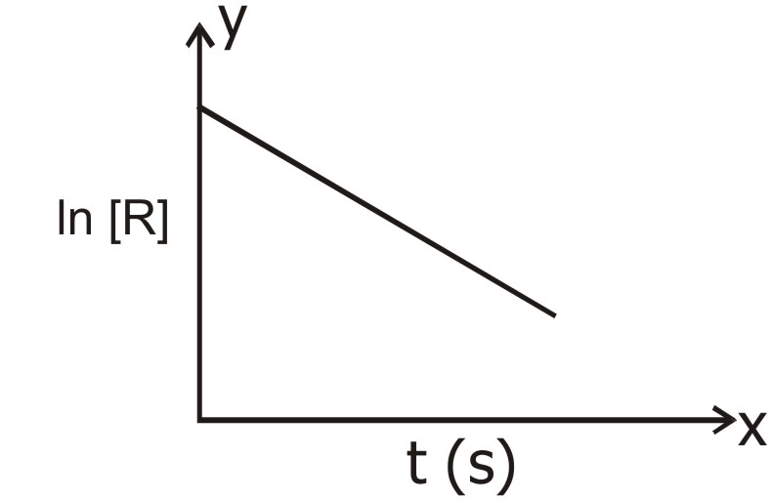

(i) What are the units of rate constant ?
(ii) Give the relationship between k and t½.
(iii) What does the slope of the above line indicate ?
Ans. (i) time–1 (s–1)
(ii) K =
(iii) rate constant K of the reaction.
Q. 4. Consider the following diagram representing potential energy plot and answer the following questions :
(i) What do ‘x’ and ‘y’ represent ?
(ii) What does ‘z’ represent in this diagram ?
(iii) Is the reaction endothermic or exothermic ?
Ans. (i) ‘x’ represents Ea for forward reaction. ‘y’ represents Ea for backward reaction.
(ii) ‘z’ represents ΔH, the enthalpy change for the reaction.
(iii) Exothermic reaction.
Q. 5. Consider a plot between k vs where T is the temperature. On the basis of this plot, answer the following questions :
(i) What is the slope in this line ?
(ii) What is the intercept of this line on the y-axis ?
(iii) What is the relation between K and T ?
Ans. (i) Slope = –
(ii) Intercept = ln A
(iii) ln k α or K = A e–Ea/RT
Q. 6. Diagram given below shows a plot of potential energy Vs reaction co-ordination for a hypothetical reaction. Write answers to the following from the plot given :
(a) Represent reactant, product and activated complex in terms of A, B and C ?
(b) Is this reaction exothermic or endothermic ?
(c) What will be the effect of a catalyst on Ea of the reaction ?
Ans. (a) A —→ Reactant
B —→ Product
C —→ Activated Complex
(b) Exothermic
(c) Catalyst will lower the activation energy for the reaction.
Q. 7. The rate of a first order reaction is 0.04 mol/h/s at 10 minutes and 0.03 mol/h/s at 20 minutes. Find the half life period of the reaction.
Ans. Rate = K C
r1 = K C1
r2 = KC2
K = log
When t = 10 min
K = log = log
= 0.0287 min–1
t½ = =
= 24.14 min.


UNIT—5
SURFACE CHEMISTRY
AND CATALYSIS

1 MARK QUESTIONS
Q. 1. What kind of adsorption is represented by the following graph :
Ans. Chemisorption.
Q. 2. In the titration of oxalic acid by acidified KMnO4, the oxidation of oxalic acid is slow in the beginning but becomes fast as the reaction progresses. Why ?
Ans. Autocatalysis by Mn+2.
Q. 3. Out of PO43–,, SO42–,, Cl–,, which wil act as the best coagulating agent for for Fe (OH)3 ?
Ans. PO43–.
Q. 4. Arrange the following in correct order of their coagulating power :
Na+, Al3+, Ba2+
Ans. Na+ < Ba2+ < Al3+
Q. 5. Which type of charged particles are adsorbed on the surface of As2S3 during its preparation ?
As2O3 + 3 H2S ——→ As2S3 + 3 HOH
Ans. S2–.
Q. 6. Which type of metals act as effective catalysts ?
Ans. Transition metals.
Q. 7. The colloidal solution of gold prepared by different methods have different colours. Why ?
Ans. Due to difference in the size of colloidal particles.
Q. 8. At high pressure, the entire metal surface gets covered by a mono molecular layer of the gas. What is the order of the process ?
Ans. Zero order.
Q. 9. What is the term used for minimum concentration of an electrolyte which is able to cause coagulation of a sol ?
Ans. Flocculation value.
Q. 10. A liquid is found to scatter a beam of light but leaves no residue when passed through the filter paper. What can the liquid be described as ?
Ans. Colloid.
Q. 11. If an electric field is applied to a colloidal sol, the dispersed phase particles are found to move towards the electrode of opposite charge. If however, the dispersed phase is made stationary, the dispersion medium is found to move in the opposite direction. What is the term used for such movement of dispersion medium ?
Ans. Electro osmosis.
Q. 12. Out of glucose, urea and dodecyl trimethyl ammonium chloride, which one forms micelles in aqueous solution above certain concentration ?
Ans. Dodecyl trimethyl ammonium chloride.
Q. 13. A plot of log versus log p for the adsorption of a gas on a solid gives a straight line. What is the slope equal to ?
Ans.
Q. 14. The formation of micelles occurs only beyond a certain temperature. What is the temperature called ?
Ans. Kraft temperature
Q. 15. What are the signs of ΔH, ΔS and ΔG for the process of adsorption ?
Ans. ΔH = –ve
ΔS = –ve
ΔG = –ve
Q. 16. Out of CO and NH3 which is adsorbed on activated charcoal to a large extent and why ?
Ans. Ammonia; because more easily liquefiable gas undergoes adsorption to a greater extent.
Q. 17. On passing H2S through dilute HNO3 the colourless solution becomes turbid. Why ?
Ans. Due to formation of colloidal sol of Sulphur.
Q. 18. A sol is prepared by addition to excess AgNO3 solution in KI solution. What charge is likely to develop on the colloidal particles ?
Ans. Positive.
Q. 19. If we add equimolar amounts of ferric hydroxide sol and arsenic sulphide sol, what will happen ?
Ans. Both the sols will get coagulated.
Q. 20. What happens when freshly precipitated Fe (OH)3 is shaken with a little amount of dilute solution of FeCl3 ?
Ans. It causes peptization leading to the formation of a positively charged sol of Fe (OH)3.
Q. 21. What happens to a gold sol if gelatin is added to it ?
Ans. It causes stabilisation of gold sol.
Q. 22. Out of NaCl, MgSO4, Al2 (SO4)3, K4[Fe(CN)6], which one will bring about the coagulation of a gold sol quickest and in the least of concentration ?
Ans. Al2 (SO4)3.
Q. 23. What is the unit for expressing flocculation value ?
Ans. millimole per litre.
Q. 24. Out of PO43–, SO42–, Al3+ and Na+, which will have the highest coagulating power for As2S3 colloid ?
Ans. Al3+.

2 MARKS QUESTIONS
Q. 1. Bleeding is stopped by the application of alum to a wound. Why ?
Ans. Blood is a colloid alum being an electrolyte, makes the blood to coagulate and form clot.
Q. 2. What is the purpose of adding gelatin to ice cream ?
Ans. Ice cream is a colloid. Gelatin imparts stability to it because gelatin is a protective colloid.
Q. 3. Dialysis is a method of purification of sols. But prolonged dialysis of the sol makes it unstable. Why ?
Ans. Traces of electrolytes in the sol, impart charge to dispersed phase particles making it stable. Prolonged dialysis removes all electrolytes thus making the sol unstable.
Q. 4. What is the function of gum arabic in the preparation of Indian ink ?
Ans. Gum arabic is a protective colloid and thus provides stability to Indian ink.
Q. 5. What is collodion ? What is its use ?
Ans. Cellulose dispersed in ethanol, is called collodion. It is used for making membranes for ultrafiltration.
Q. 6. Why the sun looks red at the time of setting ? Explain on the basis of colloidal properties.
Ans. At the time of setting, the sun is at the horizon. The light emitted by the sun has to travel a longer distance through the atmosphere. As a result, blue part of the light is scattered away by the dust particles in the atmosphere. Hence the red part is visible.
Q. 7. Addition of H2 to acetylene gives ethane in presence of palladium but if BaSO4 and quinoline or sulphur are also added, the product is ethane. Why ?
Ans. BaSO4 + quinoline / s poison the catalyst. Hence, the efficiency of the catalyst decreases and the reaction stops at the first stage of reduction.
Q. 8. SnO2 forms a positively charged colloidal sol in acidic medium and a negatively charged sol in the basic medium. Why ?
Ans. SnO2 is amphoteric in nature. It reacts with acid eg. HCl to form SnCl4 in the solution. The common Sn4+ ions are adsorbed on the surface of SnO2 particles giving them a positive charge.
SnO2 reacts with a base eg. NaOH to form Sodium Stannate in the solution. The stannate ions are adsorbed on the surface of SnO2 particles giving them a negative charge.
Q. 9. Why physical adsorption is multimolecular whereas chemisorption is unimolecular ?
Ans. Chemisorption takes place as a result of reaction between adsorbent and adsorbate. When the surface of the adsorbent is covered with one layer, no further reaction can take place.
Physical adsorption is simply by Vander Waal’s forces. So any number of layers may be formed one over the other on the surface of the adsorbent.
Q. 10. What is meant by induced catalysis ? Give an example.
Ans. It is a phenomenon in which a chemical reaction increases the rate of another reaction which otherwise may not occur in similar conditions.
Eg. Sodium arsenite (Na3AsO3) is not oxidised in air but if air is blown into a solution containing Na3AsO3 and Na2SO3, then both AsO33– and SO32– ions are oxidised.
Q. 11. What type of colloidal sols are formed in the following ?
(i) Sulphur vapours are passed through cold water.
(ii) White of an egg is mixed with water.
(iii) Concentration of soap solution is increased.
Ans. (i) Multimolecular colloid
(ii) Macromolecular colloid
(iii) Associated colloid.
Q. 12. What is common to aquasol and aerosol ? In what respect do they differ ?
Ans. Both are colloids.
In aquasol, water acts as dispersion medium.
In aerosol, air acts as dispersion medium.
Q. 13. Explain as to why SnO2 forms a positively charged sol in solutions with pH < 7 and negatively charged sol in solutions with pH > 7.
Ans. Refer Ans. 8. 
UNIT—6
GENERAL PRINCIPLES AND
PROCESSES OF ISOLATION
OF ELEMENTS

1 MARK QUESTIONS
Q. 1. Why carbon reduction process is not applied for reducing aluminium oxide to aluminium ?
Ans. Because aluminium metal itself a very powerful agent and can easily reduce CO formed during the reaction back to carbon.
Q. 2. Explain why thermit process is quite useful for repairing the broken parts of a machine ?
Ans. In thermit process, oxides of metals are reduced by aluminium in which large amount of beat is evolved, ∴ metal is in the motten state & is allowed to fall between the broken parts of a machine.
heat
Fe2O3 (s) + 2 Al (s) ———→ Al2O3 + 2 Fe (l) + heat
molen
Q. 3. Free energies of formation (ΔfG) of MgO (s) and CO (g) at 1273 K and 2273 K are given below :
ΔfG MgO (s) = – 941 KJ/mol at 1273 K
= – 344 KJ/mol at 2273 K
ΔfG CO (g) = – 439 KJ/mol at 1273 K
= – 628 KJ/mol at 2273 K
On the basis of the above data, predict the temperature at which carbon can be used as reducing agent for MgO (s).
Ans. The redox reaction is :
MgO (s) + C (s) ———→ Mg (s) + CO (g)
ΔG° = ΔfG°(Products) – ΔfG°reactant
At 1273 K ΔG° = – 439 – (– 941) = 502 KJ mol–1
At 2273 K ΔG° = – 628 – (– 314) = – 314 KJ mol–1
The reaction is feasible at 2273 K.
Q. 4. Why is Zinc and not Copper used for the recovery of Silver from the complex [Ag (CN)2] ?
Ans. Zinc is stronger reducing agent and more electropositive than Copper. (E° = + 0.34V)
Q. 5. Graphite is used as anode and not diamond. Assign reason.
Ans. In graphite there are free electrons which helps in electrical conductivity.
Q. 6. How is granular zinc & zinc dust obtained ?
Ans. Granular zinc is obtained by pouring molten zinc in cold water & zinc dust by melting zinc & then atomising it with blast of air.
Q. 7. How does NaCN act as a depressant in preventing ZnS from forming the froth ?
Ans. NaCN forms a layer of zinc complex, Na2 [Zn (CN)4] on the surface of ZnS and thereby prevents it from the formation of froth.
Q. 8. In the process of extraction of gold, Roasted gold ore :
O2
Roasted gold ore + CN– + H2O ———→ [X] + OH–
[X] + Zn ———→ [Y] + Au
Identify the complexes [X] & [Y].
Ans. [X] = [Au (CN)2]–, [Y] = [Zn (CN)4]2–
Q. 9. Why is the reduction of a metal oxide easier if the metal formed is in liquid state at the temp. of reduction ?
Ans. The reduction of metal oxide is as :
M2O (s) + xM1 (s or l) ———→ x M (s or l) + M1xO (s)
The entropy of liquid metal is more than entropy of the metal in solid state. ∴ ΔG for the reduction become more on negative side.
ΔG = ΔH – TΔS
Q. 10. What is the role of collector in froth floatation process ?
Ans. Collector enhances non-wettability of the mineral particles.
Q. 11. At which temperature direct reduction of Fe2O3 by carbon is possible ?
Ans. Above 1123 K, carbon can reduce Fe2O3.
Q. 12. Why a very high cosmic abundance of iron is there ?
Ans. A very high cosmic abundance of iron is due to its high nuclear binding energy.
Q. 13. Why refractory metals are used in construction of furnaces ?
Ans. Refractory metals are used in construction of furnaces because they can withstand high temperature.
Q. 14. What is pyrometallurgy ?
Ans. Extraction of metals using heat is called pyrometallurgy. It involves concentration of ores, roasting calcination, smelting, reduction and refining of metals. Sulphide, carbonate, oxide ores etc. are subjected to pyrometallurgy.
Q. 15. How the most electropositive metals are isolated from their ores ?
Ans. The most electropositive metals are isolated from their ores by electrolysis of fused ionic salts.


UNIT—7
p-BLOCK ELEMENTS

1 MARK QUESTIONS
Q. 1. Arrange the following in Acidic strength :
HNO3, H3PO4, H3AsO4
Ans. The order of acidity will be :
HNO3 > H3PO4 > H3AsO4
N > P > As
←————
Electronegativity of elements
Q. 2. Iodine is more soluble in KI, than H2O.
Ans. Formation of soluble complex KI3 :
I2 + I– ———→ KI3
Q. 3. R3P = 0 exist but R3N = 0 can not exist.
Ans. Phosphorus can form dπ-dπ bond while Nitrogen can not.
Q. 4. N-N, bond is weaker than P-P, on the contrary N2 is very inert.
Ans. N ≡ N has 941.4 KJ mol–1 as it is triply bonded. of small size it can form pπ-pπ bonding. Single N-N bond is weaker of high interelectronic repulsion :
σ
N ≡ N
Q. 5. Why the stability order is :
ClF3 > BrF3 > IF3 (Stable)
Ans. Cl – F > Br – F > I – F (Bond enthalpy)
Q. 6. Both Cl and O have the same electronegativity but only O forms H-bonding ?
Ans. Their sizes are different so the electron density on oxygen atom is much more than on Cl. ∴ Cl is unable to form H-bonding.
Note : Sizes : O = 66 pm, Cl = 99 pm.
Q. 7. NO is paramagnetic in the gaseous state but dimagnetic in liquid and solid state ?
Ans. NO = 5 + 6 = 11 e–, it has odd pair of e– and hence paramagnetic in gaseous state, but in liquid and solid state, it exists as dimer.
Q. 8. Give the No. of P – O and lone pair in P4O6.
Ans.
Just count P – O bonds and lone pair of e– carefully :
P – O bonds are = 12
Lone pair of e– are = 16
Q. 9. Why the bond angle is in the following order ?
NH3 PH3 AsH3 SbH3
106.5° 93.5° 91.5° 91.3°
Ans. The bond angle in NH3 is less than 109°.28’ due to repulsion between lone pair on Nitrogen atom and bonded pairs of electron. As we move down the group the bond angles gradually decreases due to decrease in bond pair.
Q. 10. Why ICl bonds are weaker than Cl2 ?
Ans. In Cl2, overlapping has to be taken place between Cl – Cl atom, their sizes are equal, overlapping is effective, but in I – Cl sizes are different ∴ “ineffective overlapping” leads to weaker bond.
Q. 11. Among Halogens F2 is the strongest oxidising agent ?
Ans. Bond dissociation enthalpy of F – F is lower, Hydration enthalpy of F– is higher i. e. more negative.
OR
Δ B. EH
(i) ½ F2 ———————→ F (g) is less in F of Interelectronic repulsion.
– Δ eg H
(ii) F (g) ———————→ F– (g)
Δ Hydration H
(iii) F– (g) + aq ——————→ F– (aq) is most negative of small size.

2 MARKS QUESTIONS
Q. 1. Apply VSEPR throry to derive the structure of XeO3.
Ans. Xe = 6 s² p6
G. S 6 s 6p
I-Excited State
II-Excited State
III-Excited State

as π bonds are not included in hybridisation
∴ sp³, hybridisation, Tetradedral :
Q. 2. (a) XeF6 is reactive and F– ion acceptor ?
OR
XeF6 is F– ion acceptor.
Ans. MF + XeF6 ———→ M+ [XeF7–] M = Na, K, Rb and Cs.
Octahedral Pentagonal
bipyramidal
XeF6 has unsymmetrical, distorted octahedral structure but on the acceptance of F– it attains Pentagonal bipyramidal structure, which is symmetrical and stable.
(b) White Phosphorus is toxic, while Red Phosphorus is not.
Ans. It consists of discrete P4 molecule, ∴ more reactive :
Red Phosphorus is polymeric, chain of P4 linked together :
Q. 3. Cl– does not give layer test, while Br– and I– gives layer test ?
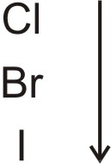
Ans. oxidising behaviour decreases from top to bottom.

Cl2 + 2 X– ———→ 2 Cl– + X2 X– = Br–, I–
Br2 + 2 I– ———→ 2 Br– + I2
∴ Cl2 water oxidises Br– into Br2 and I– into I2 which form layer with CCl4. CCl4 can dissolve Br2 to form Brown layer, dissolves I2 to form Violet layer.
Q. 4. (a) HClO4 is more acidic than HClO3.
OR
pK_{a} of HClO3 is more than HClO4.
Ans.
Conjugate anion of HClO3 Conjugate anion of HClO4
Greater number of oxygen atom, greater is the dispersal of (–) charge, greater is stability of anion.
HClO4 > HClO3
∴ ←———————
Acidity
(b) Interhalogen compounds of F are good flourinating agent ?
Ans. Bonding between XX’ is weaker and are used for flourinating agent.


UNIT—8
THE d- AND f-BLOCK ELEMENTS

Some Important Terms :
Compounds / Minerals / Reagents or mixtures etc of d- and f- block elements.
1. Argentite — Ag2S
2. Argenti ferrous galena — PbS + Ag2S
3. Azurite — Cu (OH)2 . 2 CuCO3
4. Benedict Solution — Alkaline Solution cupric ions complexed with citrate ions.
5. Blue Vitriol — CuSO4 . 5 H2O
(Blue Stone)
6. Bayer’s Reagent — Cold alkaline KMnO4 Solution
7. Blister Copper — 99% Pure Copper
8. Corrosive Sublimate — HgCl2
9. Calomel — Hg2Cl2
10. Calamine — ZnCO3
11. Coinage metal — Cu, Ag and Au
12. Copper Pyrite — CuFeS2 or Cu2S . Fe2S3
13. Copper glance — Cu2S
14. Cinnabar — HgS
15. Chromyl Chloride — CrO2Cl2
16. Chrome Yellow — PbCrO4
(Lemon Chrome)
17. Calaverite — AuTe2
18. Chromic acid mixture — K2CrO7 + Con. H2SO4
19. Delomite — CaCO3 . MgCO3
20. Delta Metal — Cu (55%), Zn (41%), Fe (4%)
21. Fischer’s Salt — K3 [CO (NO2)4]
22. Fehling Solution — CuSO4 + Sod. Pot. Tartarate + NaOH
23. Green Vitriol — FeSO4 . 7 H2O
(Hara Kasis)
24. Ferro Chrome — Fe + 2 Cr + 4 CO
25. Guigret’s green — Cr2O3 . 2 H2O
26. Haematite — Fe2O3
(Red Haematite)
27. Horn Silver — AgCl
(Chloragynite)
28. Lucas reagent — Conc. HCl + anhydrous ZnCl2
29. Lunar Caustic — AgNO3
30. Lithopone — ZnS + BaSO4
31. Lindar Catalyst — Palladised Charcoal deactivated with Sulphur compounds.
32. Malachite — Cu (OH)2 . 2 CuCO3
33. Monel Metal — Cu, Ni and Mn
34. Nesseler’s reagent — K2HgI4
35. Prussian blue — Fe4 [Fe (CN)6]3
36. Pyrites (Fool’s Gold) — FeS2
37. Quick Silver — Hg
38. Schweitzer reagent — Tetramine Copper (II) Sulphate
39. Sterling Silver — Solution of Cu in Hg
40. Scheelite — CaWO4 (Calcium tungstate)
41. Tollen’s reagent — AgNO3 + NaOH
42. Tailing of mercury — Hg2O
43. Vermilion — HgS
44. Willemite — Zn2SiO4
45. Zincite — ZnO
46. Zinc butter — ZnCl2 . 3 H2O
1 MARK QUESTIONS
Q. 1. What is the equivalent wt. of KMnO4 in :
(a) Acidic Medium (b) Neutral Medium (c) In alkaline Medium
Ans. (a) In Acidic Medium the reaction is :
5 e– + 8 H+ + MnO4– ———→ 4 H2O + Mn2+
∴ = = 31.6 g
(b) In Neutral Medium the reaction is :
MnO4– + 2 H2O + 3 e– ———→ MnO2 + 4 OH–
∴ eq. wt. = = = 52.67
(c) In Alkaline Medium the reaction is :
(i) Strongly Alkaline Medium
MnO4– + e– ———→ MnO42–
magnate ion
∴ = = 158
(ii) In Weakly Alkaline Medium the reaction is :
MnO4– + 2 H2O + 3 e– ———→ MnO2 + 4 OH–
Same as in neutral medium
∴ = = 52.67
Q. 2. K2Pt+4Cl6 is well known compound and corresponding Ni4+ Salt it unknown ? Whereas Ni+2 is more stable than Pt+2.
Ans. The stability of the compounds depend upon sum of ionization enthalpies :
IE1 + IE2 < IE1 + IE2
in Ni in Pt
∴ Ni2+ is stable than Pt+2.
IE1 + IE2 + IE3 + IE4 < IE1 + IE2 + IE3 + IE4
in Pt4+ in Ni4+
∴ Pt4+ is stable, ∴ K2PtCl6 is well known compound.
Q. 3. Sc3+ is more stable than Sc2+.
Ans. Sc = 1s² 2s² 2p6 3s² 3p6 3d¹ 4s²
Sc3+ = 1s² 2s² 2p6 3s² 3p6
Inert gas configuration ∴ more stable.
Q. 4. Why KMnO4 is bright in colour ?
Ans. It is due to charge transfer. In MnO4– an electron is momentarily transferred from O to the metal, thus momentarily O2– is changed to O– and reducing the oxidation state of the metal from Mn (VII) to Mn (VI).
Q. 5. Why gold, Pt are dissolved in aqua Ragia ?
Ans. Au + 4 Cl– ———→ AuCl4– + 3 e– (oxidation)
3 e– + 4 H+ + NO3– ———→ NO + 2 H2O (reduction)
———————————————————————————
Au + 4 H+ + 4 Cl– + NO3– ———→ AuCl4– + NO + 2 H2O
———————————————————————————
Pt + 6 Cl– ———→ PtCl62– + 4 e– × 3 (oxidation)
4 e– + 4 H+ + NO3– ———→ NO + 2 H2O × 4 (reduction)
———————————————————————————————
18 Cl– + 3 Pt + 16 H+ + 4 NO3– ———→ 3 PtCl62– + 4 NO + 8 H2O
———————————————————————————————
Q. 6. (a) CrO is basic but Cr2O3 is amphoteric ?
CrO Cr2O3
O. N. + 2 + 3
Ans. (a) Higher the oxidation state higher the acidity. In lower oxidation state some of valence e– of the metal atom are not involved in bonding, ∴ can donate e– and behave as base. In higher oxidation state e– are involved in bonding and are not available, rather it can accept e– and behave as an acid.
(b) Why the following is the order :
V2O3 V2O4 V2O5
O. N. + 3 + 4 + 5
←—————————————
Basicity.
Ans. ∴ Basicity α
refer (a) for reason.
Q. 7. (a) How is Lanthanoids magnetic moment is calculated ?
Ans. b = B. M.
Where S = Spin quantum no.
L = Orbital quantum no.
(b) In the titration of Fe2+ ions with KMnO4 in acidic medium, why dil. H2SO4 is used and not dil. HCl.
Ans. KMnO4 produce Cl2 KMnO4 in presence of dil. HCl acts as oxidising agent, Oxygen produced is used up partly for oxidation of HCl :
2 KMnO4 + 3 H2SO4 ———→ K2SO4 + 2 MnSO4 + 3 H2O + 5 (O)
2 KMnO4 + 4 HCl ———→ 2 KCl + 2 MnCl2 + 2 H2O + 6 (O)
2 HCl + (O) ———→ H2O + Cl2
Q. 8. (a) The E° value for Ce4+/Ce3+ is 1.74 Volt.
(b) K2Cr2O7 is used as Primary Standard in volumetric analysis.
Ans. (a) Ce4+ is strong oxidant, being Lanthanoid it reverts to Ce3+ as + 3 is most stable.
(b) K2Cr2O7 is not much soluble in cold water. However, it is obtained in pure state and is not Hygroscopic in nature.
Q. 9. (a) Although Cu+ has configuration 3 d10 4 s0 (stable) and Cu2+ has configuration 3 d9 (unstable configuration) still Cu2+ compounds are more stable than Cu+.
(b) Titanium (IV) is more stable than Ti (III) or Ti (II).
Ans. (a) It is due to much more (–) Δ Hydration H– of Cu2+ (aq) than Cu+, which is more than compensates for the II ionization enthalpy of Cu.
(b) 22Ti = 3 d² 4 s²
TiIII = 3 d¹
TiII = 3 d²
TiIV = 3 d°
most stable configuration.
∴ TiIV is more stable than TiIII and TiII.
Q. 10. The actinoids exhibit more number of oxidation states and give their common oxidation states.
Ans. As the distance between the nucleus and 5 f orbitals (actinoides) is more than the distance between the nucleus and 4 f (lanthanoids) hence the hold of the nucleus on valence electrons decrease in actinoids. For this reason the actinoids exhibit more number of oxidation states in general.
Common O. N. exhibited are + 3 (similar to Canthanoids) besides + 3 state, also show + 4, maximum oxidation state in middle of series i. e. Pu and Np. have anoidation state upto + 7.
Q. 11. (a) Give reason CrO3 is an acid anhydride.
(b) Give the structure of CrO5.
Ans. (a) CrO3 + H2O ———→ H2CrO4 i. e. CrO3 is formed by less of one H2O molecule from chromic acid :
– H2O
H2CrO4 ———→ CrO3
(b)

Q. 12. A wellknown orange crystalline compound (A) when burnt impart violet colour to flame. (A) on treating (B) and conc. H2SO4 gives red gas (C) which gives red yellow solution (D) with alkaline water. (D) on treating with acetic acid and lead acetate gives yellow p. pt. (E). (B) sublimes on heating. Also on heating (B) with NaOH gas (F) is formed which gives white fumes with HCl. What are (A) to (F) ?
Ans. (i) K2Cr2O7 + 4 NH4Cl + 3 H2SO4 ———→ K2SO4 +
(A) (B) Sublime
2 Cr2O2Cl2 + 2 (NH4)2SO4 + 3 H2O
Chromyl Chloride red gas (C)
(ii) CrO2Cl2 + 4 NaOH ———→ Na2CrO4 + 2 NaCl + 2 H2O
(D) Yellow Soln.
(iii) Na2CrO4 + (CH3COO)2 Pb ———→ PbCrO4 + 2 CH3COONa
Yellow p. pt. (E)
Q. 13. Why is Cr2+ reducing and Mn3+ oxidising when both have d4 configuration ?
Ans. Cr2+ is reducing as its configuration changes from d4 to d3, the d3 has half-filled t2g level. n the other hand, the change from Mn2+ to Mn3+ results in the half filled (dS) configuration which has extra stability.
Cr2+ = 3 d4 4 s0 Mn3+ = 3 d4 4 s0
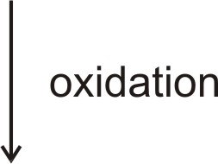
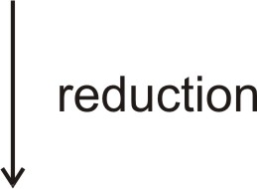

Cr3+ = 3 d3 4 s0
Cr3+ = 3 d3 4 s0 d5
have half-filled half-filled extra
t2g level. stable.
Q. 14. (a) In MnO4– ion all the bonds formed between Mn and Oxygen are covalent. Give reason.
(b) Beside + 3 oxidation state Terbium Tb also shows + 4 oxidation state. (Atomic no. = 65)
Ans. (a) In MnO4–, O. N. is + 7, but it is not possible to lose 7 electrons because very high energy is required to remove 7 electrons. Therefore it forms covalent bonds.
(b) Tb = 65 E. C. is 4 f9 6 s2
Tb4+ = 4 f7 6 s0
half-filled f-orbital ∴ stable.
after losing 4 e– it attains half-filled orbital.
Q. 15. (a) Highest manganese flouride is MnF4 whereas the highest oxide is Mn2O7.
(b) Copper can not librate H2 from dil acids :
Note : Although only oxidising acids (HNO3 and hot conc. H2SO4) react with Cu light.
Ans. (a) The ability of oxygen to form multiple bonds to metals, explain its superiority to show higher oxidation state with metal.
(b) Positive E° value (+ O – 34 Volt) accounts for its inability to liberate H2 from acids. The high energy to transform Cu (s) to Cu2+ (aq) is not balanced by its Hydration enthalpy.
Note : For (b) Consult Fig. 8.4 in NCERT
Q. 16. A metal which is strongly attracted by a magnet is attacked slowly by the HCl liberating a gas and producing a blue solution. The addition of water to this solution causes it to turn pink, the metal is
Ans. The metal is CO
CO + 2 HCl ———→ COCl2 + H2
blue solution
COCl2 in solution is [CO (H2O)6]2+
blue pink


UNIT—9
CO-ORDINATION COMPOUNDS

1 MARK & 2 MARKS QUESTIONS
Q. 1. A cationic complex has two isomers A & B. Each has one Co3+, five NH3, one Br and one SO42. A gives a white precipitate with BaCl2 solution while B gives a yellow precipitate with AgNO3 solution.
(a) What are the possible structures of the complexes A and B ?
(a) Will the two complexes have same colour ?
Ans. (a) [CO (NH3)5 Br] SO4 and [CO (NH3)5 SO4] Br
(b) NO
Q. 2. FeSO4 solution mixed with (NH4)2SO4 solution in 1 : 1 molar ratio gives the test of Fe2+ ion but CuSO4 solution mixed with aqueous ammonia in 1 : 4 molar ratio does not give the test of Cu2+ ion. Explain why ?
Ans. When FeSO4 and (NH4)2SO4 solution are mixed in 1 : 1 molar ratio, a double salt is formed. It has the formula FeSO4 (NH4)2SO4 . 6 H2O. In aqueous solution, the salt dissociates.
When CuSO4 and NH3 are mixed in the molar ratio of 1 : 4 in solution, a complex [Cu (NH3)4] SO4 is formed.
Q. 3. If to an aqueous solution of CuSO4 in two tubes, we add ammonia solution in one tube and HCl (aq) to the other tube, how the colour of the solutions will change ? Explain with the help of reaction.
Ans. In first case, colour will change from blue to deep blue.
[Cu (H2O)4]2+ + 4 NH3 ———→ [Cu (NH3)4]2+ + 4 H2O
deep blue
While in second case, its colour will change to yellow.
[Cu (H2O)4]2+ + 4 Cl– ———→ [CuCl4]2+ + 4 H2O
yellow
Q. 4. A, B and C are three complexes of Chromioum with the empirical formula H12O6Cl3Cr. All the three complexes have Cl and H2O molecules as the ligands. Complex A does not react with conc. H2SO4. Complexes B and C lose 6.75% and 13.5% of their original weight respectively on heating with conc. H2SO4. Identify A, B and C.
Ans. Data suggests that the complexes are hydrate isomers.
As comples A does not lose any molecule of H2O on heating which shows that no water molecule of H2O is outside the co-ordination sphere.
∴ A = [Cr (H2O]0] Cl3
As B loses 6.75% ∴ actual loss in wt.
= × 266.5 = 18 au
B = [Cr (H2O)5 Cl] Cl2 . H2O
As C loses 13.5% of wt. on heating which is twice the loss in the first case, ∴ C isomer exists as a dihydrate :
[Cr (H2O)4 Cl2] Cl . 2 H2O
SCN– F–
Q. 5. Fe3+ ———→ (A) ———→ (B)
excess excess
What are (A) and (B) ? Give IUPAC name of (A). Find the spin only magnetic moment of (B).
Ans. A = Fe (SCN)3, B = [FeF6]3–
IUPAC name of A = trithiocyanato iron (III)
E. C. of Fe (III) = d5, unpaired e–s = 5
Spin only magnetic moment = B. M.
= 5.916 B. M.
Q. 6. A complex is prepared by mixing COCl3 and NH3 in the molar ratio of 1 : 4, 0.1 M solution of this complex was found to freeze at – 0.372 °C. What is the formula of the complex ? Given that molal depression constant of water Kf = 1.86 °C/m.
Ans. The oretical ΔTf = Kf . m
= 1.86 × 0.1
= 0.186°
observed ΔTf = 0.372°
As observed ΔTf is double of the theoretical value this shows that each molecule of the complex dissociates to form two ions. ∴ formula is :
[CO (NH3)4 Cl2] Cl
Q. 7. How t2g and eg orbitals are formed in an octahedral complex ?
Ans. In an octahedral complex, positive metal ion is considered to be present at the centre and negative ligands at the corners. As lobes of dx² – y² and dz² lie along the axes, i. e. along the ligands repulsions are more and so is the energy. The lobes of the remaining three d-orbitals lie between the axes i. e. between the ligands, the repulsions between them are less and so is the energy.
Q. 8. Dimethyl glyoxime is added to alcoholic solution of NiCl2. When ammonium hydroxide is slowly added to it, a rosy red precipitate of a complex appears.
(a) Give the str. of the complex showing hydrogen bond.
(b) Give oxidation state and hybridisation of central metal ion.
(c) Identify whether it is paramagnetic or diamagnetic.
Ans. (a)
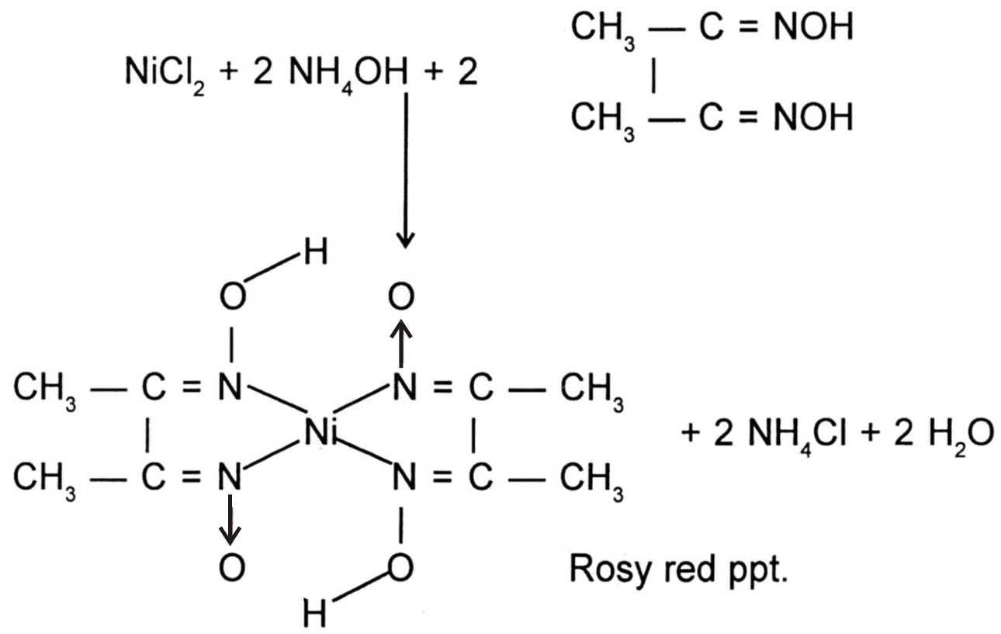

(b) O. S. = + 2
bybridisation = dsp²
(c) diamagnetic as no unpaired electron.
Q. 9. Explain the reason behind a colour of some gem stone with the help of example.
Ans. The colours of many gem stones are due to the presence of transition metal ions & colour are produced due to d-d transition. For example the mineral corundum Al2O3 is colourless when pure but when various M3+ transition metal ions are present in trace amounts various gem stones are formed. Ruby is Al2O3 containing about 0.5 – 1% Cr3+.
Q. 10. How many EDTA (lethylendiamine tetra acetic acid) molecules are required to make an octahedral complex with a Ca2+ ion.
Ans. EDTA is a hexadentate ligand therefore only one EDTA molecule is required to form octahedral complex.
Q. 11. What is the hybridisation of central metal ion and shape of Wilkinson’s catalyst ?
Ans. Wilkinson’s catalyst is (PH3P)3 RhCl. In this Rh has dsp² hybridisation and square planar shape.
Q. 12. Which vitamin is a complex compound of cobalt ?
Ans. Vitamin B12 is a complex compound in which central metal atom is cobalt.
Q. 13. Write the IUPAC name of [CO (NH3)4 B12]2 [ZnCl4].
Ans. Tetraamminedibromocobalt (III) tetrachlorozincate (II)
Q. 14. What is the value of x in the complex HxCO (CO)4 on the basis of EAN rule. (At. No. Co` = 27)
Ans. x = 36 – (27 + 4 × 2)
= 36 – 35
= 1
Q. 15. Why is the silver plating of copper, K [Ag (CN)2] is used instead of AgNO3 ?
Ans. This is because if AgNO3 is used Cu will displace Ag+ from AgNO3. The deposit so obtained is black, soft, non-adhering. To get a good shining deposit, [Ag (CN)2]– are used as it is a stable complex, the conc. of Ag+ is very small in the solution. As such no displacement of Ag+ ions with Cu is possible.


UNIT—10
HALOALKANES AND HALOARENES

1 MARK QUESTIONS
Q. 1. What happens when tert-butyl alcohol is treated with Cu / at 573 K.
Ans. Dehydration reaction will take place. Isobutene will be formed.
CH3 CH2
| CU ||
CH3 — C — OH ——————→ CH3 — C
| 573 K |
CH3 – H2O CH3
Q. 2. Arrange the following halides in order of increasing SN² reactivity :
CH3 — Cl, CH3 — Br, CH3CH2Cl, (CH3)2 CHCl
Ans. (CH3)2 CHCl < CH3CH2Cl < CH3Cl < CH3Br.
(Hint : As the size of the alkyl group increases SN² reactivity decreases.)
Q. 3. Alkyl halides, though polar, are immiscible with water. Why ?
Ans. Alkyl halides cannot form H-bonds with water molecules and hence are insoluble in water.
Q. 4. p-Dichlorbenzene has higher melting point and lower solubility than those of o- and m- isomers. Discuss.
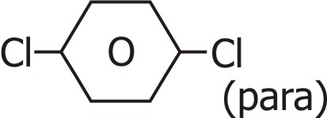
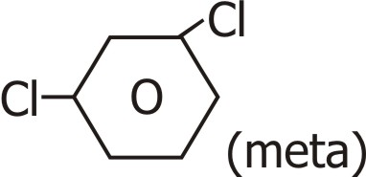
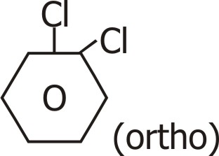
Ans.

The p-isomer being more symmetrical fits closely in the crystal lattice and thus has stronger intermolecular forces of attraction than those of o- and m- isomers. Since during melting or dissolution, the crystal lattice breaks, therefore a larger amount of energy is needed to melt or dissolve the p- isomer than the corresponding o- and meta isomers.
Q. 5. The treatment of alkyl chlorides with aq KOH leads to the formation of alcohols but in presence of alcoholic KOH, alkenes are the major products. Explain.
Ans. In aq. solution, KOH is almost completely ionised to give OH– ions which being a strong nucleophile brings about a substitution reaction to form alcohols. Further in aq. solution, OH– ions are highly solvated (hydrated).
This solution reduces the basic character of OH– ions which fail to abstract a hydrogen from the β-carbon of the alkyl halide to form an alkene.
However an alcoholic solution of KOH contains alkoxide (RO–) ions which being a much stronger base than OH– ions preferentially abstracts a hydrogen from the β-carbon of the alkyl halide to form alkene.
Q. 6. Grignard reagents should be prepared under anhydrous conditions. Why ?
Ans. Because Grignard reagents have a very strong affinity for H+ ions. In presence of water, they abstract H+ ions from water and form alkanes. To prevent this, they should be prepared under anhydrous conditions.
Q. 7. Haloalkanes react with KCN to form alkyl cyanides as major product while AgCN form isocyanide as the chief product. Explain.
Ans. KCN is a ionic compound and provides cyanide ions in solution. Although both carbon and nitrogen atoms are in a position to donate electron pairs, the attack takes place mainly through Carbon atom and not through nitrogen atom since C — C bond is more stable than C — N bond. However AgCN is mainly covalent in nature and nitrogen is free to donate electron pair forming isocyanide as the main product.
Q. 8. Explain why is Chlorobenzene difficult to hydrolyse than ethyl chloride ?
Ans. The lone pair of electrons of Chlorine is Chlorbenzene participates into resonance with the benzene ring.
As a result C — Cl bond acquires a partial double bond character. Therefore, this C — Cl bond is stronger than C — Cl bond in ethyl chloride which is a pure single bond. As such the Chlorobenzene is difficult to hydrolyse than ethyl chloride.
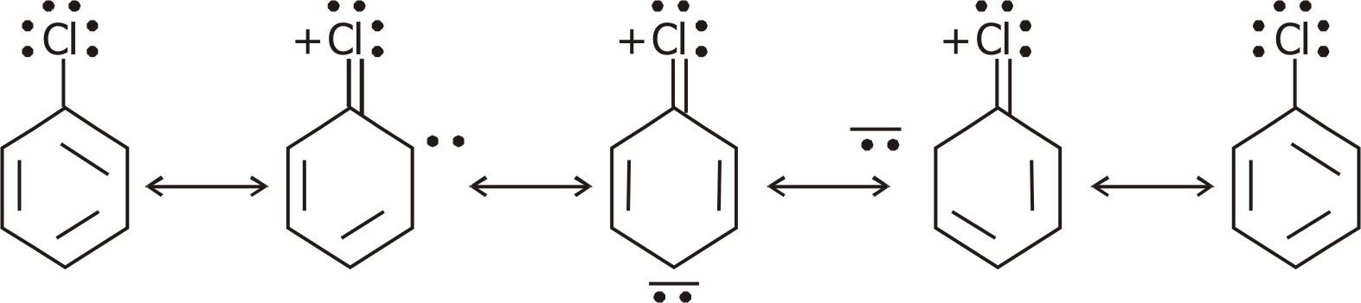

Q. 9. Tert-butyl chloride reacts with aq. NaOH by SN¹ mechanism while n-butyl chloride reacts by SN² mechanism. Why ?
Ans. Tert-butyl chloride reacts via SN¹ mechanism because the heterolytic cleavage of C — Cl bond in tert-butyl chloride gives 3 carbocation which is highly stable and favourable for SN¹ mechanism. Moreover, tert-butyl chloride (3°) bring a bulky molecule has steric hindrance which will not allow SN² mechanism to take place. Hence only SN1 mechanism can occur in tert-butyl chloride. However n-butyl chloride (1°) reacts via SN² because ‘C’ of C — Cl bond is less crowded and favourable for nucleophile to attack from back side results in the formation of transition state. It has less steric hindrance which is a favourable factor for SN² mechanism.
Q. 10. (a) Which of the following two compounds would react faster by SN² pathway : 1-bromobutane (OR) 2-bromobutane.
(b) Allyl Chloride is more reactive than n-propyl Chloride towards nucleophilic substitution reactions. Explain.
Ans. (a) The reactivity in SN² reaction depends upon the extent of steric hindrance. i-bromobutane is a 1° alkyl halide and 2-bromobutane is a 2° alkyl halide. Since there will be some steric hindrance in 2° alkyl halide than in 1° alkylhalide, therefore 1°-bromobutane will react faster than 2-bromobutane in SN² reaction.
(b) Allyl Chloride readily undergoes ionization to produce resonance stabilized allyl carbocation. Since carbocations are reactive species they readily combine with OH– ions to form allyl alcohol.
Ionization +
CH2 = CH — CH2 — Cl ————→ CH2 = CH — CH2
Slow ↑

↓
OH–
CH2 = CH — CH2OH ←———— +CH2 — CH = CH2
Fast
In contrast, n-propyl chloride does not undergo ionization to produce n-propyl carbocation and hence allyl chloride is hydrolysed more readily than n-propyl chloride.
Q. 11. R—Cl is hydrolysed to R—OH slowly but the reaction is rapid if a catalytic amount of KI is added to the reaction mixture.
Ans. Iodide ion is a powerful nucleophile and hence reacts rapidly with RCl to form RI.
KI ———→ K+ + I–; R — Cl + I– ———→ R — I + Cl–
Further I– is a better leaving group than CI– ion, therefore, RI is more rapidly hydrolysed than RCl to form ROH.
HO– + R — I ———→ R — OH + I–
Q. 12. Identify A, B, C, D, E, R, R¹ in the following :
Dry ether H2O
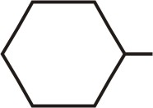
(i) Br + Mg ————→ A ————→ B

Dry ether D2O
(ii) R — Br + Mg ————→ C ————→ CH3 — CH — CH3
|
D
CH3 CH3
| | Na/ether Mg H2O
(iii) CH3 — C — C — CH3 ←———— R¹X ———→ D ———→ E
| |
CH3 CH3

dry ether
Ans. (i) Br + Mg ————→ MgBr———

(A) H2O
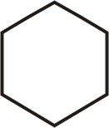

+ Mg (OH) Br

(B)
Dry ether D2O
(ii) RBr + Mg ————→ RMgBr ————→ CH3 — CH — CH3
|
D
Here R = CH3CHCH3
|
CH3 CH3 CH3
| | Na/ether |
(iii) CH3 — C — C — CH3 ←———— CH3 — C — X
| | |
CH3 CH3 CH3

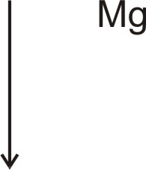

CH3 CH3
| H2O |
CH3 — C — H ←———— CH3 — C — MgBr
| |
CH3 CH3

1 MARK QUESTIONS
Q. 1. Explain why :
Haloalkanes undego nucleophilic substitutions whereas Haloarenes undegoes electrophilic substitutions.
Ans. Haloalkanes are more polar than haloarenes.
∴ C-atom carrying the halogen in haloalkanes is mroe e– deficient than that in haloarenes.
∴ Haloalkanes undergo nucleophilic substitution readily
In haloarenes, the love pair of electrons present on the halogen atom goes into resonance with the aryl ring. The aryl ring being rich in electron density, undergoes electrophilic substitutions.
Q. 2. Why alkyl halides are generally not prepared in laboratory by free radical halogenation of alkanes ?
Ans. It is because :
(i) It gives a mixture of isomeric monohalogenated products whose boiling points are so close that they cannot be separated easily.
(ii) Polyhalogenation may also take place, thereby making the mixture more complex and hence difficult to separate.
Q. 3. Why preparation of aryl iodide by electrophilic substitution requires presence of an oxidising agent ? Why can aryl flouride not be prepared by this method ?
Ans. Reactions with I2 are reversible in nature and require presence of oxidising agent (HNO3, etc.) to oxidise HI formed during iodination and promote forward reaction.
Fluoro compounds cannot be prepared due to high reactivity of flourine.
Q. 4. Why is Sulphuric acid not used during reaction of alcohol with KI ?
Ans. H2SO4 cannot be used along with KI in conversion of an alcohol to alkyl iodide as it converts KI to corresponding HI and then oxidises it to I2.
Q. 5. Why aryl halides are extremely less reactive towards nucleophilic substitution ?
Ans. (i) Resonance effect :
Due to resonance C — Cl bond acquires partial double bond character.
(ii) Difference in hybridisation of Carbon in C —X bond :
in haloarene C-atom attached to halogen in sp² hybrid while sp³ in haloalkane.
C — X bond length in sp² hybrid is shorter and hence stronger and difficult to break.
(iii) Instability of phenyl cation
(iv) Possible repulsion of nucleophile to approach e– rich arenes.
Q. 6. Why thionyl chloride method is preferred for the preparing alkyl chloride from alcohols ?
Ans. Because by products of the reaction, i. e., SO2 and HCl being gases escape into atmosphere leaving behind pure alkyl chloride.
Q. 7. (i) Arrange in order of property indicated :
CH3CH2CH2CH2Br, (CH3)3 Br, (CH3)3 CHCH2 Br
(Increasing boiling point)
(ii) CH3F, CH3I, CH3Cl, CH3Br (nucleophilic substitution)
Ans. (i) B. P. decreases with increase in branching due to decrease in Van der Waals forces of attraction.
(CH3)3 CBr < (CH3)2 CHCH2 Br < CH3CH2CH2CH2Br
(ii) Reactivity increases as C — X bond dissociation energy decreases.
CH3F < CH3Cl < CH3Br < CH3I
Q. 8. Why does 2 bromopentane gives pent-2-ene as major product in elimination reaction ?
Ans. Br
OH– | OH–
CH3 — CH2 = CH = CH2 ←— CH3—CH2—CH2—CH—CH2 —→ CH3CH2CH2CH = CH2
|
H
(81%) (19%)
(Pent-2-ene) (Pent-1-ene)
This is because of Saytzeff’s rule — In dehydrohalogen reactions, the preferred product is that alkene which has the greater number of alkyl groups attached to the doubly bonded carbon atoms.
Q. 9. Why is bond angle in ethers slightly greater than tetrahedral angle ?
Ans. Because, the interaction beetween the two bulky groups is quiet repulsive. Hence angle is slightly larger.
Q. 10. Alcohols reacts with halogen acids to form haloalkenes but phenol does not form halobenzene. Explain.
Ans. The C—O bond in phenol acquires partial double bond character due to resonance and hence be cleared by X– ions to form halobenzenes.
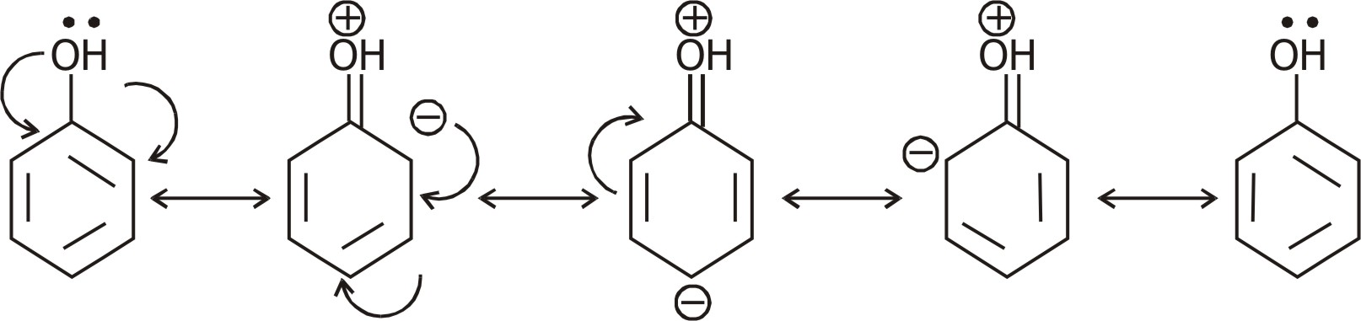

But in alcohols a pure C — O bond is maintained and can be cleared by X– ions.
Q. 11. Explain why o-nitrophenol is more acidic than o-methoxy phenol ?
Ans. Due to — R and — I effect of — NO2 group, e– density on ‘O’ if O — H bond decreases and loss of H+ is easy.
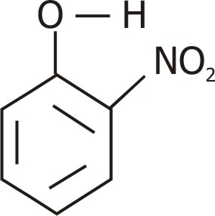
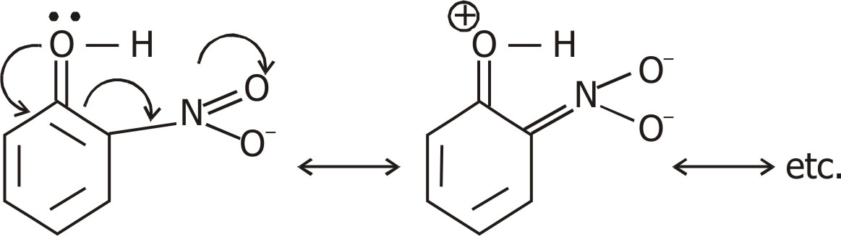

– I effect + ve charge on c-atom
——→ release of H+ easier.
In contrast in o-methoxy phenol due to + R effect, – OCH3 increases. e– density on ‘O’ of O — H group, and hence less of H+ is difficult.

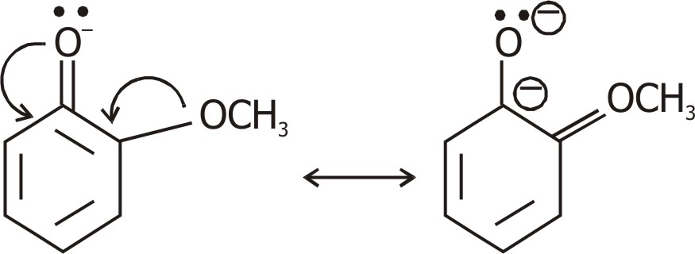

(both –ve charge repel each other)
Q. 12. Why is preparation of ethers by acid catalysed dehydration of 2° and 3° alcohols not a suitable method ?
Ans. Acid catalysed dehydration of 1° alcohols to ethers occurs by SN² reaction involving attack of nucleophile by alcohol on protonated alcohol molecule.
Under these conditions, 2° and 3° alcohols give alkenes rather than others. Due to steric hindrance nucleophilic attack on protonated alcohol does not occur instead they lose one H2O and produce alkenes.
Q. 13. Of benzene and phenol, which is more easily nitrated and why ?
Ans. Nitration is an electrophilic substitution reaction.
The — OH group in phenol increases the e– density at o- and p- position as follows :
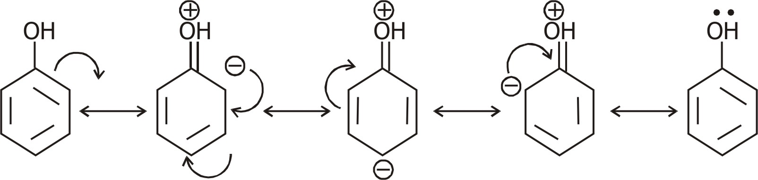

Since phenol has a higher electron density due to electron releasing nature of OH group, compared to benzene, therefore nitration is easy in phenol than benzene.
Q. 14. How will you account for the following :
Ethers possess a net dipole moment even if they are symmetrical in structure ?
Ans.
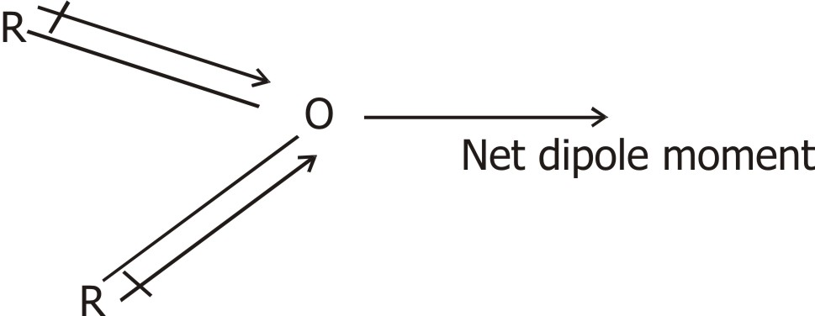

Because of greater electronegativity of o- atom than carbon C – O bonds are polar.
C – O bond are inclined to each other at an angle of 110° (or more), two dipoles do not cancel out each other.
Q. 15. How do 1°, 2° and 3° alcohols differ in terms of their oxidation reaction and dehydrogenation ?
Ans. (I) Oxidation reaction :
(O) (O)
1° alcohol ———→ aldehyde ———→ carboxylic acid
(O) (O)
2° alcohol ———→ ketone ———→ carboxylic acid
(acid with loss of 1 carbon atom)
(O)
3° alcohol ———→ resistant to oxidation

(II) Hydrogenation reaction :
give
1° alcohol ———→ aldehyde
2° alcohol ———→ ketone
3° alcohol ———→ alkene
3° alcohols prefer to undergo dehydration and form alkene.
Q. 16. (I) How is diethyl ether prepared from ethyl alcohol ?
Ans. Ethyl alcohol is first treated with sodium to form sodium ethoxide.
C2H5OH + Na ———→ C2H5O– Na+ + H2
Sodium ethoxide is then treated with ethyl halide to form di ethyl ether.
SN²
C2H5O Na + X — C2H5 ———→ C2H5O C2H5 + NaX
(Williamson synthesis)
(II) Complete the rxn :
(a) CH3OCH3 + PCl5 ———→
(b) C2H5OCH3 + HCl ———→
(c) (C2H5)2 O + HCl ———→
Ans. (a) 2 CH3Cl
(b) CH3Cl + C2H5OH
(c) C2H5Cl + C2H5OH
Q. 17. Why is reactions of alcohol/phenol and with acid chloride in the presence of pyridine ?
Ans. Because esterification rxn is reversible and presence of base (pyridine) neutralises HCl produced during reaction thus promoting forward reaction.
Q. 18. How can we produce nitro benzene from phenol ?
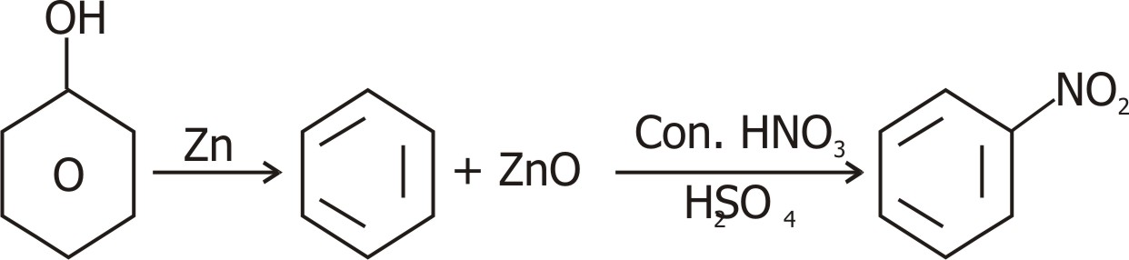

Ans. (I) First convert phenol to benzene by heating with Zn dust.
(II) Nitration of benzene with conc. nitric acid in presence of conc. sulphuric acid.


UNIT—11
ALCOHOLS, PHENOLS AND ETHERS

1 MARK QUESTIONS
Q. 1. What is the main product obtained when vapours of t-butyl alcohol are passed over copper at 300° ?
Ans. Isobutylene (2-Methyl propene)
Q. 2. What is usually added to ethyl alcohol to make it unfit for drinking purposes ?
Ans. Methanol and Pyridine.
Q. 3. Phenol has smaller dipole moment than methanol.
(OR)
Why are dipole moments of phenols smaller than dipole moments of alcohols ?
Ans. Due to electron-withdrawing effect of the benzene ring, the C — O bond in phenol is less polar but in case of methanol due to electron-donating effect of — CH3 group, C — O bond is more polar.
Q. 4. Name the products obtained when anisole is treated with HI.
Ans. Phenol and methyl iodide.
Q. 5. Why are Grignard reagents soluble in ether but not in benzene ?
Ans. Grignard reagents from co-ordination complexes with ether but not benzene since the former has lone pair of electrons but the later does not.
Q. 6. Alcohols are easily protonated than phenols. Justify.
Ans. In phenols lone pair of electrons on the oxygen atom are delocalised over the benzene ring due to resonance and hence are not easily available for protonation. In contrast in alcohols, the lone pairs of electrons on the oxygen atom are localized due to absence of resonance and hence are easily available for protonation.
Q. 7. Di-tert butyl ether cannot be made by Williamson’s synthesis. Explain why ?
Ans. To prepare di tert-butyl ether by Williamson’s synthesis, we need tert-butyl bromide and Sodium tertiary butoxide. Since tert-butyl bromide being 3°-alkyl halide prefers to undergo elimination rather than substitution, therefore the product obtained is isobutylene rather than ditertiary butyl ether.
Q. 8. While separating a mixture of ortho and para-nitro phenols by steam distillation, name the isomer which will be steam volatile. Give reasons.
Ans. In o-nitrophenol, there is intramolecular hydrogen bonding as follows :
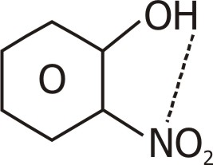

In p-nitrophenol, there is intramolecular hydrogen bonding as follows :
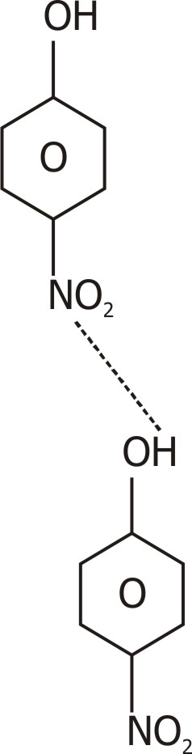

Due to intermolecular H bonding in p-nitrophenol, its b. p. is much higher than that of o-nitrophenol. Hence o-nitraphenol due to its lower b. p. is steam volatile while p-nitrophenol is not.
Q. 9. How an — OH group attached to carbon in the benzene ring activates benzene towards electrophilic substitution ?

Ans.
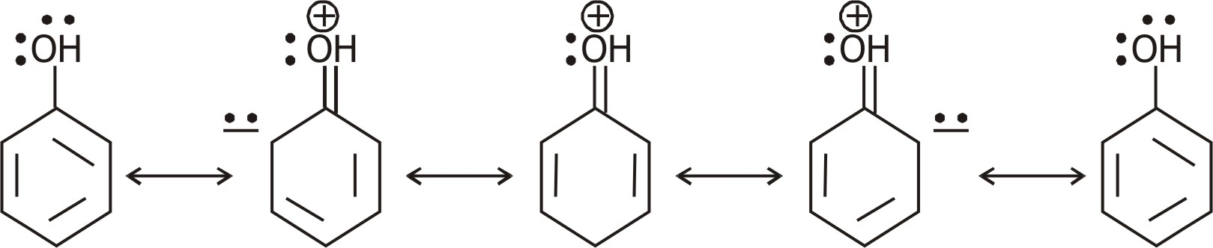

The lone pair of electrons present on oxygen atom enter into resonance with the benzene ring. As a result, the electron density becomes higher at o- and p- position and due to higher electron density, the ring gets activated towards electrophilic substitution.
Q. 10. Ethers are cleaved by acids not by based. Why ?
Ans. The C — O — C bond in ethers like the C — OH bond in alcohols is quite strong. In order to weaken it, the oxygen atom must be protonated. A subsequent nucleophile attack by a strong nucleophile such as Br– as I– ion on the less hindered carbon atom of the protonated :
+
C — O — C
|
H
bond brings about the cleavage of ethers to form an alcohol and an alkyl halide. The acids only can provide the H+ ion required for protonation of O atom of ether and therefore only acids can bring about the cleavage of ethers and not bases.
Q. 11. Phenols do not undergo substitution of the — OH group like alcohols. Explain.
Ans. The C — O bond in phenols has some double bond character due to resonance and hence cannot be easily cleaved by a nucleophile. In contrast, the C — O bond in alcohols is a pure single bond and hence can be easily cleaved by a nucleo phile.
Q. 12. Alcohols acts as weak bases. Explain.
Ans. The oxygen atom of the hydroxyl group has two lone pairs of electrons. Therefore alcohols accept a proton from strong mineral acid to form oxonium ions. Hence act as weak bases.
Q. 13. Write the mechanism of hydration of ethene to yield ethanol.
Ans. H2O + H+ ———→ H3O+
Step (i) : — Protonation of alkene to form carbocation by electrophilic attack :

Step (ii) : — Nucleophilic attack of water on carbocation :
Step (iii) : — Deprotonation to form an alcohol :


UNIT—12
ALDEHYDES, KETONES AND
CARBXYLIC ACID

1 MARK QUESTIONS
Q. 1. Name the reaction and the reagent used for the conversion of acid chlorides to the corresponding aldehydes.
Ans. Name : Rosenmund’s reaction
Reagent : H2 in the presence of Pd (supported over BaSO4) and partially poisoned by addition of Sulphur or quinoline.
O O
|| Pd/BaSO4 ||
R — C — Cl + H2 ————————→ R — C — H + HCl
+ S or quinoline
Q. 2. Suggest a reason for the large difference in the boiling points of butanol and butanal, although they have same solubility in water.
Ans. The b. pt. of butanol is higher than that of butanal because butanol has strong intermolecular H-bonding while butanal has weak dipole-dipole interaction. However both of them form H-bonds with water and hence are soluble.
Q. 3. What type of aldehydes undergo Cannizaro reaction ?
Ans. Aromatic and aliphatic aldehydes which do not contain α hydrogens.
Q. 4. Out of acetophenone and benzophenone, which gives iodoform test ? Write the reaction involved.
(The compound should have CH3CO-group to show the iodoform test.)
Ans. Acetophenone (C6H5COCH3) contains the grouping (CH3CO attached to carbon) and hence given iodoform test while benzophenone does not contain this group and hence does not give iodoform test.
C6H5COCH3 + 3 I2 + 4 NaOH ———→ CHI3 + C6H5COONa + 3 NaI + 3 H2O
Acetophenane Iodoform
I2/NaOH
C6H5COC6H5 ———→ No reaction
Q. 5. Give Fehling solution test for identification of aldehyde gp (only equations). Name the aldehyde which does not give Fehling’s soln. test.
Ans. R — CHO — 2 Cu2+ + 50 H– ———→ RCOO– + Cu2O ↓ 3 H2O
Benzaldehyde does not give Fehling soln. test.
(Aromatic aldehydes do not give this test.)
Q. 6. What makes acetic acid a stronger acid than phenol ?
Ans. Greater resonance stabilization of acetate ion over phenoxide ion.
Q. 7. Why HCOOH does not give HVZ (Hell Volhand Zelinsky) reaction but CH3COOH does ?
Ans. CH3COOH contains α hydrogens and hence give HVZ reaction but HCOOH does not contain α-hydrogen and hence does not give HVZ reaction.
Q. 8. During preparation of esters from a carboxylic acid and an alcohol in the presence of an acid catalyst, water or the ester formed should be removed as soon as it is formed.
Ans. The formation of esters from a carboxylic acid and an alcohol in the presence of acid catalyst in a reversible reaction.
H2SO4
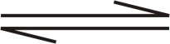
RCOOH + R’OH RCOOR’ + H2O
Carboxylic acid alcohol Ester
To shift the equilibrium in the forward direction, the water or ester formed should be removed as fast as it is formed.
Q. 9. Arrange the following compounds in increasing order of their acid strength.
Benzoic acid, 4-Nitrobenzoic acid, 3, 4-dinitrobenzoic acid, 4-methoxy benzoic acid.
Ans. Since electron donating gps. decrease the acid strength therefore 4-methoxybenzoic acid is a weaker acid because methoxy sp. is E. D. G. than benzoic acid. Further since electron withdrawing gps. increase the acid strength, therefore both 4 nitrobenzoic acid and 3, 4-dinitrobenzoic acids are stronger acid than benzoic acid. Further due to the presence of additional NO2 gp at m-position wrt COOH gt, 3, 4-dinitrobenzoic acid is a lattice stronger acid than 4-nitrobenzoic acid. Thus the increasing order of acid strength will be :
4-methoxybenzoic acid < benzoic acid < 4-nitrobenzoic acid < 3, 4, dinitrobenzoic acid.
Q. 10. How is tert-butyl alcohol obtained from acetone ?
Ans.
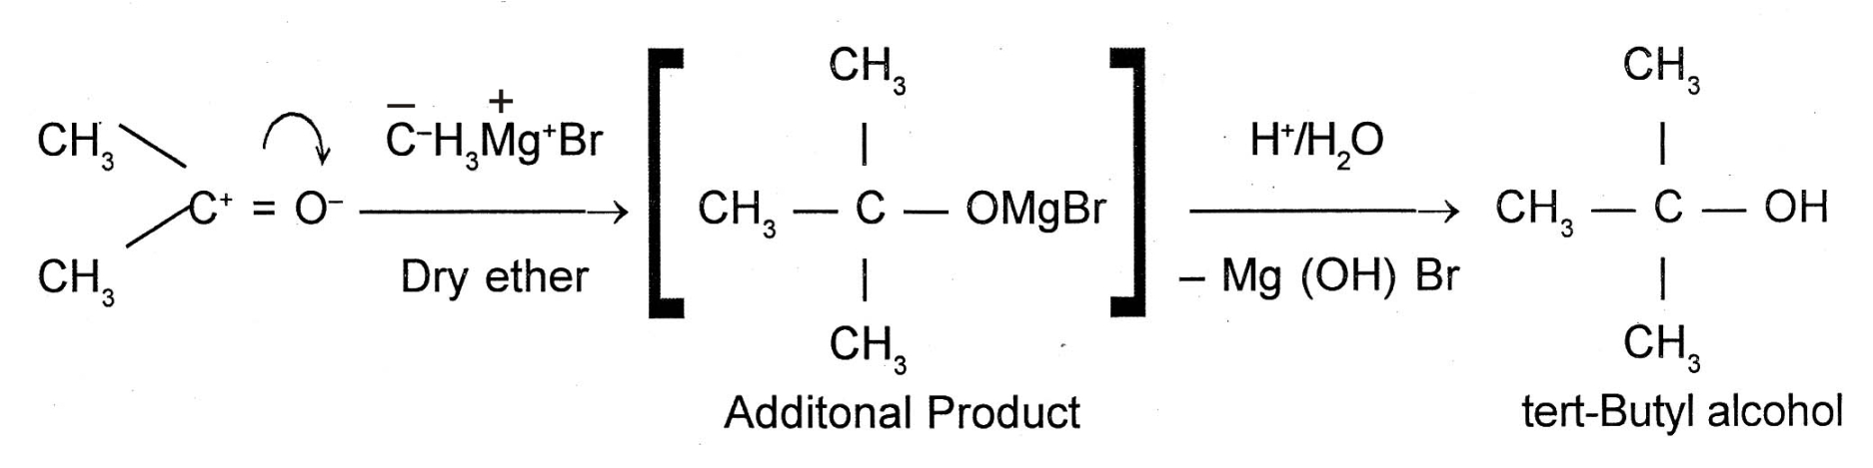

Q. 11. Give IUPAC name of the following compound :
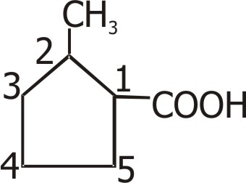

Ans. 2-methylcyclopent-3-ene-1-oic acid
Q. 12. How will you distinguish between methanol and ethanol ?
Ans. By Iodoform test :
Ethanol having α-methyl gp will give yellow ppt. of iodoform whereas methanol does not have α-methyl gp will not give ppt. of iodoform.
Q. 13. Distinguish between :
(i) Acetaldehyde and acetone
(ii) Methanoic acid and Ethanoic acid.
Ans. (i) Acetaldehyde will give positive tests with Tollen’s reagent and Fehling Solns. whereas acetone will not give these test.
(ii) Methanoic acid gives Tollen’s reagent test whereas ethanoic acid does not due to difference in their boiling points.
Q. 14. Why are aldehydes more reactive than ketones ?
Ans. It is because of 2 reasons :
The carboxyl compounds (both aldehydes & ketones) undergo nucleophilic addition reaction.
(i) + I effect : The alkyl group in ketones due to their e– releasing character decrease the electrophilicity / + ve charge on c-atom and thus reduce its reactivity.
(ii) Steric hindrance : Due to steric hindrance in ketones, they are less reactive.
Q. 15. Give the composition of Fehling A and Fehling B ?
Ans. Fehling A = aq. CuSO4
Fehling B = alkaline sodium potassium tartarate
(Rochelle Salt)
Q. 16. Name one reagent which can distiguish between 2-pentanone and 3-pentanone ?
Ans. 2-pentanone has a CH3CO-group, hence gives positive iodoform test.
3-pentanone does not have a CH3CO-group, hence does not give positive iodoform test.
Iodoform test ———→ I2/NaOH
O
|| I2
CH3CH2CH2 — C — CH3 + NaOH ———→ CHI3
(yellow ppt.)
O
||
CH3 — CH2 — C — CH2 — CH3 ———→ No rxn.
Q. 17. Why pcc cannot oxidise methanol to methane and while KMnO4 can ?
Ans. This is because pcc is a mild oxidising agent and can oxide methanol to methanal only.
While KMnO4 being strong oxidising agent oxidises it to methanoic acid.
Q. 18. Would you expect benzaldehyde to be more reactive or less reactive in nucleophlic addition reaction than propanal ? Explain.
Ans. C-atom of carbonyl group of benzaldehyde is less electrophilic than C-atom of carbonyl group in propanal. Polarity of carbonyl group is in benzaldehyde reduced due to resonance making it less reactive in nucleophilic addition reactions.
There is no such resonance effect in propanal and so the polarity of carboxyl group in it is more than in benzaldehyde. This makes propanal more reactive than benzaldehyde.
Q. 19. What are Hemiacetal and acetal ?
Ans. Hemiacetal and acetals are formed by addition of alcohols on carboxyl compounds.
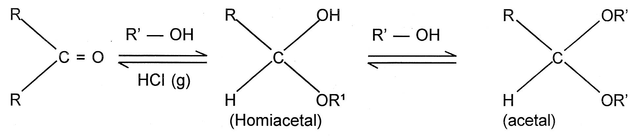

Q. 20. Why does methanal not give aldol condensation while ethanol gives ?
Ans. This is because only those compounds which have α hydrogen atoms can undergo aldol reaction. Ethanol possesses α-hydrogen and ∴ undergoes aldol condensation. Methanal has no α hydrogen atoms, hence does not undergo aldol condensation.
Q. 21. Why does methanal undergoes Cannizaro’s rxn ?
Ans. Because it does not possesses α hydrogen atom. Only those aldehydes can undergo Cannizaro reaction which do not possess α hydrogen atoms.
Q. 22. Arrange the following in order of increasing boiling points :
CH3CH2CH2OH, CH3CH2CH2CH3, CH3CH2 — OCH2CH3, CH3CH2CH2CHO
Ans. CH3CH2CH2CH3 < C2H5OC2H5 < CH3CH2CH2CHO < CH3 (CH2)2 OH
(hydrogen) (ether) (aldehyde) (alcohol)
——————————————————→
increase in bond polarity.
Q. 23. Why does solubility decreases with increasing molecular mass in carboxylic acid ?
Ans. Because of increase in alkyl chain length which is hydrophobic in nature.
Q. 24. Although phenoxide ion has more no. of resonating structures than carboxylate ion, carboxylic acid is a stronger acid. Why ?
Ans. Conjugate base of phenol —→ phenoxide ion has non equivalent resonance structures in which –ve charge is at less electronegative C-atom and +ve charge is at more electronegative O-atom.
∴ Resonance is not so effective.
In carboxylate ion, – ve charge is delocalised on two electronegative O-atoms hence resonance is more effective.
Q. 25. There are two — NH2 group in semicarbazide. However, only one is involved in formation of semicarbazones. Why ?
Ans. Although semicarbazide has two — NH2 groups but one of them is involved in resonance.
O O– O–
|| + | . . | +
H2N — C — NH2NH2 ←—→ H2N = C — NH — NH2 ←—→ H2 N — C = NH — NH2
As a result, e– density on one of the — NH2 group is reduced and hence it does not act as nucleophile.
∴ Lone pair of other — NH2 group is not involved in resonance and is available for nucleophilic attack.

2 MARKS QUESTIONS
Q. 1. Arrange the following carboxyl compounds in increasing order of their reactivity in nucleophilic addition reactions. Explain with proper reasoning :
Benzaldehyde. p-tolualdeyde, p-nitrobenzaldehyde, Acetophenone.
Ans. Acetophenone is a ketone while all others are aldehydes, therefore it is least reactive. In p-tolualdehyde, there is methyl group (CH3) at para position w.r.t. to the carboxyl gp, which increases electron density on the carbon of the carboxyl gp by hyperconjugation effect thereby making it less reactive than benzaldehyde.
On the other hand, in p-nitrobenzaldehyde, the NO2 gp is a powerfuil electron-withdrawing gp. It withdraws electrons both by inductive and resonance effect thereby decreasing the electron density on the carbon atom of carboxyl gp. This facilitates the attack of the nucleophile and hence makes it more reactive than benzaldehyde.
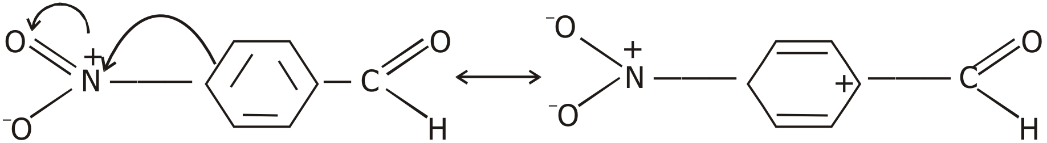

Therefore, the overall order of increasing reactivity :
acetophenone < p-tolualdehyde < benzaldehyde < p-nitrobenzaldehyde.
Q. 2. Arrange the following compounds in increasing order of their boiling points. Explain by giving reasons.
CH₃CHO, CH3CH2OH, CH3OCH3, CH3CH2CH3.
Ans. The molecular masses of all these compounds are comparable :
CH3CHO (44), CH3CH2OH (46), CH3COCH3 (46), CH3CH2CH3 (44).
CH3CH2OH exists as associated molecule due to extensive intermolecular hydrogen bonding and hence its boiling point is the highest (351 K). Since dipole-dipole interaction are stronger in CH3CHO than in CH3OCH3, hence boiling point of CH3CHO (293 K) is much higher than that of CH3OCH3 (249 K). Further, molecules of CH3CH2CH3 have only weak Vander Waals forces while the molecules of CH3OCH3 have little stronger dipole-dipole interactions and hence the boiling point of CH3OCH3 is higher (249 K) than that of CH3CH2CH3 (231 K). Thus the over all increasing order of boiling points is :
CH3CH2CH3 < CH3OCH3 < CH3CHO < CH3CH2OH
Q. 3. Which acid of each pair shown here would you expect to be stronger ?
CH3CO2H or FCH2CO2H

Ans.
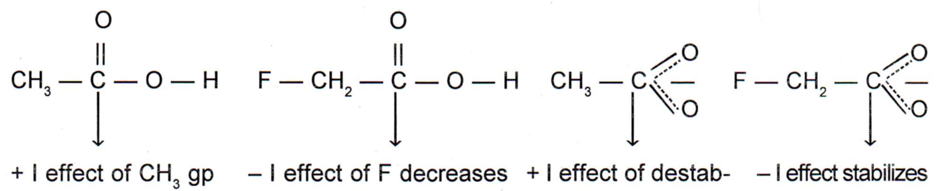

increases the electron the electron density in the lizes the carboxylate the carboxyate
density in the O — H O — H bond thereby ion by intensifying ion by dispersing
bond thereby making making the release of a the – ve charge. the – ve charge.
the relase of a proton proton easier.
difficult.
Thus due to lesser electron density in the O — H bond and greater stability of FCH2COO– ion over CH3COO– ion FCH2COOH is a stronger acid than CH3COOH.
Q. 4. Which acid is stronger and why ?

F3C — — COOH or H3C → — COOH

Ans. F3C — — C CH3 → — C

CF3 has a strong – I effect. CH3 has a weak + I effect.
It stabilises the carboxylate ion It stabilises the carboxylate ion
by dispersing the – ve charge. by intensifying the – ve charge.
Therefore due to greater stability of F3C — C6H4 — COO– (p) ion over CH3 — C6H4COO– (p) ion, F3C — C6H4 — COOH is a much stronger acid than CH3 — C6H4 — COOH.
Q. 5. Arrange the following compounds in increasing order of their reactivity towards HCN. Explain it with proper reasoning.
Acetaldehyde, Acetone, Di-tert-butyl ketone, Methyl tert-butyl ketone.
Ans. Addition of HCN to the carboxyl compounds is a nucleophilic addition reaction.
The reactivity towards HCN addition decreases as the + I effect of the alkyl gp/s increases and/or the steric hindrance to the nucleophilic attack by CN– at the carboxyl carbon increases. Thus the reactivity decreases in the order.
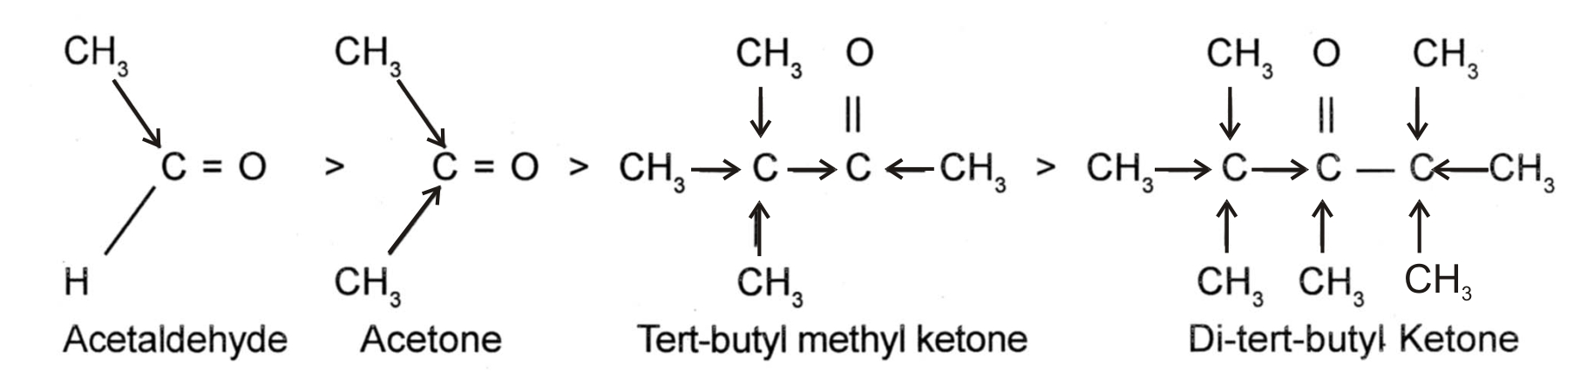

——————— + I effect increases———————→
——————— Steric hindrance increases———————→
——————— Reactivity towards HCN addition decreases ———————→
In other words, reactivity increases in the reverse order, i. e.,
Ditert-butyl Ketone < tert-Butyl methyl Ketone < Acetone < Acetaldehyde
Q. 6. Write structural formulae and names of four possible aldol condensation products from propanal and butanal. In each case, indicate which aldehyde acts as nucleophile and which as electrophile.
Ans. (i) Propanal as nucleophile as well as elecrophile.
OH CH3
5 4 3 | 2 | 1
CH3CH2CHO + CH3CH2CHO ——→ CH3CH2 — CH — CH — CHO
Propanal Propanal 3-hydroxy-2-methyl pentanal
(ii) Propanal as electrophile and butanal as nucleophile.
OH CH2 — CH3
5 4 3 | 2 | 1
CH3CH2CHO + CH3CH2CH2CHO ——→ CH3CH2CH — CH — CHO
Propanal Butanal 2-ethyl-3-hydroxy pentanal
(Electrophile) (Nucleophile)
(iii) Butanal as electrophile and propanal as nucleophile.
OH CH3
6 5 4 3 | 2 | 1
CH3CH2CH2CHO + CH3CH2CHO + ——→ CH3CH2CH2 — CH — CH — CHO
Butanal Propanal 3-hydroxy-2-methyl pentanal
(Electrophile) (Nucleophile)
(iv) Butanal both as nucleophile as well as an elecrophile.
OH CH2CH3
6 5 4 3 | 2 | 1
CH3CH2CH2CHO + CH3CH2CH2CHO + ——→ CH3CH2CH2 — CH — CH — CHO
Butanal Butanal 2-ethyl-3-hydroxy hexanal
(Electrophile) (Nucleophile)
Q. 7. An organic compound with the molecular formula C9H10O forms 2, 4-DNP derivative, reduces Tollen’s reagent and undergoes Cannizaro reaction. On vigorous oxidation, it gives 1, 2-benzenedicarboxylic acid. Identify the compound.
Ans. (i) Since the given compound with M. F. C9H10O forms a 2, 4-DNP derivative and reduces Tollen’s reagent, it must be an aldehyde.
(ii) Since it undergoes Cannizaro reaction, therefore CHO gp. is directly attached to the benzene ring.
(iii) Since on vigorous oxidation, it gives 1, 2-benzene dicarboxylic acid, therefore it must be an ortho substituted benzaldehyde. The only o-substituted aromatic aldehyde having M. F. C9H10O is 2-ethyl benzaldehyde. All the reactions can now be explained on the basis of this structure.

[Ag (NH3)2]+ OH– [O]
Ag ↓ + ←——————— ————→
Tollen’s reagent

Silver
mirror 2-ethyl benzoate 2-ethyl benzaldehyde 1, 2-benzene dicarboxylic acid
(M. F. C9H10O)

2, 4-dinitrophenyl hydrozene

2, 4-DNP derivative
Q. 8. Explain why o-hydroxybenzaldehyde is a liquid at room temperature while p-hydroxybenzaldehyde is a high melting solid.
Ans. Due to interamolecular H-bonding ortho-hydroxy benzaldehyde exists as discrete molecule whereas due to intermolecular H-bonding, p-hydroxybenzaldehyde exists as associated molecules. To break these intermolecular H-bonds, a large amount of energy is needed. Consequently, p-hydroxybenzaldehyde has a much higher m. pt. and b. pt. than that of o-hydroxy benzaldehyde. As a result, o-hydroxy benzaldehyde is a liquid at room temperature while p-hydroxy benzaldehyde is a high melting solid.
Q. 9. Identify A, B and C and give their structures :
Br2 H+
———→ A + B ———→ C (C17H12O)
NaOh Δ

Ans. The given compound (I) contains CH3CO gp and hence in the presence of Br2/NaOH undergoes haloform reaction to give sodium salt of carboxylic acid (A) and bromoform CHBR3 (B). (A) on protonation gives the corresponding acid (II). (II) being a β-ketoacid readily undergoes decarboxylation to give 2-methylcylohexanane (C).
Br2/NaOH H+
——————→ CHBr3 + ———→
Haloform reacn (B)

(A)
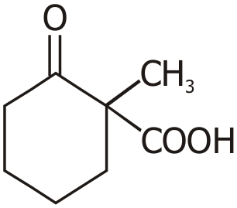
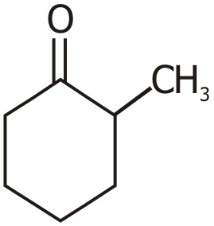
H+ Δ (— CO2)
——————→ ———————→
Dexcarboxylation

(A β-keto acid) 2-methyl cyclo hexanone
(C) M. F. = C7H12O


UNIT—13
ORGANIC COMPOUNDS
CONTAINING NITROGEN

1 MARK QUESTIONS
Q. 1. Why the presence of a base is essential in the ammonolysis of alkyl halides ?
Ans. During ammonolysis of alkyl halides, the acid liberated during the reaction combines with the amine formed to form amine salt. To liberate free amine from the amine salt, a base is needed.
Q. 2. Although — NH2 gp is an ortho and para directing gp, nitration of aniline gives along with ortho and para, meta derivatives also.
Ans. Nitration is carried out with a mixture of Conc. NO3 + Conc. H2SO4 (nitrating mix). In the presence of these acids, most of aniline gets protonated to form anilinium ion. Therefore, in the presence of acids, the reaction mixture consists of aniline and anilinium ion. Now – NH2 gp in aniline is O, p-directing and activating while –N+H3 gp in anilinium ion is m-directing and deactivating hence a mixture of all three–ortho, para and meta derivatives is formed.
Q. 3. Pkb of aniline is more than that of methyl amine.
Ans. In aniline, the lone pair of electrons on the N-atom are delocalized over the benzene ring. As a result electron density on the nitrogen decreases. In contrast in CH2NH2, + I effect of CH3 increase the electron density on the N-atom. Therefore, aniline is a weaker base than methylamine and hence its Pkb value is higher than that of methylamine.
Q. 4. Aniline gets coloured on standing in air for a long time. Why ?
Ans. Due to strong electron-donating effect (+ R effect) of NH2 gp, the electron density on the benzene ring increases. As a result, aniline is easily oxidised on standing in air for a long time to form coloured products.

Q. 5. CH3CONH2 is a weaker base than CH3CH2NH2.
Ans. Due to resonance, the lone pair of electrons on the nitrogen atom in CH3CONH2 is delocalised over the keto gp. There is no such effect in CH3CH2NH2. Due to reduction in electron density on N of CH3CONH2, it is a weaker base than CH3CH2NH2.
Q. 6. Aromatic primary aminies can’t be prepared by Gabriel phthalimide synthesis.
Ans. The preparation of aromatic primary amines (Aniline) by Gabriel phthalimide reaction requires the treatment of pot. phthalimide with C6H5Cl or C6H5Br, which is a nucleophilic substitution Rx^{n}. Since aryl halides do not undergo nucleophilic substitution under ordinary laboratory conditions, therefore C6H5Cl or C6H5Br does not react with pot. phthalimide to give N-phenyl. Phthalimide and hence aromatic primary amines can’t be prepared by this method.
Q. 7. Accomplish the following conversions :
(i) Nitrobenzene to benzoic acid
(ii) Benzyl Chloride to 2-phenylethanamine
Ans. (i) NaNO2 + HCl
(i) Fe/HCl 273 – 278 K CuCN/HCN
—————→ —————→ —————→
(ii) NaOH Diazotization Benzene
Diazanium
Aniline Chloride Benzonitrile
H3+O
—————→
Hydrolysis

Benzoic acid
(ii)
KCN (aq) Δ LaAlH4
—————→ —————→
– KCl Redue

Benzyl Chloride Phenyl ethanenitrite 2-phenylethanamine
Q. 8. Give the structures of A, B and C in the following compounds :
NaCN OH– NaOH + Br2
(i) CH3CH2I ———————→ A ——————→ B ——————→ C
Partial Hydrolysis

NH3 NaOBr NaNO2/HCl
(ii) CH3COOH ———————→ A ——————→ B ——————→ C
D
Ans. O
NaCN OH– ||
(i) CH3CH2I ——————→ CH3CH2CN ——————→ CH3 — C — NH2
(Partial Hydrolysis)
Propanenitrile (A) Ethanamide (B)
NaOH + Br2
———————————→ CH3 — NH2
Hofmann bromamide reacn Methanamine (C)
NH3 NaOBr NaNO2/HCl
(ii) CH3COOH ———→ CH3CONH2 ———————→ CH3NH2 ——————→ CH3OH
D (Hofmann bromamide ↓
Ethanoic acid Ethanoimide (A) reac.) Methanamine (B) Methanol (C)
Q. 9. Why is it difficult to prepare pure amines by ammonolysis of alkyl halides ?
Ans. By ammonolysis of alkyl halides, a mixture of primary, secondary and tertiary amines is formed. So it is difficult to separate it.
Rx Rx Rx Rx
NH3 ———→ R — NH2 ———→ R2 — NH ———→ R3 — N ———→ R4 N+ X–
1° amine 2° amine 3° amine Quaternary Salt
Q. 10. Can tertiary amines undergo acetylation reactions ? Explain.
Ans. For an amine to undergo acetylation, it should have a replaceable hydrogen atom. Tertiary amines cannot undergo acetylation reactions because these do not have replaceable hydrogen atom.
Q. 11. Sulphanilic acid has acidic as well as basic group; but it is soluble in alkali but insoluble in mineral acids. Explain.
Ans. Sulphanilic acid exists as Zwitter ion as :
In the presence of dil. NaOH the weakly acidic — NH3+ group transfers its H+ to OH– to form soluble salt P — NH2C6H4SO3–Na+. On the other hand, — SO3+ group is a very weak base and does not accept H+ from dil HCl to form NH3C6H4SO3H and therefore, it does not dissolve in dil HCl.
Q. 12. Why are aliphatic amines more basic than aromatic amines ?
Ans. In Aromatic amines, due to resonance, N-atom acquries +ve charge and ∴ lone pair of N-atom is less available.
In aliphatic amines, due to e– releasing nature of alkyl groups lone pair of e– on N-atom is more available.
∴ More basic.
Q. 13. Explain why :
(i) Ethylamine is soluble in water but aniline is not.
(ii) Aniline does not undergo Friedel Crafts reaction.
(iii) Diazonium salts of aromatic amines are more stable than that of aliphatic amines.
Ans. (i) Ethyl amine dissolves in water due to formation of H-bonding with water molecules.
H H
| |
H — N - - - - - - - - - - - - H — O - - - - - - - H — N - - - - - - - - H — O - - - - - -
| | | |
C2H5 H C2H5 H

H — N — H
|
C2H5
However in Aniline, due to larger hydrophobic alkyl part extent of H-bonding decreases considerably
∴ insoluble in water.
(ii) Aniline being a Lewis base reacts with Lewis acid AlCl3 or FeCl3 to form a salt.
C6H5NH2 + AlCl3 ———→ C6H5NH2+AlCl3–
Lewis base Lewis acid
As a result, N-atom acquires + ve charge and hence acts as a strong deactivating group for electrophilic reaction.
(iii) Diazonium salts of aromatic amines are more stable due to dispersal of +ve charge on benzene ring due to resonance.
In aliphatic amines, there is no such dispersal of + ve charge due to absence of resonance.
Q. 14. Why 1° amines have got higher boiling point than 3° amines ?
Ans. Due to presence of two H-atoms, in 1° amines they undergo extensive hydrogen bonding while due to absence of H-atom in 3° amines do not undergo H-bonding.
- - - - - - - - H R H - - - - - - - -
| | |
R — N — H - - - - - - - - N — H - - - - - - - - N — R
| |
H H - - - - - - - -

- - - - - - - - H — N — R
|
H

Due to extensive hydrogen bonding in 1° amines, they have higher boiling point – 7 than 3° amines.
Q. 15. How can you distinguish between 1° and 2° amine ?
Ans. (i) Carbylamine test :
R — NH2 + CHCl3 + 3 KOH ———→ R — NC + 3 KCl + H2O

(pungent smelling)
2° amines do not give this test.

(ii) Aryl sulphonyl chloride test :
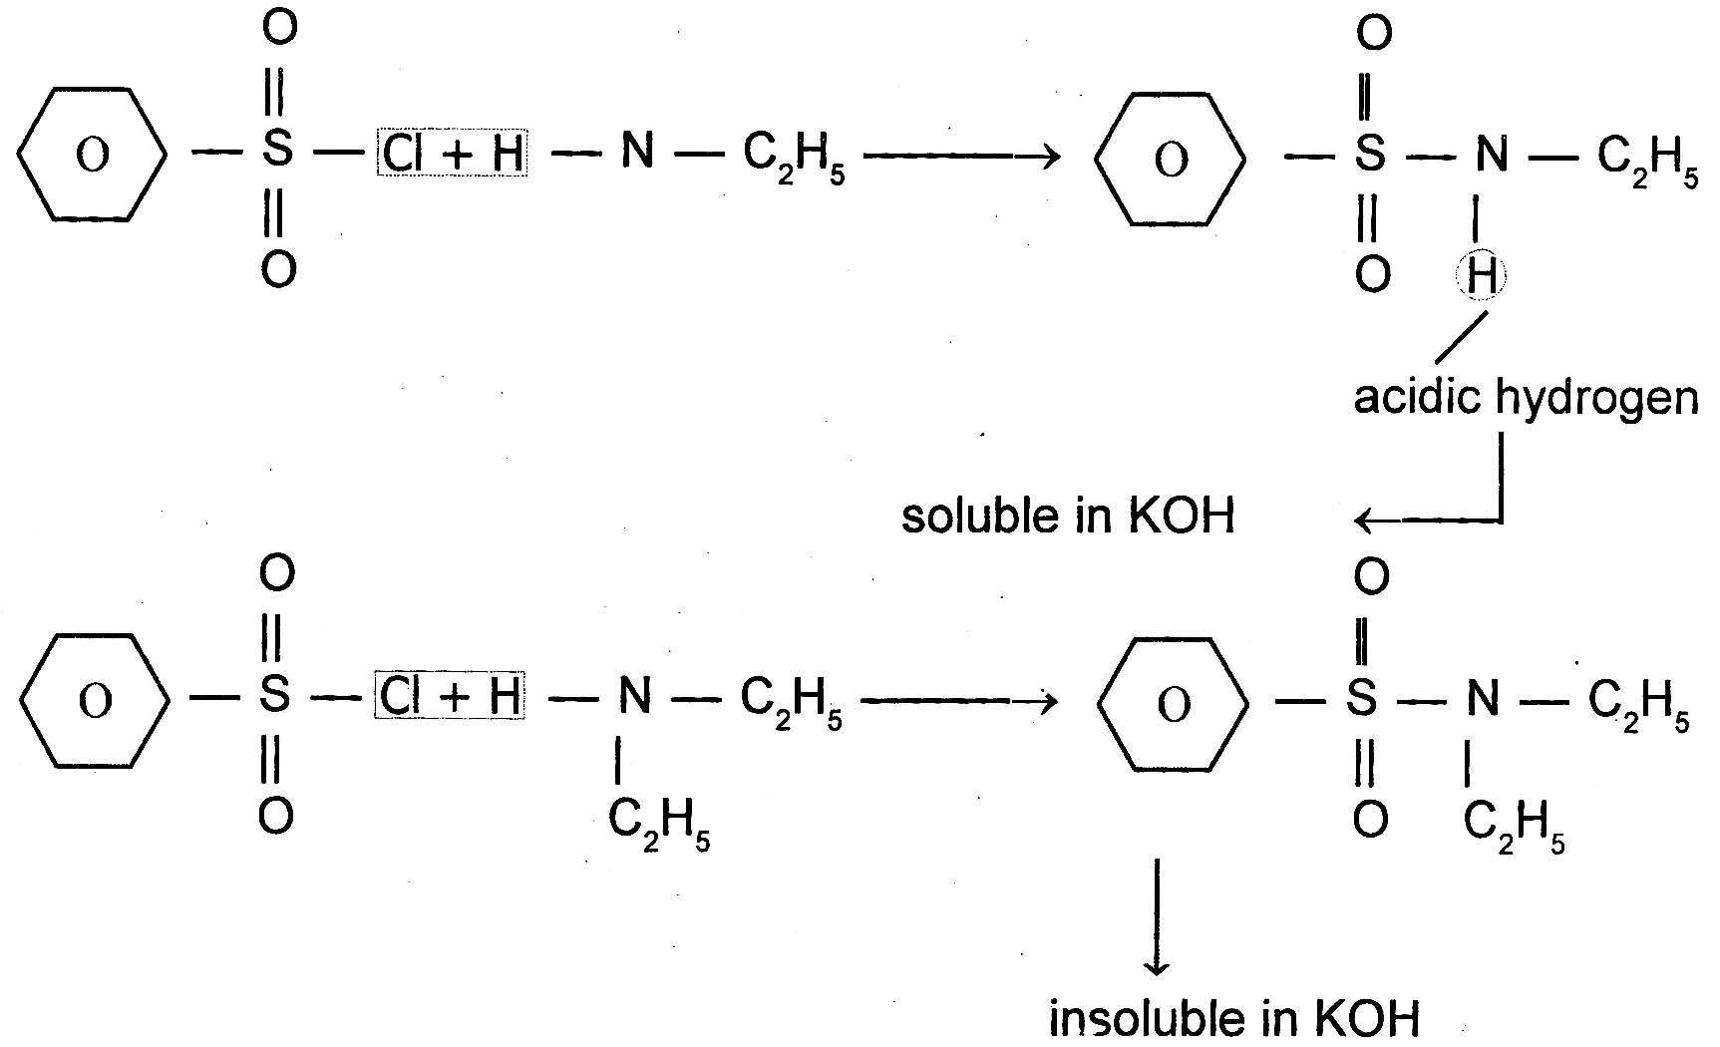

|
H

Q. 16. How can you distinguish between aromatic and aliphatic amines ?
Ans. The diaronium salts of Aromatic amines undergo coupling reactions with phneol or andine to form coloured compounds used as dyes.
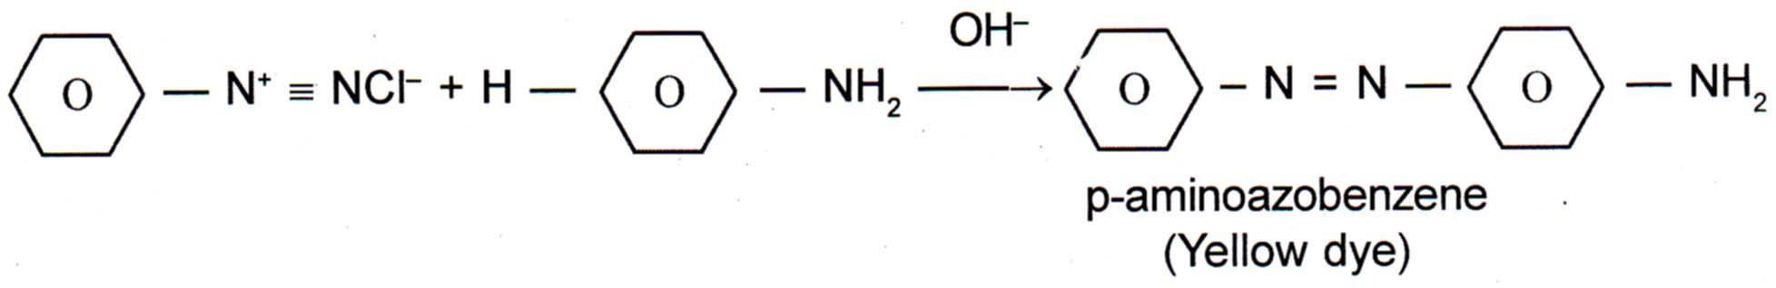

No such reactions are given by aliphatic amines.
Q. 17. How can tri substitution of Bromine be prevented in aniline ?
OR
How can we prepare mono bromo aniline ?
Ans. Because of high reactivity of aromatic amines substitution tends to occur at o- and p- positions. Monosubstituted aniline can be prepared by protecting — NH2 group by acetylation with acetic anhydride, then carrying out substitution followed by hydrolysis of substituted amide.

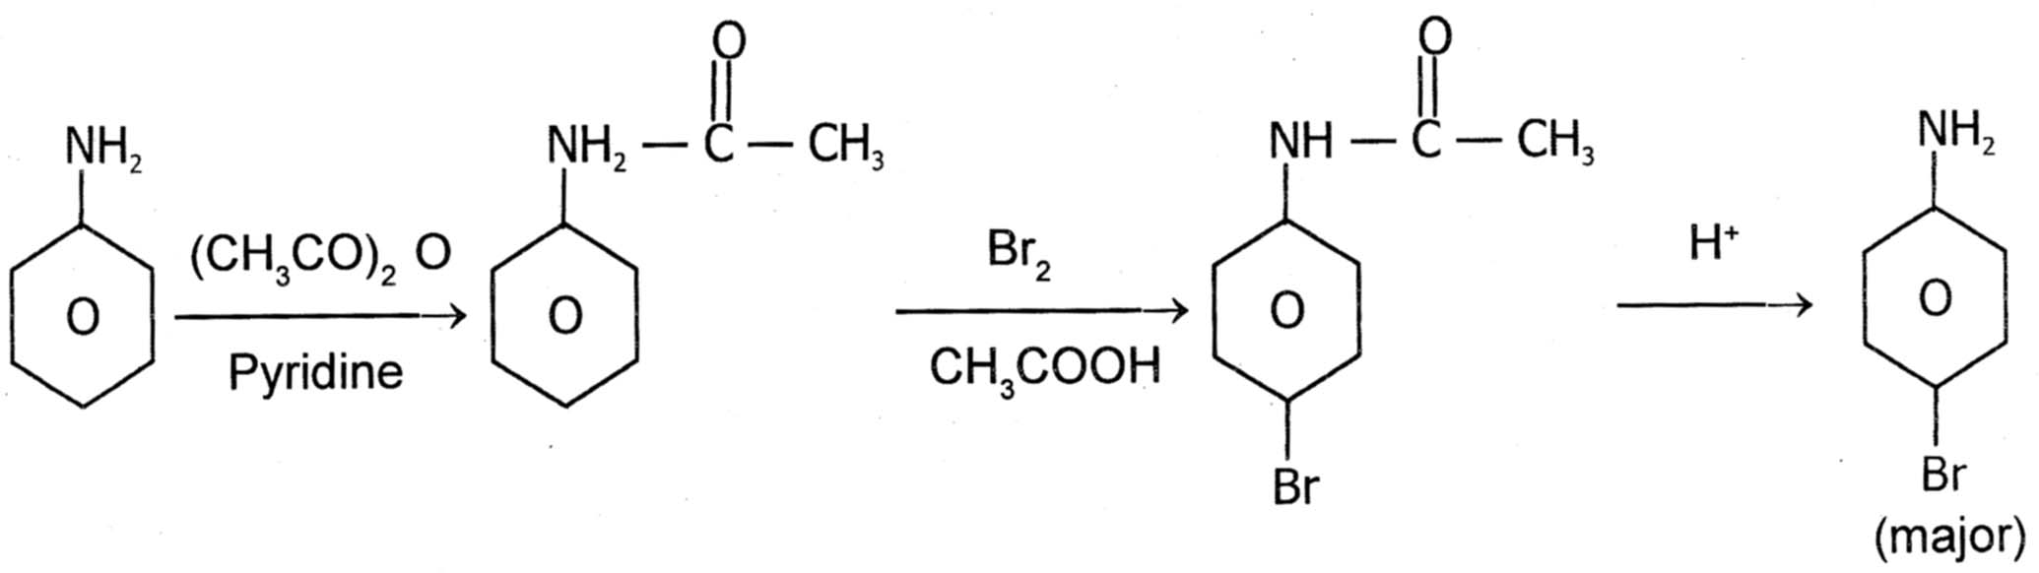

2 MARKS QUESTIONS
Q. 1. Give increasing order of reactivity towarads electrophilic substitution reaction of the following compounds :

Ans. Higher the electron density in the benzene ring, more reactive is the aromatic compound towards electrophilic substitution reaction. Now due to the presence of a lone pair of electrons on the N-atom which it can directly donate to the benzene ring. N (CH3)2 (due to two alkyl groups on N) is a much stronger electron donating gp than CH3 gp. (only one alkyl group on N). The remaining two gps contain a positive charge on the N-atom and hence act as electron withdrawing gps. But in (CH3)3 N+ — gp, the +vely charged N is directly attached to the benzene ring, therefore, its electron withdrawing ability is much stronger than — CH2N+ (CH3)2. From the above, it follows that the electron density in the benzene ring increases in the order :
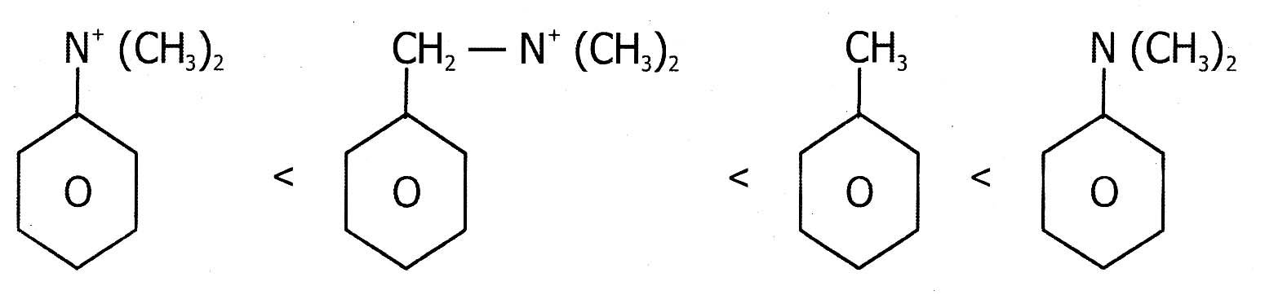

Therefore, their reactivity towards elecrophilic substitution reactions also increases in the same order.
Q. 2. Which one is more acidic ? Explain :
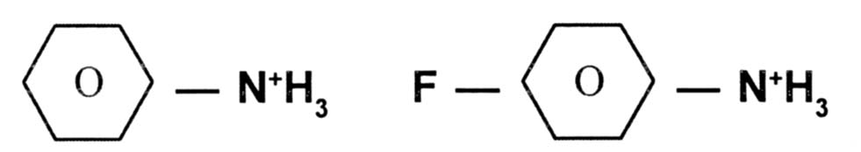

Ans. Due to powerful – I effect to the F-atom, it withdraws electrons from N+H2 gp. As a result, electron density in the N — H bond of p-fluoroanilinium ion decreases and hence release of a proton from p-fluoroanilinium ion is much more easier than from anilinium ion. Therefore, p-fluoroanilinium ion is more acidic than anilinium ion.
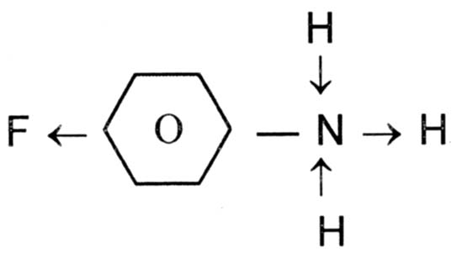

Q. 3. Explain the order of basicity of the following compounds in (i) Gaseous phase and (ii) inaqueous soln. :
(CH3)3N, (CH3)2NH, CH3NH2, NH3
Ans. Due to + I effect of alkyl gps, the electron density on the N-atom of 1°, 2° and 3° amines is higher than that on the N-atom in NH3. Therefore, all amines are more basic than NH3.
(i) In gaseous phase, solvation effects are absent and hence the relative basicity of amines depends only on + I effect of the alkyl gps. Now since + I effect increases in going from 1° to 2° to 3° amine, so the basicity of amines decreases in the order :
3° amine > 2° amine > 1° amine
(CH3)3N > (CH3)2NH > CH3NH2 > NH3
(ii) In aq. soln, the basicity depends upon two factors :
(a) + I effect of CH3 gp and
(b) Solvation effect.
Stabilization of the conjugate acid (formed addition of a proton to amine) by H-bonding explained above on the basis of + I effect, the order will be :
(CH3)3N > (CH3)2NH > CH3NH2
On the basis of Stabilisation of conjugate acids by H-bonding alone as explained below :
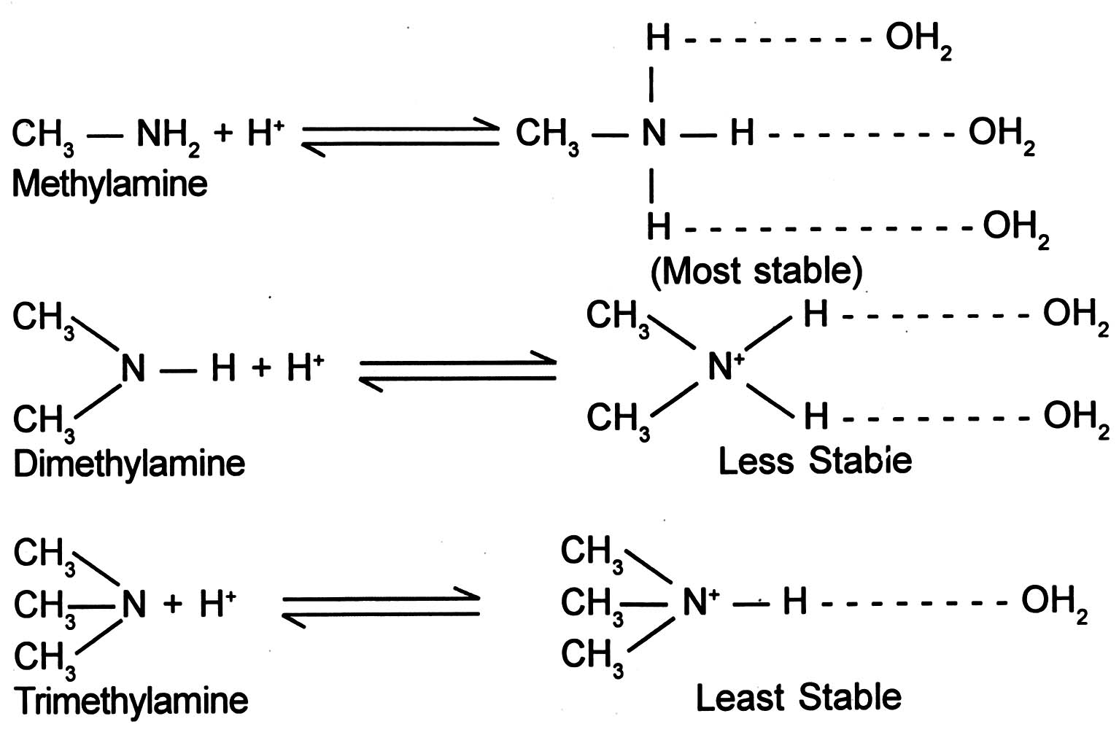

The order will be :
CH3NH2 > (CH3)2NH > (CH3)3N
The combined effect of these two opposing factors is that (CH3)2 NH is the strongest base. In case of CH3NH2 and (CH3)3 NH, the stability due to H-bonding predeminates over stability due to + I effect of CH3 gp, thereby making CH3NH2 stronger than (CH3)3 NH. So the overall order in aq. soln will be :
(CH3)2 NH > CH3NH2 > (CH3)3N > NH3


UNIT—14
BIOMOLECULES

1 MARK QUESTIONS
Q. 1. Which carbohydrate is called grape-sugar ? Give its condensed structural formula.
Ans. Glucose is called grape-sugar ? Its condensed structural formula is :
CHO
|
(CHOH)4
|
CH2OH
Q. 2. Which of the following is not an α-amino acid ?
Histidine, trypsin, cysteine, proline
Ans. Trypsin, it is a protein made from amino acids.
Q. 3. Write the structure of Zwitter ion formed from Alanine.
Ans. COO–
|
CH3 — C — H
|
NH3+
Q. 4. Wreite the name and structure of the simplest amino acid which can show optical activity.
Ans. Alanine,
Structure :
COOH
|
CH3 — C — H
|
NH2
Q. 5. How many hydrogen bonds are present between (i) A and T (ii) C and G in a double helix structure ?
Ans. (i) between A and T there exist two hydrogen bonds :
A - - - - - - - - - - T
- - - - - - - - - -
(ii) between C and G there exist three hydrogen bonds :
- - - - - - - - - -
C - - - - - - - - - - G
- - - - - - - - - -
Q. 6. When RNA in hydrolysed there is no relationship among the quantities of four bases obtained like DNA. What does this fact indicate about structure of RNA ?
Ans. This indicate that RNA has a single strand structure.
Q. 7. Where does the water present in the egg go after boiling the egg ?
Ans. After boiling, the water soluble globular protein of egg while get denatured and it cogulates into hard and rubbery insoluble mass.
Q. 8. Which vitamin is helpful in healing wound and cuts ? What is the chemical name of this vitamin ?
Ans. Vitamin-C is helpful in healing wounds and cuts, its chemical name is Ascorbic acid.

2 MARKS QUESTIONS
Q. 1. What type of bonding helps in stabilising the α-helix structure of proteins ?
Ans. In a α-helix structure, polypeptide chain of amino acids coils as a right handed screw because of the formation of all possible Hydrogen bonds between — NH group at each amino residue and > C = 0 group of adjacent turn of helix.
Q. 2. Name the water insoluble fraction of Starch. Name the monomer of this.
Ans. Amylopectin is water insoluble fraction of starch. It is a polymer of α-glucose.
Q. 3. What are the products of hydrolysis of (i) lactose (ii) sucrose. Also name the enzyme used for reaction.
Lactase
Ans. (i) C12H22O11 + H2O ————→ C6H12O6 + C6H12O6
Lactose glucose glactose
Invertase
(ii) C12H22O11 + H2O ————→ C6H12O6 + C6H12O6
Sucrose glucose fructose
Q. 4. How will you prove that all the carbon atoms of glucose are in straight chain ?
Ans. The reaction of glucose with HI gives n-hexane and it proves that all sin-carbon-atom are in straight chain.
HI
Ho CH2 — (CHOH)4 — CHO ———→ CH3 — (CH2)4 — CH3
Heat n-hexane
Q. 5. Enumerate two reactions of glucose which cannot be explained by its open chain structure.
Ans. (i) Glucose does not give Schiff‘s Test although it contains aldehyde group.
(ii) Glucose does not form crystaline product with NaHSO3.
Q. 6. B-complex is an often prescribed Vitamin. What is complex about it ? What is its usefulness ?
Ans. It is a type of Vitamin which contains B1, B2, B6 and B12. It required to release energy from food and to promote healthy skin and muscles. Its deficiency causes beri-beri (Vitamin B1) and Anaemia (Vitamin B12).
Q. 7. What are anomers ? Give two points of difference between two anomer of glucose.
Ans. The pair of optical Isomers which differ in the orientation of H and OH gp only at C1 Carbon atom are called anomers.
Difference between two anomers of glucose :
α-D (+) glucose β-D (+) glucose
(1) The specific rotation is + 111°. (1) The specific rotation is + 19.2°.
(2) The – OH gp at C1 is below the plane. (2) The – OH gp at C–1 is above the plane.


UNIT—15
POLYMERS

1 MARK QUESTIONS
Q. 1. Write an equation for the Chemistry involved when a drop of hydrochloric acid make a hole in nylon stockings.
Ans. The (— CO — NH —) amide bond in nylon gets hydrolysed.
Q. 2. Fibres are of crystalline structure. Why ?
Ans. Fibres have strong intermolecular forces of attraction which leads to close packing of their chains and impart crystalline structure.
Q. 3. Which artificial polymer is present in bubble gum or chewing gum ?
Ans. Bubble gum or chewing gum contains synthetic Styrene-butadiene rubber.
Q. 4. Name the polymer used for making medicinal Capsule.
Ans. PHBVUC Polyhydroxy butyrate-CO-β-hydroxy valerated.
Q. 5. Which polymer is used in making electrical goods and why ?
Ans. Bakelite because of its electrical insulator property.
Q. 6. Is (CH2 — CH — C6H5)n a homo polymer or a copolymer.
Ans. It is a homo polymer and the monomer from which it is obtained in styrene C6H5 CH = CH2.
Q. 7. Which colligative property is used to determine the molecular masses of the polymers ?
Ans. Osmotic pressure is the colligative property used to determine the molecular masses of polymer.

2 MARKS QUESTIONS
Q. 8. Write the names of monomers and structure used for getting the following polymers ?
PmmA, PVC, Teflon
Ans. (i) PVC — monomer — Vinylchloride, CH2 = CH — Cl
(ii) Teflen — monomer — Tetrafluoro ethylene, F2C = CF2
(iii) PMMA — monomer — Methyl methacrylate,
CH3
|
CH2 = C — COOCH3
Q. 9. Identify the monomer in the following polymer structures :
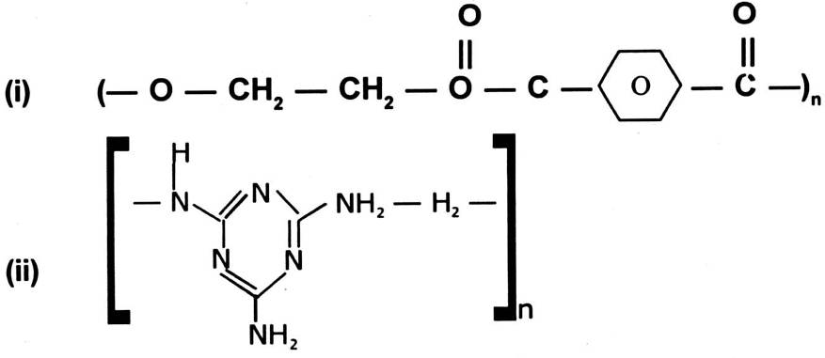

Ans. (i) HOCH2 — CH2OH and HOOC — — COOH

ethane-1, 2-dial Benzene-1, 4-dicarboxylic acid
(ii) Melamine Formaldehyde

and HCHO

Q. 10. How do double bonds in the rubber molecule influence their structure and reactivity ?
Ans. Due to presence of double bond the rubber molecule show cis-configuration because which the polymer chains can not come close to each other and get boiled but as they have their hindrance problem. This causes them to have weak Vander Waals intraction between the molecules consequently they get elastic property, solubility in organic solvents etc.
Q. 11. Why are the No. of 6, 6 and 6 put in the names of nylon-6, 6 and nylon-6 ?
Ans. The no. of 6, 6 in nylon-6, 6 implies that both the monomers of nylon-6, 6 namely hexamethylene diamine and adipic acid contain six carbon atom each. The no. of 6 in nylon-6 contains six carbon atom each. The no. of 6 in nylon-6 indicates that its monomer Caprolectum has six carbon atom in its molecule.
Q. 12. Could a copolymer be formed in both addition and condensation polymerisation or not ? Explain.
Ans. Yes, though copolymers are mostly addition polymers like styrcue butadiene rubber and butyl rubber, the term can be used for condensation polymers also eg. for example.
(i) Addition polymerisation of styrene and butadiene form copolymer styrene butadiene rubber.
n CH2 = CH — CH = CH2 + n C6H5CH = CH2 ———→
C6H5
|
(— CH2 — CH = CH — CH2)n — CH2 — CH —)n
(ii) Condensation polymer became thylene diamine and adipic acid form nylon-6, 6.
n HOOC — (CH2)4 — COOH + n H2N — (CH6) — NH2 ———→
adipic acid hexamethylene — n H2O
diamien
(— NH (CH2)6 — NH — CO — (CH2)4 — CO —)n
Q. 13. Arrange the following polymer in increasing order of their molecular forces :
(a) nylon-6, 6, Buna-S, polythene.
(b) nylon-6, Neoprene, polyvinyl chloride.
Ans. (a) Buna S < Polythene < Nylon-6, 6.
(b) Neoprene < Polyvinyl Chloride < Nylon-6.
Q. 14. Explain the difference between Buna— S and Buna — N.
Ans. Buna — N is a copolymer of 1, 3-butadiene and acrylo nitrile, Buna — S is a copolymer of 1, 3-butadiene and styrene.
Q. 15. Why should we always use purest monomer in free radical mechanism ?
Ans. Monomer has to be as pure as possible because the presence of any other molecule during free radical polymerisation can act chain initiator or inhibitor which will interfere with the normal polymerisation reaction.


UNIT—16
CHEMISTRY IN EVERYDAY LIFE

1 MARK QUESTIONS
Q. 1. Give an example of a chemical substance which can act both as an antiseptic and disinfectant.
Ans. Phenol.
Q. 2. What is the chemical name of antiseptic chloroxylenol ?
Ans. 4-Chloro-3, 5-dimethyl phenol.
Q. 3. Which alkaloid is used to control hypertension ?
Ans. Reserpine.
Q. 4. Which alkaloid is used to treat malaria ?
Ans. Quinine.
Q. 5. Identify the following :
HO — — NHCOCH3
Ans. Paracetamol.
Q. 6. What is the use of the following compound :
Ans. Analgesic.
Q. 7. Which artificial sweetner has the lowest sweetness value ?
Ans. Aspartame.
Q. 8. Which artificial sweetner has the highest sweetness value ?
Ans. Alitame.
Q. 9. What kind of a drug is Chlorpheniramine maleate ?
Ans. Anti histamine drug.
Q. 10. What is the chemical name of aspirin ?
Ans. 2-Acetoxy benzoic acid.
Q. 11. Name the antibacterial present in toothpaste.
Ans. Triclosan.
Q. 12. Identify the drug :
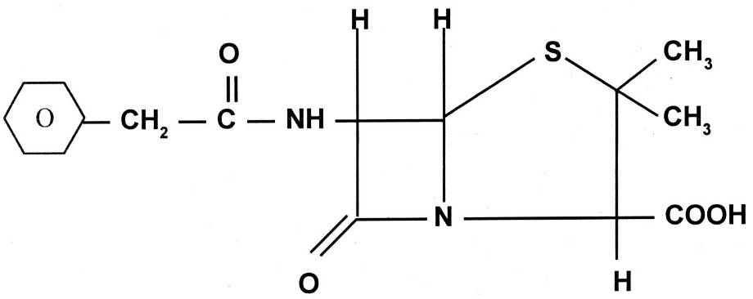
Ans. Penicillin G.
Q. 13. Which antibiotic contains NO2 group attached to aromatic nucleus in its structure ?
Ans. Chloramphenicol.
Q. 14. What is the use of barbituric acid ?
Ans. Tranquilizer.
Q. 15. Name one analgesic drug which is also used to prevent heart attacks.
Ans. Aspirin.
Q. 16. What is the application of the following molecule in everyday life ?
CH3 (CH2)11 CH2 — — SO3–Na+

Ans. It is a detergent.
Q. 17. Give an example of a drug that is antipyretic as well as analgesic.
Ans. Paracetamol.
Q. 18. Out of morphine, N-Acetyl-para-aminophenol, Diazepam and tetrahydrocatenol, which can be used as analgesic without causing addiction ?
Ans. N-Acetyl-para-aminophenol.
Q. 19. Name a sugar substitute which is 160 times as sweet as surcrose.
Ans. Aspartame.
2 MARKS QUESTIONS
Q. 1. When a mixture of salicylic acid, acetic anhydride and acetic acid is refluxed, what is the product obtained and what is its use in everyday life ?
Ans. Aspirin used as analgesic.
Q. 2. Distinguish between a narrow spectrum and broad spectrum antibiotic.
Ans. A narrow spectrum antibiotic works against a limited range of microbes whereas a broad spectrum antibiotic works against a large variety of microbes.
Q. 3. What is Salvarson ? To which class of drugs does it belong ? For what distance is it used ?
Ans. Antimicrobial agent.
Used for the treatment of STD called Syphilis.
Q. 4. How does apirin act as an analgesic ?
Ans. It inhibits the synthesis of prostaglandins which stimulates inflammation of the tissue and cause pain.
Q. 5. What are barbiturates ? To which class of drugs do they belong ?
Ans. 5, 5-derivatives of barbituric acid are called barbiturates. They belong to the class of tranquilizers. They also act as sleep producing agents.
Eg. Luminal, Veronal.
Q. 6. What is tincture iodine ? What is its use ?
Ans. Alcoholic Solution of I2.
Used as an antiseptic.
Q. 7. To what class of medicines does chloramphericol belong ? For what disease can it be used ?
Ans. Broad spectrum antibiotic
Used to cure typhoid, dysentry, acute fever.
Q. 8. Pick the odd one amongst the following on the basis of their medicinal properties mentioning the reason.
(i) Luminal, seconal, phenacetin, equanil
(ii) Chloroxylenol, phenol, chlorampherical, bithional
Ans. (i) Phenacetin is an antipyretic while all the rest are tranquilisers.
(ii) Chlorampherical is an antibiotic while all the remaining are antiseptics.
Q. 9. Why is bithional added to soap ?
Ans. Acts as an antiseptic and reduces the odours produced by bacterial decomposition of organic matter on the skin.
Q. 10. Why are cimetidine or ranitidine better antacids than sodium bicarbonate or magnesium or aluminium hydroxide ?
Ans. If excess of NaHCO3 or Mg (OH)2 or Al (OH)3 is used, it makes the stomach alkaline and thus triggers the release of even more HCl. In contrast, cimetidine or ranitidine prevent the interaction of histamine with the receptor cells in the stomach wall and thus release lesser amount of HCl.
Q. 11. Why is the use of aspartame limited to cold foods and drinks ?
Ans. It decomposes at baking or cooking temperatures and hence can be used only in cold foods and drinks.
Q. 12. What problem arises in using alitane as artificial sweetener ?
Ans. It is a high potency artificial sweetener. Therefore it is difficult to control the sweetness of the food to which it is added.
Q. 13. What is the purpose of adding antioxidants to food ? Give two examples of antioxidants.
Ans. They are added to prevent oxidation of fats and oils present in food thus preventing food from becoming rancid.
Eg. BHA (Butylated hydroxy anisole)
BHT (Butylated hydroxy toluene)


PAPER-1
MODEL QUESTION PAPER

Duration : 3 Hrs Max. Marks : 70

General Instructions :
(1) All questions are compulsory.
(2) Marks against each question are indicated.
(3) Questions from one to eight are very short answer type questions carrying one mark each.
(4) Questions from nine to eighteen are short answer type questions carrying two marks each.
(5) Questions from nineteen to twenty seven are short answer type questions carrying three marks each.
(6) Questions from twenty eight to thirty are long answer type questions carrying five marks each.
(7) Use log tables, if necessary. Calculators are not permitted.
Q. 1. A cubic solid is made of 2 elements P & Q are at the corners of the cube & P at the body centre. What is the formulae of the compound ? What are the coordination no. of P & Q ?
Ans.

At the corners each atom is equal to

∴ total Q = × 8 = 1 atom
∴ formula is PQ
Cordination No. is 8 : 8.
Q. 2. Name one important catalyst used in petroleum industry. For what purpose it is used for ?
Ans. It is ZSM–5. It converts alcohol directly into gasoline.
Q. 3. Give the hybridisation and shape of XeF4.
Ans.

Sp³ d² hybridisation
“Square planar shape”.
Q. 4. Zn, Cd, Hg are not regarded as transition elements. Why ?
Ans. Zn, Cd, Hg have completely filled d-orbitals in them. Hence, they are not regarded as transition elements.
Zn (30) = 3 d10 4 s²
Cd (40) = 4 d10 5 s²
Hg (80) = 5 d10 6 s²
Q. 5. Write IUPAC name of the following compounds :
(i) CH3 — C — CH — CH3
|| |
O Br
(ii) COOH
|
COOH
Ans. (i) 3-Bromo-2-butanone
(ii) Ethane-1, 2-dioic acid
Q. 6. What do you understand by the term coupling reaction ?
Ans.
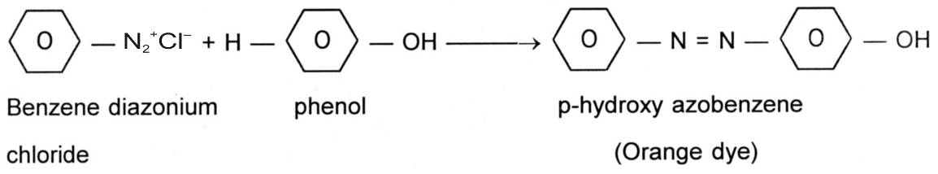

Q. 7. What are anomers ?
Ans. The isomers which differ in their configuration at C1 Carbon are known as anomers.
Q. 8. What is a broad spectrum antibiotic ? Give examples.
Ans. An antibiotic which can be used for curing from several types of microorganisms i. e. several diseases is called as a broad spectrum antibiotic.
eg. Chloramphenicol.
Q. 9. Show the graph of the deviation shown by anilin and phenol, give reason.
Ans. Negative deviation, ∴ A — B interactions are stronger than A — A and B — B interactions.
OR
H-Bonding between phenolic H+ and lone pair on nitrogen atom of anilin is stronger than individual molecules.
Q. 10. (a) Write the unit of molar conductivity.
(b) Why does the conductivity of a solution decrease with dilution ?
Ans. (a) Ohm–1 cm² mol–1
(b) Conductivity of a solution depends upon number of ions present in per unit volume. On dilution, the number of ions per unit volume decreases, ∴ conductivity also decreases.
Q. 11. (i) What is the covalence of Nitrogen in N2O5 ?
(ii) Cl2 is a bleaching reagent. Justify.
Ans. (i)

It is evident that its covalence is 4.
(ii) It is due to oxidation.
Cl2 + H2O ———→ HCl + HOCl
Due to the presence of the nescent oxygen in HOCl it possess bleaching property.
Coloured Substance + O ———→ Colourless Substance
Q. 12. Give reason for the following :
(i) Zr & Hf exhibit similar properties.
(ii) Transition elements forms alloys.
Ans. (i) Due to lanthanoid contraction, Hf & Zr have almost similar size & therefore, their properties are similar.
(ii) Transition elements have nearly the same atomic size. Hence, they can substitute one another in crystal lattice to form substitutional alloys.
Q. 13. Describe the steps involved in the preparation of potassium permanganate from manganese dioxide.
Ans. Step 1 : 2 MnO2 + 4 KOH + O2 ———→ 2 K2MnO4 + 2 H2O
Step 2 : MnO42– ———→ MnO4– + e– (Anode)
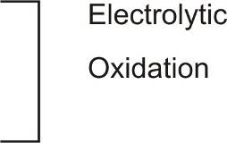
green purple
2 H+ + 2 e– ———→ H2 (Cathode)
OH– ions remain in the solun.

OR
Write the steps involved in the preparation of K2Cr2O7 from Chromite ore.
Ans. (i) 4 FeCrO4 + 16 NaOH + 7 O2 ———→ 8 Na2CrO4 + 2 Fe2O3 + 8 H2O
(ii) 2 Na2CrO4 + H2SO4 ———→ Na2Cr2O7 + Na2SO4 + H2O
(iii) Na2Cr2O7 + 2 KCl ———→ K2Cr2O7 + 2 NaCl
Q. 14. Write a brief notes on :
(a) Williamson’s ether synthesis
(b) Sandmeyer’s reaction.
Ans. (a) Alkylhalides react with sodium alkoxides to give symmetrical/unsymmetrical ethers :
R — — O — R’ ———→ R — O — R’ + NaX
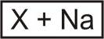
(b) The conversion of benzene diazonium chloride into chlorobenzene/bromobenzene using CuCl — HCl/CuBr — HBr is known as Sandmeyer’s reaction.
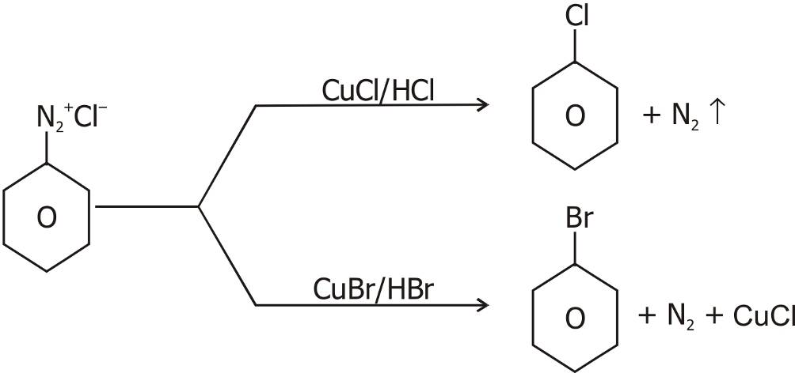

Q. 15. Explain why :
(a) Alkylhalides, though polar, are immiscible with water.
(b) Grignard reagents should be prepared under anhydrous conditions.
Ans. (a) Alkylhalides can not form H-Bonds with water and hence Alkylhalides are insoluble in water.
(b) Grignard reagent react with water and get decomposed :
R Mg X + H2O ———→ R — H + Mg (OH) X
Hence they have to be prepared under anhydous conditions.
Q. 16. Give reasons :
O-nitrophenol has lower boiling point than p-nitrophenol.
Ans. O-nitrophenol shows intra molecular hydrogen bonding and exists as discrete molecules.
Low intermolecular forces, low boiling point.
Intermolecular H-bonding takes place in p and m nitro phenol, form associated molecule, high intermolecular forces, high boiling point.
Q. 17. What is cumene ? How is phenol prepared from cumene ? Isopropyl or 2 phenyl propane is cumene.
Ans.
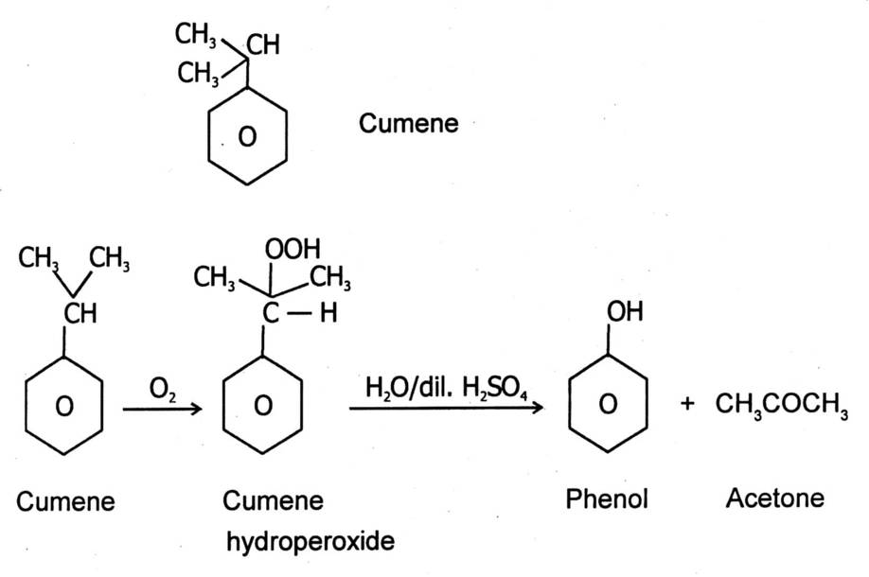

Q. 18. Explain with examples :
(a) Cationic detergent
(b) Anionic detergent
Ans. (a) Cationic Detergent :
Acetates, chlorides or bromides of quarternary ammonium salts with long hydrocarbon chain forming cationic part.

Br–

(b) Anionic Detergent :
Alkyl hydrogen sulphonates with long carbon chain forming Alkyl part.
CH3 (CH2)10 — CH2 — OSO3 — Na+
Sodium louryl sulphonate
Q. 19. (a) Gold (atomic radius = 0.144 nm) crystallises in a face centered unit cell. What is the length of a side of the cell ?
(b) If NaCl is doped with 20% CdCl2. What is the concentration of cation vacancies.
Ans. (a) For fcc a = 2 × r
= 2 × 1.414 × 0.144
= 0.407
(b) 20% vacancies
Na+ Cl– Na+ Cl–
Cl– Cl– Na+
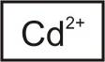
Na+ Cl– Cl–
Q. 20. 45 g of ethylene glycol (C2H6O2) is mixed with 600 g water. Calculate :
(a) freezing point depression
(b) freezing point of solution
Given that Kf for water = 1.86 K kg mol–1
Ans. ΔTf =
ΔTf = = 2.25 K
then ΔTf = T0 – T1 = 273 – T1
T1 = 273 – 2.25 = 270.75 K
Q. 21. Following data were obtained during the first order thermal decomposition of N2O5 (g) at constant volume :
2 N2O5 (g) ———→ 2 N2O4 (g) + O2 (g)
Calculate the rate constant if :
S. No. Time/s Total pressure/atm
1 0 0.5
2 100 0.512
Ans. 2 N2O5 (g) —————→ 2 M2O4 (g) + O2 (g)
Initially 0.5 atm 0 atm 0 atm
At tiem (t) (0.5 –2 x) atm 2 x atm 2 x atm
Pt = (0.5 – 2 x) + 2 x + x = 0.5 + x
x = Pt – 0.5
= 0.5 – 2 (pt – 0.5) = 1.5 – 2 Pt
At t = 100 sec.
Pt = 0.512 atm
PN2O5 = 1.5 – 2 × 0.512 = 0.476 atm
Using Ist order reaction
K = log
= log
= × 0.0216 = 4.98 × 10–4 sec–1
Q. 22. Explain the following observations :
(a) Physical adsorption in multilayered, while chemisorption is unilayer.
(b) Adsorption is always exothermic process.
(c) Ferric hydroxide soln coagulates on addition of potassium sulphate.
Ans. (a) Physical adsorption is non-specific i. e. adsorbade can be held on adsorbadely weak Vander-waal forces. Therefore no bonds have to be set up, therefore it continues while chemisorption is highly specific, chemical bonds have to be set up.
(b)

In Adsorption order increases. Therefore ΔS becomes (–) ve for a reaction to be spontaneous i. e. ΔG should always benegative that is possible only :
ΔH ΔS ΔG = ΔH – TΔS
– ve – + – ΔH > TΔS
(c) Coagulation takes place, since adsorption of SO4 ions on Fe(OH)3 which is positively charged colloid.
Q. 23.

(a) What is the significance of point A in the above graph ?
(b) Suggest a condition under which magnesium can reduce aluminium.
(c) Give method for refining nickel.
Ans. (a) At point ‘A’ ΔG° becomes O for the reaction.
(b) Below this point magnesium can reduce alumina above this point. Aluminium can reduce magnesium oxide.
(c) Mond Process is used where nickel is heated in stream of CO.
330 to 350 K
Ni + CO ——————→ Ni (CO)4
Tetracarboxyl nickel
(volatile)
450-470 K High temperature
Decomposed
Ni + 4 CO
(Pure metal)
Q. 24. Draw a figure to show splitting of degenerate d-orbitals in an octahedral. How is the magnitude of Δ0 affected by :
(i) Nature of ligand.
(ii) Oxidation State of metal ion.
Ans.

(a) Stronger the ligand, more is the splitting.
(b) Higher the oxidation state, greater is the magnitude of Δ0.
Q. 25. Complete the following reactions :
A 4 [H]
(1) R — Cl ———→ B ———→ RCH2NH2
(2) ———→

Ans. (1) KCN 4 [H]
RCl ———→ RCN ———→ RCH2NH2
(2)

Q. 26. (1) Write the monomers of BUNA-S & Teflon.
(2) Differentiate between Nylon-6 and Nylon-66.
(3) Give an example of each thermoplastic & thermosetting plastic.
Ans. (1) BUNA-S — 1-3 butadiene CH2 = CH — CH = CH2
styrene
Teflon — (CF2 = CF2)
(2) Nylon-6 — Condensation polymer of caproductum.
Nylon-66 — Condensation polymer of Adipic acid :
(HOOC — CH2 — CH2 — CH2 — CH2 — COOH)
& hexamethylene diamine :
H2N — (CH2)6 — NH2
(3) Thermoplatic — Polythene
Thermosetting plastic — Bakelite
Q. 27. Answer the following questions briefly :
(a) What are reducing sugars ?
(b) What are nucleotides ?
(c) Define enzymes.
Ans. (a) The sugar which contain free aldehydic group and reduce Tollen’s reagent or Fehling’s reagent.
(b) Nucleotide is a phosphate ester of nucleoside.
(c) Enzymes are the biological catalyst which increases the rate of metabolism and they are highly specific in nature.
Q. 28. (a) Write the Nearnst equation and the emf of the following cells at 298 K :
Sn / Sn2+ (0.050 M) // H+ (0.020 M) / H2 (g) / Pt (s)
1 bar
(b) (i) Give the order of the reaction :
(a)

(b)

(ii) Write Arrhenius equation showing the effect of temperature on rate of reaction.
Ans. (a) Reaction :
At Anode Sn ———→ Sn2+ + 2 e–
At Cathode H+ + e– ———→ H₂ × 2
————————————
Sn + 2 H+ ———→ H2 + Sn2+
∴ n = 2
Neutral Equation
Ecell = E°cell – log
= {0 – (– 0.14)} – log
= 0.14 – log 125
= 0.14 – × 2.0969
= 0.078 Volt.
(b) (i) (a) Order as t is independent of [R]0.
(b) Zero Order t α [R]0
(ii) K = A e–Ea/Rt
log K = log A –
OR
Q. 28. (a) Predict the products of electrolysis of dilute aqueous solution of H2SO4 with platinum electrodes.
(b) How will you calculate λ0 of Ba(OH)2 with the help of Kohlrausch’s law.
Ans. (a) H2SO4 (aq) ———→ 2 H+ (aq) + SO42– (aq)
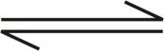
H2O H+ + OH–
At Cathode H+ + e– ———→ H
H + H ———→ H2 (g)
At Anode OH– ———→ OH + e–
4 OH ———→ 2 H2O + O2 ↑
Thus H2 is liberated at cathode, and O2 is liberated at anode.
(b) Λ°m Ba(OH)2 ———→ λ° Ba2+ + 2 × λ° OH–
Q. 29. Complete the following reactions :
(a) (i) PCl5 + H2O ———→
(ii) XeF2 + PF5 ———→
(iii) NaCl + MnO2 + H2SO4 ———→
(b) H3PO4 is tribasic whereas H3PO3 is dibasic.
(c) PCl5 is solid in ionic state.
Ans. (a) (i) PCl5 + H2O ———→ POCl3 + 2 HCl
POCl3 + 3 H2O ———→ H3PO4 + 3 HCl
(ii) XeF2 + PF5 ———→ [XeF]+ [PF6]–
(iii) 4 NaCl + MnO2 + 4 H2SO4 ———→ MnCl2 + 4 NaHSO4 + 2 H2O + Cl2
(b) H3PO4 + H2O ———→ H3O+ + H2PO4–
H2PO4– + H2O ———→ H3O+ + HPO42–
HPO42– + H2O ———→ H3O+ + PO43–
(c) [PCl4]+ [PCl6]– because of formation of this ionic compound.
OR
(a) Give the hybridisation of ClF5.
(b) Complete the following reactions :
(i) F2 + 2 X– ———→
X = ?
(ii) MnO2 + 4 HCl ———→
(iii) XeF2 + 2 H2O ———→
PbS + O3 ———→
(c) Give reasons :
(i) NH3 is more basic than PH3.
(ii) ICl is more reactive than I2.
Ans. (a) Structure + hybridisation of ClF5
Cl = 3 s² 3 p5
3 p 3 d
G. S.
I Excited State
II Excited State
∴ sp³d²

Square Pyramidal

(b) (i) F2 + 2 X– ———→ X2 + 2 F–
X = Cl–, Br–, I–
(ii) MnO2 + 4 HCl ———→ MnCl2 + Cl2 + 2 H2O
(iii) O3 ———→ O2 + O × 4
PbS + 4 [O] ———→ PbSO4
—————————————————
4 O3 + PbS ———→ 4 O2 + PbSO4
(c) (i) Because of high electronegativity & small size of nitrogen electron density is high because lone pair are diffused over a smaller area.
(ii) I — Cl bonds are weaker than I — I because of ineffective overlapping.
Q. 30. (a) By which test the following pairs of organic compounds can be distinguished :
(i) CH3CHO and C6H5CHO
(ii) H — COOH and CH3COOH
(b) Complete the following :
Pd — BaSO4 / S
(i) CH3COCl ————————→
Conc. NaOH
(ii) C6H5CHO ——————→
Cl2 / Red P4
(iii) CH3CH2COOH ———————→
Ans. (a) (i) Iodoform test :
CH3CHO give + ve test for Iodoform :
NaOH + I2 NaOH
CH3CHO —————→ CI3CHO ———→ CHI3 + HCOONa
Iodoform
NaOH + I2
C6H5CHO —————→ NO
Iodoform
(ii) Tollens reagent test :
heat
HCOOH + 2 [Ag (NH3)2] + OH– ———→ 2 Ag + 4 NH3 + CO2 + 2 H2O
mirror
Tollen reagent
CH3COOH ———————→ Na
mirror
(b) (i) CH3 — CHO (Rosenmund reduction)
(ii) C6H5CH2OH and C6H5COONa (Cannizaro’s reaction)
(iii) CH3 — CH — COOH (HVZ reaction)
|
Cl
OR
(a) How will you distinguish between aniline and N-Methylaniline (write the chemical reaction.) ?
(b) What happens when :
(i) Acetamide is treated with Br2 / NaOH.
(ii) Acetaldehyde is treated with aq. NaOH.
(iii) Ethylamine is treated with HNO2.
Ans. (a) By carbylamine test we can distinguish aniline and N-methylaniline.
C6H5NH2 + CHCl3 + 3 KOH ———→ C6H5NC+ 3 KCl + 3 H2O
C6H5 — NH — CH3 + CHCl3 + 3 KOH ———→ No reaction
(b) (i) CH3NH2 will be formed. (Hoffmann’s reagent)
(ii) Hydroxybutanol will be formed. (Aldol Condensation reaction)
(iii) C2H5 — OH will be formed.



PAPER—2
MODEL QUESTION PAPER

Duration : 3 Hours Max. Marks : 70

General Instructions :
(1) All questions are compulsory.
(2) Marks against each question are indicated.
(3) Questions from one to eight are very short answer type questions carrying one mark each.
(4) Questions from nine to eighteen are short answer type questions carrying two marks each.
(5) Questions from nineteen to twenty seven are short answer type questions carrying three marks each.
(6) Questions from twenty eight to thirty are long answer type questions carrying five marks each.
(7) Use log tables, if necessary. Calculators are not permitted.
Q. 1. Name a salt that can be added in AgCl so as to produce cation vacancies. 1
Q. 2. What type of deviation from ideal behaviour will be shown by the solution of chloroform and acetone ? 1
Q. 3. What happens when a colloidal sol of Fe [OH]3 is mixed with that of AS2S3 ? 1
Q. 4. Why NCl3 gets hydrolysed and NF3 does not ? 1
Q. 5. What is the order of reaction whose rate constant has same unit as the rate of reaction ? 1
Q. 6. Why aldehydes are more reactive than ketones towards nucleophilic substitution reaction ? 1
Q. 7. Write difference between multimolecular and macromolecular colloid ? 1
Q. 8. Why phenol is more acidic than ethanol ? 1
k
Q. 9. Consider the reaction A ———→ P. The change in concentration of A with time is shown in the following plot :
(i) Predict the order of the reaction.
(ii) Derive the expression for the time required for the completion of the reaction. 2
Q. 10. How do you account for the increase in the molar conductivity in care of KCl and CH3COOH on dilution ? 2
Q. 11. How can the constant k and n of the Freundlich adsorption equation be calculated using graph ? Explain. 2
Q. 12. For the cell reaction :
Ni (s) / Ni2– (aq) // (aq) Ag+ (aq) / Ag
Calculate the equilibrium constant at 25 °C. How much maximum work would be obtained by operation of this cell ?
E° Ni2+/Ni = – 0.25 V and E° Ag+/Ag = 0.80 V
Q. 13. The rate constant of a reaction is 1.5 × 107 s–1 at 50 °C and 4.5 × 107 s–1 at 100 °C. Calculate activation energy. 2
Q. 14. (i) Write the value of Van’t Hoff factor for H2SO4.
(ii) Why rusting of iron is quicker in saline water ? 2
Q. 15. (i) Why H3PO4 is tripotic whereas H3PO3 is diprotic ?
(ii) Give reason why NO2 dimenises to form N2O4 ? 2
Q. 16. Difference between :
(i) Starch and Cellulose
(ii) Reducing and Non-Reducing sugar 2
Q. 17. (i) What do you understand by denaturation of proteins ?
(ii) Write the two important functions of nucleic acid. 2
Q. 18. (i) Explain ethylamine is souble in H2O whereas aniline is not.
(ii) What are ambident nucleophiles ? Explain with example. 2
Q. 19. (i) Zinc Oxide is white but it turns yellow on heating, explain why ?
(ii) Aluminium crystallises in a cubic close packed structure. Its metallic radius is 125 pm.
(A) What is the length of the side of the unit cell ?
(B) How many unit cells are there in 1.00 cm³ of aluminium ? 2+1=3
Q. 20. (i) State Henry’s law.
(ii) Arrange the following solution in the increasing order of their osmotic pressure :
(a) 34.2 g / lit sucrose (C12H22O11)
(b) 60 g / lit urea [NH2CONH2] 2+1=3
Q. 21. (i) What is the role of graphite rod in the electrometallurgy of aluminium ?
(ii) Write the principle of zone refining method.
(iii) Out of C and CO, which is a better reducing agent for ZnO. 3
Q. 22. (i) Which alkyl halide from the following pair would you expect to react more rapidly by an SN² mechanism and why ?
or

(ii) Write the chemical equation for the following conversion :
2-chloro propane to 1-bromo propane
(iii) Complete the following equation :
3
Q. 23. Write short notes on :
(i) Reimer Tiemann reaction
(ii) Friedel Craft reaction
(iii) Aldol Condensation. 3
OR
(i) Write IUPAC name of the following compound :
(ii) Explain why is ortho-nitrophenol more acidic than orthomethoxyphenol ?
(iii) Distinguish between propanone and propanol. 3
Q. 24. (i) Arrange the following in increasing order of basic strength :
C6H5NH2, C6H5N (CH3)2, (C2H5)2 NH and CH3NH2
(ii) Complete the following giving appropriate represent :
Benzyl Benzyl Benyzlamine
chloride nitromethane
(iii) Write Hofmann’s Bromamide reaction. 3
Q. 25. (i) [NiCl4]2– is paramagnetic while [Ni (CO)]4 is diamagnetic though both are tetrahedral. Why ?
(ii) Write IUPAC name of [CO (en)₃]³⁺
(iii) Explain why K3[Fe (CN)6] is more stable than K4 [Fe (CN)6]. 3
Q. 26. (i) Write the name of monomers of the following polymers :
(A) Nylon-6
(B) Terylene.
(ii) Write free radical mechanism for the polymerisation of ethene.
(iii) What is the full form of PHBV ? 3
Q. 27. (i) Explain the following terms with suitable examples :
(A) Narrow spectrum antibiotic
(B) Non ionic detergents.
(ii) Label the hydrophilic and hydrophobic part in the given compound :
CH3 (CH2)10 CH2 SO3– Na+
(iii) Write the constituents of dettol. 3
Q. 28. (i) Arrange HClO4, HClO3, HClO2, HClO in order of increasing acidic strength. Give reason.
(ii) Why inter halogen are more reactive than halogens ?
(iii) OF2 should be called oxygen difluoride and not fluorine oxide. Why ?
(iv) Why HF acid is stored in wax coated glass bottles ?
(v) SF6 is known but SH6 is not known. Explain. 5
OR
(i) Deduce the molecular shape of BrF3 or the basis of VSEPR theory.
(ii) Arrange NH3, PH3, AsH3, SbH3, BIH3 in order of increasing acidic strength.
(iii) Why do noble gases form compound with oxygen and fluorine only ?
(iv) Write balanced equation for the following :
(a) NaCl is heated with sulphuric acid in presence of MnO2.
(b) Cl2 gas is passed into a solution of NaI in water. 5
Q. 29. (i) What is the effect of pH on the K2Cr2O7 solution ?
(ii) Transition metal exhibit higher enthalpies of atonisation, explain why ?
(iii) Why the transition metal generally form coloured compounds ?
(iv) Which out of the following are transition element and why ?
Zn, Ag, Cd, Au
(v) Why is the separation of lanthanide elements difficult ? 5
OR
(i) Transition metal and their many compounds act as good catalyst.
(ii) Actinoid contraction is greater from element to element than lanthanoid contraction. Why ?
(iii) K2PtCl6 is a well known compound whereas corresponding Ni compound is not known. State a reason for it.
(iv) A mixed oxide of Iron and Chronium FeO . Cr2O3 is fused with Na2CO3 in presence of air to form a yellow coloured compoud A. On acidification the compound (A) form an orange coloured compound (B) which is a strong oxidizing agent.
(a) Identify A and B.
(b) Write balanced chemical equation for each step. 5
Q. 30. An organic compound contain 69.77% carbon, 11.63% hydrogen and rest oxygen. The molecular mass of compound is 86. It does not reduce Tollen’s reagent but form an addition compound with sodium hydrogen sulphide and give positive iodoform test. On vigorous oxidation it gives ethanoic and propanoic acid. Write the possible structure of the compound. 5
OR
An organic compound (A) having molecular formula C9H10O form an orange red precipitate (B) with 2, 4 — DNP reagent. Compound (A) gives a yellow precipitate (C) when heated in the presence of iodine and NaOH along with a colourless compound (D). (A) does not reduce Tollen’s reagent or Fehling’s solution nor does it decolourise Bromine water. On drastic oxidation of (A) with chromic acid, a carboxylic acid (E) of molecular formula C7H6O2 is formed. Deduce the structure of organic compounds A
to E. 5
SOLUTION TO THE MODEL QUESTION PAPER
Ans. 1. CdCl2 or SrCl2 1
Ans. 2. Chloroform and acetone shows –ve (negative deviation) from ideality. 1
Ans. 3 Fe (OH)3 sol being positively changed whereas AS2S3 being negatively changed, their charges are neutralised on mixing. Hence, there mutual precipitation (cogulation) occur. 1
Ans. 4. In NCl3, has vacant d-orbitals to accept the lone pair of electrons donated by O-atom of H2O molecule but NF3 . F does not have d-orbitals. 1
Ans. 5. Zero order reaction 1
Ans. 6. Aldehydes are more reactive than ketones due to following reasons :
(i) Inductive effect and
(ii) Steric effect.
(i) Inductive effect — Two alkyl gp attached to carbonyl carbon in ketone, alkyl gp is electron donating therefore greater is the electron density on carbonyl carbon in ketones.
(ii) Steric effect — In ketones there are two alkyl gp attached to the carbonyl carbon. As crowding increases, the reactivity increases accordingly. ½+½=1
Ans. 7. Multi molecular Macro molecular
They are formed by aggregation of large They are molecules of large size.
number of atoms or molecules. eg. proteins, starch, nylon etc.
eg. gold, S etc. 1
Ans. 8. Since the phenolic ion left after the removal of a proton is stabilized by reronance whereas alkoxide ion (left after the removal of a proton from alcohol) is not. 1
Ans. 9. (i) Order of reaction = zero
(ii) Consider
R ———→ P
Rate = – = k [R]° ( R]° = 1)
Rate = – = k × 1
d [R] = – k dt
Integrated both sides
[R] = – kt + I — (i)
where I is the constant of integration.
At t = 0 the conc. of the reactant R = [R]0
where [R]0 is the initial conc. of reactant.
Substituting in equatiuon (i)
[R]0 = – k × 0 + I
[R]0 = I
Substituting the value of I in the equ. (i)
[R] = – kt + [R]0 — (ii)
k =
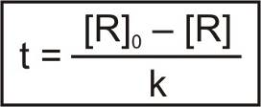 1+1=2
Ans. 10. CH3COOH is a weak electrolyte, the molar conductivity increases with dilution. KCl is a strong electrolyte also molar conductivity increases with dilution. This increase in molar conductivity in strong electrolyte is very less.
Reason — In weak electrolyte, the increase on dilution is due to increase in degree of dissociation, which increases the number of ions.
In strong electrolyte, the increase is because of decrease in interionic hindrance towards mobility ions. 1+1=2
Ans. 11.

Calculation of k and n
∝ P¹ or = constant × P — (i)
At high pressure becomes independent of the values of P. In this range of pressure
∝ P° or = constant × P° — (ii)
In the intermediate range of pressure, will depend on P raised to power between 1 and 0 i. e. fractions. For a small range of pressure values, we can write :
∝ or = k — (iii)
Taking logarithms of both sides, we get :
log = log k + log P 2
Ans. 12. Ni + 2 Ag+ ———→ Ni2+ + 2 Ag
E°cell = Ecathode – Eanode
= 0.80 – (– 0.25) = 1.05 U
T =273 + 25 = 298 k
Ecell = E°cell – log kC
at equn :
0 = 1.05 V – log kc
0 = 1.05 V – log kc at 298 k
log kc = Antilog 35.6 = 3.981 × 1035
log kc = = 35.6
kc = 3.981 × 1035
Wmax = – ΔG° = n F E°cell
= 2 × 96500 × 1.05
= 202650 Joules
Wmax = 202.65 k Joules 2
Ans. 13. T1 =273 + 50 = 323 k
T2 =273 + 100 = 373 k
log
log 3 =
0.4771 =
Ea =
Ea = 22011.75 Joules/mole 2
Ans. 14. (i) K2SO4 (aq) ———→ 2 K+ + SO4–
i (Vant’s Hoff factor) = 2 + 1 = 3
(ii) H+ ions are involved in the reduction of O2. As the H+ ion conc. is lowered i. e. pH is increased, the reduction of O2 become less favourable. If water is saline, it helps in the flow of current in the miniature cell and hence enhances the process of Rusting of Iron. 1+1=2
Ans. 15. (i) Structure :
H3PO4 H3PO3
1. H3PO4 contains 3 (three) ionizable H-atoms which are present as — OH gp, It behave as a tribasic acid.
2. H3PO3 contains 2 (two) ionizable H-atoms which are present as — OH gp, It behave as a dibasic acid.
(ii) NO2 is an odd electron (7 + 2 × 8 = 23) molecule. In the valence shell, N has seven electrons and hence is less stable. To become more stable by having even (8) number of electrons in the valence shell it undergoes dimerization to form N2O4. 2
Ans. 16. Difference between Starch and Cellulose :
(i) Starch Cellulose
Starch consist of amylose and Cellulose is linear polymer of β-D
amylopectin. Amylose is linear glucose and highly branched structure.
polymer of α-D glucose.
(ii) Reducing Sugar Non-Reducing Sugar
All those carbohydrates in which All those carbohydrates in which
aldehyde or ketonic gp is free and aldehyde or ketonic gp is not free and
reduce Fehling’s solution and cannot reduce Fehling’s solution and
Tollen’s reagent are known as Tollen’s reagent is known as
reducing sugar. non-reducing sugar.
eg. — glucose, fructose etc. eg. — starch, cellulose. 1+1=2
Ans. 17. (i) When a protein is in its native form, is subjected to a physical change, like change in temperature or a chemical change like change in pH, the native conformation of the molecule is distrupted. As a result, glubules unfold and helices get uncoiled and biological activity is lost is known as denaturation of protein.
(ii) Two functions of Nucleic acid :
(a) Replication
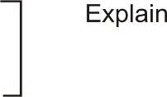
(b) Synthesis of protein 1+1=2
Ans. 18. (i) Ethylamine is dissolves in water due to intermolecular H-bonding. However aniline, due to large hydrophobic part i. e, hydrocarbon part, the extent of hydrogen bonding decreases considerably and hence aniline is insoluble in water.
(ii) When a nucleophile contain two sites but only one of them form bond with carbon is called Ambident nucleophile. eg. – CN– or NC–, NO2– or ONO2–. 1+1=2
Ans. 19. (i) When Zinc oxide heated, it loses oxygen according to the following Rxn. :
ZnO ———→ Zn2+ + O2 + 2 e–
Zn2+ ions are entrapped in the interstial voids and electrons in the neighbouring interstial voids to maintain electrical neutrality. This give rise to access metal defect. Due to pressure of electrons in the interstial voids the colour is yellow as the remaining colour of white light are absorbed by these electrons.
(ii) (a) ccp = fcc for fcc a = 2 r
a = 2 r
= 2 × 4.414 × 125 om
a = 354 pm Ans.
(b) Volume of one unit cell = (3.54 × 10–10 cm)³
= 4.44 × 10–23 cm³
Unit cells 1 cm³ =
Unit cells = 2.25 × 1022 Ans. 1+2=3
Ans. 20. (i) Henry’s law : The mass of a gas dissolved in a given volume of the liquid at constant temperature is directly proportional to the presence of the gas present in equilibrium with the liquid.
Mathematically, m α p
m = kHp
where m = mass of gas
p = pressure of gas in equn with the solvent.
kH = Constant called Henry’s law constant
(ii) No. of moles of Sucrose = = 0.1 moles
No. of moles of Urea = = 1 moles
As the osmotic pressure is directly proportion of the number of particles in the solution hence increasing order of osmotic pressure will be Sucrose < Urea. 1½+1½=3
Ans. 21. (i) Since graphite is much cheaper than other metal is used as anode, thus the role of graphite in electrometallurgy of Al is to prevent the liberation of O2 at the anode which may otherwise oxidise same of the liberated Al back to Al2O3.
(ii) Zone Refining method is based upon the principle that the impurities are more soluble in the molten State (melt) than in the solid state of the metal.
(iii) The standard force energy of formation ΔG°f of CO from C becomes lower above 1223 k and that of CO2 from C becomes lower above 1323 k than ΔG°f of ZnO. Therefore, above this temp. C can reduce ZnO to Zn. In actual practice reduction in usually carried at around 1673 k. However, ΔG°f at CO2 from CO is always higher than that of ZnO. Therefore, CO cannot reduce ZnO to Zn even around 1673 k. Thus out of C and CO, C is better reducing agent than CO for ZnO. 1+1+1=3
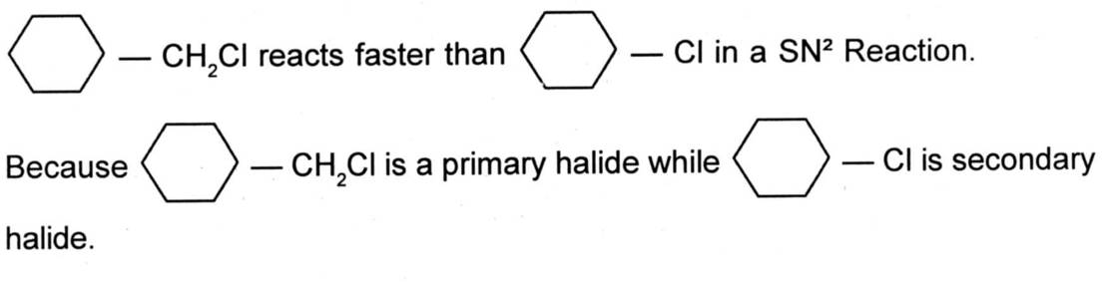
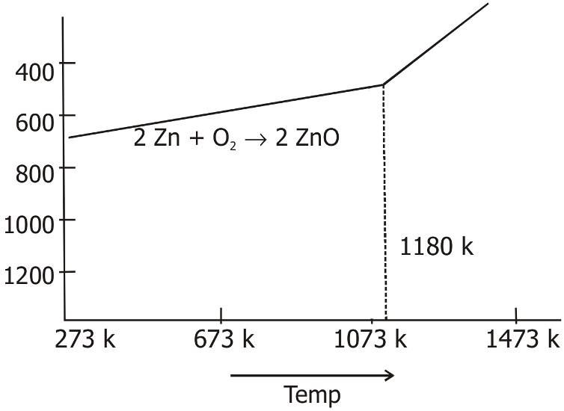

Ans. 22. (i)

(ii) 2-chloropropane to 1-bromopropane :
alc. KOH HBr
CH3 — CH — CH3 ————→ CH3CH = CH2 ———→ CH3 — CH2 — CH2Br
— HCl in presence
of Benzoyl
peroxide

(iii) Complete the following equation : 1+1+1=3
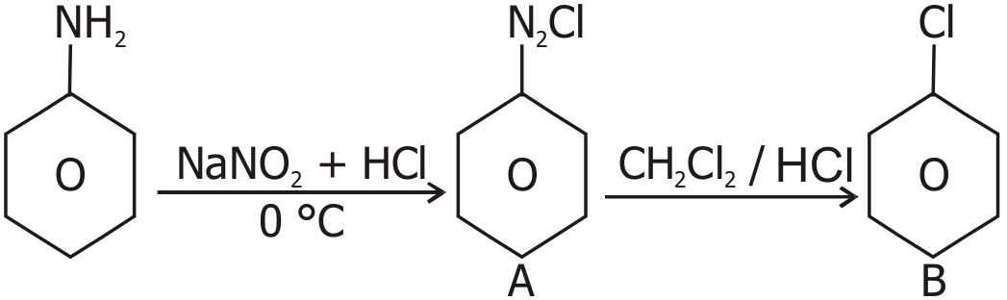

Ans. 23. (i) Reimer Tiemann Rxn : Treatment of phenol and chloroform in the presence of aq NaOH at 340 k followed by hydrolysis of the resulting product gives 2-hydroxybenzol dehyde. This Rxn is called Reimer Tiemann Rxn.
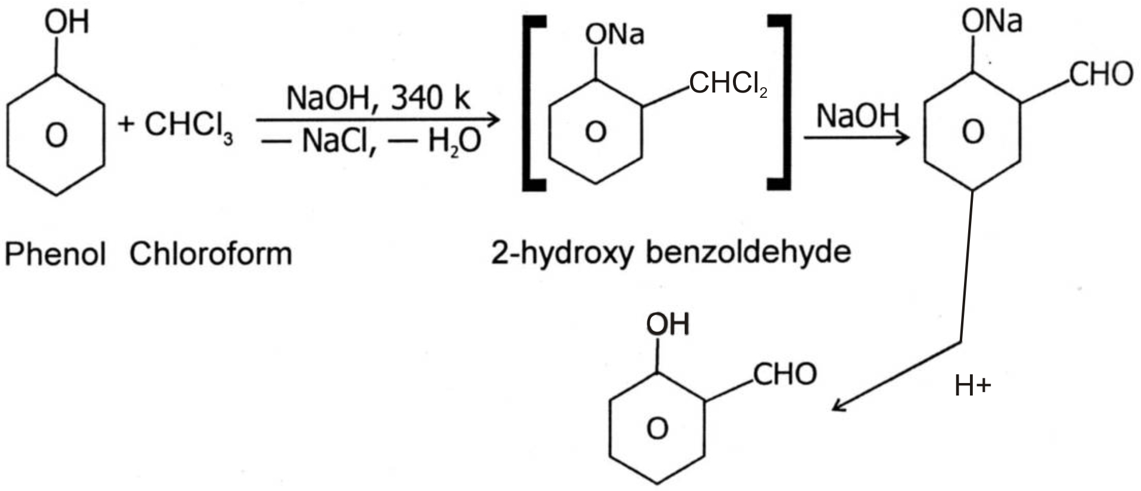

(ii) Benzene and other organic compounds react with alkyl halides or acid chlorides/acid anhydrides in presence of anhydrous AlCl3 to form alkyl benzene and Acetophenone (ketones).
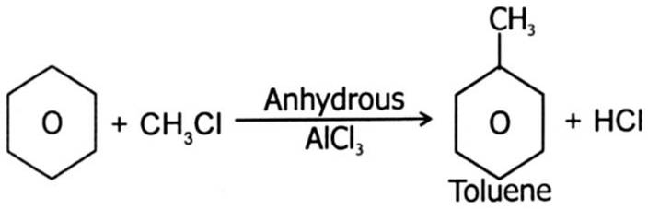

OR
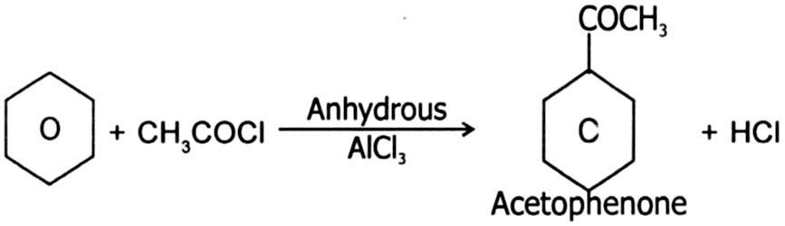

(iii) Aldol Condensation : Aldehydes or ketones containing α-hydrogen atoms on treatment with a dilute NaOH undergoes condensation to form β-hydrogen aldehydes or ketones. This Rxn is known as aldol condensation. 1+1+1=3
α
3 Hydroxy butanal
OR
(i) IUPAC name :
(ii) The — NO2 (nitro gp) is an electro with drawing gp. So nitrophenol is more acidic than phenol. — OCH3 (methoxy gp) is an electron releasing gp. So methoxy phenol is less acidic than phenol. So orthonitro phenol is more acidic than orthomethoxy phenol.
(iii) Distinguish between propanone and propanol :
Propanone gives Iodoform Test :
O
||
CH3 — C — CH3 ———→ CH3COONa + CHI3
Iodofrm
propanol gives Iodoform Test :
NaOH + I2
CH3 — CH2 — CH2OH —————→ CH3CH2 — CHO

NaOH + I2

No Rx^{n} 1+1+1=3
Ans. 24. (i) C6H5N (CH3)2 < C6H5NH2 < CH3NH2 < (C2H5)2 NH

(ii)
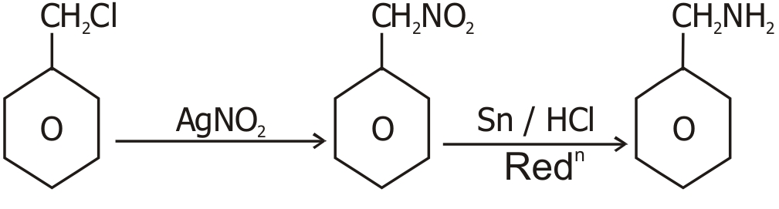

Benzyl Benzyl Benzyl
chloride nitro amine
(iii) Hofmann’s Bromoamide Rxn : The conversion of a primary amide to a primary amine containing one carbon atom less than the original amide on heating with a mixture of Br2 in presence of NaOH is called Hofmann bromoamide Rxn.
eg.
Δ
CH3CONH2 + Br2 + NaOH ———→ CH3NH2 + 2 NaBr + Na2CO3 + 2 H2O
Acetamide Methyl
amine 1+1+1=3
Ans. 25. (i) In [NiCl4]2–, Cl– is a weak field ligand and therefore no pairing of 3d electrons in Ni2+ :
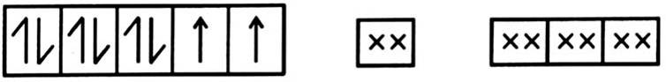
[NiCl4]2–

& then it has two unpaired electrons. In [Ni (CO)4], Ni has zero oxid. state & it involve sp³ hybridisation.
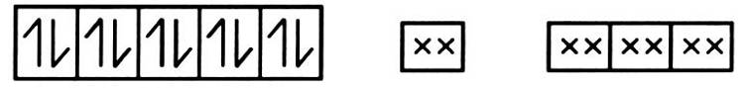
[Ni (CO)4]

As no unpaired eS– so diamagnatic.
(ii) Tris (1, 2-ethane diamine) cobalt (III) ion
(iii) It is because the stability of complex depends upon the charge density (i. e. charge/radius ratio) on central ion. More is the charge density greater is the stability. 1+1+1=3
Ans. 26. (i) (a) Caprolactum
(b) Ethylene glycol and terephthalic acid
(ii) Chain Initiation Step :
O O O
|| || ||
C6H5 — C — O — O — C — C6H5 ———→ 2 C6H5C – O ———→ 2 C6H5
C6H5 + CH2 = CH2 ———→ C6H5 – CH2 – CH2
Chain propagating Step :
C6H5CH2CH2 + CH2 — CH2 ———→ C6H5 — (CH2 — CH2)n — CH2 — C–H2
Chain terminating Step :
2 C6H5 — (CH2 — CH2)n CH2 — CH2 → C6H5 — (CH2 — CH2)n — CH2 — CH2
|
CH2
|
CH2
C6H5 — (CH2 — CH2)_{n}
(iii) Poly-Hydroxybutyrate-co-β-Hydroxyvalerate 1+1+1=3
Ans. 27. (i) (a) Def. eg. Penicilin
(b) Def. eg. Pentaerythritol monostearate
(ii) hydrophobic — CH3 (CH2)10 CH2O
hydrophilic — SO3– Na+
(iii) Chloroxylenol and terpineol 1+1+1=3
Ans. 28. (i) HClO < HClO2 < HClO3< HClO4
Conjugate base of weak acid is strong and conjugate base of strong acid is weak.
ClO4– is stable than ClO–.
ClO4– > ClO3– > ClO2– > ClO–
(ii) X — Y bond is weaker than X — X & Y — Y bonds.
(iii) Because fluorine is more electronegative than oxygen.
(iv) Because in glass SiO2 is present which dissolve in HF to give soluble H2 [SiF6].
SiO2 + 4 HF ———→ SiF4 + 2 H2O
SiF4 + 2 HF ———→ H2SiF6
(v) In the highest oxidation state, sulphur can combine only with highly electro negative element like fluorine. 1×5=5
OR
(i) Bent T-shaped with sp³d hybridisation :
(ii) NH3 < PH3 < AsH3 < SbH3 < BiH3
(iii) Both oxygen and fluorine being highly electronegative atom can easily cause promotion of electrons from filled p-orbital to vacant d-orbital.
(iv) (a) 2 NaCl + MnO2 + 2 H2SO4 ———→ NaSO4 + MnSO4 + 2 H2O + Cl2 ↑
(b) 2 NaI + Cl2 ———→ 2 NaCl + I2 5
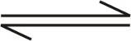
Ans. 29. (i) Cr2O72– + H2O 2 Cr2O42– + 2 H+
In acidic medium, it mainly exists as Cr2O72– & hence has orange colour. In basic medium, it exists mainly as Cr2O42– & hence has yellow colour.
(ii) Transition elements have strong interatomic bonds due to their small size and large no. of unpaired electrons in their atom.
(iii) Due to the presence of unpaired electrons and d-d transition.
(iv) Zn & Cd are not transition elements, since their d-orbitals are completely filled in their ground state as well as in their common oxidation states.
(v) Due to lanthanoid contraction, there is very small difference in the size and as a result similar chemical properties.
OR
(i) (a) They show variable Oxidation State & then also form unstable intermediate compounds & provide a new path with lower activation energy.
(b) Transition metals provide a suitable surface for the reaction to take place.
(ii) Due to poor screening by 5 f electrons.
(iii) The sum of first two ionization energies is less for Ni than Pt whereas sum of first four ionisation energies is less for Pt than Ni.
(iv) 4 FeCr2O4 + 8 Na2CO3 + 7 O2 ———→ 8 Na2CrO4 + 2 Fe2O3 + 8 CO2
(A)
Na2CrO4 + H2SO4 ———→ Na2Cr2O7 + Na2SO4 + H2O
(B) 5
Ans. 30. S. No. Element % Mole Ratio Relative Ratio
1 C 69.77 = 5.84 = 5
2 H 11.63 = 11.63 = 10
3 O 18.60 = 1.16 = 1
E. F. Mass = 86
E. F. = C5H10O M. M. = 86
M. F. = C5H10O n = n = = 1
CH3 — C — CH2CH2CH3 + NaHSO3
||
O
OSO2Na
|
—————→ CH2 — C — CH2CH2CH3
|
OH
CH3 — C — CH2CH2CH3 + I2 + NaOH
||
O
Pentan-2-one ————→ CHI3 + C2H5CH2COONa + 5 H2O + 5 NaI
Pentan-2-one
OR
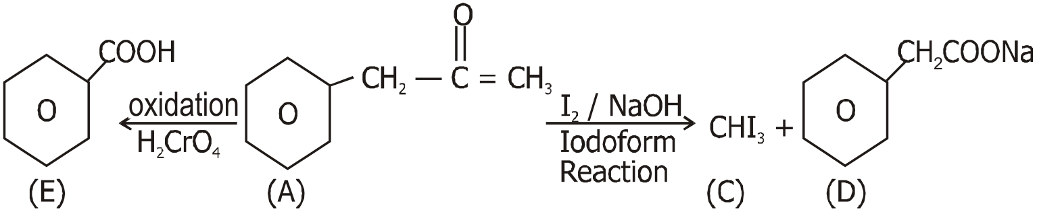

Benzoic acid mF = C9H10O Iodoform Solution
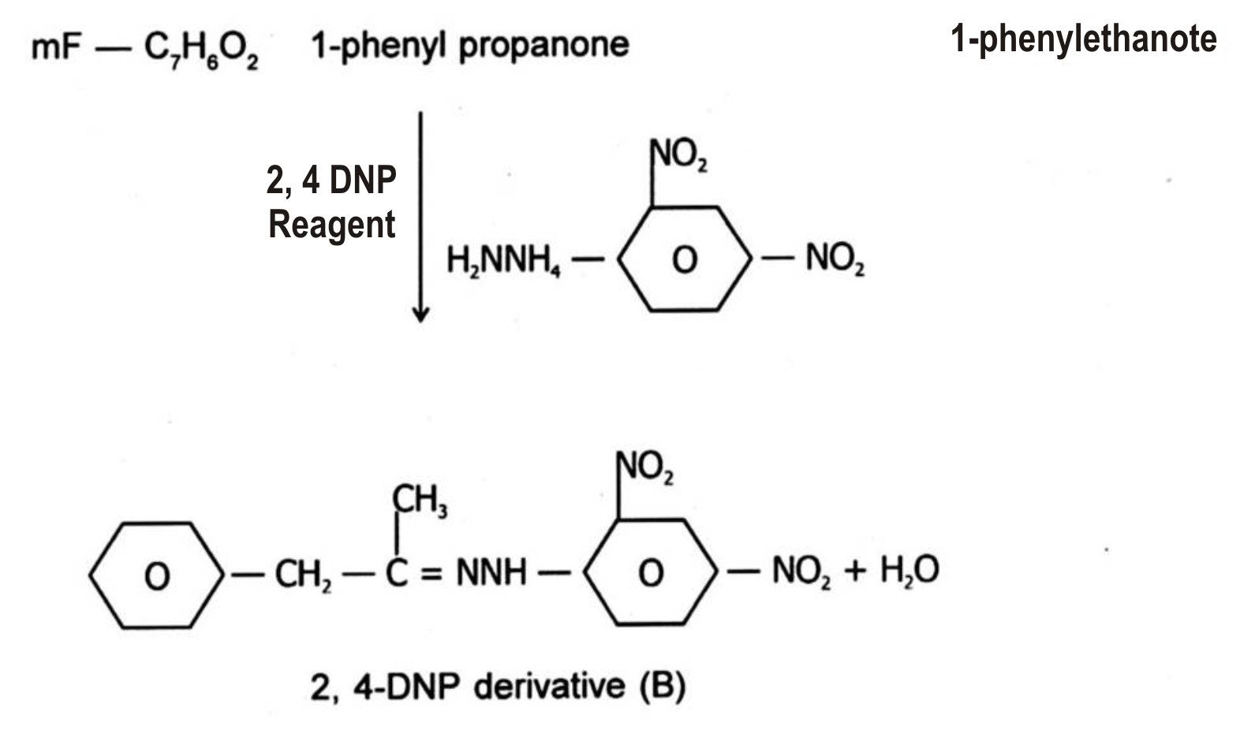

5


PAPER—3
MODEL QUESTION PAPER

Duration : 3 Hours Max. Marks : 70

General Instructions :
1. All questions are compulsory.
2. Questions No. 1 to 8 are very short answer questions and carry 1 mark each.
3. Questions No. 9 to 18 are short answer questions and carry 2 marks each.
4. Questions No. 19 to 27 are also short answer questions and carry 3 marks each.
5. Questions No. 28 to 30 are long answer questions and carry 5 marks each.
6. Use Log tables, if necessary, use of calculators is not allowed.
Q. 1. What happens when freshly precipitated Fe (OH)3 is shaken with a little amount of dilute solution of FeCl3 ?
Q. 2. Give the IUPAC name of K3 [Co(NO2)6].
Q. 3. Ortho-Nitro phenol is more acidic than ortho-methoxy phenol. Why ?
Q. 4. Name the reaction and the reagent used for the conversion of acid chlorides to the corresponding aldehydes ?
Q. 5. Identify A and B in the following :
NaNO3 CuBr
C6H5NH2 ——————→ A —————→ B
HCl (0 – 5 °C)
Q. 6. What type of linkage holds together the monomers of DNA ?
Q. 7. Give the name of the polymer which is used for making non stick utensils ?
Q. 8. Name the chemicals responsible for the antiseptic properties of Dettol ?
Q. 9. State the difference between Schottky and Frenkel defects ? Which of these two changes the density of the solids ? (Any 2 differences)
Q. 10. Caesium Chloride crystallizes as a body centered cubic lattice and has a density of 4 g/cm³. Calculate the length of the edge of the unit cell of Caesium Chloride Crystal ? (Molar Mass of CsCl = 168.5 g/mol)
Q. 11. State Henry’s law and write one important application of the law ?
Q. 12. What is a fuel cell ? Write the electrode reactions in a fuel cell ?
Q. 13. Which of the d-block elements are not regarded as transition metals and why ?
Q. 14. [Co(NH3)6]3+ is diamagnetic whereas [Co(F6)]3– is paramagnetic. Give reasons.
Q. 15. Explain why :
(i) Haloalkanes are more reactive towards nucleophilic substitution reaction than haloarenes.
(ii) Thionyl Chloride method is preferred for preparing alkyl chlorides from alcohols.
Q. 16. Write the structure of the major product in each of the following reactions :
ethanol
(i) (CH3)3 CBr + KOH —————→
heat
Peroxide
(ii) CH3CH2CH = CH2 + HBr —————→
Q. 17. What is a biodegradable polymer ? Give an example.
Q. 18. Low level of noradrenaline is the cause of depression. What type of drugs are needed to cure this problem ? Name any two drugs.
OR
Differentiate between bactericidal antibiotics and bacteriostatic antibiotics with one example each.
Q. 19. The vapour pressure of pure benzene at a certain temperature is 0.850 bar. A non volatile non-electrolyte solid weighing 0.5 g is added to 39 g of benzene. The vapour pressure of the solution is 0.845 bar. What is the molar mass of the solid substance ?
Q. 20. Represent the cell and calculate the emf of the cell in which the following reactions takes place :
Mg (s) + 2 Ag+ (0.0001 M) ———→ Mg2+ (0.130 M) + 2 Ag (s)
E°cell = 3.17 V
OR
The conductivity of 0.001028 mol/L acetic acid is 4.95 × 10–5 S cm–1.
Calculate its dissociation constant if Λ°m is 390.5 S cm² mol–1.
Q. 21. Explain what is observed :
(a) (i) When a beam of light is passed through a colloidal solution.
(ii) Electric current is passed through a colloidal solution.
(b) What do you mean by activity and selectivity of a catalyst ?
Q. 22. Name the chief ore of aluminium and describe the steps involved in the extractions of aluminium metal from its ore.
Q. 23. Give reasons for the following :
(i) Noble Gases have very low boiling points.
(ii) Halogens have maximum negative electron gain enthalpy in the respective period of the periodic table.
(iii) Ozone acts as a powerful oxidising agent.
Q. 24. Indicate the steps in the preparation of K2Cr2O7 from Chromite ore.
Q. 25. You are given benzene, concentrated Sulphuric Acid and Sodium Hydroxide. Write the equations for the preparation of phenol using these reagents ?
Q. 26. Arrange the following :
(i) Increasing order of basic strength : Aniline, p-nitroaniline and p-toluidine
(ii) Increasing order of boiling points : C2H5OH, (CH3)2 NH, C2H5NH2
(iii) Increasing order of solubility in water : C6H5NH2, (C2H5)2 NH, C2H5NH2
Q. 27. What happens when D-Glucose is treated with the following reagents :
(i) HI
(ii) Bromine Water
(iii) HNO3
Q. 28. For a certain chemical reaction, variation in the concentration in [R] vs time (s) plot is given. For this reaction :
(i) What is the order of the reaction ?
(ii) What are the units of rate constant k ?
(iii) Give the relationship between k and t_{½} ?
(iv) What does the slope of the plot line indicate ?
(v) Draw the plot log vs time t (s).
OR
For a certain chemical reaction :
A + 2 B ———→ 2 C + D
The experimentally obtained information is tabulated before :
Experiment [A]0 [B]0 Initial rate of reaction
1. 0.30 0.30 0.096
2. 0.60 0.30 0.384
3. 0.30 0.60 0.192
4. 0.60 0.60 0.768
For this reaction :
(i) Derive the order of the reaction with respect to both reactants A and B.
(ii) Write the rate law.
(iii) Calculate the value of rate constant.
(iv) Write the expressions for the rate of the reaction in terms of A and C.
Q. 29. Arrange the following in the order of property indicated for each set :
(a) F2, Cl2, Br2, I2 ; Increasing Bond Energy
(b) HF, HCl, HBr, HI ; Increasing acid strength
(c) NH3, PH3, AsH3, BiH3 ; Increasing base strength
(d) H2O, H2S, H2Se, H2Te ; Increasing acid strength
(e) NaF, NaCl, NaBr, NaI ; decreasing ionic character
OR
(a) How are XeO3 and XeF4 prepared ? Draw their molecular shape.
(b) Write the formulae of the noble gas compound that is isostructural with
(i) IBr2–
(ii) BrO₃–
Q. 30. An organic compound (A) having molecular formula C8H8O forms an orange red precipitate (B) with 2, 4 — DNP reagent. Compound (A) gives a yellow precipitate (C) when heated in the presence of iodine and Sodium Hydroxide along with a colourless compound (D). (A) does not reduce Tollen’s reagent or Fehling’s solution nor does it decolourise bromine water. On drastic oxidation of (A) with chromic acid, a carboxylic acid (E) of molecular formula C7H6O2 is formed. Deduce the structure of organic compounds A to E.
OR
Write Chemical equations for the following reactions :
(i) Aldol Condensation
(ii) Canizzaro Reaction
(iii) Clemmenson Reduction Reaction
(iv) Gattermann Koch Reaction
(v) Esterification Reaction
SOLUTION TO THE MODEL QUESTION PAPER
Ans. 1. Peptization (The precipitate changes into a colloidal sol) 1
Ans. 2. Potassium hexanitrito-N-cobaltate (III) 1
Ans. 3 — NO2 group is electron withdrawing, decreases electron density on benzene ring, facilitating the release of H+. 1
— OCH3 group is electron releasing, it increases electron density on benzene ring thereby making the release of H+ comparatively difficult. 1
Ans. 4. Rosenmund Reduction :
H2 / Pd / BaSO4 1
Ans. 5. A— C6H5N2Cl
B— C6H5Br 1
Ans. 6. Phosphodiester linkage 1
Ans. 7. Polytetra fluoro ethylene (Teflon) 1
Ans. 8. Chloroxylenol and turpeniol 1
Ans. 9. Schottky defect Frenkel defect
Equal number of cations and atoms The smaller ion usually the cation is dislocated
are completely missing from their from its normal site to an interstitial.
lattice sites. site.
Density of substance reduced. No effect on density of the substance.
Shown by substance in which cation Shown by substances in which there is a large
and anion are almost of same size. difference in the size of ions.
Schottky defect changes the density of the solid. 2
Ans. 10. d =
a³ =
=
a³ =
a³ = 1.39 × 10–22; a = 2.404 × 10–7 cm 2
Ans. 11. The solubility of a gas in a liquid is directly proportional to the pressure of the gas.
Applications :
To increase the solubility of CO2 in soft drinks and soda water, the bottle is sealed under high pressure. 2
Ans. 12. Fuel cell is a device that can convert the energy of combustion of fuels like hydrogen, methane, methanol etc. directly into electrical energy. 2
At cathode : O2 (g) + 2 H2O (l) + 4 e– ———→ 4 OH– (aq)
At anode : 2 H2 (g) + 4 OH– (aq) ———→ 4 H2O (l) + 4 e–
Ans. 13. Zinc, cadmium and mercury are not regarded as transition metals because they have completely filled d orbitals in their ground state as well as in their oxidised state. 2
Ans. 14. In [Co(NH3)6]3+, cobalt ion is in + 3 oxidation state and has the electronic configuration 3 d6. It undergoes d² sp³ hybridisation. Each hybrid orbital receives 1 pair of electrons from ammonia. Since all electrons are paired it is diamagnetic.
In [CoF6]3+, cobalt ion is in + 3 oxidation state and has the electronic configuration 3d6. It undergoes sp³ d² hybridisation. Each hybrid orbital receives a pair of electrons from F–. THe 3 d electrons of Co remain unpaired making it paramagnetic. 2
Ans. 15. (i) In haloarenes, there is resonance. Due to resonance, the C — X bond aquires a double bond character making its cleavage difficult whereas there is no such resonance in haloalkanes.
(ii) Because the side products are gaseous so the main product is easily obtained in a pure form. 2
Ans. 16. (a) H3C — C = CH2 + KBr + H2O
|
CH3
(b) CH3CH2CH2CH2Br 2
Ans. 17. Those polymers which can be easily degraded by microorganisms in the environment.
Eg. PHBV 2
Ans. 18. Antidepressants.
Eg. Iproniazid and phenelzine. 2
OR
Bactericidal antibiotics kill the bacteria.
Eg. Penicillin.
Whereas bacteriostatic antibiotics only inhibit the growth of bacteria.
Eg. Tetracycline.
Ans. 19. Given p° = 0.850 bar, p = 0.845 bar
Molar Mass of solvent (M1) = 78 g/mol,
Mass of Solvent w1 = 39 g
Mass of Solute w2 = 0.5 g
M2 = 170 g/mol 3
Ans. 20. Mg / Mg2+ (0.130 M) || Ag+ (0.0001 M) / Ag
Ecell = E°cell – ln
= 3.17 V – log
= 3.17 V – 0.21 V
= 2.96 V 3
OR
Λm = = 48.15 S cm² mol–1
α = = 0.1233
K = = 1.78 × 10–5 mol L–1
Ans. 21. (a) (i) The path of beam in the colloidal dispersion is illuminated. Light is scattered by the sol particles.
(ii) The dispersed phase particles start moving towards the electrode of opposite charge. The process is called as electrophoresis.
(b) The activity of a catalyst is its ability to catelyse a reaction or its ability to accelerate the reaction.
While selectivity of a catalyst is its ability to direct a reaction to yield a particular product. 3
Ans. 22. Chief ore of aluminium — Bauxite
Extraction of Aluminium :
(a) Concentration of ore :
(i) The powdered ore is treated with Conc. NaOH.
Al2O3 (s) + 2 NaOH (aq) + 3 H2O (l) ——→ 2 Na [Al (OH)4] aq
(ii) The aluminate in solution is neutralised by passing CO2 gas and hydrated Al2O3 is precipitated.
2 Na [Al (OH)4] (aq) + CO2 (g) —→ Al2O3 . x H2O (s) + 2 NaHCO3 (aq)
(iii) The hydrated alumina is filtered, dried and heated to give back pure Al2O3.
1470 K
Al2O3 . x H2O (s) ———→ Al2O3 (s) + x H2O (g)
(b) Reduction of Al2O3 to Al :
Electrolyte — molten Al2O3 and cryolite
Anode — Carbon rods
Cathode — Carbon lining inside the electrolytic tank
At cathode — Al3+ + 3 e– ———→ Al (l)
At anode — C (s) + O2– ———→ CO (g) + 2 e–
C (s) + 2 O2– ———→ CO2 (g) + 4 e– 3
Ans. 23. (i) Being monoatomic, they have no interatomic forces except weak dispersion forces, hence they have low boiling point.
(ii) Smallest size in the respective period, therefore high effective nuclear charge, facilitating electron gain.
(iii) Thermodynamically unstable with respect to oxygen and hence easily liberates nascent oxygen :
O3 ———→ O2 + O 3
Ans. 24. (1) Fusion of chromite ore (FeCr2O4) with sodium on potassium carbonate in free access of air.
4 FeCr2O4 + 8 Na2CO3 + 7 O2 ———→ 8 Na2CrO4 + 2 Fe2O3 + 8 CO2
(2) Sodium chromate is filtered and acidified with sulphuric acid to give a solution from which sodium dichromate can be crystallised.
2 Na2CrO4 + 2 H+ ———→ Na2Cr2O7 + 2 Na+ + H2O
(3) Sodium dichromate on treating with potassium chloride, gives potassium dichromate.
Na2Cr2O7 + 2 KCl ———→ K2Cr2O7 + 2 NaCl 3
Ans. 25.

3

Ans. 26. (i) p-nitroaniline < Aniline < p-toluidine
(ii) (CH3)2 NH < C2H5NH2 < C2H5OH
(iii) C6H5NH2 < (C2H5)₂ NH < C2H5NH2 3
Ans. 27. (i) n-hexane is formed.
CHO
| HI
(CHOH)4 ———→ CH3 — CH2 — CH2 — CH2 — CH2 — CH3
| Δ
CH2OH
(ii) Gets oxidised to six carbon carboxylic acid. (Gluconic acid)
CHO COOH
| Br2 water |
(CHOH)4 —————→ (CHOH)4
| |
CH2OH CH2OH
(iii) A dicarboxylic acid, saccharic acid is formed.
CHO COOH
| Oxidation |
(CHOH)4 —————→ (CHOH)4
| HNO3 |
CH2OH COOH 3
Ans. 28. (i) First order
(ii) s–1
(iii) t_{½} =
(iv) – K
(v) 5

OR
(i) Rate = K
0.096 = K [0.30]x [0.30]y .......................... (1)
0.384 = K [0.60]x [0.30]y .......................... (2)
0.192 = K [0.30]x [0.60]y .......................... (3)
Dividing (1) by (2)
x = 2
Dividing (1) by (3)
y = 1
Order wrt A = 2
wrt B = 1
(ii) Rate = K . [A]² [B]¹
(iii) 0.096 = K (0.30)² 0.30
K =
(iv) Rate =
Rate =
Ans. 29. (a) I2 < F2 < Br2 < Cl2
(b) HF < HCl < HBr < HI
(c) BiH3 < AsH3 < PH3 < NH3
(d) H2O < H2S < H2Se < H2Te
(e) NaF > NaCl > NaBr > NaI 5
OR
(a) XeO3 is prepared by hydrolysis of XeF4 and XeF6 with water.
6 XeF4 + 12 H2O ———→ 4 Xe + 2 XeO3 + 24 HF + 3 O2
XeF6 + 3 H2O ———→ XeO3 + 6 HF
XeF4 is prepared by direct combination of Xe and F2 in (1 : 5) ratio, at 873 K, 7 bar.
873 K, 7 bar
Xe (g) + 2 F2 (g) ——————→ XeF4 (s)
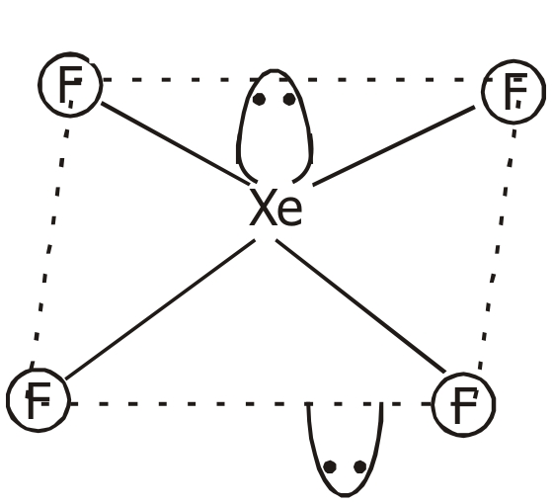
1 : 5 Ratio

XeF4 XeO4
(b) (i) XeF2
(ii) XeO3
Ans. 30. (a)

(b)

(c) CHI3
(d)

(e) 5

OR
(i) Aldol Condensation :
dil NaOH Δ
2 CH3 — CHO ————→ CH3 — CH — CH2 — CHO ———
| – H2O
OH

CH3 — CH = CH — CHO

(ii) Cannizaro Reaction :
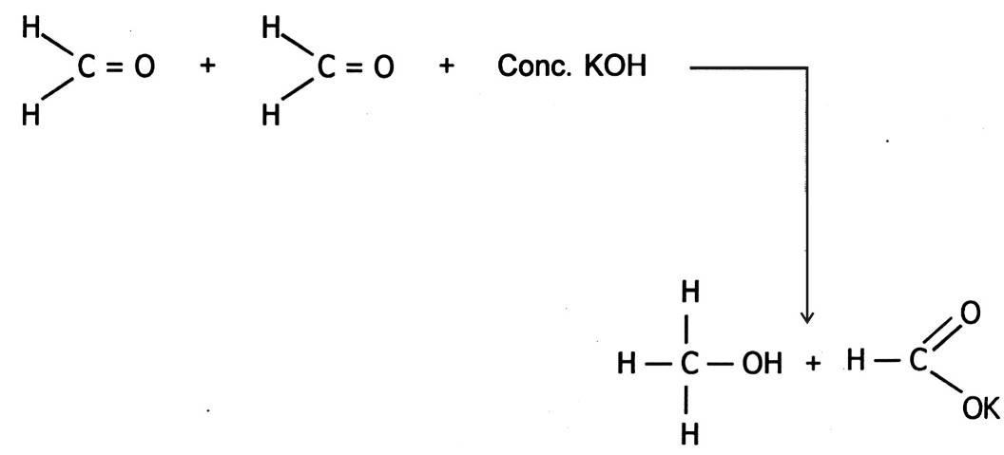

(iii) Clemenson Reduction reaction :
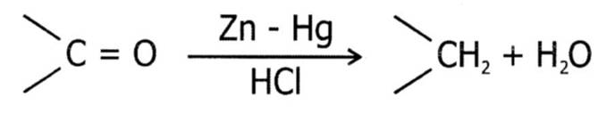

(iv) Gatterman-Koch reaction :
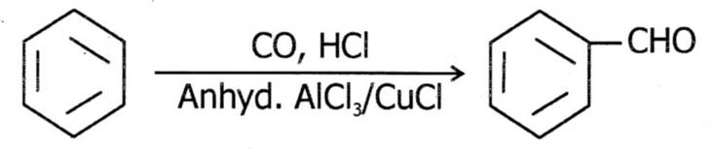

(v) Esterification reaction :
Conc. H2SO4
CH3COOH + C2H5ΟΗ ———————→ CH3COOC2H5 + H2O



