Triangles

1 Mark Questions

Q1. In fig, if A=CDE, AB=9cm, AD=7cm, CD=8cm, CE=10cm. Find DE
if Δ CAB ΔCED.
C

8
10
D D
E

7

A
B
9

Q2.Find ‘y’ if ΔABC Δ PQR
P
R
A

9
Y

10
12
Q

B
C
7

Q3. ΔADE ˜ Δ ABC , if DE=4cm, BC=8cm and ar( ΔADE)=25sq cm. Find the area of ΔABC.

Q4. If D and E are respectively the points on the sides AB and AC of a ΔABC such that AD=6cm, BD=9cm, AE=8cm, EC=12cm, Then show that DE||BC.

Q5.
A
Q

80
40
40
80
60
60
B
C
P
R

Write symbolic representation for above similarity.

Q6. If ar ΔABC = ar ΔDEF Find

Q7. Find if D is mid point of AB and DE||BC.
A

D
E

B
C

Q8. Δ ABC is a right triangle, right angled at B, BD AC then Δ ADB _____________
A

D

B
C

Q9. In Δ ABC, if 2AB²=AC², Find B.

Q10. In fig B=90⁰, if AB²+BC²+CD²=AD² Find ACD.

D

C

A
B

2/3 Mark Questions

Q1. If Δ PQR ˜ ΔABC and PQ=AB show that Δ PQRΔ ABC.

Q2. In fig. =and 1=2 Show that ΔPQS ˜ Δ TQR

T

P

∟
R
Q
1
2

S

Q3.In fig =and PST= PRQ. Prove that PQR is an isosceles triangle.
P

S
T

R
Q

Q4. In fig ,AC||BD. Is =. Justify your answer.

A
C

E

B
D

Q5. In fig, DE|| AC and DF ||AE. Prove that=

A

D

B
C
E
F

Q6. In fig, considering Δ BEP and Δ CPD. Prove that BP X P D= EP X PC
A

B

D
E
P

C

Q7. In fig, E is a point on side CB produced of an isosceles triangle ABC with AB=AC.
A

F

C
B
D

If AD BC and EF AC, Prove that Δ ABD ˜ Δ ECF.

Q8. In ΔPQR, M is a point on QR such that PM QR and PM² =QM.MR. Show that PQR is a right triangle.

Q9. In Fig, ACB=90⁰ and CDAB. Prove that BC²/AC²=.

C

B
A
D

Q10. Two poles of height ‘a’ meters and ‘b’ meters (a<b) are ‘p’ meters apart. Prove that the height of the point of intersection of the lines joining the top of each pole of the foot of the other pole is given by ()m.

Triangles
1 Marks Questions

- 6 cm
- 2.5
- 100

- 1

Circles

1 Mark Questions
1.
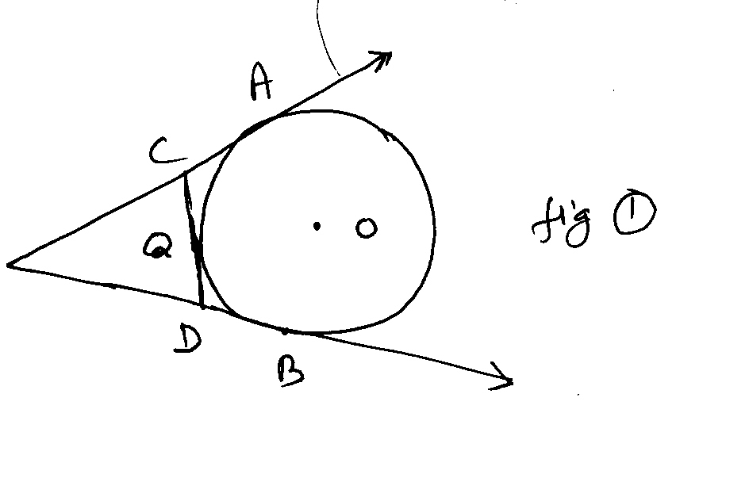
In the fig.1 PA and PB are tangents to the circle with centre O drawn from an external point P. CD is a third tangent touching the circle at Q. If PB=10cm Q =2 cm. What is the length of PC?

2. The length of tangent from point A at a distance at 5 cm. from the centre of the circle is 4 cm. What will be the radius of the circle?

3.
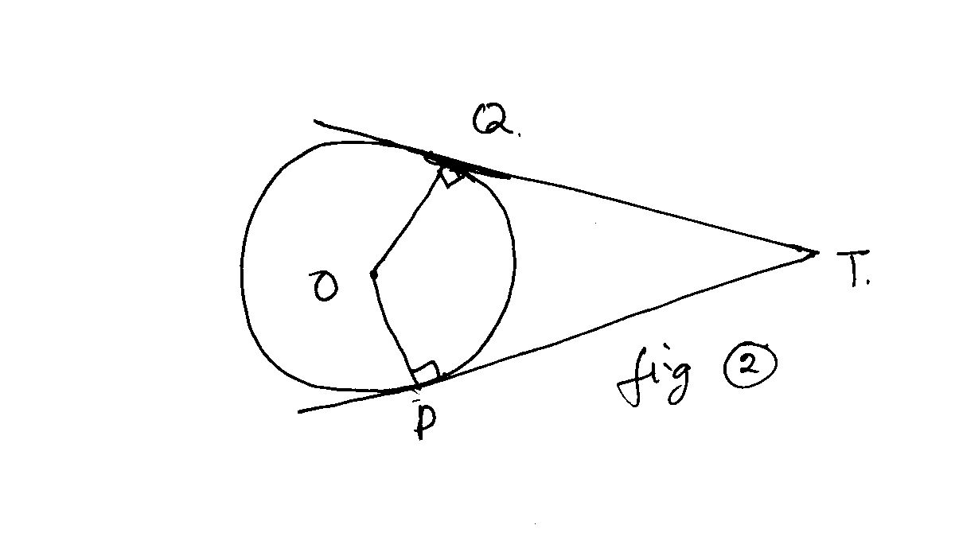
Two tangents TP and TQ are drawn from an external point ‘T’ to a circle with centre O as shown in fig they are inclined to each other at an angle of 100⁰ then what is the value of POQ?

- How many tangents can be drawn to a circle from a point outside the circle?

2/3 MARKS

5.In fig, a circle touches all the four sides of a quadrilateral ABCD whose sides AB = 8 cm., BC = 9 cm. and CD = 6 cm. find AD.

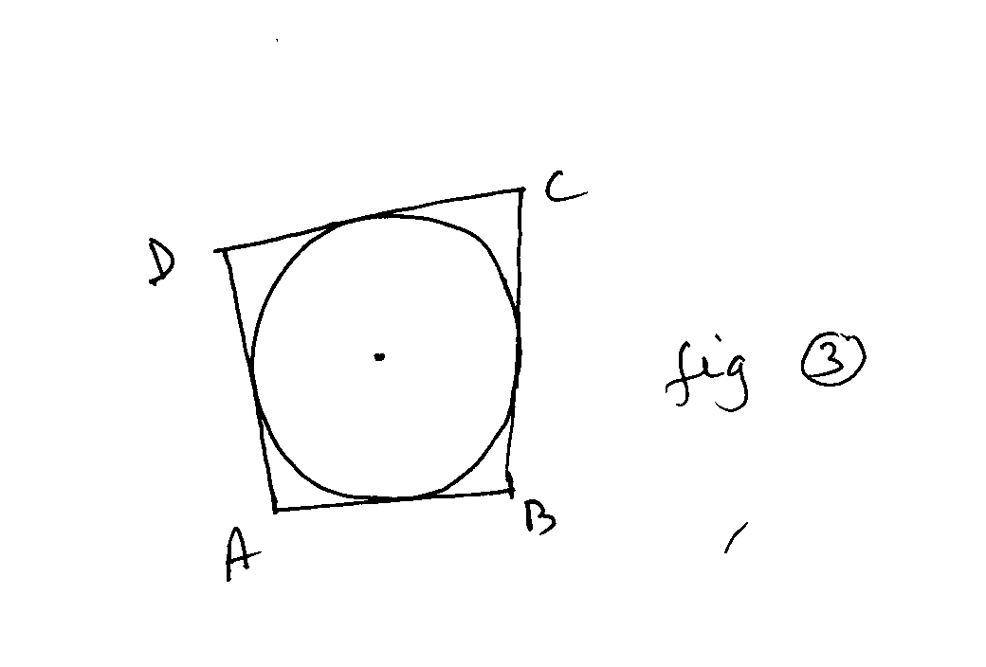

- What is the distance between two parallel tangents of a circle of the radius 4 cm.?

- How many tangents can be drawn to a circle from a point inside the circle.

8. TP and TQ are tangents to the circle with centre O if TOQ = 50⁰ find OTQ.

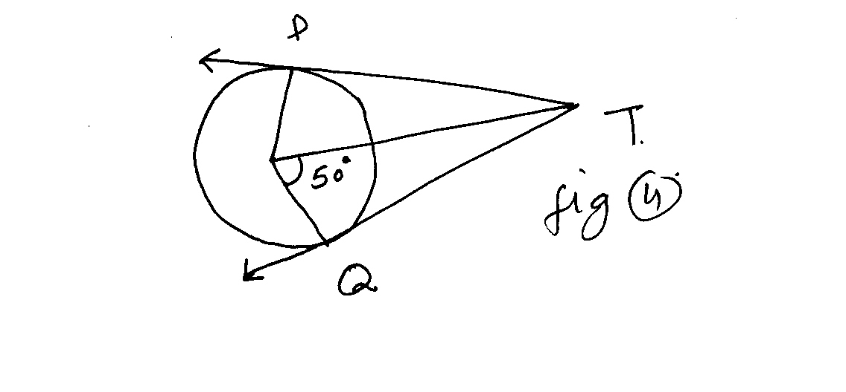

- If O is the centre of two concentric circles of radius 5 cm. and 13 cm. if AB is chord of larger circle which touches the smaller circle. Find the length of chord AB.

10.In the adjoining figure (fig. 5) a circle is inscribed in a quadrilateral ABCD in which B= 90⁰.If AD= 23cm, AB =29cm, and DS =5cm. find the radius of the circle.

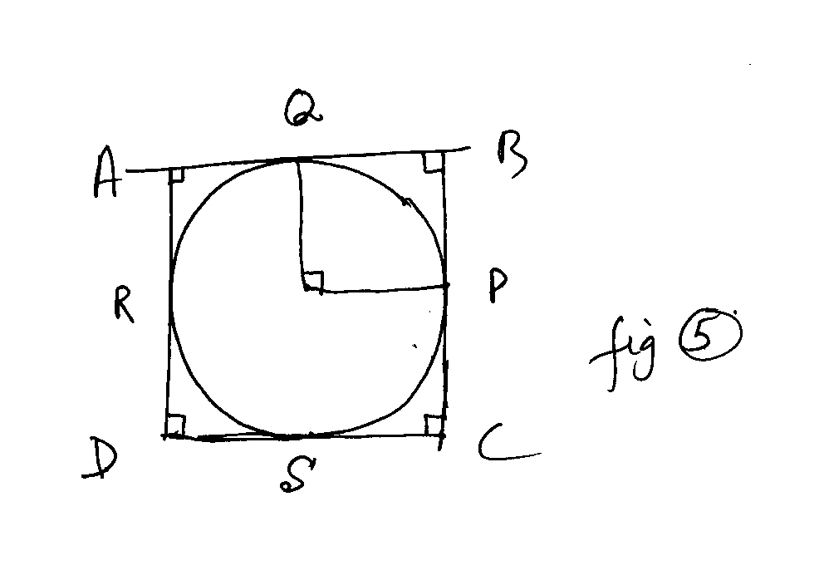

Circles(Answer)

- 8cm
- 3 cm
- Two
- 5 cm
- 8 cm
- None
- 24 cm
- 11 cm

CONSTRUCTIONS

Q1. Construct a triangle with sides 4cm, 5cm and 6 cm and then another triangle whose sides are of the corresponding sides of the first triangle.
Q2. Draw a pair of tangents to a circle of radius 5 cm which are inclined to each other at an angle of 300.

Q3. Draw a line segment of length 8 cm and divide it in the ratio 3:2. measure the two lengths.

Q4. Draw a circle of radius 5 cm. From a point 11 cm away from its center. Construct the pair of tangents to the circle.

Q5. Let ABC be a right triangle in which AB= 6 cm and BC is 8 cm, B=90⁰, BD is perpendicular from B on AC. The circle through B, C, D is drawn. Construct the tangents from this circle.

Area related to Circle
(1 Mark Questions)

- A wire in the shape of square of perimeter 88 cm. is bent so as to form a circular ring. Find the radius of the ring.

- What is the perimeter of a semi circular protractor whose diameter is 14cm?

3. In fig. 6 OACB is a quadrant of a circle of radius 7 cm. What is its perimeter?
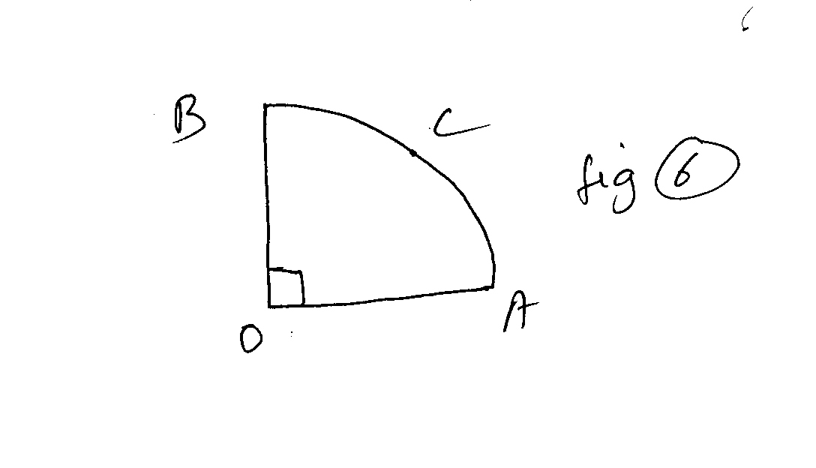
4. In fig.7, which is a sector of a circle of radius 10.5 cm. Find the perimeter of the sector (٨ = 22/7)

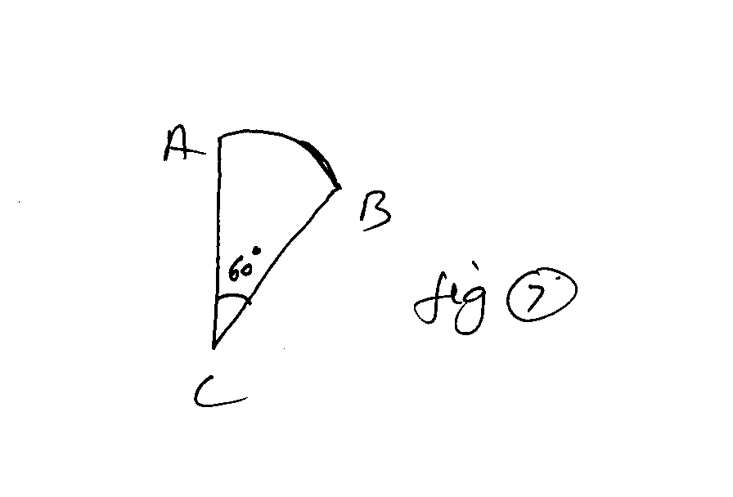

- What is the ratio of the areas of a circle and an equilateral triangle whose diameter and a side are respectively equal.

- The length of a minute hand of a wall clock is 7 cm. What is the area swept by it is 30 minutes.

- What is the radius of the circle whose circumference and area are numerically equal?

- Find the area of a sector whose radius is ‘r’ and central angle is complete angle.

- What is the perimeter of a sector of radius ‘r’ and of central angle Q (in degrees).

10. In fig.8 ABPC is a quadrant of radius ‘r’. Find the area of the shaded region.

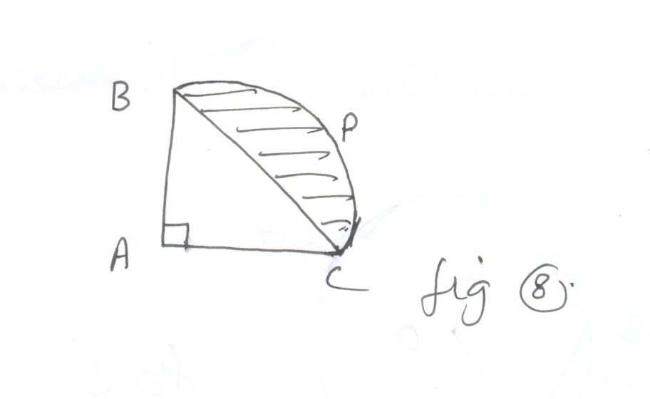
2/3 Marks Questions
1.
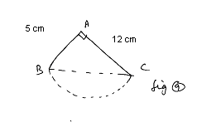
Find the perimeter of adjoining figure (fig. 9), if a semicircular arc is drawn on side BC as diameter.

2.
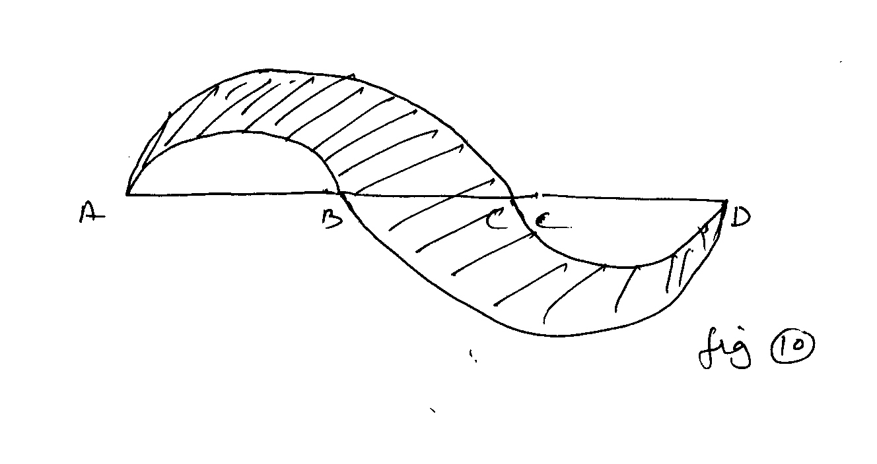
In the given figure (fig. 10) AB=BC=CD and AD=42 cm. find the area of shaded figure.

3.
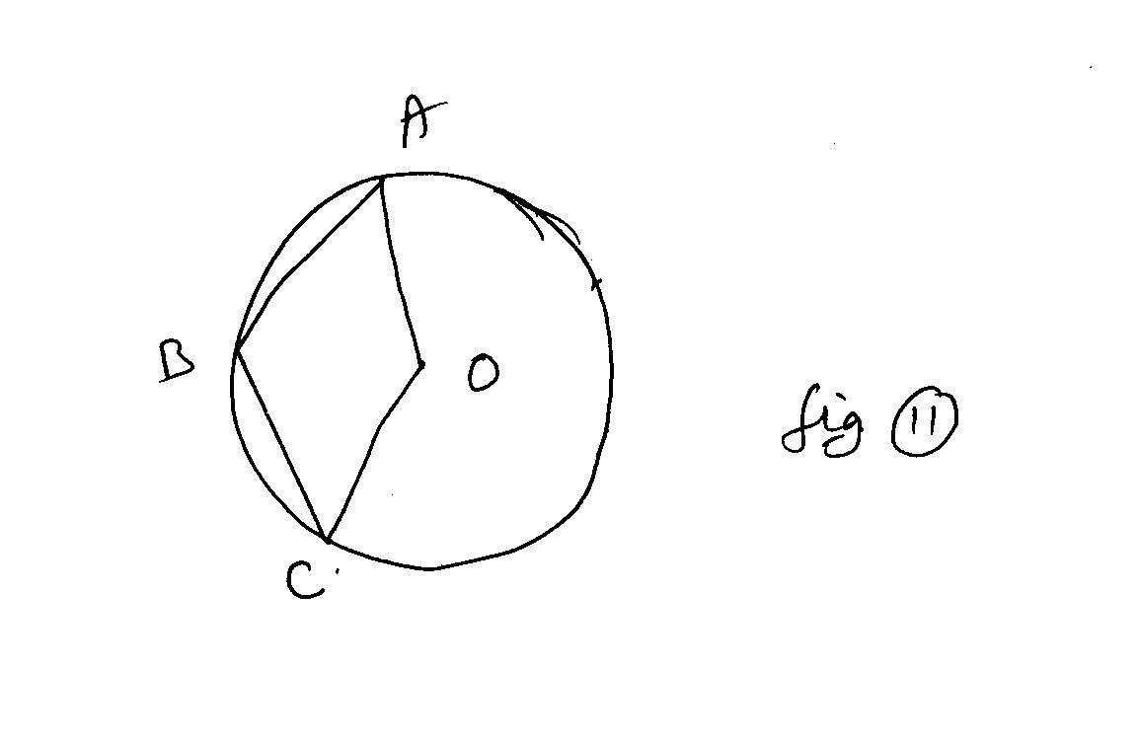
In the given figure (fig.11) OABC is a rhombus, three of whose vertices lie on a circle with centre O. If the area of the rhombus is 32√3 cm². Find the radius of the circle.

4.
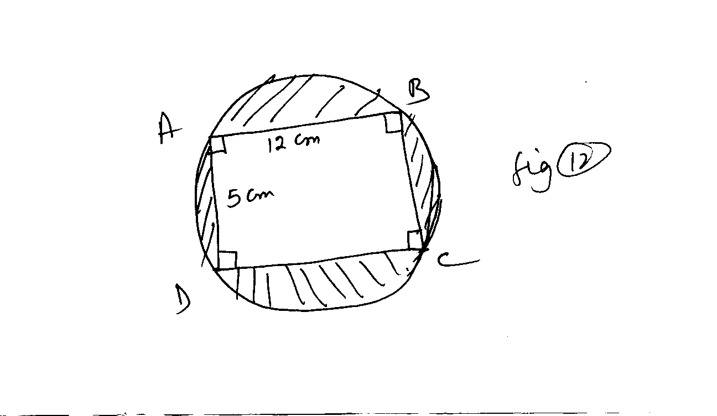
Find the area of shaded portion in the given figure (fig.12).

- A wire is looped in the form of a circle of radius 28cm. if is reverted into a square form. Determine the area of the square so formed.

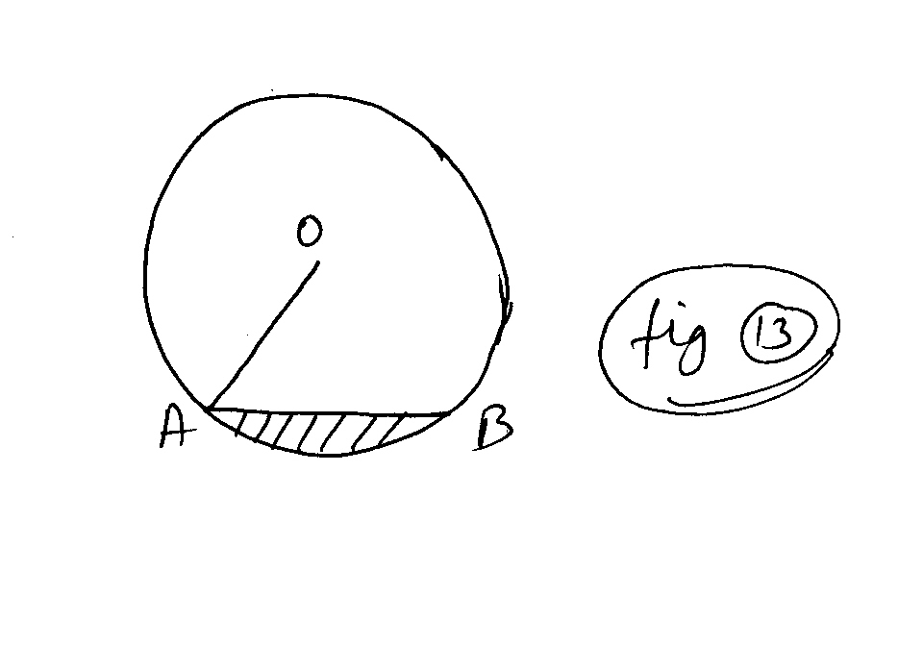
In the following figure(fig. 13) chord AB is equal to the radius of the circle. Find area of shaded region if radius is 7 cm.

- If the perimeter of a sector of a circle of radius 5.2 cm. is 16.4 cm. find the area of the sector.

- The short and long hands of a clock are 4cm. & 6cm. long respectively. Find the sum of distance travelled by their tips in two days. (Take =)

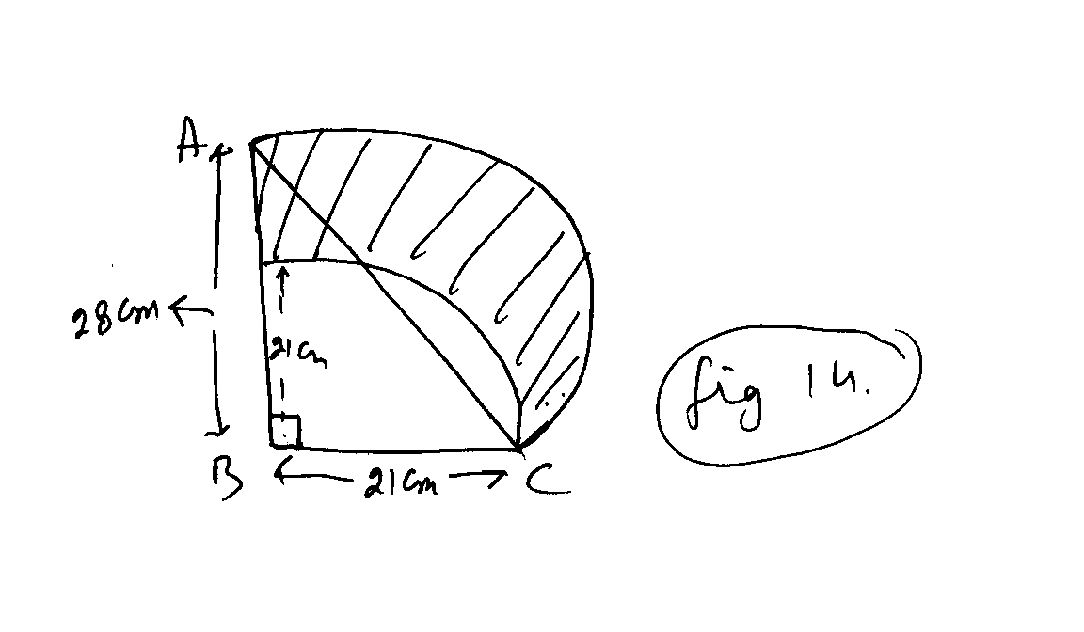
∆ ABC is a right-angled triangle,B= 90⁰, AB= 28cm, BC= 21cm. With AC as diameter semicircle is drawn and with BC as radius a quarter circle is drawn. Find the area of the shaded portion. (Fig. 14)
10.
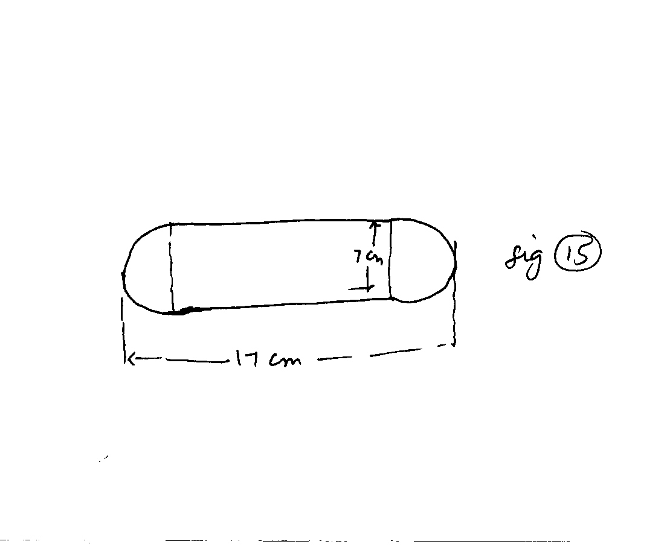
Above figure is a running track with semicircular ends of diameter 7 cm. Find the length of the track as per given dimensions.

Area related to Circle
1 Marks Questions

- 14 cm
- 36 cm
- 25 cm
- 32 cm
- 12.8 cm
- 2

PROBABLITY

- A die is thrown once. Find the probability of getting multiple of 2 or 3.

- Find the probability of getting 53 Fridays in a leap year.

- Write a sample space when two coins are tossed simultaneously?

- A bag contain 4 red, 5 black and 6 white balls & ball is drawn from the bag at random. Find the probability that ball drawn is

a) Not black b) Red or White

- In a single throw of two dice, find the probability of not getting the same number on the two dice.

- The probability that it will rain tomorrow is 0.85. What is the probability that it will not rain tomorrow ?

- What is the probability of

a) A sure event b) Impossible event

- A card is drawn at random from a well shuffled pack of playing cards.
Find the probability that the card drawn is

a) Red and a queen b) Either a king or jack

- Two coins are tossed simultaneously once. What is the probability of getting

a) Exactly one head b) No head

- 15 cards numbered 1,2,3………15 are put in a box and mixed thoroughly & card is drawn at random from the box. Find the probability that the card drawn is

- neither prime nor odd b) a number which is a perfect square.

- A box contains 90 discs which are numbered from 1 to 90. If one disc is drawn at random from the box, find the probability that it bears.

- not divisible by 5 or 10.

- two digit number.

- Two coins are tossed simultaneously once. Find the probability of getting

- at least one head and one tail.

- at most 2 heads.

- In a single throw of two dice, find probability of getting

- doubles
- a total of 11

- A bag contains 12 balls out of which x are black. If one ball is drawn at random from the box, what is the probability that it will be a black ball. If more black balls are put in the box the probability of drawing a black ball is now double of what it was before. Find x

- Two customers Shyam and Ekta are visiting a particular shop in the same week (Tuesday to Saturday) each is equally likely to visit the shop on any day as on another day. What is the probability that both will visit the shop on

- the same day?
- consecutive day?
- Different day?

- One card is drawn from well-shuffled pack of 52 cards. Find the probability of getting

- the jack of hearts
- a face card.

- A lot consists of 144 ball pens of which 20 are defective and the others are good. Nuvi will buy a pen if it is good, but will not buy it if it is defective. The shopkeeper draws one pen at random and gives it to him. What is the probability that

- She will buy it
- She will not buy it

- All the three face cards of spade are removed from a well shuffled pack of 52 cards & card is drawn from the remaining pack. Find the probability of getting

- a black face card
- a queen of diamond
- a spade
- a black card

- Savita and Hamida are friends what is the probability that both will have

- the same birthday?
- different birthday?

- A letter is chosen at random from the letters of the word “ASSASSI NATION” and the probabilities that the letter chosen is a

i) vowel ii) consonant

ANSWERS

- S = {1,2,3,4,5,6} n(S) = 6
E = {2,3,4,6} n(E) = 4 P(E) = =

- A leap year consist of 52 weeks and 2 extra days.

n(S) = 7 , n(E) = 2 , P(E) =
- S = { HH,HT,TH,TT}
- 4R (a) P() = =
5B (b) p( R or W ) = =
6W
- n(S) = 36
n(E) = 30
P(E) = =

- P(E) = 0.85
P(E) = 1 – P(E) = 1 – P(E) = 1 - .085 = 0.15

- (a) P(S) = 1 (b) P(2) = 0

- (a) = (b) = (c) =

- S = { HH,HT,TH,TT}
(a) (b)

- (a) E= {4,6,8,10,12,14} n(E) = 6; n(S) = 15
P(E) = =
(b) E = {1,4,9} n(E) = 3
P(E) = =

- (a) n(E) = divisible by 5 or 10 = 18
P(E) = =
P() = 1 – =

(b) P(E) = =
(12) S= {HH,HT,TH,TT}
(a) E= {HT,TH} n(E)=2
n(S) = 4 , P(E) = =
(b) P(E) = =1
(13) (a) P(E) = = (b) P(E) = =

- xb+6
(1) (2) P(E) =
= x + 6 = 3x 2x = 6 x = 3
(15) S= { Tue, Wed, Thur, Fri, Sat} n(S) = 25

(1) = (2) (3) =

(16) (a) (b) = (Jack, King & Queen)

- 20 Defected & 124 Non-Defected
(1) = (2) =

- (1) (2) (3) (4)

- (1) (2)

- A,A,I,A,I,O = 6’s Vowels S,S,S,S,N,T,N = 7’S Constants
(1) (2)

