Reg. No. ________
Karunya University
(Karunya Institute of Technology and Sciences)
(Declared as Deemed to be University under Sec.3 of the UGC Act, 1956)

End Semester Examination – November/December 2011

Subject Title: ENGINEERING MECHANICS Time: 3 hours
Subject Code: CE204 Maximum Marks: 100

Answer ALL questions
PART – A (10 x 1 = 10 MARKS)

1. Define triangular law of forces.
2. Define force.
3. Write the necessary and sufficient equilibrium condition for a rigid body.
4. Define beam.
5. What do you understand by moment?
6. The value of moment of inertia of any body about its centroid is always less compared to that of other axis. Say True or False.
7. The formula for finding the moment of inertia about the centroidal XX axis of a triangle of base width ‘b’ and height ‘h’ is ________.
8. Define projectile.
9. The value of acceleration is _______ when the object is travelling with uniform velocity.
10. Define impact.

PART – B (5 x 3 = 15 MARKS)

11. Two equal forces are acting at a point with an angle of 60º between them. If the resultant force is equal to 34.64 N, find the magnitude of each force.
12. Define Lami’s theorem and mention its limitations.
13. A particle is projected at such an angle with the horizontal range is four times the greatest height attained by the particle. Find the angle of projection.
14. A car is moving with a velocity of 15 m/s. The car is brought to rest by applying brakes in 5 seconds. Determine the retardation and displacement.
15. A motorist travelling at a speed of 70 kmph suddenly applies brakes and halts after skidding 50 m. Determine the time required to stop the car.

PART – C (5 x 15 = 75 MARKS)

16. A system of four forces acting on a body is shown in figure below. Determine the resultant and its inclination with horizontal.
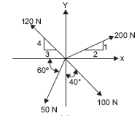

(OR)
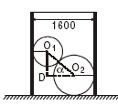
17. A hollow right circular cylinder of radius 800 mm is open at both ends and rests on a smooth horizontal plane as shown in figure below. Inside the cylinder there are two spheres having weights 1 kN and 3 kN and radii 400 mm and 600 mm respectively. The lower sphere also rests on the horizontal plane. Neglecting friction find the minimum weight W of the cylinder for which it will not tip over.

[P.T.O]

18. Determine the reactions at the supports A and B of the overhanging beams shown in figure below. Neglect the self weight of the beams.

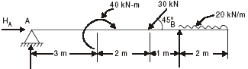
(OR)
19. A ladder is 6 m long and is supported by a horizontal floor and vertical wall. The coefficient of friction between wall and ladder is 0.25 and that between the floor and the ladder is 0.4. The weight of ladder is 200 N and the ladder also supports a vertical load of 900 N at a distance of 1 m along the length of the ladder from the upper end (near the vertical wall). Determine the least value of angle of inclination of the ladder with the horizontal may be placed without slipping. Also determine the reaction at that stage.

20. Determine the forces in all the members of the frame shown in figure below. Indicate the nature of the forces also taking Tension as positive and Compression as positive.
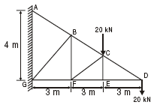

(OR)
21. Locate the centroid of the area shown in figure with respect to the axes shown.
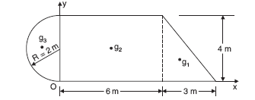

22. A soldier fires a bullet with a velocity of 31.32 m/s at an angle α upwards from the horizontal from his position on a hill to strike a target which is 100 m away and 50 m below his position. Find the angle of projection α. Find also the velocity with which the bullet strikes the object.
(OR)
23. A ball is dropped from the top of a tower 30 m high. At the same instant, a second ball is thrown upward from the ground with an initial velocity of 15 m/s. When and where do they cross and with what relative velocity?

24. In a police investigation of tyre marks, it was concluded that a car while in motion along a straight level road skidded for a total of 60 m after the brakes were applied. If the coefficient of friction between the tyres and the pavement is estimated as 0.5. What was the probable speed of the car just before the brakes were applied?
(OR)
25. A pile hammer, weighing 15 kN drops from a height of 600 mm on a pile of 7.5 kN. How deep does a single blow of hammer drive the pile if the resistance of the ground pile is 140 kN? Assume the ground resistance is constant.

