Test Code : QR ( Short answer type ) 2005

M.Tech. in Quality, Reliability and Operations Research

The candidates applying for M.Tech. in Quality, Reliability and Operations Research will have to take two tests : Test MIII (objective type) in the forenoon session and Test QR ( short answer type ) in the afternoon session.

For Test MIII, see a different Booklet. For Test QR, refer to this Booklet
ONLY.

If you are from Statistics / Mathematics Stream, you will be required to ANSWER PART I.
If you are from one of the Engineering Streams, you will be required to ANSWER PART II.

In PART I, you will find in Test QR, a TOTAL of TEN [10] questions, divided in TWO Groups : Statistics & Probability – each carrying FIVE [5] questions. You will be required to answer a TOTAL of SIX [6] questions – taking AT LEAST TWO [2] from each group.

In PART II, there will be six groups E1-E6, each containing three questions. You will be required to answer from Group E1 (Mathematics) and from any three groups from the remaining five groups as per the instruction given within each group.

Syllabus

PART I : STATISTICS / MATHEMATICS STREAM

Statistics (S1)

Descriptive statistics for univariate, bivariate and multivariate data.
Standard univariate probability distributions [Binomial, Poisson, Normal] and their fittings, properties of distributions, sampling distributions.
Theory of estimation and tests of statistical hypotheses.
Multiple linear regression and linear statistical models, ANOVA.
Principles of experimental designs and basic designs [CRD, RBD & LSD].
Elements of non-parametric inference.
Elements of sequential tests.
Sample surveys – simple random sampling with and without replacement, stratified and cluster sampling.

Probability (S2)

Classical definition of probability and standard results on operations with events, conditional probability and independence.
Distributions of discrete type [Bernoulli, Binomial, Multinomial, Hypergeometric, Poisson, Geometric and Negative Binomial] and continuous type [Uniform, Exponential, Normal, Gamma, Beta] random variables and their moments.
Bivariate distributions (with special emphasis on bivariate normal), marginal and conditional distributions, correlation and regression.
Multivariate distributions, marginal and conditional distributions, regression, independence, partial and multiple correlations.
Order statistics [including distributions of extreme values and of sample range for uniform and exponential distributions].
Distributions of functions of random variables.
Multivariate normal distribution [density, marginal and conditional distributions, regression].
Weak law of large numbers, central limit theorem.
Basics of Markov chains and Poisson processes
Syllabus

PART II : ENGINEERING STREAM

Mathematics (E1)

Elementary theory of equations, inequalities.
Elementary set theory, functions and relations, matrices, determinants, solutions of linear equations.
Trigonometry [multiple and sub-multiple angles, inverse circular functions, identities, solutions of equations, properties of triangles].
Coordinate geometry (two dimensions) [straight line, circle, parabola, ellipse and hyperbola], plane geometry, Mensuration.
Sequences, series and their convergence and divergence, power series, limit and continuity of functions of one or more variables, differentiation and its applications, maxima and minima, integration, definite integrals areas using integrals, ordinary and partial differential equations (upto second order), complex numbers and De Moivre’s theorem.

Engineering Mechanics (E2)

Forces in plane and space, analysis of trusses, beams, columns, friction, principles of strength of materials, work-energy principle, moment of inertia, plane motion of rigid bodies, belt drivers, gearing.

Electrical and Electronics Engineering (E3)

D.C. circuits, AC circuits (1-φ), energy and power relationships, Transformer, DC and AC machines, concepts of control theory and applications.
Network analysis, 2 port network, transmission lines, elementary electronics, analog and digital electronic circuits.
Theromodynamics (E4)

Laws of thermodynamics, internal energy, work and heat changes, reversible changes, adiabatic changes, heat of formation, combustion, reaction, solution and dilution, entropy and free energy and maximum work function, reversible cycle and its efficiency, principles of internal and external combustion engines.

Engineering Properties of Metals (E5)

Structures of metals, tensile and torsional properties, hardness, impact properties, fatigue, creep, different mechanism of deformation.

Engineering Drawing (E6)

Concept of projection, point projection, line projection, plan, elevation, sectional view (1st angle/3rd angle) of simple mechanical objects, isometric view, dimensioning, sketch of machine parts.
(Use of set square, compass and diagonal scale should suffice).

SAMPLE QUESTIONS

PART I:STATISTICS AND PROBABILITY

GROUP S−1 : STATISTICS

- Denote by φ(z) and Φ(z) the standard normal pdf and cdf respectively. Let Z be a random variable defined over the real line with pdf

f_{λ}(z) = c φ(z) Φ(λz) where λ is a fixed constant, -∞ < λ < ∞.

- Show that c = 2.
- Show that ⏐Z⏐ is CHI with 1 df.
- Show that E(Z) = √[2 / π] ψ(λ) where ψ(λ) = λ / √[1 + λ]².
- Find the mode of the distribution of Z.

2. Consider a simple linear regression of Y on X with homoscadastic errors and involving the parameters α and β, as usual. Suppose the x-values, viz. x₁, x₂,…, x_{n}, are all inside the open interval (0,1). Show that for estimation of α, β or any linear function of the parameters, it may be possible to improve on the efficiency by suitably re-allocating the x-values. Specifically, show that the reallocation results into taking the values 0 and 1 with repeat numbers n₀ and n₁ so that n₀+n₁= n. Taking n = 5, x₁ =0.20, x₂ = 0.25, x₃ = 0.40, x₄ = 0.55, x₅ = 0.60, find the values of n₀ and n₁ to achieve this feature.

- If X = , A = x₁, B = x₂ + x₃, C = x₄ + x₅ + x₆ where x_{I}'s have zero means, unit standard deviations and are uncorrelated then show that the multiple regression equation of X on A, B and C is given bY
∧
= A + +

- Calculate r_{X.ABC} and r_{XC.AB} and interpret the results.

- A town has N taxis numbered 1 through N. A person standing on roadside notices the taxi numbers on n taxis that pass by. Let M_{n} be the largest number observed. Assuming independence of the taxi numbers and sampling with replacement, show that
$\overset{}{N}$ = (n + 1) M_{n} / n

is an approximately unbiased estimator of N for large N.

- Let x₁, x₂, . . ., x_{n} be a random sample from the rectangular population with density
1 / θ , 0 < x < θ
f(x) =
0 otherwise

Consider the critical region x_{(n)} > 0.8 for testing the hypothesis H₀ : θ = 1, where x_{(n)} is the largest of x₁, x₂, . . ., x_{n}. What is the associated probability of error I and what is the power function?

- Let x₁, x₂, . . ., x_{n} be a random sample from a population having p.d.f.

e− θx x², 0 < x < ∞
f(x, θ) =
0 otherwise

Obtain the maximum likelihood estimate of θ and also obtain the Cramer Rao lower bound to the variance of an unbiased estimator of θ.

6. (a) Let X_{t} be equal to the number of particles emitted from a radio-active source during a time interval of length t. Assume that X_{t} has a Poisson distribution with parameter α t. A counting device is set up to keep count of the number of particles emitted. Suppose that there is a constant probability p that any emitted particle is not counted. If R_{t} equals the number of particles counted during the specified interval, what is the probability distribution of R_{t}?

(b) In a CRD set-up involving 5 treatments, the following computations were
made:
n = 105, Grand Mean = 23.5, SSB = 280.00, SSW = 3055.00

- Compute the value of the F-ratio and examine the validity of the null
hypothesis.
(ii) It was subsequently pointed out that there was one additional treatment
that was somehow missed out! For this treatment, we are given sample
size = 20, Sum = 500 and Sum of Squares (corrected) = 560.00. Compute
revised value of F-ratio and draw your conclusions.
7. If X₁, X₂, X₃ constitute a random sample from a Bernoulli population with mean p, show why [X₁ + 2X₂ + 3X₃ ] / 6 is not a sufficient statistic for p.

8. If X and Y follow a trinomial distribution with parameters n, θ₁ and θ₂, show
that
(a)$E(Y/X=x)=\frac{(n−x)θ_{2}}{1−θ_{1}}$,
(b) $V(Y/X=x)=\frac{(n−x)θ_{2}(1−θ_{1}−θ_{2})}{(1−θ_{1})^{2}}$
Further show, in standard notations,
(c)$V_{1}E_{2}=\frac{{nθ}_{1}θ_{2}^{2}}{1−θ_{1}}$, (d)$E_{1}V_{2}=\frac{{nθ}_{2}(1−θ_{1}−θ_{2})}{1−θ_{1}}$,
(e)$V(Y)={nθ}_{2}(1−θ_{2})$

9. Life distributions of two independent components of a machine are known to be exponential with means μ and λ respectively. The machine fails if at least one of the components fails. Compute the chance that the machine will fail due to the second component. Out of n independent prototypes of the machine m of them fail due to the second component. Show that $m/ (n−m)$ approximately estimates the odds ratio $θ=λ/μ$.

GROUP S–2 : Probability

- (a) A coin is tossed an odd number of times. If the probability of getting
more heads than tails in these tosses is equal to the probability of getting
more tails than heads then show that the coin is unbiased.

(b) For successful operation of a machine, we need at least three components (out of five) to be in working phase. Their respective chances of failure are 7%, 4%, 2%, 8% and 12%. To start with, all the components are in working phase and the operation is initiated. Later it is observed that the machine has stopped but the first component is found to be in working phase. What is the likelihood that the second component is also in working phase?

(c) A lot contains 20 items in which there are 2 or 3 defective items with
probabilities 0.4 and 0.6 respectively. Items are tested one by one from the
lot unless all the defective items are tested. What is the probability that the
testing procedure will continue up to the twelfth attempt ?

- Suppose a young man is waiting for a young lady who is late. To amuse himself while waiting, he decides to take a random walk under the following set of rules:

He tosses an imperfect coin for which the probability of getting a head is 0.55. For every head turned up, he walks 10 yards to the north and for every tail turned up, he walks 10 yards to the south.

That way he has walked 100 yards.

- What is the probability that he will be back to his starting position?

- What is the probability that he will be 20 yards away from his starting position?

- A boy goes to his school either by bus or on foot. If one day he goes to the school by bus, then the probability that he goes by bus the next day is 7/10. If one day he walks to the school, then the probability that he goes by bus the next day is 2/5.

- Given that he walks to the school on a particular Tuesday, find the probability that he will go to the school by bus on Thursday of that week.

- Given that the boy walks to the school on both Tuesday and Thursday of that week, find the probability that he will also walk to the school on Wednesday.

[You may assume that the boy will not be absent from the school on Wednesday or Thursday of that week.]

- Let S and T be distributed independently as exponential with means 1/λ and 1/μ respectively. Let U = min{S,T} and V = max{S,T}. Find E(U) and E(U+V).

- Let X be a random variable with U(0,1) distribution. Find the p.d.f. of the random variable Y = ( X / (1 + X) ).

- Let X₁, X₂, . . . , be a sequence of independent and identically distributed U(0,1) variables. If Z_{n} = ()^{1/n} , then show that Z_{n} converges in probability to some constant C. Also find C.

- Three out of every four trucks on the road are followed by a car, while only one out of every five cars is followed by a truck. What fraction of vehicles on the road are trucks?

- Let X be a random variable with density

4 x3 , 0 < x < 1
f_{X}(x) =
0 otherwise.

For the minimum X₍₁₎ of n iid random observations X₁, X₂, . . ., X_{n} from the above distribution, show that n^{1/4} X_{(n)} converges in distribution to a random variable Y with density

4 e−y4 y3 , y > 0
f_{Y}(y) =
0 otherwise.

- A random sample of size n is taken from the exponential distribution having p.d.f.
e−x , 0 ≤ x < ∞
f (x) =
0 otherwise.

Find the p.d.f. of the sample range.

- If X, Y are independent normal variates with means 7, 13 and variances 16, 4 respectively, then determine θ such that

P(2X + 3Y ≤ 2θ) = P(3X + 8Y ≥ 3θ).

- Consider the following bivariate density function

c ⋅ xy , x > 0, y > 0, x + y < 1
f(x,y) =
0 otherwise

- Find c.
- Find the conditional expectation, E(Y⏐X = x), for 0 < x < 1.

8. Suppose in a big hotel there are N rooms with single occupancy and also suppose that there are N boarders. In a dinner party to celebrate the marriage anniversary of one of the boarders they start drinking alcohol to their hearts' content and as a consequence they become unable to identify their own rooms. What is the probability that at the end of the dinner party none of the boarders occupies the room originally assigned to them? What is the limiting value of this probability as $N→∞$?

9. (a) Consider a Markov Chain with state space I = {1,2,3,4,5,6} and transition
probability matrix P given by

1/2 1/2 0 0 0 0
P = 1/4 3/4 0 0 0 0
0 0 2/3 1/3 0 0
0 0 1/8 7/8 0 0
1/4 0 1/2 0 1/8 1/8
0 0 1/4 3/4 0 0

Find the various classes of this chain and classify them as recurrent or transient.

(b) Pulses arrive at a Geiger Counter according to a Poisson Process with parameter λ > 0. The counter is held open only a random length of time T (independent of the arrival time of the pulses), where T is exponentially distributed with parameter β>0. Find the distribution of N = Total number of pulses registered by the counter.

PART II : MATHEMATICS & ENGINEERING

GROUP E-1 : Mathematics

1(a) Let f(x) be a polynomial in x and let a, b be two real numbers where a ≠ b.
Show that if f(x) is divided by (x - a)(x - b) then the reminder is
$\frac{(x−a)f(b) − (x−b)f(a)}{b−a}$.
(b) Find if x^{Cosy} + y^{Cosx} = 1.

- Let A be the fixed point (0,4) and B be a moving point (2t, 0). Let M be the mid-point of AB and let the perpendicular bisector of AB meets the y-axis at R. Find the equation of the locus of the mid-point P of MR.

- Inside a square ABCD with sides of length 12 cm, segment AE is drawn where E is the point on DC such that DE = 5 cm.
The perpendicular bisector of AE is drawn and it intersects AE, AD and
BC at the points M, P and Q respectively.
Find the ratio PM : MQ.

3(a) Evaluate the value of 3.9^{1/2}.27 ^{1/4}. 81 ^{1/8}. ...up to infinity.

(b) Solve: $\frac{d^{2}y}{{\text{dx}}^{2}} =e^{2x−3y}$

4.(a) Show that
$\underset{n→∞}{\text{Lim}} \left[\frac{1}{\sqrt{n^{2}+1}}+\frac{1}{\sqrt{n^{2}+2}}+\frac{1}{\sqrt{n^{2}+3}}+⋯ (\text{upto} [n/2] \text{terms})\right] = \frac{1}{2}$.

(b) Test the convergence of the series $x+\frac{2^{2}x^{2}}{2!}+\frac{3^{3}x^{3}}{3!}+\frac{4^{4}x^{4}}{4!}+⋯∞$. Assume x > 0 and examine all possibilities.

- Find the limit of the following function as x → 0.

Sin()

If the line ax + by + c =0 is a normal to the curve xy =1 then show that a⋅b < 0.

- If ω is a complex cube root of unity then show that
a³ + b³ + c³ - 3abc = (a + b + c) (a + bω + cω²)(a + bω² + cω).

- If a = 1 + + + . . . .
b = x + + + . . . .
c = + + + . . . .

then show that a³ + b³ + c³ − 3abc = 1.

7(a) Cable of a suspension bridge hangs in the form of a parabola and is attached to the supporting pillars 200 m apart. The lowest point of the cable is 40 m below the point of suspension. Find the angle between the cable and the supporting pillars. State all the assumptions involved.

(b) Show that
$${\text{Cos}}^{8}θ=\frac{1}{\text{128}}[\text{Cos} 8θ+8 \text{Cos} 6θ+\text{28} \text{Cos} 4θ+\text{56} \text{Cos} 2θ+\text{35}]\text{.}$$

$\iint{\text{dxdy}}$8(a) Evaluate the following integrals directly and compare them.
${\text{ax}}^{2} + {\text{by}}^{2}≤ 1$$\iint{\text{dxdy}}$ and $\sqrt{a}$$\left|x\right| ≤1,$$\sqrt{b}$$\left|y\right| ≤1$

- Determine x, y and z so that the 3 x 3 matrix with the following row vectors
is orthogonal : (1 / √3, 1 / √3, 1 / √3), (1/ √2, -1/ √2, 0), (x, y, z).

GROUP E-2 : Engineering Mechanics

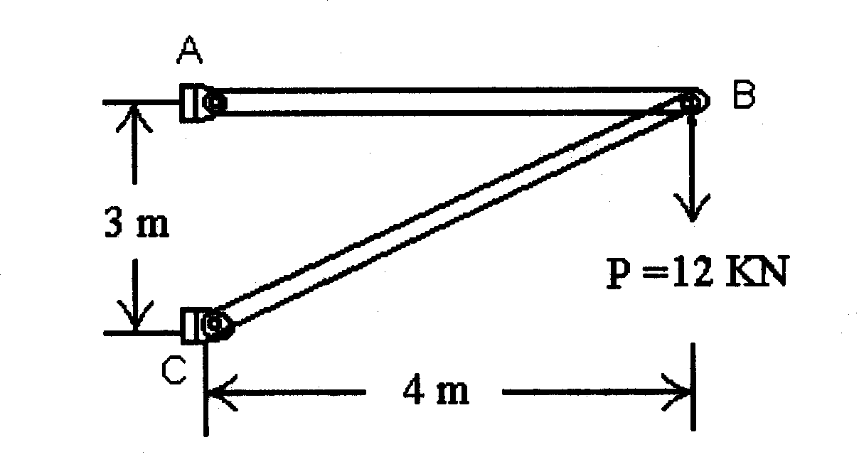
1.(a) The simple planar truss in the given Fig.1 consists of two straight two-force members AB and BC that are pinned together at B. The truss is loaded by a downward force of P=12 KN acting on the pin at B. Determine the internal axial forces F₁ and F₂ in members AB and BC respectively. (Neglect the weight of the truss members).

Fig. 1

- Derive the expression for moment of inertia I_{YY} of the shaded hollow rectangular section (Fig. 2).
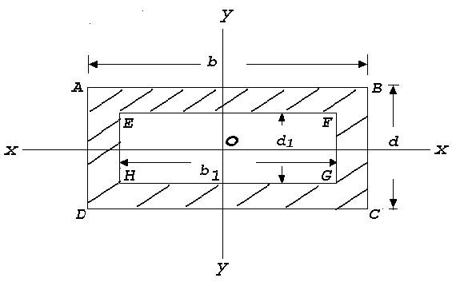
Fig. 2

- A turbine rotor weighs 20 tonnes and has a radius of gyration of 1.75 meter when running at 200 rpm. It is suddenly relieved of part of its load and its speed rises to 205 rpm in 1 sec. Find the unbalanced uniform turning moment.

An Aluminium thin-walled tube (radius/thickness = 20) is closed at each end and pressurized by 6 MPa to cause plastic deformation. Neglect the elastic strain and find the plastic strain in the circumferential (hoop) direction of the tube. The plastic stress-strain curve is given by $\overline{σ}$ = 170 (strain rate)^{0.25}.
3.(a) A uniform ladder 5 m long and 14 kg mass is placed against a vertical wall at an angle 50⁰ to the horizontal ground. The co-efficient of friction between ladder and wall is 0.2 and between ladder and ground in 0.5. Calculate how far up the ladder a man of 63 kg. can climb before the ladder shifts.

(b) Determine the diameter of a steel shaft rotating at an angular velocity of 300 rpm transmitting 500 HP. The allowable stress = 800 kg/cm². The allowable angle of twist = 0.5⁰ per m, G = 8 × 10⁵ kg/cm² . What would be the savings if a hollow shaft is used to transmit the same power under the same condition, the ratio of diameters being 0.9?

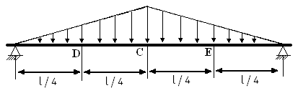
4.(a) For the beam and loading shown in Fig.3, determine the equation defining the shear and bending moment at any point and at point D.

Fig. 3

- As illustrated in the given Fig.4 a metal punch (similar in principle to a paper punch) is used to punch holes in thin steel sheet that will be used to make a metal cabinet. To punch a 60 mm diameter disk or "slug" out of the sheet metal that is 10 mm thick requires a punch force of P=500 kg. Determine the average shear stress in the sheet metal resulting from the punching operation.
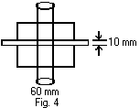
5. | (a) | A tie rod in the suspension of a car is to be constructed from a grade of steel which has 0.1% proof stress equal to 250 MN/m². The tie rod is to be constructed as a solid round bar of length 350 mm long. If the tie rod is subjected to a maximum axial force of 10 KN,  - Determine the minimum diameter of the tie rod  - The extension of the tie rod under load ( E= 2094 GN/m² )  - The minimum diameter of the tie rod if a factor of safety of 2.5 is applied to the proof stress
 | (b) | Find the width of the belt necessary to transmit 11.25 KW power to a pulley of diameter 300mm when the pulley makes 1600 rpm. Assume the co-efficient of friction between the belt and the pulley is 0.22 and angle of contact is 210º. Maximum tension in the belt will not exceed 10N/mm width.

GROUP E-3 : Electrical and Electronics Engineering

- A centrifugal pump, which is gear-driven by a DC motor, delivers 810 kg of water per minute to a tank of height 11 meter above the level of the pump. Draw the block diagram of the overall arrangement. Determine input power across the gearing and current taken by the motor operated at 220 volt provided the efficiency of the pump, gearing and motor respectively be 70%, 70% and 90% only. (Take g = 9.8 ms⁻²).

(b) The rms value of a sinusoidal alternating voltage at a frequency of 50 Hz is 155volt. If at t = 0 it crosses the zero axis in a positive direction, determine the time taken to attain the first instantaneous value of 155 volt. How much time it takes to fall from the maximum peak value to its half? Explain with suitable waveform .

- On full-load unity power factor test, a meter having specification of 235 V and 5A makes 60 revolutions in 6 minutes, but its normal speed is 520 revolution/KWh. Does the meter has any inaccuracy? If so, find the percentage error.

(b) The open-loop gain of an amplifier circuit is 90. Now via a feedback loop having β=0.01 a fraction of the output is fed back. Find out the conditions for regenerative and degenerative feedback. In each case determine the closed loop gain and explain the justification of the terminology mentioned (Necessary derivation may be shown, if required).

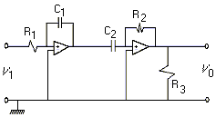3 | (a) | By intelligent selection of loop currents write down the mesh equations of the given circuit (as shown in Fig. 5) and determine the current flowing through that branch of the circuit containing capacitor. (All resistances/reactances are in ohms).  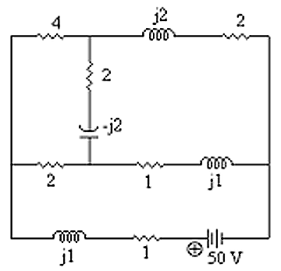  Fig. 5  (b)
Fig. 6

Refer Fig. 6. Find the expression for V₀. What would be the nature of V₀ When R₁ = R₂ and C₁ = C₂?
(Consider the Op-amps to be identical)

4. (a) A series ac circuit that resonates at 48 Hz consists of a coil (having R = 30 Ω and L = 500 mH) and a capacitor. If the supply voltage is 100 volt determine the value of the capacitor.

(b) Calculate the value of a capacitor which when connected across the circuit (as of Q. 4 (a) above), enhances the resonant frequency to 60 Hz. Compare the value of the source current in both the cases.

- (a) A 200/400 - V, 10KVA, 50Hz single phase transformer has, at full load, a Cu loss of 120W. If it has an efficiency of 98% at full load unity power factor, determine the iron losses. What would be the efficiency of the transformer at half load 0.8 power factor lagging?

(b) In the 2-port network given below, the parameters at two parts are related by the equations,

V₁ = AV₂ - BI₂
I₁ = CV₂ - DI₂

- Find expressions for A,B,C and D
- Show that AD - BC = 1
- What are the physical interpretations of the above coefficients?
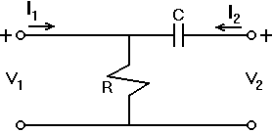

Fig 7

GROUP E-4 ; Thermodynamics

1.(a) In a thermodynamic system of a perfect gas, let U = f (V,T) where U, V and T refer to internal energy, volume of a gram-molecule of the substance and temperature (in absolute scale) respectively. An amount of heat δQ is added so that the volume expands by δV against a pressure P. Prove that:

C_{p} – C_{V} = $\left[P+{\left(\frac{δU}{δV}\right)}_{T}\right] {\left(\frac{δV}{δT}\right)}_{P}$
where C_{p} and C_{V} stand for specific heat at constant pressure and specific heat at constant volume respectively.

(b) 0.15 cu.m. of air at a pressure of 1.06 kg/cm² is compressed to a volume of 0.008 cu.m. at 361 kg/cm². Calculate (i) the quantity of heat rejected, (ii) change in internal energy if the process of compression is a) Adiabatic b) Polytropic with n = 1.3.

2.(a) A compression ignition engine has a stroke of 28 cm and a cylinder diameter of 18 cm. The clearance volume is 475 cm³. The fuel injection takes place at constant pressure for 4.5% of the stroke. Find the air standard efficiency of the engine assuming that it works on diesel cycle. If the fuel injection takes place at 10% of the stroke, find the loss in air standard efficiency.

(b) A diesel engine has a compression ratio 14 to 1 and the fuel supply is cut off at 0.08 of the stroke. If the relative efficiency is 0.52, estimate the weight of fuel of a calorific value 10400 k.cal per kg that would be required per horsepower.

- Calculate the change in entropy of saturated steam at a given pressure such that the boiling point = 152.6 ºC and the latent heat at this temperature = 503.6 cal/gm. [Use Log _{e} 1.56 = 0.445.]

- Draw the pv and T−Φ diagrams for a diesel cycle in which 1 kg of air at 1 kg / cm² and 90 ⁰C is compressed through a ratio of 14 to 1. Heat is then added until the volume is 1.7 times the volume at the end of compression, after which the air expands adiabatically to its original volume. Take C_{v} = 0.169 and γ = 1.41.

- The approximated equation for adiabatic flow of super heated steam through a nozzle is given by pvn = constant. Show that

p₂ / p₁ = (2 / (n+1)) n / (n-1)

where p₁ = pressure of steam at entry ; p₂ = pressure of steam at throat and p₂ / p₁ is the critical pressure ratio.

The dry saturated steam is expanded in a nozzle from pressure of 10 bar to pressure of 4 bar. If the expansion is super saturated, find the degree of under cooling.

- Three rods, one made of glass (k = 1.09 W/m-°C), one of pure Aluminium (k = 228 W/m-°C) and one of wrought iron (k = 57 W/m-°C), all have diameters of 1.25 cm, lengths of 30 cm, and are heated to 120 °C at one end. The rods extend into air at 20 °C, and the heat transfer coefficient on the surface is 9.0 W/m²-°C. Find
- the distribution of temperature in the rods if the heat loss from the ends is neglected,
- the total heat flow from the rods neglecting the end heat loss,
- the heat flow from the rods if the end heat loss is not neglected, and heat transfer coefficient at the ends is also 9.0 W/m²- °C

GROUP E-5 : Engineering Properties of Metals

1. | (a) | Distinguish between modulus of rigidity and modulus of rupture. Give an expression for the modulus of rigidity in terms of the specimen geometry, torque, and angle of twist. Is the expression valid beyond the yield strength (torsion)?
 | (b) | A steel bar is subjected to a fluctuating axial load that varies from a maximum of 340 kN to a minimum of 120 kN compression. The mechanical properties of the steel are σ_{u} = 1090 MPa, σ₀ = 1010 MPa and σ_{e} = 510 MPa. Determine the bar diameter to give infinite fatigue life based on a safety factor of 2.5.
2 (a) The stress intensity for a partial-through thickness flaw is given by K = $\sqrt{Π a \text{Sec}(Πa /2t)}$ where, a is the depth of penetration of the flaw through a wall thickness t. If the flaw is 5 mm deep in a wall 12 mm thick, determine whether the wall will support a stress of 172 Mpa if it is made from a special Al-alloy. [Fracture toughness (K_{IC}) of material independent of crack length, geometry or loading system = 24 MPa m.]

2 (b) A 25 mm diameter bar is subjected to an axial tensile load of 100 kN. Under action of this load a 200 mm gauge length is found to extend 0.19 x10⁻³ mm. Determine the modulus of elasticity of the bar material

- What is strain hardening of metal? Show in which part of the stress and strain curve, strain hardening of metal takes place. Does that part also imply uniform plastic deformation? How? From which point of the curve, localised deformation starts? Why?

What is modulus of elasticity in shear? How would you derive the expression for torsional stress corresponding to large plastic strain ?

4. | (a) | Suppose a crystalline material has fcc structure with atomic radius of 1.278Å. Determine the density of the crystalline material. Assume number of atoms per unit cell and molecular weight are n and M gm respectively.
 | (b) | Suppose there is an electron in an electric field of intensity 3200 volts/m. Estimate the force experienced by the electron. If it moves through a potential difference of 100 volts, find the kinetic energy acquired by the electron.

GROUP E-6 : Engineering Drawing

- A triangular prism of 40mm base and 60mm height is lying on HP on one of its rectangular faces with its axis inclined at 45º to VP. It is sectioned by a horizontal plane at a distance of 15mm above the ground. Draw its top view.

Two balls are vertically erected to 18cm and 30 cm respectively above the flat ground. These balls are away from a 3 cm thick wall (on the ground) by 12 cm and 21 cm respectively but on either side of the wall. The distance between the balls, measured along the ground and parallel to the wall is 27 cm. Determine their approximate distance .

2. | (a) | Sketch the profile of a square thread, knuckle thread and a white-worth thread showing all relevant dimensions in terms of the pitch.
 | (b) | Sketch:  - single riveted lap joint,  - double riveted lap joint chain-riveting,  - double riveted lap joint zigzag-riveting, and  - single cover single riveted butt joint.

- Draw the isometric view of an octahedron erected vertically up on one of its vertices. (Distinct free hand sketch only.)

(b) | Diameter of a hollow spherical metallic ball with six tiny holes is 10 cm. The holes are of same size and are placed on both sides of the three principal axes of the ball. You are given six cylindrical rods with conical top as shown in Fig. 7. Enter the six rods through these six holes so that the

conical tops of the rods just touch the centre of the ball. Now draw any two views of the whole arrangement in third angle projection. [You may consider diameter of the hole is just enough to allow the rod to enter.]
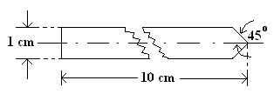

Fig. 8: Sectional View of the Rod

4. A parallelepiped of dimension 100×60×80 is truncated by a plane which passes through 85, 45 and 65 unit distance on the associated edges from the nearest top point of the object. Draw the isometric view of the truncated solid object. In third angle projection method, draw its plan. (All dimensions are in mm).

