Sample Paper – 2011
Class –X
Subject –ENGLISH (COMMUNICATIVE)
GRAMMAR

1. The following passage has not been edited. There is one error in each line. Write the incorrect word and the correction in your answer sheet against the correct question number. Remember to underline the word you have supplied.
Incorrect Correct
Often these days we hear and speak of the conquered (eg.) conquered conquest
in nature, ‘the taming of a river’, ‘the war against insects’ (a) _________ _________
and so on. Often these phrases being used without consciously (b) _________ _________
attaching any value to them, but they have an
underlying attitude of hostile towards Nature and Nature’s (c) _________ _________
creatures, a viewpoint which seeming to assume (d) _________ _________
Nature as an enemy that needs to being vanquished. (e) _________ _________
Alternatively, Nature is seen merely as the ‘resource’ to be (f) _________ _________
‘exploited’.
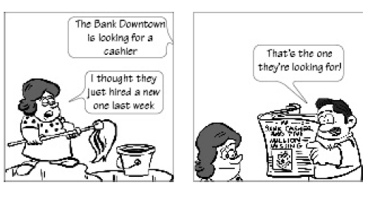
- Read the following conversation and complete the paragraph. Write the answers in your answer sheet against the correct blank numbers.

One morning while reading the paper, Raj told his wife (a)..................................... His wife, Rita, said that she thought (b)......................................... . Raj replied that (c)................................... as the cashier had run away with Rs 5 million.
- Complete the headlines by choosing the correct answers from the options given below:
- Drive against Liquor Mafia launched
The police ______________________ engaged in smuggling of liquor to the state.

- China develops medical robot
A polytechnic university in China ______________________ that can conduct surgeries.

- Read the extract given below and answer the questions that follow by choosing the correct options.
All pity choked with custom of fell deeds:
And Caesar’s spirit, ranging for revenge,
With Ate by his side come hot from hell
Shall in these confines with a monarch’s voice
Cry ‘Havoc’, and let slip the dogs of war;
1.Who is speaking these lines and when?
- Brutus at Caesar’s funeral
- Cassius at Caesar’s funeral
- Antony before Caesar’s body
- Antony to the Roman mob
2.How shall Caesar appear and what for?
- as a ghost to take revenge
- as a ghost with Ate to take revenge
- as a ghost to announce doomsday
- as a ghost to destroy humanity
3.Ate’ in Greek mythology is the
- goddess of revenge
- goddess of death
- goddess of destruction
- goddess of deception.

- Answer the following questions briefly: ( 20-25 words) (1 ½ x 3 = 4 ½ Marks)
    - Antony was indeed an excellent orator who ignited the spirit of revenge in the minds of the Roman people. Describe how he moulded the minds of the Roman people and turned them against the conspirators.
    - How is Brutus successful in taking Caesar to the Senate inspite of Calpurnia’s efforts to the contrary?
    - Write a note on the famous words ‘Et tu Brute!’ spoken by Caesar.
- Though both Brutus and Antony address the public of Rome before Caesar’s funeral, there is a basic difference between the two. Bring out this contrast. Your answer should not exceed 75 words. (6 Marks)

Paper Sumitted By:

Name Dharm Raj Bhargava (Tutor)
Email draj.bhargava@gmail.com

