Q. 1. R be a differentiable function with f(0)=-1and f’(0)=1,Let g(x)= .then
- –4
- 0
- –2
- 4
Sol :
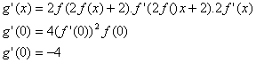
Answer: (1)
Q. 2. There are two urns. Urn A has 3 distinct red balls and urn B has 9 distinct blue balls. From each urn two balls are taken out at random and then transferred to the other. The number of ways in which this can be done is.
- 36
- 66
- 108
- 3
Sol :
Total number of ways
Answer: (4)
Q. 3. An urn contains nine balls of which three are red, four are blue and two are green. Three balls are drawn at random without replacement from the urn. The probability that the three balls have different colours is.
Sol :
Required probability=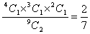
Answer: (1)
Q. 4. For two data sets, each of size 5, the variances are given to be 4 and 5 and the corresponding means are given to be 2 and 4, respectively. The variance of the combined data set is
Sol :
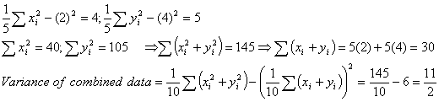
Answer: (1)
Q. 5 . Let be a continuous function defined by . 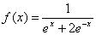.
Statement-1: 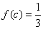, for some . .
Statement-2: 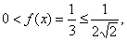for all .
- Statement-1 is true, Statement-2 is true; Statement-2 is not a correct explanation for Statement-1.
- Statement-1 is true, Statement-2 is false.
- Statement-1 is false, Statement-2 is true.
- Statement-1 is true, Statement-2 is true; Statement-2 is a correct explanation for Statement-1.
Sol :
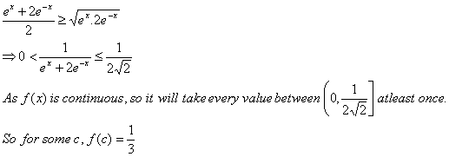
Answer: (4)
Q. 6. For a regular polygon, let r and R be the radii of the inscribed and the circumscribed circles. A false statement among the following is.
- There is a regular polygon with 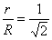
- There is a regular polygon with 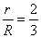
- There is a regular polygon with 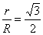
- There is a regular polygon with 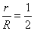
Sol :
If O is centre of polygon and AB is one of the side, then by figure:
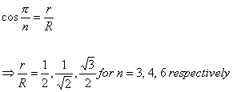
Answer : (2)
Q. 7. If two tangents drawn from a point P to the parabola are at right angles, then the locus of p is.
- 2x +1=0
- x = -1
- 2x +1=0
- x = 1
Sol.
Locus of point P is directrix of parabola i.e., x=-1
Answer: (2)
Q. 8. If the vectors and are mutually orthogonal ,
then
- (2,-3)
- (-2,3)
- (3,-2)
- (-3,2)
Sol :
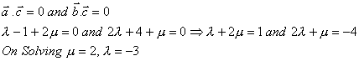
Answer (c)
Q. 9. Consider the following relations:
R = {(x, y) | x, y are real numbers and x=wy for some rational number w };
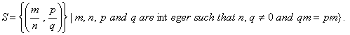
Then
- neither R nor S is an equivalence relation
- S is an equivalence relation but R is not an equivalence relation
- R and S both are equivalence relations
- R is an equivalence relation but S is not an equivalence relation
Sol :
R is not equivalence but
S in equivalence 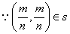
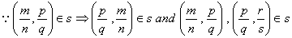
Answer : (2)
Q. 10. be defined by 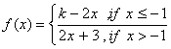. If f has a local minimum at x = -1 ,
then a possible value of k is.
- 0
- -1
- 1
Sol :
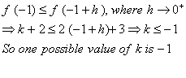
Answer : (3)
Q. 11. The number of 3 X 3 non-singular matrices, with four entries as 1 and all other entries as 0, is
- 5
- 6
- at least 7
- less than 4
Sol :
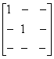 are 6 non-singular matrices because 6 blanks will be filled by 5 zeros and 1 one.
Similarly, 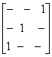 are 6 non-singular matrices.
So, required cases are more than 7.
Answer: (3)
Directions: Questions number 12 to 16 are Assertion-Reason type questions. Each of these questions
contains two statements:
Statement-1 : (Assertion) and
Statement-2 : (Reason).
Each of these questions also has four alternative choices, only one of which is the correct answer.
You have to select the Answer.
Q. 12. Four numbers are chosen at random (without replacement) from the set {1, 2, 3, ……,20}.
Statement-1: The probability that the chosen numbers when arranged in some order will form an AP is.
Statement-2: If the four chosen numbers form an AP, then the set of all possible values of common difference is
- Statement-1 is true, Statement-2 is true; Statement-2 is not a correct explanation for Statement-1.
- Statement-1 is true, Statement-2 is false.
- Statement-1 is false, Statement-2 is true.
- Statement-1 is true, Statement-2 is true; Statement-2 is a correct explanation for Statement-1.
Sol :
Required probability = 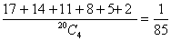
Statement -2 is false because common difference can also be ±6.
Answer: (2)
Q. 13. Statement-1: The point is the mirror image of the point
in the plane .
Statement-2: The plane bisects the line segment joining and
- Statement-1 is true, Statement-2 is true; Statement-2 is not a correct explanation for Statement-1.
- Statement-1 is true, Statement-2 is false.
- Statement-1 is false, Statement-2 is true.
- )(Statement-1 is true, Statement-2 is true; Statement-2 is a correct explanation for Statement-1.
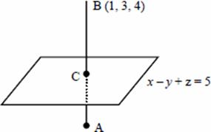
Sol :
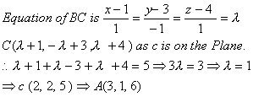
Statement I and II both are true but statement II is not the correct explanation.
Plane is not just bisector but it is perpendicular bisector of AB.
Answer: (1)
Q. 14. Let 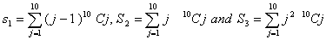
Statement-1:
Statement-2:
- Statement-1 is true, Statement-2 is true; Statement-2 is not a correct explanation for Statement-1.
- Statement-1 is true, Statement-2 is false.
- Statement-1 is false, Statement-2 is true.
- Statement-1 is true, Statement-2 is true; Statement-2 is a correct explanation for Statement-1.
Sol :
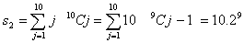
Answer (2)
Q 15. Let A be a 2 x 2 matrix with non-zero entries and let A2 =1 , where I is 2 x2 identity matrix. Define Tr=(A) sum of diagonal elements of A and = determinant of matrix A.
Statement-1: = Tr(A) =0
Statement-2: =
- Statement-1 is true, Statement-2 is true; Statement-2 is not a correct explanation for Statement-1.
- Statement-1 is true, Statement-2 is false.
- Statement-1 is false, Statement-2 is true.
- Statement-1 is true, Statement-2 is true; Statement-2 is a correct explanation for Statement-1
Sol :
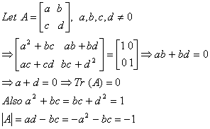
Answer: (2)

