Q. 1. A rectangular loop has a sliding connector PQ of length l and resistance and it is moving with a speed v as shown. The set-up is placed in a uniform magnetic field going into the and I are :
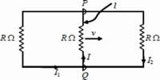
- 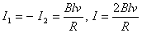
- 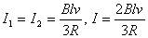
- 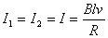
- 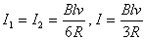
induced across and the equivalent circuit becomes as shown in the figure
Sol:
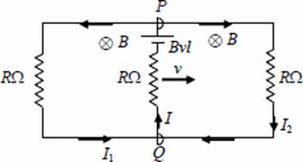
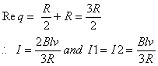
Answer : (2)
Q. 2. A particles is moving with velocity , where K is a constant. The general equation for its path is
Sol:
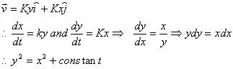
Answer : (4)
Directions: Questions number 33-34 contain Statement-1 and Statement-2. Of the four choices given after the statements, choose the one that best describes t the two statements.
Q. 3. Statement-1: Two particles moving in the same direction do not lose all their energy in a completely inelastic collision.
Statement-2: Principle of conservation of momentum holds true for all kinds of collisions.
- Statement –1 is true, Statement- 2 is true; Statement -2 is the correct explanation of Statement-1
- Statement –1 is true, Statement- 2 is true; Statement -2 is not the correct explanation of Statement-1.
- Statement –1 is false, Statement- 2 is true
- Statement –1 is true, Statement- 2 is false
Sol:
By conservation of momentum, magnitude of momentum can not become zero.
So kinetic energy can not be lost completely
Answer : (1)
Q. 4. Statement-1: When ultraviolet light is incident on a photocell, its stopping potential is V0 and the maximum kinetic energy of the photoelectrons is Kmax. When the ultraviolet light is replaced by X-rays, both V0 and Kmax increase.
Statement-2: Photoelectrons are emitted with speeds ranging from zero to a maximum value because of the range of frequencies present in the incident light.
- Statement –1 is true, Statement- 2 is true; Statement -2 is the correct explanation of Statement-1.
- Statement –1 is true, Statement- 2 is true; Statement -2 is not the correct explanation of Statement-1.
- Statement –1 is false, Statement- 2 is true
- Statement –1 is true, Statement- 2 is false
Sol:
Answer : (4)
Q. 5. A ball is made of a material of density where with oil and water representing the densities of oil and water, respectively. The oil and water are immiscible. If the above ball is in equilibrium in a mixture of this oil and water, which of the following pictures represents its equilibrium position?
- 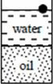

- 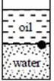

- 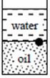

- 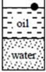
Sol:
Water must be below as and ball cannot float on oil because
Answer : (2)
Q. 6. Let be the capacitance of a capacitor discharging through a resistor R. Suppose is the time taken for the energy stored in the capacitor to reduce to half its initial value and is the time taken for the charge to reduce to one-fourth its initial value. Then the ratio will be
Sol:
As for discharging RC circuit
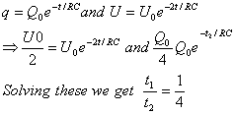
Answer : (3)
Q. 7. In the circuit shown, the key K is closed at t = 0. The current through the battery is
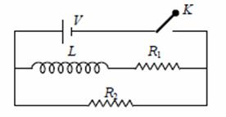
- 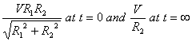
- 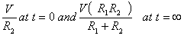
- 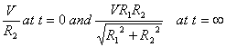
- 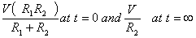
Sol :
At time t = 0 equivalent circuit becomes
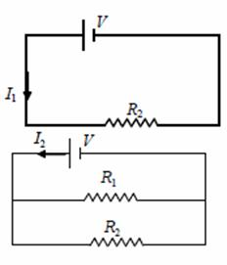
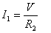
At time t =
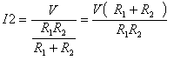
Answer: (2)
Q. 8. Two long parallel wires are at a distance 2d apart. They carry steady equal currents flowing out of the plane of the paper as shown. The variation of the magnetic field B along the line XX’ is given by
- 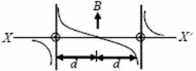
- 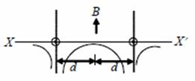
- 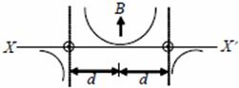
- 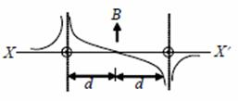
Sol:
As the direction and magnitude of current is same in both the wires B is zero at mid of line joining wire 1 and 2
Just right of wire 1, B > 0
Just left of wire 1, B < 0
Just right of wire 2, B > 0
Just left of wire 2, B < 0
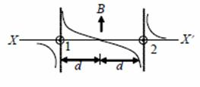
Answer : (1)
Q. 9.Two fixed frictionless inclined planes making an angle 30º and 60º with the vertical are shown in the figure. Two blocks A and B are placed on the two planes. What is the relative vertical acceleration of A with respect to B?
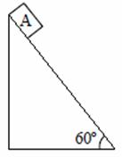
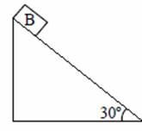
- in horizontal direction
- in vertical direction
- Zero
- in vertical direction
Sol:
The required relative acceleration,
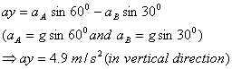
Answer : (4)
Q. 10. The figure shows the position-time (x – t) graph of one-dimensional motion of a body of mass 0.4 kg. The magnitude of each impulse is 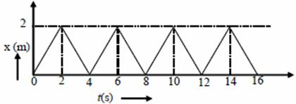
- 0.4 Ns
- 0.8 Ns
- 1.6 Ns
- 0.2 Ns
Sol:
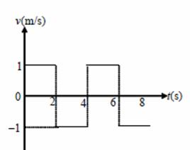
The velocity-time (v-t) curve of body will be, Impulse = 0.4 x [1 – (–1)] = 0.8 Ns
Answer : (2)

