Note: Questions with (*) mark are from syllabus of class XI.
Q.1. A solution containing 2.675 g of CoCl₃.6NH₃ (molar mass = 267.5 g mol⁻¹) is passed through a cation exchanger. The chloride ions obtained in solution were treated with excess of AgNO₃ to give 4.78 g of AgCl (molar mass = 143.5 g mol⁻¹). The formula of the complex is (Atomic mass of Ag = 108 u)
- [Co(NH₃)₆]Cl₃
- [CoCl₂(NH₃)₄]Cl
- [CoCl₃(NH₃)₃]
- [CoCl(NH₃)₅]Cl₂
Sol :
Number of moles of the complex 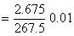
Number of moles of AgCl formed 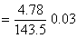
Number of moles of AgCl formed = 3 × Number of moles of the complex
The formula of the complex is [Co(NH₃)₆]Cl₃
Answer: 1
Q. 2. If 10⁻⁴ dm³of water is introduced into 1.0 dm³ flask at 300 K, how many moles of water are in the vapour phase when equilibrium is established? (Given: Vapour pressure of H₂O at 300 K is 3170 Pa ; R = 8.314 JK⁻¹ mol⁻¹)
- 5.56 × 10⁻³mol
- 1.53 × 10⁻² mol
- 4.46 × 10⁻²mol
- 1.27 × 10⁻³ mol
Sol :
The volume occupied by water molecules in vapour phase is (1 – 10⁻⁴) dm³, that is approximately 1 dm³.
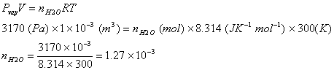
Answer: 4
Q. 3. The time for half life period of a certain reaction A Products is 1 hsour. When the initial concentration of the reactant ‘A’, is 2.0 mol L⁻¹, how much time does it take for its concentration to come from 0.50 to 0.25 mol L⁻¹ if it is a zero order reaction?
- 4 h
- 0.5 h
- 0.25 h
- 1 h
Sol:
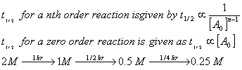
Answer: 3
Q. 4. The standard enthalpy of formation of NH₃ is – 46.0 kJ mol⁻¹. If the enthalpy of formation of H₂ from its atoms is – 436 kJ mol⁻¹ and that of N₂ is – 712 kJ mol⁻¹, the average bond enthalpy of N–H bond in NH₃ is
- – 964 kJ mol⁻¹
- + 352 kJ mol⁻¹
- + 1056 kJ mol⁻¹
- – 1102 kJ mol⁻¹
Sol :
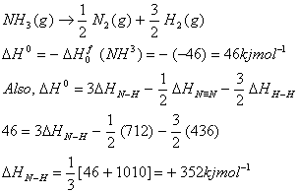
Answer: 2
Q. 5. If sodium sulphate is considered to be completely dissociated into cations and anions in aqueous solution, the change in freezing point of water (kf = 1.86 K kgmol⁻¹), when 0.01 mol of sodium sulphate is dissolved in 1 kg of water, is (Kf = 1.86 K kg mol⁻¹)
- 0.0372 K
- 0.0558 K
- 0.0744 K
- 0.0186 K
Sol :
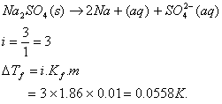
Answer: (2)
Q. 6 . In the chemical reactions,
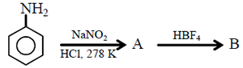
The compounds ‘A’ and ‘B’ respectively are
- nitrobenzene and fluorobenzene.
- phenol and benzene.
- benzene diazonium chloride and fluorobenzene.
- nitrobenzene and chlorobenzene.
Sol :
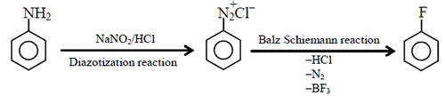
Answer: (3)
Q. 7. The energy required to break one mole of Cl–Cl bonds in Cl₃ is 242 kJ mol⁻¹. The longest wavelength of light capable of breaking a single Cl–Cl bond is
- 594 nm
- 640 nm
- 700 nm
- 494 nm
Sol :
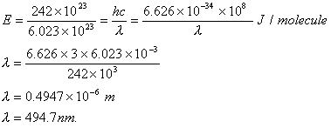
Answer: (4)
Q. 8. Which one of the following has an optical isomer?
- [Zn(en)(NH₃)₂]⁻¹
- [Co(en)₃]³⁺
- [Co(H₂O)₄(en)]³⁺
- [Zn(en)₄]²⁺ (en = ethylenediamine)
Sol :
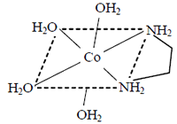
Square planar complexes of Zn²⁺ cannot show optical isomerism. So, options (1) and (4) are ruled out.
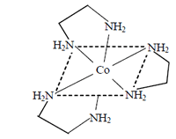
will have two planes of symmetry, so it is optically inactive. Thus optically active compound is
as it has no plane of symmetry.
Answer: (2)
Q. 9. The main product of the following reaction is.
- 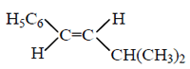
- 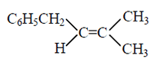
- 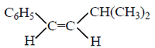
- 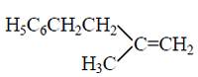
Sol.:
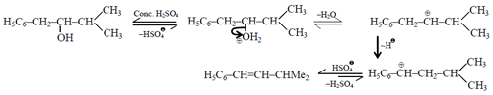
Trans isomer is more stable than cis isomer, so it is formed as the major product.
Answer: (1)
Q. 10 . The edge length of a face centred cubic cell of an ionic substance is 508 pm. If the radius of the cation is 110 pm, the radius of the anion is.
- 288 pm
- 398 pm
- 618 pm
- 144 pm
Sol :
(a) If it is a NaCl type lattice,
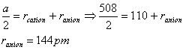
(b)Ifit is ZnS typelattice,
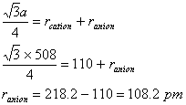
Answer: (4)
Q. 11. Solubility product of silver bromide is . The quantity of potassium bromide (molar mass taken as 120 g mol⁻¹) to be added to 1 litre of 0.05 M solution of silver nitrate to start the precipitation of AgBr is.
Sol :
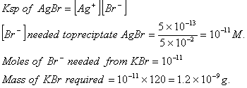
Answer: (2)
Q. 12. At 25°C, the solubility product of Mg(OH)² is 1.0 × 10⁻¹¹. At which pH, will Mg²⁺ ions start precipitating in the form of Mg(OH)₂from a solution of 0.001 M Mg²⁺ ions?
- 9
- 10
- 11
- 8
Sol :
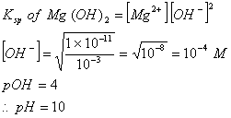
Answer: (2)
Q. 13. Out of the following, the alkene that exhibits optical isomerism is
- 3-methyl-2-pentene
- 4-methyl-1-pentene
- 3-methyl-1-pentene
- 2-methyl-2-pentene
Sol.: Only 3-methyl-1-pentene has a chiral carbon atom, responsible for its optical rotation.
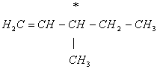
Answer: (3)
Q. 14. The correct order of values with negative sign for the four successive elements Cr, Mn, Fe and Co is.
- Mn > Cr > Fe > Co
- Cr > Fe > Mn > Co
- Fe > Mn > Cr > Co
- Cr > Mn > Fe > Co o
Sol :
The value of for given metal ions are}
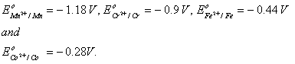
The correct order of values without considering negative sign would be .
Answer: (1)
Q. 15. For a particular reversible reaction at temperature T, were found to be both +ve. If Te is the temperature at equilibrium, the reaction would be spontaneous when .
- Te > T
- T > Te
- Te is 5 times T
- T = Te
Sol :
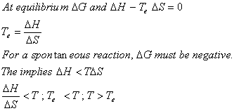
Answer: (2)
Q. 16. Biuret test is not given by
(1) carbohydrates
(2) polypeptides
(3) urea
(4) proteins
Sol :
Polypeptides, proteins and urea have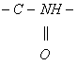(peptide) linkage while carbohydrates have glycosidic linkages. So, test of carbohydrates should be different from that of other three. Biuret test produces violet colour on addition of dilute CuSO4 to alkaline solution of a compound containing peptide linkage.
Answer: (1)
Q. 17. The polymer containing strong intermolcular forces e.g. hydrogen boding, is
- teflon
- nylon 6,6
- polystyrene
- natural rubber
Sol :
Nylon 6,6 has amide linkages capable of forming hydrogen bonding.
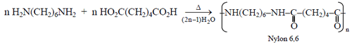
Answer: (2)
Q. 18. The correct order of increasing basicity of the given conjugate bases (R = CH₃) is
- sss
Sol :
The order of acidity among
The order of basicity of their conjugate bases is.
Answer: (4)
Q. 19. Three reactions involving are given below:
(i)
(ii)
(iii)
In which of the above does act as an acid?
- (ii) only
- (i) and (ii)
- (iii) only
- (i) only
Sol :
Only in (ii) reaction is giving a proton, so it is acting as an acid.
Answer: (1)
Q. 20. On mixing, heptane and octane form an ideal solution. At 373 K, the vapour pressures of the two liquid components (heptane and octane) are 105 kPa and 45 kPa respectively. Vapour pressure of the solution obtained by mixing 25.0 g of heptane and 35 g of octane will be (molar mass of heptane = 100 g mol⁻ ¹ and of octane = 114 g mol⁻ ¹)
- 72.0 kPa
- 36.1 kPa
- 96.2 kPa
- 144.5 kPa
Sol :
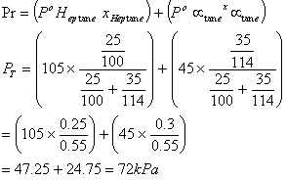
Answer: (1)
Q. 21. The correct sequence which shows decreasing order of the ionic radii of the elements is
So l :
are isolectronic species having 10 electrons each. Cation having positive charge is smallest in size and the anion with high negative charge is largest in size.
Answer: (4)
Q. 22. Percentages of free space in cubic close packed structure and in body centered packed structure are respectively
- 30% and 26%
- 26% and 32%
- 32% and 48%
- 48% and 26%
Sol :
Packing efficiency of CCP and BCC structures are 74% and 68% respectively, so the % of free space in CCP and BCC are 26% and 32% respectively.
Answer: (2)
Q. 23. In aqueous solution the ionization constants for carbonic acid are
Select the correct statement for a saturated 0.034 M solution of the carbonic acid.
- The concentration of is 0.034 M.
- The concentration ofis greater than that of
- The concentrations of and are approximately equal.
- The concentration of is double that of .
Sol :
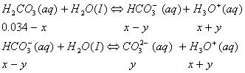
The concentration cannot be 0.034 as H2CO3 and are weak acids. dissociates very little in second step, such that . Concentration of
Answer: (3)
Q. 24. The Gibbs energy for the decomposition of Al₂O₃ at 500°C is as follows:
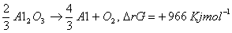
The potential difference needed for electrolytic reduction of Al2O3 at 500°C is at least.
- 4.5 V
- 3.0 V
- 2.5 V
- 5.0 V
Sol :
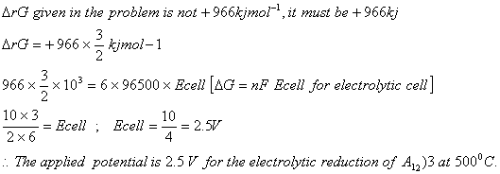
Answer: (3)
Q. 25. Consider the following bromides:
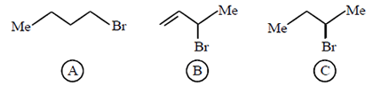
The correct order of SN1 reactivity is.
- B > C > A
- B > A > C
- C > B > A
- A > B > C
Sol :
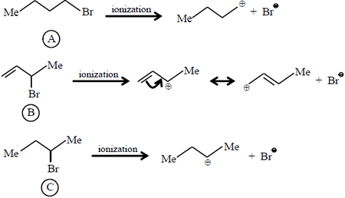
More stable the carbocation, more is the rate of S_{N}1 reaction. Thus, the order of S_{N}1 reactivity is (B) > (C) > (A)
Answer: (1)
Q. 26. Ionisation energy of He+ is 19.6 × 10⁻¹⁸ Jatom⁻¹. The energy of the first stationary state (n = 1) of Li²⁺ is.
Sol:
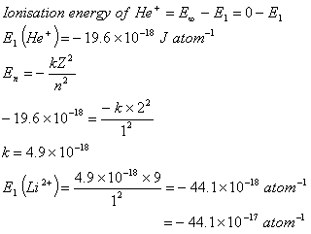
Answer: (2)
Q. 27. From amongst the following alcohols the one that would react fastest with conc. HCl and anhydrous ZnCl₂, is
- 2-Butanol
- 2-Methylpropan-2-ol
- 2-Methylpropanol
- 1-Butanol
Sol :
2-Methylpropan-2-ol reacts fastest with HCl and anhydrous ZnCl₂ as it proceeds through the formation of stable tertiary carbocation.
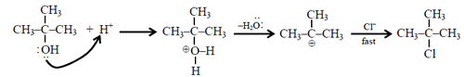
Answer: (2)
Q. 28. 29.5 mg of an organic compound containing nitrogen was digested according to Kjeldahl’s method and the evolved ammonia was absorbed in 20 mL of 0.1 M HCl solution. The excess of the acid required 15 mL of 0.1 M NaOH solution for complete neutralization. The percentage of nitrogen in the compound is
- 59.0
- 47.4
- 23.7
- 29.5
Sol :
Mass of organic compound
Initial moles of HCl taken
Moles of NaOH reacted with excess of HCl
Moles of excess of HCl
Moles of HCl that reacted with
Moles of NH3 absorbed
Moles of N in NH3
Mass of N in organic compound
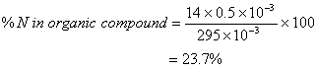
Answer: (3)
Q. 29. Consider the reaction:
The rate equation for this reaction is s
Rate = k[Cl₂] [H₂S]
Which of these mechanisms is/are consistent with this rate equation?
(A)
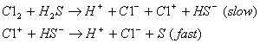
(B)
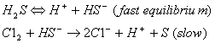
- (B) only
- Both (A) and (B)
- Neither (A) nor (B)
- (A) only
Sol : According to mechanism (A) the rate law expression is
Answer: 4
Q. 30. One mole of a symmetrical alkene on ozonolysis gives two moles of an aldehyde having a molecular mass of 44 u. The alkene is.
- propene
- 1-butene
- 2-butene
- ethene
Sol :
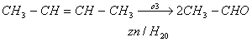
Molecular mass of CH₃CHO is 44 u.
Answer: (3)

