IIT JEE : 2012.
Best Books for the Preparation of IIT JEE and AIEEE.
IIT JEE and AIEEE is the most famous engineering entrance examination of India. Every year a large number of aspirant appear in this examination to test their fate but seat is limited so competition become really hard. Hard work is the only a way for the success in the examination. if you are preparing for the IIT JEE and AIEEE examination and if you have need some good books for the preparation then here i give you the some good books name which is helpful for you.
Physics Books for IIT JEE.
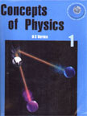
Concept of Physics, Part-1
By : H.C Verma.
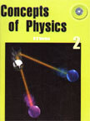
Concept of Physics, Part-2.
By : H.C Verma.
Chemistry Books for the IIT JEE.
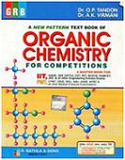
Organic Chemistry for IIT JEE.
By : O.P Tandon.
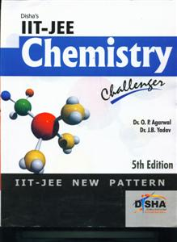
Chemistry Practice Book for IIT JEE.
By : Disha Publication.
Mathematics books for IIT JEE.
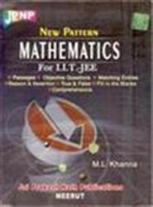
Mathematics for IIT JEE.
By : M.L Khana.
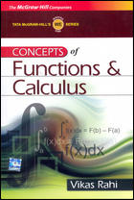
Function and Calculus for IIT JEE.
By : Vikash Rahi.
These are the good books for the preparation of IIT JEE entrance examination. If you will do preparation for IIT JEE then automatically you will be prepare for the AIEEE examination because the syllabus of both examination is about same. You can buy these book from the nearest book stall of your city. You can also do practice from the previous year paper of IIT JEE. Do preparation well for the examination and crack the exam.
Tips for the Preparation of IIT JEE and AIEEE.
-> Always start preparation from the basic because it is important. Without basic concept you can not solve the problem.
-> Never prefer solution before giving 2-3 attempt of any question. Try to solve the problem self. Always keep syllabus with you.
-> Don't leave question in middle and never jump one question to other in hurry. Some candidates practice question without attempting it fully.
-> Divide your time for the preparation because the time management is really important to do well for any examination.
These are the some tips for the preparation of IIT JEE and AIEEE. I think that if you do preparation according to the above tips then you can get a success with a good rank in the examination. I wish you will get success in the examination.
Regards
Divya

