**Agriculture**Known to be the mainstay of Indian economy Agriculture includes Dairying, Poultry Farming and Horticulture apart from production of Fruits, Vegetables and food grains. In this field there many options available like research and teaching. one can select among these *courses after 12th science* in agriculture;-

[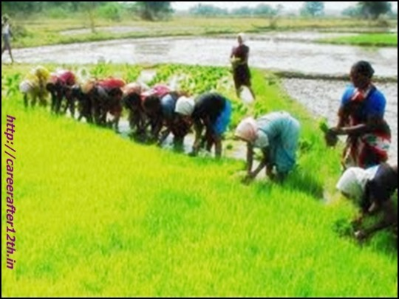](http://careerafter12th.in/wp-content/uploads/2013/01/career-after-12th-science1.jpeg)

1.   B. Sc in  Agriculture.

2.   B.Science in Agricultural Eco and Farm management

3.   B. Sc in Agricultural Meteorology

4.   B. Sc in Agricultural Biotechnology

5.   B. Sc in Agricultural Statistics

6.   B. Sc in Agronomy

7.   B.Sc (Agriculture Mktg and Business Management)

8.   B.Sc (Bio-chem and Agricultural Chemistry)

9.   B. Sc in Crop Physiology

10. B. Sc in Entomology

11.  B. Sc (Hons) in Agriculture

**Forensic Science**:  The field of Forensic science involves investigating of a crime with the help of applying scientific principles. These are degrees and diplomas after 12th  for students who is interested  in forensic science as **career options after 12th.**

[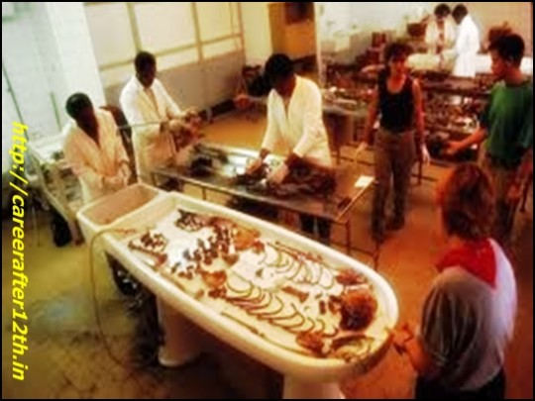](http://careerafter12th.in/wp-content/uploads/2013/01/career-after-12th-science2.jpeg)

1.   B. Sc in Forensic Sciences

2.   B. Sc  in Life Science, Chemistry, Forensic Science

3.   Diploma in Criminology and Forensic Science for Police personnel

4.  B.Sc in Forensic Sciences

5.  Diploma in F/Sciences (Ballistics and Finger Prints)

6.  Diploma in Forensic Science (Cyber Crimes)

7.  Diploma in Forensic Science  (Computer Forensics)

**Bio Technology**: The field of Biotechnology is totally a combination of biology with modern technology, which produce result in alter cells to manipulate them as required. It helps scientists to develop treatments for various diseases and very helpful to humans and other living forms. Biotechnology used in a variety of fields like Environmental, Agricultural, Pharmaceutical, Energy and Chemical. These are the degrees and diplomas*after 12th*in biotechnology*:-*

[ Courses after 12th Science](http://careerafter12th.in/wp-content/uploads/2013/01/career-after-12th-science3.jpeg)

1.   B.Science in Biotechnology

2.   B. Sc in  Biotechnology and Bio informatics

3.   B.E. in Biotechnology

4.   B.Tech (Industrial Biotechnology)

5.   Diploma in Biotechnology

**Geology:** Geology is the study of earth and everything related to its structure, processes including study of organisms inhabited on earth.  Geology also comprises study of oceanography, hydrogeology, geostatistics. Interest and study in this field may get you the chance to work with the environmental consultant companies, non profit organisation, natural resources consultant and companies, Universities and government agencies and Geological survey of India. These are the degrees and diploma after 12th in geology:-

[](http://careerafter12th.in/wp-content/uploads/2013/01/career-after-12th-science4.jpeg)

1.   B. Science in Geology

2.   B.Sc (Hons) Geology

3.   PG Diploma in Environmental Geology

4.   PG Diploma in Engineering Geology

5.   PG Diploma in Geology (Ground water)

**Zoology:** It deals with the study of living and extinct animals their evolution, structure, behavior, function and interaction with environment. Zoology is diverse and broad field which includes studies of mammals, insects, birds, amphibians, reptiles, fishes and a lot of other. One can become zoologist, lecturer, ornithologist and even wildlife expert after studying in this branch of science. These are degree in zoology while considering career after 12th science:

[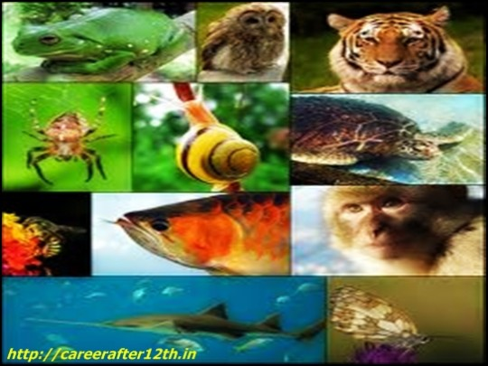](http://careerafter12th.in/wp-content/uploads/2013/01/career-after-12th-science5.jpeg)

1.   B. Sc in Zoology

2.   B.Science (Hons) in Zoology

3.   B. Science in Aquaculture (Fishery Microbiology)

4.   B. Sc in Advanced Zoology and Biotechnology

5.   B. Sc in Zoology and Animal Biotechnology

**Food Technology**: Food Technologist demand is growing day by day as rise in demand for packaged food and its long preservation due to many modern changes in food habbits.  Food technology deals with the scientific understanding about foods we eat and what are the actual production process to make foods, packaged and preserved. A degree in this field can get one the job of Food Quality controller, Research Officer, Packaging manager and a lot of others jobs. Students may go for food technology**courses after 12th science**;

[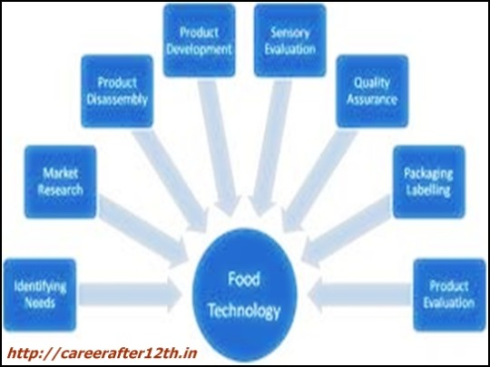](http://careerafter12th.in/wp-content/uploads/2013/01/career-after-12th-science6.jpeg)

1.   B. Sc in Food Preservation and Processing

2.   B. Sc in Food Processing

3.   B. Sc in Food Processing and Technology

4.   B. Sc in Food Storage, Preservation and Food Tech.

5.   B. Sc in Food Technology (Bio-Chemical Engineering)

6.   Diploma in Fish Processing Technology

7.   Diploma in Sugar Technology

**Microbiology:** This field is study of living organisms which may be a cell cluster, single cell or may be no cell at all, these are invisible to naked eye such as fungi, bacteria and viruses. There are many types of different microbiology. But Medical microbiology is well known as it deals with the human illness. Other Microbiology includes food microbiology, environmental microbiology and veterinary microbiology. There are ample of career opportunities and jobs for Microbiologists in Pharmaceutical, Food, Research and development laboratories in hospital, Beverage and chemical industries, Research organisations, Agriculture and Health care research.

[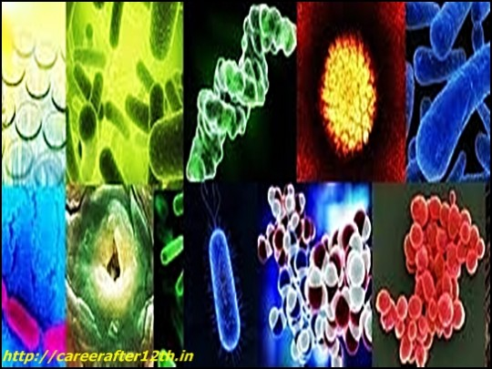](http://careerafter12th.in/wp-content/uploads/2013/01/career-after-12th-science7.jpeg)

1.   B.Science in Microbiology

2.   B.Science (Hons) in  Microbiology

3.   Diploma in Clinical Microbiology

4.   Diploma in Clinical Pathology

5.   Diploma in Industrial Microbiology

**Textile:** – Textile industries, with growing demands expanding multi dimensional and demand for its professional is sky rocketing. In this branch of engineering, scientific principle and techniques are being used in development and manufacturing of all types of textile fabric and fibers. Textile engineering also deals with physical and chemical principles which are being used for analysis of the polymer behavior involved in textile fiber formation. Textile engineering plays major role in control and design of Apparel and textile processes, products, machineries and fibers. There are a lot of job opportunities in this industries as a Process Engineer, Development Engineer, Medical Textile Engineer, Researchers, Quality control supervisor, Technologist, Operation Trainee, Technical services/Sales Manager etc. **courses after 12th science** in Textile technology are;-

[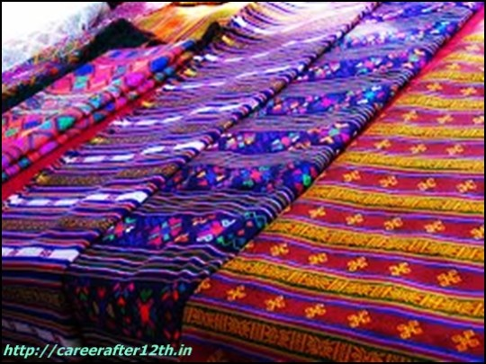](http://careerafter12th.in/wp-content/uploads/2013/01/career-after-12th-science8.jpeg)

1.   Diploma in Textile Tech

2.   Diploma in Textile Eng

3.   Diploma in Fabrication Tech and Erection Eng

4.   B.E in Textile Technology

5.   B.E in Textile Chemistry

6.   B.E in Man Made Fiber Technology

**Architecture**: Architecture deals with the construction of Buildings, bridges and other structures with ventilation, lighting planning, structural integrity, air conditioning system, electrical system and fire safety. An Architect job is provide plans on layout  and design of buildings and structure. Architecture is a multi dimensional profession that revolves around a range of tasks and in recent times is a  hot career among the aspirants. There are multiple opportunities in this field both in public and private sectors.  After completing course there is a lot of employment opportunities in Central and state public work departments, housing and urban development boards, municipalities and private organizations. These are degrees and diploma after 12th in architecture ;

1.     Diploma in Architecture Assistantship

2.     Diploma in Architecture Engineering

3.     Bach Eng  in  Architecture Engineering

4.     B. Tech in  Architecture Engineering

**Information Technology** Information Technology is an ever green career inspiring a lot of students for a better career and attractive pay perks from reputed companies like TCS, Wipro, Infosys and a lot of others. Information technology (IT) is the use of telecommunication and computers equipment to gather, control, store, retrieve information and after processing, transmit and manipulate data. IT includes both hardware and software sectors.  Now a days present evolution is sometimes considered as Information technology age. There is a lot of scope after trained in IT as Quality Analyst, PHP Developer, Programmers, IT Specialist, Software Developer, Technology Engineer, Graphic Designer and a lot of others. These are the degrees and diplomas after 12th in information Technology ;

[](http://careerafter12th.in/wp-content/uploads/2013/01/career-after-12th-science10.jpeg)

There are four types of Information Technology Course in computers:

1.    University courses (Some offered dual qualification)

 2.  Courses offered by world class IT authorities          companies like Microsoft, Sun and Oracle.

 3.  Department of Elect Accredited Computer courses.

 4.    Courses offered by small and large training institutes  which are either affiliated with foreign universities or        Indian and some have no affiliation at all.

Science is a field that also gives opportunity to the students to switch steams if they so desire. A science student also has the option of taking up careers in commerce and Humanities stream if they wish to afterwards. This gives a science stream student plethora of opportunities and career options after 12th science.

Now without getting confused and with the above suggestions move forward to choose a career path according to interest and abilities.