I am providing you the detail information.
First of all log it into your account
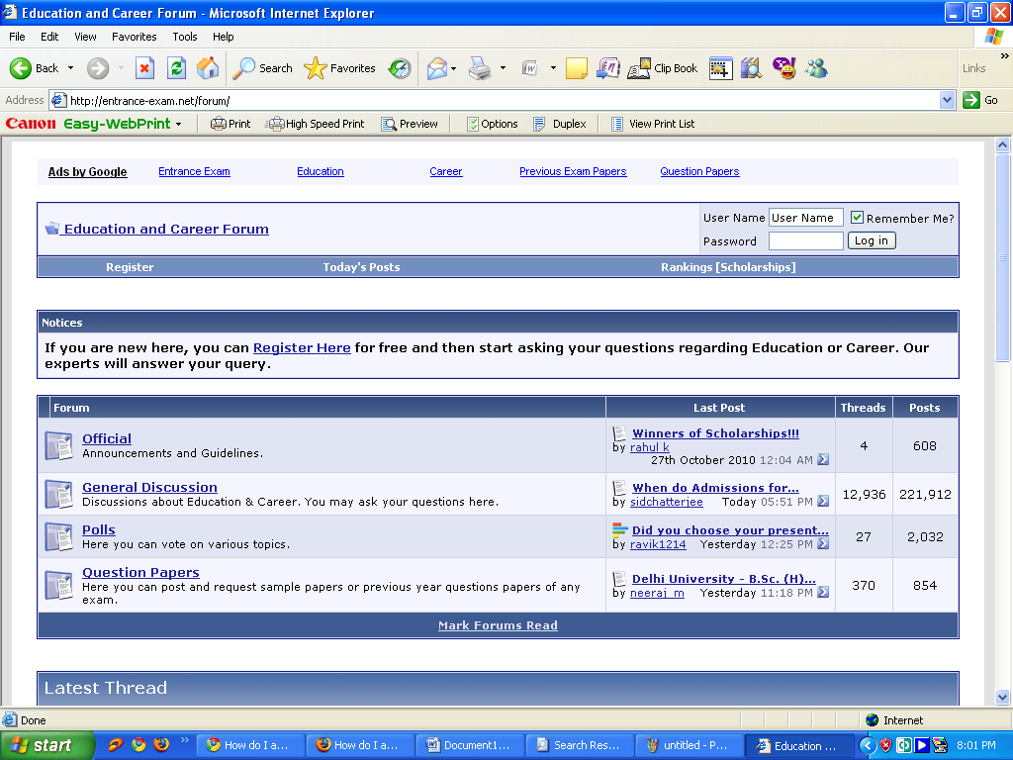

After logging it into your account click on unanswered question

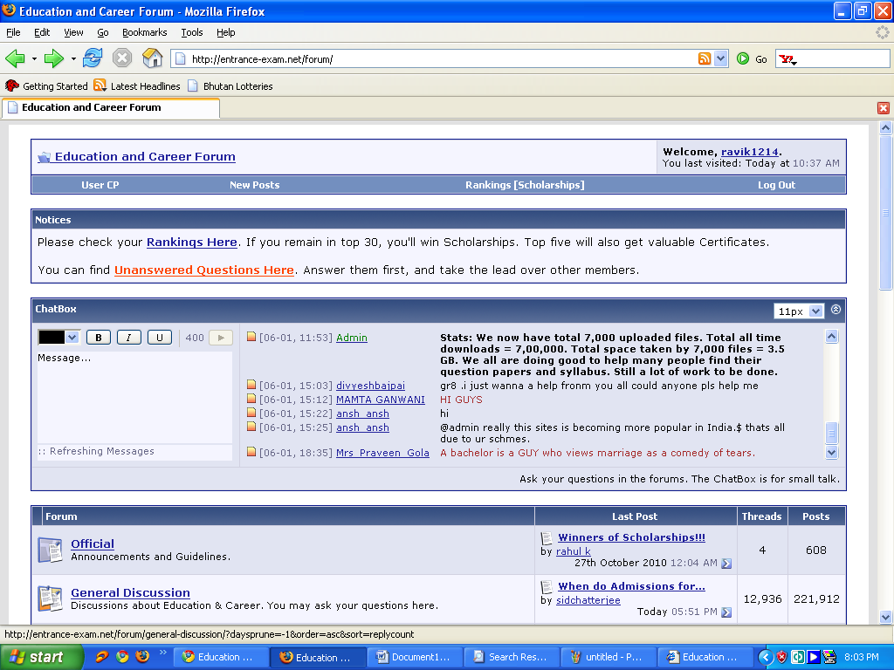

The list of unanswered question will be displayed
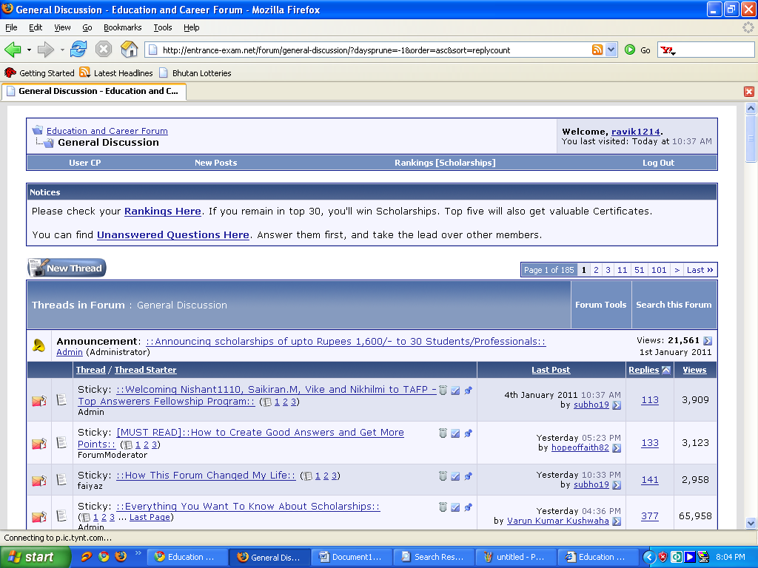

Click on any desire question to answer
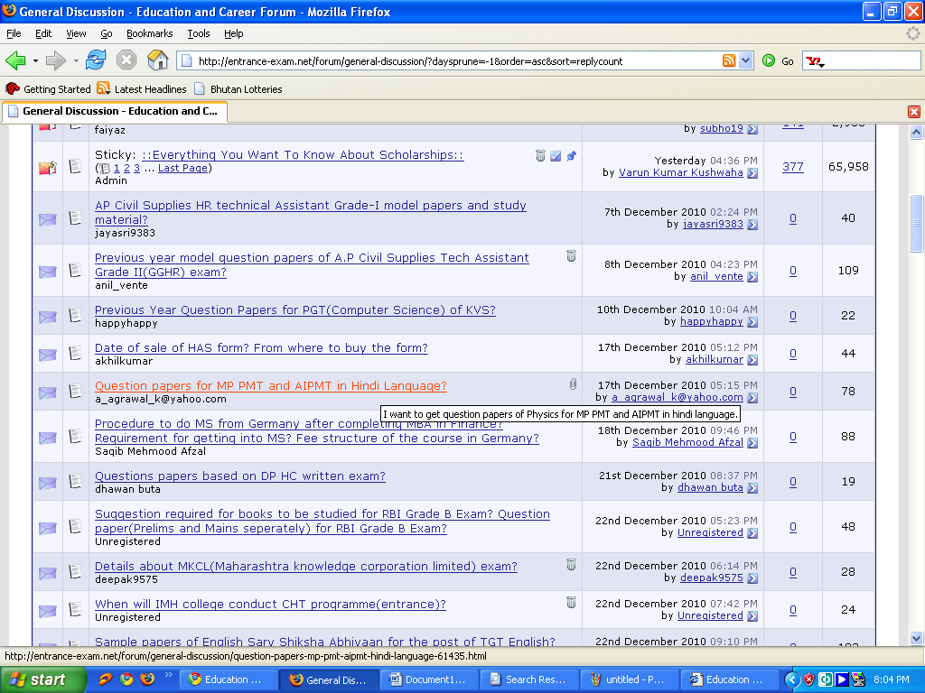

You will see this type of window

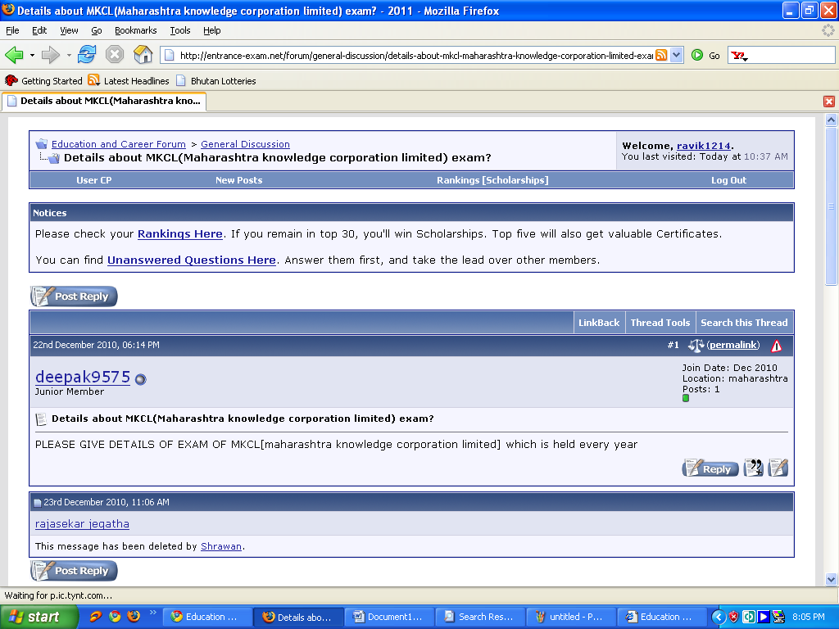
After clicking on reply you will see this wndow .type your answer here and attach your attachement if needed then click submit.
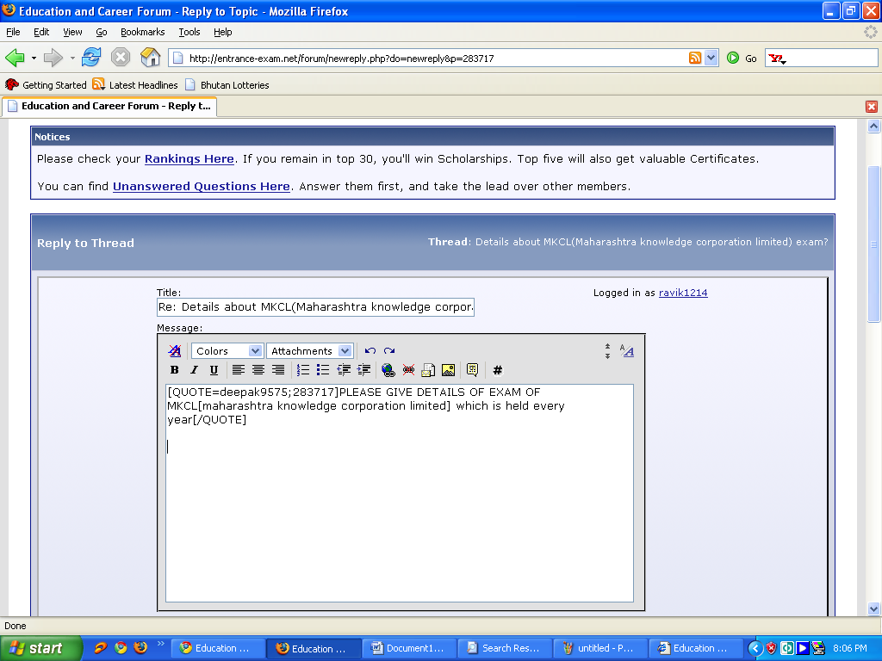

You can also answer by clicking quick answer tab or general discussion forum. Good luck

