ISC Mathematics
Class – XII
Q1. Solve for x and y:
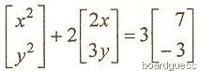 3
Q2. A straight line y = mx passes through the intersection of the straight lines x + 2y – 1 = 0 and 2x – y + 3 = 0 . Find the value of m. 3
Q3. Find the foci and lotus return for the hyperbola x²/4 – y²/5 = ½ . 3
Q4. If 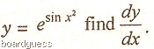 3
Q5. If sin(xy) + cos (xy) = 1 and tan (xy), then show that dy/dx = – y/x. 3
Q6. Solve the following differential equation: dy/dx – e^{y+x} = e^{x-y}. 3
Q7. Evaluate 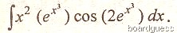 3
Q8. A straight line is parallel to the x-axis and passes through the intersection of the lines x + 2y + 1 = 0 and y = x + 7. Find the equation of the straight line. 3
Q9. Show that 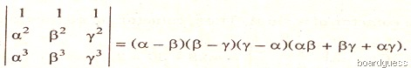 5
Q10. Show that the equation x² – 3xy +2y² + 3x – 5y +2 = 0 represents two straight lines. Find the angle between them. 5
Q11. Find the adjoint of the matrix 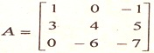 and hence find the matrix A⁻¹. 5
Q12. Verify Rolle’s theorem for the function. f(x) = e^{2x} (sin2x – cos2x) defined in the interval [π/8, 5π/8]. 5
Q13. Find the volume of the largest cone that can be inscribed in a sphere of radius R. 5
Q14. In a binomial distribution, the sum of its mean and the variance is 1.8. Find the probability of two successes if the event was conducted 5 times. 5
Q15. Solve the following system of equations using matrices: 5
x + y + z = 6
x – y + z = 2
2x + y – z = 1

