Test Code : QR ( Short answer type ) 2004

M.Tech. in Quality, Reliability and Operations Research

The candidates applying for M.Tech. in Quality, Reliability and Operations Research will have to take two tests : Test MIII (objective type) in the forenoon session and Test QR ( short answer type ) in the afternoon session.

For Test MIII, see a different Booklet. For Test QR, refer to this Booklet ONLY.

If you are from Statistics / Mathematics Stream, you will be required to ANSWER PART I.
If you are from one of the Engineering Streams, you will be required to ANSWER PART II.

In PART I, you will find in Test QR, a TOTAL of TEN [10] questions, divided in TWO Groups : Statistics & Probability – each carrying FIVE [5] questions. You will be required to answer a TOTAL of SIX [6] questions – taking AT LEAST TWO [2] from each group.

In PART II, there will be six groups E1-E6, each containing three questions. You will be required to answer from Group E1 (Mathematics) and from any three groups from the remaining five groups as per the instruction given within each group.

Syllabus

PART I : STATISTICS / MATHEMATICS STREAM

Statistics (S1)

Descriptive statistics for univariate, bivariate and multivariate data.
Standard univariate probability distributions [Binomial, Poisson, Normal] and their fittings, properties of distributions, sampling distributions.
Theory of estimation and tests of statistical hypotheses.
Linear regression and linear statistical models, ANOVA.
Principles of experimental designs and basic designs [CRD, RBD & LSD].
Elements of non-parametric inference.
Elements of sequential tests.
Sample surveys – simple random sampling with and without replacement.

Probability (S2)

Classical definition of probability and standard results on operations with events, conditional probability and independence.
Distributions of discrete type [Bernoulli, Binomial, Hypergeometric, Poisson, Negative Binomial] and continuous type [Uniform, Exponential, Normal, Gamma, Beta] random variables and their moments.
Bivariate distributions (with special emphasis on bivariate normal), marginal and conditional distributions, regression and correlation.
Multivariate distributions, marginal and conditional distributions, regression, independence, partial and multiple correlations.
Order statistics [including distributions of extreme values and of sample range].
Distributions of functions of random variables.
Multivariate normal distribution [density, marginal and conditional distributions, regression].
Weak law of large numbers, central limit theorem.
Elements of Markov chains and Poisson process.

PART II : ENGINEERING STREAM

Mathematics (E1)

Elementary theory of equations, inequalities.
Elementary set theory, functions and relations, matrices, determinants, solutions of linear equations.
Trigonometry [multiple and sub-multiple angles, inverse circular functions, identities, solutions of equations, properties of triangles].
Coordinate geometry (two dimensions) [straight line, circle, parabola, ellipse and hyperbola], plane geometry.
Sequences, series and their convergence and divergence, power series, limit and continuity of functions of one or more variables, differentiation and its applications, maxima and minima, integration, definite integrals, areas using integrals, ordinary and partial differential equations, geometry of complex numbers and De Moivre’s theorem.

Engineering Mechanics (E2)

Forces in plane and space, analysis of trusses, beams, columns, friction, principles of strength of materials, work-energy principle, moment of inertia, plane motion of rigid bodies.

Electrical Sciences (E3)

D.C. circuits, single phase A.C. circuits, energy and power relationships, network analysis.
Transformers, A.C. and D.C. machines, fundamental concepts of control theory and applications, elementary electronics, analog and digital electronic circuits.

Theromodynamics (E4)

Laws of thermodynamics, internal energy, work and heat changes, reversible changes, adiabatic changes, heat of formation, combustion, reaction, solution and dilution, entropy, free energy and maximum work function reversible cycle and its efficiency, principles of internal and external combustion engines.

Engineering Properties of Metals (E5)

Structure of metals, tensile and torsional properties, hardness, impact properties, fatigue, creep, different mechanism of deformation.

Engineering Drawing (E6)

Concept of projection, point projection, line projection, plan, elevation, sectional view of simple mechanical objects, isometric view, dimensioning, sketch of machine parts.
(Use of set square, compass and diagonal scale should suffice).
SAMPLE QUESTIONS

PART I

GROUP S−1 : STATISTICS

- Denote by φ(z) and Φ(z) the standard normal pdf and cdf respectively. Let Z be a random variable defined over the real line with pdf

f_{λ}(z) = c φ(z) Φ(λz) where λ is a fixed constant, -∞ < λ < ∞.

- Show that c = 2.
- Show that ⏐Z⏐ is CHI with 1 df.
- Show that E(Z) = √[2 / π] ψ(λ) where ψ(λ) = λ / √[1 + λ]².
- Find the mode of the distribution of Z.

- Consider the following observational equations
E(y₁) = β₁ + β₃
E(y₂) = β₁ + β₂
E(y₃) = β₁ + β₃

Var(y_{i}) = σ² ∀ i and Cov(y_{i} , y_{j}) = 0 ∀ i ≠ j.

- Obtain a necessary and sufficient condition for the estimability of a linear parametric function where l_{i}'s (i = 1, 2, 3) are known constants.

- Obtain least square estimates of the parameters β₁, β₂ and β₃. Are the least square estimates unique? Are they unbiased?

- Obtain the best linear unbiased estimate [BLUE] of (4β₁ + 5β₂ - β₃) and also obtain its variance.

- If X = , A = x₁, B = x₂ + x₃, C = x₄ + x₅ + x₆ where x_{I}'s have zero means, unit standard deviations and are uncorrelated then show that the multiple regression equation of X on A, B and C is given by
∧
= A + +

- Calculate r_{X.ABC} and r_{XC.AB} and interpret the results.

- A town has N taxis numbered 1 through N. A person standing on roadside notices the taxi numbers on n taxis that pass by. Let M_{n} be the largest number observed. Assuming independence of the taxi numbers and sampling with replacement, show that ∧
N = (n + 1) M_{n} / n

is an approximately unbiased estimator of N for large N.

- Let x₁, x₂, . . ., x_{n} be a random sample from the rectangular population with density
1 / θ , 0 < x < θ
f(x) =
0 otherwise

Consider the critical region x_{(n)} > 0.8 for testing the hypothesis H₀ : θ = 1, where x_{(n)} is the largest of x₁, x₂, . . ., x_{n}. What is the associated probability of error I and what is the power function?

- Let x₁, x₂, . . ., x_{n} be a random sample from a population having p.d.f.

e− θx x², 0 < x < ∞
f(x, θ) =
0 otherwise

Obtain the maximum likelihood estimate of θ and also obtain the Cramer Rao lower bound to the variance of an unbiased estimator of θ.

- Suppose {x_{o}, x₁, ……., x_{n}} constitute a random sample from a Bernoulli population with parameter p. Let

1 if x_{i} ≤ x_{o}
z_{i =}
0 otherwise

for i = 1, 2,……..n.

- Find the probability distribution of z_{i}. Find E (z_{i}), V (z_{i} ) and cov(z_{i}, z_{j}), i ≠ j.

- Let y = . Find the probability distribution of y.

- If X₁, X₂, X₃ constitute a random sample from a Bernoulli population with mean p, show why [X₁+ 2X₂ + 3X₃ ] / 6 is not a sufficient statistic for p.

GROUP S–2 : Probability

- A coin is tossed an odd number of times. If the probability of getting more heads than tails in these tosses is equal to the probability of getting more tails than heads then show that the coin is unbiased.

- Suppose a young man is waiting for a young lady who is late. To amuse himself while waiting, he decides to take a random walk under the following set of rules:

He tosses an imperfect coin for which the probability of getting a head is 0.55. For every head turned up, he walks 10 yards to the north and for every tail turned up, he walks 10 yards to the south.

That way he has walked 100 yards.

- What is the probability that he will be back to his starting position?

- What is the probability that he will be 20 yards away from his starting position?

- A boy goes to his school either by bus or on foot. If one day he goes to the school by bus, then the probability that he goes by bus the next day is 7/10. If one day he walks to the school, then the probability that he goes by bus the next day is 2/5.

- Given that he walks to the school on a particular Tuesday, find the probability that he will go to the school by bus on Thursday of that week.

- Given that the boy walks to the school on both Tuesday and Thursday of that week, find the probability that he will also walk to the school on Wednesday.

[You may assume that the boy will not be absent from the school on Wednesday or Thursday of that week.]

- Let S and T be distributed independently as exponential with means 1/λ and 1/μ respectively. Let U = min{S,T} and V = max{S,T}. Find E(U) and E(U+V).

- Let X be a random variable with U(0,1) distribution. Find the p.d.f. of the random variable Y = ( X / (1 + X) ).

- Let X₁, X₂, . . . , be a sequence of independent and identically distributed U(0,1) variables. If Z_{n} = ()^{1/n} , then show that Z_{n} converges in probability to some constant C. Also find C.

- Three out of every four trucks on the road are followed by a car, while only one out of every five cars is followed by a truck. What fraction of vehicles on the road are trucks?

- Let X be a random variable with density

4 x3 , 0 < x < 1
f_{X}(x) =
0 otherwise.

For the minimum X₍₁₎ of n iid random observations X₁, X₂, . . ., X_{n} from the above distribution, show that n^{1/4} X_{(n)} converges in distribution to a random variable Y with density

4 e−y4 y3 , y > 0
f_{Y}(y) =
0 otherwise.

- A random sample of size n is taken from the exponential distribution having p.d.f.
e−x , 0 ≤ x < ∞
f (x) =
0 otherwise.

Find the p.d.f. of the sample range.

- If X, Y are independent normal variates with means 7, 13 and variances 16, 4 respectively, then determine θ such that

P(2X + 3Y ≤ 2θ) = P(3X + 8Y ≥ 3θ).

- Consider the following bivariate density function

c ⋅ xy , x > 0, y > 0, x + y < 1
f(x,y) =
0 otherwise

- Find c.
- Find the conditional expectation, E(Y⏐X = x), for 0 < x < 1.

PART II : MATHEMATICS & ENGINEERING

GROUP E-1 : Mathematics

- If f(a) = 2, f ′(a) = 1, g(a) = −1, g′(a) = 2, find the value of
lim {g(x) f(a) – f(x) g(a)} / (x – a)
x → a

(b) Find if x^{cosy} + y^{cosx} = 1.

- Let A be the fixed point (0,4) and B be a moving point (2t, 0). Let M be the mid-point of AB and let the perpendicular bisector of AB meets the y-axis at R. Find the equation of the locus of the mid-point P of MR.

(b) Inside a square ABCD with sides of length 12 cm, segment AE is drawn where E is the point on DC such that DE = 5 cm. The perpendicular bisector of AE is drawn and it intersects AE, AD and BC at the points M, P and Q respectively. Find the ratio PM : MQ.

- Evaluate the value of 3.9^{1/2}.27 ^{1/4}. 81 ^{1/8}. ...up to infinity.

- Solve: dy/dx = (y + 2) / (x-2).

- Find the limit of the following function as x → 0.

sin()

If the line aX + bY + c = 0 is a normal to the curve xy = 1 then show that a⋅b < 0.

- If ω is a complex cube root of unity then show that
a³ + b³ + c³ - 3abc = (a + b + c) (a + bω + cω²)(a + bω² + cω).

- If a = 1 + + + . . . .
b = x + + + . . . .
c = + + + . . . .

then show that a³ + b³ + c³ − 3abc = 1.

GROUP E-2 : Engineering Mechanics

1.(a) Calculate the critical load of a strut which is made of a bar circular in section and 5 meter long and which is pin jointed at both ends. The same bar when freely supported gives a mid-span deflection of 1 cm with a load of 8 kgf at the centre.

- Derive the expression for moment of inertia I_{YY} of the shaded hollow rectangular section (Fig. 1).
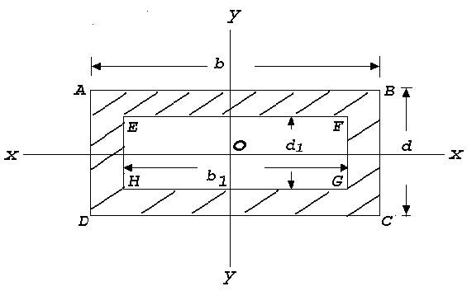
Fig. 1

- A turbine rotor weighs 20 tonnes and has a radius of gyration of 1.75 meter when running at 200 rpm. It is suddenly relieved of part of its load and its speed rises to 205 rpm in 1 sec. Find the unbalanced uniform tuning moment.

Find the diameter of a hollow shaft of diameter ratio of 2/3 to transmit 500 h.p (metric) at 250 rpm if the allowable shear stress is 450 kg / cm² and the maximum torque is 30 % greater than the mean.

3.(a) A uniform ladder 5 m long and 14 kg mass is placed against a vertical wall at an angle 50⁰ to the horizontal ground. The co-efficient of friction between ladder and wall is 0.2 and between ladder and ground in 0.5. Calculate how far up the ladder a man of 63 kg. can climb before the ladder shifts.

(b) Determine the diameter of a steel shaft rotating at an angular velocity of 300 r.p.m. transmitting 500 HP. The allowable stress = 800 Kg/cm². The allowable angle of twist = 0.5⁰ per m, G = 8 × 10⁵ Kg/cm² . What would be the savings if a hollow shaft is used to transmit the same power under the same condition, the ratio of diameters being 0.9?

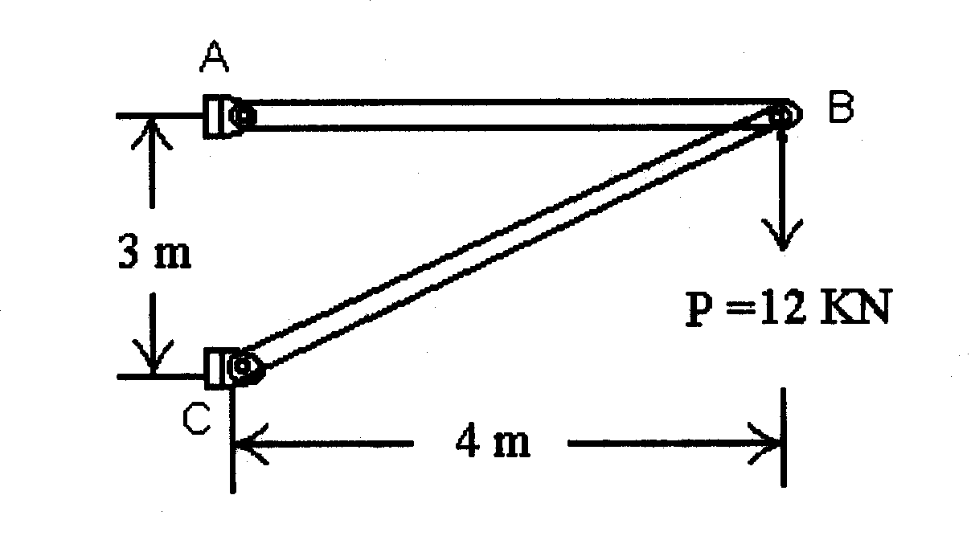
4.(a) The simple planar truss in the given Fig.2 consists of two straight two-force members AB and BC that are pinned together at B. The truss is loaded by a downward Force of P=12 KN acting on the pin at B. Determine the internal axial forces F₁ and F₂ in members AB and BC respectively. Neglect the weight of the truss members.
Fig. 2

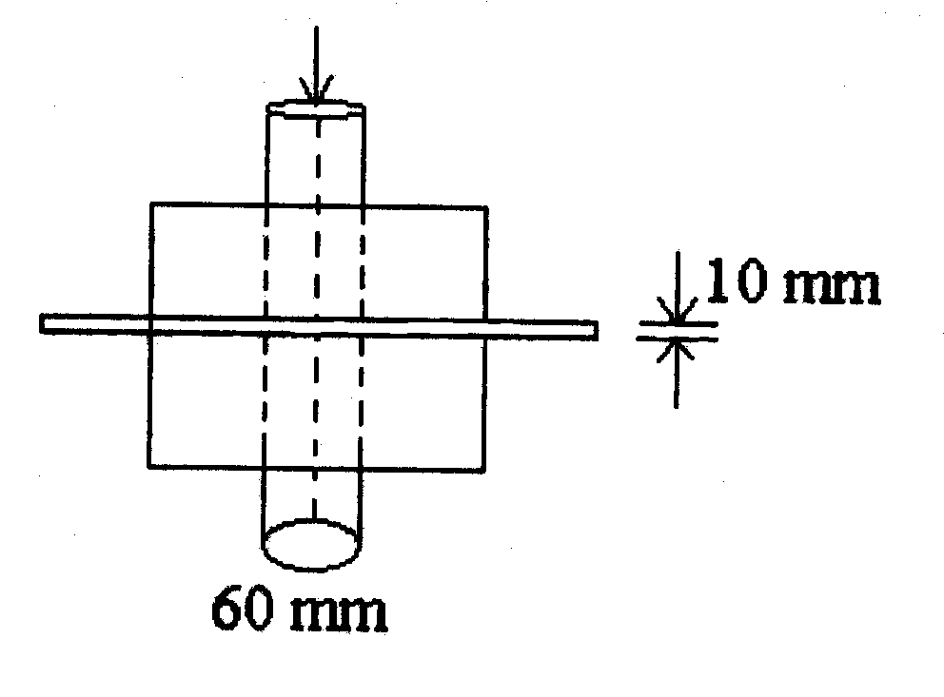
(b) As illustrated in the given Fig.3 a metal punch (similar in principle to a paper Punch) is used to punch holes in thin steel sheet that will be used to make a metal cabinet. To punch a 60 mm diameter disk or "slug" out of the sheet metal that is 10 mm thick requires a punch force of P=500 Kg. Determine the average shear stress in the sheet metal resulting from the punching operation.

Fig. 3

GROUP E-3 : Electrical Sciences

- A centrifugal pump, which is gear-driven by a DC motor, delivers 810 Kg of water per minute to a tank of height 11 meter above the level of the pump. Draw the block diagram of the overall arrangement. Determine input power across the gearing and current taken by the motor operated at 220 volt provided the efficiency of the pump, gearing and motor respectively be 70%, 70% and 90% only. (Take g = 9.8 ms⁻²).

(b) The root mean square value of a sinusoidal alternating voltage at a frequency of 50 Hz is 155volt. If at t = 0 it crosses the zero axis in a positive direction, determine the time taken to attain the first instantaneous value of 155 volt. How much time it takes to fall from the maximum peak value to its half? Explain with suitable waveform diagram.

- A 220 volt, single phase energy meter has a load current of 10 ampere at unity power factor (pf) and it records 2200 revolutions in 4 hours. A faulty energy meter records 1848 revolutions during that period at 0.8 pf, (the other conditions being unchanged). State whether the faulty meter revolves fast or slow and calculate its percentage error.

(b) The open loop gain of an electrical system with input V_{in} and output V_{o} is given by$G(s)=K[{Sτ}_{1}(1+{Sτ}_{1})(1+{Sτ}_{2})]^{−1}$. By introducing negative feed back from the output, the given system is converted to a closed loop one. Draw block diagram of the feed back circuit and using Hurwitz-Routh method, determine the necessary condition(s) for the system to be stable.

- Apply Fermi−Dirac distribution function to determine the probability of occupancy of an electron at E_{F}, the Fermi level energy state.
What will be the current density of a semiconductor material in terms of its electron and hole mobilities? From this expression show that the minimum conductivity occurs when
n₀ = n_{i} ( μ_{p}/μ_{n} ) ½

- Design a circuit using operational amplifiers (OpAmp) to realize the differential equation, dv/dt + k₁v + k₂ = 0.
[Consider all OpAmps have infinite gain.]

4. (a) A series a.c. circuit consists of a coil (having R=30 Ω and L= 0.5 H) and a capacitor which resonates at 48 Hz. If the supply voltage is 100 Volt, determine the value of the capacitor in this condition.

(b) Calculate the capacitance of a capacitor, which when connected across this circuit (as given in (a) above), enhances the resonant frequency to 60Hz. What type of resonance occurs this time? Compare the value of the supply current in both the cases. In each case clearly draw / label the necessary circuit diagrams.

(c) On full-load unity power factor test, a meter having specification of 235 V and 5A makes 60 revolutions in 6 minutes, but its normal speed is 520 revolution/KWh. Does the meter has any inaccuracy? If so, find the percentage error .

GROUP E-4 ; Thermodynamics

1.(a) In a thermodynamic system of a perfect gas, let U = f (V,T) where U, V and T refer to internal energy, volume of a gram-molecule of the substance and temperature (in absolute scale) respectively. An amount of heat δQ is added so that the volume expands by δV against a pressure p. Prove that:

C_{p} – C_{V} = [ p +
where C_{p} and C_{V} stand for specific heat at constant pressure and specific heat at constant volume respectively.

(b) A mass of m₁ Kg of a certain perfect gas at a temperature T₁⁰K is mixed at constant pressure with m₂ Kg of mass of the same gas at a temperature T₂⁰K (T₁>T₂). The system is thermally insulated. Find the change in entropy of the universe. Deduce the same when m₁ equals m₂. Show that the change is necessarily positive.

2.(a) A compression ignition engine has a stroke of 28 cm and a cylinder diameter of 18 cm. The clearance volume is 475 cm³. The fuel injection takes place at constant pressure for 4.5% of the stroke. Find the air standard efficiency of the engine assuming that it works on diesel cycle. If the fuel injection takes place at 10% of the stroke, find the loss in air standard efficiency

(b) A six cylinder petrol engine has a volume compression ratio of 5:1. The clearance volume of each cylinder is 110 cc. The engine consumes 10 Kg of fuel per hour whose calorific value is 10,000 Kcal/kg. The engine runs at 2400 rpm and efficiency ratio is 0.66. Estimate the indicated mean effective pressure developed.

- A diesel engine has the following specification:

number of cylinders : 8, diameter of piston : d cm., length : l cm., BHP : B, rpm : r, number of strokes / cycle : 2, fuel use rate : x kg / minute, calorific value of fuel : C Kcal / kg, average indicated m.e.p : p kgf / cm².

Write down the expressions for (i) IHP / cylinder (ii) Indicated thermal efficiency and, (iii) Brake thermal efficiency.

- Draw the p v and T−Φ diagrams for a diesel cycle in which 1 kg of air at 1 kg / cm² and 90 ⁰C is compressed through a ratio of 14 to 1. Heat is then added until the volume is 1.7 times the volume at the end of compression, after which the air expands adiabatically to its original volume. Take C_{v} = 0.169 and γ = 1.41.

- The approximated equation for adiabatic flow of super heated steam through a nozzle is given by pvn = constant. Show that

p₂ / p₁ = (2 / (n+1)) n / (n-1)

where p₁ = pressure of steam at entry; p₂ = pressure of steam at throat; p₂ / p₁ is the critical pressure ratio.

The dry saturated steam is expanded in a nozzle from pressure of 10 bar to pressure of 4 bar. If the expansion is super saturated, find the degree of under cooling.

GROUP E-5 : Engineering Properties of Metals

1. Explain the different stages of creep with the help of creep curve. What is fatigue failure? State the methods for the reduction of fatigue failure.

2. Draw T-T-T diagram for eutectoid steel. What is the difference between isothermal cooling and continuous cooling? How would you differentiate between bainitic and martensitic transformations. Calculate the relative amounts of ferrite and cementite in pearlite in case of eutectoid steel.

- What is strain hardening of metal. Show in which part of the engineering stress and engineering strain curve, strain hardening of metal takes place. Does that part also imply uniform plastic deformation? How? From which point of the curve, localised deformation starts? Why?

What is modulus of elasticity in shear? How would you derive the expression for Torsional stress corresponding to large plastic strain..

4.(a) A 25 mm diameter bar is subjected to an axial tensile load of 100 KN. Under action of this load a 200 mm gauge length is found to extend 0.19 x10⁻³ mm. Determine the modulus of elasticity of the bar material.

(b) A solid shaft, 100 mm diameter, transmits 75 KW at 150 rev/mm. Determine the value of the maximum shear stress set up in the shaft and the angle of twist per meter of the shaft length if G=80 GN/m².

GROUP E-6 : Engineering Drawing

- A triangular prism of 40mm base and 60mm height is lying on HP on one of its rectangular faces with its axis inclined at 45º to VP. It is sectioned by a horizontal plane at a distance of 15mm above the ground. Draw its top view.

The top view of a 100mm straight line measures to 80mm. This line is in VP with one of its end being 20mm above HP. Draw the figure neatly. From the figure, determine the angle of inclination the line makes with HP and also locate the other end of this line.A cube of 40 mm long edges is resting on the ground on one of its faces with a vertical face inclined at 45º to the V.P. It is cut by a section plane parallel to the V.P. and 10 mm away from the axis and nearer the V.P. Draw its sectional front and sectional top views.

2. Draw neat sketches of forms and portions of the following rivet joints:

- Single riveted lap joint
- Double riveted lap joint
- Single lever single riveted butt joint
- Double riveted lap joint zigzag riveting
- Double lever single riveted butt joint
- Double lever double riveted butt joint zigzag formation

- Draw the isometric view of an octahedron erected vertically up on one of its vertices. (Distinct free hand sketch only.)

From this isometric view you obtained, sketch all the three projected views.

4. A parallelepiped of dimension 100×60×80 is truncated by a plane which passes through 85, 45 and 65 unit distance on the associated edges from the nearest top point of the object. Draw the isometric view of the truncated solid object. In third angle projection method, draw its plan. All dimensions are in mm.

