____________________________________________________________________
HISTORY & CIVICS
H.C.G. - Paper - 1
(Two hours)
Answers to this Paper must be written on the paper provided separately.
You will not be allowed to write during the first 15 minutes.
This time is to be spent in reading the question paper.
The time given at the head of this Paper is the time allowed for writing the answers
____________________________________________________________________
Attempt all questions from Part I (Compulsory). A total of five questions are to be
attempted from Part II, two out of three questions from Section A and three out of
five questions from Section B.
The intended marks for questions or parts of questions are given in brackets [ ].
____________________________________________________________________
PART I (30 Marks)
Attempt all questions from this Part

Question 1
(a) What is meant by a federal structure of government? [1]
(b) Who is the presiding officer of the Lok Sabha? [1]
(c) Name the two Houses of a Bicameral Legislature. [1]
(d) Who settles disputes in connection with the election of the Vice President? [1]
(e) When can an ordinance be issued by the President? [1]
(f) Under which situation may the President exercise his discretion in selecting
the Prime Minister? [1]
(g) By whom and on whose advice can the Legislative Assembly be dissolved? [1]
(h) Mention the grounds on which a Judge of the Supreme Court be removed? [1]
(i) What is the purpose of the writ of prohibition? [1]
(j) Which jurisdiction will give the High Court the authority to hear cases
regarding Admiralty and Contempt of Court? [1]

Question 2
(a) Mention any two social reforms advocated by the British which affected
the religious traditions of the people. [2]
(b) Name any two methods through which the Moderates carried their
agitation. [2]
(c) Name the two Weeklies through which Tilak spread the message of
liberty. [2]
(d) Who founded the Mohammedan Anglo Oriental College at Aligarh?
Name the Viceroy who was responsible for granting separate
representation to the Muslims in 1909. [2]
(e) Which tragic incident prompted Gandhiji to launch the Non Cooperation
Movement? Why was the Khilafat Movement launched? [2]
(f) Which country was blamed for the assassination of Archduke Francis
Ferdinand?
Which treaty was the symbol of humiliation to the German people? [2]
(g) What is the term of office of the President of the International Court of
Justice? Who elects the non-permanent members of the Security Council? [2]
(h) What was the Marshall Plan? Name any two military alliances that came
into being as a consequence of Cold War. [2]
(i) Mention any two functions of the World Health Organisation. [2]
(j) Who were the architects of the Non-Aligned Movement? [2]

PART II (50 Marks)
SECTION A
Attempt any two questions from this Section

Question 3
With reference to the Union Parliament and the State Legislature, discuss:
(a) The procedure laid down for the passage of money bills by the State
Legislature. [3]
(b) The circumstances under which the Union Parliament may make laws on
subjects in the State List. [3]
(c) The grounds for disqualifying a person from being a member of the Rajya
Sabha. [4]

Question 4
Assess the position of the Governor and the Chief Minister under the following
heads:
(a) The judicial powers of the Governor. [3]
(b) The power of the Chief Minister in relation to the State Legislature. [3]
(c) The legislative powers of the Governor. [4]

Question 5
Our Constitution provides for the establishment of an independent, integrated
judiciary with the Supreme Court as the final tribunal in the country. In this
context, explain:
(a) The meaning and scope of Original Jurisdiction. [3]
(b) The term Judicial Review.
Why is the Supreme Court described as a Court of Record? [3]
(c) The independence of the judiciary from the control of the executive. [4]

SECTION B
Attempt any three questions from this Section

Question 6
The revolt of 1857 had far-reaching effects on the administrative setup, judicial
administration and military organization in India. In this context, discuss:
(a) Rights granted to the Indian princes. [3]
(b) Rise of nationalism in India. [3]
(c) The changes introduced in the administrative setup of the British
territories in India. [4]

Question 7
The period between 1905 and 1914 saw the rise of aggressive nationalism. In this
context, state:
(a) The contribution of Tilak to the freedom struggle. [3]
(b) Those measures that illustrate the repressive policies of Lord Curzon. [3]
(c) The achievements of the aggressive nationalists. [4]

Question 8
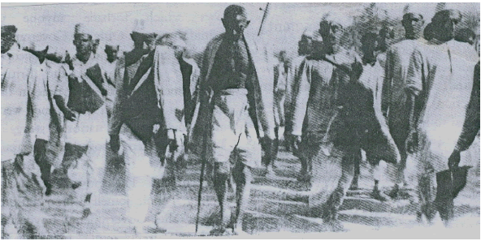
(a) Name the historic event associated with the picture given above. With this
event, the Indian National Congress launched a national movement in
1930. Name the movement and the causes leading to this movement. [4]
(b) Why was the movement suspended? [3]
(c) Why was the movement renewed? [3]

Question 9
The Cabinet Mission Proposal evoked a mixed reaction from the leaders of both the
congress and the Muslim League. In this context, state briefly:
(a) Any four proposals made by the Cabinet Mission. [4]
(b) The reaction of the Congress to the Cabinet Mission proposals. [3]
(c) The reaction of the League to the Cabinet Mission proposals, and later
rejection of the Cabinet Mission proposals. [3]

Question 10
With reference to the First World War:
(a) Mention any three objectives of the League of Nations. [3]
(b) Describe briefly any three results of the First World War. [3]
(c) What do you mean by Human Rights? Many commissions are playing an
active role in the implementation of Human Rights. In this connection,
describe the role of any one commission. [4]

