Preliminary Exam Details :
paper 1:
General Studies :
current events
Indian History
global & Indian Geography
Indian Economics & polity
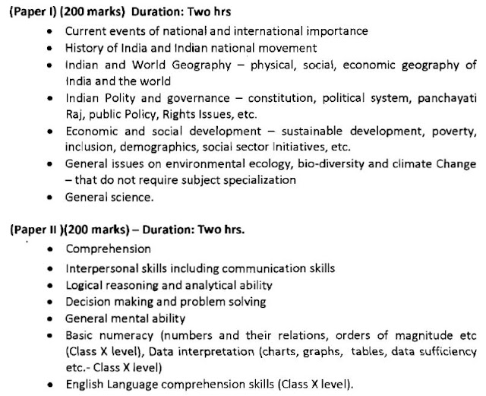
Paper 2 :
Optional subjects
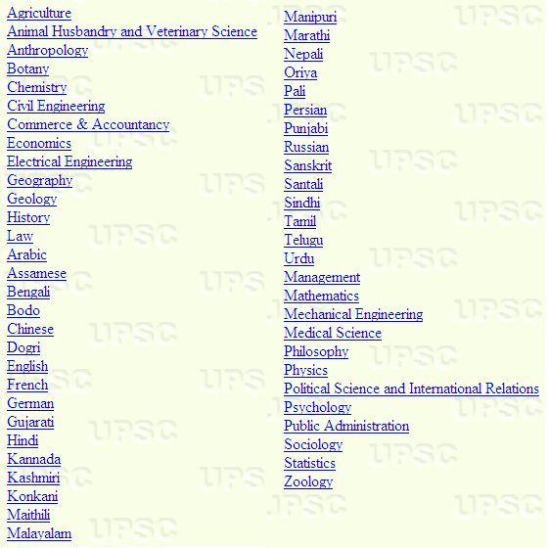
Main Exam :
Paper 1 :
Indian Language
Paper 2 :
General English
Paper 3 :
Essay
Paper 4 :
General Studies I
Paper 5 :
General Studies II
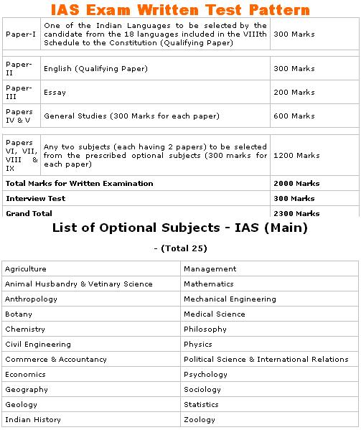
Interview process:
eligible or pass in the all the exams , that candidates are called for an interview
some interview questions :
Meaning of your name or about a famous person who has the same name as you
about your choice of career
recent current topics
how do you plan to perform your duty
about your academic record
hypothetical questions

