Specific Instructions for filling up the online application form
(Course Programme: ME / M Tech / M Des)

Step 1: Register with your e-mail address and password to start the online application process.
Registration form for IISC Online Application

- Name of the candidate: Enter you name as it appears in your degree certificate.
- Password: Choose password of your choice.
- Date of Birth: Enter your date of birth as it appears in your degree certificate.
- Email Address: Enter your e-mail address.
- Security Question: Select any one security question: “What is your mother’s maiden name” for your password retrieval purpose.
- Security Answer: Enter the answer for the question you have chosen above
When you submit the registration form, you will receive an e-mail asking you to verify your e-mail address by clicking on a link.
After the e-mail address is verified, your registration is complete.
Step 2: Log in to the website to fill the application form. You will need information about / from the following documents, so have them handy.

- Certificate / Mark sheets of: 10th Std, 12th Std, UG Degree and/or PG Degree.
- Details (Registration/Roll Numbers, Paper Code and Marks/Ranks etc.) of GATE / CEED.
- Your e-mail address.
- Demand draft for the amount of the application fee (Rs 600 for GN & Rs.300 for SC/ST/PH candidates).
- Your passport size photograph (to be uploaded).
- A scanned image of your signature (to be uploaded)
The Application Form is divided into four parts, each appearing inside a separate tab (see the screenshot below)
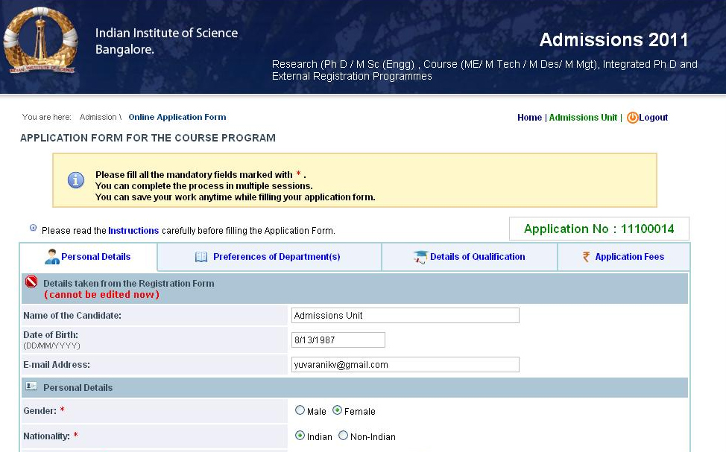
  - You have to fill all the details (especially mandatory fields) within a given tab, click on “Save & Proceed” button to proceed to the next tab.
  - Unless you fill the mandatory fields in a tab you will not be allowed to move to the next tab.
  - On clicking the “Save & Proceed” button, if the browser does not take you to the next tab, it means some mandatory fields have not been filled (correctly), if this happens look for error messages which are displayed in red.
  - Detailed instructions for the fields in each tab are given below.
TAB 1: Personal Details

- Name of the candidate: has been taken from your Registration form. You cannot edit/change it now.
- Date of Birth: has been taken from your Registration form. You cannot edit/change it now.
- Email Address: has been taken from your Registration form. You cannot edit/change it now.
- Gender: Choose your gender by clicking any of the radio buttons.
- Nationality: Choose your nationality by clicking any of the radio buttons.
- State of domicile: will appear if you are Indian. Select state of domicile in the dropdown menu.
- Country: will appear if you are non Indian. Select the country in the dropdown menu.
- Category: chose your category by clicking on the appropriate radio button.
- OBC - Sub-Classification: will appear if you choose “Other backward class”. Again select from one of those radio buttons.
- Sub category: choose one from the radio button.
- Father/guardian’s name: Please enter the name of your father/guardian in the text box.
- Relationship: choose the relationship of the person mentioned in Item 17 from the dropdown menu.
- Mother’s name: Please enter your mother’s name in the text box.
- Family background: use the dropdown menu to provide details about the educational qualification, Occupation and Annual income of your Father/Guardian and Mother.
- Contact Details: Provide your contact details by filling the text boxes and making the choice from the dropdown menu for ‘State’.
- Are you currently employed: Please select from the radio buttons, if you click “Yes”, please provide Name of the company, Designation, office address and experience.
- Passport size photograph: Click on the space provided and upload your photograph in jpeg, gif, tiff, or png formats (Note: it should not exceed 1 Mb).
- Scanned image of your signature: same as above.

Note:
On clicking the “Save & Proceed” button, if the browser does not take you to the next tab, it means some mandatory fields have not been filled (correctly), if this happens look for error messages which are displayed in red.

TAB 2: Preference of Departments
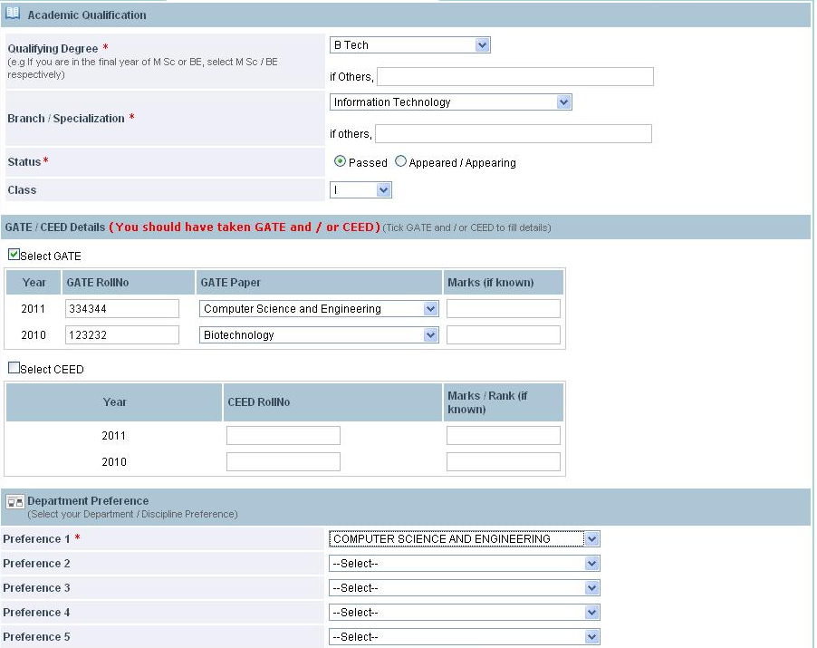

- Qualifying Degree: Select your Qualifying degree from the drop-down menu.
- Branch/Specialization: Select your branch in your qualifying degree from the drop-down menu.
- Status: choose appropriate status from the radio buttons
- Class: choose the class from the dropdown menu (if your university does not announce the class leave it blank)
- Details of GATE/CEED:
  - If qualified GATE 2010/appeared in GATE 2011 give your Roll Number, select the Gate Paper from the drop down menu and marks (out of 100). If qualified in both the years, higher of the two marks will be considered.
  - If qualified CEED 2010/ appeared in CEED 2011, give your Roll Number, and marks (out of 100). If qualified in both the years, higher of the two marks will be considered.
  - You should update the GATE/ CEED results, as applicable, if passed, immediately after the declaration of the results.
- Preferences of Discipline(s): Give your choices by selecting from the dropdown menu. If applying to only one discipline, leave the remaining columns blank.

Note:
Please note that based on the particulars filled in Degree, Branch and GATE / CEED columns, list of ME / M Tech/ M Des disciplines you are eligible will be listed in the preferences columns.

TAB 3: Details of qualification
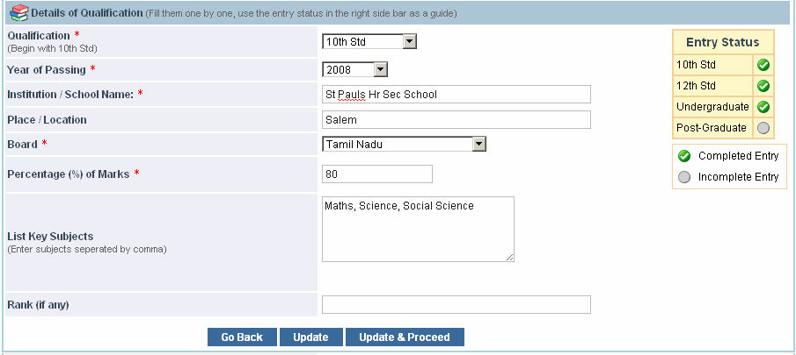
In this tab you will provide details of marks/grades you obtained in examinations: 10th Std*, 12th Std*, Undergraduate* and Post-Graduate, (if applicable).
Each of these exam is to be selected from the dropdown menu in item 1, for example you choose 10th std from the dropdown menu: after entering all the details, you press the “SAVE” button. In the side bar entitles “Entry Status” you will see a green (tick mark) against 10th Std.
Now select the next exam in the “Qualification” dropdown and fill the details.
The right side bar entitled “Entry Status” (see the picture above) provides visual feedback to you about the details of what you have filled.
- Qualification: choose from the dropdown menu, 10th and 12th std , Undergraduate or Post-Graduate
- SSLC/10th Standard: Select the year of passing from the popup menu. Fill in the school name and place; select the board you studied from the popup menu. Enter the aggregate percentage of marks and the main subjects you studied.

- II PUC/12th Standard: Same as above.

- Undergraduate:

  - Degree: Select your degree you are studying or completed. If your degree is not listed in the dropdown, choose “others” and specify below.
  - Branch / Specialization: Select your branch / Specialization. If your branch is not listed in the dropdown, choose “others” and specify below.
  - Year of passing: Select from the drop down menu.
  - Fill in the institution/college name and place.
  - University: Select from the drop down menu. If not listed in the dropdown, choose “others” and specify below.
  - List Key Subjects: Fill the key subjects you have studied separated by comma. (Max 250 characters).
  - Rank: Fill if you have any.
  - Class: Choose the class from the dropdown menu (if your university does not announce the class, leave it blank.
  - Semester-wise Marks:
    - Percentage / GPA: Select appropriately. If GPA, then specify “out of”
    - Enter the percentage of marks obtained semester wise in the semester columns if in semester pattern OR otherwise if you are under annual pattern fill the marks of 1st ,2nd 3rd and 4th year in the 2nd, 4th, 6th, 8th semester columns for 1st,2nd,3rd,4th year marks respectively. If you are in the final year and do not have the marks of the 7th and 8th semester, fill in up to the 6th semester and leave the other columns blank.
  - If you qualified in any one of the following degree, after filling up all the above details, and on clicking “Save” button, you will get next screen where you have to give the details of your BSc degree.
    - B Sc followed by AMAeSI
    - B Sc followed by AMIE
    - B Sc followed by AMIIChE
    - B Sc followed by AMIIM
    - B Sc followed by AMIMechE(I)
    - B Sc followed by Grad IETE

- Post-Graduate: Same as above, (if applicable)

Note:
Either your Undergraduate degree or Post-Graduate degree must match with the 'Qualifying Degree' that you entered in 'Preference of Department(s)' page.

TAB 4: Application Fees
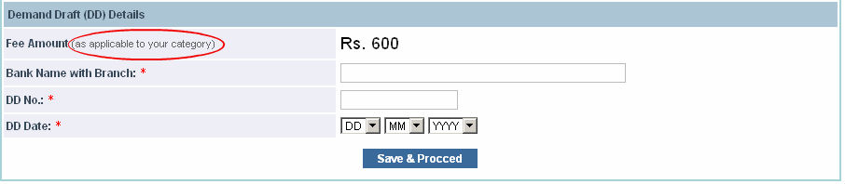
- Fee Amount: Will display automatically as per your category.
- Bank Name with Branch: Enter the bank name with branch on which you have drawn the Demand Draft.
- DD No: Enter the DD Number.
- DD Date: Enter the DD Date.
When you complete the application form you will see the following screen,
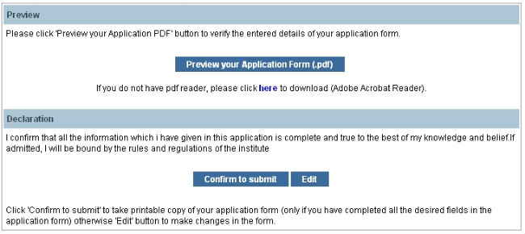
Please preview your application for by clicking the ‘Preview your Application form’ button.
On clicking the “Preview your Application form” button you will get a PDF of preview copy of your Application form, go through it carefully to verify all the details, if you find any errors go back to the online Application form by clicking ‘EDIT’ button and correct them. Preview this version again; to ensure all the corrections have been incorporated.
Repeat this process until your Application form is completely and correctly filled.
Be careful you” CANNOT “edit/change the application form (except for entrance test details etc) after you SUBMIT the application form.
After satisfying yourself about the correctness of the application form, press “CONFIRM TO SUBMIT” Button.
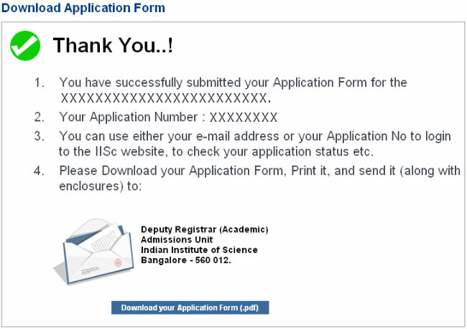
This will give you the PDF of your application form, store it carefully
- For your records
- Send it to the “Deputy Registrar (Academic), Admissions unit, Indian Institute of Science, Bangalore -560 012.” on or before 21 Mar 2011 along with the documents mentioned in check list (the first page of this pdf contains the instructions to be followed)

