Time allowed: 3 hours Maximum Marks: 70

Sample Paper – 2011
Class: XII
Subject: Physics

General Instructions:
- All questions are compulsory.
- There are 30 questions in total. Questions 1 to 8 carry one mark each, questions 9 to 18 carry two marks each, questions 19 to 27 carry three marks each and questions 28 to 30 carry five marks each.
- There is no overall choice. However, an internal choice has been provided in one question of 2 marks, one question of 3 marks and all the three questions of 5 marks. You have to attempt one of the choices in such questions.
- Use of calculators is not permitted.
- You may use the following values of physical constants wherever necessary:
c = 3 x 10⁸ ms^{–1}
h = 6.626 x 10^{–34} Js
e = 1.602 x 10^{–19} C
μ₀ = 4 π x 10^{–7} T m A^{–1}
$\frac{1}{4{\text{πε}}_{0}} = 9 x {\text{10}}^{9} N m^{2} C^{−2}$

Mass of neutron m_{n} ≅ 1.675 x 10^{–27} kg
Boltzmann’s constant k = 1.381 x 10^{–23} J K^{–1}
Avogadro’s number NA = 6.022 x 10²³ / mol ^{–1}

Q.1 The distance of the field point, on the axis of a small electric dipole is doubled. By what factor will the electric field due to a dipole change?
Q.2 How does the drift velocity of electrons in a metallic conductor vary with increase of temperature?
Q.3 A charged particle enters in to a uniform magnetic field and experiences an upward force as shown in fig. What is the charge sign on the particle?

N
S

A
B
Force

Q.4 Experimental observations have shown that X-rays: (i) travel in vacuum with a speed of 3x10⁸m/s. (ii)exhibit the phenomenon of diffraction and can be polarized. What conclusion can be drawn about the nature of the X-rays from each of these observations?

Q.5 The line PQ in the adjoining ray diagram represents a lens. State, with proper reason, whether the lens is convex or concave.

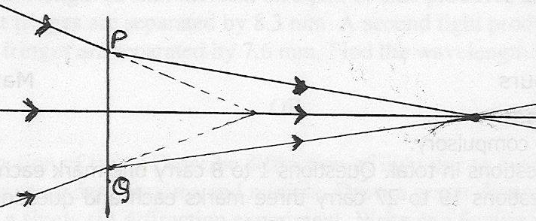
Q.6 The photoelectric cut-off the voltage in a certain photoelectric experiment is 1.5V. What is the maximum kinetic energy of the photoelectrons emitted?

Q.7 In an experiment on photoelectric effect, the following graphs were obtained between the photoelectric current (I) and the anode potential difference (V). Name the characteristic of the incident radiation that was kept constant in this experiment.
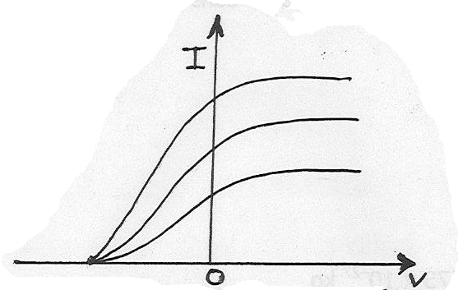
Q.8 What is the ground- state energy of the electron in the hydrogen atom? What for n = ∞ (ionised state).

Q.9 What do you mean by modulation? Explain the need of modulation.

Q.10 You are given two circuits as shown in fig. which consists of NAND gates. Identify the logic operation
carried out by the two circuits.
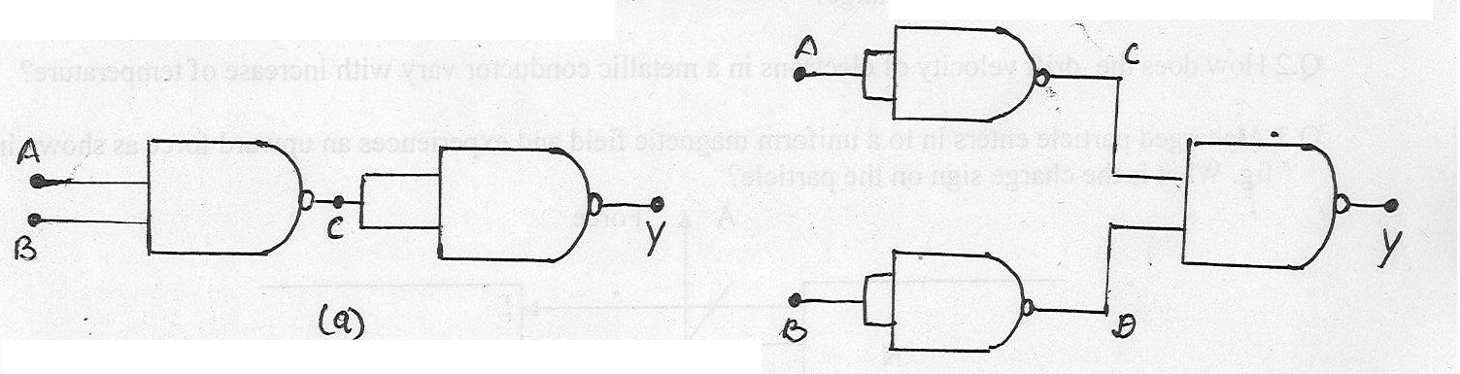

Q.11 How will the angular separation and visibility of fringes in Young’s double slit experiment change
when (i) screen is moved away from the plane of the slits. (ii)width of source slit is increased.

OR
The value of Brewster’s angle for a transparent medium is different for lights of different colours,
why?

Q.12 Calculate the work done to dissociate the system of three charges placed on the vertices of a triangle as
shown in fig. given q = 1.6 x 10⁻¹⁰C.

Q.13 Identify the part of the electromagnetic spectrum which is:
(i) suitable for radar systems used in aircraft navigation.
(ii) adjacent to low frequency end of electromagnetic spectrum.
(iii) produced in nuclear reactions and
(iv) produced by bombarding a metal target by high speed electrons.

Q.14 Explain with reason, in which direction does the current loop KLMN move, when kept near an
infinitely long straight wire carrying current as shown in the adjoining fig.

Q.15 Explain how does the width of the depletion layer in a p-n junction diode change when the junction
is(i) forward biased (ii) reverse biased.

Q.16 A magnet is moved in the direction indicated by an arrow between two coils AB and CD as shown in the fig. Suggest the direction of current in each coil.

Q.17 For photoelectric effect in sodium, the figure shows the plot of cut-off voltage versus frequency of
incident radiation. Calculate (i) threshold frequency (ii) Work function of sodium.

Q.18 Calculate the binding energy per nucleon in ₂₀Ca nucleus. Given m ( ₂₀Ca ) = 39.962589u,
m_{n} = 1.008665u, m_{p} = 1.007825u, 1u = 931MeV/c².

Q.19 What do you mean by self induction and self inductance? Derive an expression for the self inductance
of a long air cored solenoid of length (l) and radius(r) and number of turns N.
OR
What are eddy currents? How are they produced? Give two applications of eddy currents.

Q.20 With the help of a labeled diagram explain the construction and working if an AC generator. Deduce the
expression for emf generated in the coil in terms of its speed of rotation.

Q.21 Draw the graph, showing variation of binding energy per nucleon with mass number. Explain using
the graph, why heavy nuclei can undergo fission.

Q.22 Using Kirchhoff’s law, calculate the value of electric currents I₁, I₂ and I ₃ in the given network.
OR

A potentiometer wire of length 1m is connected to a driver cell of emf 3V as shown in fig. When a cell
of emf 1.5V is used in the secondary circuit, the balance point is found to be 60cm.On replacing this cell
by a cell of unknown emf, the balance point shifts to80cm.
(i) Calculate the unknown emf of the cell.
(ii) Explain with reason, whether the circuit works if the driver cell is replaced with a cell of emf 1V.
(iii) Does the high resistance R, used in the secondary circuit affect the balance point? Justify your answer.

Q.23 Deduce the condition for balance in a Wheatstone bridge. Using the principle of Wheatstone bridge
describe the method to determine the specific resistance of a wire in the laboratory. Draw the circuit
diagram and write the formula used.

Q.24 With the help of a circuit diagram, explain how an n-p-n transistor can be used as an amplifier in
common emitter configuration. Explain how the input and output voltages are out of phase by180⁰ for
a common emitter transistor amplifier.

Q.25 Draw a ray diagram to show the formation of image by a refracting type astronomical telescope for
normal adjustment position. Obtain expression for its magnifying power.

Q.26 A convex lens made up of glass of refractive index 1.5 is dipped, in turn, in:
(i) medium A of refractive index 1.65.
(ii) medium B of refractive index 1.66.

Explain giving reasons, whether it will behave as converging lens or a diverging lens in each of these
two media.

Q.27 Explain briefly with the help of diagrams, the terms:
(i) amplitude modulation (ii) frequency modulation.
Which of these (a) gives better quality transmission (b) has a large coverage?

Q.28 (i) Explain the principle, construction and working of Van de Graaff generator with the help of a
labeled diagram.

(ii) A parallel plate capacitor with air between the plates has a capacitance of 8pF. What will be the
capacitance if the distance between the plates is reduced by half and the space between them is filled
with a substance of dielectric constant 6?
OR

- Derive an expression for the capacitance of a parallel plate capacitor, whose plates are separated by a dielectric medium?
- The area of each plate of a parallel plate capacitor is 100cm² and the electric field strength between the plates is 100N/C. Calculate the charge on each plate.

Q.29 Draw a neat and labeled diagram of a cyclotron. State the underlying principle and explain how a
positively charged particle gets accelerated in this machine. Show mathematically that the cyclotron
frequency does not depend upon the speed of the particle.
OR

Derive an expression for the torque acting on a loop of N-turns, area A, carrying current I, when held in a uniform magnetic field B. With the help of a circuit, show how a moving coil galvanometer can be converted into an ammeter of given range. Write the necessary mathematical formula.

Q.30 (i) Derive an expression for the distance of any bright fringe and dark fringe from the central fringe, in
Young’s double slit experiment. Hence find the expression for fringe- width.
(ii) Laser light of wavelength 630nm incident on a pair of slits produces an interference pattern in
which the bright fringes are separated by 8.3 mm. A second light produces an interference pattern
in which bright fringes are separated by 7.6 mm. Find the wavelength of the second light.

OR

- What is diffraction of light? Describe diffraction of light due to a single slit and write the expression for secondary maxima and minima. Draw a graph showing the variation of intensity with angle in a single slit diffraction experiment. Write one feature which distinguishes the observed pattern from the double slit interference pattern.
- What do you mean by the resolving power of an optical instrument? Write the formula for the resolving power of a microscope. How can the resolving power of microscope be increased?
.

Paper Sumitted By:

Name: Archana Ashok
Email: sanjay_eishan@yahoo.com
Phone No. 971370375

