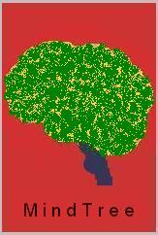

Hi this is Aravindan. I m very crazy about mindtree…. So I just designed a logo for my mindtreee….

