SAIL Technical Papers Electronics-Engineering MT
2010
1. Two coils in differential connection have self-inductance of 2 mH and 4 mH and a mutual inductance of 0.15 mH. The equivalent inductance of the combination is
A. 5.7 mH
B. 5.85 mH
C. 6 mH
D. 6.15 mH.
2. Two point charges Q and -Q are located on two opposite corners of a square as shown in figure. If the potential at the corner A is taken as 1V, then the potential at B, the centre of the square will be
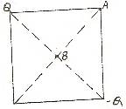
- zero
- 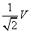
- 1V
3. Optocouplers combine
A. SITs and BJTs
B. IGBTs and MOSFETS
C. Power transformers and silicon transistor
D. Infrared light-emitting diode and a silicon phototransistor
4. The difference between the indicated value and the true value of a quantity is known as
A. Gross error
B. Absolute error
C. Dynamic error
D. Relative error
5. The principles of homogeneity and super-position are applied to :
A. linear time variant systems
B. non-linear time variant systems
C. linear time invariant systems
D. non-linear time invariant systems.
6. In a 8085 microprocessor system with memory mapped I / 0,
A. I / 0 devices have 8-bit addresses
B. I / 0 devices are accessed using IN and OUT instructions
C. there can be a maximum of 256 input devices and 256 output devices.
D. arithmetic and logic operations can be directly performed with the I / 0 data.
7. The transistor shown in figure below, is biased
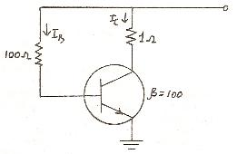
- at cut-off
- at saturation
- well into saturation
- well into cut-off
8. In any transmitting antenna system, efficiency primarily depends upon
A. ohmic losses of various conductors
B. radiation resistance
C. ground conductivity
D. atmospheric conditions.
9. An instruction used to set the carry Flag in a computer can be classified as
A. data transfer
B. arithmetic
C. logical
D. program control
10. The binary representation of 5.375 is
A. 111.1011
B. 101.1101
C. 101.011
D. 111.001
11. Dislocations in materials are
A. point defect
B. line defect
C. planer defect
D. surface defects.
12. In TV system, vertical pulses are separated out from horizontal pulses by the use of
A. integrator
B. differentiator
C. sweep credit
D. sync separator.
13. Frequency in the UHF range propagate by means of
A. Ground waves
B. Sky waves
C. Surface waves
D. Space waves.
14. 200 MHz may be classified as
A. VHF
B. SHF
C. UHF
D. EHF
15. A communication satellite is a repeater between
A. a transmitting station and a receiving station
B. a transmitting station and many receiving stations
C. many transmitting stations and many receiving stations
D. none of the above

16. The power in a series R-L-C circuit will be half of that at resonance when the magnitude of the current is equal to
A. V / 2R
B. V /
C. V /
D.
17. A point charge Q is located on the surface of a sphere of radius R as shown in the figure. The average electric field on the surface of the sphere will be
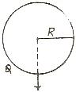
- infinite
- 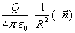
- 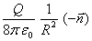
- Zero

18. The efficiency of a chopper can be expected in the range
A. 50 to 55 percent
B. 65 to 72 percent
C. 82 to 87 percent
D. 92 to 99 percent
19. Which one out of the following instruments should be used to measure 600 kV a.c. voltages?
A. Hot wire instrument
B. Electrostatic voltmeter
C. Moving coil voltmeter
D. Moving iron voltmeter.

20.
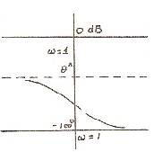
Which one of the following transfer functions represents the Bode plot shown in the above figure :
- 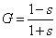
- 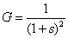
- 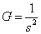
- 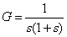

21. The following programme is run on an 8085 microprocessor,
Memory address in Hex Instruction
2000 LXI SP, 1000
2003 PUSH H
2004 PUSH D
2005 CALL 2050
2008 POP 2050
2009 HIT
As the completion of execution of the program, the program the program counter of the 8085 contains ………, and the stack pointer contains ……..
- 2050, OFFC
- 2251, OFFC
- 1025, OCCF
- 1025, OCCF
22. With reference to figure, value of VCE is
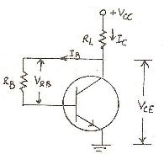
- 0 V
- 5 V
- -5V
- none of the above
23. The smallest change in sound intensity that can be detected
A. 1 dB
B. 3 dB
C. 10 dB
D. 20 dB.
24. In a generic microprocessor, instruction cycle time is
A. shorter than machine cycle time
B. larger than machine cycle time
C. exactly double the machine cycle time
D. exactly the same as the machine cycle time
25. The value of M in the end will be
Do 100 I = 1, 2
DO 200 J = 1, 2
M = M + I + J
200 CONTINUE
100 CONTINUE
STOP
END
- 10
- 11
- 12
- 14
26. Resistivity of electrical conductors is most affected by
A. temperature
B. pressure
C. composition
D. all of the above.
27. In CCIR B-system of TV, blanking pulse is placed during
A. equalizing pulse
B. retrace interval between each line
C. retrace period of vertical line
D. none of the above.
28. The polarization required in ground wave propagation is
A. Horizontal (linear)
B. vertical (linear)
C. Circular
D. Elliptical
29. Multicavity Klystron
A. is not a microwave device
B. is not a good low level amplifier because of noise
C. is not suitable to pulse operation
D. has a high repeller voltage to insure small transit time
30. Transponder comprises of
A. Transmitter
B. Receiver
C. Antenna
D. a, b, c combined

31. Consider the following statements regarding the circuit shown in the given figure :
1. If the switch K is closed at a proper instant there will be no transient
2. The instant at which K is closed such that the transient is zero depends on the frequency of the supply
3. The instant at which K is closed such that the transient is zero depends on the circuit elements
4. There will always be a non-zero transient after the switch K is colosed.
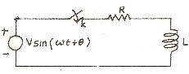
Of these statements :
- 1 alone is correct.
- 1 and 2 are correct.
- 1 and 3 are correct
- 4 alone is correct.

32. A circular ring carrying a uniformly distributed charge Q and a point charges -Q on the axis of the ring are shown in the fig. The magnitude of the dipole moment of the charge system is
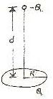
- Qd
- Q R2 / d
- Q
- QR.
33. Which of the following regulator provides output voltage polarity reversal without a transformer
A. Buck regulator
B. Boost regulator
C. Buck-boost regulator
D. Cuk regulator
34. The deflection of hot wire instrument depends on
A. RMS value of alternating current
B. voltage
C. average value of a.c. current
D. instantaneous value of a.c. current.
35. Match List-I with List-II and select the correct answer using the codes given below the Lists :
List-I List-II
(Response to a unit step input) (Location of poles in the s-plane)
- 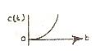 1.One at the origin
B. 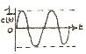 2.Two identical roots on the negative real axis.
C. 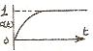 3.Two on the imaginary axis
D. 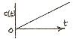 4.One on the position real axis.
Codes:
A B C D
A. 4 3 2 1
B. 3 4 1 2
C. 3 4 2 1
D. 4 3 2 1
36. Dual slope integration type Analog-to-Digital converters provide
A. higher speeds compared to all other types of A / D converters
B. very good accuracy without putting extreme requirements on component stability
C. poor rejection of power supply hums
D. better resolution compared to all other types of A / D converters for the same number
of bits.
37. In the figure given below, the collector current is
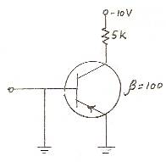
- 2 mA
- 200 mA
- Almost zero
- 0.02 mA
38. The frequency modulated (FM) radio frequency range is nearly
A. 250 - 300 MHz
B. 150 - 200 MHz
C. 90 - 105 MHz
D. 30 - 70 MHz
39. A 32 bit microprocessor has the word length equal to
A. 2 bytes
B. 1 byte
C. 4 bytes
D. 8 bytes
40. In electronic microcircuits, a resistor may be fabricated from constant-thickness layer of semiconductor material with conductor connections at the edges as shown below. If the resistor shown has resistance R, then a similar resistor 0.2 millimeter has a resistance of
- 4 R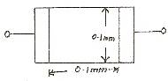
- 2 R
- R
- R / 2
41. Line imperfection in a crystal is called
A. Schottky defect
B. Frenkel defect
C. edge dislocation
D. Miller defect.
42. The function of diplexer bridge in a TV transmitter is
A. to prevent the loading of several transmitters by video transmitter
B. to increase the bandwidth
C. to increase the power output
D. to increase the efficiency of transmission.
43. Sometimes microwave signals follow the earth’s curvature. This due to
A. Ionospheric reflection
B. Faraday rotation
C. Ducting
D. Ionospheric scatter.
44. The modes in a reflex Klystron
A. give the same frequency but different transit time
B. result from excessive transit time across the resonator gap
C. are caused by spurious frequency modulation
D. are just for theoretical considerations.
45. The capacity of a channel is
A. number of digits used in coding
B. volume of information it can take
C. maximum rate of information transmission
D. bandwidth required for information

Solution
1.A. When two inductors are connected in series, the effective inductance is
Leff = L1 + L2± 2 m.
In this case, Leff = L1 + L2 - 2 M
= 2 + 4 - 2 × 0.15
= 5.7 mH.
2.C. The plane midway between a and -a, i.e., the one passing through ABC and perpendicular to the plane of the paper is an equipotential plane. Hence the potential at B is the same as that of A or C, i.e., 1V.
3.D. In optocouplers the input signal is applied to the ILED and the output is takes from the phototransistor. These are used to isolate the gate signals from the power circuit.
4.C. The difference between the indicated value and the true value of a quantity is known as dynamic error.
5.C. The Principles of homogeneity and superposition are applied to linear time invariant systems.
6.D. In an 8085 microprocessor system with memory mapped I / 0 arithmetic and logic operations can be directly performed with I / 0 data.
7.B. Neglecting VBE, IB = 10 / 100 = 0.1 A.
IC = 100 × 0.1 = 10 A. Drop over RL = 10 v.
Hence, VCE = 0 which is the condition for saturation.
8.B. 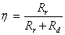
whereRr is radiation resistance and Rd is the total loss resistance of the antenna.
9.B. Arithmetic
10.C. 101.001 = (4 + 0 + 1)
(0 + 0.25 + 0.125)
= 5.375
11.B. Dislocations in materials are line defects.
12.A. Integrator.
13.D. Frequency in the UHF Range propagate by means of space waves.
14.A. VHF.
15.C. a communication satellite is a repeater between many transmitting stations and many receiving stations.
16.C. V / Ö2 R
17.C. The point charge Q emanates a total electric displacement flux of Q. If a plane is passed through the point of location of charge and tangential to the sphere, half the flux is on one side and half on the other. The first half of flux is passing through the spherical surface. Thus the average displacement density has a direction opposite to that of n and the magnitude is
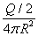
\ Average electric
field is :
Eav =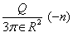
18.D. The efficiency of a practical chopper varies from 92 to 99 percent.
19.B. Electrostatic voltmeter should be used to measure 600 kV a.c. voltage.
20.A. it can easily be checked that the corresponding function is
G (s) = (1 - s) / (1 + s)
It is seen immediately that | G (jw) |
= 1 and hence gain is db = 0.
21.A. Memory address in hex Instruction Remarks
2000 LXI SP 1000
2003 PUSH H
2004 PUSH D We do not
2005 CALL 2025 know the
contents of
subroutine
at 2050.
2006 50
2007 20
2008 POP H
2009 HALT
At the completion of the execution of the program, the program counter of the 8085 contains 2050 and the stack pointer contains OFFC.
22.B. Neglecting, VBE
= 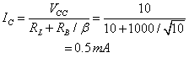
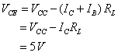
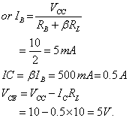
23.B. Increase = 10 log10 P2 / P1 = 10 log102
= 10 × 0.3 = 3dB.
24.D. Instruction cycle time is exactly the same as the machine cycle time.
25.C. Taking index of I = 1 and M = 0 computing the value of M with
J = 1, 2
J = 1
M = 0 + 1 + 1 = 2
J = 2
M = 2 + 1 + 2 = 4
Taking index of I = 2 and computing the value of M with J = 1, 2
J = 1
M = 5 + 2 + 1 = 8
J = 2
M = 1 + 2 + 2 = 12
26.A. Resistivity of electrical conductors is most affected by temperature.
27.B. In CCIR B-system of TV, blanking pulse is placed during retrace interval between each line
28.B. The polarization required in ground wave propagation is vertical (linear).
29.A. Multicavity Klystron is not a good low level amplifier because of noise.
30.D. Transponder comprises of transmitter, receiver and antenna.
31.C. If the switch is closed at instant t = to, the complete expression for current will be
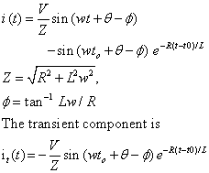
The transient is zero if wt0 + q - f = 0
or t0 = (f - q) / w
Thus it is possible to find to such that there is no transient. Further to depends upon the circuit parameters and the frequency.
So, the statements 1 and 3 are true.
32.A. For points far away, the charge on the ring may be considered to be located be at the centre of the ring. Hence, the dipole moment becomes Qd.
33.C. a puck-boost regulator provides on output voltage which may be less than or greater than the input voltage. The output voltage polarity is opposite to that of the input voltage. It has high efficiency.
34.A. The deflection of hot wire instrument depends on RMS value of alternating current.
35.A. Considering that there are poles of H (s), then
H1 (s) = 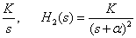
H3 (s) = 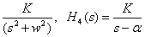
The impulse responses [a-1 H (s)] can be found and the step response are integrations of the corresponding impulse responses.
36.B. Dual slope integration type A to D converters are of slow speed and require more number of bits, than successive approximation ADC.
37.C. Since emitter and base have same polarity and same potential, EBJ is not biased property. Hence, IB is zero and so is IC.
38.C. The frequency modulated (FM) radio frequency range is nearly 90 - 105 MHz.
39.C. 4 bytes.
40.C. Resistance will be directly proportional to length and inversely proportional to the cross-sectional area. Let t mm be the thickness of semi-conductor material so that the cross-sectional area for R ohm resistor is 0.1 × t sq. mm and length of semi - conductor material 0.1 mm.
For a 0.2 mm × 0.2 mm section, cross - sectional area = 0.2 × t sq. mm. Length = 0.2 mm
Hence, resistance,
= R = 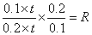
41.C. Line imperfection in a crystal is called edge dislocation.
42.A. The function of diplexer bridge in a TV transmitter is to prevent the loading of several transmitters by video transmitter.
43.C. Sometimes microwave signals follow the earth’s curvature. This is due to ducting.
44.A. The modes in a reflex Klystron give the same frequency but different transit time.
45.C. The capacity of a channel is maximum rate of information transmission
Mechanical-Engineering MT 2009
A definite area or space where some thermodynamic process takes place is known as
A thermodynamic system B thermodynamic cycle
C thermodynamic process D thermodynamic law
2. Which of the following is an intensive property of a thermodynamic system?
A volume B Temperature
C mass D energy
3. Temperature at which the volume of the gas becomes 0 is called
A absolute scale of temperature B absolute 0 temperature
C absolute temperature D none of these
4. The unit of energy in SI units is
A joule B joule metre
C watt D joule/metre
5. 1 joule is equal to
A 1 Nm B kNm
C 10 Nm/s D 10 kNm/s
6. In an irreversible process there is a
A loss of heat B no loss of heat
C gain of heat D no gain of heat
7. The following is an SI engine
A diesel engine B petrol engine
C gas engine D none of the above
8. In a 4 stroke cycle petrol engine during suction stroke
A only air is sucked in B only petrol is sucked in
C mixture of petrol and air is sucked in
D none of the above
9. The thermal efficiency of petrol engine as compared to diesel engine is
A lower B higher
C same for same power output D same for same speed
10. Compression ratio of diesel engines may have a range
A 8 to 10 B 10 to 15
C 16 to 20 D none of the above
11 The thermal efficiency of good I.C engine at the rated load is in the range of
A 80 to 90% B 60 to 70%
C 30 to 35% D 10 to 20%
12 Carburettor is used for
A SI engines B gas engines
C CI engines D none of the above
13 In SI engine to develop high voltage for spark plug
A battery is installed B distributor is installed
C carburetor is installed D ignition coil is installed
14 In a four cylinder petrol engine the standard firing order is
A 1-2-3-4 B 1-4-3-2
C 1-3-2-4 D 1-3-4-2
15 The knocking is SI engines increases with
A increase in inlet air temperature B increase in compression ratio
C increase in cooling water temperature D all of the above
16 Petrol commercially available in India for Indian passenger cars has octane
number in the range
A 40 to 50 B 60 to 70
C 80 to 85 D 95 to 100
17 The knocking tendency in C.I engines increases with
A decrease of compression ratio B increase of compression ratio
C increasing the temperature of inlet air D increasing cooling water
temperature
18 The air standard otto cycle comprises
A two constant pressure processes and two constant volume processes
B two constant pressure and two constant entropy processes
C two constant volume processes and two constant entropy processes
D none of the above
19 The thermal efficiency of theoretical otto cycle
A increases with increase in compression ratio
B increases with increase in isentropic index gamma
- C does not depend upon the pressure ratio
D follows of the above
20 Thermal efficiency of a gas turbine plant has compared to diesel engine plant is
A higher B lower
C same D may be higher or lower
21 Mechanical efficiency of a gas turbine as compared to internal combustion
Reciprocating engine is
A higher B lower
C same D unpredictable
22 For a gas turbine the pressure ratio may be in the range
A 2 to 3 B 3 to 5
C 16 to 18 D 18 to 22
23 Thermal efficiency of a closed cycle gas turbine plant increases by
A reheating B intercooling
C regenerator D all of the above
24With the increase in pressure ratio thermal efficiency of a simple gas turbine
Plant with fixed turbine inlet temperature
A decreases B increases
C first increases and then decreases D first decreases and then increases
25In two stage turbine plant, reheating after first stage
A increases work ratio B decreases work ratio
C does not affect work ratio D none of the above
26For a jet propulsion unit , ideally the compressor work and turbine work are
A equal B unequal
C not related to each other D unpredictable
27 Various kinematic pairs are given below.choose the lower pair
A ball bearings B tooth gears in mesh
C camm and follower D crank shaft and bearing

28The relation between the number of pairs forming a kinematic chain and the
Number of links is
A l=2p-2 B l=2p-3
C l=2P-4 D l=2p-5
29In a reciprocating engine
A crankshaft and flywheel form 2 kinematic links
B crankshaft and flywheel form 1 kinematics links
C crankshaft and flywheel do not form kinematic links
D flywheel and crankshaft separately form kinematic links
30A kinematic chain is known as a mechanism when
A none of the link is fixed
B one of the links is fixed
C two of the links are fixed
D all of the links are fixed
31 Which of the following is an inversion of single slider crank chain?
A beam engine
B watt’s indicator mechanism
C elliptical trammels
D whitworth quick return motion mechanism
32 control volumes refer to
A a fixed region in space
B a specified mass
C an isolated system
D a closed system
33An isentropic process is always
A irreversible and adiabatic
B reversible and isothermal
C friction less and irreversible
D reversible and adiabatic
34Work done in a free expansion process is
A 0
B minimum
C maximum
D positive

35.The figure shows a pin-jointed plane truss loaded at the point M by hanging a mass of 100 kg. The
member LN of the truss is subjected to a load of?
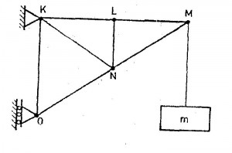
(a) 0 Newton
(b)490 Newtons in compression
(c)981 Newtons in compression
(d) 981 Newtons in tension
36.In terms of.Poisson’s ratio (v) the ratio of Young’s Modulus (E) to Shear Modulus (G) of elastic materials is ?
(a)2(1 + v)
(b) 2(1 — v)
(c)(1 + v)/2
(d)(1 — v)/2
37. Two mating spur gears have 40 and 120 teeth respectively. The pinion rotates at
1200 rpm and transmits a torque of 2O N. m. The torque transmitted by the gear is
(a) 6.6 Nm
(b) 20 Nm
(c) 40 Nm
(d) 60 Nm
38. The figure shows the state of stress at a certain point in a stressed body. The magnitudes of normal stresses in the x and y direction are 100 MPa and 20 MPa respectively. The radius of Mohr’s stress circle representing this state of stress is
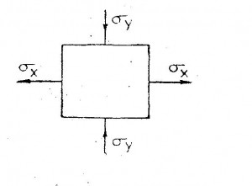
(a)120
(b)80
(c)60
(d)40
39.For a mechanism shown below, the mechanical advantage for the given configuration is?
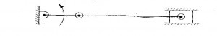
(a)0
(b) 0.5
(c)1.0
(d)Infinity
40.A vibrating machine is isolated from the floor using springs. If the ratio of excitation frequency of vibration of machine to the natural frequency of the isolation system is equal to 0.5, the transmissibility of ratio of isolation is
(a)1/2
(b)3/4
(c)4/3
(d)2
41. A torque of 10 Nm is transmitted through a stepped shaft as shown in figure.
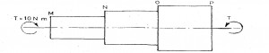
The torsional stiffnesses of individual sections of lengths MN, NO and OP are 20 Nm/rad 30 Nm/rad and 60 Nm respectively. The angular deflection between the ends M and P of the shaft is?
(a) 0.5 rad
(b) 1.0 rad
(c) 5.0 rad
(d) 10.0 rad
42.
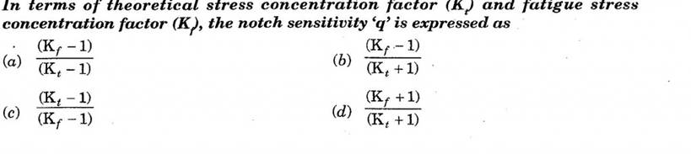
43. The S-N curve for steel becomes asymptotic nearly at
(a)10 3 cycles
(b) 10 4 cycles
(c)10 6 cycles
(d) 10 9 cycles
44. In the window air conditioner, the expansion device used is
(a)capillary tube
(b) thermostatic expansion valve
(c)automatic expansion valve
(d) float valve
45. During chemical de-humidification process of air
(a) dry bulb temperature and specific humidity decrease
(b) dry bulb temperature increases and specific humidity decreases
(c) dry bulb temperature decreases and specific humidity increases
(d) dry bulb temperature and specific humidity increase
46.An incompressible fluid (kinematic viscosity, 7.4 x 10-7 m2 /s, specific gravity, 0.88) is held between two parallel plates. If the top.plate is moved with a velocity of 0.5 rn/s while the bottom one is held stationary, the fluid attains a linear velocity profile in the gap of 0.5 mm between these plates; the shear stress in Pascals on the surface of top plate is ?
(a)0.651 x 10 -3
(b) 0.651
(c)6.51
(d) 0.651 x 103
47.Environment friendly refrigerant R134a is used in the new generation domestic refrigerators. Its chemical formula is ?
(a)CH ClF2
(b) C2 Cl 3F3
(c)C2 Cl 2F4
(d) C2 H2F4
48.
(a)x—2y=0
(b) 2x+y=0
(c)2x—y=0
(d) x+2y=0
49. A gas contained in a cylinder is compressed, the work required for compression being 5000 kJ. During the process, heat interaction of 2000 kJ causes the surroundings to the heated. The change in internal energy of the gas during the process is
(a)—7000kJ
(b) —3000kJ
(c)+ 3000 kJ
(d) + 7000 kJ
50.The compression ratio of a gas power plant cycle corresponding to maximum work output for the given temperature limits of Tmin and Tmax will be
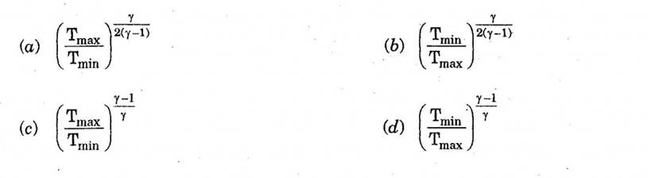
51.
(a)10 microns
(b) 20 microns
(c)30 microns
(d) 60 microns
51.
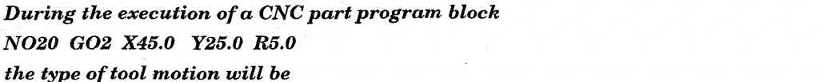
(a) circular Interpolation — clockwise
(b) circular Interpolation — counterclockwise
(c) linear Interpolation
(d) rapid feed
52. The mechanism of material removal in EDM process is
(a) Melting and Evaporation
(b) Melting and Corrosion
(c) Erosion and Cavitation
(d) Cavitation and Evaporation
53. Two 1 mm thick steel sheets are to be spot welded at a current of 5000 A. Assuming, effective resistance to be 200 micro-ohms and current flow time of 0.2 second, heat generated during the process will be
(a)0.2 Joule
(b) 1 Joule
(c)5 Joule
(d) 1000 Joules
54. In PERT analysis a critical activity has
(a)maximum Float
(b) zero Float
(c)maximum Cost
(d) minimum Cost
55. For a product, the forecast and the actual sales for December 2002 were 25 and 20 respectively. If the exponential smoothing constant (a) is taken as 0.2, the forecast sales for January 2003 would be ?
(a)21
(b)23
(c)24
(d) 27
56. Misrun is a casting defect which occurs due to
(a) very high pouring temperature of the metal
(b) insufficient fluidity of the molten metal
(c) absorption of gases by the liquid metal
(d) improper alignment of the mould flasks
57. The percentage of carbon in gray cast iron is in the range of
(a)0.25 to 0.75 percent
(b) 1.25 to 1.75 percent
(c)3 to 4 percent
(d) 8 to 10 percent
58.In the figure shown,
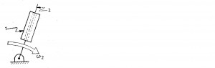
the relative velocity of link1 with respect to link 2 is 12 m/sec. Link 2 rotates at a constant speed of 120 rpm. The magnitude of Coriolis component of aceeleration of link 1 is
(a)302 m/s2
(b)604 m/s2
(c)906 m/s2
(d) 1208 m/s2
59. The figure below shows a planar mechanism with single degree of freedom.
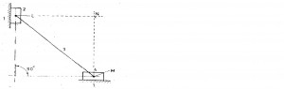
The instant center 24 for the given configuration is located at a position ?
(a) L
(b) M
(c) N
(d)Infinity
60.A uniform stiff rod of length 200 mm and having a weight of 300 N is pivoted at one end and connected to a spring at the other end.
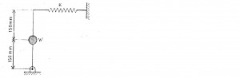
For keeping the rod vertical in a stable position the minimum value of spring constant K needed is ?
(a) 300 N/m
(b) 400 N/m
(c) 500 N/m
(d) 1000 N/m
61. In a bolted joint two members are connected with an axial tightening force of 2200 N.
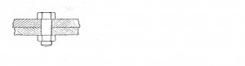
If the bolt used has metric threads of 4 mm pitch, the torque required for achieving the tightening force is?
(a)0.7Nm
(b)1.0 Nm
(c)1.4 Nm
(d) 2.8 Nm

