Sample Paper – 2011
Class – XII
Subject –Physics

Time: 3 Hours Max. Marks: 70

General Instructions:
(i) All questions are compulsory.
(ii) Question numbers 1 to8 are very short answer type questions, carrying one mark each,
(iii) Question numbers 9-18 are short answer type question, carry two marks each.
(iv) Question numbers 19to27 are also short answer type question, carrying 3 mark each.
(v) Question number 28to30 are long answer type question carrying five marks each.
(vi) Use log tables for necessary calculations.
------------------------------------------------------------------------------------
1. Which are of the following will describe the smallest circle when projected with the same velocity v perpendicular to the magnetic field B (i) α particle and (ii) β particle?
2. In a series LCR circuit the voltage across inductor, a capacitor and a resistor are 30 V, 30 V and 60 V respectively. What is the phase difference between applied voltage and current in the circuit?
3. Write the truth table for the following combination of gates :
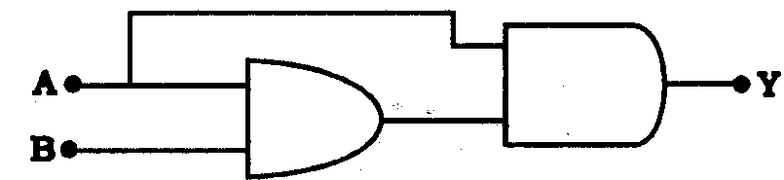
4. The charging current for a capacitor is 0.25 A, What is the displacement current across its plate?
5. What changes in the focal length of a (1) concave mirror and (ii) convex lens occur, when the incident violet light on them is replaced by red light
6. Compare the radii of two nuclei with mass number 1 and 27 respectively.
7. A lamp is connected in series with an inductor to a d.c. source. What will happen to its glow, when it is connected directly to the same source?
8. How does the energy gap in a semiconductor vary, when doped with a pentavalent impurity?

9. An electric dipole is held in a uniform electric field.
(i) Show that no force acts on its
(ii) Derive an expression for the torque acting on it.
10. 4 identical cells, each of emf 2 v are joined in parallel providing supply of current to external circuit consisting of two 15 Ω resistance joined in parallel. The terminal voltage of the cells, as read by an ideal voltmeter is 1.6 volt. Calculate the internal resistance of each cell.
11. For the same angle of incidence the angles of refraction in three media A , B , C are 15⁰ , 25⁰, and 35⁰ respectively. In which medium the velocity light is minimum.
12. A compass needle, pivoted about the horizontal axis, and free to move in the magnetic meridian, is observed to point along the :
(i) vertical direction at place A
(ii) horizontal direction at a place B.
Give the value of the angle of dip at these two places
13. Identify the part of the electromagnetic spectrum to which is
(i)Suitable for radar system used in aircraft navigation.
(ii)Adjacent to low frequency end of the electromagnetic spectrum.
(iii) Produced in nuclear reactions.
14. A uniform wire of resistance 1Ω cm-1 is bent in the shape of letter A, the sides of letter are 30cm each and the cross piece in the middle is 15 cm long while the apex angle is 60⁰. find the resistance of letter between the two ends of legs.
15. Draw a graph showing the variation of stopping potential with frequency of incident radiations in relation to photoelectric effect. Deduce an expression for the slope of this graph using Einstein’s photoelectric equation.
16. The following table gives the value of work function for a new photosensitive metal.
S.No | Metal | Work Function (eV)
1 | Na | 1.92
2 | K | 2.15
3 | Mo | 4.17
In each of these metals is exposed to radiations of wavelength 300 nm which of them will not emit photoelectrons and why?
17. The ground state energy of hydrogen atom is -13.6 ev. What is the kinetic and potential energies of the electron in this state?

OR
A radioactive isotope has a half life of T years. How long will it take the activity to reduce (i) 3.125% (ii) 1% of its original value?.
18. Draw the block diagram of a communication system. what are analog and digital signals?
19. Two point charges A and B of value +5 x 10⁻⁹ C and +3 x 10⁻⁹C are kept 6cm apart in air. Calculate the work done, when charge B is moved by 1cm towards charge A.
20. In the following network of capacitors, find the equivalent capacitance and total charge and potential difference across each capacitor.
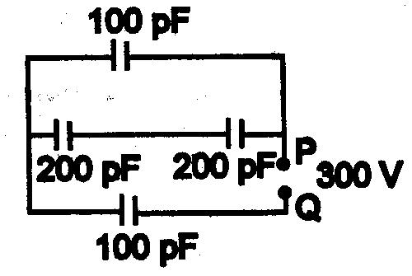
21. Using Kirchhoff’s laws, calculate the value of the electric currents, I₁, I₂ and I₃ in the given electrical network.
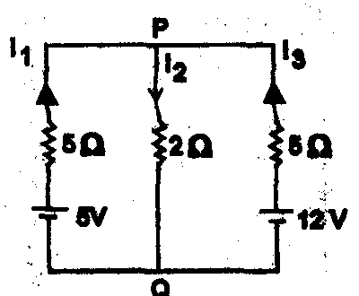

OR
AB is 1 meter long uniform wire of 10 ohm resistance. The other data are as shown in the circuit diagram given below :
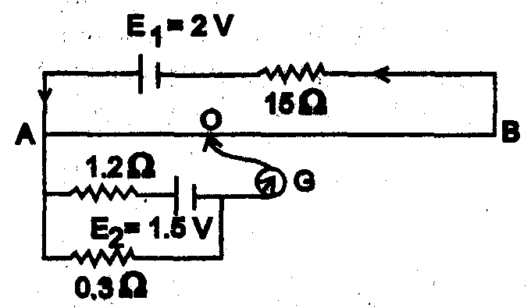
Calculate (i) potential gradient along AB, and (ii) length AO of the wire, when the galvanometer shows no deflection.
22. Derive Snell’s law of refraction by drawing the refracted wave front corresponding to a plane wave front incident on the boundary separating a rarer medium from a denser medium.
23. Define resolving power of a compound microscope. How does the resolving power of a compound microscope change when
(i) refractive index of medium between the object and objective lens increases. (ii) wavelength of radiation is increased.
24. A sinusoidal voltage V=200sin 314t is applied to a resistor of 10 ohm resistance. Calculate
a. Rms value of voltage
b. Rms value of current
c. Power dissipated as heat in watt
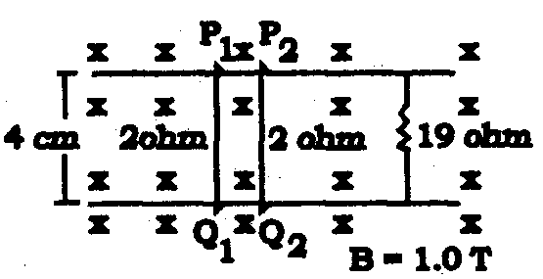
25. Consider the situation shown in fig. The wires P₁Q₁ and P₂Q₂ are made to slide on the rails with the same speed 5 cm/ s. Find the electric current in the 19 ohm resistor if (a) both the wires move towards right and (b) if P₁Q₁ moves towards left but P₂Q₂ moves towards right.

26. The energy levels of an atom of element are shown in the following diagram. Which one of the level transitions will result in the emission of photons of wavelength 620 nm ?
Support your answer with mathematical calculations.
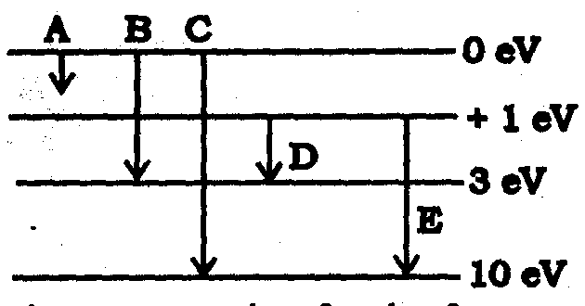
27. Explain the need of modulation. Derive an expression for covering range of TV transmission towers.
28. Define the terms ‘potential barrier’ and ‘depletion region’ for a p – n junction. Explain, with the help of a circuit diagram, the use of a p – n diode as a full wave rectifier. Draw the input and output wave forms.

OR
Draw a labelled circuit diagram of a common emitter amplifier using a p-n-p transistor. Define the term voltage gain and write an expression for it. Explain how the input and output voltages are out of phase by 1800 for a common-emitter transistor amplifiers.
29. State and prove Amperes circuital law. Use Amperes circuital law. To obtain an expression for the magnetic field within a long solenoid
OR
State Biot savart law .use it to derive an expression for the magnetic field due to a current carrying circular loop of N turns and radius R, at a point distance x from its centre on the axis of the loop

30. Derive the expression for the fringe width in Young’s double slit interference experiment.
If one face of a prism of prism angle 30º and μ = is silvered, the incident ray retraces its initial path. What is the angle of incidence ?

OR
Derive an expression for the width of the central maxima for diffraction of light at a single slit. How does this width change with increase in width of the slit.
Two polaroids are placed 90º to each other and the transmitted intensity is zero. What happens to the intensity of transmitted light when one more Polaroid is placed between these two bisecting the angle between them ?

Paper Sumitted By:
Name : arun joshi
Email : arunjoshi_67568@rediffmail.com
Phone No. 09414827275

