Sample Question Paper – 2011
Class – X
Subject –Science (PHYSICS / CHEMISTRY)

MM : 80

Sec-A

Q.1 Give one example of redox reaction which is also displacement reaction. 1x3=3
Q.2 Electrical Resistivity of few material is givenin ohm-meter. Which of these can be used for heating element (give reason) x = 6.92 x 10⁻⁸, y = 2.9 x 10⁵, z = 3.9 x 10⁶, p = 2x10⁻⁴, q =4x10⁻⁵
Q.3 Name and state the rule which gives the direction of induced current.
Sec-B
Q.4 A proton enters a magnetic field at right angles to it as shown in 2x7=14
fig. what is the direction of force acting on the proton.

Q.5 What is a major constituent of Biogas (Gobar Gas)? How is Biogas superior to dry animal dung as a fuel.
Q.6 A radio set of 60w runs for 50 hrs. how much energy is consumed (Joules & KWH).
Q.7 A baker found that cake prepared is hard and small in size. Which ingredient has he for gotten to add? Write the name and formula of ingredient and explain how it would be help to make cake spongy and soft.
Q.8 Write the Lewis dot structure of (a) H₂S (b) Calcium Chloride
Q.9 An aqueous solution has hydrogen ion concentration (H+) = 1x10-9 mol L-1
(a)Is solution acidic or basic (b)what is the pH of solution (c)How would its pH changes on adding few drops of 1M HCl to it explain
Q10 Why metals replace hydrogen from dilute acids where non metal do not ? Explain
Q11 You are given following current time graphs from two different sources
(a ) Name the type of current in two cases(b)what is the frequency of current in case II in India © Which one is prefer over another why

Q12 Draw a schematic diagram of circuit consisting battery of 12V , three resistors of 5 ohm,10 ohm, and 20ohm connected in parallel.Show an ammeter and voltmeter to measure current and pot. Diff. also calculate the current in circuit
Q13 Draw a sketch of pattern of field lines due to a solenoid carrying current . Why does a current carrying solenoid when suspended freely rests along particular direction
Q14 Why is it necessary to balance a chemical reaction . Write the type of reaction & balanced chemical reaction when Lead Nitrate heated
Q15 A compound X on electrolysed in aqueous solution produces strong base Y along with two gases P and Q. Q is used in manufacturing of bleaching powder . Identify X,Y P and Q Write the name of the process and balanced chemical reaction
Q16 Two students perform the experiment on series and parallel combination of two given resistance R1 and R2 shown in graph Which of this grph is correctly labeled in terms of the words “series” and “parallel” Justify your ans. (b) An electrical geyser has the rating 200W-220V marked on it. What should be the minimum rating in whole number of fuse wire that may be required of for safe use with their geyser
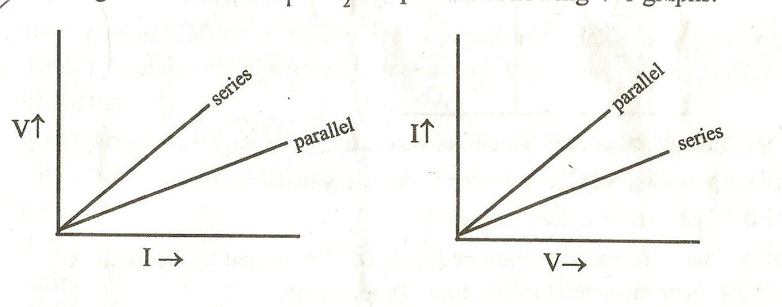

Q17 (a) Two compounds of our daily use , table salt and sugar, on heating strongly in
separate pans shows the melting of sugar only. Why ? Give reasons.
(b) Write the proper method to dilute the conc. Sulphuric acid and reason behind that
method
Sec-C
5X2 = 10

Q18 Explain (a ) What are environmental consequences of increasing demand for energy?What steps would you suggest to reduce energy consumption?
(b) Why series arrangement is not prefer for domestic circuit (c) How resistance and Resistivity changes if length of wire is drawn to double by pulling (d)State the rule to determine the direction of magnetic field around a straight conductor carrying current
Q19 Explain (a) A person observed a black coating on silver medal ,green coating on copper coins. Which phenonmenon is responsible for these coating Write the name of black and greem coating(b) Which one is blue in colour CuSO₄ 5H₂O or CuSO₄
© Which gas is collected in double amount when electrolysis of water why? (d) Write basic difference between calcinations and roasting Which one is used to get Zinc from calamine (write the reaction)(e) Why dry ammonia has no action on litmus paper but solution of ammonia solution in water turns red litmus paper blue
1x9 = 9
MCQ

Q.20 Four students were provided the test tube holders, test tubes and some chemical. The teacher asked them to take some quantity of chemical in the test tube in heat in correct way. The correct way of heating is shown in set up is:
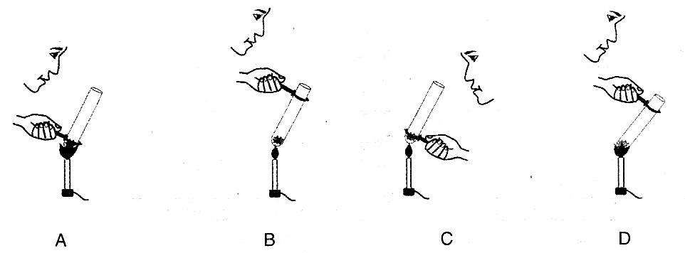

Q.21 A student was given few drops of an unknown solution and a strip of pH paper. He/she places a drop of the given solution on the strip, the colour of the strip changes to red. the solution is
(1) Alkaline (2) Neutral
(3) Acidic (4) Nothing confirmed
Q.22 The current I and voltage V graph for two given metallic wires having resistance R₁ and R₂ are shown in.

(1) R₁>R₂ (2) R₁<R₂
(3) R₁= R₂ (4) R₁<R₂

Q.23 A student is given three solutions marked A, B and C to arrange them in correct order of increasing strength. He puts two drops of each of the solutions on the strip. The colour of the pH strip changes as follows.

Increasing order of acidic character is.
(1) C<A<B (2) B<C<A
(3) A<B<C (4) None
Q.24 In the following diagram ammeter is shown. The least count of the ammeter is
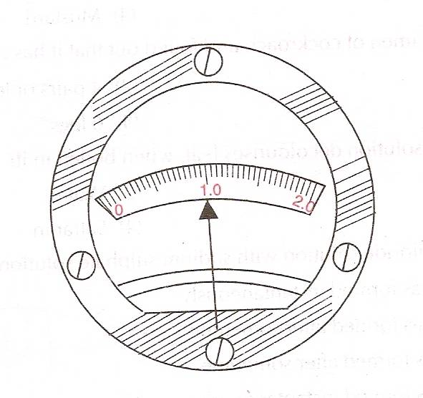
(1) 0.05 A (2) 0.1 A
(3) 0.5 A (4)0.005 A
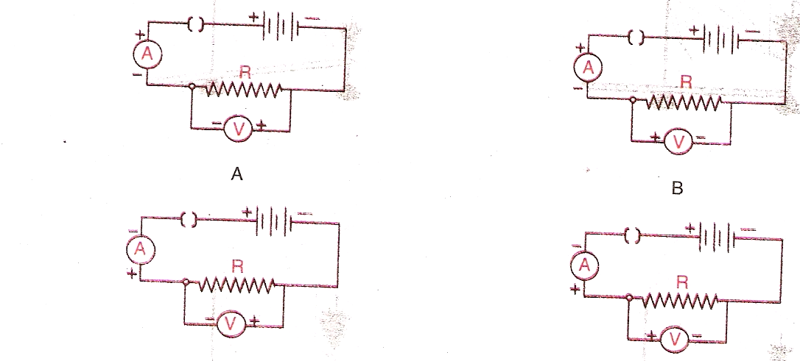
Q.25 Out of the four circuits shown for studying the dependence of the current on the potential difference across a resistor, the correct circuit is

(1) A (2) B
(3) C (4) D

Q.26 A moist red litmus paper was introduced into a jar of sulphur dioxide gas. The red litmus paper
(1) Turns blue (2) Remains unchanged
(3) Turns yellow (4) Turns colourless
Q.27 To study the dependence of current (I) on potential difference (V) across a resistor R, two set ups shown in fig. Ammeter and Voltmeter readings will maximum when the contact J is in the position.
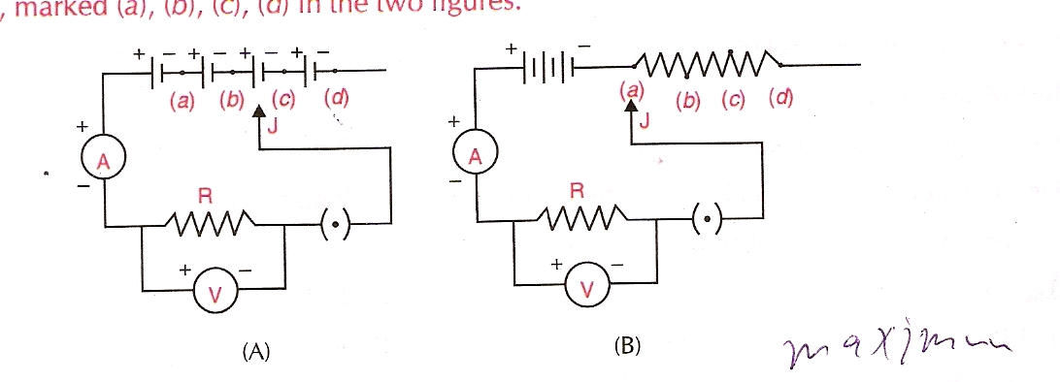

(1) (d) in both the set ups. (2) (a) in both the set ups
(3) (a) in set up (A) and (d) in set up (B) (4) (d) in set up (A) and (a) in set up (B).
Q.28 The colour of the pH paper strip turned red when it was dipped into a sample. The sample could be
(1) tap water (2) dilute sodium bicarbonate solution
(3) dilute hydrochloric acid (4) dilute sodium hydroxide solution

X – BIOLOGY
MCQ

Q.1 Following is stored in the form of carbohydrates in human body. 6x1=6
a. Starch b. Glucose c. Glycogen d. Fructose
Q.2 PCT, loop of Henle, DCT are a part of
a. Neuron b. RBC c. Nucleus c. Nephron
Q.3 Respiratory substrate in humans is
a. Starch b. Glycogen c. Glucose d. Lactic Acid
Q.4 The blood leaving the tissues become richer in
a. CO2 b. Water c. Haemoglolun d. Oxygen
Q.5 Which is the first enzyme to mix with food in the digestive tract?
a. Pepsen b. Amylase c. Cellulase d. Trypsin
Q.6 Involuntary actions of our body are controlled by
a. Medulla in fore brain b. Medulla in mid brain
c. Medulla in hind brain d. Cerebellum

Answer in short 2x3=6

A. Name the endocrine gland associated with brain.
B. Nervous and hormonal systems together perform the function of control & co-ordination in human beings? Justify it.
C. What will happen if mucous is not secreted by gastric glands.

Answer the following 3x2=6

Q.1 a. Draw the T.S. of human heart.
b. Why do veins have thin walls as compared to arteries.
c. Dist the contents of the blood.
Q.2 a. Draw the diagram of alimentary canal of man & label
Mouth, Esophagus, Stomach, Intestines
- Describe the process of urine formation in kidneys
- Write the role of glands in digestive system.

Answer the following in detail 5x1=5

a. Draw the diagram of brain & label its parts.
b. Clearly list down the functions of each part of the brain.
c. Differentiate between voluntary and involuntary actions.

Pradeep Sahajwani Classes (BASE MAKER)

IX – X CBSE (Maths / Science)
S-20, Vivekanand Colony, Bhopal, Phone : 0755-2751377, 9893213700

