ICICI Bank Probationary Officer Practice Exam Paper
VERBAL COMPREHENSION
Directions: Read the given passage and answer the questions that follow.
Passage: On clear moonless evenings when it is completely dark, you can sometimes see a faint glow from the horizon. It is called the zodiacal light as it runs along the zodiac, the constellation through which the planets appear to travel. This glow is sunlight, reflected off dust particles in the solar system it is brightest near the sun, so it is best visible after sunset or before dawn, when the sun is just far enough below the horizon to leave the sky completely dark.
1. According to this passage the zodiac is a________
a. Collection of sun signs
b. Constellation
c. Star
d. Planet
2. The zodiacal light can be seen only on_____
a. Moonless nights
b. Starry Nights
c. Moonless evenings
d. Alternate days
Directions: Choose the best word from the given options to complete the sentence.
1. Passing gravy through a ________removes lumps.
a. Mixture
b. Sieve
c. Tap
d. Cap
2. The politician’s poor behaviour was overlooked because of his ________.
a. Selfishness
b. Reluctance
c. Resistance
d. Charisma
3. The latest novel in the series opened with a _________ of the previous books.
a. Syntax
b. Signage
c. Symphony
d. Synopsis
4. Salt is a __________ ingredient in the preparation of any type of food.
a. Indicative
b. Cheerful
c. Outstanding
d. Vital
NUMERICAL COMPREHENSION
Directions: Each of the questions below is followed by two statements, labeled (1) and (2), in which certain data are given. In these questions you do not actually have to compute an answer, but rather you have to decide whether the data given in the statements are sufficient for answering the questions. Using the data given in the statements plus your knowledge of mathematics and everyday facts (such as the number of days in a month), you are to blacken the box on the answer sheet under:
A. If statements (1) ALONE is sufficient but Statement (2) alone is not sufficient to answer the question asked.
B. If statement (2) ALONE is sufficient but statement (1) alone is not sufficient to answer the question asked.
C. If BOTH statements (1) and (2) TOGETHER are sufficient to answer the question asked, but NIETHER statement ALONE is sufficient.
D. If EACH statement is sufficient by itself to answer the question asked. E. If statements (1) and (2) TOGETHER are NOT sufficient to answer the question asked and additional data specific to the problem are needed.
1. How much did Seema weigh before she started dieting?
1. She now weighs 63 kilos
2. Seema lost 9 kilos
2. If x and y are numbers, which weighs more: x blue marbles or y red marbles?
1. x = 5 y
2. Red marbles weigh 1 gram each
3. Are there more than 200 pages in the book?
1. John reads at 7 pages an hour
2. There are 500 pictures in the book with at least one picture per page
Directions: read the problem statements give below and choose the answer that best fits as a solution.
1) A & B invested RS 2000 & RS 5000. So if there is a profit of RS 28000 what is A’s share if they share the profits in the ratio 2:5?
a) 4000
b) 5000
c) 8000
d) 7000
2) If apples are bought at 11 for RS 10 & sold at 10 for RS 11, how much will be the gain %?
a) 5%
b) 4%
c) 3%
d) 2%
3) Viral can do a piece of work in 10 days & Raja in 15days. If both of them work together how long will it take to finish the work?
a) 6days
b) 5days
c) 7days
d) 8days
Directions: Refer to the data give in the table below and answer the questions that follow.
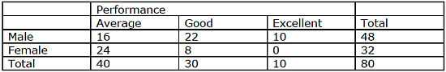
1. What proportion of good students are male?
a. 2%
b. 3%
c. 4%
d. 5%
2. Among average students, what is the ratio of male to female?
a. 2:3
b. 3:2
c. 2:5
d. 3:4
3. Among which group (male/ female) is the number of good students exactly one third of the number of average students?
a. Male
b. Female
c. Neither
d. Both
LOGICAL REASONING
Directions: There are a series of symbols below that represent a certain action. Each question consists of two or more figures in a column. Work down the column, starting with the top figure and applying the action as represented by the symbol against it. You must then choose from the five possible answers the column that results from carrying out the actions as required on the figures.
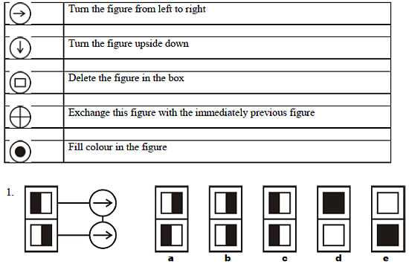
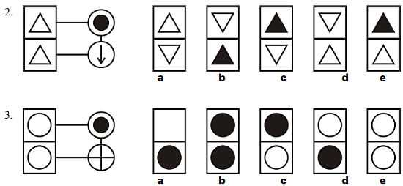
Directions: Choose from the five diagrams marked a, b, c, d and e the one that best illustrates the relationship among three given classes in each of the questions. Each class is depicted as a circle in the figures below.
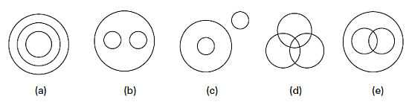
1. Vanilla, Chocolate, Ice cream
2. Lotus, flowers, orange
3. Doctors, Teachers, Painters
4. Dentists, Veterinarians, Doctors
Directions: Consider the information given and answer the questions that follow. Suresh is heavier than Anil, but not as heavy as Raju. Anil is heavier than Jayesh. Krishnan is heavier than Suresh, but lighter than Raju.
Who among them is the heaviest?
a. Anil
b. Krishnan
c. Suresh
d. Raju
e. Jayesh
Who among them is the lightest?
a. Anil
b. Krishnan
c. Suresh
d. Raju
e. Jayesh

Answer Key
Reading comprehension  1. b  2. c  Sentence completion  1. b  2. d  3. d  4. d  Numerical: Sufficiency  1. c  2. e  3. b  Numerical: arithmetic  1. c  2. a  3. a | Numerical: Data Interpretation  1. b  2. a  3. b  Logical: Diagrammatic  1. a  2. c  3. d  Logical: Venn diagrams  1. b  2. c  3. d  4. b  Logical: working with data  1. d  2. e

