Full Question Paper
Maths, X Class

Time: 3 Hrs MM: 80
General Instructions:
1. All questions are compulsory.
2. The questions paper consists of 34 questions divided into four sections A,B,C and D. Section – A comprises of 10 questions of 1 mark each, Section – B comprises of 8 questions of 2 marks each, Section – C comprises of 10 questions of 3 marks each and Section – D comprises of 6 questions of 4 marks each.
3. Question numbers 1 to 10 in Section – A are multiple choice questions where you are to select one correct option out of the given four.
4. There is no overall choice. However, internal choice has been provided in 1 question of two marks, 3 questions of three marks each and 2 questions of four mark each. You have to attempt only one of the alternative in all such questions.

SECTION –A
- Which constant should be added and subtracted to solve the quadratic equation 4x² - 3 x-5 = 0 by the method of completing the square? (a) 3/64 (b) 3/16 (c) ¾ (d) √3/8

- If angles of a triangle are in A.P, then one of the angle is : (a) 40⁰ (b) 50⁰ (c) 60⁰ (d) 90⁰.

- If a pair of tangents to a circle are inclined to each other at an angle of 35⁰, then angle between two radii, drawn at the point of contacts of two tangents is : (a) 105⁰ (b) 70⁰ (c) 140⁰ (d) 145⁰ .

- If O is the centre of a circle, PQ is chord and tangent PR at P makes an angle of 50⁰ with PQ, then ∠POQ is equal to (a) 100⁰ (b) 80⁰ (c) 90⁰ (d) 75⁰.

- The ratio in which the line segment joining A(3,4) and B(-2,1) is divided by the y-axis is (a) 1:2 (b) 2:3 (c) 3:2 (d) 2:5.

- Two posts are 25 metres and 15 metres high and the line joining their tips makes an angle of 45º with the horizontal. The distance between these points are: (a) 5 m (b) 5 m (c) 10 m (d) 15 m

- Three coins are tossed simultaneously, then probability of getting atleast two tails is : (a) 3/8 (b) ½ (c) ¾ (d) 1/8.

- The radii of two cylinders are in the ratio 2 : 3 and their heights are in the ratio 5 : 3. The ratio of their volumes is : (a) 3:4 (b) 5:3 (c) 27:20 (d) 20:27.

- A right circular cylinder of height 45 cm and radius 4 cm is made by melting of spheres of radius 6 cm each. Find the number of spheres. (a) 3 (b) 4 (c) 5 (d) 6

- Find the area of a quadrant of a circle whose circumference is 22 cm. (a) 9.25 cm² (b) 7.15 cm² (c) 3.65 cm² (d) 1.75 cm²

SECTION B
- Solve the quadratic equation by method of completing square : 4x² + 3x +5= 0.

- One card is drawn from a well shuffled deck of 52 playing cards. Find the probability of getting (i) a non face card (ii) a black king or a red queen

- If 9th term of an AP is zero, prove that 29th term is double the 19th term. Or Is 68 a term of the AP 7, 10, 13, ………?

- If P(0,1) is equidistant from A(5,-3) and B(x,6), Find the values of x. Also find the distance PB and AB.

- In the fig., if AP=4cm, CR=5cm and BQ=6cm, find the perimeter of ∆ABC. 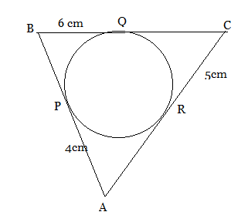
- In the fig. common tangents AB And CD to two circles intersect at E. Prove that AB=CD
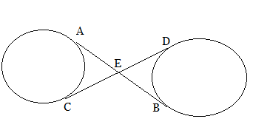
- A cone of maximum size is carved out from a cube of edge 14cm. Find the surface area of the cone and of the remaining solid left out after the cone is carved out.

- The slant height of a frustum of cone is 4cm and the perimeters (circumferences ) of its circular ends are 18cm and 6cm. Find the curved surface area of the frustum. (π =22/7)
SECTION C
- Construct a ∆ABC in which BC=6.5 cm AB=4.5cm and ∠ABC =60⁰. Construct a triangle similar to this triangle whose sides are ¾ of the corresponding sides of the ∆ ABC. Or Construct an isosceles triangle whose base is 9cm and altitude is 5cm.Then construct another triangle whose sides are ¾ of the corresponding sides of the first isosceles triangle.

- Find the middle term of the series 10,7,4,…..(-62) Or In the sequence 20,19 ,18 ,…… Sum to n terms is 300. Find n.

- Find the roots of the following quadratic equation : x² -3√ 5x +10=0.

myguru@coolguru.net www.coolGuru.net

- Prove that the parallelogram circumscribing a circle is a rhombus. Or A triangle ABC is drawn to circumscribe a circle of radius 2cm, such that the segment BD and DC into which BC is divided by the point of contact D are of length 4cm and 3cm respectively. If area of ABC =21cm², then find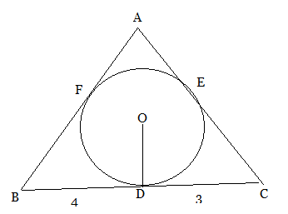 the length of sides AB and AC.
- Two dice are thrown simultaneously. What is the probability of getting a total of at least 10?

- A boy standing on a horizontal plane finds a bird flying at a distance of 100m from him at an elevation of 30º .A girl standing on the roof of 20 m high building finds the angle of elevation of the same bird to be 45º. Both the boy and the girl are on opposite sides of the bird. Find the distance of bird from the girl.

- A square field and an equilateral triangle park have equal perimeters . If the cost of ploughing the field @ Rs.5/m² is Rs. 720, find the cost of maintaining the park @Rs.10/m². Or A round table cover has six equal designs as shown in fig. If the radius of cover is 35cm, then find the total area of the designs. ( take √3=1.732 and π=3.14) 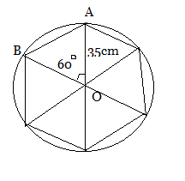
- A solid sphere of radius 6cm is melted into a hollow cylinder of uniform thickness. If the external radius of the base of the cylinder is 5cm and its height is 32cm, find the uniform thickness of the cylinder.

- P (5,-3) is one of the two points of trisection of line A(7,-2) B(1,-5) near to A. Find the other point.

- Points P,Q,R and S in that order are dividing a line segment A(2,6) and B(7,-4) in five equal parts. Find the coordinates of Q and S.

SECTION D
- Solve the following equation for x: 9x²-9(a+b)x+(2a²+5ab+2b²)=0

- A man standing on the deck of a ship, which is 10m above water level. He observes the angle of elevation of the top of a hill as 60 and the angle of depression of the base of the hill as 30. Calculate the distance of the hill from the ship and the height of the hill.

- A person buys National Savings Certificates of value exceeding the last year's purchase by Rs.500. After 10 years he finds the total face value of certificates purchased by him is Rs. 27,500. Find the value of certificates purchased by him in the first year. Or
Rs.6500 is divided equally among a certain number of persons. Had there been 15 more persons, each would have got Rs.30 less .find the no. of persons.

- With vertices A,B and C of a triangle ABC as centres, arcs are drawn with 5cm each. If AB=14cm, BC=48cm and CA =50cm, then find the area of the shaded region. ( take π=3.14) 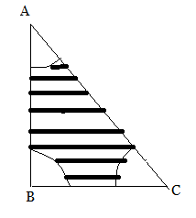

- The area of an equilateral triangle is 49√3 cm² .Taking each vertex as centre , circles are drawn with radius equal to half of the side of triangle . Find the area not included in the circles.

- A bucket of height 8 cm and made up of copper sheet is in the form of Frustum of a right circular cone with radii of its lower and upper ends as 3 cm and 9 cm respectively .Calculate: (i)the volume of water which can be filled in the bucket. (ii) the area of copper sheet required to make the bucket (leave your answer in terms of π ). Or A solid consisting of a right circular cone, standing on a hemisphere, is placed upright, in a right circular cylinder, full of water, and touches the bottom. Find the volume of water left in the cylinder, having been given that the radius of the cylinder is 3 cm and its height is 6 cm, the radius of the hemisphere is 2 cm and the height of the cone is 4 cm.
==========================

