Mahindra Placement Paper: Logical and Analytical Reasoning

In each of the following series determine the order of the letters. Then from the given options select the one which will complete the given series.

Q.1 E D C H G F K J I N ?
L M
O P
M O
M L

Q.2 IXT, MAV, QDX ?
WGX
VHY
UGZ
YHZ

Instruction for Q. No. 3
In the following questions select the number(s) from the given options for completing the given series.

Q.3 48,?,24,30,12,90
56
10
33
16

Instruction for Q. No. 4
In the given series find the number which is wrong.

Q.4 4,8,11,22,18,36,24,50
8
22
36
24

Instruction for Q. No. 5
In the questions given below one term is missing. Based on the relationship of the two given words find the missing term from the given options.

Q.5 DUST : BUSY :: JOIN :?
ROIT
SOON
RIOT
COST

Instruction for Q. Nos. 6 to 8 :
In the following questions, select the number from the given options which follows the same relationship as shared between the first two numbers.

Q.6 8 : 27 :: 64 :?
277
125
250
99

Q.7 23 : 53 :: 8 :?
66
57
27
19

Q.8 27 : 47 :: 32 :?
70
92
66
84

Instruction for Q. No. 9
Three of the following four in each question are alike in a certain way and so form a group. Select the group of letters that does not belong to that group.

Q.9
JKkL
OPpQ
DEEF
VWwx

Instruction for Q. No. 10
In the following questions, which of the following pair of letters is different from the other three?

Q.10
AE - OL
UI - OE
IO - UE
EA - OU

Instruction for Q. Nos. 11 to 12 :
In each of the following questions, there are four options. The numbers, in these options, are alike in a certain manner. Only one number does not fit in. Choose the one which is different from the rest.

Q.11
24
90
54
36

Q.12
18
12
30
20

Instruction for Q. Nos. 13 to 14 :
In the following questions select the right option which indicates the correct code for the word or letter given in the question.

Q.13 If the word TRAIN is coded as WUDLQ, then how will the word BUS be coded?
EXU
DWU
EXV
VXE

Q.14 Certain words are coded as follows : BEAR-9281, DRUM-0683,PRY-485 AND DOOR-7899.What is the code for 'R'?
9
3
8
4

Instruction for Q. Nos. 15 to 16 :
Read the given coded information and choose the correct answer from the given options.

Q.15 If 'orange' is called 'ashen', 'ashen' is called' red', 'red' is called 'blue', 'blue' is called 'brown', 'brown' is called 'black', 'black' is called 'white' and 'white'is called 'pale', what is the colour of a tree trunk?
black
brown
blue
white
red

Q.16 If 'light' is called 'colour', 'colour is called 'red', 'power'is called 'light', 'red'is called 'dust' and 'dust' is called 'waste', what do we get from sun?
colour
light
red
power
dust

Instruction for Q. No. 17
In the following questions, under-stand the arrangement pattern and then select the right answer from the given options.

Q.17 Five boys are sitting in a row. Raghu is not adjacent to Shyam or Amit. Ajay is not adjacent to Shyam. Raghu is adjacent to Mayank. If Mayank is at the middle in the row, then Ajay is adjacent to whom out of the following?
Amit
Raghu
Mayank
Shyam
Data Inadequate

Instruction for Q. No. 18
In the following questions, select the right answer from the given options to depict the correct direction / distance.

Q.18 I was walking in South-East direction. After a while I turned 90 degree to the right and walked ahead.Later I turned 45 degree to the right.In which direction am I walking now?
North
North - East
South - West
East

Instruction for Q. No. 19
Choose the correct option.

Q.19 If the following words are arranged in natural sequence in descending order, what will come in the second place from the last?

1. Teacher
2. Lecturer
3. Dean
4. Tutor
5. Reader
Dean
Lecturer
Tutor
Reader
Teacher

Instruction for Q. No. 20
Find out the one word among the options which cannot be formed by using the letters of the word as given in each question.

Q.20 BOISTEROUS
STEREO
SHOUT
BOOSTER
TRESS

Instruction for Q. No. 21
Find out the one word among the options which can be formed by using the letters of the word as given in each question.

Q.21 BELLIGERENT
GREEN
LEGAL
BLOAT
INFER

Instruction for Q. Nos. 22 to 26 :
Read the paragraph carefully and answer the questions below it.
(i) A, B, C, D and E are five friends.
(ii) B is elder to E, but not as tall as C.
(iii) C is younger to A, and is taller to D and E.
(iv) A is taller to D, but younger to E.
(v) D is elder to A but is shortest in the group.

Q.22 If F, another friend is taller than C, how many of them will be between F and E according to their height?
Four
One
Two
Three
None of these

Q.23 If selection is to be made among them who would be relatively older and also taller, who among them should be chosen?
A
E
D
C
None of these

Q.24 Who among the following is the eldest?
C
B
D
A
None of these

Q.25 Which of the following pairs of students is elder to D?
BA
BC
EA
BE
None of these

Q.26 Which of the following statements is correct about B?
(i) B is not the tallest.
(ii) B is shorter to E.
(iii) When they are asked to stand in ascending order with respect to their heights,B is in the middle.
Only (i) is correct
All are correct
All are incorrect
Only (i) and (ii) are correct
None of these

Instruction for Q. Nos. 27 to 31 :
Read the paragraph carefully and answer the questions below it.
P is the father of R, but R is not his son.
T is the daughter of R. U is the spouse of P.
Q is the brother of R. S is the son of Q.
V is the spouse of Q. W is the father of V.

Q.27 Who is the Grandmother of S?
W
P
R
U
None of these

(A) 'P + Q' means 'P is the brother of Q'.
(B) 'P * Q' means 'P is the father of Q'.
(C) 'P / Q' means 'P is the mother of Q'.
Reading the above information answer the questions below :

Q.28 Which of the following would mean 'R' is the son of 'M'?
M + R * S
M * S / R
M / R * S
M * S * R
None of these

Q.29 To arrive at the answer to the above question, which of the statements can be dispensed with?
Only A
B or C
A or B
Only B
None

(A) 'P + Q' means 'P' is the brother of 'Q'.
(B) 'P * Q' means 'P' is the father of 'Q'.
(C) 'P - Q' means 'P' is the sister of 'Q'.
Reading the above information answer the questions below :

Q.30 Which of the following represents 'S' is the niece of 'T'?
a) T * S + M - K
(b) T + M * S - K
c) K - S * M + T
d) T * M + S - K
e) None of these

Q.31 To find out the answer to the above question which of the statements can be dispensed with ?
A only
B only
C only
B or C only
All are necessary

Instruction for Q. Nos. 32 to 35 :
Choose the correct option.

Q.32

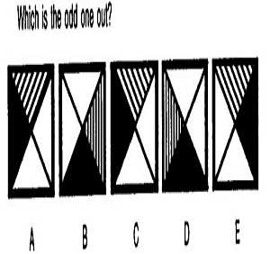

Q.33
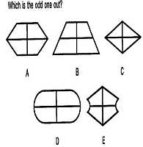

Q.34

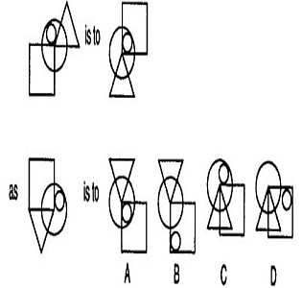

Q.35

